Keeper of the Cards Rulebook
2nd Edition
Introduction
Keeper of the Cards is a trading card game, loosely inspired by elements from various populer trading card games you may be familiar with. The primary distinguishing factor of Keeper of the Cards, however, is that you don't just trade cards; you create cards.
Unlike other trading card games, there are no official cards for Keeper of the Cards. Instead, there are official effect components that can be used for cards and official rules for calculating the cost of playing any given card. These rules are laid out separately in the document titled, “Card Building Guide”.
This document, on the other hand, serves to explain the rules of the game.
Setup
Keeper of the Cards can be played by 2 or more players. There is theoretically no limit, but it is recommended to keep the number of players small, preferably between 2 and 8. In the case of a game with more than two players, each player works alone, with their own hitpoints and field.
Each player starts with their shuffled deck, a hand of 5 cards, and 60 hitpoints. A piece of paper is recommended to keep track of hitpoints. In addition, you should have a reasonable amount of six-sided dice (preferably at least 10-20 dice), and some objects such as coins or chips to use as counters. You must also determine who goes first. One suggested method is for each player to roll two six-sided dice and for the player with the highest roll to go first.
Card Types and Layout
There are two types of cards in Keeper of the Cards: creatures, and spells. Below are some examples of both:
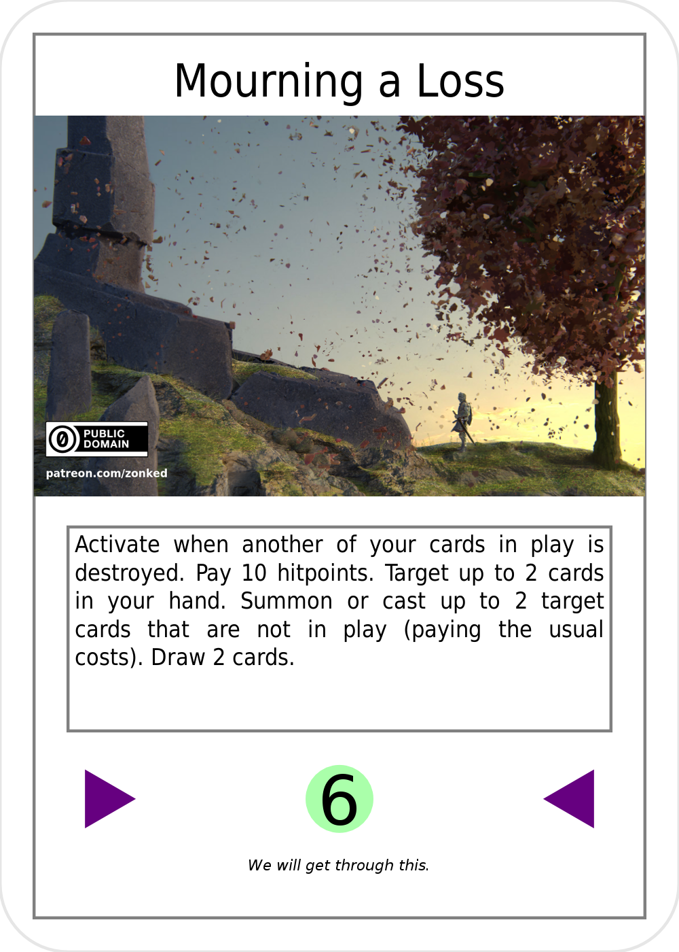
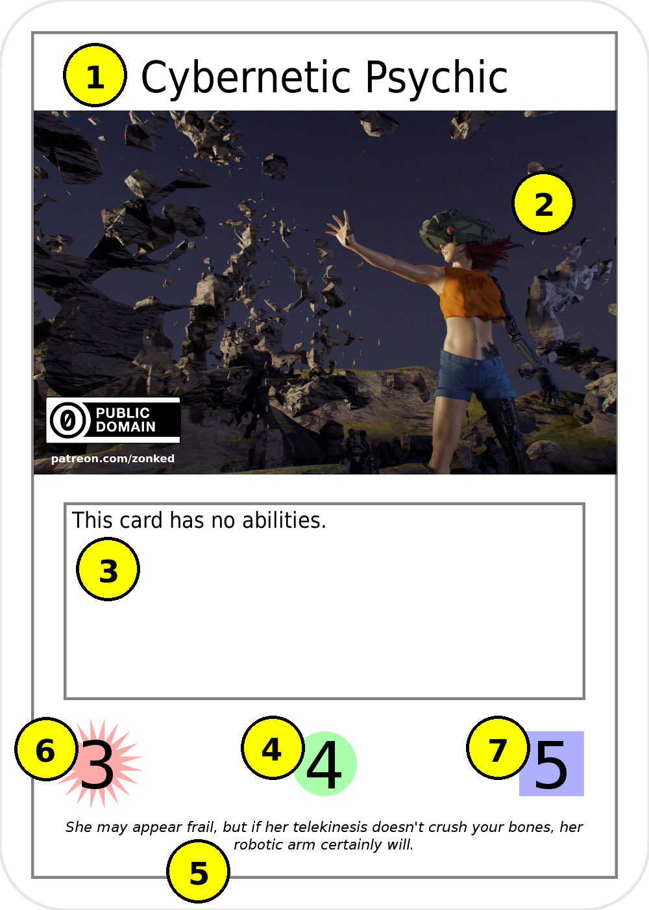

The card on the left is a creature, and the card on the right is a spell. As you can see, they are both very similar; the only real difference is that spells have a pair of triangles instead of the additional elements found on a creature.
The elements marked on “Cybernetic Psychic” are:
- The name of the card. This is purely cosmetic and has no effect on the game.
- The card image. This is purely cosmetic and has no effect on the game.
- The ability text of the card.
- The resource cost of the card.
- The flavor text of the card. This is purely cosmetic and has no effect on the game.
- The offensive power (“offense”) of the card.
- The defensive power (“defense”) of the card.

Deck Building Considerations
A deck in Keeper of the Cards must have exactly 50 cards. All cards must look the same from the back; this can be achieved by using sleeves if necessary.
Other than that, there are no restrictions on what legal cards you can put in your deck. In particular, there is no restriction on how many copies of a given card you may have in your deck; if you like, you can populate your deck with 50 identical cards. The reason for this is simply that such a rule would be difficult to enforce; any dedicated deck builder would be able to get around such a requirement simply by adding unnecessary targetings, slightly varied activation costs, slightly varied power levels, etc. Secondarily, even if it could be enforced properly, such a rule is unnecessary as things such as instant win conditions are not a particular issue for this game.
The Field
Each player's field contains the following zones:
- Deck: Contains your deck. The deck's contents are not revealed to anyone, and it is shuffled before the start of the game.
- Graveyard: Typically to the right of your Deck. Any card which is destroyed or sacrificed is sent here, face-down. The contents of the graveyard are not public knowledge, but its owner may look through it at any time.
- Creature Zone: Typically above your Trap Zone. Contains your “in play” creatures. The contents of this zone are public knowledge.
- Trap Zone: Typically to the left of your Deck. Contains your “in play” spells (a.k.a. “traps”). The contents of this zone are not public knowledge, but its owner may look at the cards within at any time.
- Resource Zone: Typically below your your Trap Zone. Contains your resources. The contents of this zone are not public knowledge, but its owner may look at the cards within at any time.
- Hand: The cards you currently have available to play, held in your hand. The contents of a hand are not public knowledge, but its owner may look at the cards within at any time.
Turn Order
Each turn in Keeper of the Cards consists of the following phases:
- Resource Phase: Place up to two cards from your hand, face-down, onto the Resource Zone, oriented vertically (unexhausted). Then draw a number of cards equal to two minus the number of cards you placed into the Resource Zone.
- Action Phase: You may play any cards from your hand that you are able to, and you may also activate in-play creature abilities and in-play traps with no activation condition.
- Battle Phase: You may do battle with your unexhausted creatures.
- Recovery Phase: Unexhaust all cards (on every player's field) and restore the offense and defense of all creatures to the numbers printed on the respective cards.
Resources and Exhaustion
Resources are used to summon creatures and cast spells. A resource can be any card. Resources are placed into the Resource Zone unexhausted during the Resource Phase (as explained above). When you place a resource into the Resource Zone, it is always played face-down, as its identity is not public knowledge.
To pay a resource cost is to exhaust a number of unexhausted resources. For example, to pay a resource cost of 3, exhaust three of your currently unexhausted resources by turning them sideways.
“Exhausted”, for any card, means that the card cannot currently be used, and is marked by turning the card sideways. To unexhaust a card, return it to an upright orientation. This is done only during the Recovery Phase.
Creatures, Abilities, and Battles
Creatures are used to do battle, but may also have special abilities.
To summon a creature, pay a number of resources equal to the card's resource cost, and then place it, exhausted, into the Creature Zone.
Some creatures have “caveats”, special rules which apply to them. Caveats are always on the first line of the ability text and include the term “this creature” somewhere in the text. Caveats may include such things as extra costs for summoning the creature, costs for attacking or defending, and restrictions on what the creature can do.
A creature's abilities are indicated in the ability text (after the caveat, if any), one paragraph for each ability. You can activate an ability of an unexhausted creature by exhausting it.
Some abilities have an activation condition, which is a sentence indicating when to activate the ability; in this case, you may only use the ability at such a time when the activation condition is satisfied. If an ability has no explicit activation condition, you may only use it during your own Action Phase. These rules apply to the abilities of spells as well.
Some activation conditions may cause abilities to activate while the card is not in play. Therefore, if any creature or spell has its ability activated when it is not in play and was not in play immediately prior to the action responsible for fulfilling the condition, the card's resource cost is paid before the effect activates. This, again, also applies to spells.
Some abilities also have an activation cost, which is a special cost (such as removing a certain number of counters, sacrificing one of your cards, or paying a certain number of hitpoints) that you must pay upon activation of the ability. Activation costs are designated at the beginning, after any activation condition, but before any targeting or effect text. If you activate an ability you are unable to fully pay the activation cost for, the effect of the ability disappears. It should be noted that “sacrificing” a card is not considered to be the same as “destroying” the card, and “paying” hitpoints is not the same as taking damage; therefore, these costs cannot be used to satisfy activation conditions referring to the destruction of a card or damage to hitpoints.
To battle, the attacking player exhausts any number of unexhausted creatures, which become the attacking team, and declares one target: a player, or a creature. The target player, or the owner of the target creature, may then exhaust any number of their own unexhausted creatures (which may or may not include the target itself), which become the defending team. After the attacking team and the defending team are selected, all other players have an opportunity to respond to the attack (see “Chains” below). Then the attacking player rolls a number of six-sided dice equal to the total offense of the attacking team, and the defending player rolls a number of six-sided dice equal to the total offense of the defending team. Each player must then take each of the opposing team's dice, one at a time (in any order), and inflict the result as damage to any one creature in their respective team until either all dice are used or all creatures in their respective team are destroyed. Then, if the target and any of the attacking team's dice remain, inflict the total result of the remaining dice to the target. All damage is considered to be inflicted simultaneously.
To inflict damage to a creature, subtract the damage from the creature's defense, and then if the defense is less than or equal to zero, destroy the creature. For example, if 8 damage is inflicted to a creature with 15 defense, that creature will have 7 defense left and not be destroyed. If 8 damge is inflicted to a creature with 8 defense, however, that creature will have 0 defense left and be destroyed.
As an example, consider an attacking team with three creatures that each have 2 offense and 5 defense, targeting a player, who then chooses to defend with two creatures that each have 1 offense and 10 defense. The attacking player rolls six dice, and the defending player rolls two dice. Suppose the attacking player rolls the following numbers: 1, 6, 5, 5, 3, 6; while the defending player rolls the following numbers: 6, 2. The attacking player chooses to apply the 2 to one creature, reducing its defense to 3, and then apply the 6 to that same creature, reducing its defense to 0 and destroying it. The defending player chooses to apply a 6 and the 3 to one creature, reducing its defense to 1, then apply a 5 and the 3 to the other creature, reducing its defense to 2. They then apply the remaining 6 to one creature, destroying it, and apply the remaining 5 to the other creature, also destroying it. Since all of the defending team's creatures have been destroyed and one die is left over, the remaining die (a 1) is applied as damage to the target (in this case, the defending player).
During your battle phase, you may initiate as many battles as you want to as long as you have unexhausted creatures remaining.
Casting Spells and Setting Traps
Spells are cards that only have a single ability (like creatures, shown in the card's ability text). Spells can be used in two ways: they can be cast during your action phase, and they can be set as traps for use later.
To cast a spell, pay a number of resources equal to the card's resource cost, reveal the spell to all other players, follow the instructions on the card immediately, and send the spell to the graveyard. Only a spell with no activation condition can be cast in this way; any spell with an activation condition must first be set as a trap before it can be activated. Note: a spell cast this way is not considered to be “in play”.
Traps function the same way as spells, but there are two key differences. Firstly, a spell with an activation condition may only be activated as a trap. Secondly, the resource cost of a trap is not paid at the same time the trap is activated.
To set a trap, pay a number of resources equal to the card's resource cost, then place the card into the Trap Zone, face-down and exhausted. Note: the identity of the card is not public knowledge.
To activate a trap, it must be unexhausted. Additionally, just like with creature abilities, a trap with an activation condition can only be activated in the designated condition, and a trap with no activation can ony be activated during your own action phase. Note that activating a trap does not incur any additional resource cost. Simply turn the trap over to reveal it to all other players, and follow the instructions on the card. Note: once activated, a trap is no longer considered to be “in play”.
Chains
Some abilities are activated in response to other actions. In such a case, it is important to understand what chains are and how they work.
Every time a card is played, an attack is initiated, a creature ability is activated, or a trap is activated (after selecting targets, if applicable), that starts a “chain”, and the action that started the chain is the first “link”. At this point, after all appropriate costs are paid, any player may then activate the ability of an unexhausted creature or an unexhausted trap (but not a spell within their hand) that has an appropriate activation condition. Such conditions are phrased as “Activate in response to X”, where X is the specific event the condition refers to. When such an ability is activated, it becomes the next chain link, and the process repeats until no player wishes to activate another creature effect or trap. Then, each chain link's effects are resolved, starting with the most recent link and working backwards until the first link is resolved.
Each chain link can only have one ability activated in response to it. If multiple players wish to respond to the current chain link, then the player who most recently completed their turn is given priority. You may not respond to your own chain links.
Note that once a chain is completed, it must be resolved before any additional action is taken by any player. This rule is to prevent potential confusion that can arise if the resolution of a chain has to be paused mid-way.
All links in a chain are considered to have happened at the same time. This means, in particular, that after a chain finishes resolving, you may activate “when” effects that are triggered by chain links other than the first one.
One important term when it comes to chains is the term “negate”. To “negate” something means to make it so that it never happens. If something is negated, any relevant costs are still paid (including the exhaustion required for creature attacks and abilities).
Winning and Losing
Any given player can lose in three ways:
- by having their hitpoints reduced to 0;
- by having an empty deck; or
- by voluntarily forfeiting.
Any player who loses is out of the game and can no longer affect the game in any way. When only one player remains in the game, that player is declared the winner.
Ability Clarifications/Rulings
This section serves to clarify some things regarding ability texts. It is listed alphabetically based on the text portion at hand.
- “A total of”: Texts that indicate “a total of” some number mean that the number indicated is spread out among targets in a way determined by you. You must use the entirety of that number if possible (and otherwise must use as much of it as possible). You may not reduce either the offense or the defense of any one creature below 0 (so for example, if an effect inflicts “a total of” 10 damage and one of the targets has only 6 defense, you cannot apply all 10 damage to that target; you can apply 6 damage to it only, and the remaining 4 damage must be applied to other cards). You may not manipulate attributes that don't exist on a given card (i.e. offense and defense of spells may not be manipulated because they don't have these attributes).
- “Different player of your choice”: This refers not to opponents, but to players other than the current controller of the card(s) in question. For example, if the effect is talking about a creature controlled by an opponent, the “different player” can be you, but it cannot be the opponent who currently controls the creature.
- “Each”: When the term “each” is used to refer to targets, it means that each target is affected separately, i.e. any decision required by the effect is made for each card separately.
- “Offense counter”, “defense counter”, etc: Special, named counters can be removed at any time to cause some effect stated by the card text. These counters can be removed literally at any time, that is to say, during any phase of any player's turn, and even during resolution of a chain, triggering the stated effect. Removing such counters for this reason does not require exhausting the creature and does not start a chain. The player who placed the counters is the one who can remove them for this purpose, regardless of who controls the creature; for example, if you place one of these counters on an opponent's creature, it is you who can then remove the counters to trigger the effect, and the opponent cannot do so.
- “One player”: For texts that say “one player”, you select the player. It can be any player, including yourself.
- “Reveal”: To “reveal” a card is to show it to all players, including yourself.
- “Sacrifice”: You can only “sacrifice” cards that you control. A sacrificed card is not “destroyed”. No card is permitted to “sacrifice” itself under any conditions, which also means that an opponent may not select the activated card when choosing a card for you to sacrifice.
- “Selected by an opponent”: When a variable number of targets are selected by an opponent, you choose the number; the opponent must choose that number of cards for you to target. For example, an opponent cannot choose to target zero cards. However, note that the opponent does not have to choose targets that make sense for the effect. For example, if the effect inflicts damage to targets, the opponent may wish to choose traps that are in play, since traps cannot be damaged, and creatures on your field, since that may force you to inflict damage to your own creatures.

Revised Ability Text
This section lists old ability text portions which have been revised. The revision is indicated as the old text, then an arrow pointing to the right, and then the new text. Redacted text is crossed out in the old text, and added text is bold in the new text. If you see any of these old text portions in a card, you must use the card in the way indicated by the new text, if applicable. These are listed in alphabetical order. Note: [x], [y], and [z] are replaced with numbers in cards.
- “Exhaust [x] of your unexhausted cards in play.” → “Exhaust [x] of your unexhausted creatures in play.”
- “Exhaust [x] of your unexhausted cards in play chosen by an opponent of your choice.” → “Exhaust [x] of your unexhausted creatures in play chosen by an opponent of your choice.”

Redacted Ability Text (Banned Cards)
This section lists ability texts which have been redacted. This is generally because the text results in cards that are too powerful or create a bad game experience. Any card with any of these texts is considered to be banned, i.e. may not be used in a game. Note: [x], [y], and [z] are replaced with numbers in cards.
- “Inflict [x] damage to any one player.”

