GIAW — Technology Stack
Components, versions, hosting and the reasons for each choice
GPHA Internal Audit Department
Version 1.0 · 16 October 2026
Table of Contents

Document control
Item | Value
Document | Technology Stack
Version | 1.0
Baseline | Commit 4e0d386; versions below are those locked in uv.lock on 16 October 2026
Audience | IT management, infrastructure, security review, developers
Recorded decision | 15 October 2026: the stack is FastAPI + MySQL with a plain JavaScript front end. React, TypeScript, Vite, Tailwind, Celery and Redis are not used.

1. Stack at a glance
Layer | Technology | Version | Why it was chosen
Language | Python | 3.12+ (tested on 3.13) | Widely known; strong libraries for data, documents and security
Package and environment manager | uv | current | One command installs exact, locked versions (uv sync --frozen)
Web framework | FastAPI | 0.143.0 | Typed, fast and automatic validation; built-in API documentation
ASGI server | Uvicorn | 0.54.0 | Production-grade server for FastAPI; runs as a Windows service
Web toolkit | Starlette | 1.7.0 | Underlying FastAPI; middleware for security headers
Data validation | Pydantic / pydantic-settings | 2.14.1 / 2.15.0 | Field-level validation and environment configuration (GPHA_ prefix)
ORM | SQLAlchemy | 2.1.4 | Mature ORM with transactions and events
Migrations | Alembic | 1.20.0 | Versioned, reviewable schema changes; applied at start-up
Database | MySQL | 8.x (production target 8.4 LTS; Docker dev image 8.0) | GPHA-supported, robust, free; InnoDB with triggers for the append-only trail
Database driver | PyMySQL | 1.2.3 | Pure-Python driver, no compiler needed on Windows
Password hashing | bcrypt | 5.0.0 | Industry-standard slow hash
Encryption at rest | cryptography | 50.0.2 | Encrypts uploads and backups (GPHA_ENCRYPTION_KEY)
Sessions and signing | itsdangerous | 2.2.0 | Signed tokens
Directory sign-in | ldap3 | 2.9.1 | Optional Active Directory bind
Word documents | python-docx | 1.2.0 | Reports, packs, engagement letters, controlled copies
Excel | openpyxl | 3.1.5 | Register exports and Excel import
Uploads | python-multipart, aiofiles | 0.0.32, 25.1.0 | Multipart file upload, async file I/O
E-mail validation | email-validator | 2.3.0 | Validates addresses
Front end | Plain HTML, CSS and JavaScript (ES2020) | – | No build step, so no Node toolchain on the server; easy to audit and maintain
Icons and fonts | Bootstrap Icons, Inter (self-hosted) | – | No external CDN calls; works offline and passes a strict CSP
HTTPS front door | Apache (Laragon) or Caddy 2 | – | TLS termination and reverse proxy (deploy/laragon/gpha-audit.conf, deploy/Caddyfile)
Windows service | NSSM | – | Runs Uvicorn as a service that restarts after failure
Development database | Docker Desktop + mysql:8.0 | – | Same engine as production, on port 3307
Tests | pytest, httpx, Playwright (Chromium) | 9.1.1, 0.28.1, 1.64.0 | API, integration and browser tests
Code quality | ruff, bandit, pip-audit | 0.17.0 | Lint, static security analysis, dependency vulnerability check
Diagrams (docs) | Graphviz | – | Architecture and workflow diagrams in these documents

2. Runtime topology
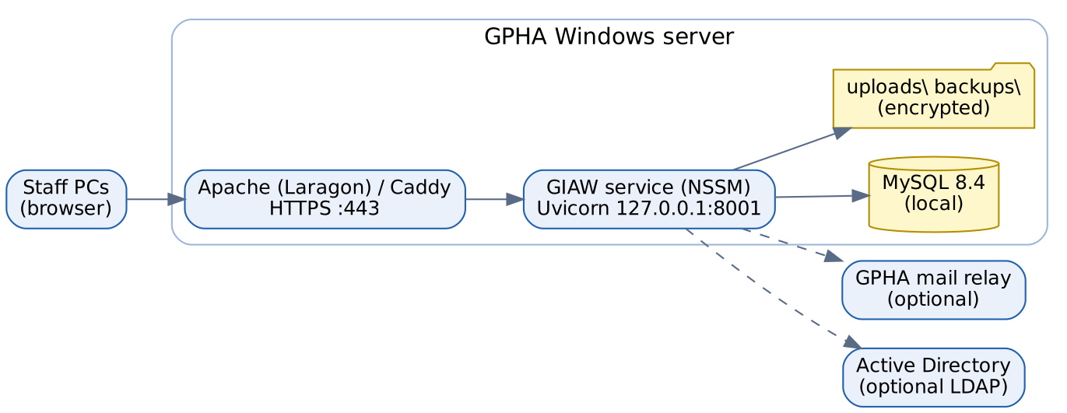
Production deployment
Component | Where | Port | Notes
Browser | Staff PCs | – | Recent Edge or Chrome; phones and tablets are supported
Apache / Caddy | GPHA server | 443 (HTTPS) | TLS certificate from GPHA (or tls internal)
GIAW (Uvicorn) | GPHA server | 127.0.0.1:8001 | Only reachable through the proxy
MySQL 8.4 | GPHA server (or a GPHA DB server) | 3306 (prod), 3307 (dev Docker) | Needs log_bin_trust_function_creators=1
File storage | Server disk: uploads\, backups\ | – | Encrypted; include in server backups
SMTP relay | GPHA Exchange / Microsoft 365 | 25/587 | Optional
Active Directory | GPHA domain controllers | 389/636 | Optional

3. Server sizing (recommendation)
These are provisional recommendations for about 50 to 150 users. Confirm them with GPHA IT.
Resource | Minimum | Recommended
Operating system | Windows Server 2019 / Windows 10 Pro | Windows Server 2022
CPU | 2 vCPU | 4 vCPU
Memory | 4 GB | 8 GB
Disk | 60 GB | 200 GB (uploads grow with evidence)
Backup target | Separate disk or share | Off-server copy, encrypted

4. Environments
Environment | Purpose | Data | Database
Development | Building and testing (developer PC: .\run.ps1, http://127.0.0.1:8001) | Demo data only (scripts/seed_demo.py) | Docker MySQL on port 3307
Test (automated) | pytest | Created and dropped each run | gpha_workspace_test
Staging (recommended) | UAT and release rehearsal | Copy of production structure, synthetic or masked data | MySQL 8.4
Production | Live use | Real GPHA data; starts empty | MySQL 8.4

5. What is deliberately not used, and why
Not used | Reason
React / TypeScript / Vite / Tailwind | Adds a build pipeline and toolchain the GPHA team would have to maintain. The plain JavaScript design system covers the needs.
Celery / Redis | Background work is light; in-process schedulers are enough and need no extra servers
External CDNs and analytics | Data protection and offline resilience; strict Content-Security-Policy
Cloud-only services | GPHA hosts the system on its own infrastructure

6. Upgrade and support policy (recommendation)
- Pin all versions in uv.lock. Upgrade quarterly in staging first, run the full test suite and pip-audit, then release.
- Apply Windows and MySQL security patches monthly.
- Keep Python on a supported release (3.12 or later).
- Review this document at every major release.

