GIAW — Administration Guide
Installation, configuration, users and access, backups, maintenance and troubleshooting
GPHA Internal Audit Department
Version 1.0 · 16 October 2026
Table of Contents

Document control
Item | Value
Document | Administration Guide
Version | 1.0
Audience | Super Administrators, Administrators (platform), GPHA IT (server, database, network)
Baseline | Commit 4e0d386
Security rule. Never put .env, the encryption key, backups or database dumps in e-mail, chat or source control.

1. Administration roles
Who | GIAW job role | Main duties
Super Administrator (at least two people) | super_admin | Full control: the Roles & permissions matrix, appointing administrators, Apps & customization (switch apps on or off, rename, branding)
Administrator | admin | Day-to-day platform running: users, configuration, reference data, workflow rules, methodology libraries, backups, activity logs. Does not perform or approve audit work.
GPHA IT | (server access, not a GIAW role) | Server, Windows service, MySQL, HTTPS certificate, network, off-server backups, patching
GIAW system owner | (business) | Approves configuration changes and new users; owns the decision register

2. Installation

2.1 Development or demonstration PC
- Install Docker Desktop, uv and Git.
- Get the code into C:\dev\GPHAIAWORKSPACE.
- Copy .env.example to .env and adjust it.
- Open PowerShell in the folder and run .\run.ps1. The script:
  - starts Docker and the MySQL container (gpha-mysql, port 3307);
  - installs dependencies (uv sync);
  - checks the database and applies migrations;
  - starts the app.
- It refuses to start if the database cannot be reached.
- Open http://127.0.0.1:8001 and sign in with the bootstrap administrator from .env.
- Optional: load demo data with uv run python -m scripts.seed_demo. Never do this on production.

2.2 Production server (Windows)
Follow deploy/PRODUCTION.md. Summary:
# | Step | Command / action | Who
1 | Server ready | Windows Server, Laragon (Apache + MySQL 8), uv, NSSM, Git; static IP and DNS name (e.g. audit.gpha.gov.gh) | IT
2 | Get the code | Clone to e.g. C:\apps\gpha-audit. Do not copy .env, uploads\, backups\ or a development database. | IT
3 | Database | Run deploy\mysql\create-production-database.sql (set the password); add log_bin_trust_function_creators=1 under [mysqld] in my.ini | DBA
4 | Configuration | powershell -ExecutionPolicy Bypass -File deploy\windows\1-new-production-env.ps1: generates the keys on the server and asks for the database account, folders and first administrator | IT
5 | Install | deploy\windows\2-install.ps1: installs dependencies, creates the empty schema and the first administrator, runs the readiness check | IT
6 | Service | deploy\windows\3-install-service.ps1 -Nssm C:\tools\nssm\win64\nssm.exe: runs on 127.0.0.1:8001, starts with Windows, restarts on failure | IT
7 | HTTPS | Copy deploy\laragon\gpha-audit.conf into Apache sites-enabled, set the server name and certificate, enable mod_ssl mod_proxy mod_proxy_http mod_headers mod_rewrite. Alternatively use deploy\Caddyfile. | IT
8 | First sign-in | Browse to the HTTPS address, sign in, set up your own two-step verification, then empty GPHA_ADMIN_PASSWORD= in .env | Super Admin
9 | Reference data | Organizations (ports, departments, units, plan destinations), users and job roles, audit types, audit universe, criteria library | Admin / Audit Admin
10 | Configuration review | Reporting recipients, follow-up and professional-practice texts, KPI targets, escalation days, public holidays, e-mail | GM Audit
11 | Backup proof | uv run --no-dev python -m scripts.verify_backup; keep the output and repeat quarterly | IT
12 | Readiness | uv run --no-dev python scripts/production_check.py: all items OK except the two-step switch | IT
13 | Go-live | Configuration › Security: choose the roles and tick Enforce two-step verification; announce the address | Super Admin
With GPHA_ENVIRONMENT=production, the app refuses to start until:
- GPHA_SECRET_KEY is a random value of 32 or more characters;
- GPHA_ENCRYPTION_KEY is set (back it up: encrypted files are unreadable without it);
- GPHA_ADMIN_PASSWORD is not the default;
- GPHA_COOKIE_SECURE=true;
- the database is MySQL.

2.3 Updating to a new release
- Take a backup (Backups screen, or wait for the scheduled one) and confirm it completed.
- nssm stop GPHA-Audit
- git pull, then uv sync --no-dev --frozen
- nssm start GPHA-Audit. Database changes are applied automatically at start-up.
- Check /health and sign in. Users press Ctrl+F5 once.

3. Environment settings (.env)
Setting | Default | Purpose
GPHA_ENVIRONMENT | development | production turns on the start-up guard and hides the API docs
GPHA_SECRET_KEY | dev value | Application secret (generate for production)
GPHA_ENCRYPTION_KEY | derived | Encrypts working papers, evidence and backups (back up separately)
GPHA_DATABASE_URL or GPHA_MYSQL_* | dev DSN | Database connection
GPHA_SESSION_TTL_HOURS | 12 | Session lifetime
GPHA_COOKIE_SECURE | false | true behind HTTPS
GPHA_ADMIN_USERNAME / _PASSWORD / _EMAIL / _FULL_NAME | admin | Bootstrap administrator
GPHA_LOGIN_MAX_ATTEMPTS / GPHA_LOGIN_LOCKOUT_MINUTES | 5 / 15 | Account lockout
GPHA_LOGIN_RATE_LIMIT_PER_MINUTE | 10 | Sign-in attempts per computer per minute
GPHA_MAX_UPLOAD_MB / GPHA_UPLOAD_ALLOWED_EXTENSIONS | 25 / office, PDF, image, mail, audio | Upload limits
GPHA_BACKUP_DIR / _RETENTION / _INTERVAL_HOURS | ./backups / 7 / 24 | Backups
GPHA_SMTP_HOST / _PORT / _USER / _PASSWORD / _FROM / _STARTTLS | empty / 25 | E-mail (empty host means in-app bell only)
GPHA_APP_BASE_URL | http://127.0.0.1:8001 | Links in e-mails
GPHA_LDAP_* | empty | Active Directory sign-in
GPHA_ESCALATE_MANAGER_DAYS / _CAE_DAYS / GPHA_ESCALATION_CHECK_MINUTES | 14 / 30 / 60 | Overdue-action escalation
GPHA_MFA_REQUIRED_ROLES | empty | Roles that must use two-step verification
GPHA_AI_API_KEY | empty | AI provider key (never stored in the database)
Most business rules can also be changed on the Configuration screen. A value saved there overrides the .env default and takes effect without a restart.

4. Users and access
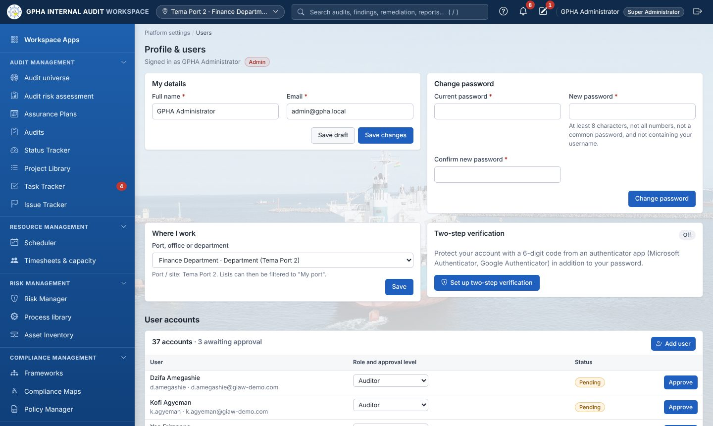
Users (Profile & Users)

4.1 Creating and managing users
- Open Platform settings › Users (Profile & Users).
- Select Add user, then enter the username, full name, e-mail, temporary password and job role. The job role sets the access tier and approval level.
- For managers, set the review level: Unit Head, Manager, PIA or CAE (GM Audit).
- Ask the user to set Where I work (port or department). This drives port scoping and plan distribution.
- Self-registered and Active Directory accounts arrive inactive. Review them and activate the genuine ones.
Task | How
Unlock a locked account | Users › select user › Unlock
Reset two-step verification (lost phone) | Users › the user’s row › Reset 2-step
Leaver | Set the user inactive. Their sessions end immediately. Users with activity are never deleted.
Role change | Edit the job role. Their other sessions end and must sign in again.
Password reset (server) | uv run python -m scripts.reset_password (break-glass)

4.2 Job roles and permissions
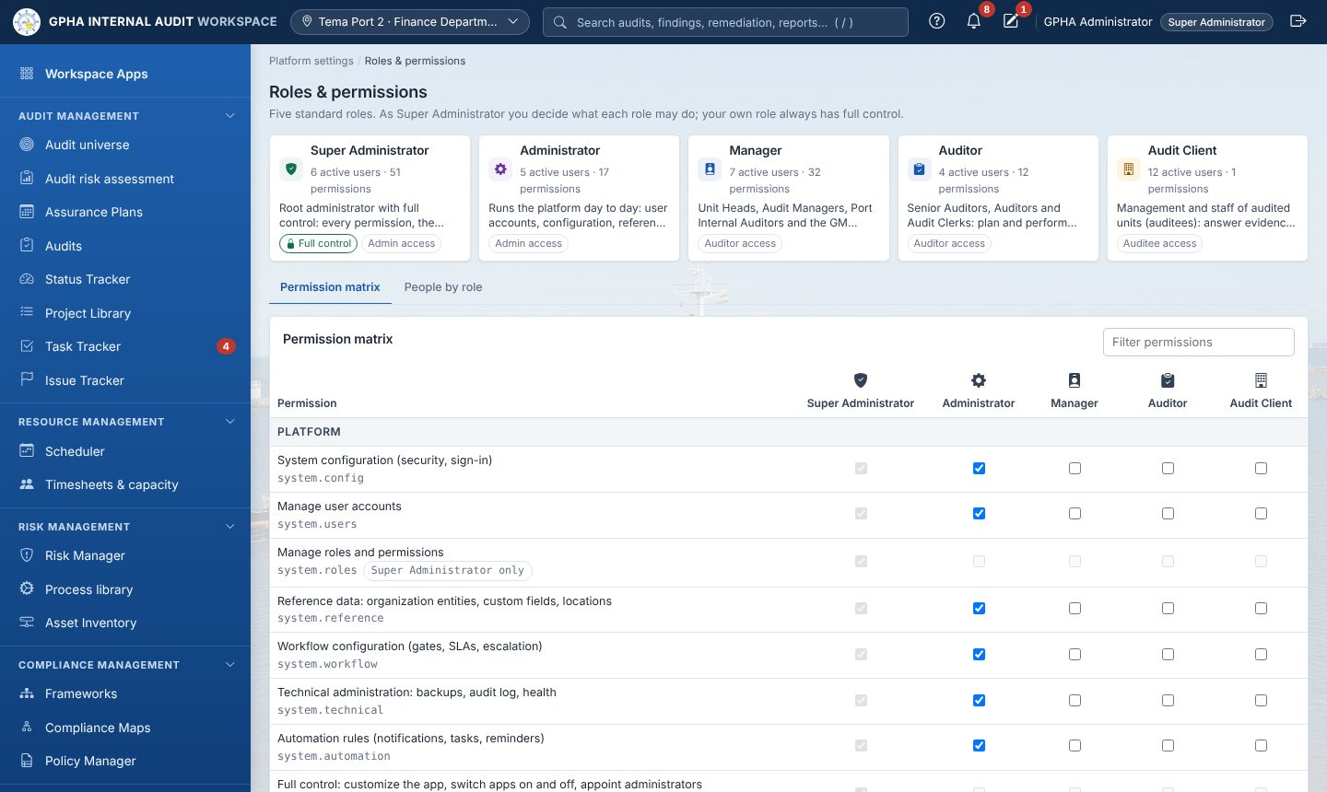
Roles & permissions
Job role | Tier | Default scope
Super Administrator | Admin | All 51 permissions, including system.superadmin (locked role)
Administrator | Admin | Platform, configuration, methodology libraries, reference data, backups, logs. No audit execution or approval.
Manager | Auditor | Unit Heads, Audit Managers, PIAs and GM Audit (set the review level). Plan, approve, review, close, follow-up, oversight.
Auditor | Auditor | Senior Auditors, Auditors, Audit Clerks: plan and perform engagements, fieldwork, evidence, findings, validation
Audit Client | Auditee | Management and staff of audited units: respond to requests, findings and actions, attest to policies, keep their risks current
The Roles & permissions matrix lets a Super Administrator tick or untick any of the 51 permissions for each role, and Reset a role to its defaults. The 9 permission categories are:
- Platform;
- Audit methodology;
- Planning & oversight;
- Engagements;
- Review & reporting;
- Follow-up;
- Auditee & governance;
- Risk & compliance;
- Services.
Separation of duties is enforced by the system regardless of permissions. A preparer can never approve their own plan, test, report, closure, policy or remediation.
Open item (QA-03). Audit Committee member accounts cannot currently be created: the Committee tier is converted to Auditee. Until GPHA decides, committee information is shared through the Committee pack (Word).

5. Organization and reference data
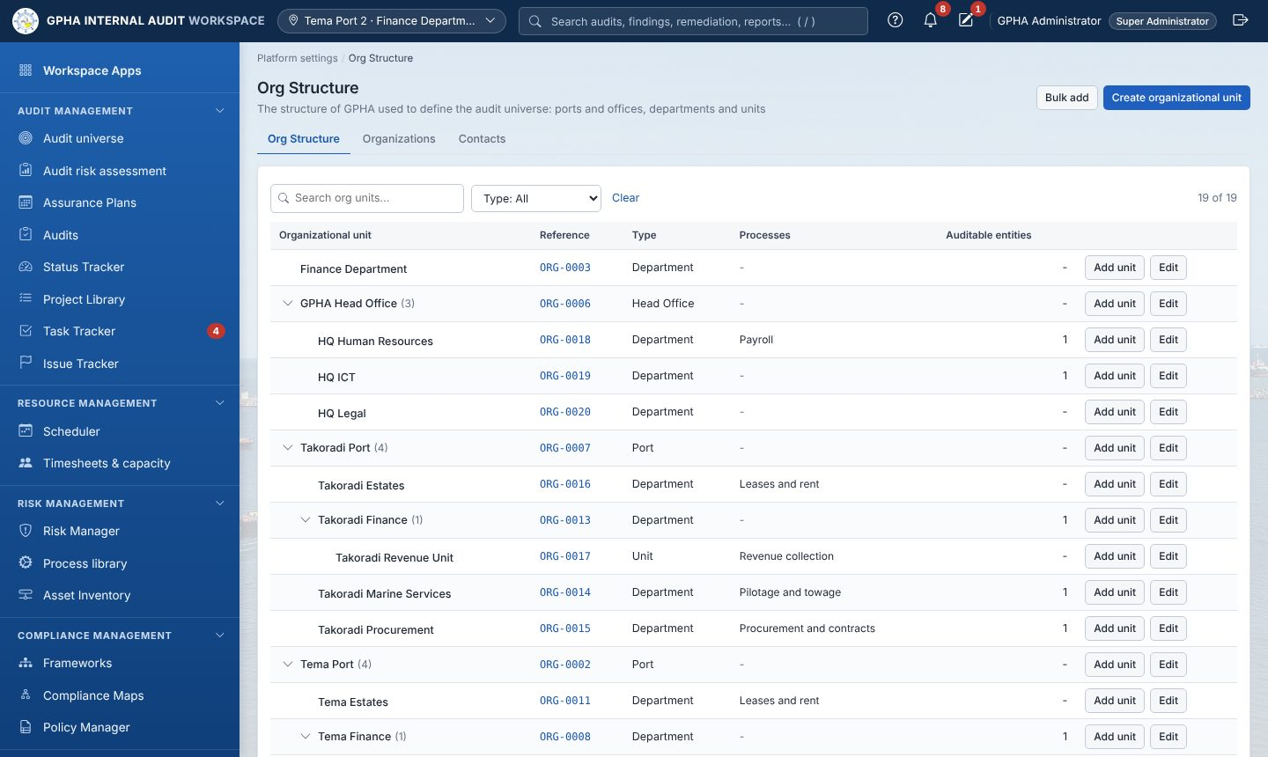
Org Structure
What | Where | Notes
Ports, head office, departments, units, external parties | Org Structure › Organizations | Each entity has a type, a parent (“Part of”) and an address. Types marked as ports or sites file every entity under its port.
Plan destinations (HQ, PIA Tema, PIA Takoradi) | Organization record › Receives the approved Assurance Plan | Nothing is hard-coded
Processes | Process library | Linked to org units, risks and controls
Contacts | Org Structure › Contacts (Stakeholders) | Auditee contacts
Custom fields | Configuration | On organizations, audits, findings and recommendations (text, number, date, drop-down, yes/no)
Audit types, terms and custom attributes | Configuration › Audit types | 17 renameable terms per audit type; up to 10 custom attributes per page
Frameworks and standard controls | Frameworks | Typed in or imported from CSV (/api/library/controls/template.csv)

6. Configuration (business rules)
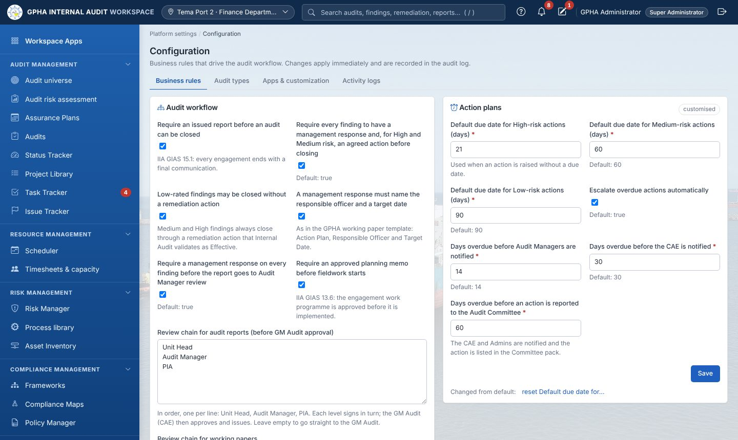
Configuration
Every change made on Configuration is logged with who, what and when. The rule groups are:
Group | Rules (examples)
Audit workflow (12) | Issued report required to close; management responses and agreed actions before closing; Low findings without action; approved planning memo before fieldwork; review chains for reports and working papers; survey at closure; notify auditees when fieldwork starts
Action plans (7) | Default due days by risk (High 30 / Medium 60 / Low 90); escalation on/off; days to escalate to Audit Managers, CAE, Audit Committee
KPI targets (5) | Plan delivery %, actions closed on time %, survey score, days to report, time charged to audit work
Audit methodology (10) | Audit types; Workplan vs Internal Control workflow; sample sizes by control frequency; rating scale; issue types; sign-off levels; preparer-first rule; password on sign-off; framework kinds; working hours per day
Plan configuration (9) | High/Medium risk thresholds; audit cycle in years by risk level; plan-cycle enforcement; distribution before execution; significant-change %; default engagement hours
Organizations (3) | Entity types; Org Structure types; port/site types
Security (5) | Roles requiring two-step verification; port and team scoping; HQ workplace types; enforce two-step; sign-in attempts per minute
Follow-up & reporting (9) | Days to respond to draft reports; public holidays; recommendation sources; timeframes; committee closes recommendations; report recipients; annual statement due date
Professional practice (9) | Independence declarations before fieldwork; declaration texts; CPD hours; charter review months; EQA years; conformance statement; file retention years
AI (7) | Allow AI; provider; model; endpoint (http/https only); redact personal data; maximum characters; timeout
Reports (4) | Organisation and department name; classification footer; default methodology paragraph
Risk & compliance (10) | Risk categories; appetite levels; treatments; risk review months; obligation kinds; policy categories; policy review months; asset and third-party types; classifications; third-party review months

7. Apps & customization
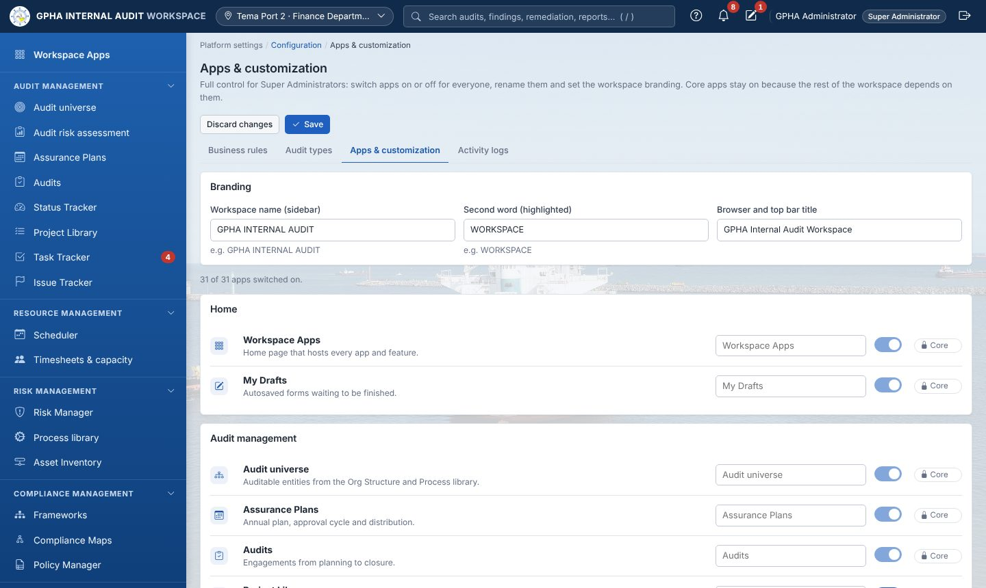
Apps & customization
The Super Administrator can:
- switch apps off: they disappear for everyone and their API is refused;
- rename apps: the new name shows in the sidebar and on the Workspace Apps page;
- set the branding: workspace name and browser tab title.
Core apps stay on. Select Save to apply, or Discard changes.

8. Security operations
Task | How
Enforce two-step verification at go-live | Configuration › Security: choose the roles, tick Enforce two-step verification for the roles above
Locked out of two-step verification (server) | uv run python -m scripts.mfa_policy (show), --off / --clear, --roles Admin
Review activity | Activity logs (Configuration tab): filter by user, action and date; export to Excel or CSV
Review access quarterly | Export Users; confirm every active account with its line manager; deactivate leavers
Secrets | Rotate GPHA_SECRET_KEY if exposed (all users must sign in again). Never lose GPHA_ENCRYPTION_KEY.
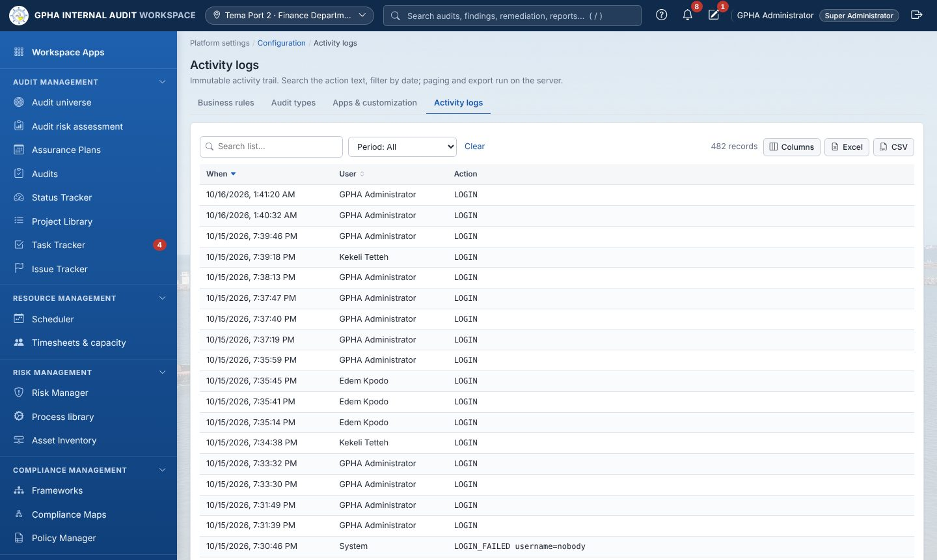
Activity logs

9. Backups and restore
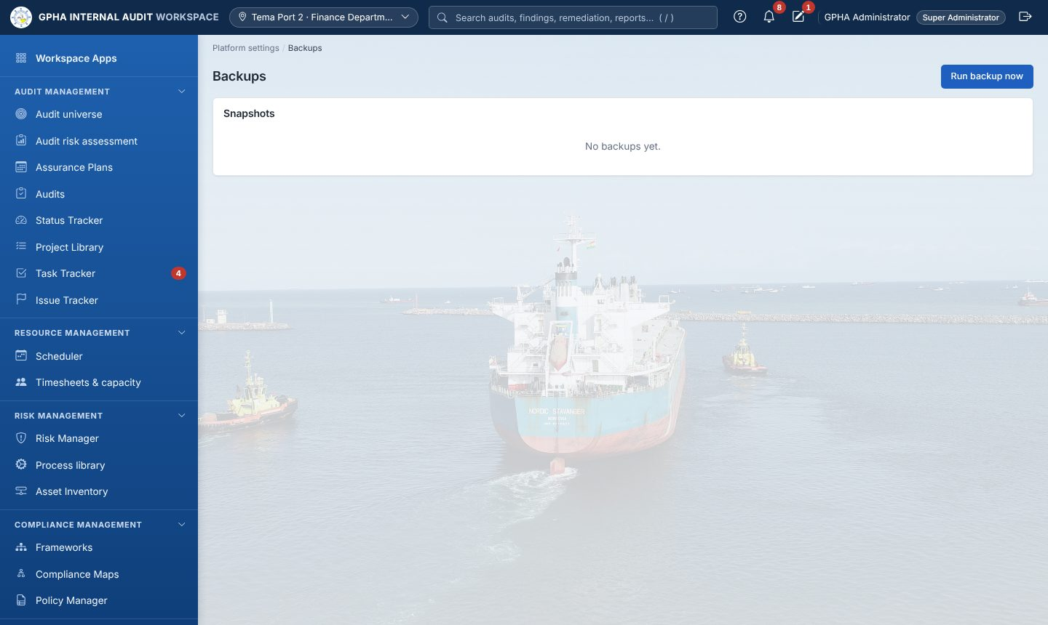
Backups
Item | Detail
Automatic | Every GPHA_BACKUP_INTERVAL_HOURS (24 h); newest GPHA_BACKUP_RETENTION (7) kept; encrypted backup_<stamp>.json.enc or .sql.enc; sessions excluded
On demand | Backups screen › Run backup now (Administrators)
Off-server copy | GPHA IT copies backups\ (and uploads\) to separate storage daily
Verify (quarterly) | uv run --no-dev python -m scripts.verify_backup: restores into a scratch database and compares every table
Decrypt only | uv run python -m scripts.restore_backup backups\<file>.enc --decrypt-only (delete the plaintext afterwards)
Restore | Point GPHA_DATABASE_URL at a new, empty database, then uv run python -m scripts.restore_backup backups\<file>.enc --yes
The encryption key must be stored separately from the backups, for example in a sealed envelope in the safe and in the IT password vault. Without it, backups cannot be restored.

10. Automations, robots and notifications
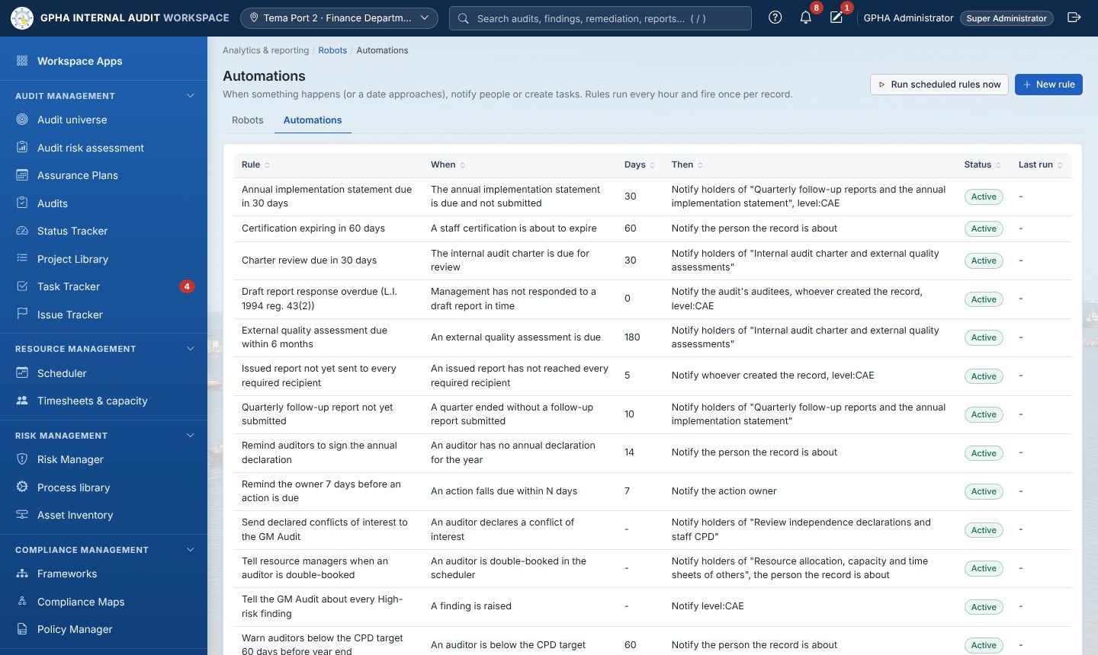
Automations
- Automations are rules of the form when [and conditions] then notify people / create tasks. There are 12 built-in rules (due-date reminders, overdue draft responses, declarations, CPD, charter review, statutory reports, High-risk findings and others) that can be edited, previewed or switched off. They run hourly and fire once per record, and every run is logged.
- Robots run fixed, read-only analytics on a schedule (for example open High issues or overdue actions) and publish into Results tables.
- E-mail is sent only when GPHA_SMTP_HOST is set; otherwise users see notifications under the bell.

11. Monitoring and health
Check | How | Expected
Application up | https://<server>/health | 200 with database status and can_save: true
Service | nssm status GPHA-Audit | SERVICE_RUNNING
Database outage | Users see a red banner; the API returns 503 | The app migrates and recovers automatically when the database returns
Disk space | Windows monitoring on uploads\ and backups\ | At least 20 % free
Backups | Newest file date on the Backups screen | Within 24 h

12. Troubleshooting
Symptom | Likely cause | Fix
run.ps1 stops: “database cannot be reached” | Docker or MySQL not running | Start Docker Desktop and run .\run.ps1 again
Page looks unstyled or old | Browser cache after an update | Press Ctrl+F5
“Account temporarily locked” | 5 failed sign-ins | Wait 15 minutes, or have an administrator select Unlock
“Too many attempts” (429) | Per-computer throttle | Wait one minute
A user cannot see an app | App switched off, or role lacks the permission | Apps & customization / Roles & permissions
An auditee cannot see an audit | Not assigned as auditee | Audit › Auditees with access › add
An issue is not visible to the auditee | Not published | Publish the issue (or send the draft report)
Cannot close an audit | Closure checklist not met, or you prepared it | Complete the checklist; a different authorised person signs
E-mails not arriving | SMTP not set or blocked | Check GPHA_SMTP_* and the relay allow-list
App will not start in production | Start-up guard: unsafe settings | Run scripts/production_check.py and fix each item
Git “File exists … .lock” | Stale lock file after a crash | Rename the .git\*.lock file and retry

13. Script reference
Script | Purpose
scripts.init_db | Create the schema and bootstrap administrator
scripts.seed_demo | Demo data (development only)
scripts.production_check [--secrets] | Readiness report; prints fresh secrets
scripts.verify_backup | Restore-test the newest backup
scripts.restore_backup | Decrypt or restore a backup
scripts.reset_password | Reset a user’s password from the server
scripts.mfa_policy | Show or change the two-step verification policy

