**Continuous Integration and Tools**

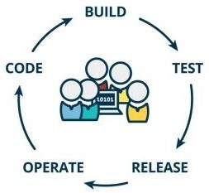

**Situation if there is no Continuous Integration tool is used**

* Integration of code happens manually
* Time factor - it takes time to integration the code of developers
* Testing activity after integration of code
* Need to fix the errors/bugs/recode if required
* “ last minute rush” activities in project
* Project delays

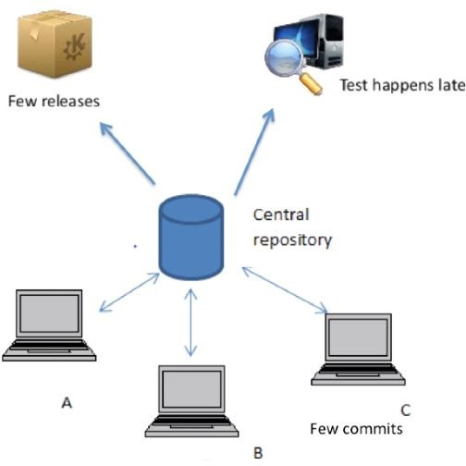

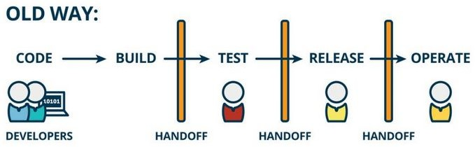

**CI FLow**

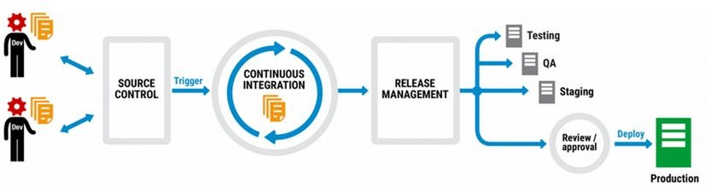

CI: Continues integration

It's a development practice where members of team integrate their work frequently.

Usually each person integrates at least once in a daily and leading to multiple integrations per day. Each integration is verified by an automated build to detect integration errors as early as possible

Improve the code quality and reduce integration problems

* Continuous integration (CI) is a software engineering practice
* Here, the fresh changes are immediately tested and reported when they are integrated to main branch
* In traditional software development process integration is generally done at the end of day when every developer had completed their work.
* As a result of this integration took lots of time and was a very painful process
* Developers generally use a tool called CI Server to do the building and the integration for code
* This code runs a self-test to ensure that it is working as expected

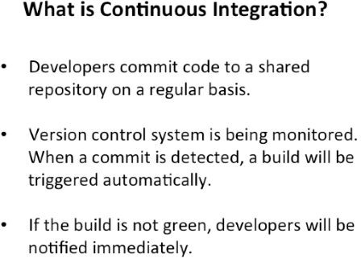

Benefits of CI

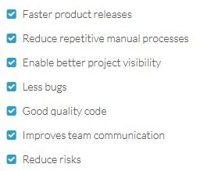

**GENERIC ARCHITECTURE MODEL OF C.I**

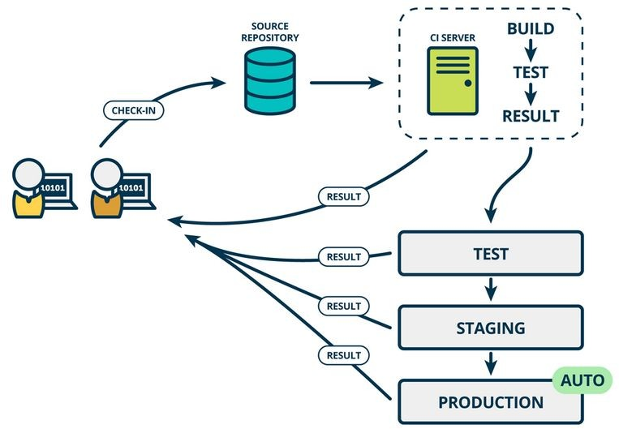

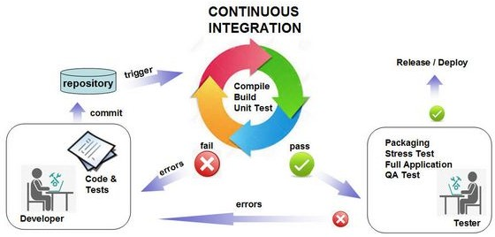

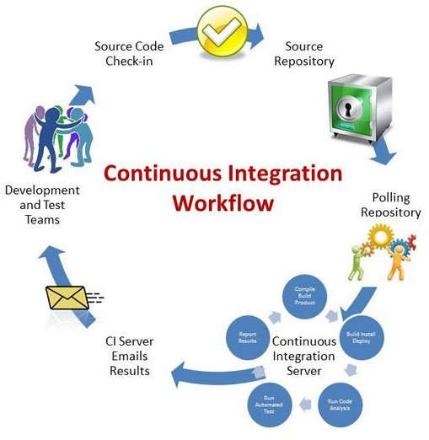

Features of Jenkins

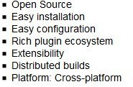

**Other Notable CI Tools**

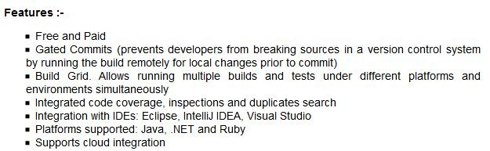





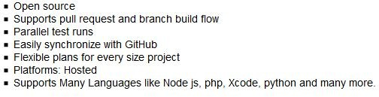

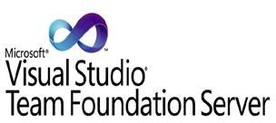

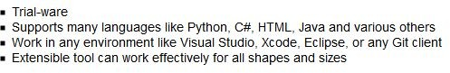



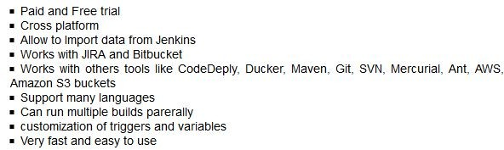

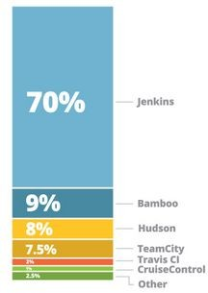

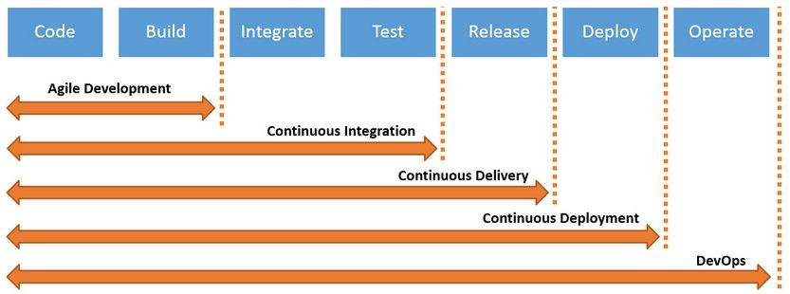

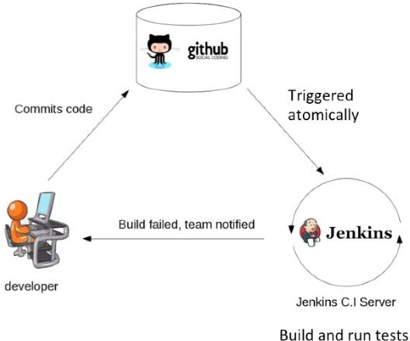

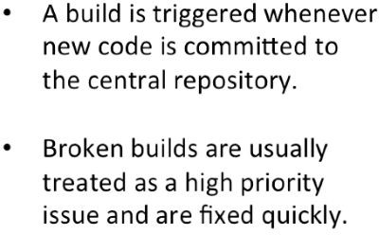

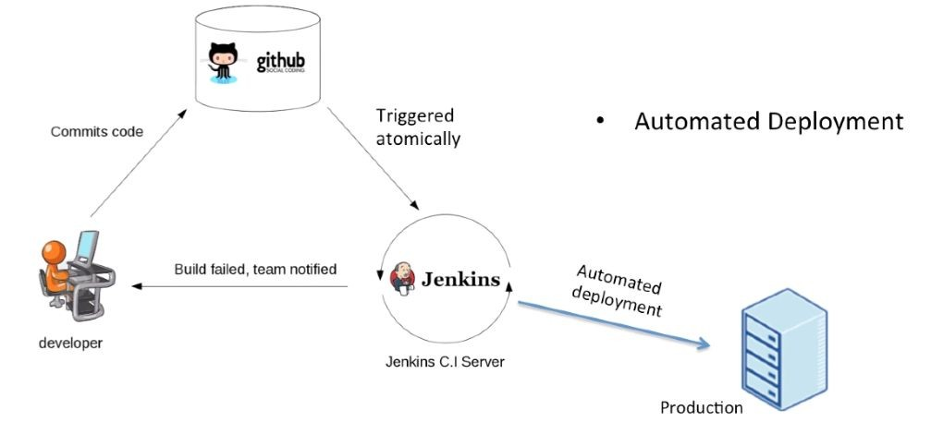

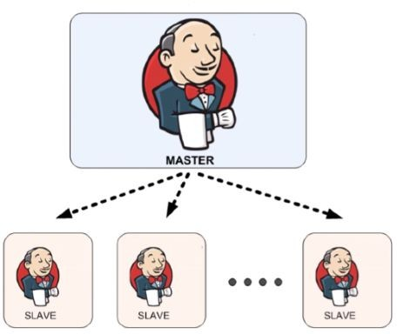

## JENKINS MASTER-SLAVE ARCHITECTURE

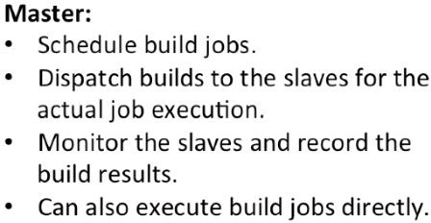

JENKINS -Technical Features

* Build Server
* Distributed build Support
* Gets the code from Repository
* Trigger builds - Manual, Periodically and Automatically
* Automatic build and tests ….. etc
* Open Source C.I tool written in JAVA language
* Jenkins is used in variety of Projects like in Java, .net, Ruby, PHP etc

JENKINS - RECOMMENDED HARDWARE PREREQUISITES

* 1 GB RAM
* 50 GB + HDD

JENKINS - RECOMMENDED SOFTWARE PREREQUISITES

* Need Java
* App Server

JENKINS - Supported Platforms

* Windows
* Linux
* Mac

JENKINS SETUP USING GENERIC WAR FILE

Step 1 - Verify if Java is installed on the PC or not

Step 2 - If not installed, install the Java Java Environment variables

***\*\* Check with Java Environmental Doc for steps***

Step 4 - Install Jenkins using war file, download from jenkins web site

Types of Installing

i. Stand alone

ii. Deploy war

iii. As a service

Stand alone Method

### WAR file

The Web application ARchive (WAR) file version of Jenkins can be installed on any operating system or platform that supports Java.

### To download and run the WAR file version of Jenkins:

1. Download the [latest stable Jenkins WAR file](http://mirrors.jenkins.io/war-stable/latest/jenkins.war) to an appropriate directory on your machine.
2. Open up a terminal/command prompt window to the download directory.
3. Run the command java -jar jenkins.war.
4. Browse to http://localhost:8080 and wait until the **Unlock Jenkins** page appears.
5. Continue on with the [Post-installation setup wizard](https://jenkins.io/doc/book/installing/#setup-wizard) below.