1. Copy/paste 5 short texts (e.g. quotes, tips, ideas) that ChatGPT generates for us into a Google Sheet.

**steps for 1:**

**1.1 record 5 (any number) predefined short text in google sheets**

* **API**
* we can use selenium
* human
* others …

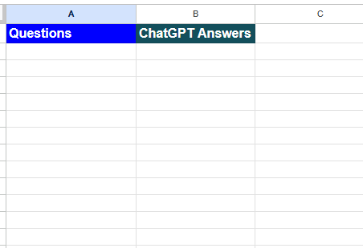

I have use Google API for recording questions in Google Sheets,

after script execution:

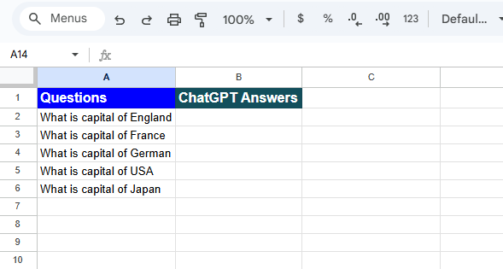

api code snippet:

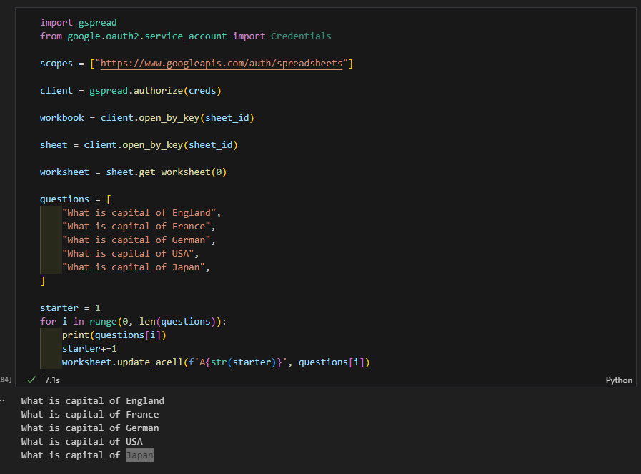

**1.2 read data from google sheets**

* **API**
* we can use selenium
* human
* others …

read data from Google sheets with API, code snippet

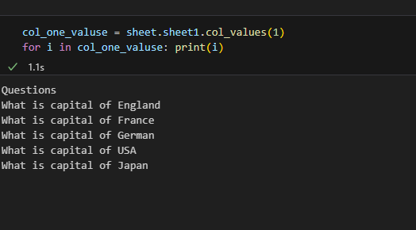

**1.3 ask ChatGPT questions**

* **selenium with chrome debugging**
* selenium with chrome driver
* API
* x,y based screen controllers

I have choose selenium with chrome debugging, because with selenium driver chatGPT will fire captcha, and it is extra headache, chatGPT API is not free, x,y base is very inefficient, because nowadays browsers are very dynamic, and to follow every x,y coordinates takes too much time

code snippet for chatGPT interactions

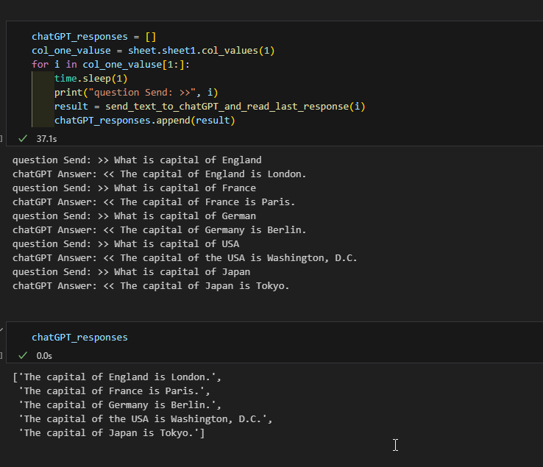

screenshots from ChatGPT interface

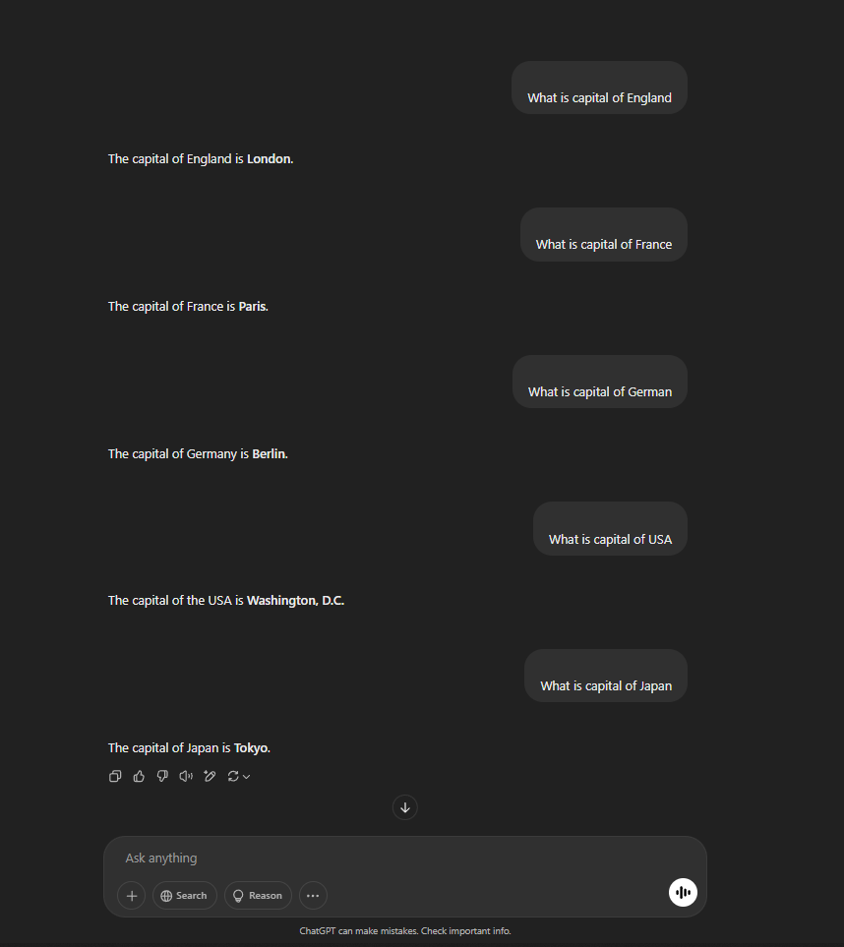

upload our generated questions to Google Sheets (extra)

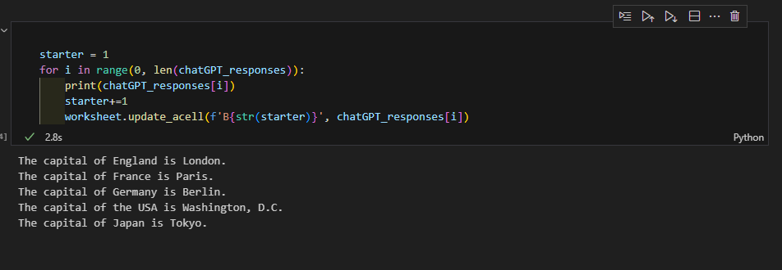

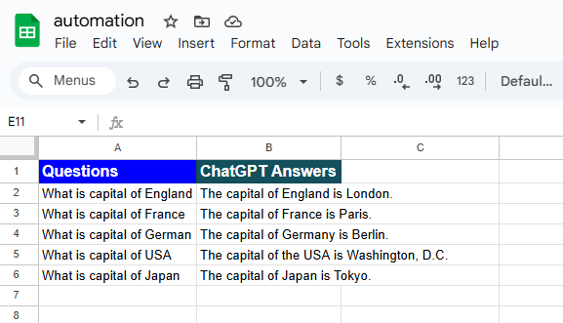

2. This triggers a specific Canva template.

**steps for 2**

2.1 open another sheet for **Canva**

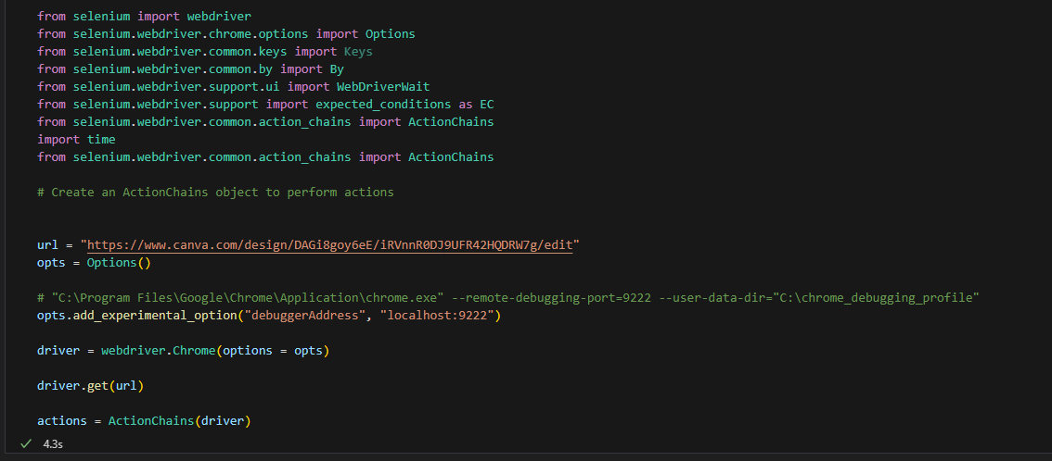

2.2 prepare functions for web page interactions

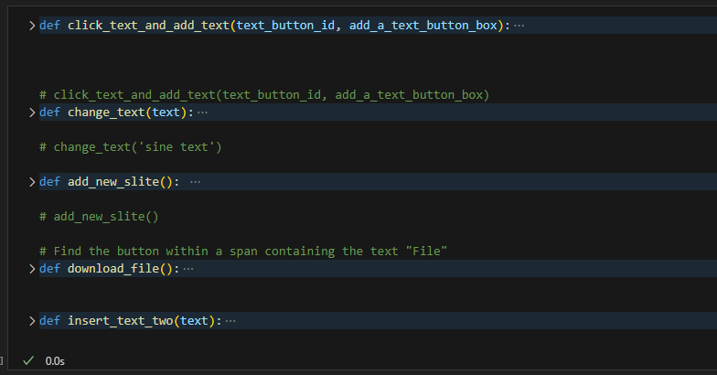

**3. Automatically upload each line of text to the Canva template (one per slide).**

3.1 loop through ChatGPT generated answers

3.2 type with selenium answer per slide

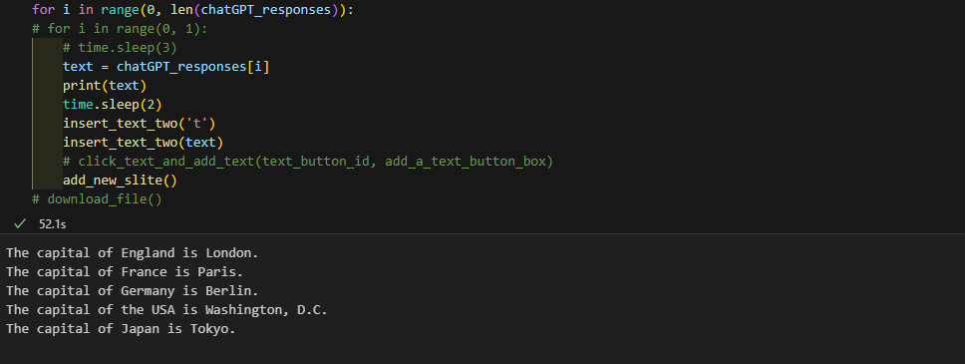

canva screenshots

