I want to build a an agentic framework with an orchestrator agent and sub agents framework as an MCP server compatible, Basically the MCP server gets an input of a code repo (github or Gitlab or other) or a zip file upload (local or network or from cloud) as a zip file of the entire code repo. The code is a legacy Delphi code (object pascal),The orchestraotr agent understands and go through the code exhaustively and then using Langchain creates a subagent which using https://github.com/RomanYankovsky/DelphiAST parser and build an ASG/AT graph.

The steps are as follows in the picture,
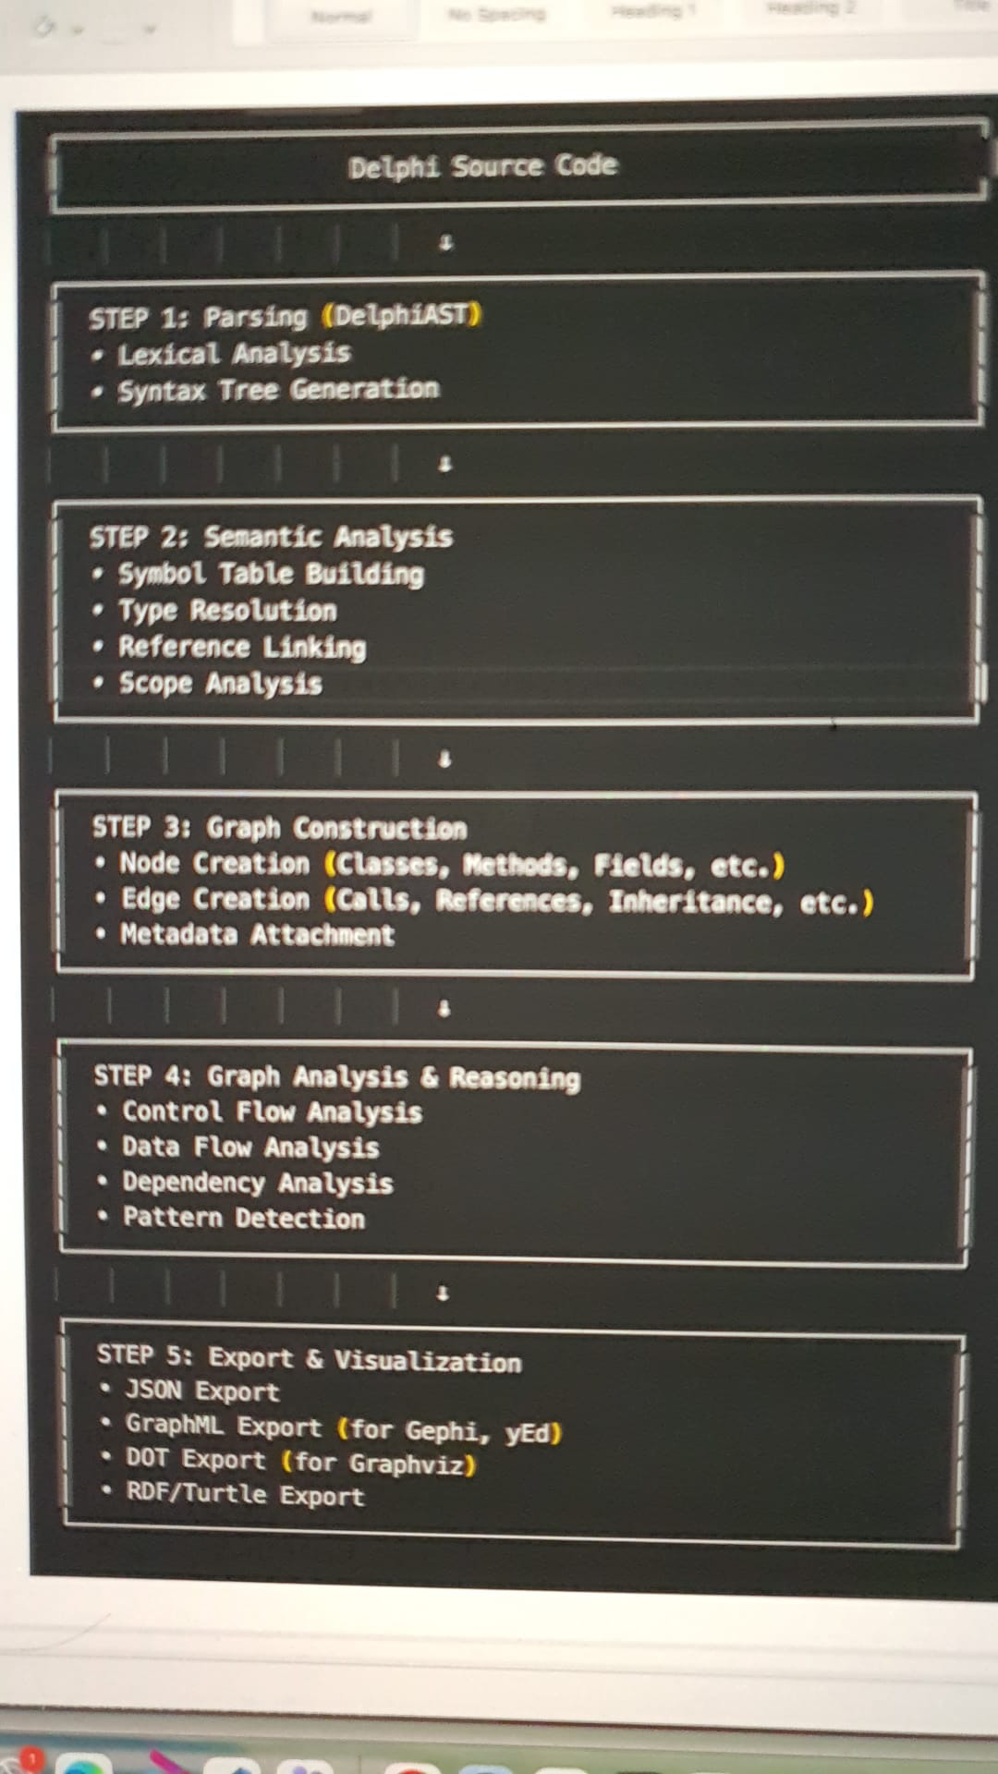
The orchestrator agent coordinated and monitor all the sub agents described below.
Step1 is the Parsing sub agent step 2 and 3 will be combines and done by the next sub agent called semantic and Graph constructor sub agent and once its completed step 4 a new agent will be created called a reasoning sub agent and finally an exporter subagent for step 5 in the diagram above which also store the RDF triplet in an RDF4 instance and a viewer to visualise it and run sparql queries. All the states in the langchain will be persisted as a statemachine events in a simple queue like rabbit MQ iand the progress will be shown during the process.
The whole process should be detailed as documentation. The step 5 exporter sub agent will also create business workflow diagrams in terms of BPMN and additional Busines data entity flow diagrams. If its MVC it should explain the layers in details of the architecture with the flow and backend services if any, To test the above MCP server use the following git repo for delphi code

https://github.com/DeveloppeurPascal/Delphi-samples

https://github.com/JAM-Software/Virtual-TreeView

This should be a fully scalable application production ready and create a specification plan and using spectoolkit and create and follow all the 4 steps Specify Plan tasks and implement and produce all the artifacts for the stages.
It should also create acceptance criteria and test it thoroughly with the regression testing pack included. The architecture should be thoroughly validated and the solution should include the above mentioned parser as part of the project.

The entire thing should be housed /deployed in a docket container with the RDF4j Db and should work without any issues like port issue or any other network issue etc.
Use chain of thoughts and think and ask questions and do not assume anything or give false promises or give false positive, the entire features should be thoroughly tested. The Project and MCP server should be called as Delphi Legacy Code analyser.

