PEP PROGRAM SCHEDULE

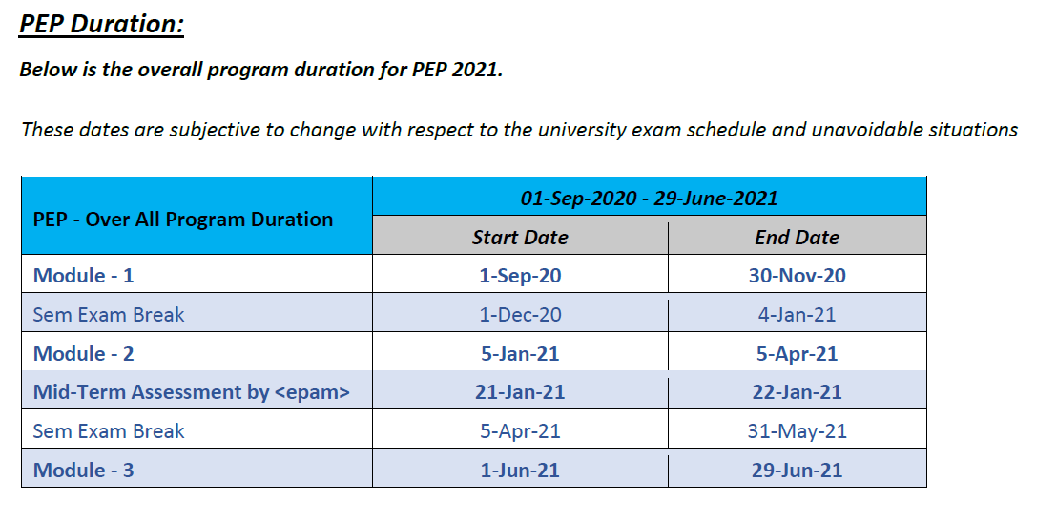

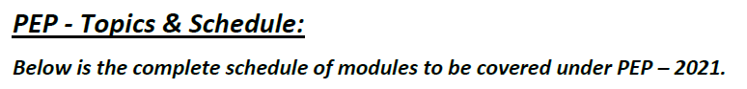

**Online Class Timings: Every Tuesday , 7:00 PM -9:00 PM**

