AWS WORK-SHOP
- Create IAM User
Login AWS account
Go to IAM
click on user
create user

create it and we will find one URL click on the URL

Login into IAM User
Give credentials

AWS computing services have the following characteristics:
Right compute for your workloads
Accelerate from idea to market
Offer built in security
Flexibility to optimize costs
Provide compute resource where you need it
Create key pair
Click on EC2
Go to key pair

2.Launch instance
Click on launch instance
Give name
Choose required AMI

Choose instance type and key pair

Select networking settings
Give security groups

Give user data

Launch instance
copy the public IP address and browse it

Give Amazon SSM Manager permissions to instance
Go to IAM
Click on role
add permission of AmazonSSMManager

Create it
Go to EC2
Select instance
go to actions
Click on security

Change the IAM role of instance and save it

Select instance and click on connect
Click on session manager and connect

Connect instance by using SSH client
ssh -i ".pem" ec2-user@<Public IPv4 DNS>

Connect into terminal

Clean up the resources
select instance
Go to instance state
Click on terminate

2. Create windows instance
Lunch instance
Choose windows AMI

Choose instance type and key pair

Select network setting
Give security groups

Launch it
select instance and connect it
Click on RDP client
Upload the private keypair

download remote desktop file
Clickon get password

after some time get password
Copy the password
Open the downloaded file and paste the password
Open another windows

Create elastic IP
Click on elastic IP

Click on allocate Elastic Ip
create the elastic IP
Choose instance and associate with instance

Terminate the instance
Create auto-scaling
Go to cloud-formation
create stack
Upload yaml script file for create instance

Copy the public IP and browse it

Create own AMI
Select instance and go to actionds
Click on image and template
Create image

create it

Launch Template: A Launch Template is a feature of EC2 Auto Scaling that allows a way to templatize your launch requests. It enables you to store launch parameters so that you do not have to specify them every time you launch an instance. For example, a launch template can contain a specific Amazon Machine Image, instance type, storage, and networking settings that you typically use to launch instances. For each Launch Template, you can create one or more numbered Launch Template Versions. Each version can have different launch parameters.
Create launch template
Click on create launch template

Give name and auto scaling guidence

Choose own AMI

Select instance type and key pair

Select network settings

Remaining set as default
In advanced settings enable the cloud watch monitoring

Creating launch template

Create auto-scaling
Click on auto-scaling group

Click on create auto-scaling
Give name and choose launch template

Select VPC and Subnets

choose new load balancer and create

Creating target group and health checks

grouping size

scaling policies

Add notification

Add tags and review and create it

Configure security group
Go to security group
Select auto-scaling security group
Edit inbound rules and in source give my IP/32

Change outbound rules
Remove the all traffic and add HTTP
In source give autoscaling security group id

Go to load balancer
Select load balancer and go to actions
Click on the edit security group

Save it
Copy the DNS name and browse it
Check the auto-scaling work or not
terminate the all resource

Networking and content delivery on AWS

AWS Networking services have the following characteristics:
More secure
Highest network availability
Consistent high performance
Broadest global coverage
Create VPC
- Go to VPC
- Click on create VPC
- create it
- Click on subnet
- Create subnet
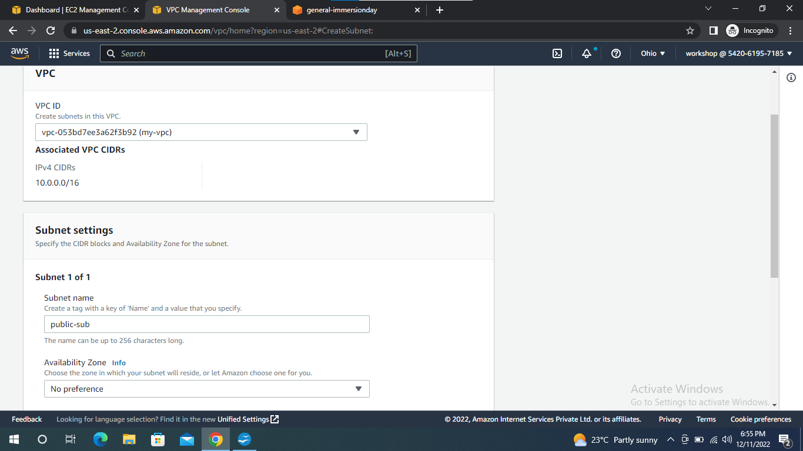
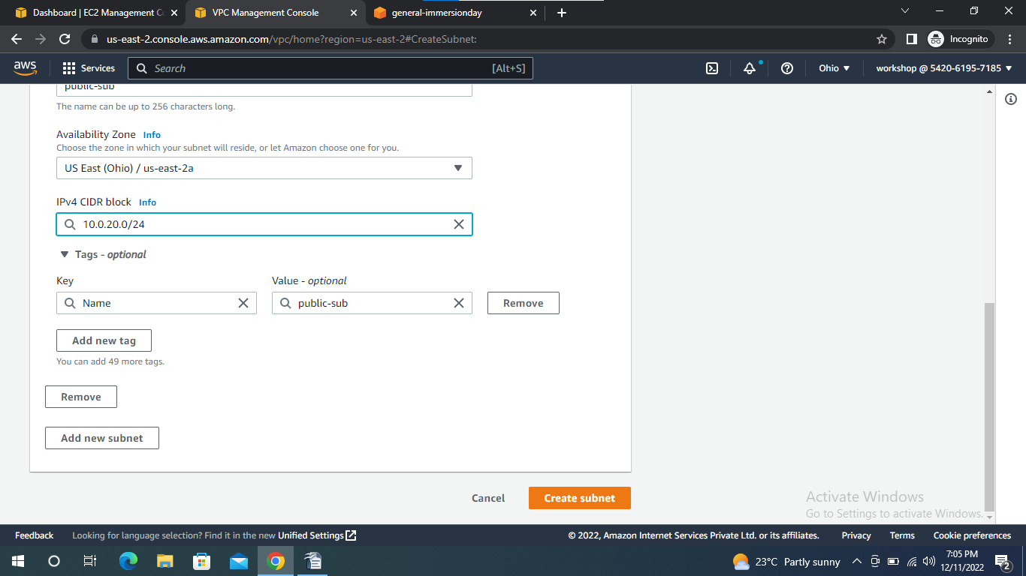

- Give CIDR block rang
- Create internet gateway
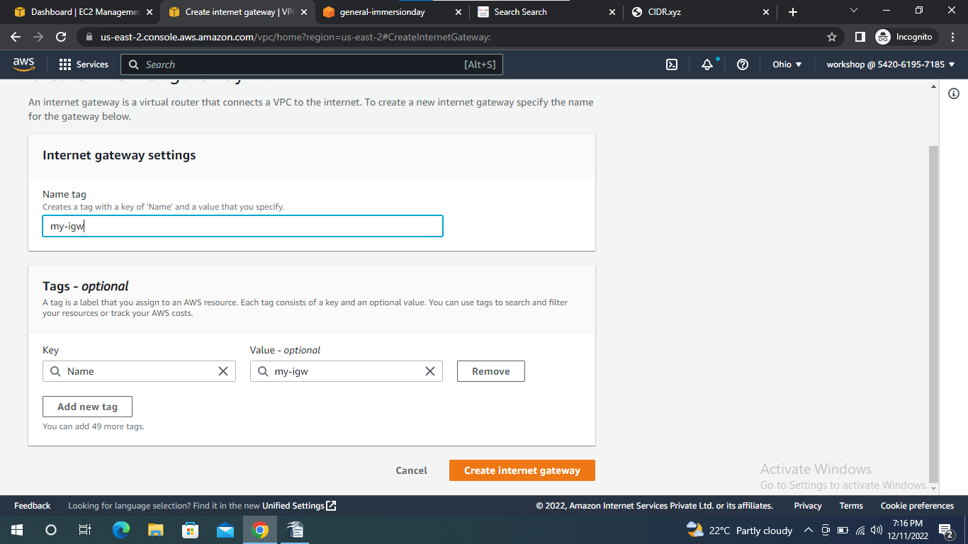

- internet gate way attacah with VPC
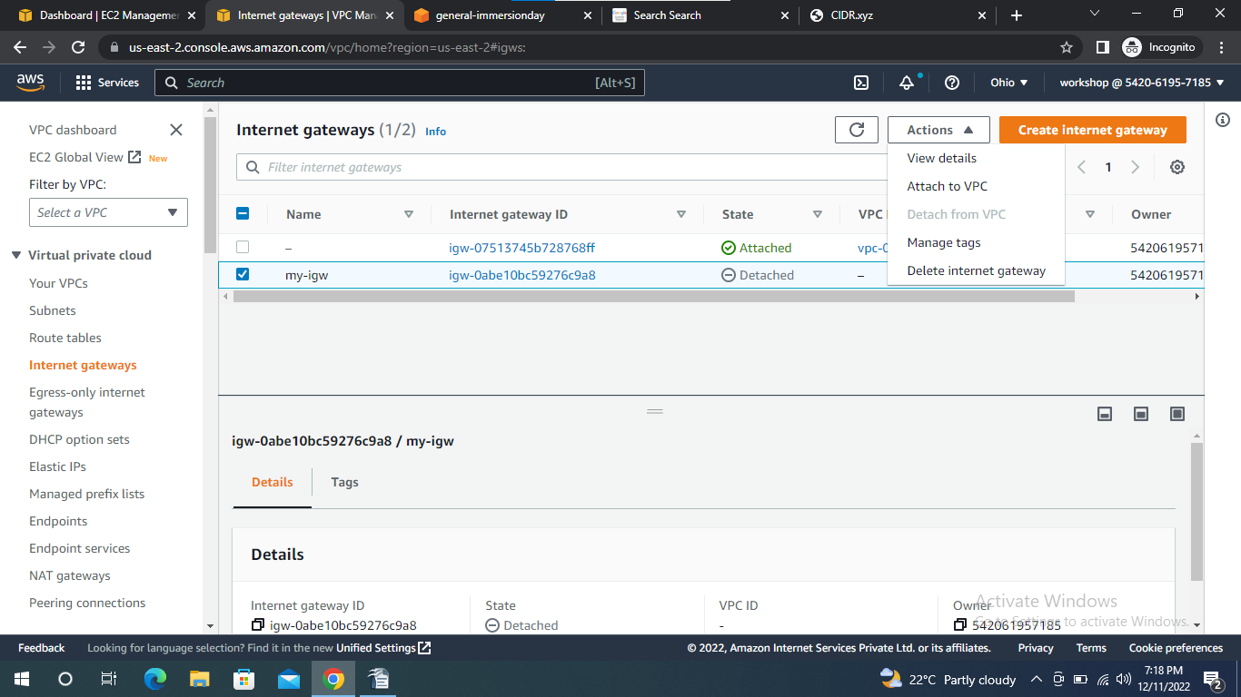
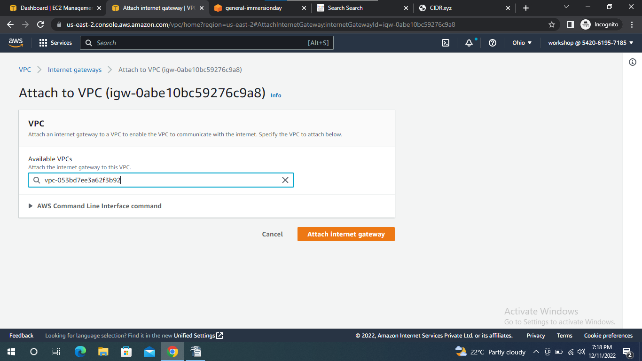

- Create Route table
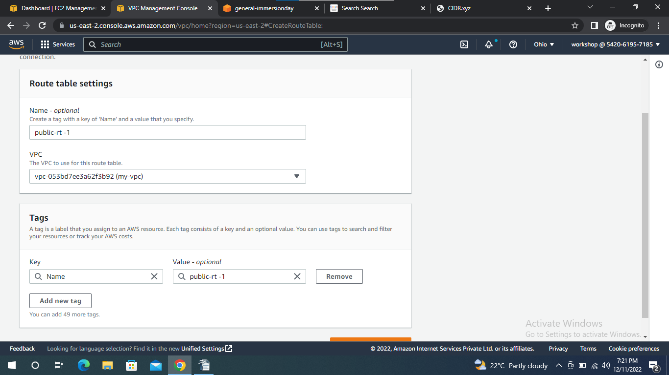
- Give internet connection to route table
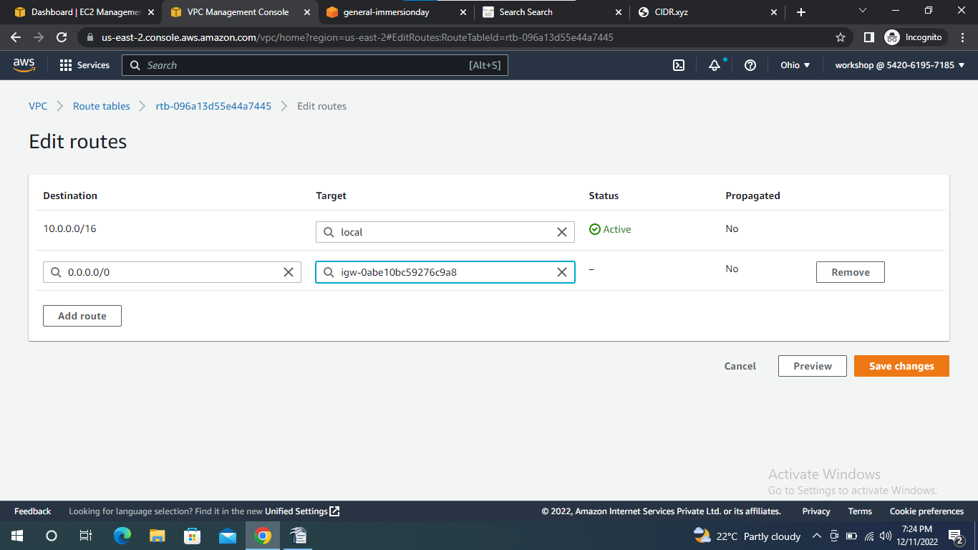

- Create security groups
- Click on the security groups
- Create security group
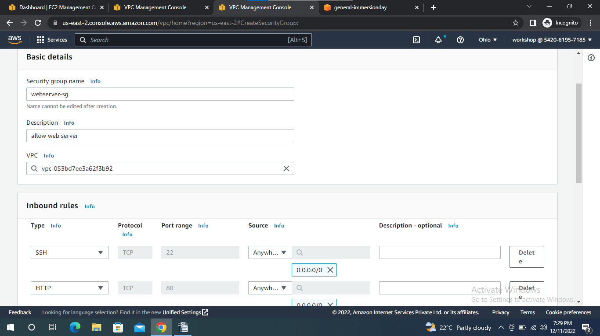

Create VPC Flow Logs
VPC Flow Logs is a feature that enables you to capture information about the IP traffic going to and from network interfaces in your VPC. Flow log data can be published to Amazon CloudWatch Logs or Amazon S3. After you create a flow log, you can retrieve and view its data in the chosen destination.
Flow logs can help you with a number of tasks, such as:
- Diagnosing overly restrictive security group rules
- Monitoring the traffic that is reaching your instance
- Determining the direction of the traffic to and from the network interfaces
- Flow log data is collected outside of the path of your network traffic, and therefore does not affect network throughput or latency. You can create or delete flow logs without any risk of impact to network performance.
In this lab, Flow data will be published to Amazon CloudWatch Logs.

- Create cloud formation stack
- Upload a file which is download from browser
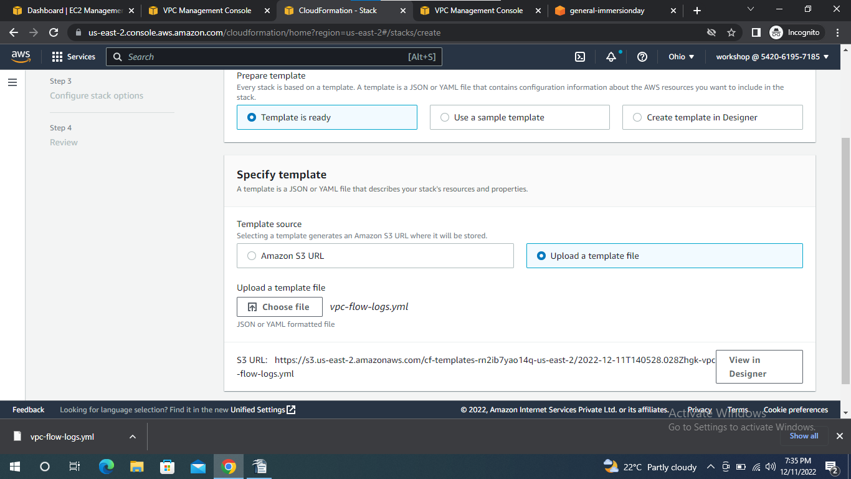
- Select vpc and subnet
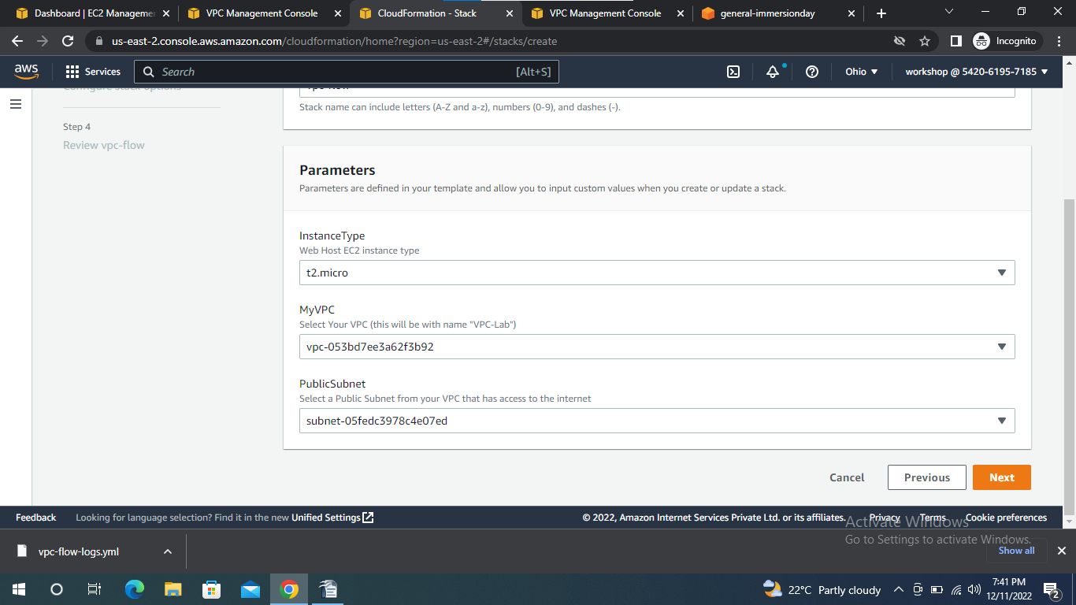
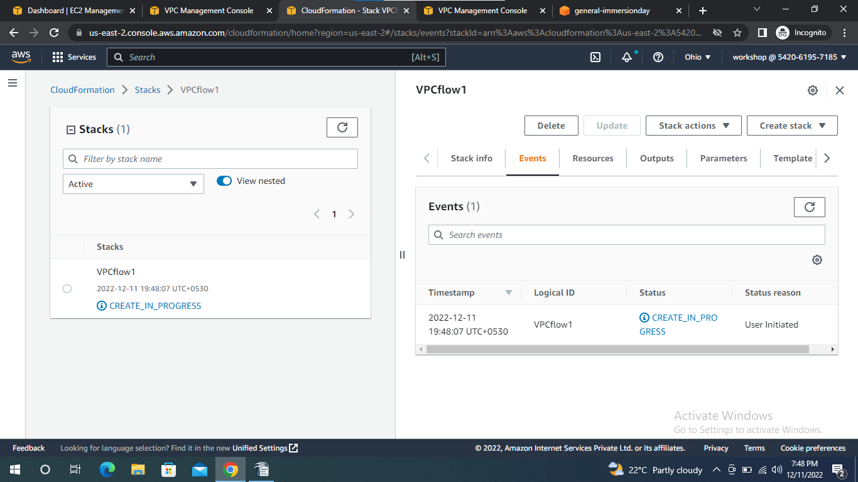
- Create VPC flow
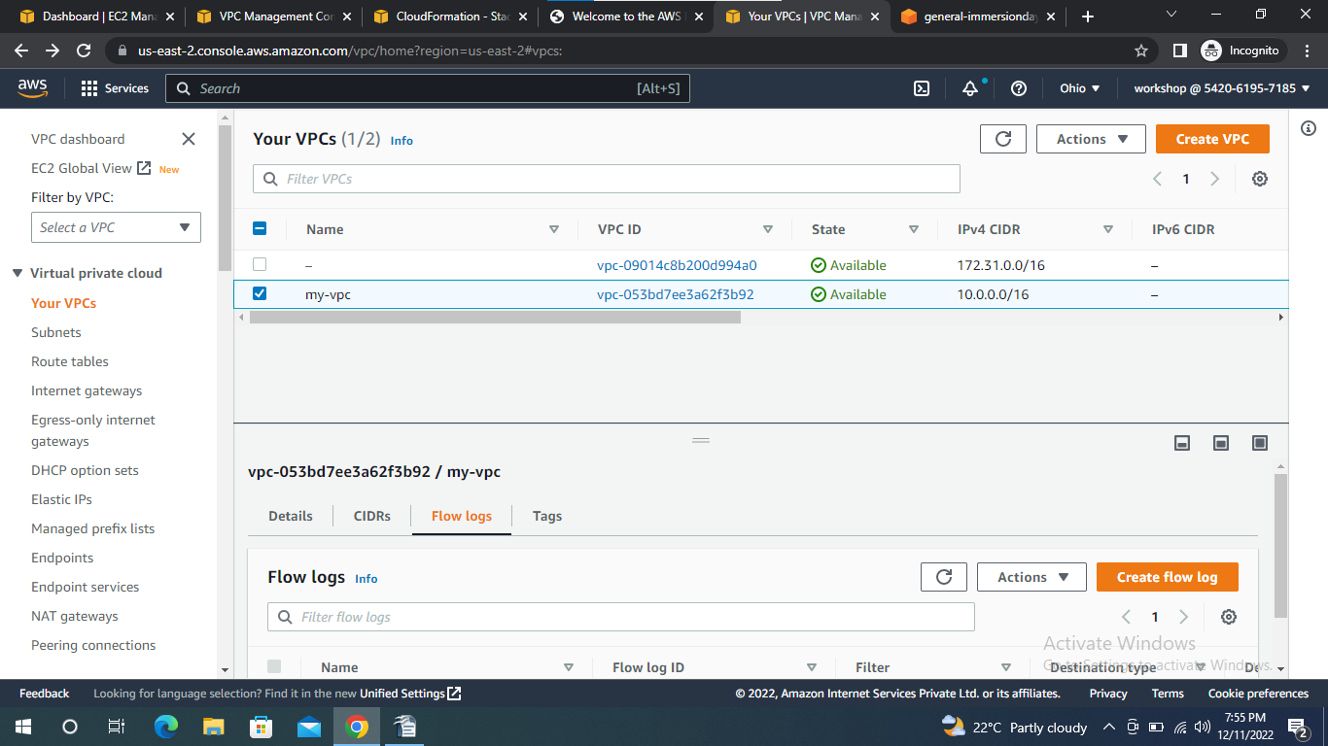
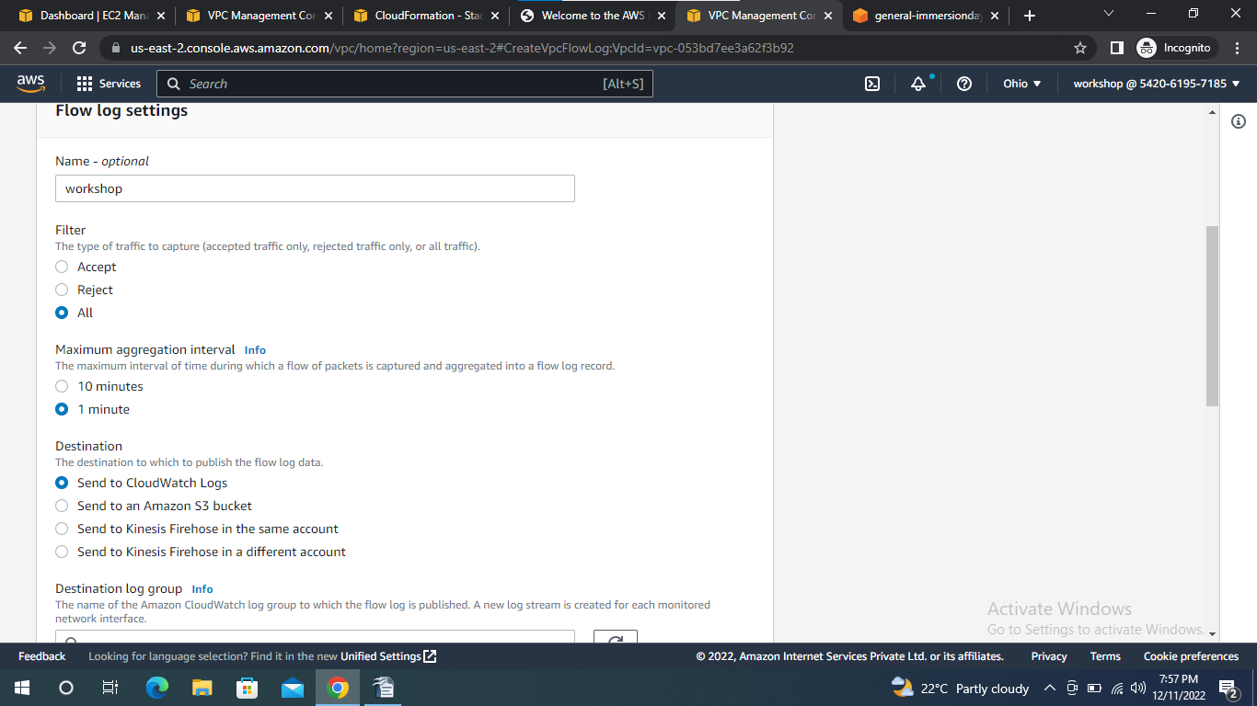

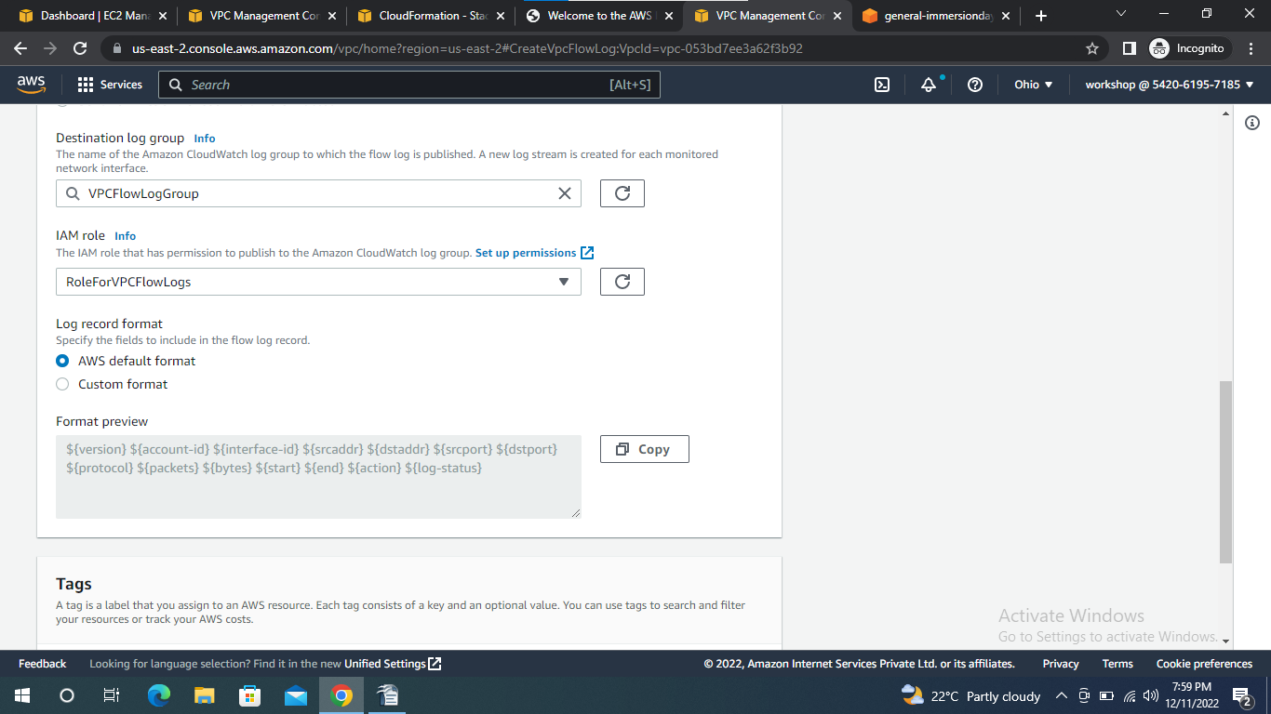
- Go to cloud watch
- Click on logs


