***Create And Implement CI/CD Pipeline Of Webapp.Tech Stack Using Git, Docker, Jenkins, AWS***

Jenkins CI/CD pipeline with GitHub webhook integration for deploying Docker application on EC2 instances using declarative pipeline.

**Follow the steps:**

* Firstly, Go to the AWS console and create new EC2 instance.As,

1. Name: Jenkins-server
2. AMI: Ubuntu
3. Instance type: t2.micro (free tier)
4. Key pair login: create > docker.pem
5. Security groups: SSH, HTTP, HTTPS
6. Click on the launch instance

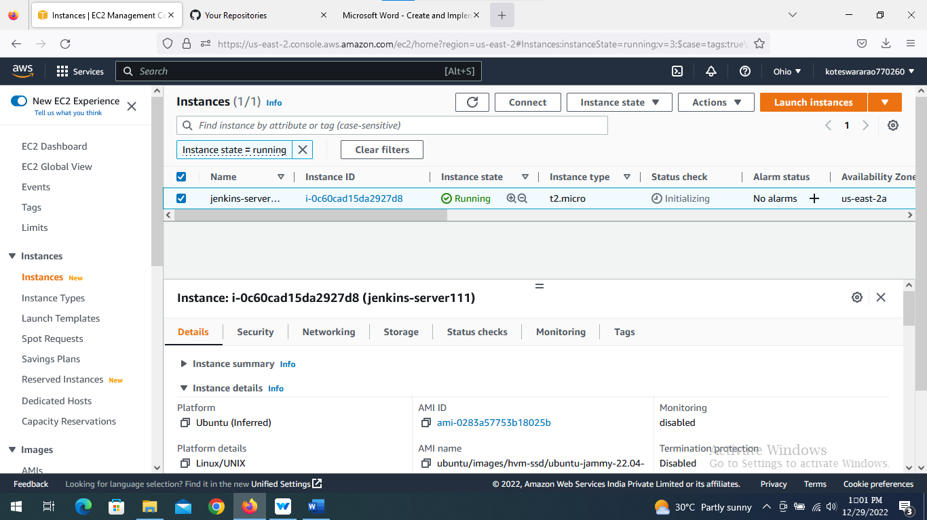

* Now, connect the instance that you have created and Copy the SSH from server

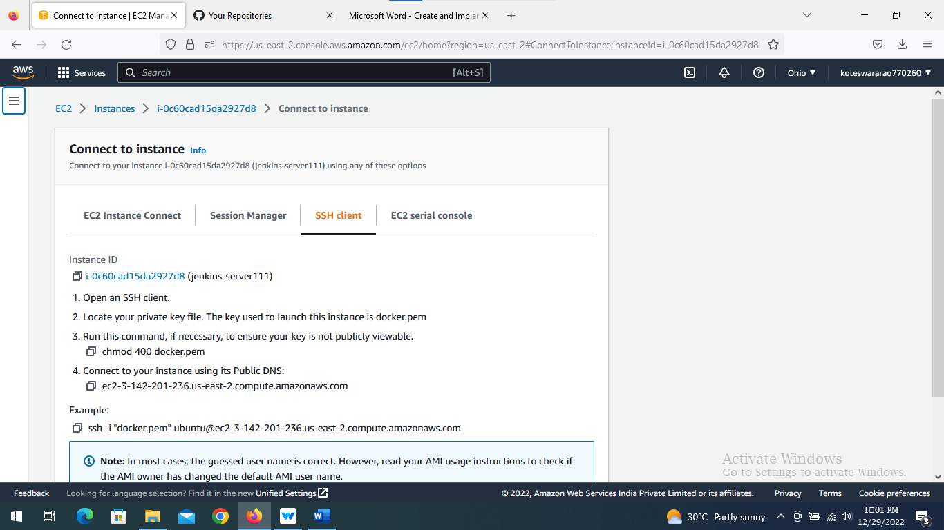

* Go to the download folder, where the .pem file downloaded in terminal and paste the SSH.

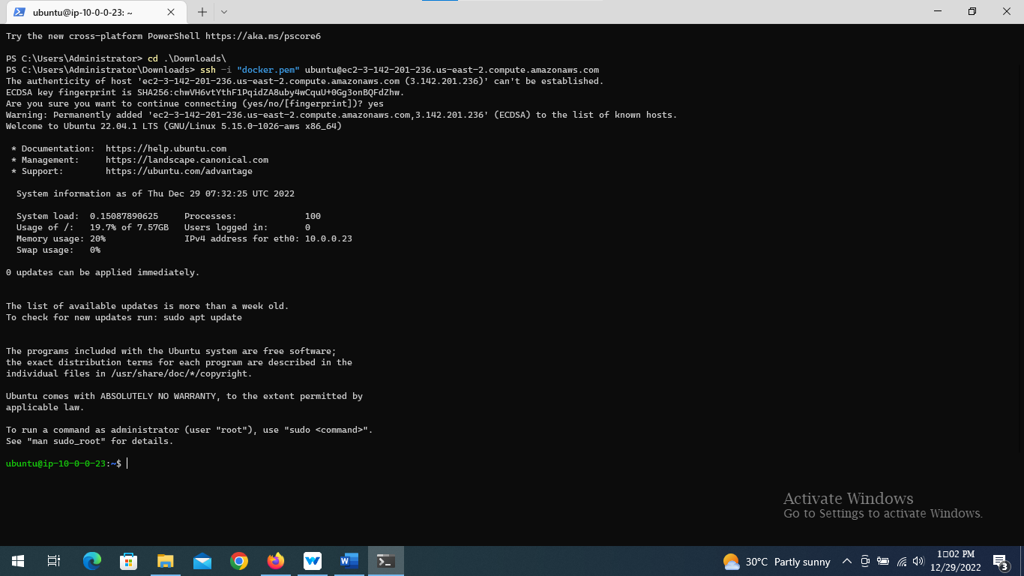

* In that machine run the following commands,

**“ssh-keygen”**

***ubuntu@ip-10-0-0-23:~$ ssh-keygen***

this will generate the public and private keys in the machine.

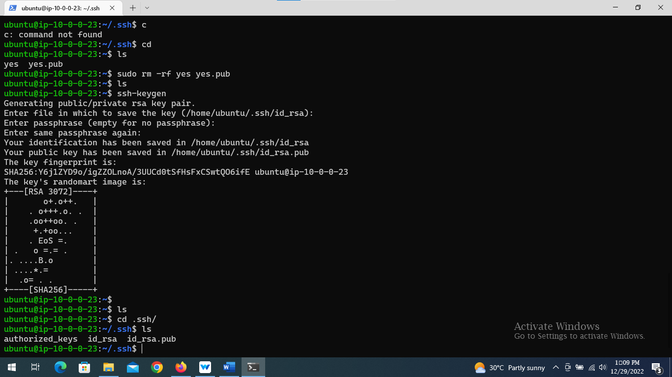

* Now, install java version 11 for running the Jenkins

***ubuntu@ip-10-0-0-23:~/.ssh$ sudo apt install openjdk-11-jre-headless***

* Install Jenkins by using the some repo’s

***ubuntu@ip-10-0-0-23:~$ curl -fsSL https://pkg.jenkins.io/debian-stable/jenkins.io.key | sudo tee \***

***/usr/share/keyrings/jenkins-keyring.asc > /dev/null***

***ubuntu@ip-10-0-0-23:~$ echo deb [signed-by=/usr/share/keyrings/jenkins-keyring.asc] \***

***https://pkg.jenkins.io/debian-stable binary/ | sudo tee \***

***/etc/apt/sources.list.d/jenkins.list > /dev/null***

***ubuntu@ip-10-0-0-23:~$ sudo apt-get update***

***ubuntu@ip-10-0-0-23:~$ sudo apt-get install jenkins***

* Install docker as well to machine

***ubuntu@ip-10-0-0-23:~$ sudo apt-get install docker.io***

* Allow 8080 and 8001 port numbers for this machine as a inbound rules from security groups

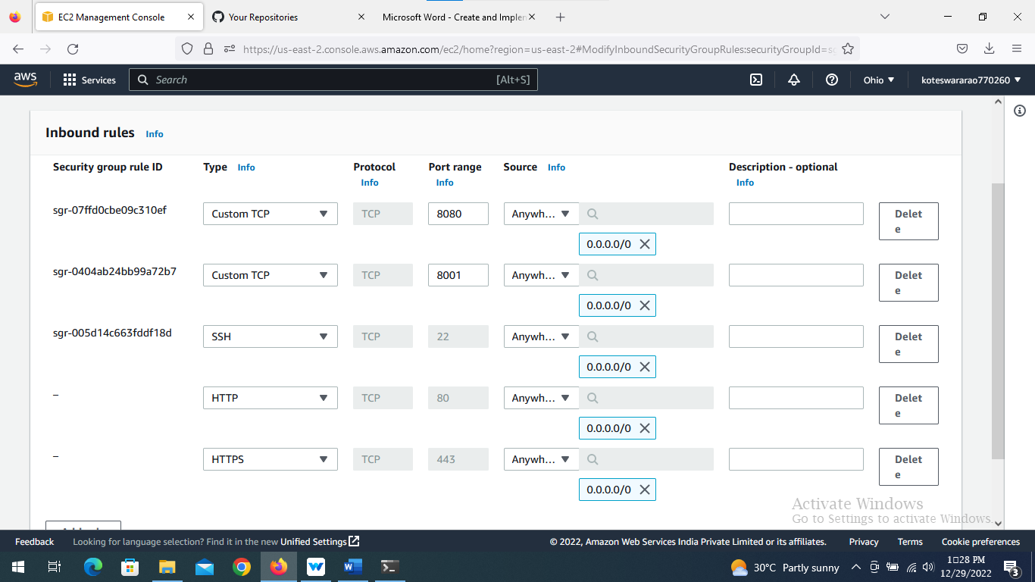

* Copy the public IP of jenkins server instance and browse it with port number

***IP:8080***

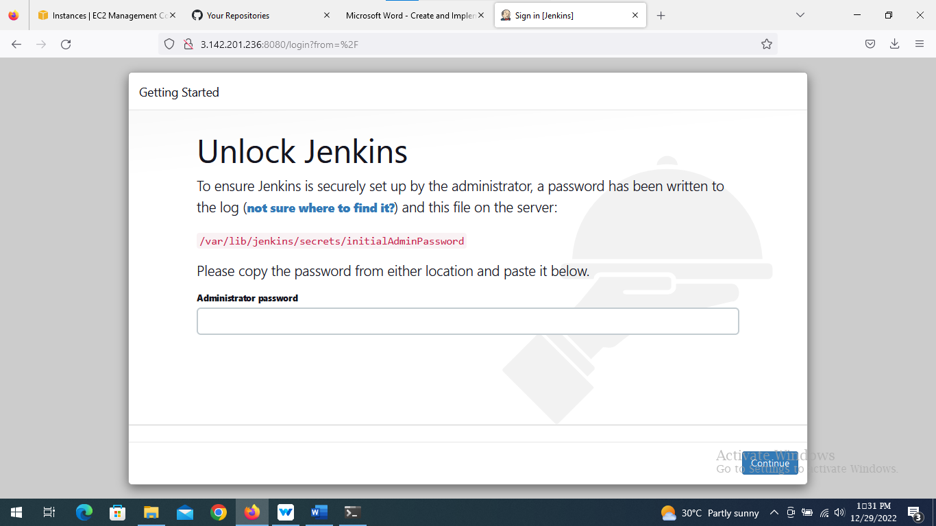

* Copy the path for getting password from jenkins google page and paste it in terminal

***ubuntu@ip-10-0-0-23:~$ sudo cat /var/lib/jenkins/secrets/initialAdminPassword***

* Get password in terminal and copy it and paste it into jenkins page

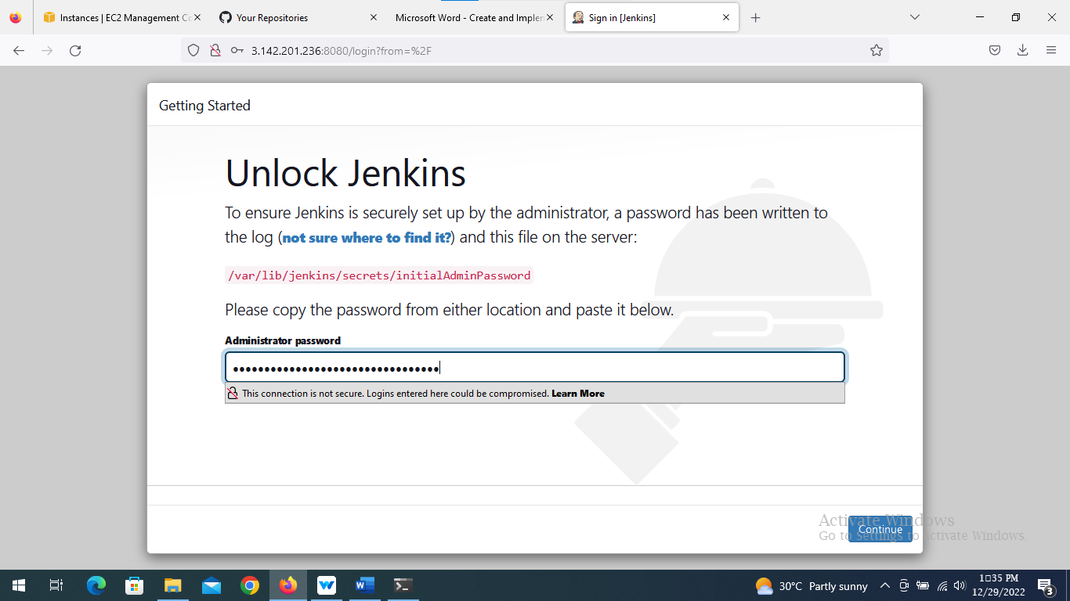

* Select installed plugins

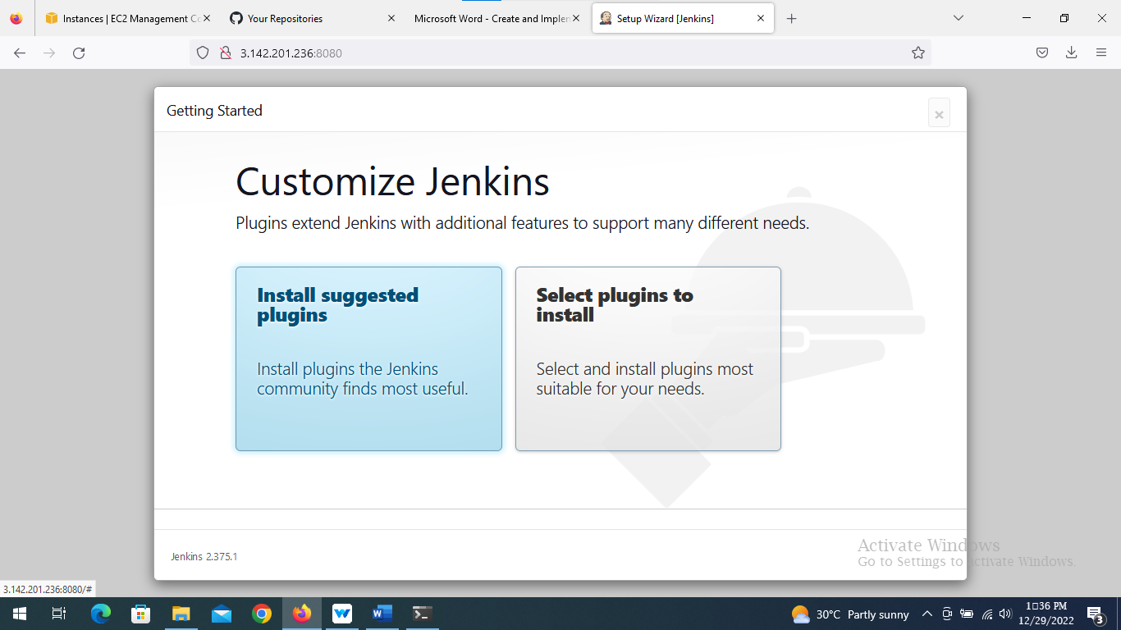

* Now, install the plugins

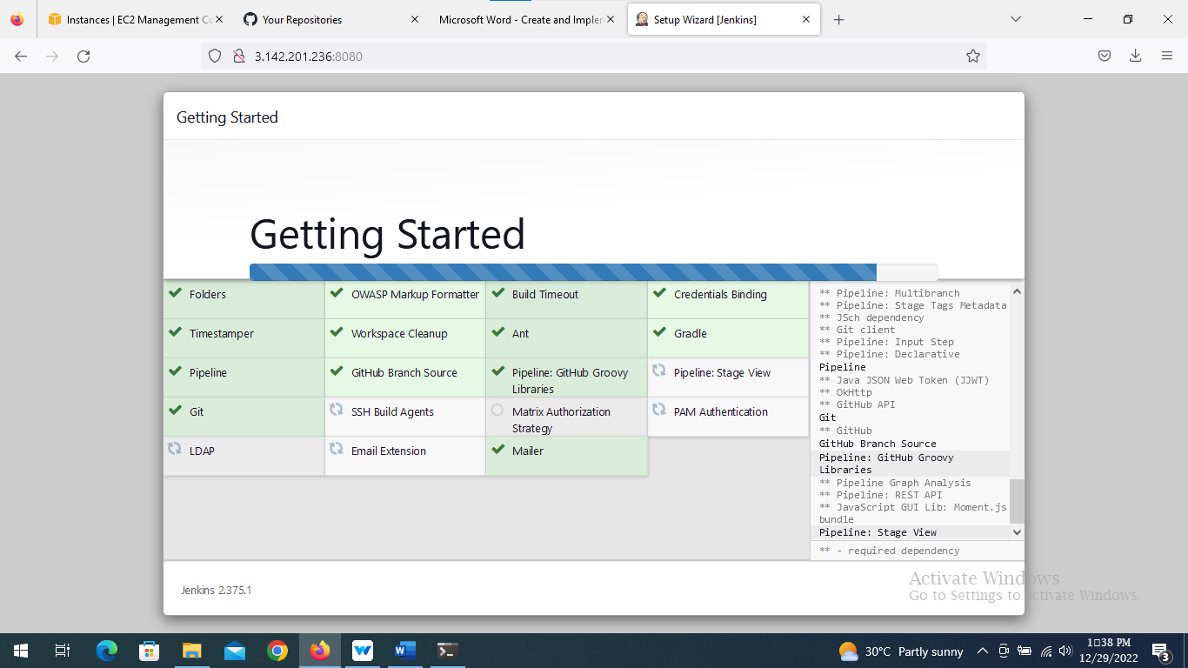

* Jenkins asks first admin user credentials

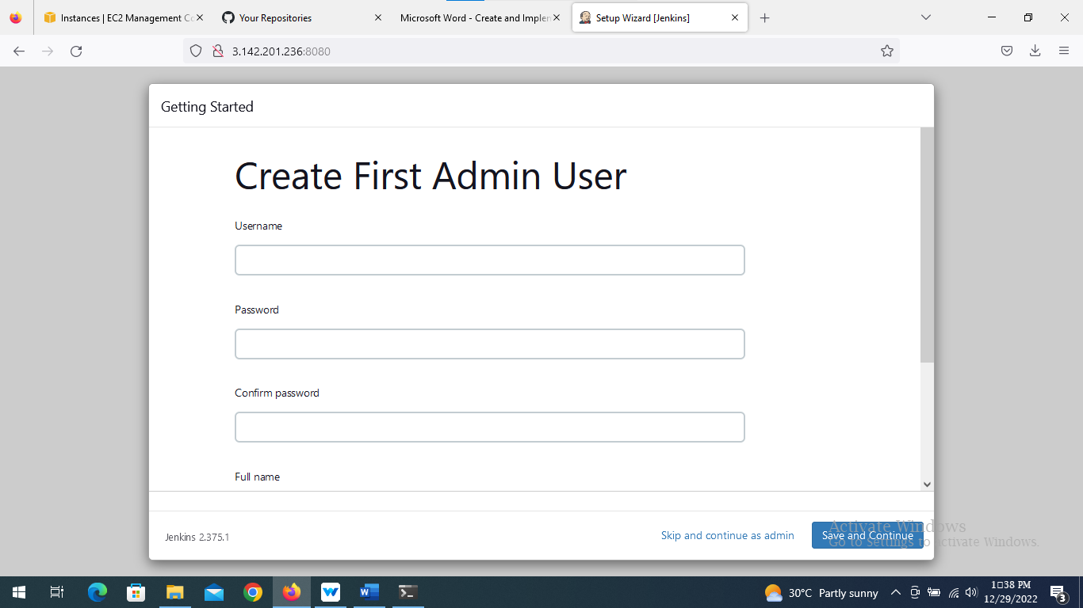

* Jenkins home page looks like this,

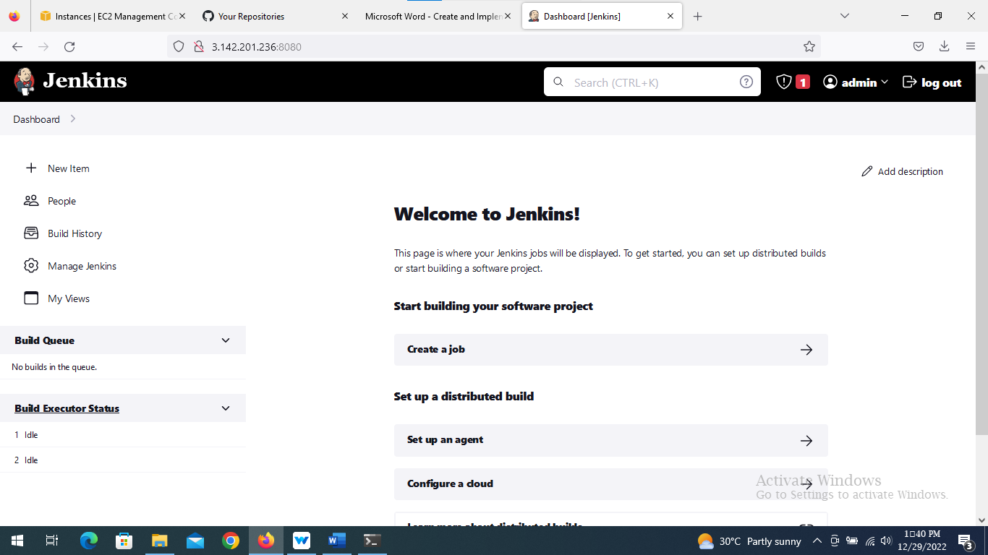

* We will create the CI/CD pipeline , which we will clone the code from github
* From jenkins dashboard, create a “New item”

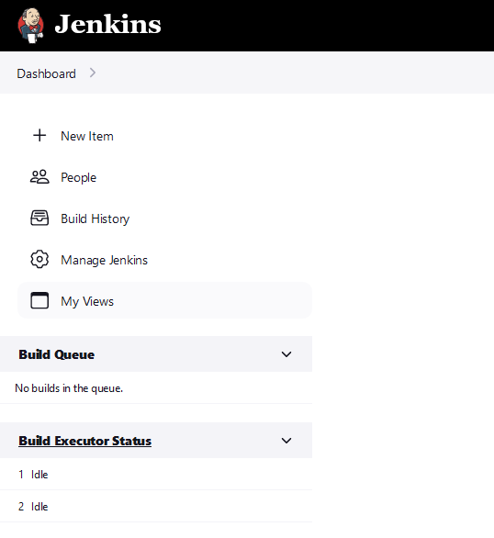

* Add name and pipeline

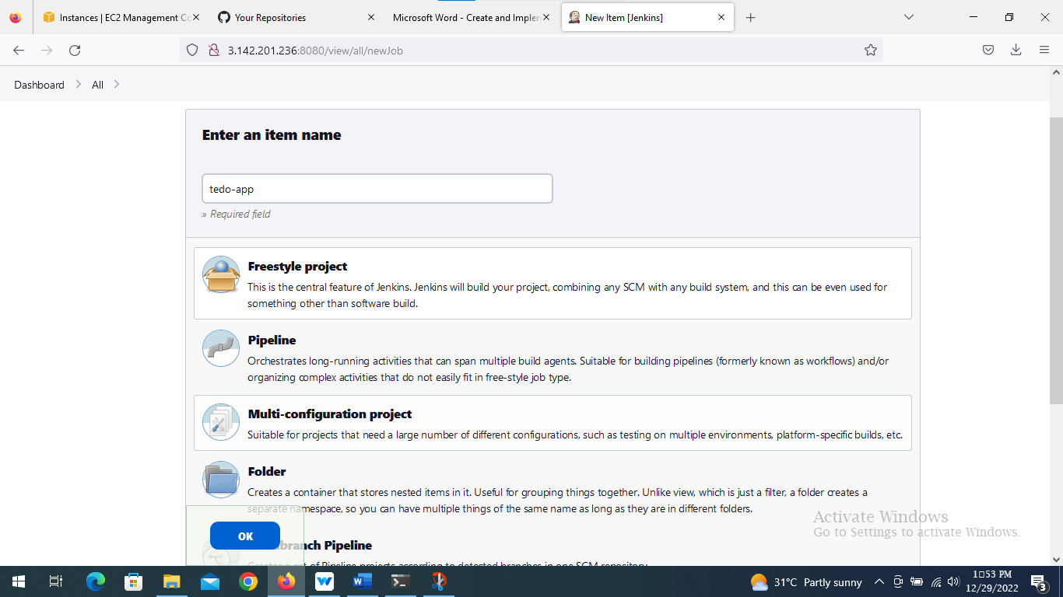

* Clone the code from GitHub

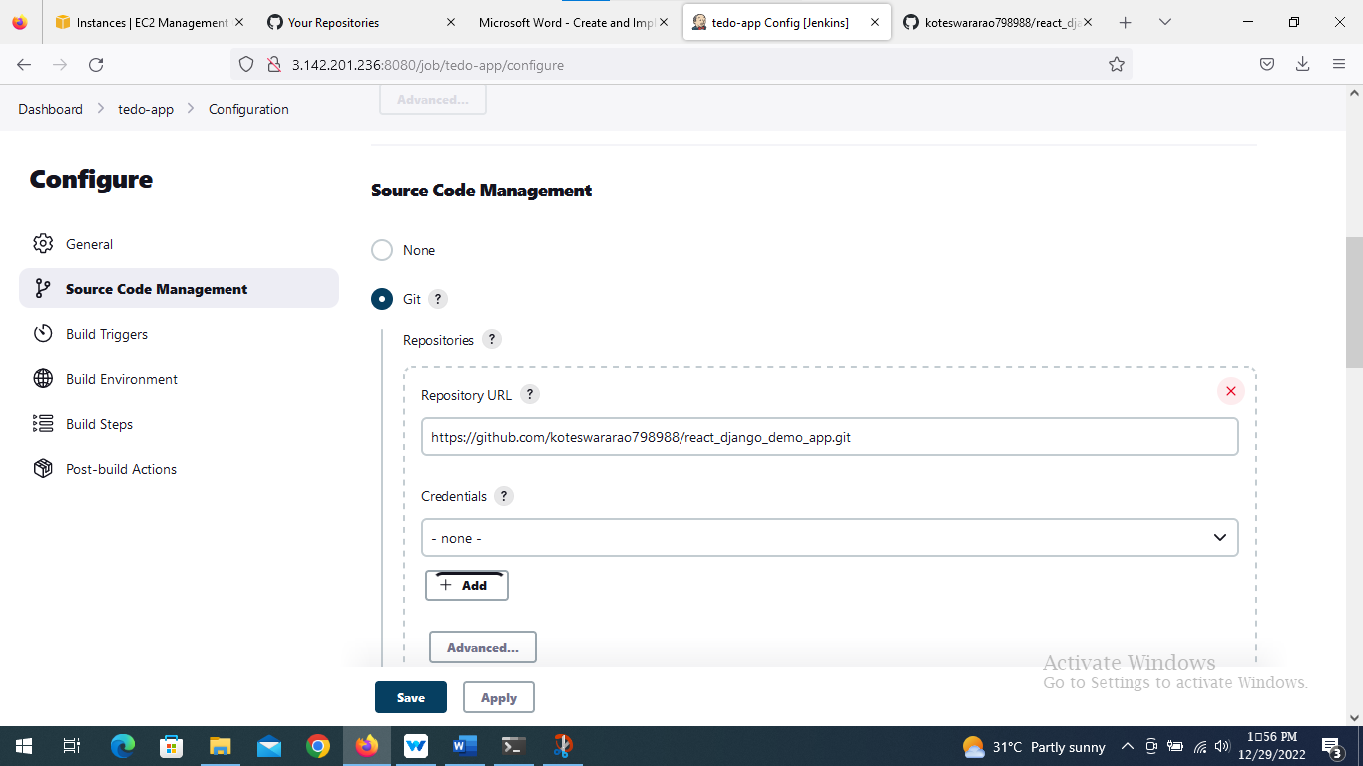

* Success the job

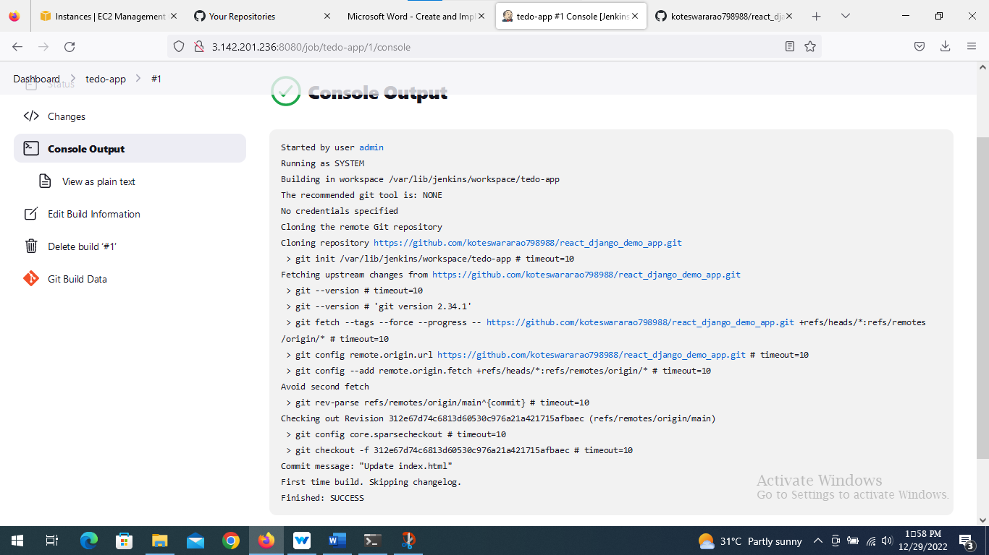

* In build step , choose execute shell and write following command to build docker image and from docker image we create the docker container.

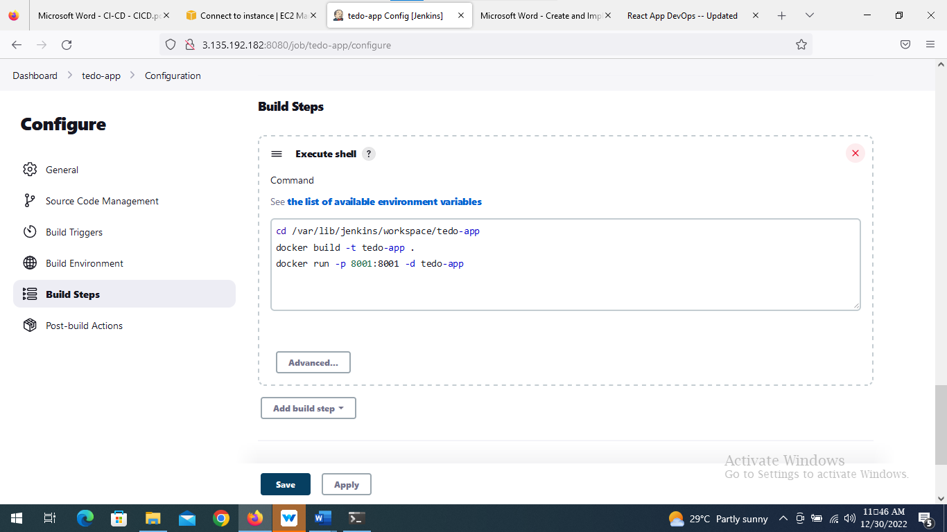

* Copy the public IP and browse it with port number

***IP:8001***

* We will get web page like this

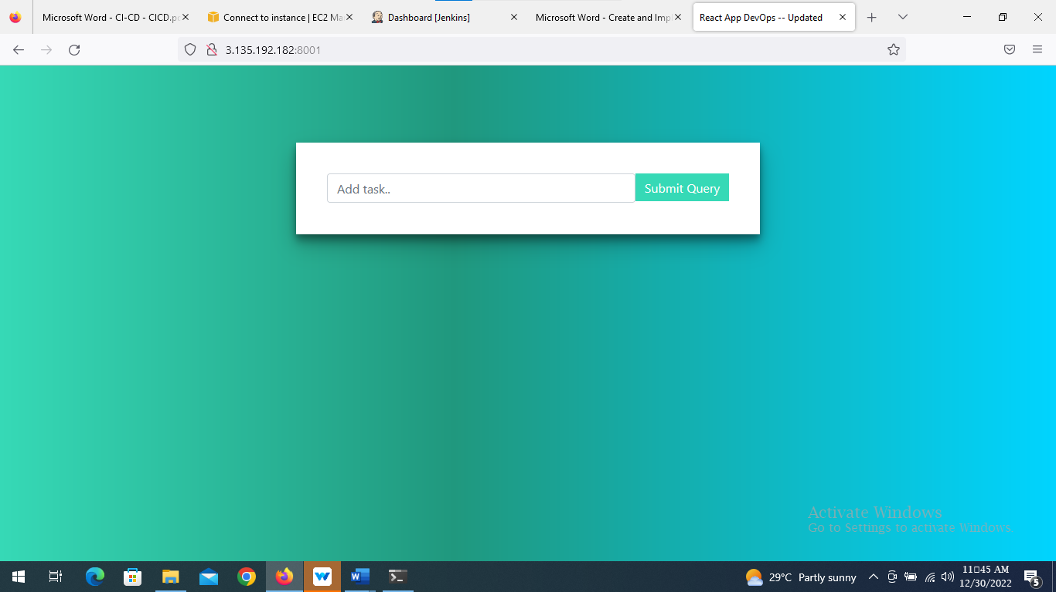

**Web-Hooks:**

* Whenever the developer commits their code in GitHub, after every commit, it should reflect in the live web app.
* For that, we will use “GitScm polling”.
* Every time, a developer made a commit, a trigger will run automatically,which will rebuild the image and run a container on your behalf as a part of automation that will run the pipeline automatically.
* Now, configure the project again and add

1. Build Trigger: GitHub hook trigger for GitScm polling.
2. Description: GitHub webhook integration

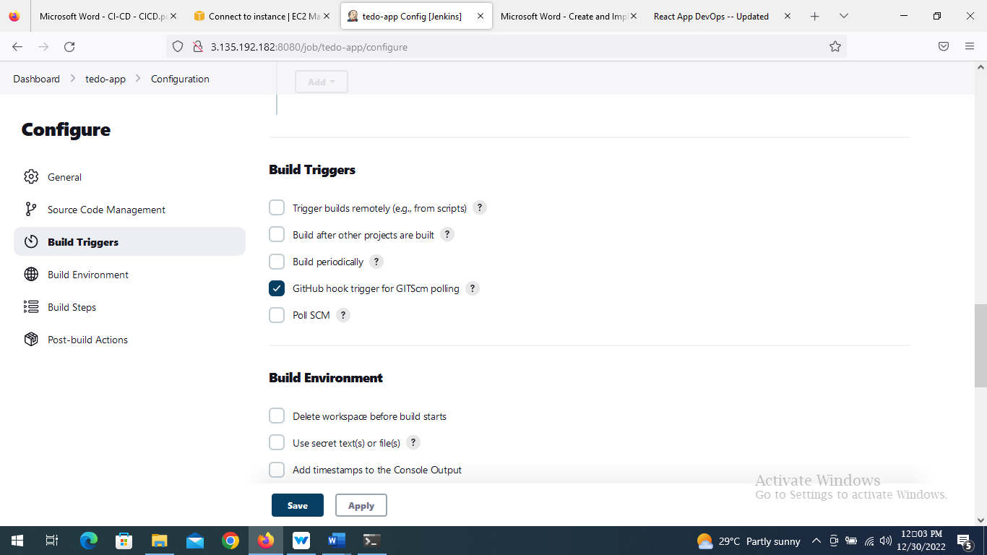

* We need to install “GitHub integration” plugin from plugin manager by following path

(Manage Jenkins >> manager plugin >> GitHub Integration)

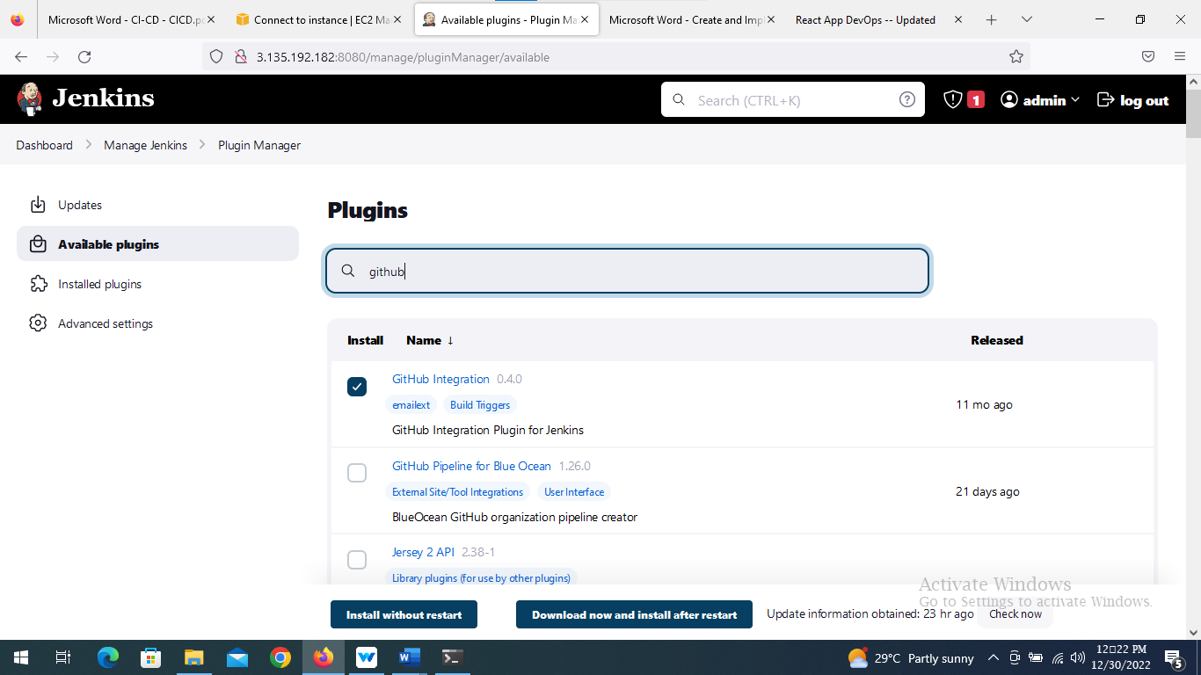

* Go to Git Hub >> Settings >> SSH and GPG Keys >> New SSH keys

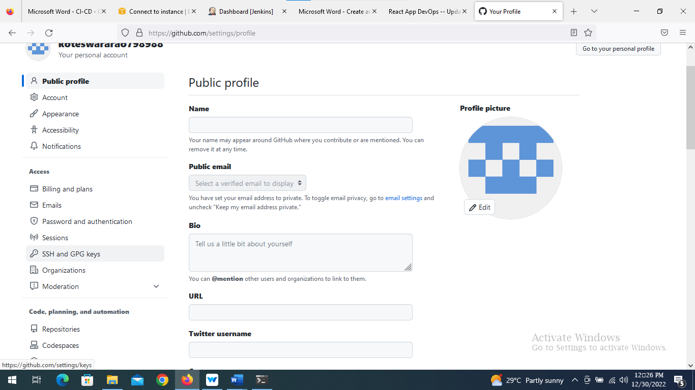

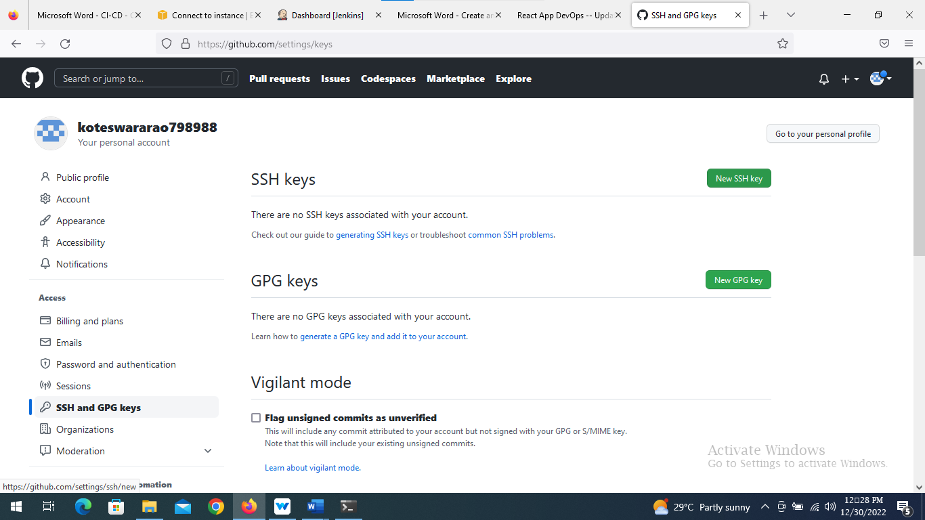

* add details as

**Title**: [koteswararao798988@gmail.com](mailto:koteswararao798988@gmail.com)

**Key_type**: authorized-keys

**Key**: public-key

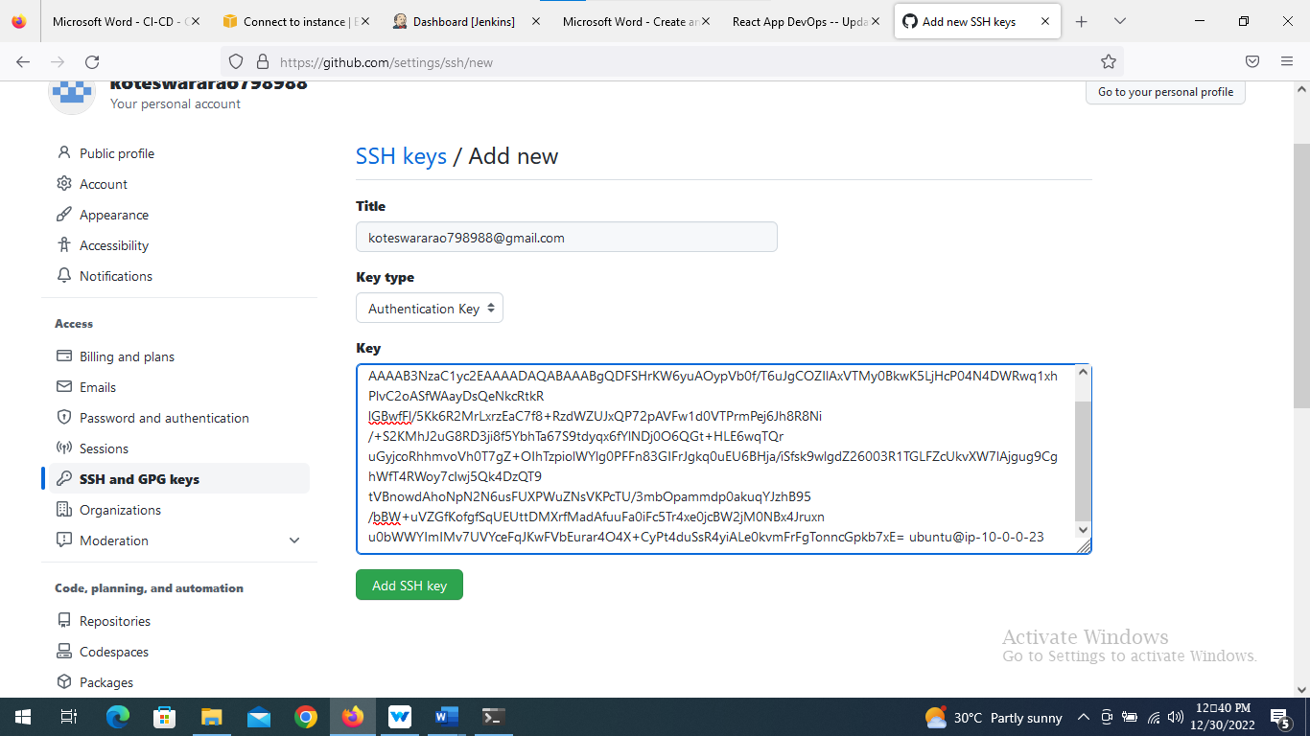

* For getting the public key

In terminal, go to .ssh directory and follow command

***ubuntu@ip-10-0-0-23:~/.ssh$ sudo cat id_rsa.pub***

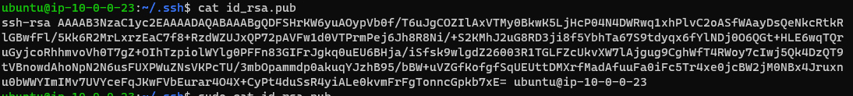

* Now, go to github

GitHub > Repo “react-django-demo-app” > Settings > Webhook

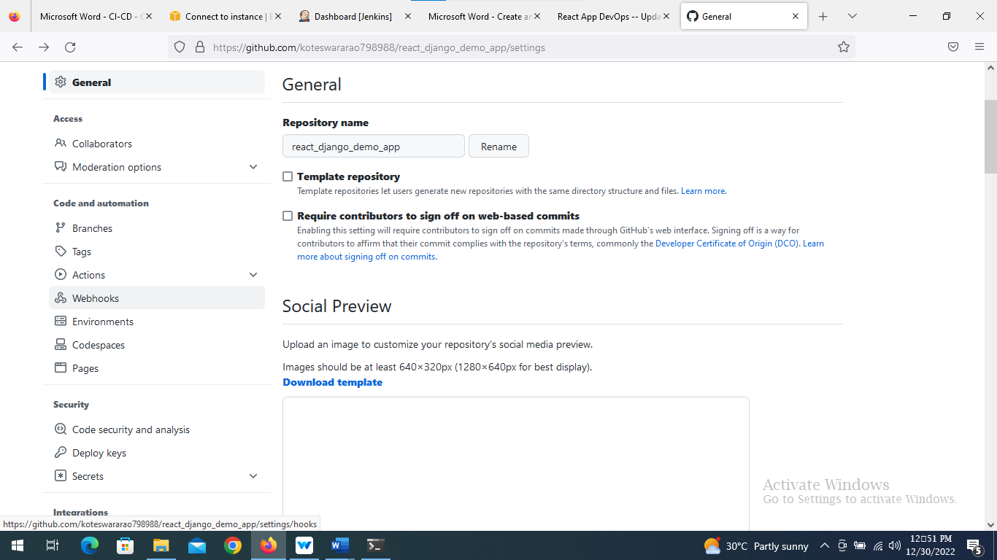

* In Git Hub , go to repo “[**react-django-demo-app**](https://github.com/koteswararao798988/react_django_demo_app)” >> settings >> webhooks

Add following details

1. **Playload URL:** https://<public_IP>:8080/github-webhook/
2. **Content type:** application/json
3. **Which events would you like to trigger this webhook?:** Just the push event.
4. **Active: true**
5. Click on add webhooks

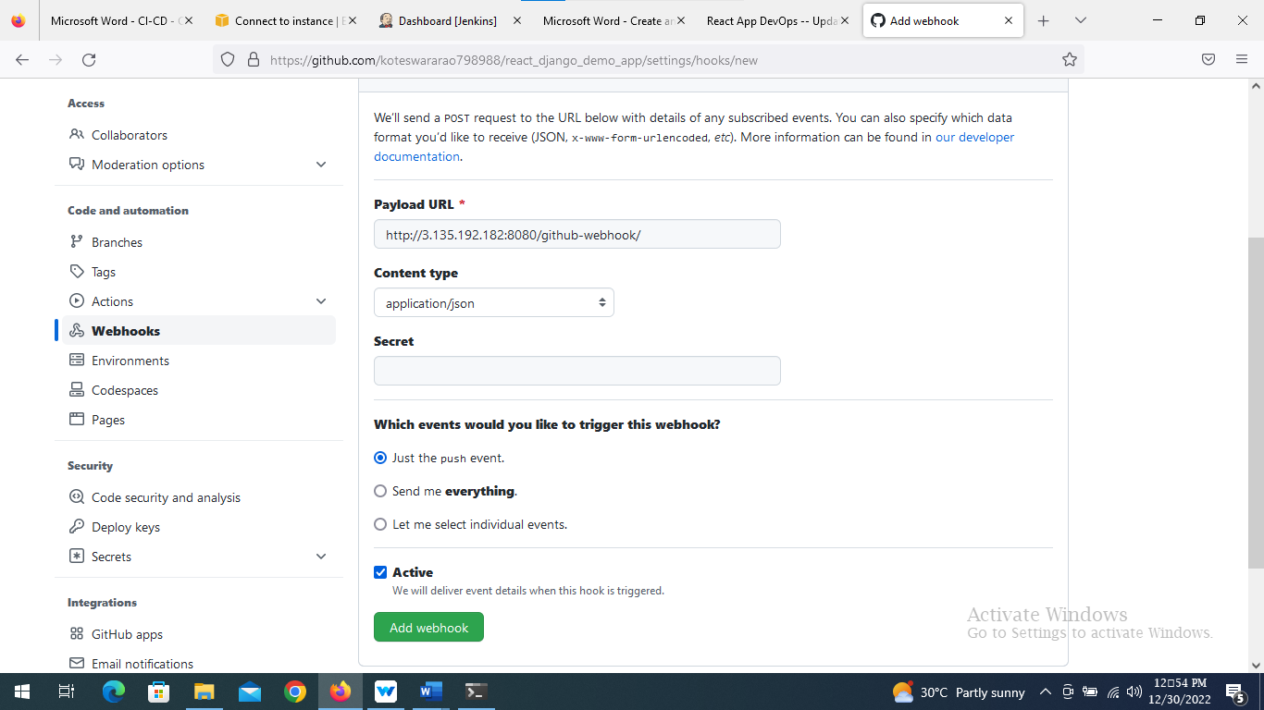

* Now, Save the configured project.
* Do some changes in the code and push to GitHub, this will automatically run a pipeline, and the new code will be Live.