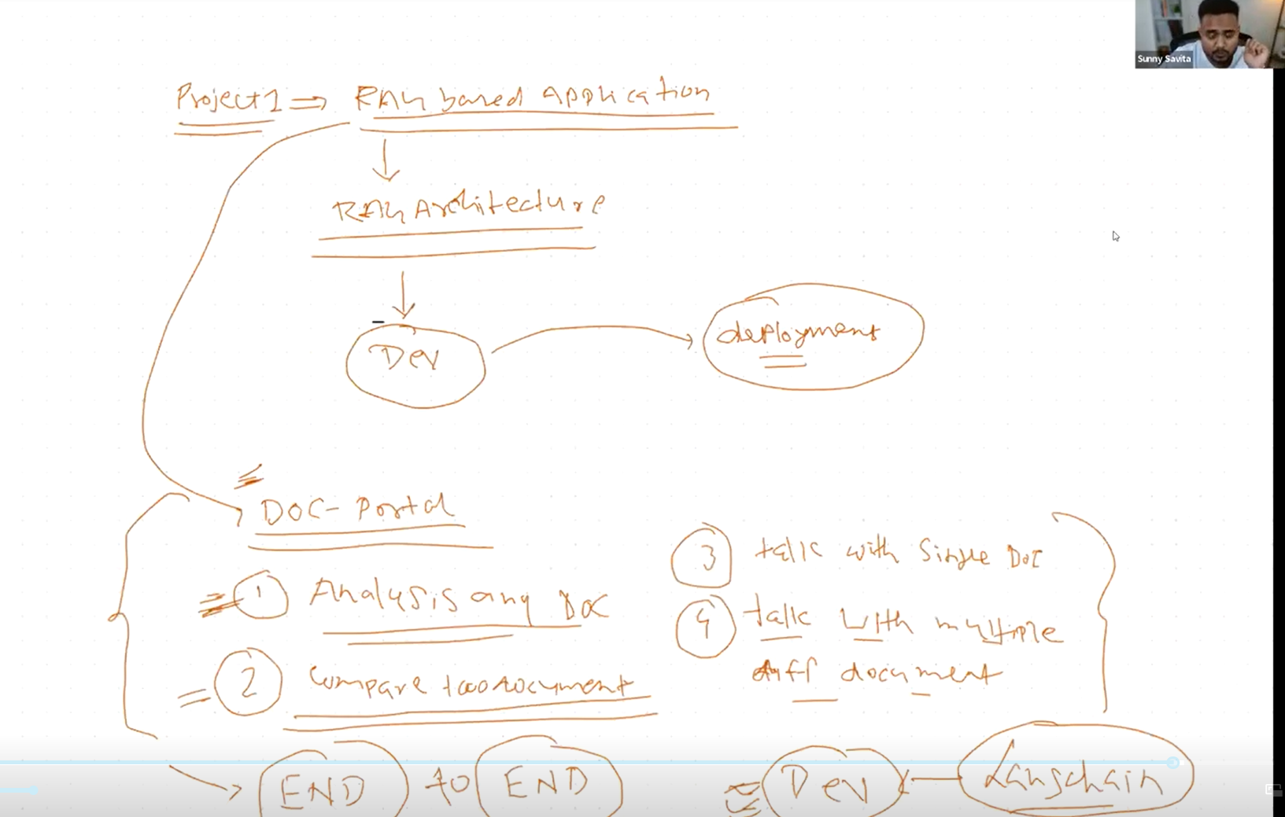

1. LLM model
2. Embedding model
3. Vector Database i)In memory, ii)Disk iii)Cloud based

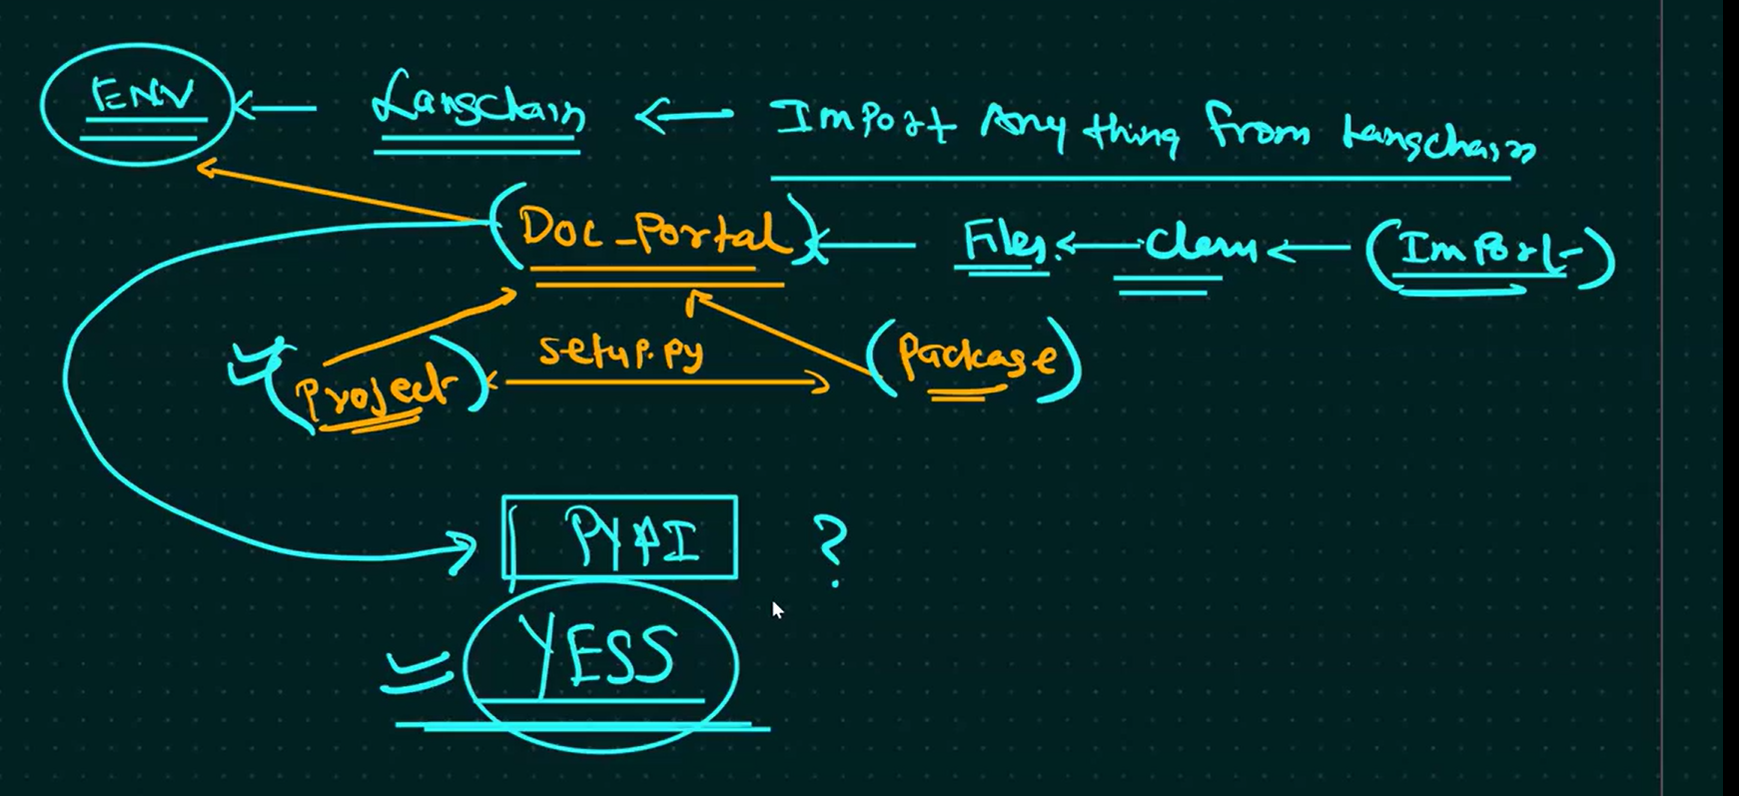

pip install -e .