OPS-CLOUD-P2-002
Automate Blob Storage Static Site
Phase: 2 — Azure CLI + Bash Automation
Status: ✅ Complete
Date: 10–11 July 2026

Jira Ticket
Ticket: OPS-CLOUD-P2-002 : Automate Blob Storage Static Site
Sprint: Week 1 — Compute & Storage Automation
Type: Infrastructure Automation

Problem Statement / Scenario
A company needs a landing page for an internal tool. The content is pure static HTML/CSS with no server-side logic. The naive approach — spinning up a VM and installing a web server (as in OPS-CLOUD-P2-001) — means paying for compute 24/7, patching an OS, and maintaining a web server, all just to serve files that never change based on user input.

What I'm Solving For
- Host a static webpage reachable by a public URL
- Avoid the cost and operational overhead of running a VM for content that doesn't need one
- Make the deployment repeatable via CLI/script, not manual Portal clicks, so it can be re-run or handed to another engineer without re-doing 15–30 minutes of manual configuration each time
- Keep cost proportional to actual traffic/criticality (Hot tier + LRS for this low-traffic, non-critical use case)

Requirements
- Resource Group created via CLI
- Storage Account created via CLI (Standard_LRS)
- Static website hosting enabled (property update, auto-creates $web)
- index.html uploaded to $web
- Public endpoint URL printed at the end of the script
- Script safely re-runnable (idempotent where the tooling allows)

What I Built
A bash script (deploy-blob-static-site.sh) that provisions a fully working static website on Azure using Blob Storage — no VM, no VNet, no NSG. The script:
- Creates a Resource Group
- Creates a Storage Account (Standard_LRS, StorageV2)
- Enables static website hosting (a property update, not a new resource)
- Uploads index.html into the auto-created $web container
- Prints the live public site URL
Live endpoint: https://p2mystorage1657.z8.web.core.windows.net/

Why I Built It This Way

PaaS over IaaS for static content
A static landing page has no server-side logic — no reason to run and maintain a VM (OS patching, Apache config, NSGs, uptime) just to serve HTML/CSS. Blob Storage static website hosting removes the entire compute and networking layer: Azure handles replication, scaling, and serving. This is the direct opposite dependency chain of P2-001 (RG → VNet → NIC → VM) — here there's nothing to build below the storage account.

Time savings
Manually configuring this in the Azure Portal (storage account creation, static website toggle, container upload, endpoint lookup) takes roughly 15–30 minutes depending on familiarity with the console. The script does the same work in under 2 minutes and is fully repeatable — this matters for a company that wants to redeploy or replicate the same site (e.g. dev/staging/prod) without re-doing manual clicks each time.

Cost target: near-zero for a low-traffic internal site
No compute to pay for 24/7, no OS licensing, no patching labor. This directly serves a company that doesn't want to spend money on VM provisioning or maintenance just to host a static page.

SKU / access tier decisions
- Access tier: Hot — chosen because this file is expected to be read regularly by the public. Hot tier optimizes for frequent access at the cost of slightly higher storage price per GB (vs. Cool/Archive, which are cheaper to store but expensive to read).
- Redundancy: Standard_LRS — chosen because this is a low-traffic, non-critical internal page with no backup/disaster-recovery requirement. LRS keeps 3 copies within a single datacenter, which is sufficient here.
  - Production note: if this were a business-critical site, GRS or GZRS would be the better choice — both replicate data to a second, geographically distant region (in addition to the 3 local copies), protecting against a full regional outage. That durability comes at a higher cost, which is why it wasn't justified for this project's scope.

Reusability
The script is portable with minimal changes:
- Within the same subscription, only resource names need to change (to avoid collisions with existing resources).
- Across a different subscription, resource group and general naming can stay identical — the only hard constraint is the storage account name, which must be globally unique across all of Azure, not just within one subscription.

Problems Encountered, Fixes, and Why

1. CLI API version mismatch (InvalidApiVersionParameter)
What happened: az storage account update failed, citing an API version the resource provider didn't recognize.
Root cause: The installed Azure CLI (2.73.0) was out of date and was requesting a deprecated API version.
Fix: az upgrade (via Homebrew) → CLI updated to 2.88.0.
Learning: CLI tooling drifts out of date silently. Production teams typically pin/version-lock their CLI in CI pipelines specifically to avoid this kind of mid-deployment surprise.

2. Second API version mismatch after upgrading
What happened: Even after upgrading, the same command failed again — this time requesting an API version newer than what the provider actually supported.
Root cause: A stale local CLI cache/metadata mismatch after the upgrade.
Fix: az cache purge, followed by az provider register --namespace Microsoft.Storage to re-confirm provider registration. When the issue persisted, worked around it using the generic ARM command (az resource update --api-version <known-good-version>) instead of the storage-specific CLI command, explicitly pinning a version the provider listed as supported.
Learning: When a specific az subcommand misbehaves, the generic az resource commands are a reliable fallback since they let you pin an exact, provider-confirmed API version.

3. az role assignment create --assignee <email> failed to resolve identity
What happened: Attempting to grant myself the "Storage Blob Data Contributor" role (needed for --auth-mode login) failed with "Cannot find user or service principal in graph database."
Root cause: Microsoft/Gmail-based (MSA) accounts don't always resolve cleanly via email lookup against Azure AD Graph, unlike native work/school Azure AD accounts.
Fix: Fell back to --auth-mode key for the upload step to stay unblocked and complete the deployment on schedule.
Learning / follow-up: The correct production fix is to use --assignee-object-id (from az ad signed-in-user show --query id -o tsv) instead of --assignee <email>. This is intentionally left as a known gap to revisit properly during Week 3 (Service Principal + RBAC), where identity-based access is the core topic.

4. Incorrect assumption: allowBlobPublicAccess needed to be true
What happened: After seeing "allowBlobPublicAccess": false in the storage account JSON output, I assumed the static site would be blocked from public access and manually patched it to true.
What was actually true (verified via Microsoft Learn docs): Static website hosting is served through a separate endpoint (*.z8.web.core.windows.net), independent of the standard blob endpoint (*.blob.core.windows.net). Microsoft's documentation confirms disabling public access on a storage account does not affect static websites hosted in that account — the static site endpoint always serves $web content anonymously by design, regardless of the account-level allowBlobPublicAccess setting.
Fix: None needed — the site was live and public the entire time, even with the setting at false.
Learning: Don't assume a setting applies globally just because it sounds related — verify against source documentation. This was a wasted troubleshooting step caused by an incorrect assumption, not an actual bug.

5. Empty file execution / unsaved editor state
What happened: Ran the script and got no output at all.
Root cause: The script had been edited in VS Code but never saved — the terminal was executing a stale, mostly-empty version of the file from disk.
Fix: Saved the file (Cmd+S), confirmed contents with cat, re-ran.
Learning: The VS Code editor pane and the integrated terminal read from different states until a save happens — editing is not the same as persisting to disk.

Auth-Mode Decision (Key vs. Login vs. Key Vault)
The script currently uses --auth-mode key for the upload step as a pragmatic workaround for problem #3 above. This is not the ideal production pattern:
- Storage account keys are master credentials — full read/write/delete access to the entire account, not scoped to one container. They don't expire automatically and require manual rotation if leaked.
- The stronger production pattern is identity-based auth (--auth-mode login, or a Managed Identity if running from a pipeline/App Service) — this avoids a long-lived secret existing at all.
- Key Vault is a legitimate fallback if a key must be used — it centralizes rotation, adds audit logging, and controls who/what can retrieve the key. But it's a mitigation for using a key, not a replacement for fixing the underlying identity/RBAC problem.
Follow-up for a future revision: resolve the RBAC assignee lookup issue (via --assignee-object-id) and switch the script back to --auth-mode login, removing the key dependency entirely.

What Could Go Wrong (Production Thinking)
Q: If this script's key-based auth call were committed to a shared repo or CI pipeline, what's the actual exposure?
Anyone with access to that pipeline config or repo history gets full read/write/delete access to every container in the storage account — not just $web. There's no way to scope a storage account key to a single container or action. This is exactly why the identity-based approach (--auth-mode login / Managed Identity) is the correct long-term fix, not just a nice-to-have.

Deployment Script
deploy-blob-static-site.sh
#!/bin/bash
# OPS-CLOUD-P2-002 : Automate Blob Storage Static Site
set -euo pipefail
RG="rg-p2-002"
STGACCOUNT="p2mystorage1657"
MYLOC="australiaeast"
# 1. Resource Group
az group create \
--name "$RG" \
--location "$MYLOC"
# 2. Storage Account (Standard_LRS)
az storage account create \
--name "$STGACCOUNT" \
--resource-group "$RG" \
--location "$MYLOC" \
--sku Standard_LRS
# 3. Enable Static Website Hosting
az storage blob service-properties update \
--account-name "$STGACCOUNT" \
--static-website \
--index-document index.html \
--auth-mode login
# 4. Upload index.html to $web (key-mode: see auth-mode decision above)
az storage blob upload \
--account-name "$STGACCOUNT" \
--container-name '$web' \
--name index.html \
--file index.html \
--auth-mode key \
--overwrite
# 5. Print the live site URL
SITE_URL=$(az storage account show \
--name "$STGACCOUNT" \
--resource-group "$RG" \
--query "primaryEndpoints.web" \
--output tsv)
echo "Deployment complete."
echo "Static site live at: $SITE_URL"

Portal & CLI Verification Screenshots

1. Variables Defined and Resource Group Created
The script defines RG, STGACCOUNT, and MYLOC, then creates the resource group. Terminal output on the right confirms provisioningState: Succeeded.
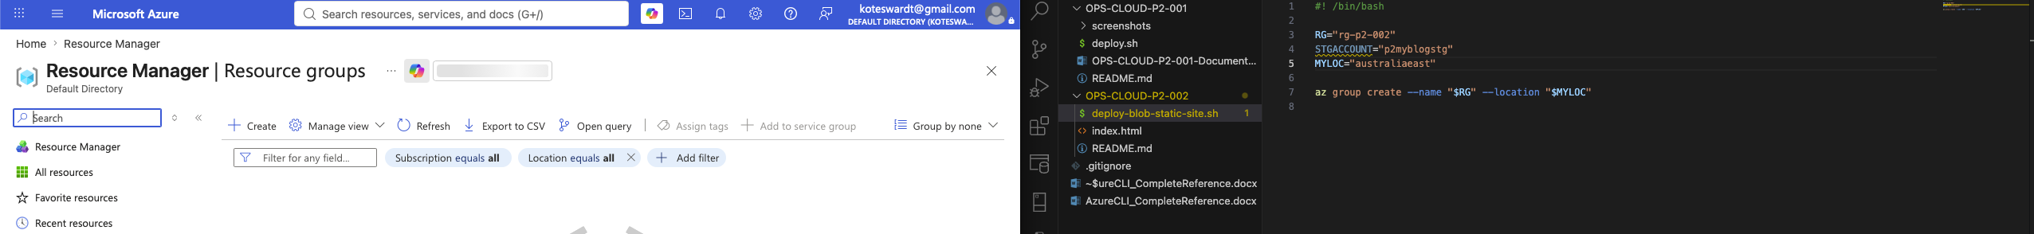
Script variables and az group create — RG provisioning succeeded

2. Resource Group — Full Script Output
Confirms the resource group JSON response, showing subscription, location, and provisioning state.
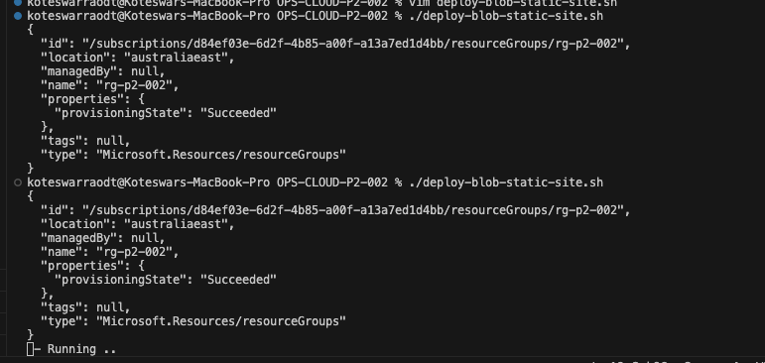
Resource group creation output

3. Storage Account Created (Output — Run 1)
Full storage account JSON returned by az storage account create, confirming StorageV2 kind, Standard_LRS SKU, and australiaeast location.
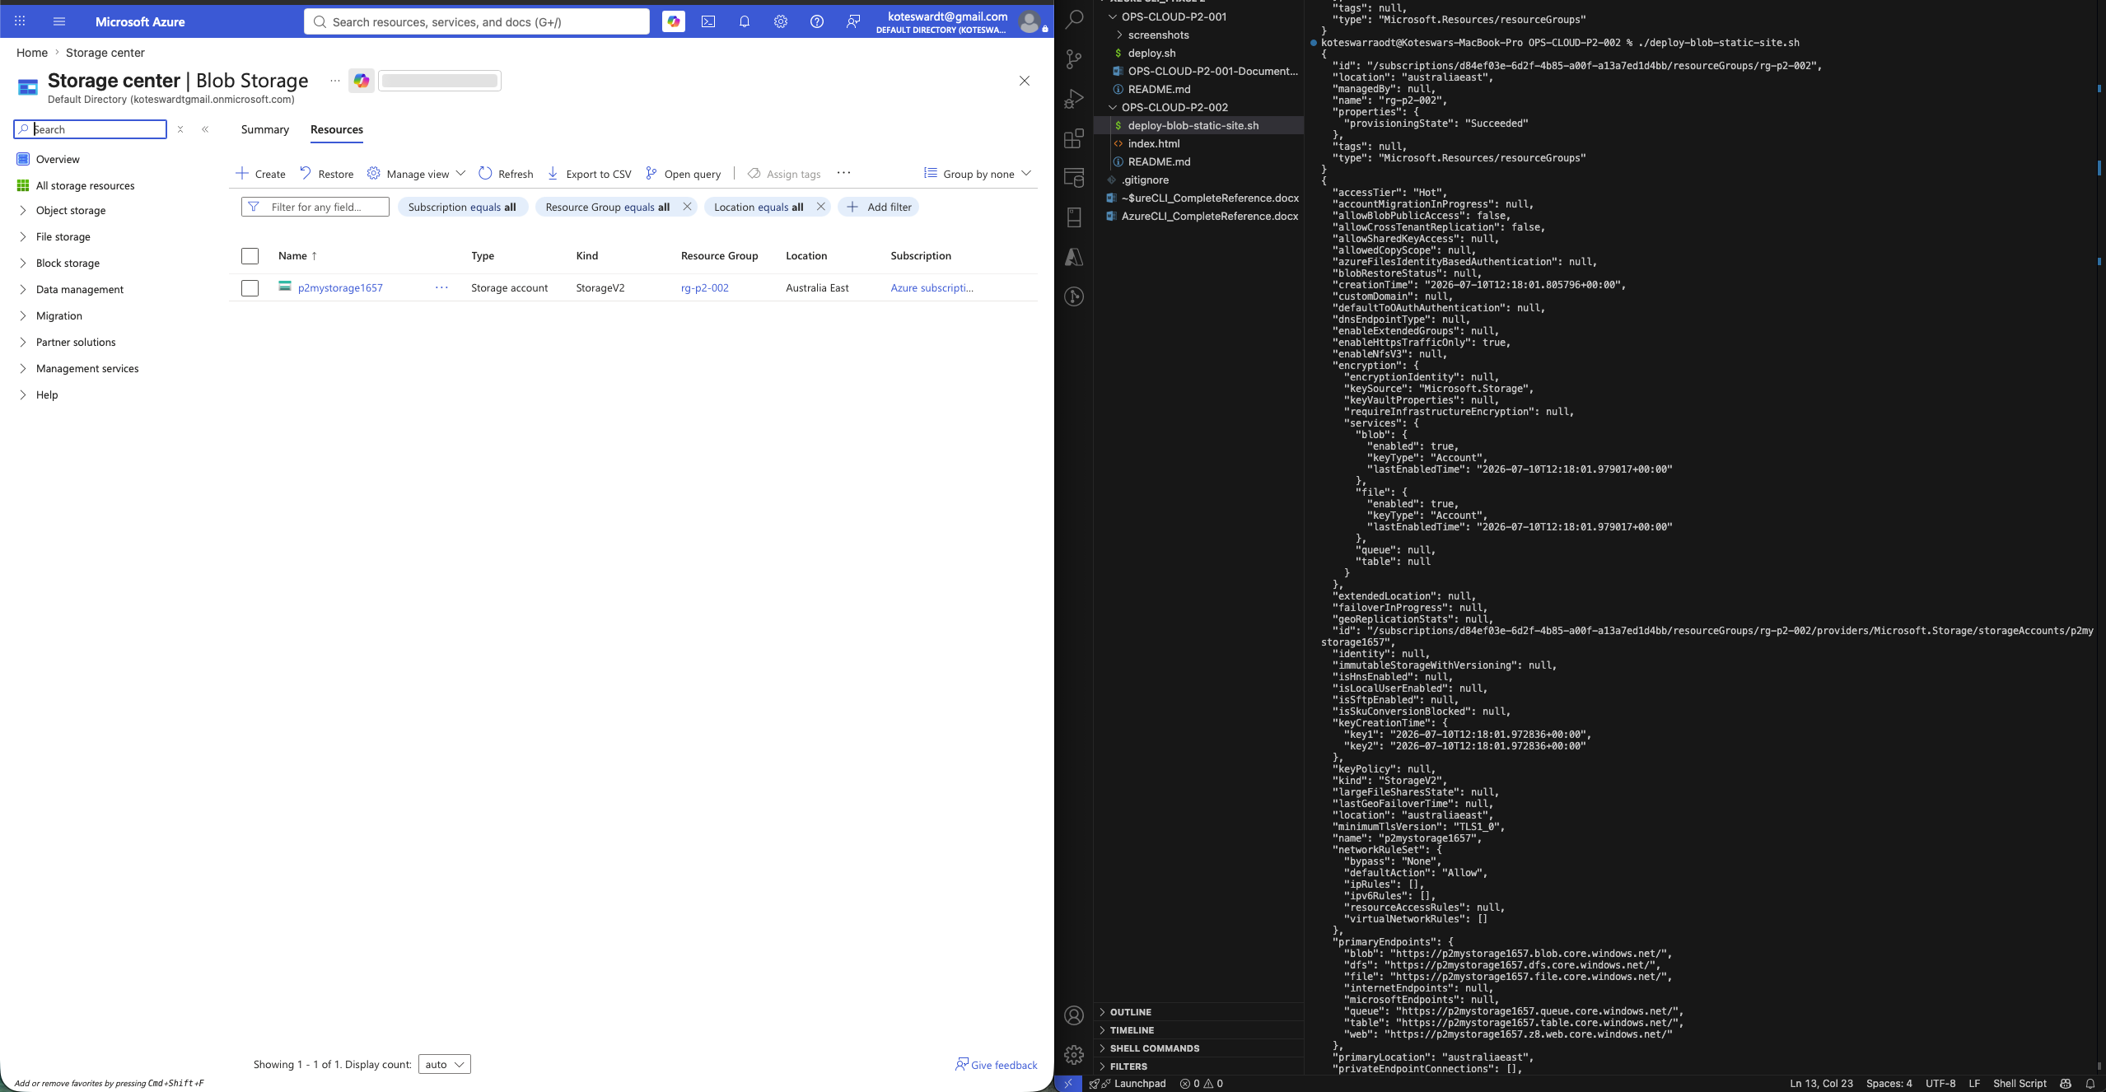
Storage account creation — full properties JSON

4. Storage Account Created (Output — Run 2, Portal Cross-Check)
Portal view of the Blob Storage resource list alongside the same CLI JSON output, confirming CLI and Portal state match.
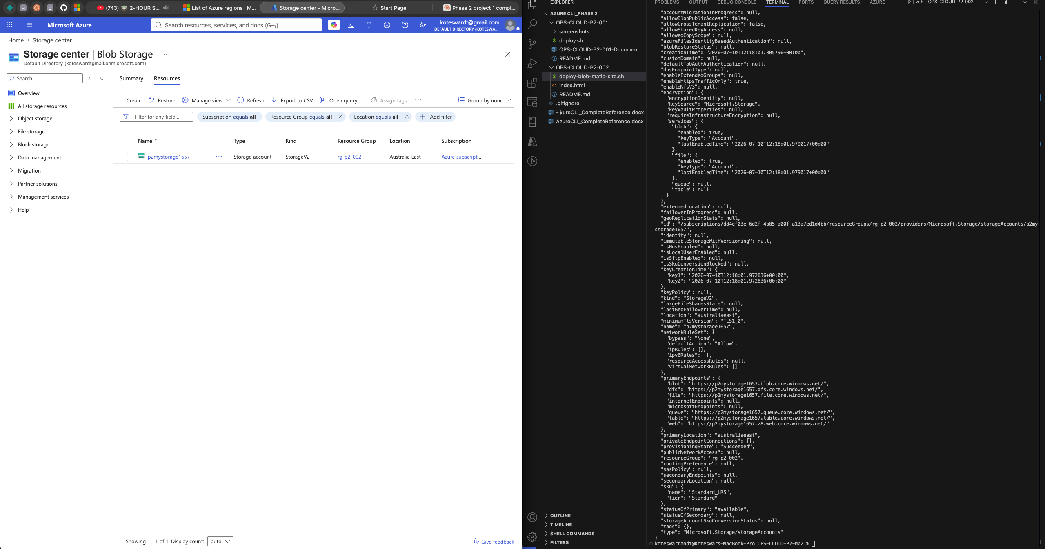
Portal resource list matched against CLI output

5. Static Website Hosting Enabled
The Portal's Static Website panel confirms hosting is Enabled, with the primary endpoint and index document (index.html) correctly configured. Note the $web container link, auto-created by Azure.
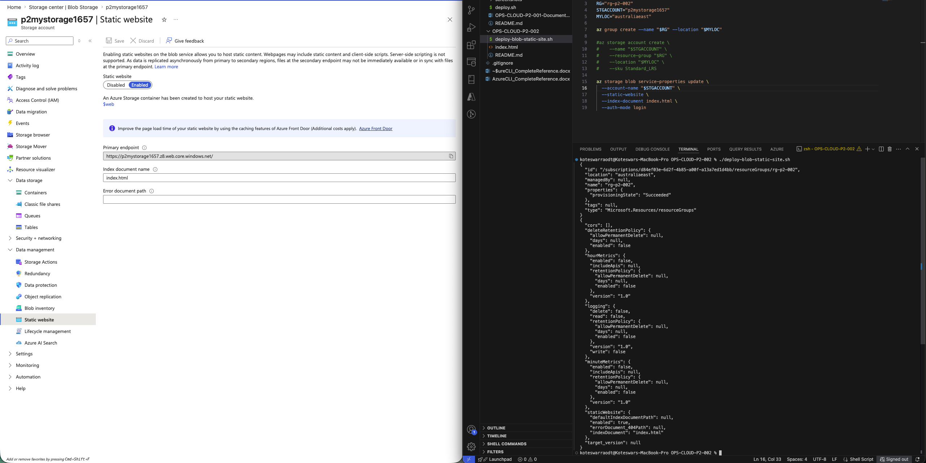
Static website hosting — enabled, endpoint and index document confirmed

6. index.html Uploaded to $web
The $web container showing index.html successfully uploaded — Block blob, 1.23 KiB, Available lease state.
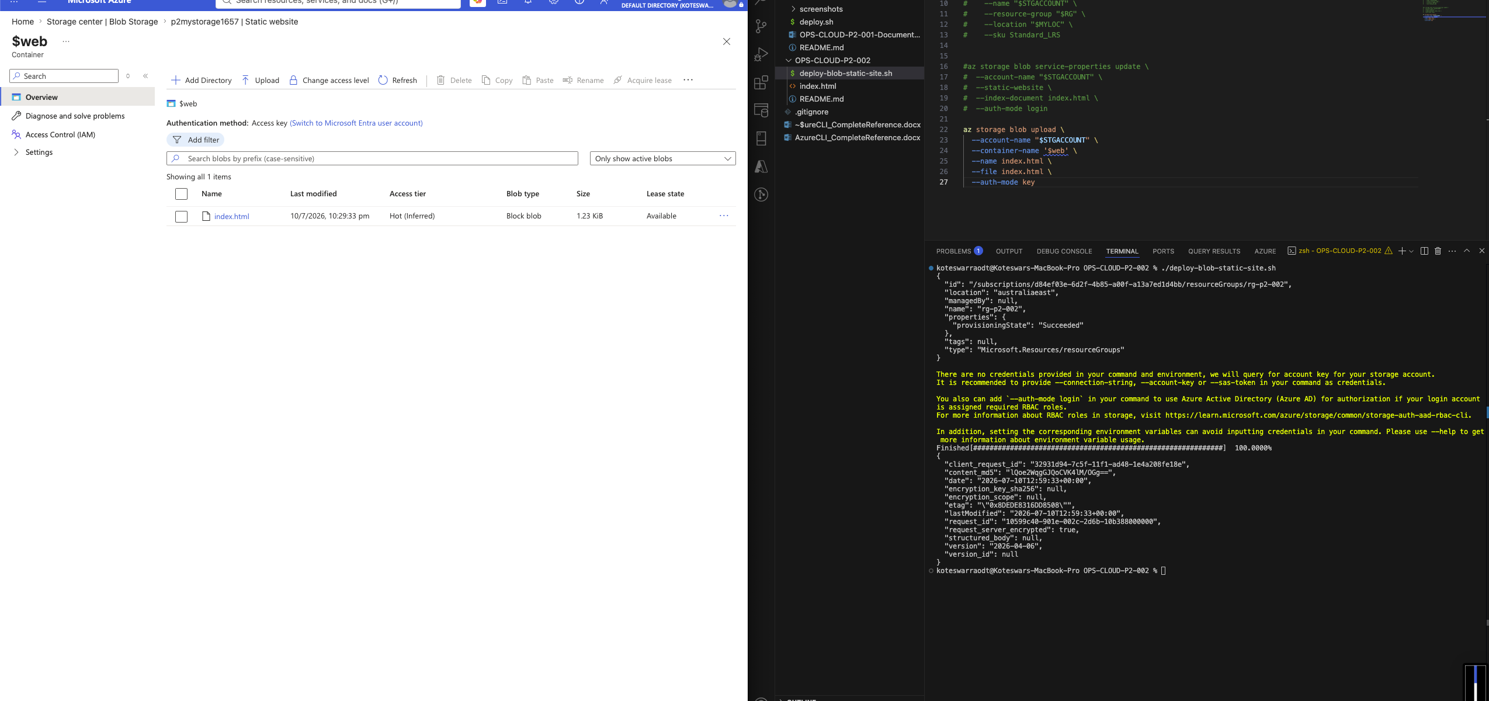
index.html present in the $web container

7. Live Site — Browser Verification (Incognito)
Final verification: loading the primary static website endpoint in a private/incognito browser window confirms the page is genuinely publicly accessible, not just reachable due to a cached or authenticated session.
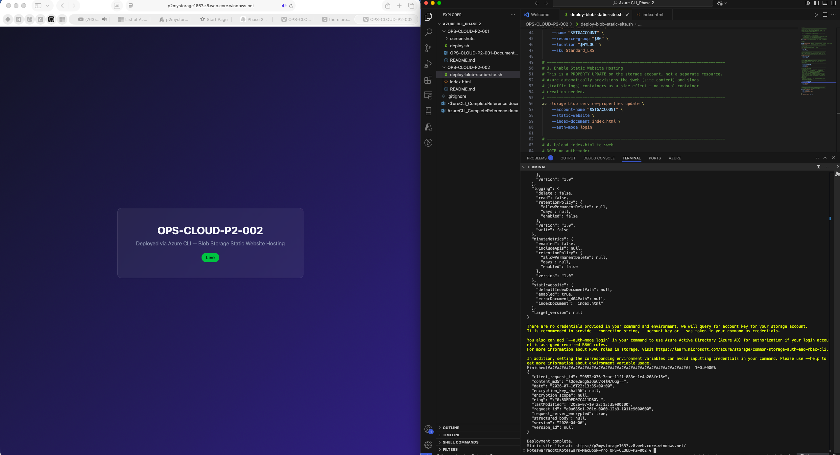
Live static site rendering at the public endpoint, verified in a private browser window

Deliverables
- deploy-blob-static-site.sh — full automation script
- index.html — static landing page
- README.md — companion markdown version of this document
- Portal screenshots — RG, storage account, $web container, static website config, live site (incognito-verified)

