OPS-CLOUD-P2-003
Automate Cross-Region VNet Peering
Phase 2 — Azure CLI + Bash Automation | 12–14 July 2026

Jira Ticket
OPS-CLOUD-P2-003 : Automate Cross-Region VNet Peering
Sprint: Week 2 — Networking Automation
Type: Infrastructure Automation
Status: ✅ Complete

Problem Statement / Scenario
A company needs two regions to talk to each other privately — think a database replica for disaster recovery, or an app split across regions for latency. The traffic between those two regions needs to stay off the public internet, especially if it's database traffic. I already built this once by hand in the Portal in OPS-CLOUD-002 (Australia East ↔ Central India). This time the goal was to reproduce it entirely through the CLI, so it's repeatable instead of 20-30 minutes of manual clicking that's easy to get wrong.

What I'm Solving For
- Two VNets in two different regions that can reach each other over private IP addresses, routed across Azure's private backbone instead of the public internet
- Prove it with a real before/after connectivity test, not just a "Connected" status in the Portal
- Build it entirely via CLI — no Portal clicks for resource creation
- Keep the whole thing simple enough for a lab, while still understanding what changes in a real production setup

What I Built
One Resource Group, two VNets in two regions with non-overlapping address spaces, one VM per VNet, and a bidirectional peering link between them.
Component | Region 1 (Australia East) | Region 2 (Central India)
VNet | OPS-CLOUD-P2-003-Vnet1 — 10.0.0.0/16 | OPS-CLOUD-P2-003-Vnet2 — 10.1.0.0/16
Subnet | OPS-CLOUD-P2-003-subnet1 — 10.0.0.0/24 | OPS-CLOUD-P2-003-subnet2 — 10.1.0.0/24
VM | OPS-CLOUD-P2-003-VM1 | OPS-CLOUD-P2-003-VM2
Private IP | 10.0.0.4 | 10.1.0.4
Public IP | 20.211.5.58 | 4.224.120.126

Peering links: Vnet1-to-Vnet2 and Vnet2-to-Vnet1 — both created via separate az network vnet peering create calls, both confirmed Connected and Fully Synchronized in the Portal.
I ran the same ping test twice — once before peering (both directions failed, 100% packet loss) and once after peering (both directions succeeded, 0% packet loss, ~147ms RTT). That RTT lines up with what OPS-CLOUD-002 measured for the same two regions in the Portal, which was a nice sanity check that the CLI build is behaving the same way the manual build did.

Why I Built It This Way

One Resource Group, not two
I went back and forth on this. Technically an RG is just a management boundary — it doesn't restrict what regions the resources inside it live in, so one RG works fine here. In production I'd lean toward separate RGs per region (like I did in OPS-CLOUD-002), because it mirrors how larger orgs actually split ownership by region and means deleting one region's resources doesn't touch the other's lifecycle. For a short-lived lab with a fixed teardown date, that benefit barely matters, so I kept it simple with one RG.

/16 for the VNet, /24 for the subnet
/16 gives the company room to grow — 65,536 addresses is far more than this lab needs, but it means if they add more subnets or projects into this VNet later, they're not boxed in. /24 per subnet is a sensible chunk (256 addresses) without over-allocating.

Non-overlapping address spaces (10.0.x.x vs 10.1.x.x)
This is the one rule that will break peering outright if you get it wrong. I actually made this mistake myself while drafting the variables — see "Mistakes I Made" below.

CLI over Portal
Same reasoning as every Phase 2 ticket: the Portal version of this (OPS-CLOUD-002) took roughly 20-30 minutes of clicking. The script does the same work in a fraction of that, and it's rerunnable — if I need this exact setup again for a new project or a different region pair, I'm editing variables, not re-doing the whole manual flow.

Where this actually gets used in production
VNet peering like this is the backbone of things like multi-region database replication / disaster recovery (a standby replica synced privately in a second region), global applications with regional compute (app servers close to users in each region, sharing one private backend), and — at bigger scale — hub-and-spoke architectures, where instead of every VNet peering directly with every other VNet (which doesn't scale, since peering isn't transitive), everything peers into one central hub. That's actually the next thing on my Intermediate track.

Mistakes I Made and What I Learned

1. Almost broke the non-overlap rule without noticing
Early on I typed 10.0.0.1/16 for Vnet1 and 10.0.0.2/16 for Vnet2. At a glance that looks like two different addresses, but a /16 prefix only cares about the first two octets — both of these are 10.0.x.x, so they weren't different address spaces at all, and the .1/.2 I'd put in the third octet were invalid host bits for a /16 network address anyway. Claude caught it before I ran it, but it drove home that CIDR math isn't just "make the numbers look different" — you have to know which octets the prefix length actually protects.

2. Confused a VNet's location with a restriction on its resources
I assumed a Resource Group's location meant everything inside it had to live in that same region. It doesn't — an RG's location is just where its own metadata sits. You can create a VNet in Australia East and another in Central India inside the exact same RG, which is exactly what let me use one RG for this whole project.

3. Tried to ping a private IP from my own laptop
Before I understood the private/public IP distinction properly, I ran ssh azureuser@10.0.0.4 straight from my MacBook and got "Network is unreachable" immediately. That's because 10.0.0.4 is a private IP — it only exists inside that VNet. My laptop, sitting on my home network, has no route to it at all, peered or not. The actual test has to run from inside one VM, targeting the other VM's private IP — not from my own machine.

4. CLI rejected an API version that the Portal was using fine
When I tried az network vnet show ... --query id to grab a VNet's resource ID, the CLI threw InvalidApiVersionParameter for 2025-07-01 — even right after running az upgrade and confirming I was on the latest CLI version. But when I opened the same VNet's Resource JSON in the Portal, it was using apiVersion: 2025-07-01 without any issue. So the Portal and my local CLI were working against different API version sets at the same moment — I worked around it by grabbing the VNet's Resource ID straight from the Portal's JSON view instead of the CLI command. Good reminder that "my CLI is up to date" doesn't guarantee it's in sync with everything the Portal can do.

5. Peering is genuinely two separate operations, not one
I already knew from OPS-CLOUD-002 that peering isn't automatically bidirectional, but doing it via CLI made it a lot more concrete — the Portal's single "Add peering" form quietly fires two API calls behind the scenes. Writing this by hand meant I had to explicitly create Vnet1-to-Vnet2 and then, separately, Vnet2-to-Vnet1 — with the --vnet-name (local) and --remote-vnet (the other side) flipped between the two calls. Much harder to gloss over when you're the one typing both commands.

What Could Go Wrong (Production Thinking)
Q: If I ran this whole script a second time without deleting the RG first, what happens?
Some of it would fail loudly and safely — az group create and az network vnet create are idempotent-ish, they'd either succeed again cleanly or just confirm the existing state matches. But az vm create and az network vnet peering create would likely throw "already exists" errors partway through, leaving me with a script that dies in the middle rather than cleanly reporting "nothing to do here." For a real production script I'd want existence checks (az group exists, az network vnet show wrapped in an if) before each block, so the script can be safely re-run without babysitting it through failures.

Requirements (from the ticket)
- Resource Group created via CLI — done
- Two VNets in two regions, non-overlapping CIDRs — done
- Two subnets, one per VNet — done
- Two VMs, one per VNet, for connectivity testing — done
- Bidirectional peering (both az network vnet peering create calls) — done
- Peering status verified as Connected + Fully Synchronized, both sides — done
- Private connectivity proven with a before/after ping test — done

Deployment Script
deploy-vnet-peering.sh
#!/bin/bash
# ── Variables ──
RG="OPS-CLOUD-P2-003-RG"
Location1="australiaeast"
Location2="centralindia"
MYVNET1="OPS-CLOUD-P2-003-Vnet1"
MYVNET2="OPS-CLOUD-P2-003-Vnet2"
MYSUBNET1="OPS-CLOUD-P2-003-subnet1"
MYSUBNET2="OPS-CLOUD-P2-003-subnet2"
VMNAME1="OPS-CLOUD-P2-003-VM1"
VMNAME2="OPS-CLOUD-P2-003-VM2"
VMImage="Ubuntu2204"
VMsize="Standard_B1s"
VNET1_PREFIX="10.0.0.0/16"
SUBNET1_PREFIX="10.0.0.0/24"
VNET2_PREFIX="10.1.0.0/16"
SUBNET2_PREFIX="10.1.0.0/24"
ADMIN_USER="azureuser"
# ── Resource Group ──
az group create \
--name "$RG" \
--location "$Location1"
# ── VNet + Subnet (Region 1) ──
az network vnet create \
--resource-group "$RG" \
--name "$MYVNET1" \
--address-prefix "$VNET1_PREFIX" \
--subnet-name "$MYSUBNET1" \
--subnet-prefix "$SUBNET1_PREFIX" \
--location "$Location1"
# ── VNet + Subnet (Region 2) ──
az network vnet create \
--resource-group "$RG" \
--name "$MYVNET2" \
--address-prefix "$VNET2_PREFIX" \
--subnet-name "$MYSUBNET2" \
--subnet-prefix "$SUBNET2_PREFIX" \
--location "$Location2"
# ── VM (Region 1) ──
az vm create \
--resource-group "$RG" \
--name "$VMNAME1" \
--image "$VMImage" \
--size "$VMsize" \
--vnet-name "$MYVNET1" \
--subnet "$MYSUBNET1" \
--admin-username "$ADMIN_USER" \
--authentication-type ssh \
--generate-ssh-keys \
--location "$Location1"
# ── VM (Region 2) ──
az vm create \
--resource-group "$RG" \
--name "$VMNAME2" \
--image "$VMImage" \
--size "$VMsize" \
--vnet-name "$MYVNET2" \
--subnet "$MYSUBNET2" \
--admin-username "$ADMIN_USER" \
--authentication-type ssh \
--generate-ssh-keys \
--location "$Location2"
# ── Resource IDs for peering (pulled from Portal JSON — see
# "Mistakes" section, item 4, for why) ──
VNET1_ID="/subscriptions/<sub-id>/resourceGroups/$RG/providers/Microsoft.Network/virtualNetworks/$MYVNET1"
VNET2_ID="/subscriptions/<sub-id>/resourceGroups/$RG/providers/Microsoft.Network/virtualNetworks/$MYVNET2"
# ── Peering: Vnet1 → Vnet2 ──
az network vnet peering create \
--resource-group "$RG" \
--name "Vnet1-to-Vnet2" \
--vnet-name "$MYVNET1" \
--remote-vnet "$VNET2_ID" \
--allow-vnet-access
# ── Peering: Vnet2 → Vnet1 ──
az network vnet peering create \
--resource-group "$RG" \
--name "Vnet2-to-Vnet1" \
--vnet-name "$MYVNET2" \
--remote-vnet "$VNET1_ID" \
--allow-vnet-access

Portal & CLI Verification Screenshots

1. Resource Group Before Anything Exists
Clean slate — no resource groups for this project yet, confirming the build started from nothing.
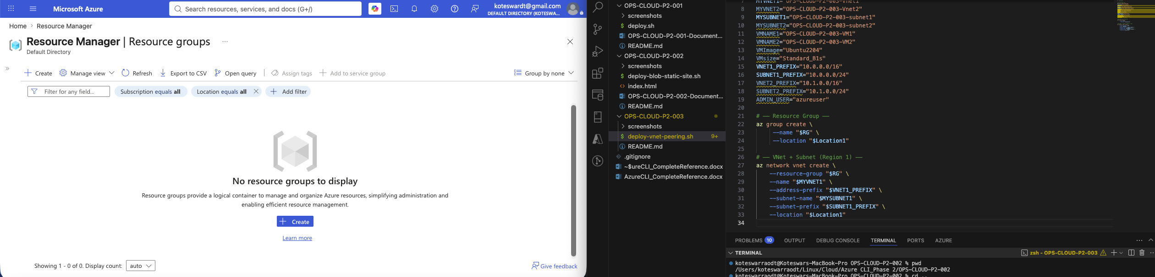
Portal — Resource Groups: none exist before deployment

2. RG + Vnet1 Created (Region 1)
Portal confirming the Resource Group exists after running the CLI script, alongside the auto-created NetworkWatcherRG.
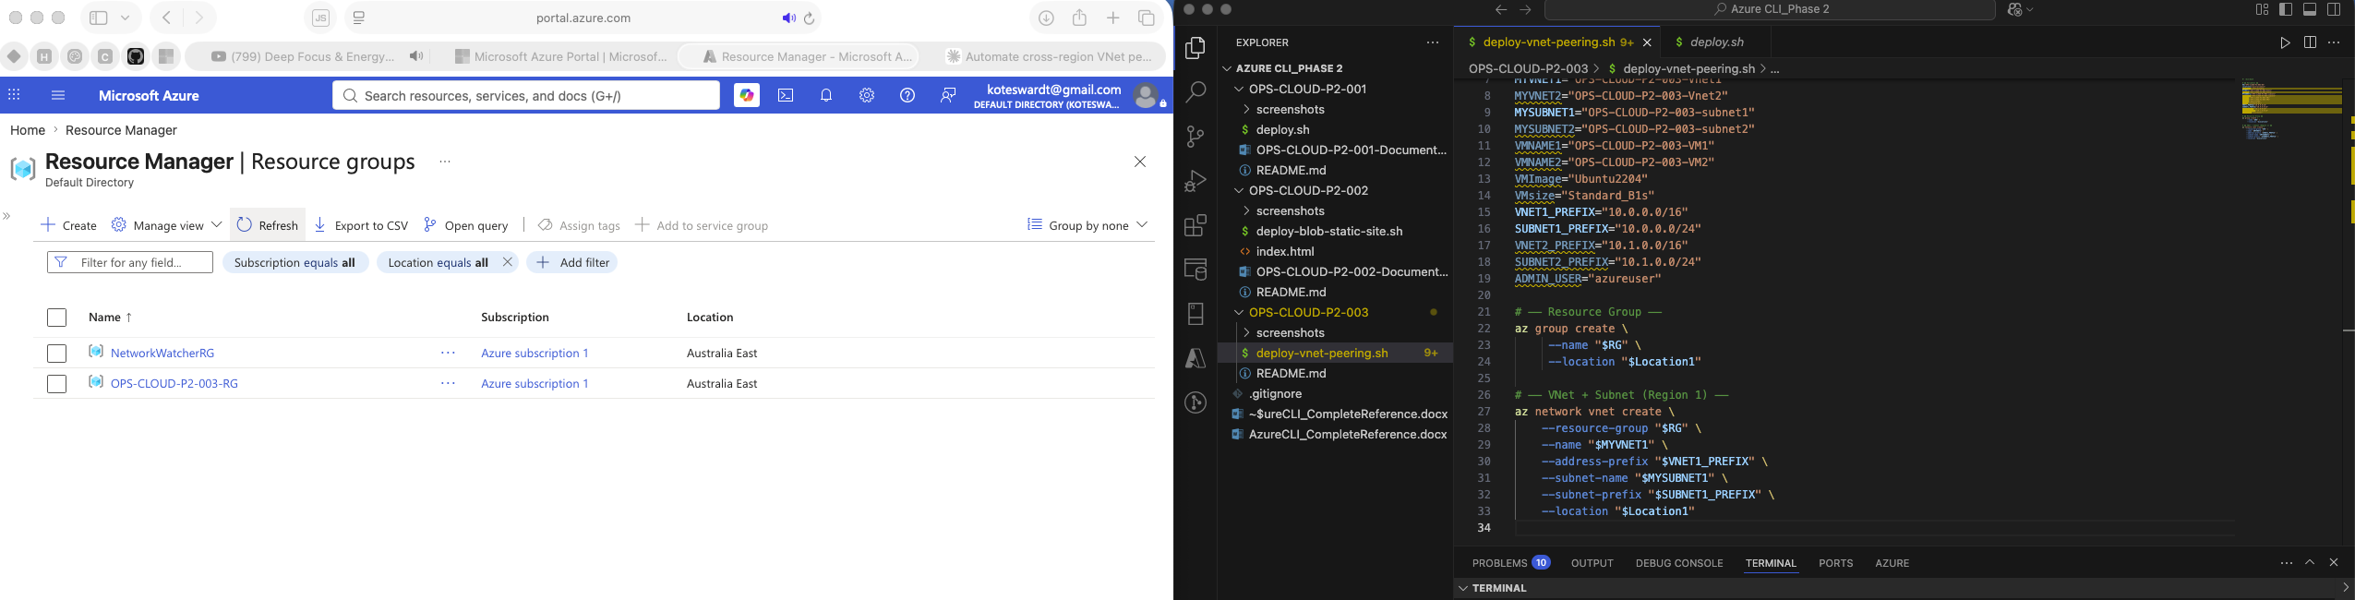
Portal — Resource Group OPS-CLOUD-P2-003-RG created

3. Vnet2 + Both VMs Created
Portal view confirming both VMs are Running with public IPs assigned — VM1 in Australia East, VM2 in Central India.
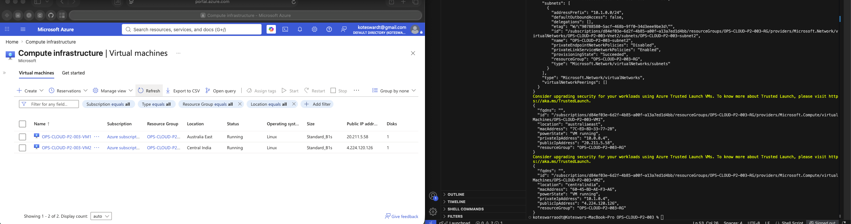
Portal — VM1 (Australia East) and VM2 (Central India), both Running

4. Pre-Peering Ping Test — VM1 → VM2
SSH'd into VM1 (Australia East) and pinged VM2's private IP (10.1.0.4). 100% packet loss — expected, since no peering exists yet.
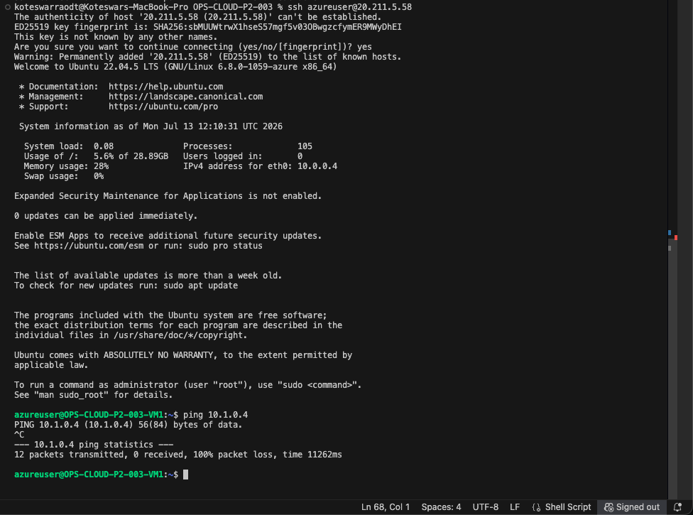
Pre-peering: 12 packets sent, 0 received, 100% loss

5. Pre-Peering Ping Test — VM2 → VM1
Same test in reverse — SSH'd into VM2 and pinged VM1's private IP (10.0.0.4). Also 100% loss, confirming isolation is symmetric.
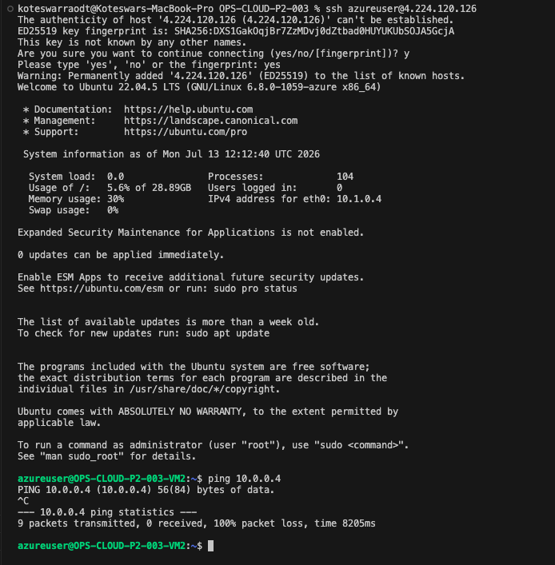
Pre-peering: 9 packets sent, 0 received, 100% loss

6. Peering Status — Vnet1's Peerings Blade
Vnet1-to-Vnet2 link showing Connected and Fully Synchronized.
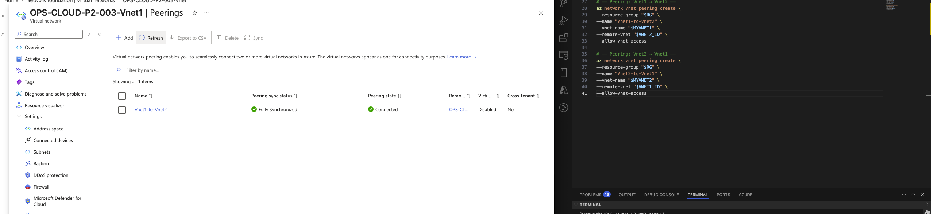
Portal — Vnet1 Peerings blade: Connected, Fully Synchronized

7. Peering Status — Vnet2's Peerings Blade
Vnet2-to-Vnet1 link, also Connected and Fully Synchronized — confirming both directions of the bidirectional link succeeded independently.
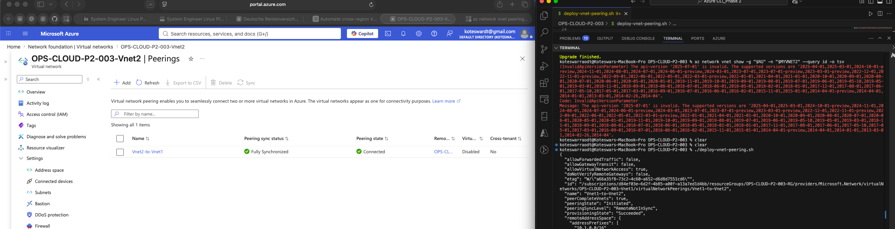
Portal — Vnet2 Peerings blade: Connected, Fully Synchronized

8. Post-Peering Ping Test — Both Directions
Same ping test repeated after peering was live. VM1 → VM2: 5 packets, 5 received, 0% loss, ~147-150ms RTT. VM2 → VM1: 3 packets, 3 received, 0% loss, ~147ms RTT. That RTT matches the real-world latency OPS-CLOUD-002 measured for the same two regions.
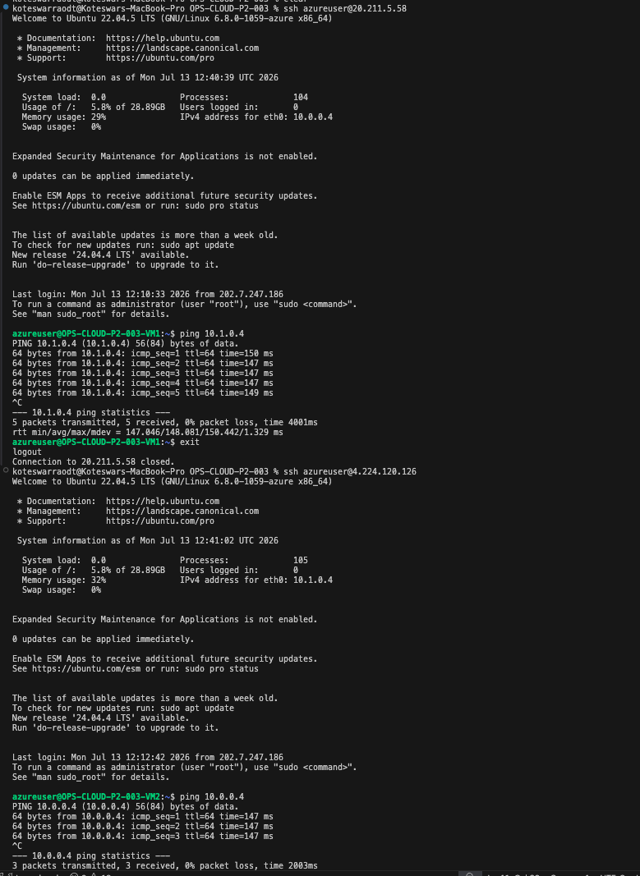
Post-peering: 0% packet loss both directions, ~147ms RTT

Cleanup
Deleted the entire Resource Group (OPS-CLOUD-P2-003-RG) after capturing all verification screenshots — same lesson as always: delete the whole RG, not individual resources, so nothing (disks, NICs, public IPs) gets left behind still billing.
End of Document — OPS-CLOUD-P2-003

