OPS-CLOUD-P2-001
Automate Linux VM + Apache Deployment via Azure CLI
Project Phase | Phase 2 — Azure CLI + Bash Automation
Sprint | Week 1 — Compute & Storage Automation
Status | Complete
Engineer | Koteswar Rao
Subscription | Azure Subscription 1 (d84ef03e-...)
Date Completed | 7 July 2026

1. Aim / Objective
The goal of this project is to reduce the time and human error involved in manually provisioning a Linux VM through the Azure Portal — for example, forgetting to open the correct NSG port. A reusable Bash automation script was written so that future deployments only require changing variable values (VM size, location, resource group name, etc.), rather than repeating manual console steps.

2. What Was Built, In Order
- Resource Group — the container all other resources live inside.
- Virtual Network + Subnet — isolates this environment, conceptually similar to a private network segment inside a larger company network. Used a /16 address space for the VNet (65,536 addresses) and a /24 for the subnet (256 addresses).
- Virtual Machine — Ubuntu 22.04, Standard_B1s size, SSH key-based authentication only (no passwords).
- NSG Rules — port 22 (SSH) is open by default when the VM is created; port 80 (HTTP) was explicitly opened for public web traffic.
- Apache2 — installed remotely via az vm run-command, without ever SSHing into the VM manually.
- Public IP — captured and printed by the script at the end of the run.

Why /16 for the VNet
A /24 subnet (256 addresses) was sufficient for this small project's needs, but the VNet itself was sized at /16 to leave headroom for adding more subnets later without re-architecting the network — a company-scale environment can require significantly more address space than a single project.

3. Dependency Order — Portal vs CLI
Even though the Azure Portal's VM creation wizard feels like it lets you configure the VNet at the end (inside the Networking tab), Azure always creates the VNet and subnet first, behind the scenes — the VM's network interface (NIC) requires an existing subnet to attach to before it can be given a private IP. The Portal simply batches all three actions into a single "Review + Create" click, hiding this order. Scripting the deployment with CLI makes the real dependency chain explicit and visible:
Resource Group → VNet / Subnet → NIC (auto-created) → Virtual Machine

4. Commands Used

4.1 Resource Group
az group create --name "$RG" --location "$Location"

4.2 VNet + Subnet
az network vnet create \
--resource-group "$RG" \
--name "$MYVNET" \
--address-prefix "10.0.0.0/16" \
--subnet-name "$MYSUBNET" \
--subnet-prefix "10.0.1.0/24" \
--location "$Location"

4.3 Virtual Machine (SSH key auth)
az vm create \
--resource-group "$RG" \
--name "$VMNAME" \
--image "$VMImage" \
--size "$VMsize" \
--vnet-name "$MYVNET" \
--subnet "$MYSUBNET" \
--admin-username "azureuser" \
--authentication-type ssh \
--generate-ssh-keys \
--location "$Location"

4.4 Open Port 80
az vm open-port --resource-group "$RG" --name "$VMNAME" --port 80

4.5 Install Apache Remotely
az vm run-command invoke \
--resource-group "$RG" \
--name "$VMNAME" \
--command-id RunShellScript \
--scripts "sudo apt-get update && sudo apt-get install -y apache2"

4.6 Print Public IP
IP=$(az vm show -d --resource-group "$RG" --name "$VMNAME" --query publicIps -o tsv)
echo "Apache deployed. Visit: http://$IP"

5. Production Considerations (Beyond This Ticket's Scope)
This ticket intentionally leaves port 22 open on the public IP for simplicity in a dev/learning environment. In a real production deployment, SSH would not be exposed directly to the internet. Instead:
- Use Azure Bastion for secure SSH/RDP access without assigning the VM a public IP.
- Or disable port 22 entirely and use short-lived, token-based (JWT / OAuth) access for admin tasks.
- Place a Load Balancer in front of multiple VM instances to distribute traffic and remove any single point of failure.

6. Mistakes Made and Resolved
- Curly quotes / em-dashes: writing commands inside the Mac Notes app auto-converted straight quotes (" ") into curly quotes (“ ”) and double-hyphens (--) into em-dashes (—), silently breaking every affected flag. Resolved by switching to a plain-text code editor (VS Code), which never auto-formats characters.
- Missing # on continuation lines: when commenting out a multi-line az command to avoid re-running it, only commenting the first line left the remaining lines as broken, standalone commands. Resolved using Vim visual-block mode (Ctrl+Q → select lines → Shift+I → # → Esc) to comment every line of a block at once.
- Empty variables outside the script: variables such as $RG and $VMNAME only exist for the lifetime of the script's own process. Running an az command directly in the terminal (outside deploy.sh) using those variable names silently passed empty strings, producing a confusing "resource not found" API error.
- Missing -y flag on apt install: without it, the install hung indefinitely waiting for a y/n confirmation prompt that no one was present to answer, since run-command executes unattended on the remote VM.

7. Key Learnings
- az group create is idempotent — safe to re-run. az vm create is NOT — re-running it against an existing VM risks conflicts or orphaned resources (a NIC or disk left behind from a failed attempt). This is exactly the class of problem Infrastructure-as-Code tools such as Terraform solve, by tracking actual vs. desired state instead of blindly re-running imperative create commands.
- Resource names are not portable across re-runs within the same subscription. Hardcoded names such as rg-p2-001 would collide if a second engineer — or the same engineer a second time — ran the script again. True re-usability requires either parameterized names (script arguments) or idempotency checks, e.g. az vm show ... || az vm create ...
- Scripting with CLI forces you to see the full dependency chain (RG → VNet → NIC → VM) that the Portal wizard hides behind a single "Create" button — this is the deeper value of automation, beyond just speed.

8. Portal Verification Screenshots
The screenshots below confirm each resource created via CLI matches what appears in the Azure Portal.

8.1 Resource Group
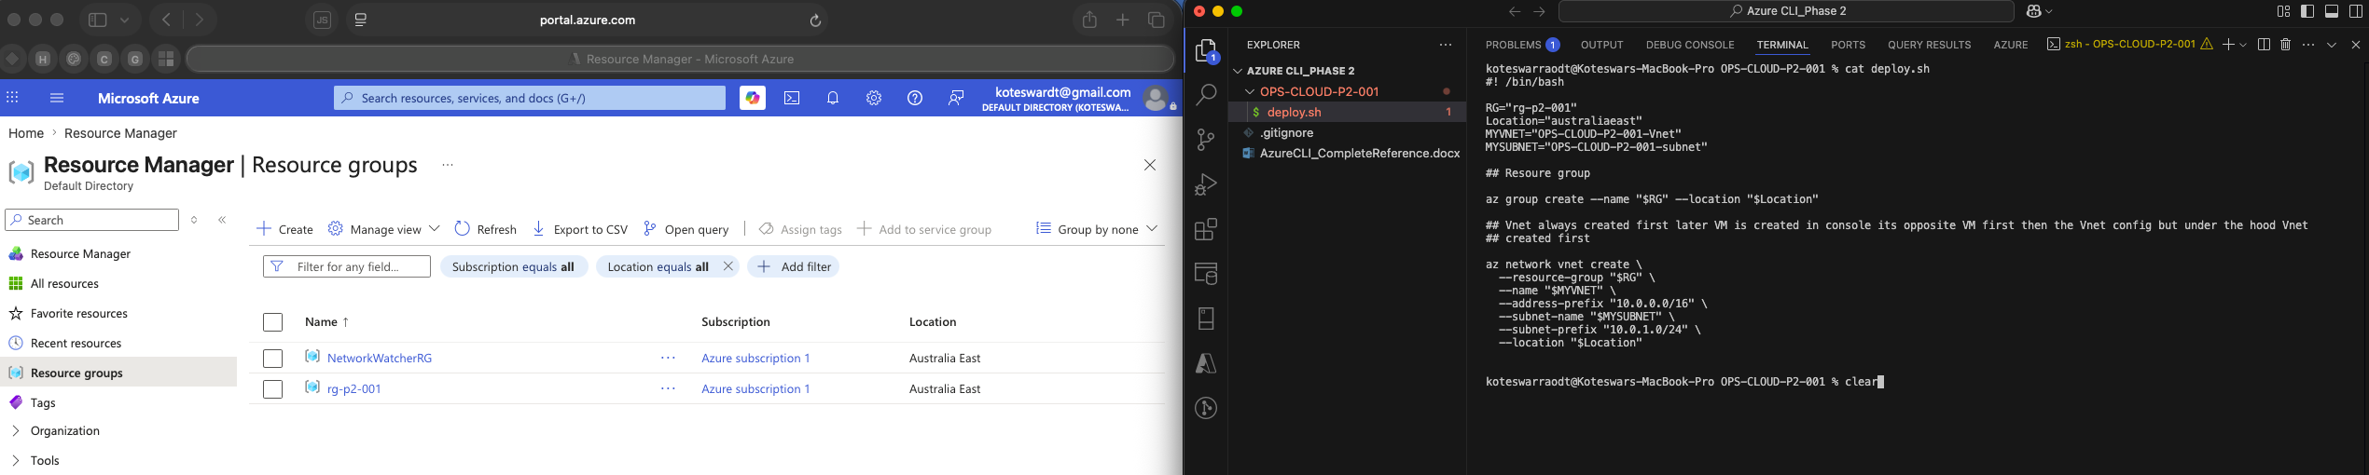
rg-p2-001 — Australia East

8.2 VNet + Subnet
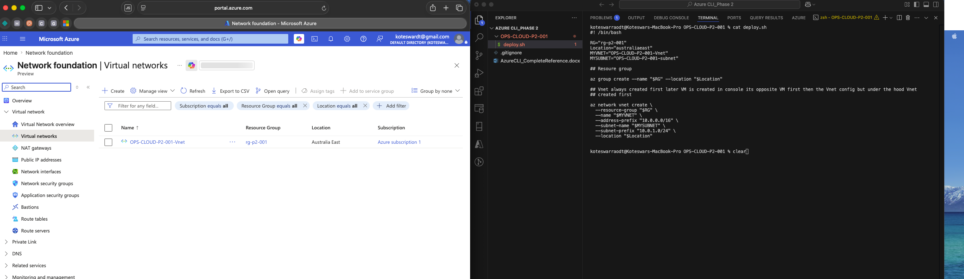
OPS-CLOUD-P2-001-Vnet — 10.0.0.0/16, subnet 10.0.1.0/24

8.3 Virtual Machine
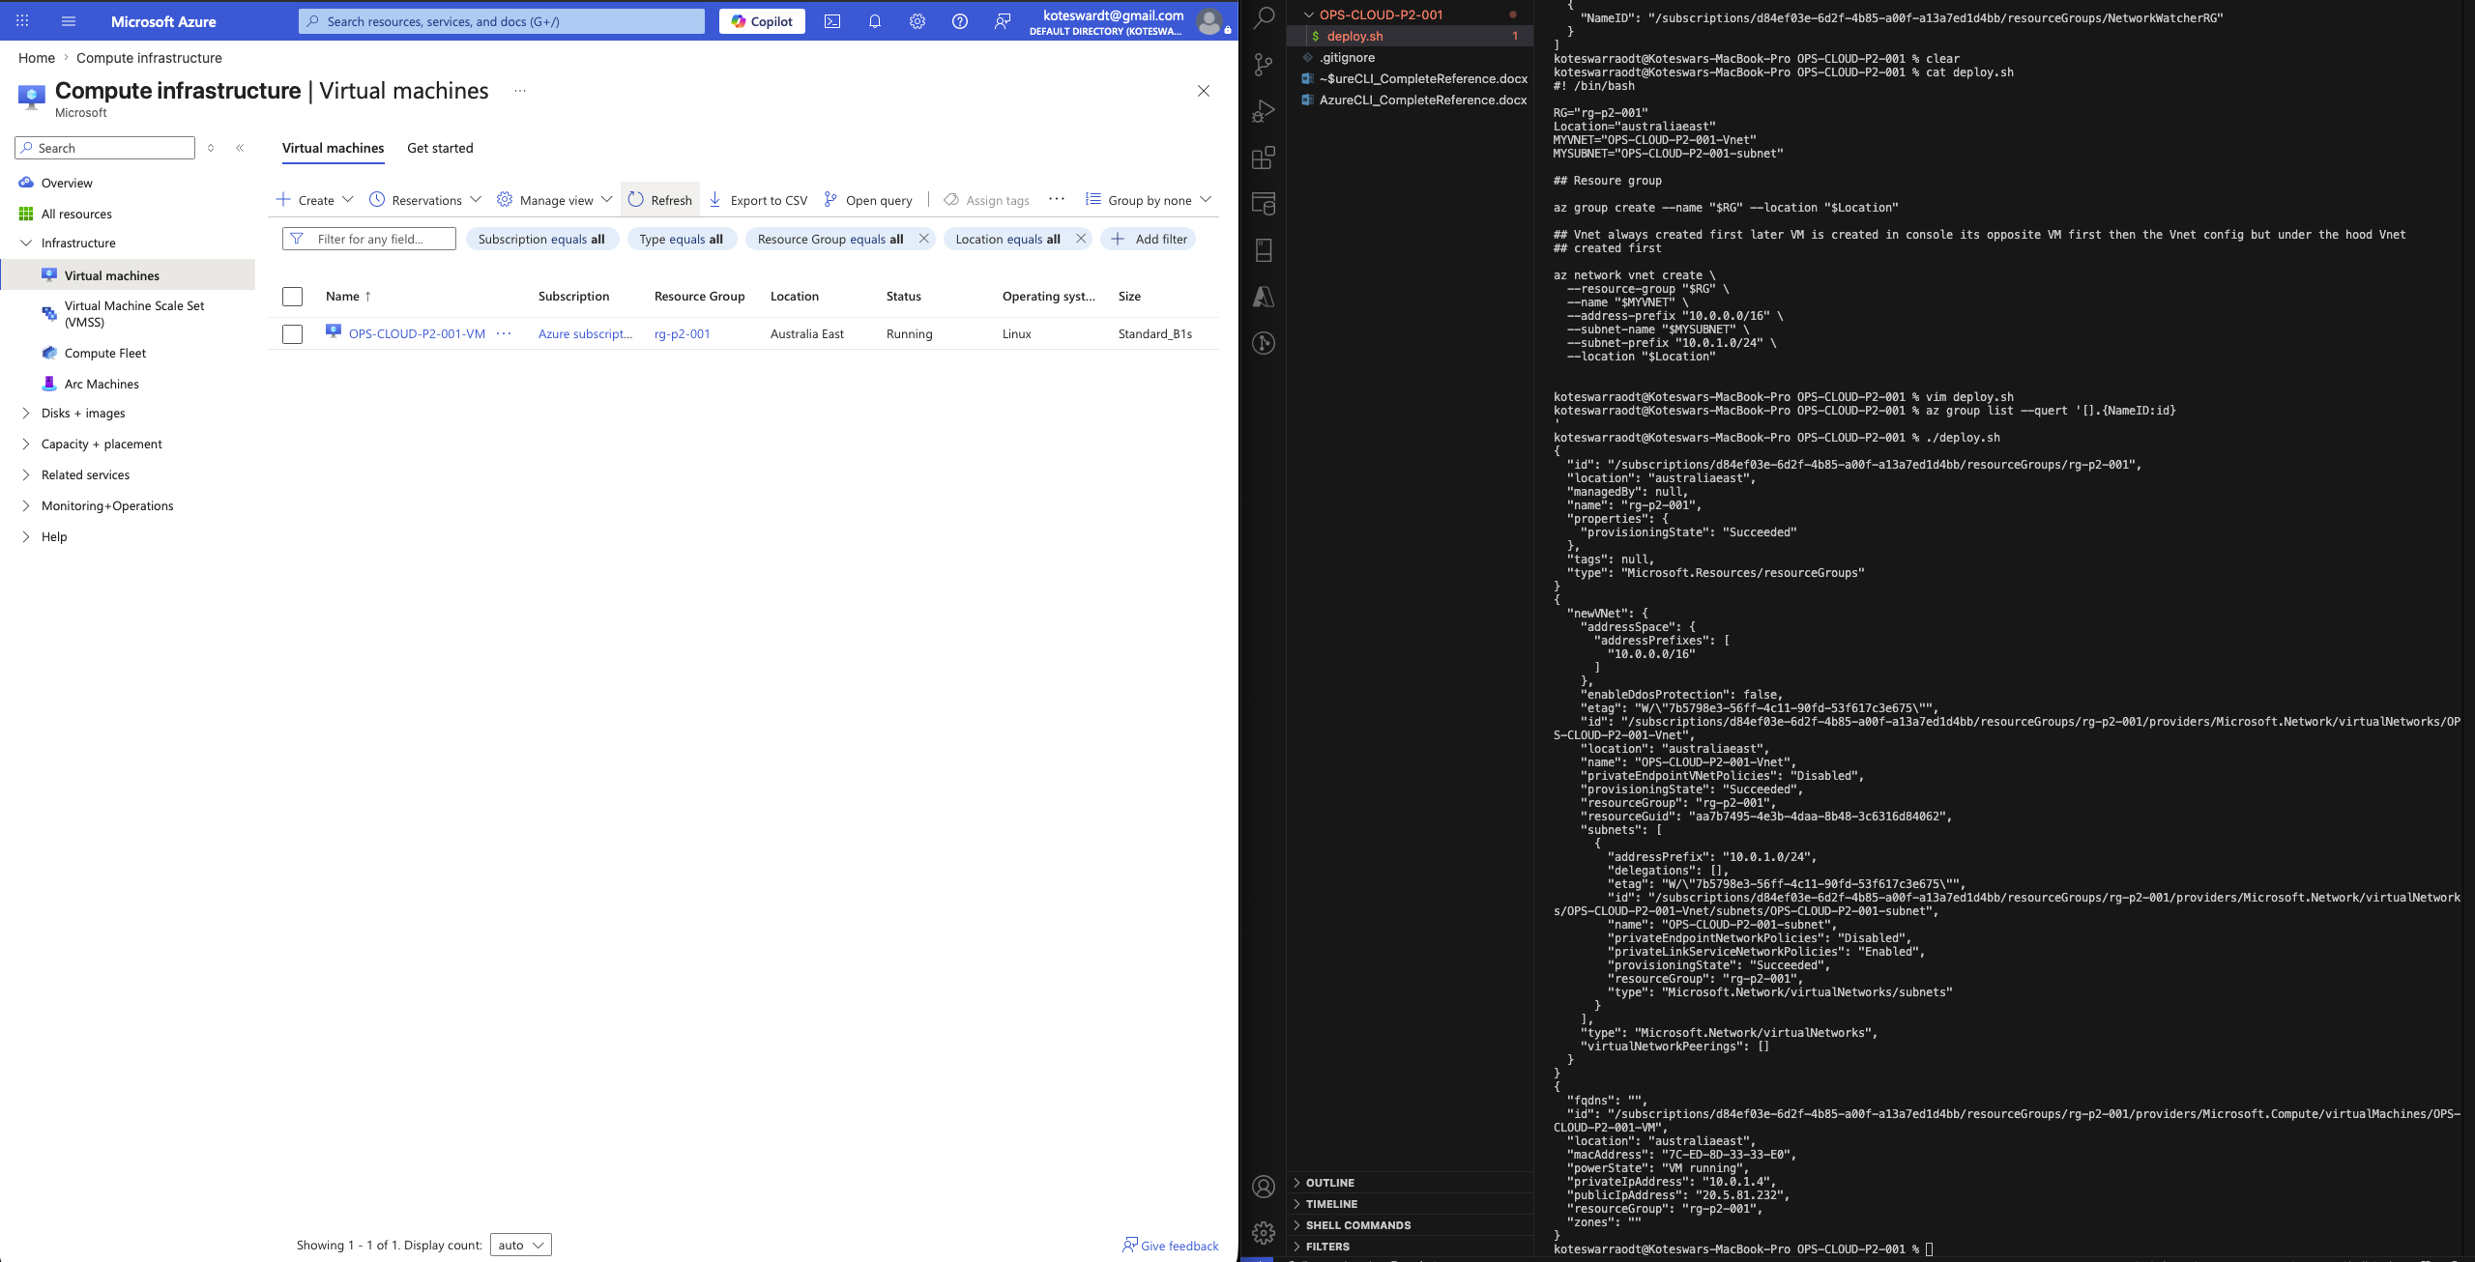
OPS-CLOUD-P2-001-VM — Running, private IP 10.0.1.4

8.4 Apache Installed Remotely (run-command output)
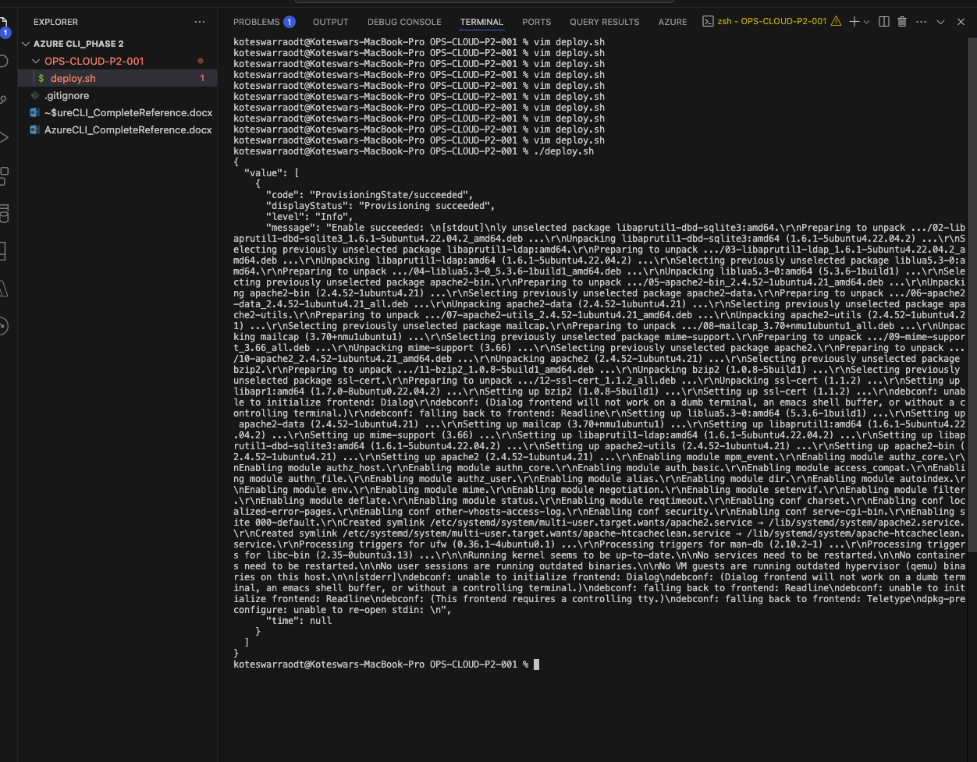
az vm run-command invoke — Apache install succeeded

8.5 Apache Default Page — Browser Confirmation
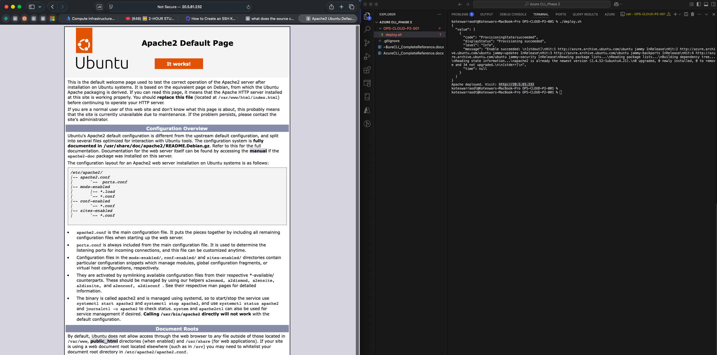
http://<public-ip> — Apache2 Ubuntu Default Page confirmed

9. Verification Summary
Deliverable / Step | Status
Resource Group created and verified in Portal | Done
VNet (10.0.0.0/16) and Subnet (10.0.1.0/24) verified in Portal | Done
VM created — private IP 10.0.1.4 confirmed inside correct subnet | Done
NSG rules restricted to ports 22 and 80 only, verified | Done
Apache installed and running (systemctl status confirmed) | Done
Public IP printed by script | Done
curl http://<public-ip> returned Apache2 Ubuntu default page | Done
Browser verification of Apache default page | Done

End of Document — OPS-CLOUD-P2-001

