Scholario Ops — Project Document
Oct 6, 2026 · @Adobe-Byline-7

1. Executive summary
Scholario Ops is a global, application-level operations platform that monitors every application and every VPS an organisation runs, across Production (PRD) and Disaster Recovery (DR) environments. It replaces manual checks across many consoles with one live control centre for availability, infrastructure health, incidents and DR readiness, built only from real data.
The platform is application-agnostic. Any number of applications, servers, providers and regions are registered in the dashboard, and each application has its own PRD and DR servers, URLs, tier, RTO/RPO targets, and either a Cloudflare Load Balancer or a DNS failover record.
Problem. Teams running many applications on many VPS check URLs, hosting consoles, Cloudflare and each server separately. Outages are noticed late, capacity problems are found only after they cause downtime, and DR readiness is rarely measured.
Solution. Scholario Ops probes every application endpoint on a schedule (30 seconds by default), reads Cloudflare Load Balancer and DNS health, collects CPU, memory, disk and service telemetry from a lightweight agent on every VPS, raises incidents automatically, alerts on-call teams, and scores DR readiness for each application with 13 checks.
Users. Operations administrators, operators who respond to incidents, and viewers such as management who need status at a glance.

2. Objectives and scope
The project delivers one trusted control centre for PRD and DR health, with every status taken from a live source and missing data shown as UNKNOWN, never as healthy.
Objectives
- Detect application outages within one minute (30-second HTTPS checks, confirmed failures).
- Show Cloudflare Load Balancer pool and origin health next to our own probes.
- Measure DR readiness continuously instead of during a disaster.
- Raise, track and resolve incidents with a full audit trail.
- Alert the right people through Teams, Email, Webhook or PagerDuty.
- Support any number of applications and VPS, configured in the dashboard and stored in PostgreSQL, with nothing hard-coded.
In scope
Area | Included
Monitoring | HTTP/HTTPS, TCP, DNS and TLS certificate probes; check history for availability and SLA
Infrastructure | Agent telemetry (CPU, memory, disk, load, network, services, processes); Hostinger VPS import
Cloudflare | Zones, DNS records, Load Balancer pools, origin health and RTT for every application
Resilience | DR readiness (13 checks), failover pre-flight, approve or reject decision, backups view
Incident management | Auto-create, acknowledge, assign, notes, severity, resolve, timeline
Operations | Maintenance windows, runbooks, deployment and backup reports from CI
Administration | Users and four roles, audit log, notification channels, escalation policies
Out of scope
- Automatic failover for Load Balancer applications: the console runs pre-flight checks, shows the manual Cloudflare steps and records the decision. Applications using DNS-record failover can opt in to automatic failover.
- Deploying or patching application code on the VPS.
- Running the backups themselves; the dashboard only receives backup reports.

3. System architecture
One Node.js process on the Ops server runs the dashboard, the API, the monitoring engine and all schedulers, and stores everything in PostgreSQL.
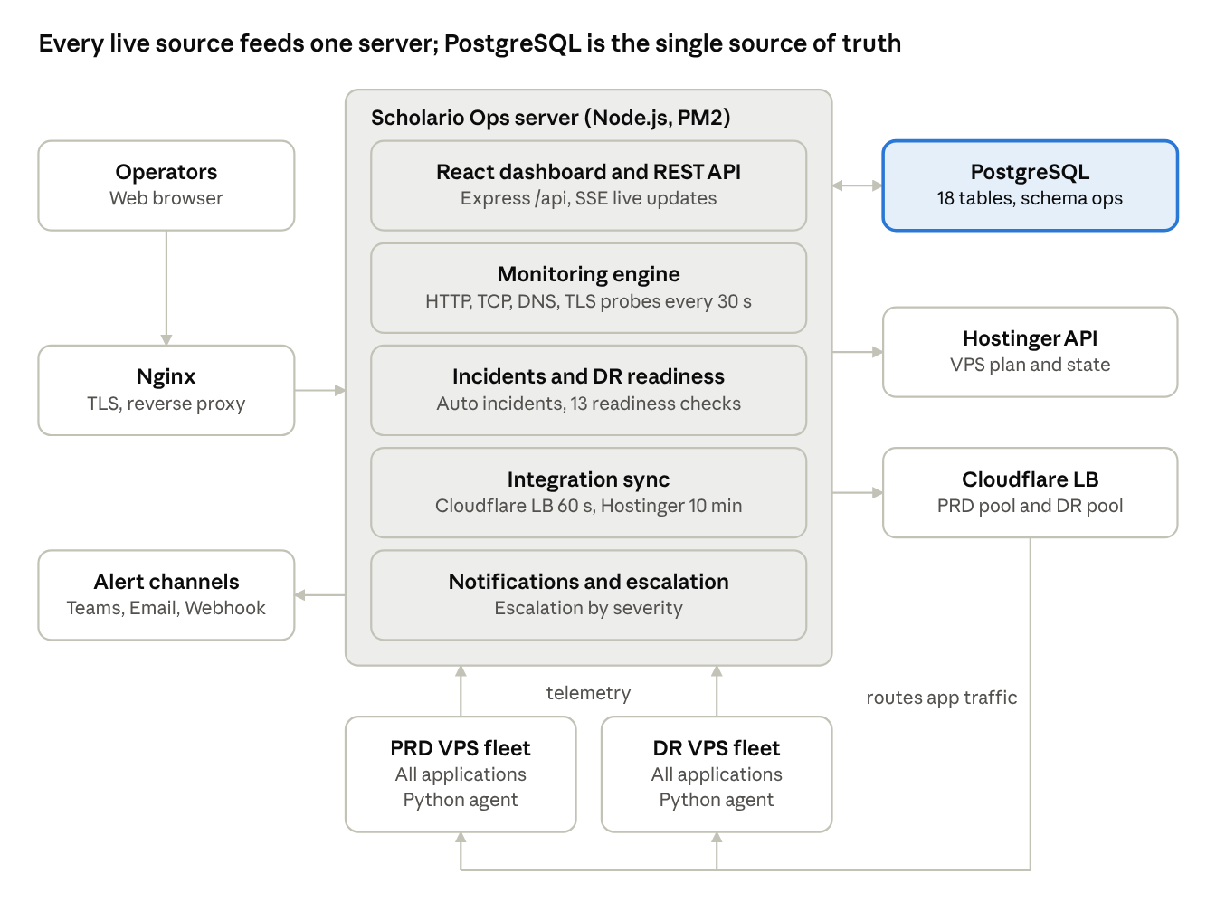
System architecture · Ops server, data store, VPS pair and integrations
Operators reach the dashboard through Nginx. The engine probes the PRD and DR URLs from outside, agents on both VPS push telemetry over outbound HTTPS, and the server reads Cloudflare and Hostinger through their APIs. Alerts go out to the team's channels.
Data flow for an outage
- The monitoring engine probes the PRD URL every 30 s and stores each result in check_results.
- After the configured number of consecutive failures, the monitor turns CRITICAL.
- The engine checks Cloudflare origin health to confirm the outage and opens one de-duplicated incident.
- Notifications go to the configured channels, escalating by severity until acknowledged.
- The DR dashboard and failover pre-flight show whether DR is READY; an operator follows the Cloudflare steps and the decision is audited.
- When checks pass again for the recovery threshold, the incident is resolved automatically.
Deployment topology
Node | Role | Specification
Ops server | Runs Scholario Ops, PostgreSQL and Nginx | Ubuntu VPS, Node.js 20+, PM2
PRD VPS fleet | Serves live traffic for each registered application; runs the telemetry agent | Any Linux VPS, any provider or region; Hostinger plan data imported automatically
DR VPS fleet | Standby copy of each application; runs the telemetry agent | Any Linux VPS, ideally in a different region from PRD
Cloudflare LB or DNS record | Routes each application's traffic to its PRD or DR pool | Configured per application

4. Technology stack
The whole system is TypeScript on Node.js 20, with one process serving both the API and the React dashboard.
Layer | Technology | Purpose
Frontend | React 19, React Router 6, Vite 8 | Single-page dashboard with deep-linked views
Styling and UI | Tailwind CSS 4, Lucide icons, Motion | Layout, icons and animation
Backend | Node.js 20+, Express 4, TypeScript | REST API, monitoring engine, schedulers
Database | PostgreSQL (pg driver), schema ops | Single source of truth for configuration and operational data
Realtime | Server-Sent Events (/api/v1/realtime/stream) | Pushes status changes to open dashboards
Agent | Python 3 (standard library only), systemd | Telemetry from each Linux VPS over outbound HTTPS
Email | Nodemailer (SMTP) | Email notification channel
Build | Vite (frontend), esbuild (server bundle) | Produces dist/ and dist-server/server.js
Process manager | PM2 (fork mode, single instance) | Keeps the service running and restarts on failure
Reverse proxy | Nginx | TLS, proxies /api, no buffering for the realtime stream
External APIs | Cloudflare API, Hostinger VPS API | Load Balancer health, DNS, zone data, VPS plan data
Testing | Node test runner via tsx --test | End-to-end tests against throw-away PostgreSQL schemas

5. Functional modules
The application is organised into ten modules, each with its own dashboard view and API group.
Module | What it does | Main views
Authentication and users | Login, token refresh, logout, password change; user management with four roles | Login, Users
Setup and connections | Register servers and applications, PRD/DR URLs, Cloudflare LB pools, DNS failover settings, agent install | Setup
Monitoring engine | Runs HTTP/HTTPS, TCP, DNS, TLS and heartbeat monitors on a 1-second scheduler; confirms failures and recoveries over several consecutive checks | Monitors
Infrastructure telemetry | Python agent on each VPS reports CPU, RAM, disk, load, network, services, top processes and error logs; marked STALE after 60 s of silence | Infrastructure
Cloudflare and Hostinger | Reads zones, DNS, LB pools, origin health and RTT (every 60 s); imports VPS plan and state from Hostinger (every 10 min) | Cloudflare, Hostinger, Load Balancer panel
Incident management | Auto-creates de-duplicated incidents on confirmed DOWN or unhealthy origin; acknowledge, assign, notes, severity, auto-recovery | Incidents, Incident timeline
Notifications and escalation | Teams, Email, Webhook and PagerDuty channels; escalation policies per severity; test-send | Communications
DR and failover | 13-check DR readiness score; failover pre-flight; manual Cloudflare steps; approve or reject decision written to audit | DR dashboard, LB failover console, Dependency map
Operations | Maintenance windows (pause alerts), runbooks with step checklists, deployment and backup reports from CI | Maintenance, Runbooks, Deployments, Backups
Reporting and audit | Availability and SLA from stored check results, daily and uptime reports, full audit log | Overview, Reports, Audit logs
Monitor result classes. Every check is recorded as UP, DEGRADED, DOWN, TIMEOUT, DNS_ERROR, TLS_ERROR or CONNECTION_ERROR.
DR readiness verdicts. Each check returns PASS, FAIL, WARNING or UNKNOWN. The overall result is READY, DEGRADED, NOT READY or UNKNOWN; any FAIL makes it NOT READY.
Dead-man switch. The server pings an external heartbeat service every 60 s, so someone is alerted if Scholario Ops itself goes down.

6. Data model
All data lives in 18 PostgreSQL tables inside one schema (ops by default), created by migration 001_init.sql at start-up. Administrator-entered configuration is stored in typed columns; volatile live state is kept in a state JSONB column.
Table | Holds | Key relationships
users | Email, name, role, active and on-call flags, scrypt password hash, token version | Parent of refresh_tokens
refresh_tokens | Active refresh sessions with expiry | user_id → users
servers | Hostname, IP, PRD/DR role, provider, region, plan CPU/RAM/disk, agent token, Hostinger VM id | Linked from applications and monitors
applications | Name, code, tier, RTO/RPO targets, PRD/DR URLs, Cloudflare zone, DNS record, failover state, health-check settings | prd_server_id, dr_server_id → servers
application_load_balancers | Cloudflare account, LB hostname, PRD pool id, DR pool id | One per application
monitors | Type, target, interval, timeout, thresholds, confirmation counts, expected status, managed_by flag | application_id → applications; server_id → servers
check_results | Every individual check: time, OK flag, probe status, HTTP code, latency, reason | Indexed by monitor and time
monitor_buckets | Hourly totals for uptime and average latency | Per monitor per hour
server_metrics | 1-minute rollups of CPU, RAM, disk, load, network in/out | Per server per minute
incidents | Title, severity, status, fingerprint, root cause, owner, acknowledgement, timeline (JSONB) | References application and environment
audit_logs | Timestamp, operator, action, category, target, details | Written by every change
channels, escalation_policies, maintenance_windows, runbooks, deployments, backups | Operational records stored as JSONB documents | Referenced by id from monitors and incidents
meta | Key-value system settings | None
Database rules enforce valid data: roles and environments are restricted lists, Cloudflare ids must be 32-character hex, and plan capacity must be positive.

7. API reference
The REST API is served under /api and returns JSON. Read endpoints need any signed-in user; the minimum role for changes is shown below.
Group | Endpoints | Minimum role for changes
Health | GET /health | Public
Auth | POST /auth/login, /auth/refresh, /auth/logout, /auth/change-password; GET /auth/me | Public / signed-in
Agent and CI | POST /v1/agent/ingest; GET /v1/agent/install/:serverId, /v1/agent/uninstall; GET/POST /v1/heartbeat/:token; POST /v1/deployments/report, /v1/backups/report | Per-server or CI token
System | GET /v1/bootstrap, /v1/integrations, /v1/system/summary, /v1/deadman/status, /v1/realtime/stream (SSE) | Viewer
Servers | GET/POST /v1/servers; GET/PATCH/DELETE /v1/servers/:id; /metrics, /agent, /rotate-token | IT administrator
Applications | GET/POST /v1/applications; GET/PATCH/DELETE /v1/applications/:id; /dr-readiness, /availability | IT administrator
Failover | GET /v1/applications/:id/failover/preflight; POST .../failover/decision, POST .../failover | Operator (pre-flight), super admin (decision)
Monitors | GET/POST /v1/monitors; PATCH/DELETE /v1/monitors/:id; /toggle, /probe, /history; POST /v1/monitors/probe-all | IT administrator (config), operator (probe)
Diagnostic tools | POST /v1/tools/http, /tcp, /dns, /ssl | Operator
Incidents | GET/POST /v1/incidents; /acknowledge, /status, /severity, /assign, /notes, /resolve | Operator
Notifications | GET/POST/PATCH/DELETE /v1/channels; POST /v1/channels/:id/test; GET/PUT /v1/escalation-policies | IT administrator
Maintenance and runbooks | /v1/maintenance (create, complete, delete); /v1/runbooks (CRUD, step toggle, reset) | Operator / IT administrator
Deployments and backups | GET /v1/deployments, GET /v1/backups | Viewer
Cloudflare and Hostinger | GET /v1/cloudflare/zones, /accounts, /lb-pools; GET /v1/loadbalancers; GET /v1/hostinger/vms; POST .../sync | Operator (sync), IT administrator (accounts, pools)
Users and audit | GET/POST /v1/users; PATCH /v1/users/:id; DELETE /v1/users/:id; GET /v1/audit | IT administrator; super admin to delete
Reports | GET /v1/reports/summary, /uptime, /daily | Viewer

8. Security
Access is controlled by signed tokens and four nested roles, and every change is written to the audit log.
Roles (each role has all rights of the roles below it)
Role | Level | Can do
Super admin | 4 | Everything, including failover decisions and deleting users
IT administrator | 3 | Configure servers, applications, monitors, channels, runbooks, users
Operator | 2 | Run probes, handle incidents, maintenance windows, syncs, failover pre-flight
Viewer | 1 | Read-only access to all dashboards and reports
Controls
- Passwords are hashed with scrypt (N = 16384) and a random salt; the first admin password must have at least 10 characters with upper case, lower case and a number.
- Sessions use HS256-signed access tokens (8 hours by default) and rotating refresh tokens (7 days). A token version on each user lets an admin revoke all sessions.
- Brute-force protection allows 10 failed logins per IP and per account, then blocks for 15 minutes.
- Agent and CI access uses per-server and deployment tokens compared in constant time; agent reports more than 300 s off server time are rejected.
- Secrets (Cloudflare and Hostinger tokens, SMTP password, JWT secret) stay in .env on the server. A test confirms the Cloudflare token never reaches the browser.
- Network: the app listens on 127.0.0.1:4000 behind Nginx with TLS 1.2/1.3; agents only make outbound HTTPS calls, so no ports are opened on the VPS.
- HTTP headers: X-Content-Type-Options: nosniff, X-Frame-Options: DENY, strict referrer policy, and an allow-list for CORS origins.
- Least privilege at Cloudflare: Load Balancer monitoring needs read-only permissions; DNS edit is only needed for applications that use DNS-record failover.
- Audit: logins, configuration changes, incident actions and failover decisions are recorded with operator, time and details.

9. Configuration and deployment
The service runs as one PM2 process on an Ubuntu VPS behind Nginx; only ADMIN_EMAIL and DATABASE_URL are needed to start, and every other setting enables an integration.
Key environment variables (.env)
Variable | Default | Purpose
PORT, HOST | 3000, 0.0.0.0 (production: 4000, 127.0.0.1) | Listen address
PUBLIC_URL | None | HTTPS address used by agents and notification links
DATABASE_URL, DB_SCHEMA | ops schema | PostgreSQL connection and schema
ADMIN_EMAIL, ADMIN_PASSWORD, ADMIN_NAME | Generated password if empty | First super admin
JWT_SECRET, ACCESS_TOKEN_TTL_SEC, REFRESH_TOKEN_TTL_SEC | Generated, 28800, 604800 | Session signing and lifetimes
CLOUDFLARE_API_TOKEN, CLOUDFLARE_ACCOUNT_ID | Empty | Cloudflare read access
CLOUDFLARE_SYNC_INTERVAL_SEC, CLOUDFLARE_LB_SYNC_INTERVAL_SEC | 300, 60 | Zone and LB poll intervals
HOSTINGER_API_TOKEN, HOSTINGER_SYNC_INTERVAL_SEC | Empty, 600 | VPS plan import
SMTP_HOST, SMTP_PORT, SMTP_USER, SMTP_PASS, SMTP_FROM | Port 587 | Email alerts
DEADMAN_HEARTBEAT_URL, DEADMAN_INTERVAL_SEC, DEADMAN_TOLERANCE_SEC | Empty, 60, 180 | External heartbeat for the Ops server itself
TELEMETRY_STALE_THRESHOLD_SEC, METRICS_RETENTION_HOURS | 60, 48 | Agent staleness and metric retention
CHECK_HISTORY_RETENTION_DAYS, AUDIT_RETENTION_ENTRIES | 90, 5000 | History retention
DR_LATENCY_THRESHOLD_MS | 2000 | DR latency warning level
DEPLOY_REPORT_TOKEN | Empty | Lets CI report deployments
Production install
- Install Node.js 20+, PostgreSQL, Nginx and PM2 on the Ubuntu VPS.
- Copy .env.example to .env and set DATABASE_URL, PUBLIC_URL and ADMIN_EMAIL.
- Run npm ci && npm run build to produce dist/ and dist-server/server.js.
- Run npm run db:migrate (migrations also run automatically at start).
- Run pm2 start ecosystem.config.js --env production, then pm2 save and pm2 startup.
- Install nginx/scholario-ops.conf with a Let's Encrypt certificate; it proxies to port 4000 and does not buffer the realtime stream.
- Sign in, then in Setup add the PRD and DR servers, run the agent install command on each VPS as root, add the application and add notification channels.
Local development: npm install then npm run dev serves the API and UI at http://localhost:3000.
Backup: all state is in PostgreSQL, so back up with pg_dump --schema=ops.

10. Testing and quality
The project has 15 end-to-end tests in two suites, each run against its own throw-away PostgreSQL schema so production data is never touched.
Suite | Tests | What is verified
config-flow.test.ts | 11 | Migrations create the schema; servers and applications are saved to PostgreSQL; bad input is rejected; managed URL monitors follow edits; Cloudflare pools persist; the Cloudflare token never reaches the browser; configuration reloads after restart; deleting a URL or app cleans up monitors and LB mapping
loadbalancer.test.ts | 4 | "Load pools" lists pools from the Cloudflare API; pool health and RTT are parsed; an origin failure routes to DR, raises an incident and then recovers; a missing permission shows PERMISSION_REQUIRED instead of a stale "healthy"
Cloudflare responses are replaced with recorded response shapes, so the Load Balancer tests run without a live account.
How to run
- npm test runs both suites (needs DATABASE_URL).
- npm run lint type-checks the frontend and backend.
Live verification. Each newly registered application is verified end to end before go-live: both URLs answer the monitors, both agents report CONNECTED, Cloudflare pools and origins are read, and the DR readiness score is reviewed.
Quality rules built into the code
- Missing or stale data is shown as UNKNOWN or STALE, never as PASS.
- Failures and recoveries need several consecutive checks before status changes, which avoids false alarms.
- Inputs are validated on the server and again by database constraints.

11. Risks, limitations and roadmap
The main limitation is that Scholario Ops runs as a single instance, so its own availability depends on one server; the dead-man heartbeat makes that failure visible.
Risk or limitation | Impact | Mitigation
Single PM2 instance (scheduler and realtime state are in-process) | Ops dashboard down if its host fails | External dead-man heartbeat alerts within 3 minutes; PM2 auto-restart
Load Balancer failover is manual | Recovery time depends on an operator | Pre-flight checks and step-by-step Cloudflare instructions; decision recorded in audit
Cloudflare token missing or under-privileged | LB health shows Not configured or Permission required | Clear status in the UI and README permission list
Agent clock drift | Telemetry reports rejected | 300 s skew limit with a message to enable NTP
Login rate limit kept in memory | Counters reset on restart | Acceptable for one instance; move to the database if scaled out
PostgreSQL holds all state | Data loss if not backed up | Scheduled pg_dump --schema=ops backups
Roadmap
- Onboard every application and VPS in the organisation through the same Setup flow.
- Optional automatic Load Balancer failover with approval guard rails.
- Run a second Ops instance with shared state for high availability.
- Scheduled SLA reports sent by email to management.
- Wider test coverage for incidents, notifications and the agent.

12. Conclusion
Scholario Ops gives the operations team one live, trustworthy view of PRD and DR health across every application and VPS, built only from real probes, agent telemetry and Cloudflare data. It shortens outage detection to under a minute, measures DR readiness every day, and records every incident and failover decision for review. New applications, servers and providers are added from the dashboard without code changes, so the platform grows with the organisation.

Appendix A. Repository layout
Path | Contents
server/ | Backend: server.ts (entry), routes.ts (API), engine.ts (monitor scheduler, incidents, dead-man), probes.ts, readiness.ts, loadbalancer.ts, cloudflare.ts, hostinger.ts, agent.ts, notify.ts, auth.ts, store.ts, db.ts
server/migrations/ | 001_init.sql PostgreSQL schema
src/ | React frontend: App.tsx, components/ (views by area), context/, services/, types/
tests/ | End-to-end test suites
nginx/ | Reverse-proxy configuration
ecosystem.config.js | PM2 production configuration
.env.example | All configuration variables with explanations

Appendix B. Glossary
Term | Meaning
PRD | Production (primary) environment
DR | Disaster Recovery (standby) environment
RTO | Recovery Time Objective: maximum acceptable downtime
RPO | Recovery Point Objective: maximum acceptable data loss
LB | Cloudflare Load Balancer that routes traffic between the PRD and DR pools
Pool / origin | A group of servers in the LB / one server address inside a pool
RTT | Round-trip time measured by Cloudflare to an origin
Agent | Python service on each VPS that sends telemetry to Scholario Ops
Dead-man switch | External heartbeat that alerts when Scholario Ops itself stops
SSE | Server-Sent Events, used to push live updates to the browser

