MINI PROJECT REPORT
Smart Hostel Outpass Management System Using Natural Language Processing (NLP)
Submitted by: [Student Name] | Register No.: [Register Number]
Department: [Department] | Guide: [Guide Name]
[College Name] | Academic Year: [Year]
(Replace the bracketed placeholders before submission.)

Abstract
Hostel outpass requests are traditionally written on paper or entered through long forms, which is slow for students and wardens. This project presents a web-based Smart Hostel Outpass Management System in which a student types a request in ordinary English. A Python NLP pipeline preprocesses and tokenizes the message, classifies the reason using a TF-IDF + Naive Bayes model, extracts the destination, date and return time with rule-based methods, detects missing information and suggests a priority. The structured application is stored in SQLite and reviewed by the warden, who can approve or reject it with remarks. Approved requests generate a PDF digital outpass containing a QR code that can be verified at the gate. The system is built with Flask, SQLite, Bootstrap, scikit-learn, ReportLab and the qrcode library.

1. Introduction
Outpass management is a routine hostel activity. Students must state why they are leaving, where they are going, on which day and when they will return, and the warden must check, decide and record the decision. Manual systems cause delays, lost slips and difficulty in tracking history. A computerised system with a natural-language interface reduces the effort for students and makes data structured for the warden.

1.1 Objectives
- Allow students to submit outpass requests as free text.
- Extract reason, destination, date, return time and priority automatically using NLP.
- Detect missing information and let the student confirm the structured application.
- Provide a warden dashboard to review, approve or reject requests with remarks.
- Generate a digital outpass PDF with a QR code for verification.
- Store all requests and decisions persistently with proper security.

1.2 Scope
The system covers one hostel with one or more wardens and any number of students. It is designed as a lightweight demonstration project running on a personal laptop. English text input is supported.

2. System Analysis

2.1 Existing system
Paper slips or spreadsheets: slow approval, no priority information, no easy history, easy to forge, and manual record keeping.

2.2 Proposed system
A Flask web application with student and warden modules, NLP-based form filling, role-based access, an audit trail (approval history) and verifiable QR outpasses.

2.3 Technologies used
Layer | Technology
Frontend | HTML5, CSS3, JavaScript, Bootstrap 5 (bundled locally), Bootstrap Icons
Backend | Python 3, Flask
Database | SQLite (sqlite3 module)
NLP | Regular expressions, custom stop-word list, scikit-learn (TF-IDF, Multinomial Naive Bayes)
QR / PDF | qrcode, ReportLab
Security | Werkzeug password hashing, Flask sessions, CSRF tokens, HMAC signatures

3. System Design

3.1 Architecture
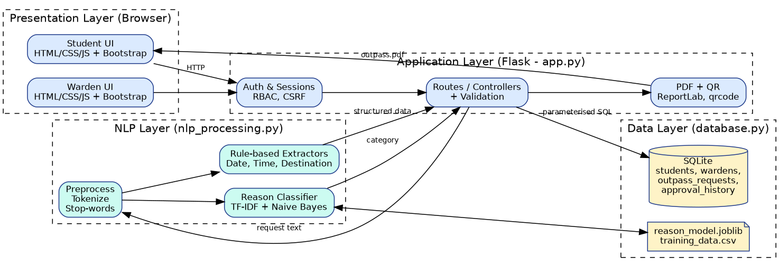
Figure 1: System architecture diagram

3.2 Data flow diagram
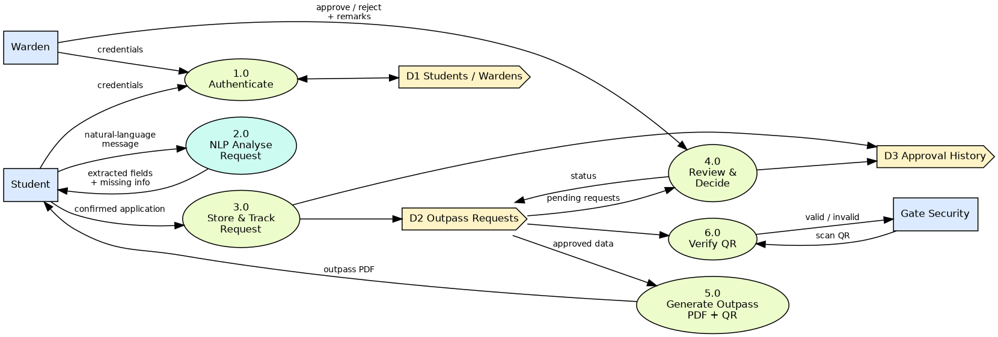
Figure 2: Data flow diagram

3.3 Use case diagram
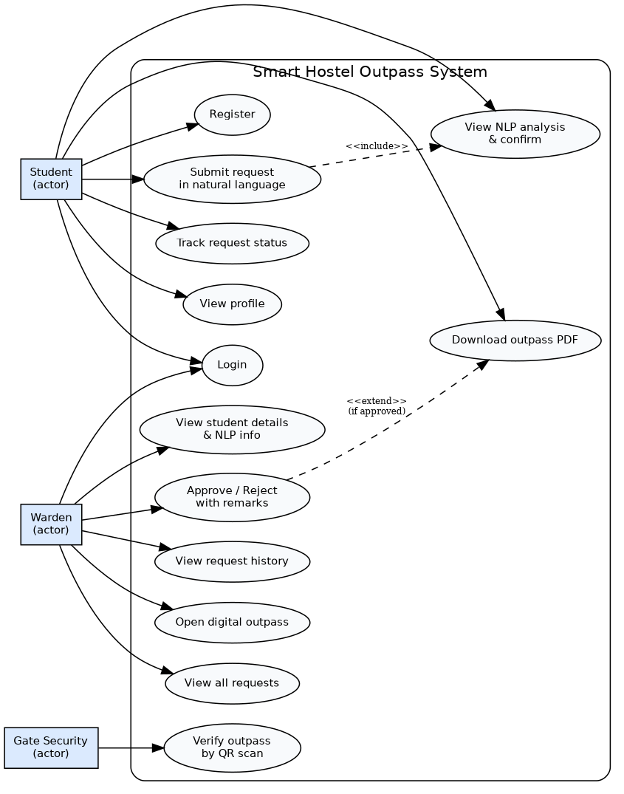
Figure 3: Use case diagram

3.4 Database design
The database has four tables. students and wardens store user accounts with password hashes. outpass_requests stores the original text, the structured NLP result (including the full analysis as JSON), the status (Pending, Approved, Rejected) and the deciding warden. approval_history is an audit log with one row for each submission and decision.
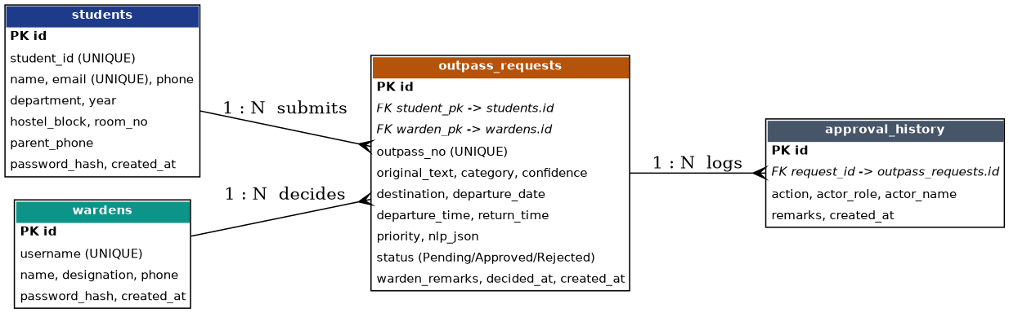
Figure 4: Entity-relationship diagram

4. NLP Module
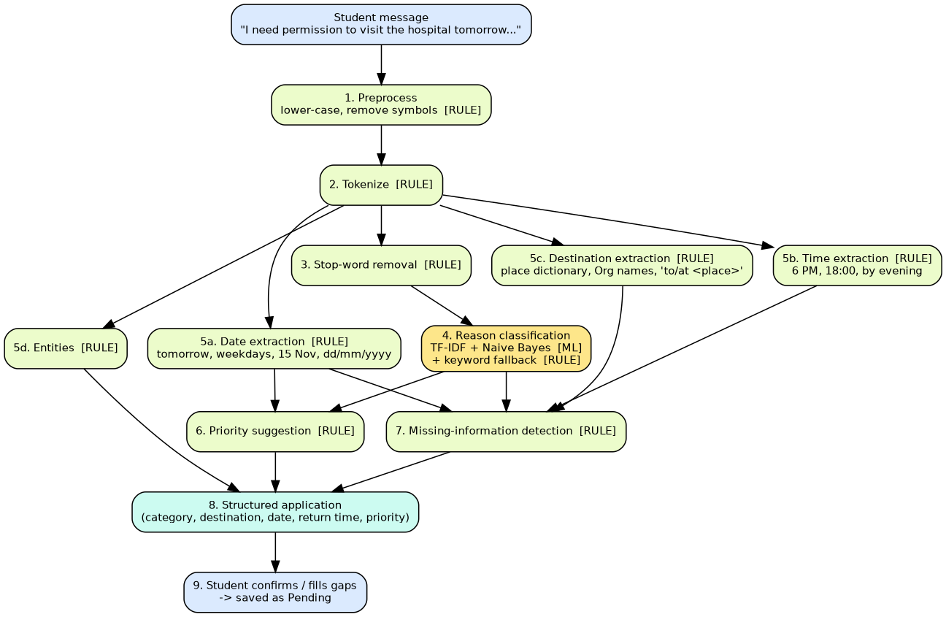
Figure 5: NLP workflow diagram
Step | Method | Type
Preprocessing (lower-case, symbol removal) | Regex | Rule-based
Tokenization | Regex word tokenizer (keeps 6:30 together) | Rule-based
Stop-word removal | Custom list; negations such as 'not' are kept | Rule-based
Reason classification (6 classes) | TF-IDF (1-2 grams) + Multinomial Naive Bayes, trained by train_model.py on 120 sentences; keyword fallback when confidence is low | Machine learning (+ rule fallback)
Date extraction | today, tomorrow, day after tomorrow, weekdays, '15 November', 'Nov 9', dd/mm/yyyy, 'in N days' | Rule-based
Time extraction | 6 PM, 8:30 pm, 18:00, 'by evening'; context words decide return vs departure | Rule-based
Destination extraction | Capitalised organisation names, place dictionary, 'to/at <noun phrase>' pattern, category default | Rule-based
Priority suggestion | Urgency keywords and category | Rule-based
Missing-information detection | Checks destination, date and return time | Rule-based

Classifier evaluation: 5-fold cross-validation accuracy on the 120-sentence training set is approximately 77% (standard deviation about 6%). This is measured on a small, hand-written dataset and should be seen as a rough indicator only. Because accuracy is limited, the student reviews and may edit every extracted value before submission, and the warden makes the final decision.
Example: "I need permission to visit the hospital tomorrow because I am not feeling well. I will return by 6 PM." -> Reason: Medical; Destination: Hospital; Date: the actual date of tomorrow; Return time: 6:00 PM; Priority: High.

5. Implementation
- app.py - routes, authentication, validation, PDF and QR generation.
- nlp_processing.py - the NLP pipeline.
- database.py - schema and all SQL (parameterised).
- train_model.py - reproducible model training; data/training_data.csv - the dataset.
- templates/ and static/ - 15 Jinja2 pages, CSS and JavaScript.
- tests/ - 19 automated tests.

5.1 Security measures
- Salted password hashes (scrypt) - no plain-text passwords in code or database.
- Session-based login; role checks on every protected route; students receive 403 on warden pages.
- CSRF token on all POST requests.
- Parameterised SQL queries only.
- Server-side validation of all inputs (name, phone, e-mail, password strength, dates, times).
- Students can only see their own requests (others return 404).
- QR verification links are signed with HMAC so numbers cannot be guessed.

6. Testing
Automated tests (tests/test_nlp.py and tests/test_app.py) were run in the development environment (Linux, Python 3.12): 19 tests, all passed. The complete workflow - registration, login, request, NLP analysis, warden approval, PDF and QR - was exercised both by tests and by a scripted browser session that produced the screenshots in this report. The application has not been run on Windows 11 by the author of this package; please run the test command on your laptop to confirm.
ID | Scenario | Expected result | Result
T01 | Student registration | Account created, hashed password | Pass
T02 | Duplicate / weak registration | Rejected with error | Pass
T03 | Student login | Dashboard opens | Pass
T04 | Invalid login / SQL-injection string | 401, error message | Pass
T05 | POST without CSRF token | 400 | Pass
T06 | NL request: hospital sentence | Medical / Hospital / tomorrow / 6 PM / High | Pass
T07 | Reason classification (5 categories) | Correct label | Pass
T08 | Date extraction (10 patterns) | Correct dates | Pass
T09 | Time extraction (6 patterns) | Correct times | Pass
T10 | Destination extraction | Correct place / none | Pass
T11 | Missing-information detection | Gaps listed | Pass
T12 | Warden login (valid / invalid) | Dashboard / 401 | Pass
T13 | Approval | Status Approved, outpass number, history rows | Pass
T14 | Rejection needs remark | Blocked until remark given | Pass
T15 | Duplicate request same date | Blocked | Pass
T16 | Unauthorised access (anonymous / student) | Redirect / 403 | Pass
T17 | Other student's request / PDF | 404 / 403 | Pass
T18 | PDF generation | Valid PDF, only after approval | Pass
T19 | QR generation and verification | PNG; valid link OK, tampered link invalid | Pass

7. Results - Screenshots
All screenshots below were captured from the running application with demo data.
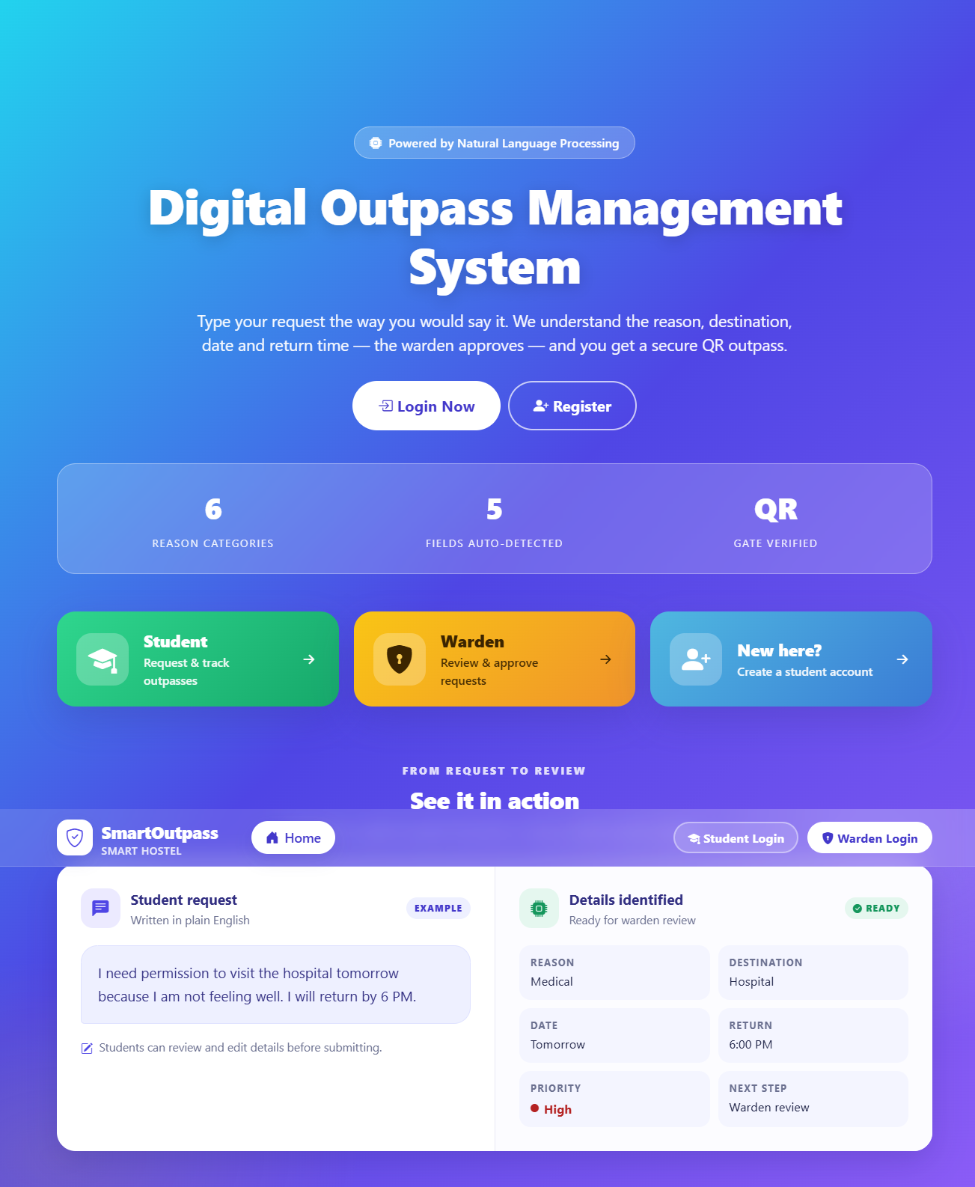
Figure: Home page
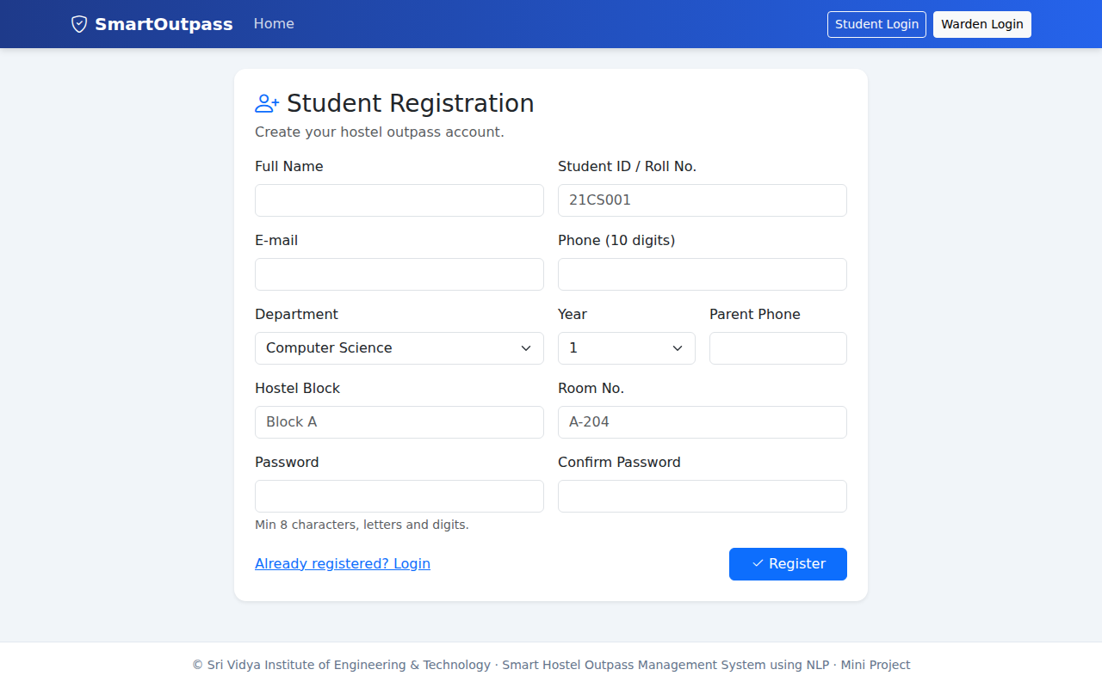
Figure: Student registration
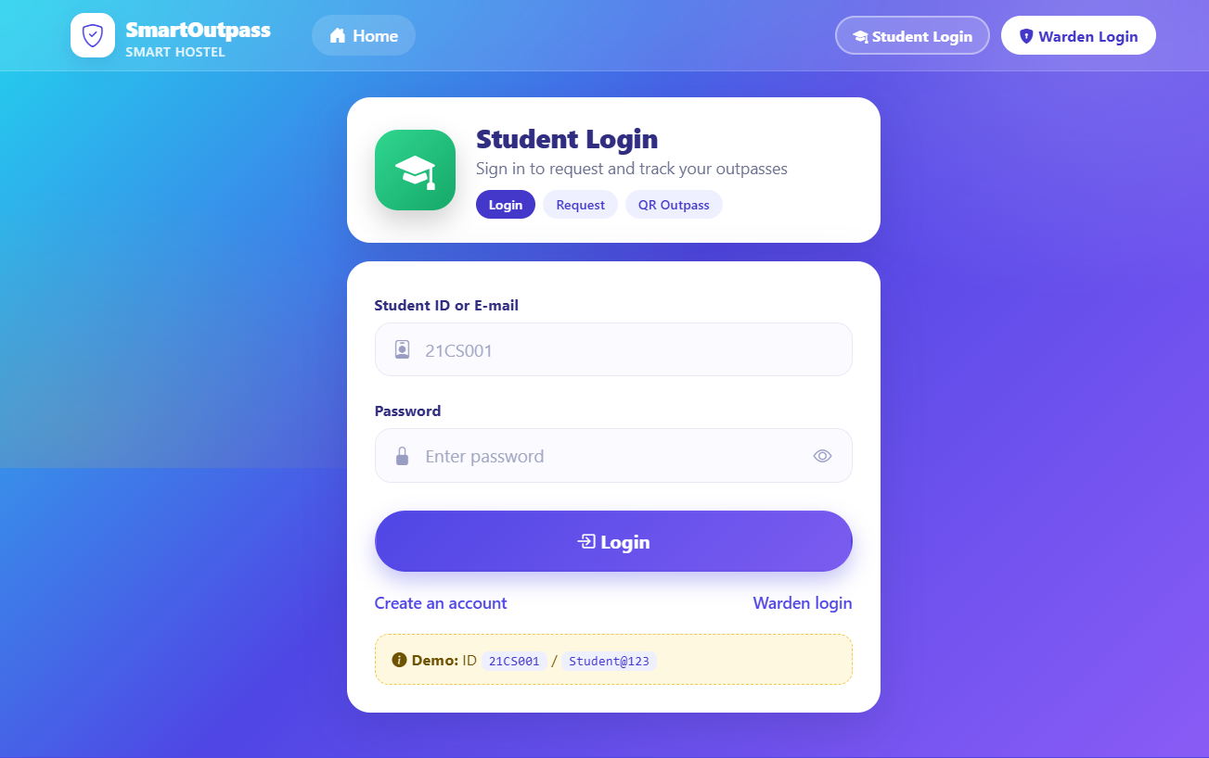
Figure: Student login
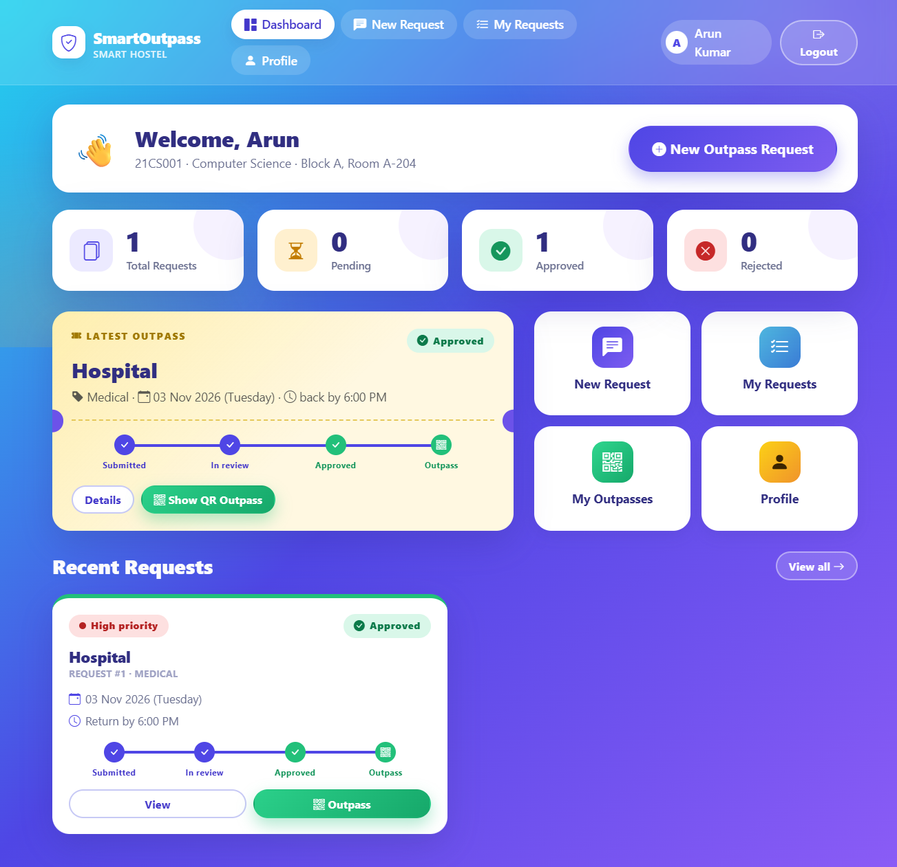
Figure: Student dashboard
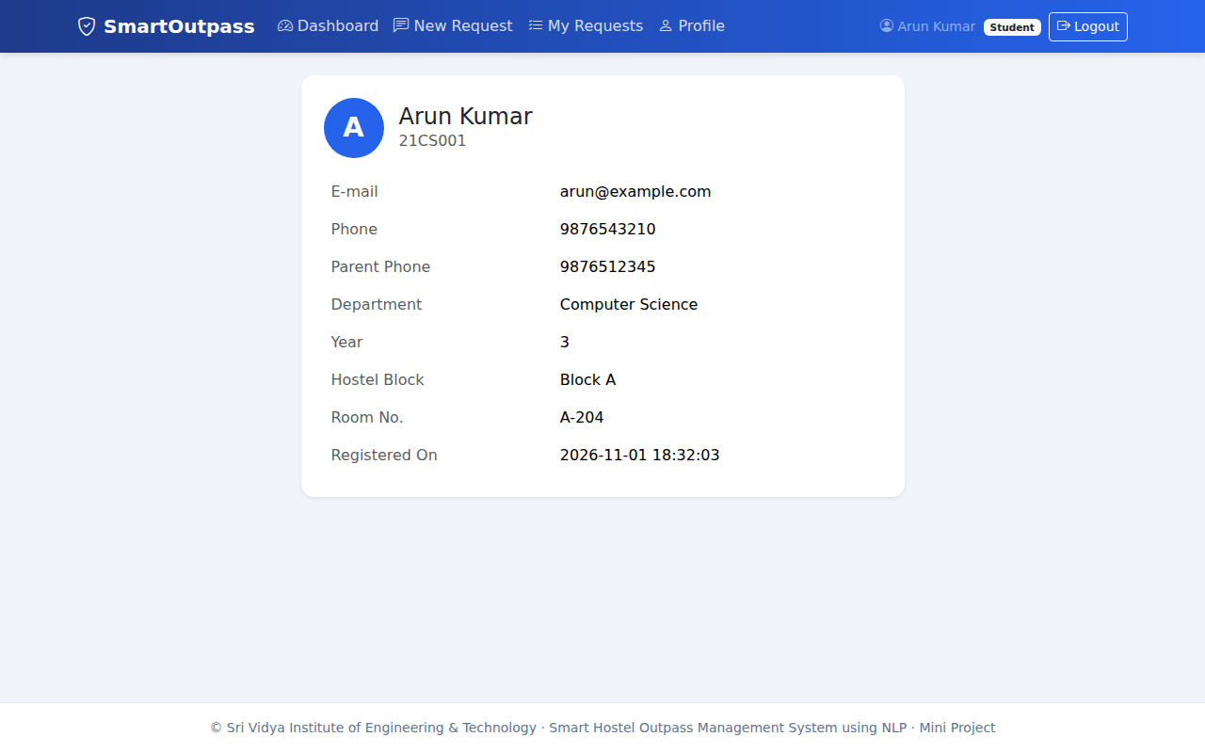
Figure: Student profile
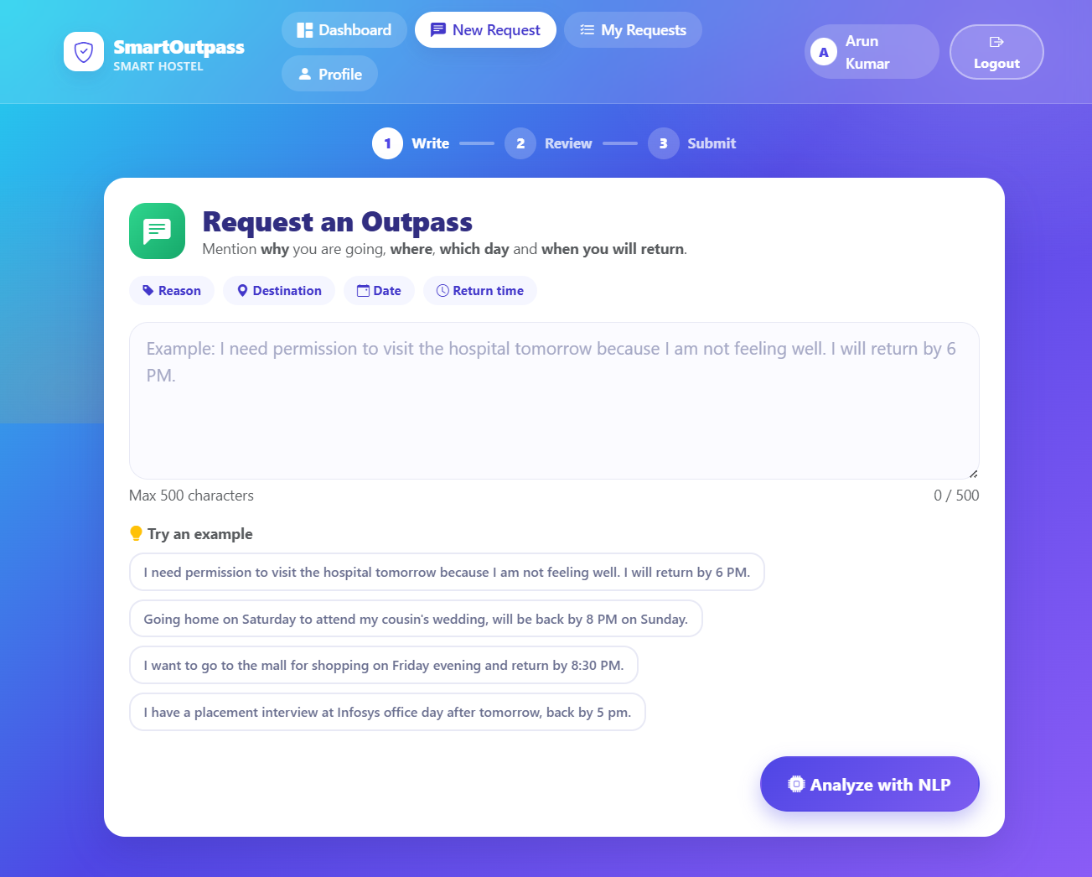
Figure: Natural-language request form
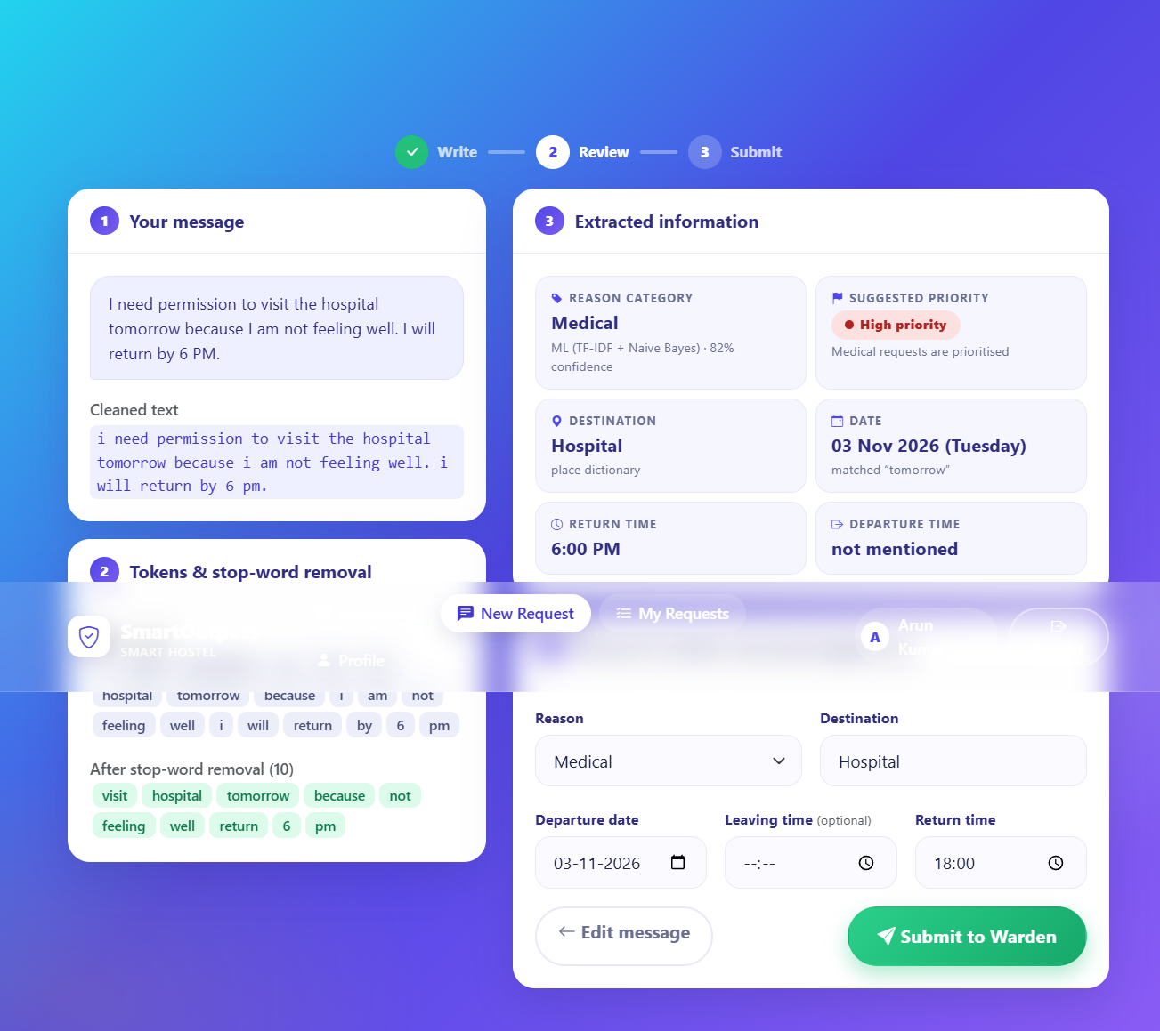
Figure: NLP analysis result page
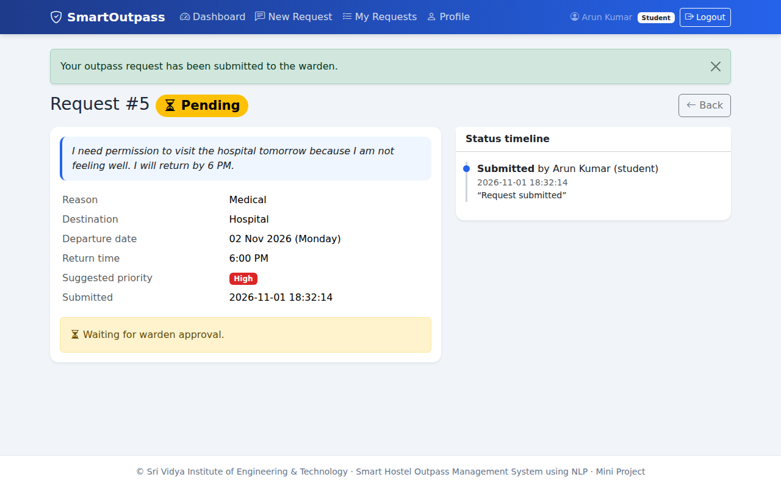
Figure: Request status page
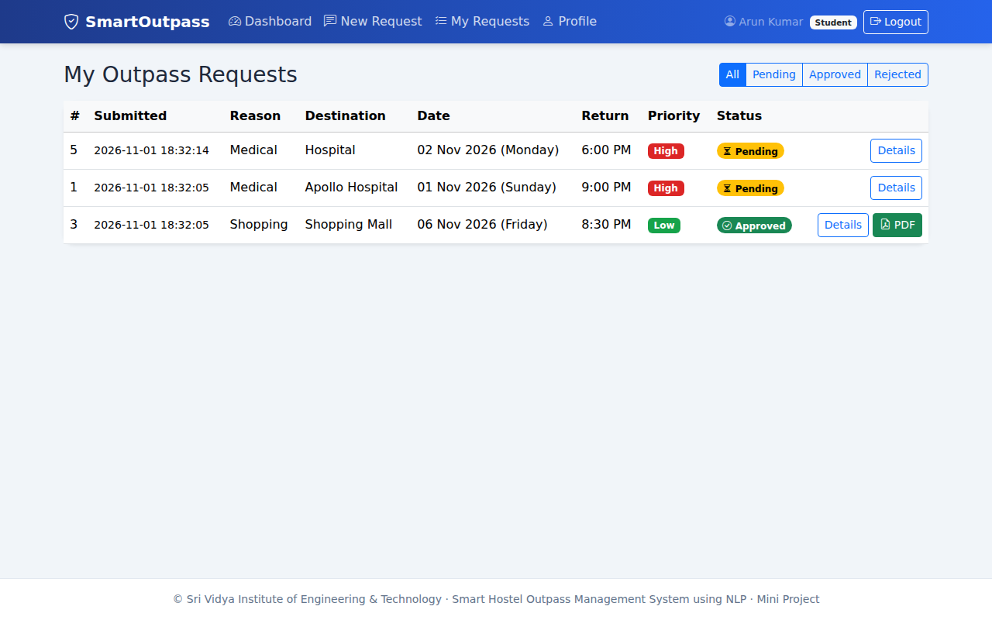
Figure: My requests
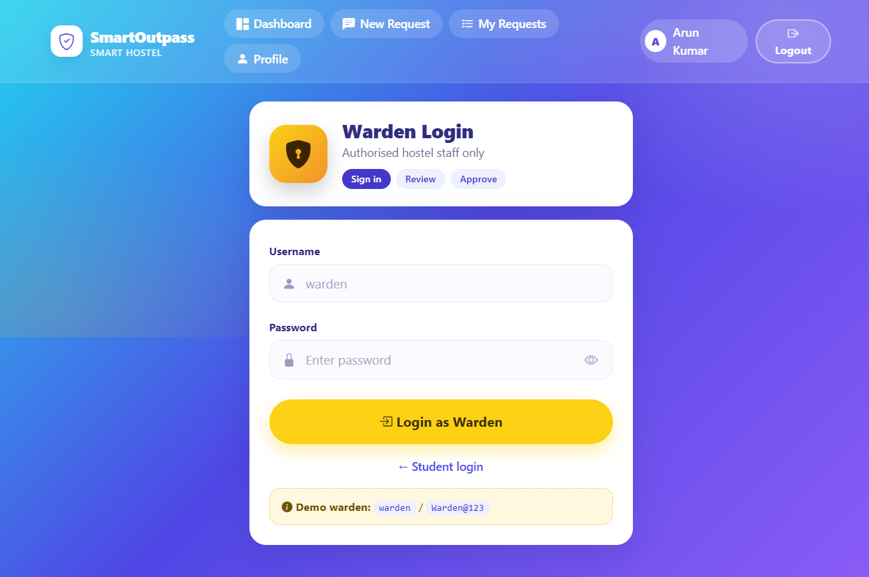
Figure: Warden login
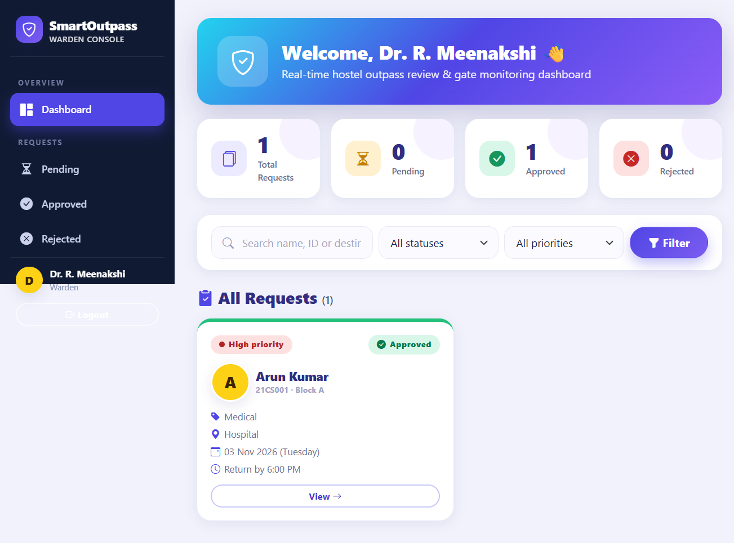
Figure: Warden dashboard
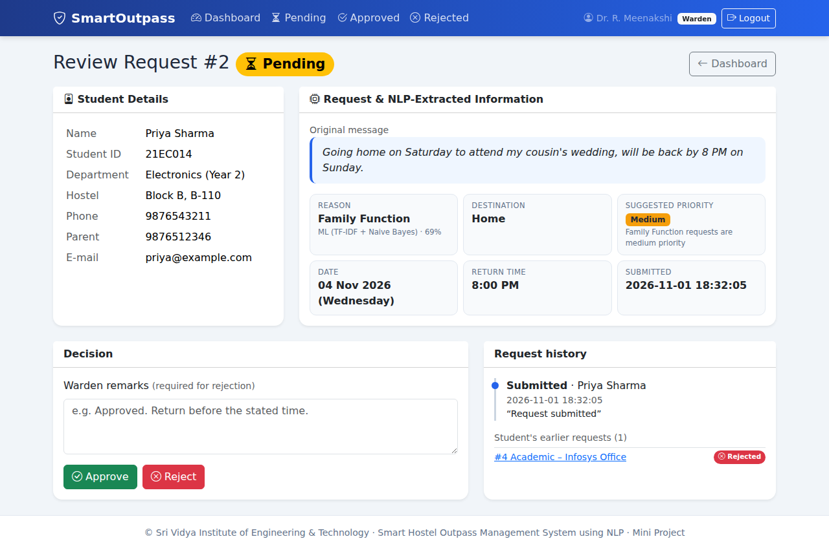
Figure: Request review page
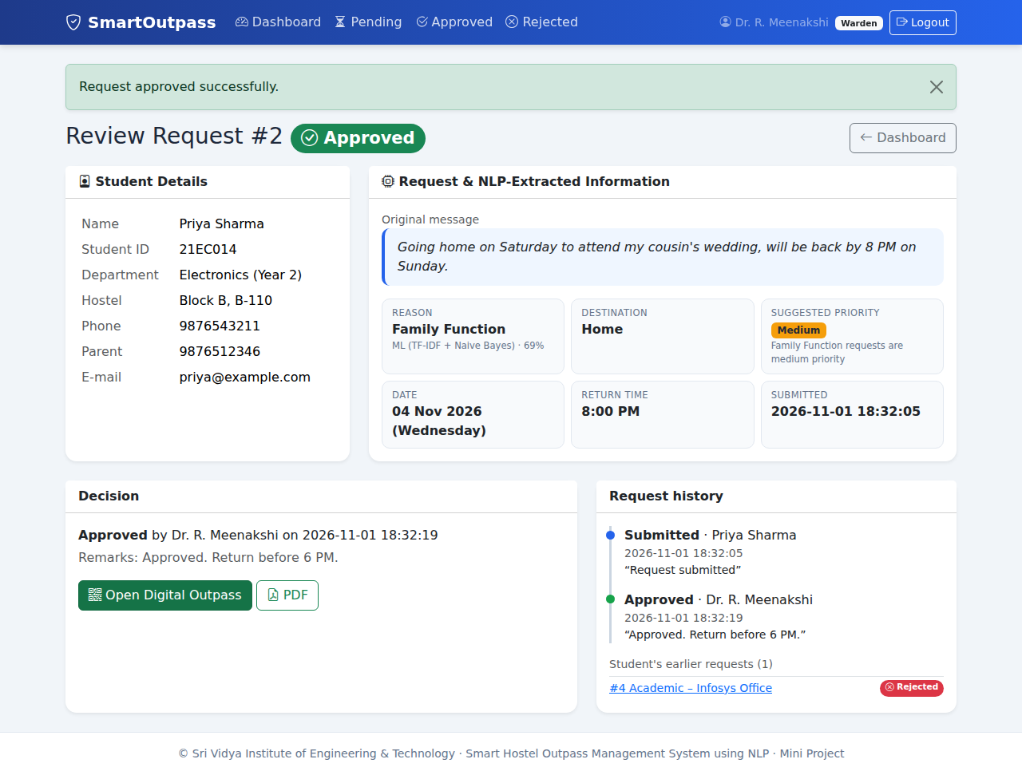
Figure: After approval
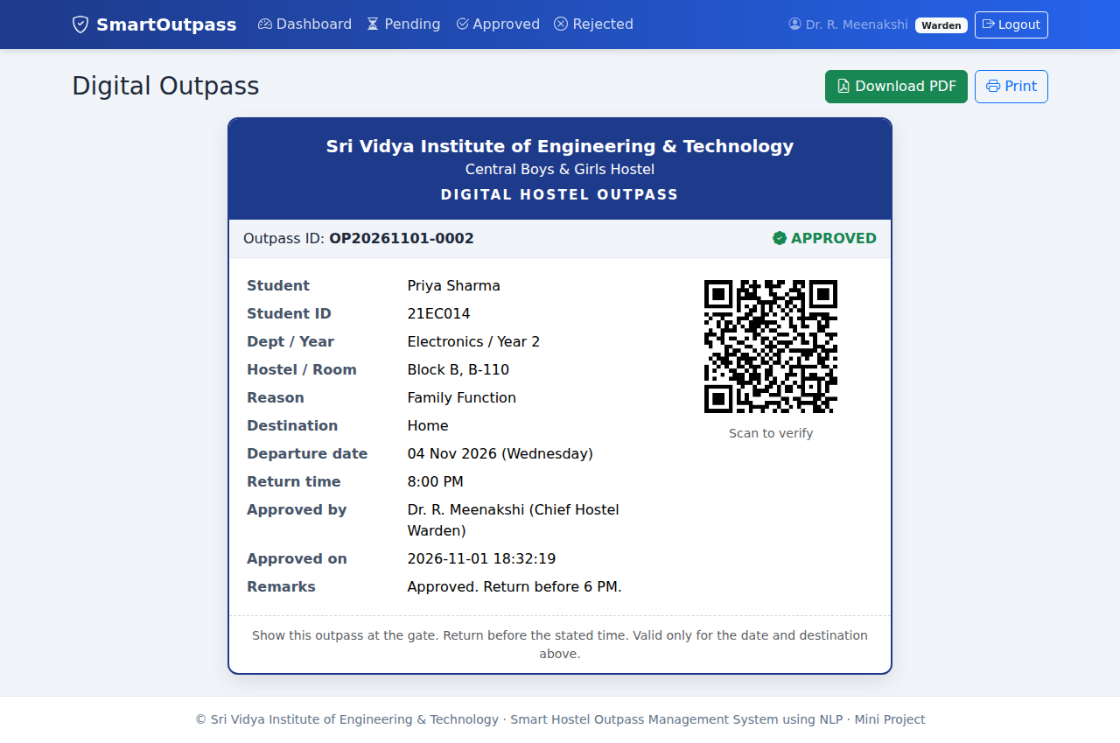
Figure: Approved digital outpass page
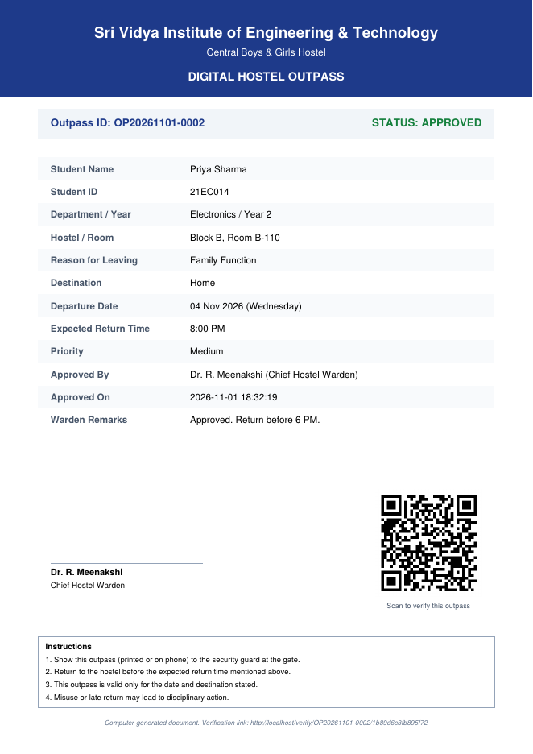
Figure: Digital outpass PDF with QR code

8. Limitations and Future Enhancements
- Small training set; larger data or a transformer model would improve classification.
- English only; multilingual input could be added.
- Rule-based date/destination extraction does not cover every phrasing.
- No SMS/e-mail notifications; no automatic late-return tracking.
- Flask development server and SQLite are suitable for demonstration, not heavy production use.

9. Conclusion
The project demonstrates how simple NLP techniques can turn free-text requests into structured, reviewable applications and how a complete approval workflow with a verifiable digital outpass can be delivered with lightweight open-source tools.

10. References
- Flask documentation - https://flask.palletsprojects.com
- scikit-learn documentation - https://scikit-learn.org
- ReportLab User Guide - https://www.reportlab.com/docs/
- python-qrcode - https://pypi.org/project/qrcode/
- Bootstrap 5 documentation - https://getbootstrap.com
- Jurafsky & Martin, Speech and Language Processing.

