**Single Linked List**

**Insertion**

In a single linked list, the insertion operation can be performed in three ways. They are as follows...

1. Inserting At Beginning of the list
2. Inserting At End of the list
3. Inserting At Specific location in the list

**Inserting At Beginning of the list**

We can use the following steps to insert a new node at beginning of the single linked list...

* **Step 1 -**Create a **newNode** with given value.
* **Step 2 -**Check whether list is **Empty** (**head** == **NULL**)
* **Step 3 -**If it is **Empty** then, set **newNode→next** = **NULL** and **head** = **newNode**.
* **Step 4 -**If it is **Not Empty** then, set **newNode→next** = **head** and **head** = **newNode**.

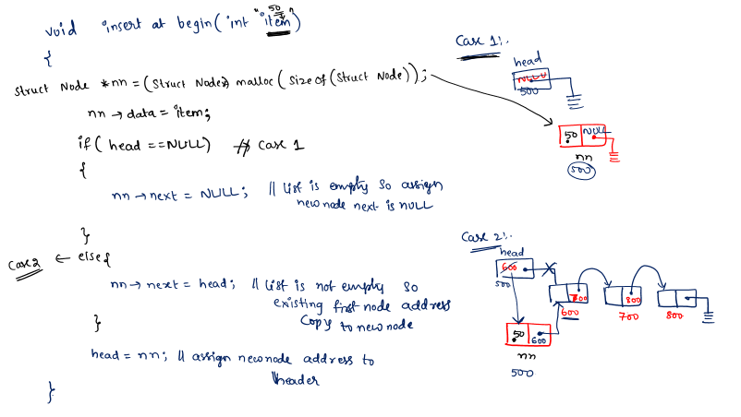

**Inserting At End of the list**

We can use the following steps to insert a new node at end of the single linked list...

* **Step 1 -**Create a **newNode** with given value and **newNode → next** as **NULL**.
* **Step 2 -**Check whether list is **Empty** (**head** == **NULL**).
* **Step 3 -**If it is **Empty** then, set **head** = **newNode**.
* **Step 4 -**If it is **Not Empty** then, define a node pointer **temp** and initialize with **head**.
* **Step 5 -**Keep moving the **temp** to its next node until it reaches to the last node in the list (until **temp → next** is equal to **NULL**).
* **Step 6 -**Set **temp → next** = **newNode**.

