**Example: If the snapshot is created and any volume is not attached to any ec2 or volume is attached to ec2 and if delete ec2 then snapshot should br deleted.**

Create one instance

Take snapshot of the volume

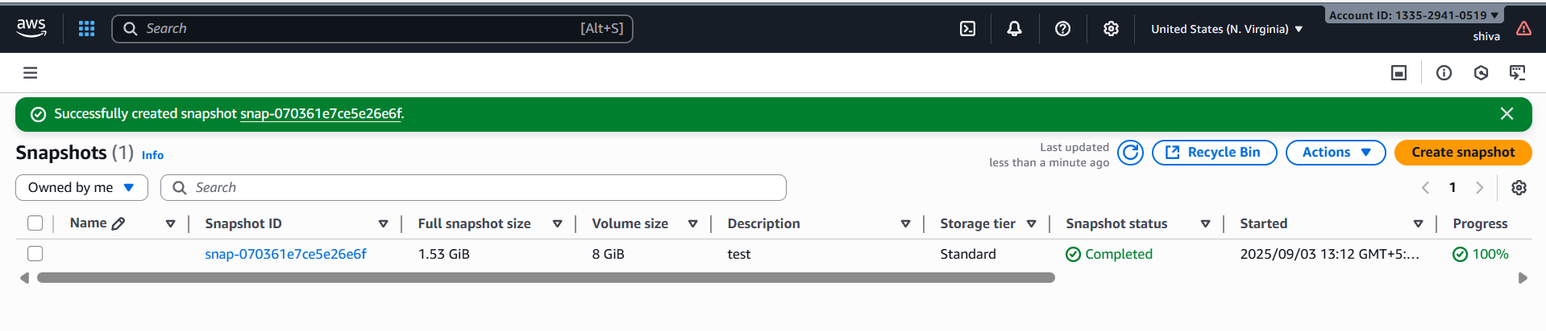

Create a function in lamda with the code:

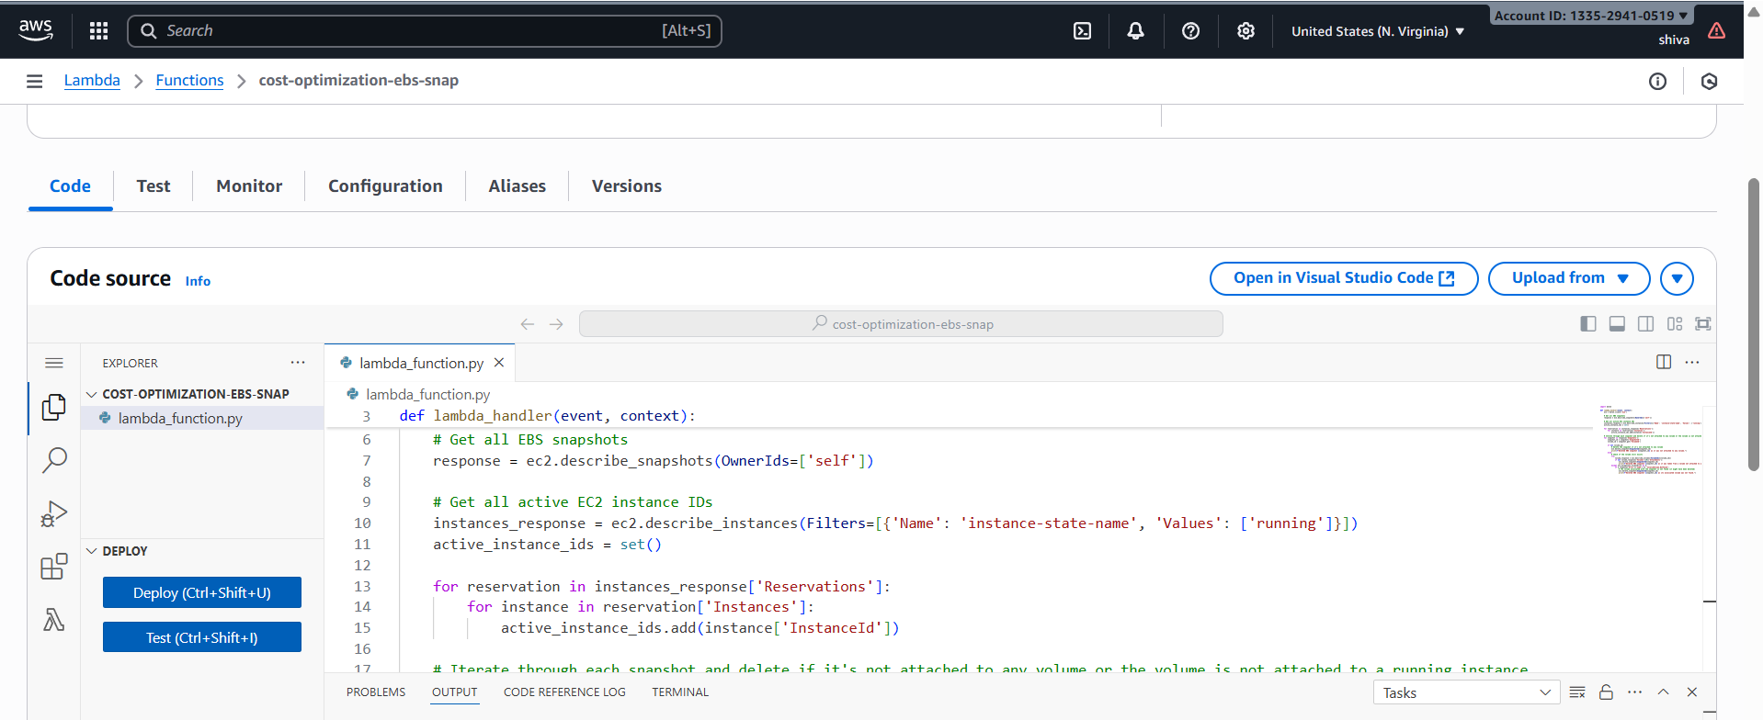

Add permissions to the function

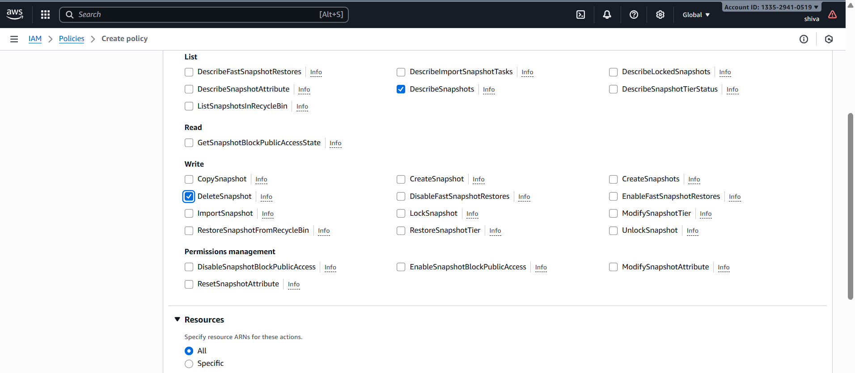

It got failed bcz we have attached the volume to instance.

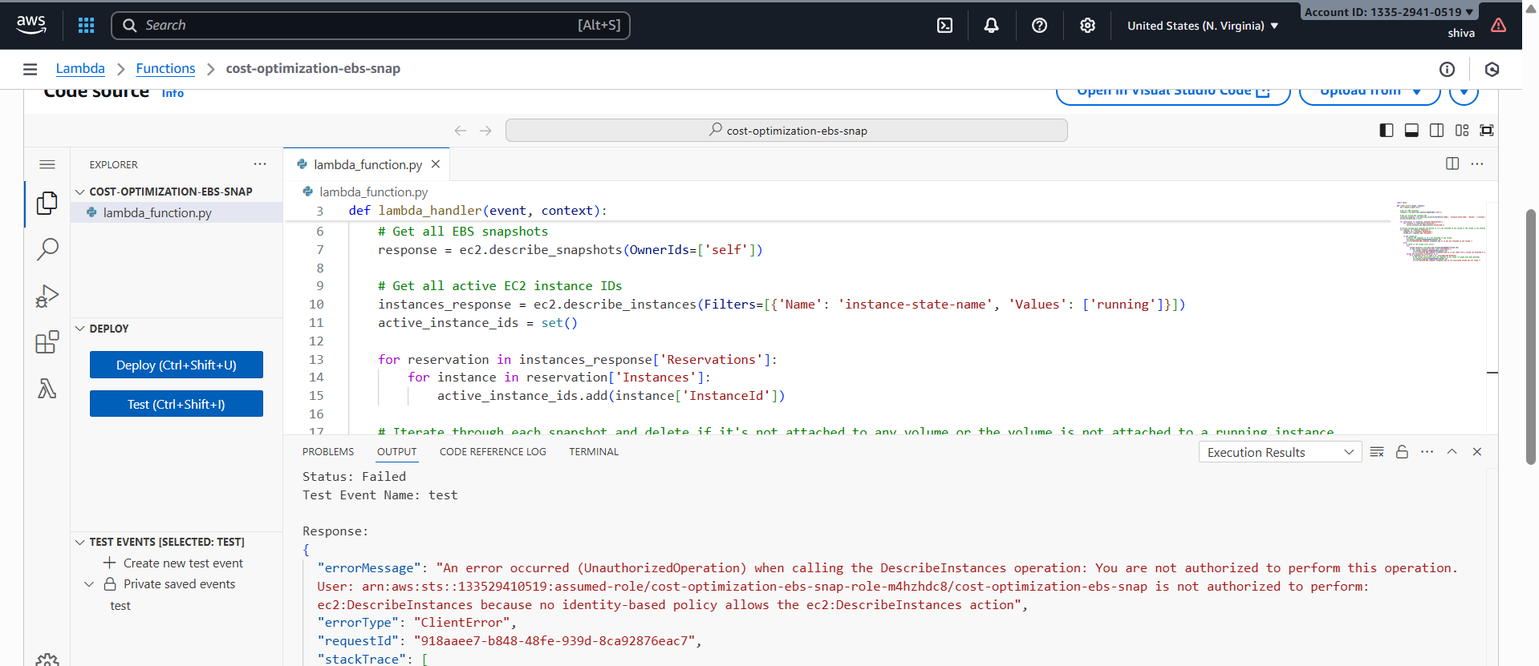

Add Describe instance and volume policy and attach

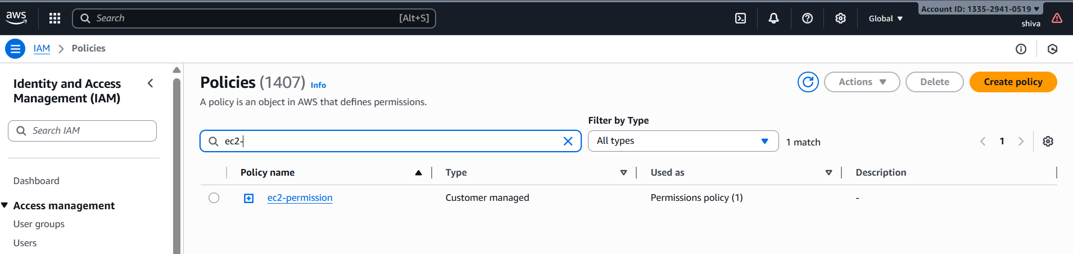

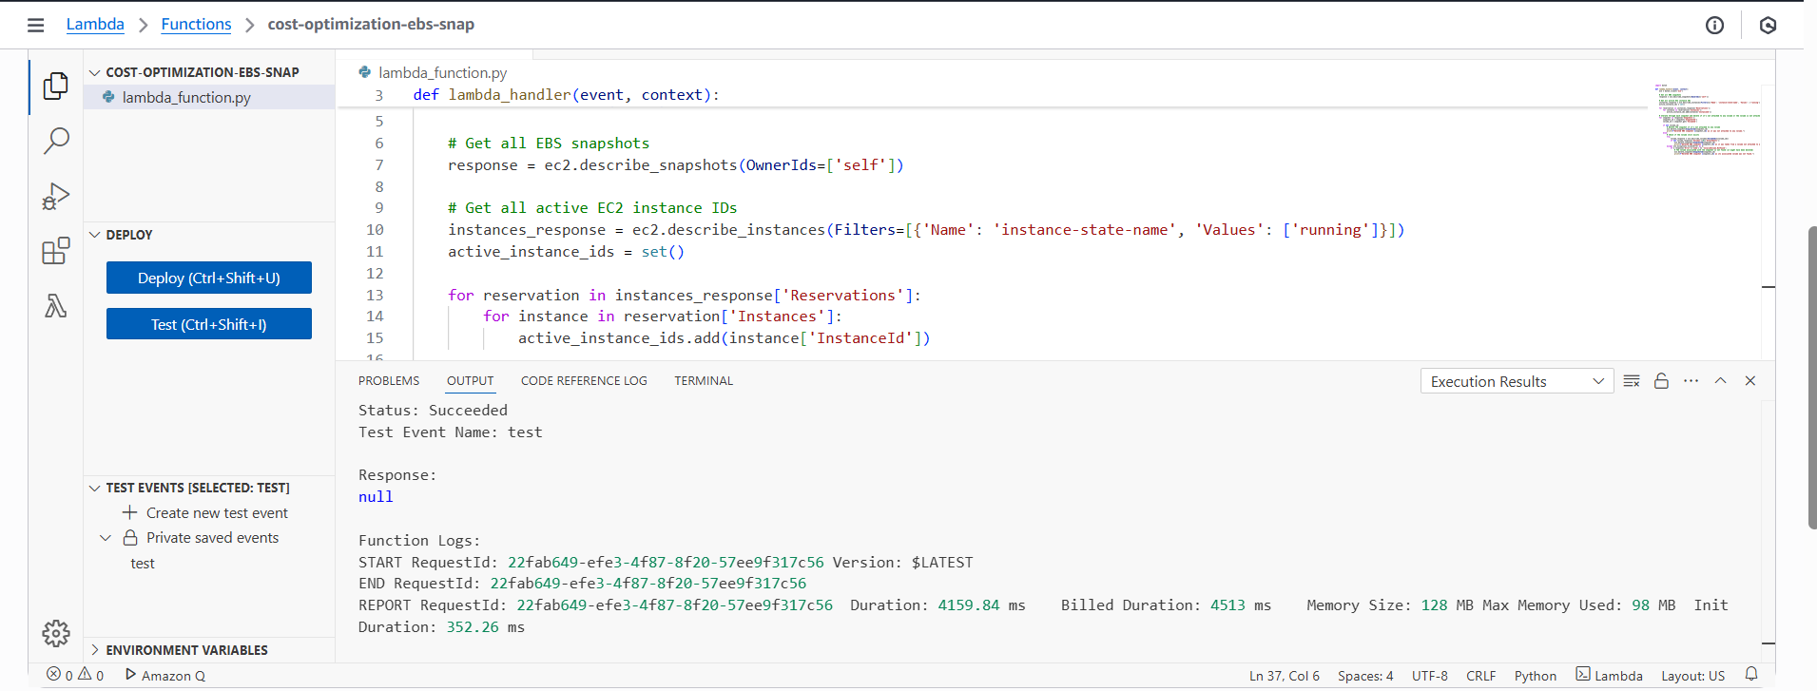

Delete the instance

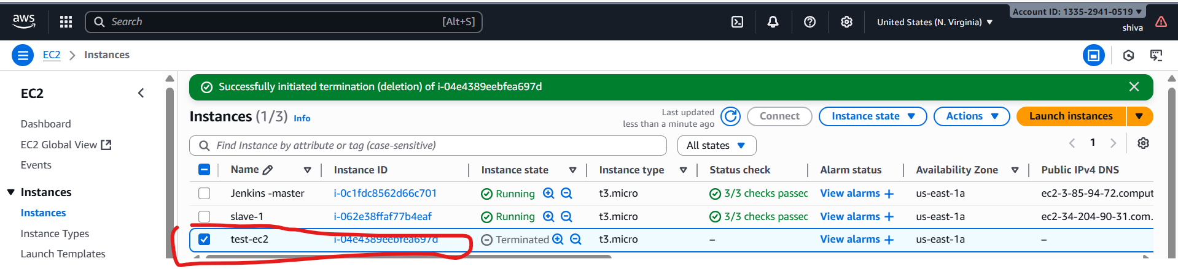

Now we don’t have instance and volume. Only we have snapshot

Again execute the lambda function then it will delete the snapshot aswell.

