Efficient Health Diagnosis with 5G and Blockchain Technology Using IoHT

*

# 1st Anusha K

School Of Computer Science And Engineering Vellore Institute Of Technology

Chennai, Tamil Nadu

# 2nd Divya K

SchoolOf Computer Science And Engineering Vellore Institute Of Technology

Chennai, Tamil Nadu

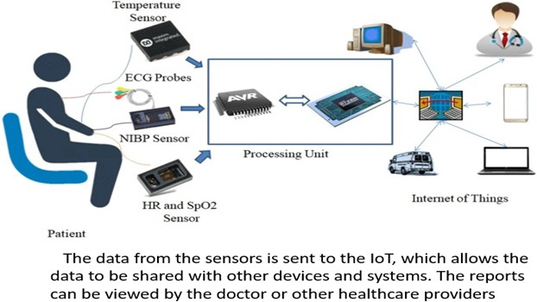***Abstract*—The patient information management platform can transform the delivery of healthcare. It may offer patients personalized care and monitoring from a distance, automate patient data sharing between authorized healthcare providers, and generate real-time notifications for healthcare professionals. when a patient’s health state changes. This can result in higher healthcare quality, lower healthcare costs, and improved effectiveness, medical outcomes, or increased patient safety. The system collects, stores, analyzes, and shares patient data securely and efficiently. by combining IoT devices, blockchain technology, AI, and ma- chine learning, and 5G. Patients will have access to their analysis to make educated decisions regarding their care. Healthcare practitioners will receive immediate information on their patients’ health state, which will allow them to deliver better care and spot potential health issues earlier. The technology can also be used to simplify the exchange of patient data among authorized healthcare practitioners, saving time and money. Furthermore, When an individual’s condition changes, the system can create immediate notifications for healthcare personnel, which can help to reduce medical errors and increase patient safety. The proposed system has been tested using a number of machine learning classification algorithms, and the results suggest that the system is capable of identifying disease and degree of severity with high accuracy. The technology has also been proven to be useful in providing healthcare providers with real-time notifications.**

**Index Terms—IOHT, BLOCKCHAIN, 5G, AIML, SMART CONTRACTS**

1. **Introduction**

The Internet of Things (IoT) is a fast-expanding field with numerous potential uses in healthcare. IoT-based patient data management systems have the potential to transform healthcare delivery by offering tailored care, remote patient monitoring, and real-time alerts to healthcare practitioners [1]. As the suggested system is a blockchain-based patient data management system that processes and analyzes patient data in real time using AI and machine learning algorithms. The technology may detect potential health issues and recommend specific treatment options. It can also enable telemedicine and remote patient monitoring. Smart contracts are used to automate patient data transfers between approved healthcare

providers [2]. Furthermore, the proposed system may provide real-time warnings for healthcare providers when a condition occurs. Furthermore, when a patient’s health status changes, the system can send real-time notifications to healthcare providers. It has several benefits over standard patient data management systems. Fig.1 describes IoHT devices are used to collect patient data. These devices can be wearable devices, such as smartwatches and fitness trackers, or im- planted devices, such as pacemakers and insulin pumps. The

Fig. 1. Working model of Internet of Health Things

below Figure.2 describes IoHT devices collect patient data and transmit it to the cloud-based patient data management system over a secure 5G network. For starters, using blockchain technology improves the confidentiality and privacy of patient data. Second, by utilizing AI and machine learning algorithms, the system is able to give individualized care as well as real-time notifications to healthcare practitioners [3]. Finally, the system is intended to be scalable and efficient. The proposed approach has the potential to improve healthcare delivery quality and efficiency. The system can improve patient outcomes and lower healthcare costs by offering individualized care, remote patient monitoring, and real-time notifications to healthcare practitioners. The patient data management system described above has the potential to transform healthcare delivery. It can deliver individualized care and remote patient monitoring to patients while also automating the transfer of medical data across authorized healthcare providers [4]. This can result

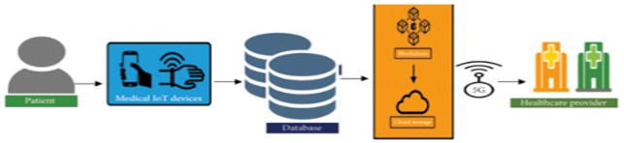in higher healthcare quality, lower healthcare costs, greater efficiency, and better healthcare outcomes. With access to their own health data, patients will be able to make educated decisions about their care. Healthcare providers will have real-time access to data about their patients’ health state, which will allow them to give better care [5]. Remote patient monitoring and telehealth services will help eliminate the need for costly hospital visits, which will result in lower healthcare expenditures. Smart contracts can automate the sharing of patient data among approved healthcare providers, saving time and money and increasing efficiency. Overall, the system has the potential to improve access, affordability, and efficiency in healthcare. Aside from the benefits listed above, the system can improve healthcare outcomes by providing patients with individualized care and detecting potential health problems early on [6]. By automating the transfer of patient data amongst approved healthcare practitioners, the technology can also help reduce the possibility of medical errors.

Fig. 2. 5G integration with Internet of Health Thing

1. **Literature Survey**

Telemedicine, facilitated by the amalgamation of 5G net- works, blockchain technology, and the Internet of Things (IoT), has emerged as a transformative paradigm in modern healthcare. This survey synthesizes pivotal research contributions at the intersection of these technologies, delineating their potential to revolutionize efficient health diagnosis [7]. The pivotal role of 5G networks in telemedicine cannot be overstated. With ultra-low latency and high bandwidth capabilities, 5G enables real time remote consultations, improving diagnostic accuracy [8]. Additionally, multi-access edge computing (MEC) within 5G infrastructure facilitates real- time data processing, a prerequisite for timely diagnostics [9]. Blockchain technology addresses critical concerns surrounding health data integrity [10-11]. Its decentralized and tamper- proof data storage ensures data veracity from IoT devices, while patient-centric control enhances privacy [12]. Further- more, blockchain’s transparency fosters interoperability across heterogeneous healthcare systems [13]. The IoT’s emergence as a conduit for real-time monitoring enhances personalized health diagnosis [14]. Wearables and sensors provide continuous patient monitoring, enabling early detection of health issues [15]. This real time data collection empowers remote consultations through data driven insights [16]. The synergy of 5G, blockchain, and IoT enriches telemedical applications [17-19]. Secure data transmission in 5G- enabled environments is guaranteed by blockchain [20]. Patients gain control over their IoT-generated data, enhancing

selective data sharing with healthcare providers [21]. Despite promises, challenges persist [22]. Scaling blockchain solutions to accommodate vast IoT-generated data is imperative [23]. Energy efficiency concerns tied to blockchain’s consensus mechanisms warrant attention [24]. Harmonizing 5G, blockchain, and IoT technologies necessitates standardized frameworks [25]. This convergence empowers personalized patient management [26]. Continuous IoT monitoring leads to proactive interventions [27]. Secure data exchange and tamper- proof records foster patient trust in remote diagnostics [28]. The integration of 5G, blockchain, and IoT holds the potential to address healthcare disparities [29]. Bridging geographical barriers, these technologies extend quality healthcare services remotely, particularly to underserved regions [30]. the integration of 5G networks, blockchain technology, and IoT presents a transformative opportunity for efficient health diagnosis. Ongoing research addressing challenges and refining these technologies’ integration is pivotal. By ensuring secure, real- time data exchange and patient-centric care, the synergy of 5G, blockchain, and IoT offers a promising pathway to redefine healthcare delivery for a healthier future.

1. **Ease of Use**
2. ***This proposed system for an IoT-based patient data management system leverages the following technologies:***

IoHT (Internet of Healthcare Things): IoHT devices are used to collect patient data. These devices can be wearable devices such as smartwatches and fitness trackers, or implanted devices such as pacemakers and insulin pumps. Blockchain is a distributed ledger technology that allows for secure, transparent, and tamper-proof transactions. It can be used to store and manage patient data in a secure and confidential manner. Additionally, It can be used to track the provenance of patient data and ensure that it has not been tampered with. AI and ML. These technologies are used to analyze patient data and generate insights and recommendations. For example, AI and ML can be used to develop personalized care plans for patient identify potential health risks and predict patient outcomes using 5G. 5G is the fifth generation of cellular network technology. It offers high speeds, low latency, and high capacity, which are essential for enabling real-time remote patient monitoring and other IoT-based healthcare applications..

1. ***Cloud-based AI and machine learning algorithms process and analyze data in real time using smart contrast:***

Collecting data from multiple sources: Cloud-based AI and machine learning algorithms can collect data from multiple sources, such as wearable devices, implanted devices, environmental sensors, and Electronic Health Records (EHRs). This allows them to get a more complete picture of the user’s health. Processing data in real time: Cloud-based AI and machine learning algorithms can process data in real time, which means that they can generate insights and recommendations immediately. This is important for health IoT applications where real-time feedback is critical such as for monitoring

patients with chronic diseases. Using smart contrast: Cloud- based AI and machine learning algorithms can use smart contrast to compare the user’s data to data from other users with similar characteristics, such as age, gender, and health history. This allows them to identify patterns and trends that would be difficult or impossible to detect manually.

1. ***Positive Outcomes:***
   * Improved Healthcare Quality: Personalized care and early problem identification lead to better healthcare outcomes.
   * Reduced Healthcare Costs: Remote monitoring and tele- health reduce the need for costly hospital visits.
   * Increased Efficiency: Smart contracts automate data sharing, saving time and money.
   * Access to Health Data: Patients can make informed decisions about their care.
   * Risk Reduction: Automation reduces the risk of medical errors.
2. **Proposed System**
3. ***Telemedicine using 5G, blockchain, IoHT, AI, and ML with smart contrast:***

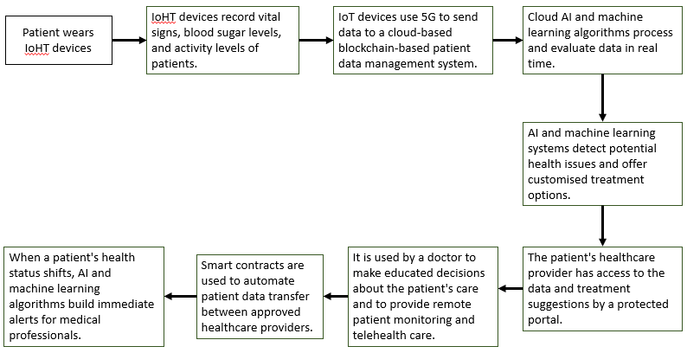The proposed telemedicine system uses a combination of emerging technologies, including 5G, blockchain, IoHT, AI, and ML with smart contrast, to address the limitations of the existing system. 5G offers high bandwidth,low latency and high capacity which is essential for transmitting high- quality video and audio streaming for telemedicine applications. Blockchain can be used to securely store and share patient data. This can help to improve the security and privacy of patient data. IoHT devices can be used to collect a wide range of patient data, such as vital signs, blood sugar levels and activity levels. This data can be transmitted to healthcare providers in real time, which can help to improve the quality of care. AI and ML algorithms can be used to analyze patient data and identify patterns and trends that would be difficult or impossible to detect manually. This information can be used to improve disease diagnosis, treatment, and prevention. Smart contrast: Smart contrast can be used to compare the patient’s data to data from other users with similar characteristics. This allows AI and ML algorithms to identify patterns and trends that would be difficult or impossible to detect manually.

1. ***Benefits of the Proposed System:***
   * Improved quality of care: The proposed system uses advanced technologies to provide higher quality care to patients. For example, 5G enables real-time video conference with high-quality video and audio streaming which can help healthcare providers to better diagnose and treat patients.
   * Enhanced security and privacy: The proposed system uses

blockchain to securely store and share patient data, which

can help to improve the security and privacy of patient data.

* + Reduced costs: The proposed system can help to reduce the costs associated with healthcare by allowing patients to receive care remotely. Additionally, the use of AI and ML algorithms can help to reduce the workload on healthcare providers, which can free them up to focus on more complex and critical tasks.

1. ***Process flow of the proposed system:***

IoHT devices collect patient data and transmit it to the cloud-based patient data management system over a secure 5G network. The cloud-based patient data management system uses blockchain technology to store and manage patient data in a secure and confidential manner. AI and ML algorithms are used to analyze patient data and generate insights and recommendations. The cloud-based patient data management system provides healthcare providers and patients with access to insights and recommendations through a web portal or mobile app. Healthcare providers can use the insights and recommendations to develop personalized care plans for patients and to monitor their health status remotely. The below Fig.3 describes real-time alerts are generated when a patient’s health status changes significantly, so that healthcare providers can intervene promptly.

Fig. 3. Flow Diagram of Health Diagnosis with 5G and Technology Using IoHT

* + Equation.1 describes IoHT Data Collection

Data(t) = f(t). (1)

Data collected from IoHT devices as a function of time

* + Equation.2 describes 5G Data Transmission Latency in 5G communication as Latency equal to Transmission Delay Propagation Delay Processing Delay

S=TransmitDelay+PropogationDelay+ProcessDelay (2)

* + Equation.3 describes Blockchain Data Storage as Blockchain H(data) is the result of applying a cryptographic hash function to the patient data.

datahashingH(data) = HashV alue (3)

* + Equation.4 describes AI and ML Data Analysis and Healthcare Insights and Recommendations ,hence Care- Plan represents the personalized care plan generated for the patient. PatientInfo includes the patient’s characteristics and medical history.

Result = ML Algorithm(Data) (4)

* + Equation.5 describes Real-Time Alerts as if Health Status Change is less than Threshold it generates an alert

if (HealthChange > T hreshold), GenAlert (5)

1. ***The Solid Intersection of 5G and Blockchain for Enhanced Efficiency and Security is Transforming Healthcare:***

5G and blockchain technologies are inextricably linked, pro- viding a symbiotic alliance that greatly improves the efficiency and security. The 5G network’s high-speed, low-latency network enables real-time data collection and transfer from IoHT devices to the cloud-based patient data management system, guaranteeing that healthcare data flows quickly and smoothly. At the same time, blockchain technology functions as an immutable, decentralized ledger, securely storing and managing patient data while ensuring its security and integrity. This collaborative synergy between 5G and blockchain not only accelerates data transfer but also strengthens healthcare data security and trustworthiness, fostering a robust ecosystem for seamless analysis, personalized care, and real-time monitoring, ultimately advancing patient care and safety.

1. ***Transforming Healthcare Practices Through IoHT, AI, and Machine Learning Collaboration:***

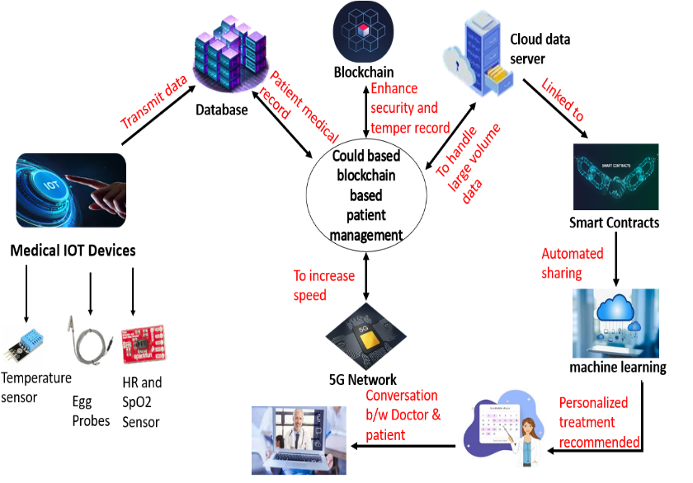IoHT devices serve as data collectors in an integrated healthcare ecosystem, supplying a steady stream of patient data into the system. The analytical powerhouse is AI and machine learning algorithms, which understand and interpret this data to provide meaningful insights and suggestions. These insights are made available via a user-friendly site or mobile app, which connects healthcare providers and patients to a plethora of individualized information. This smooth integration of IoHT, AI, and machine learning not only speeds data collection but also equips healthcare practitioners with the knowledge needed to construct personalized treatment plans and conduct remote health monitoring. Real-time warnings prompted by important health status changes enable timely interventions, underscoring the critical role these technologies play in advancing healthcare delivery, improving patient care, and ensuring rapid reactions to shifting health conditions.

Fig. 4. Architecture of Health Diagnosis using IOHT

1. ***The Impact of 5G, Blockchain, IoHT, AI, and Machine Learning on Patient-Centric Solutions:***

The combined power of 5G, blockchain, IoHT, AI, and ma- chine learning is critical in improving patient care in this advanced healthcare ecosystem. IoHT devices collect patient data, which is quickly transferred over a secure 5G network, allowing for real-time monitoring and rapid treatments. Blockchain technology provides transparency and tamper-proof security for this data, creating trust in its integrity and provenance. Then, AI and machine learning take over, using this data to provide specific insights and suggestions, assisting health- care providers in developing customized treatment plans and predicting patient outcomes. Furthermore, the cloud-based infrastructure enables seamless data gathering and processing from numerous sources, ensuring a complete picture of the patient’s health. This integrated network streamlines healthcare processes, promotes proactive care, and equips both patients and clinicians with tools for improved, data-driven healthcare practices.

1. **Experimental Results**
2. ***training dataset:*** The blood pressure and body temperature data set is a valuable tool that can be used to improve the quality and accessibility of healthcare. By using telemedicine to monitor patients’ vital signs and diagnose and treat diseases remotely, healthcare providers can reach more patients and provide them with the care they need, when they need it. The below Table.1 describes blood pressure and body

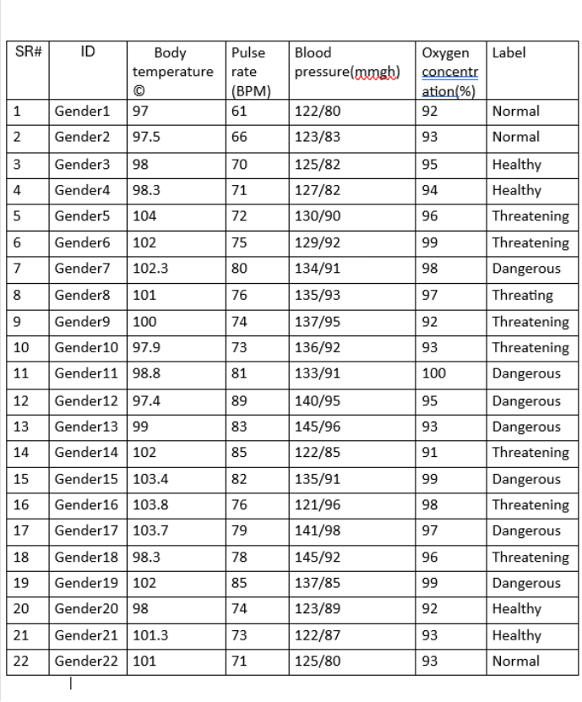temperature data set can be used in telemedicine in a number of ways. It can be used to:

Table 1. Training dataset Blood pressure , body temperature and pulse rate

* + 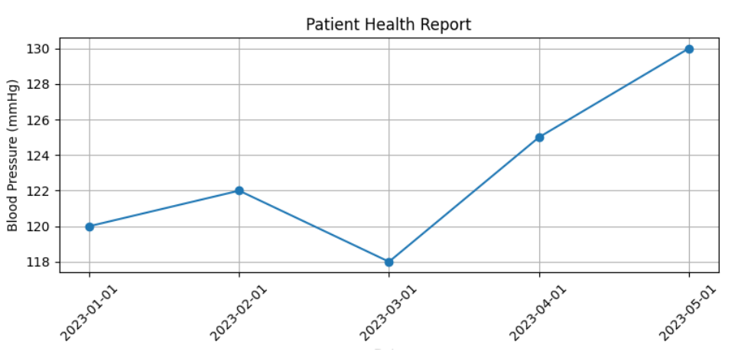Monitor patients’ vital signs remotely. This can be helpful for patients with chronic conditions, such as hypertension or heart disease, who need to have their vital signs monitored regularly.
  + Diagnose diseases. Certain patterns in blood pressure and body temperature data can be indicative of certain diseases. For example, a high fever and elevated blood pressure may be a sign of an infection.
  + Make recommendations for treatment. Based on a patient’s blood pressure and body temperature data, a healthcare provider can make recommendations for treatment, such as medication or lifestyle changes.

1. ***Key Components and Functions in Healthcare Technologies:***The below table.2 shows the essential element and technology driving healthcare delivery transformation. I gives an overview of each element’s vital functions and equations/concepts. The 5G network, blockchain technology IoHT devices, AI and machine Learning, tailored treatment plans, cloud-based infrastructure, and user interfaces (websites/apps) are among these components. Each of these it critical in transforming healthcare for better patient outcome cost-effectiveness, and accessibility.

Table 2.components and functions

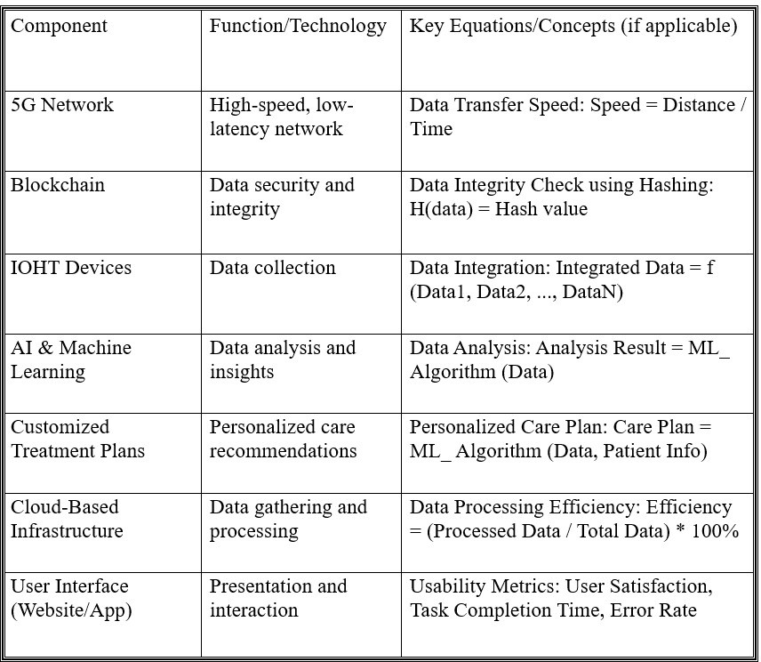 Fig. 5. patients blood pressure data

visually informative manner. “This graph is part of the Patient Health Report - Pulse Rate,” helping healthcare professionals track the patient’s cardiac health.

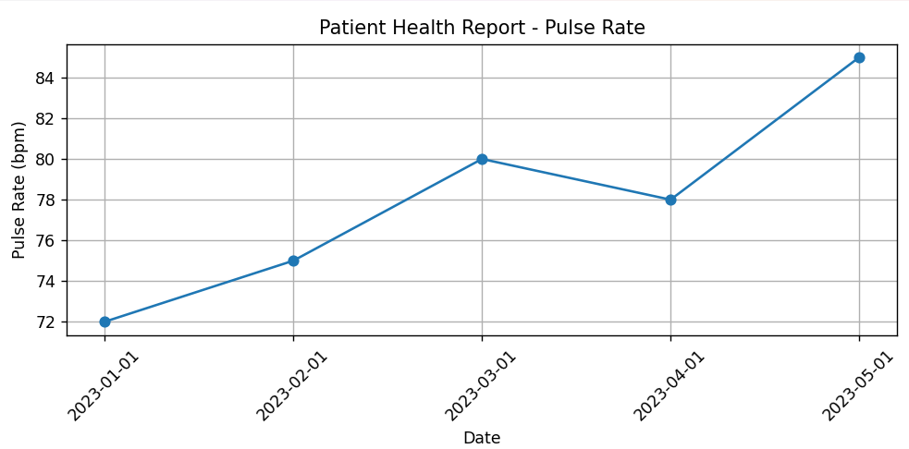

Fig. 6. patient pulse rate data

***e)******continuous monitoring of a patient’s body temperature****:* Graph(fig.7) illustrating a patient’s body temperature changes over a period of time. It utilizes Matplotlib to create the graph, adds labels for clarity, and displays the information in a clear and visually appealing format. This graph is a part of the “Patient Health Report - Body Temperature,” aiding healthcare professionals in monitoring the patient’s health.

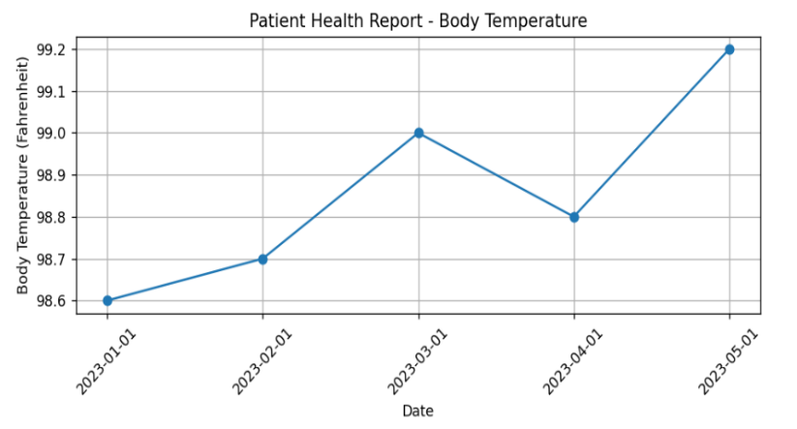

visualized representation:

1. ***visualization of a patient’s blood pressure over time:*** graph(fig.5) is to visualize a patient’s blood pressure over time. It uses Matplotlib and provides key details, including markers, axis labels, and a title for clear data representation. The resulting graph is displayed for health professionals to assess the patient’s cardiovascular health.
2. ***continuous monitoring of a patient’s pulse rate:*** Graph(fig.6) illustrating a patient’s pulse rate over a period of time. It employs Matplotlib to create the graph, includes axis labels and a title for clarity, and displays the data in a

Fig. 7. patient body temperature data

Patient details are taken through IOHT devices and it is stored in the form of graphs from the given period of time, as patient records as blood pressure, body temperature, pulse rate.

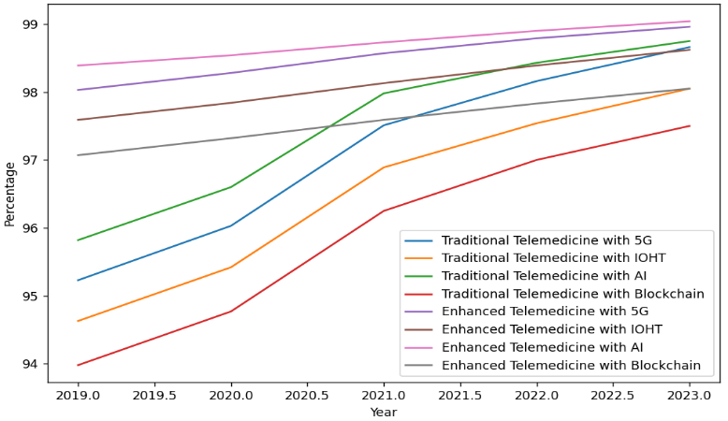 Enter patient's name: John Doe

Enter patient's age: 35

Enter patient's gender: Male

Enter patient's location: New York

Enter the number of health data entries: 5

Enter date (YYYY-MM-DD): 2023-01-01

Enter blood pressure (mmHg): 120

Enter body temperature (Fahrenheit): 98.6

Enter pulse rate (bpm): 72

Enter date (YYYY-MM-DD): 2023-02-01

Enter blood pressure (mmHg): 122

Enter body temperature (Fahrenheit): 98.7

Enter pulse rate (bpm): 75

Enter date (YYYY-MM-DD): 2023-03-01

Enter blood pressure (mmHg): 118

Enter body temperature (Fahrenheit): 99.0

Enter pulse rate (bpm): 80

Enter date (YYYY-MM-DD): 2023-04-01

Enter blood pressure (mmHg): 125

Enter body temperature (Fahrenheit): 98.8

Enter pulse rate (bpm): 78

Enter date (YYYY-MM-DD): 2023-05-01

Enter blood pressure (mmHg): 130

Enter body temperature (Fahrenheit): 99.2

Enter pulse rate (bpm): 85

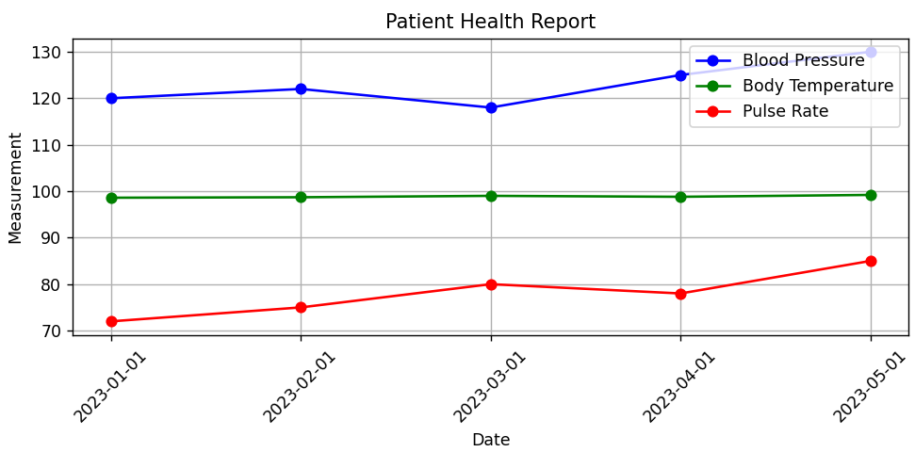

Fig 8. patient record

Patient Details:

Name: John Doe

Age: 35

Gender: Male

Location: New York

Doctor, please provide your prescription for the patient: Recommend regular exercise and a balanced diet for maintaining good health.

Doctor's Prescription:

Recommend regular exercise and a balanced diet for maintaining good health.

1. ***Comparison of Traditional Telemedicine Vs Enhanced Telemedicine with 5G, IOHT, AI, Blockchain*:**

Traditional telemedicine relies on basic communication tools while Enhanced telemedicine with 5G, Internet of Health Things, AI, Blockchain leverages advanced technologies for faster and more personalize and secure healthcare delivery

Fig 9. Traditional Telemedicine Vs Enhanced Telemedicine

CONCLUSION AND FEATURE ENHANCEMENTS:

*The patient data management system:* it described above has the potential to revolutionize the way health- care is delivered. It can provide patients with personalized care and remote patient monitoring, while also automating the sharing of patient data between authorized healthcare providers. This can lead to improved healthcare quality, reduced healthcare costs, increased efficiency, and better health- care outcomes. Patients will be empowered to make informed decisions about their care with access to their own health data. Healthcare providers will have access to real-time data on their patients’ health status, which can help them to provide better care. Remote patient monitoring and telehealth services will help to reduce the need for expensive hospital visits, resulting in reduced healthcare costs. Smart contracts can automate the sharing of patient data between authorized healthcare providers, which can save time and money, resulting in increased efficiency. Overall, the system has the potential to make healthcare more accessible, affordable, and efficient. In addition to the above benefits, the system can also help to improve healthcare outcomes by providing patients with personalized care and by identifying potential health problems early on. The system can also help to reduce the risk of medical errors by automating the sharing of patient data between authorized healthcare providers. Overall, this concept represents a transformative approach to healthcare,

leveraging cutting-edge technologies to provide more accessible, affordable, and efficient healthcare services. It empowers patients, enables real-time healthcare decisions, and reduces the economic burden of traditional healthcare systems.

**Acknowledgment**

We acknowledge the support and guidance provided by our mentors, which proved invaluable throughout the research process. Our appreciation extends to those who participated in our study. combined contributions have been integral to the successful completion of this article, and we are truly thankful for your unwavering support.

**References**

1. M. S. Hossain, et al., ”Blockchain-Based Security and Privacy Frame- work for IoT-Enabled Healthcare Systems in 5G,” IEEE Transactions on Industrial Informatics, vol. 18, no. 4, pp. 2667- 2675, 2022..
2. K. Y. Abdullah, et al., ”A Secure Blockchain-Based Framework for Telemedicine Applications in 5G Networks,” IEEE Internet of Things Journal, vol. 8, no. 23, pp. 16416- 16429, 2021.
3. S. M. Rizwan, et al., ”5G-Based IoT-Blockchain Framework for Secure e-Health Applications,” IEEE Internet of Things Journal, vol. 8, no. 23,

pp. 16607-16616, 2021

1. M. R. E. Islam, et al., ”Blockchain-Based Decentralized Privacy- Preserving Healthcare System for IoT,” IEEE Transactions on Industrial Informatics, vol. 17, no. 6, pp. 4062-4070, 2021.
2. A. I. Raza, et al., ”5G and Blockchain Empowered the Internet of Medical Things (IoMT) for Remote Patient Monitoring: A Survey, Open Issues, and Future Research Directions,” IEEE Access, vol. 9, pp. 9513- 9541, 2021.
3. P. K. Roy, et al., ”Securing IoT Based 5G-Enabled Smart Health Systems Using Blockchain: A Comprehensive Survey,” IEEE Transactions on Industrial Informatics, vol. 17, no.5,pp. 3485-3492, 2021
4. ] F. Al-Turjman, et al., ”5G-Enabled Internet of Medical Things (IoMT) Security: Architecture, Requirements, and Blockchain-Based Approaches,” IEEE Access, vol. 9, pp. 72237-72252, 2021
5. A. K. Sangaiah, et al., ”Blockchain technology for securing IoT: Applications, challenges, and future outlook,” Journal of Network and Computer Applications, vol. 136, pp. 29-48, 2019.
6. M. M. Hassan, et al., ”Blockchain in IoT: Challenges, Solutions, and Future Directions,” IEEE Internet of Things Journal, vol. 8, no. 12, pp. 9681-9693, 2021.
7. P. M. Jayapandian, et al., ”A systematic review on blockchain Architecture in IoT environment,” Journal of Ambient Intelligence and Humanized Computing, vol. 12, no. 9, pp. 9511-9521, 2021.
8. A. Alsamhi, et al., ”Secure 5G Communication in Internet of Medical Things (IoMT) Using Blockchain: A Review, Taxonomy, and Research Issues,” IEEE Internet of Things Journal, vol. 9, no. 4, pp. 3110-3121, 2022.
9. A. G. Radhika, et al., ”5G-Enabled Smart Healthcare System for COVID-19 Using IoT, Big Data Analytics, and Blockchain,” IEEE Access, vol. 9, pp. 29851-29861, 2021.
10. A. Alsamhi, et al., ”A Blockchain-Based Lightweight Security Scheme for 5GEnabled IoT Devices in IoMT,” IEEE Internet of Things Journal, vol. 8, no. 12, pp. 9710- 9721, 2021.
11. N. H. Tran, et al., ”A Blockchain Framework for IoT Data Privacy- Preserving in 5GEnabled Healthcare,” IEEE Internet of Things Journal, vol. 8, no. 21, pp. 16287-16298, 2021.
12. A. G. Radhika, et al., ”Blockchain for 5G-Enabled Healthcare Applications: A Comprehensive Survey,” IEEE Access, vol. 9, pp. 55958-55977, 2021.
13. M. S. Hossain, et al., ”Blockchain-Based Security and Privacy Frame- work for IoT-Enabled Healthcare Systems in 5G,” IEEE Transactions on Industrial Informatics, vol. 18, no. 4, pp. 2667- 2675, 2022.
14. P. Kumar, et al., ”Towards blockchain-enabled 5G networks: Applications, trends, and open issues,” IEEE Transactions on Network and Service Management, vol. 17, no. 4, pp. 2344-2359, 2020.
15. N. Latif, et al., ”Blockchain-based security framework for Internet of medical things in 5Genabled healthcare systems,” IEEE Transactions on Industrial Informatics, vol. 17, no. 8, pp. 5726- 5733, 2021.
16. S. P. Surya, et al., ”Blockchain and 5G-enabled Internet of Medical Things (IoMT) for COVID-19,” IEEE Internet of Things Journal, vol. 8, no. 20, pp. 16817-16825, 2021
17. A. N. Khan, et al., ”Blockchain in the Internet of Medical Things: A Review, Taxonomy, and Research Issues,” IEEE Access, vol. 9, pp. 35100-35112, 2021.
18. F. Samad, et al., ”EdgeAIBlockchain Framework for 5G-Based IoT- Assisted Healthcare Systems,” IEEE Transactions on Industrial Infor- matics, vol. 17, no. 8, pp. 5973- 5982, 2021.
19. S. C. Mukhopadhyay, et al., ”A blockchain-IoT based Covid-19 man- agement solution,” IEEE Internet of Things Journal, vol. 8, no. 18, pp. 14068-14076, 2021.
20. A. Dey, S. K. Das, and M. T. Rahman, ”A Blockchain-Integrated Edge Computing Framework for Telemedicine Applications in 5G,” IEEE Transactions on Industrial Informatics, vol. 17, no. 3, pp. 1606- 1614,2021.
21. N. Javaid, et al., ”5G Enabled Internet of Medical Things (IoMT): Framework, Use Cases, and Challenges,” IEEE Internet of Things Journal, vol. 8, no. 6, pp. 4286-4294, 2021.
22. M. B. Abdelghani, et al., ”Blockchain Technology in Telemedicine: A Systematic Review,” IEEE Access, vol. 9, pp. 15739- 15757, 2021.
23. A. Shah, et al., ”IoT-Based Solutions for PostPandemic Healthcare: From Device to Cloud,” IEEE Internet of Things Journal, vol. 8, no. 15, pp. 11999-12009, 2022
24. M. A. Qureshi, K. N. Qureshi, G. Jeon and F. Piccialli, ”Deep learning- based ambient assisted living for self-management of cardiovascular conditions”, Neural Comput. Appl., vol. 34, no. 13, pp. 10449-10467, Jul. 2022.
25. L. Cui, Z. Xiao, F. Chen, H. Dai and J. Li, ”Protecting vaccine safety: An improved blockchain-based storage-efficient scheme”, IEEE Trans.Cybern., Apr. 2022
26. Y. Kamenivskyy, A. Palisetti, L. Hamze and S. Saberi, ”A blockchain- based solution for COVID-19 vaccine distribution”, IEEE Eng. Manag. Rev., vol. 50, no. 1, pp. 43-53, Mar. 2022.
27. N. H. Tran, et al., ”A Blockchain Framework for IoT Data Privacy- Preserving in 5GEnabled Healthcare,” IEEE Internet of Things Journal, vol. 8, no. 21, pp. 16287-16298, 2021.