### ACKNOWLEDGEMENT

The development of the project in Project Based learning (B20AI05,4th Semester) though was an arduous task, it has been made by the help of many people. We are pleased to express our thanks to the people whose suggestions, comments, criticisms greatly encouraged us in betterment of the project.

We would like to express my sincere gratitude and indebtedness to my project Guide

**N.KARTHIK sir** for his valuable suggestions and interest throughout the course of this project.

We would like to express my sincere thanks and profound gratitude to **Dr. K. PRAKASH,** principal of Vaagdevi College of Engineering, for his support, guidance and encouragement in the course of our project.

We are also thankful to the Head of the Department **Dr. THANVEER JAHAN madam**, for providing excellent infrastructure and a nice atmosphere for completing this project successfully.

We are highly thankful to the Project Coordinators for their valuable suggestions, encouragement and motivations for completing this project successfully.

We are thankful to all other faculty members for their encouragement We convey my heartfelt thanks to the lab staff for allowing me to use the required equipment whenever needed.

We are also thankful to **N.KARTHIK sir** and supporting staff of Vaagdevi college for their valuable suggestions, encouragement and motivations for completing this project successfully.

Finally, We would like to take this opportunity to thank my family for their support through the work. I sincerely acknowledge and thank all those who gave directly or indirectly their support in completion of this work.

K.Shiva sai (21641A66J4)

V.Pranitej(21641A66F4)

B.Sai Kiran(22645A6613)

P.Lahari (21641A66G7)

M.Darshan Reddy(21641A66K4)

D.Sridhar(21641A66J9)

DECLARATION

DECLARATION

We declare that the work reported in the project entitled “ STUDENT MANAGEMENT WEBSITE “ is a record of work done by us in partial fulfilment for the award for the degree Bachelor of Technology in computer science of engineering, Vaagdevi college of engineering affiliated by JNTUH ,Accredited by NBA ,under the guide of N.KARTHIK SIR CSE(AI AMD ML) Department .We hereby declare that the project work bears no resemblance to any other project submitted at vaagdevi college of engineering or any other college/university for the award of the degree.

## INDEX

**TOPIC PAGE NO**

1. INTRODUCTION 04

1.1 ABSTRACT 05

2. LITERATURE SURVEY 06

2.1 EXSISTING SYSTEM AND PROPOSED SYSTEM

3 .DESIGN 07

3.1 SOFTWARE REQUIREMENTS AND

HARDWARE REQUIREMENTS

4. IMPLEMENTATION 08

4.1 FLOW CHART 09

4.2 CODE 10

5. INPUT 18

6. OUTPUT 19

6. CONCLUSION AND REFERENCE 20

## 

## CHAPTER-1

## INTRODUCTION

* The Student Management Website is an online platform designed to revolutionize student management by providing a centralized hub for students, teachers, and administrators to access and update relevant information. This web-based system aims to create a seamless and user-friendly environment that simplifies administrative tasks, facilitates effective communication, and promotes data-driven decision-making. By undertaking this PBL project, we aim to develop a practical, scalable, and user-friendly Student Management Website that caters to the unique needs of educational institutions.
* Through our user-friendly interface and comprehensive content, we aim to simplify the complexities of student life. Our website offers a wide range of features and resources designed to help you succeed academically, expand your horizons, and connect with like-minded individuals. From informative articles and study materials to event listings and career advice, we're here to support every aspect of your educational journey.
* Explore our diverse range of courses and programs, where you'll find detailed descriptions, prerequisites, and expert faculty members dedicated to your growth and development. Discover an array of valuable resources, including textbooks, research materials, academic support services, and libraries, all aimed at enhancing your learning experience.

### ABSTRACT

* The Student Management Website is a project aimed at developing an online platform that facilitates efficient management of student information, academic records, and administrative tasks in educational institutions. The website serves as a centralized hub for students, teachers, and administrators to access and update relevant data, fostering seamless communication and streamlined workflows.
* The website provides a comprehensive system for storing and organizing student information. The platform facilitates effective communication between students, teachers, and parents/guardians. The Student Management Website provides comprehensive reports on student performance, attendance trends.
* With Bootstrap's intuitive and mobile-friendly interface, our website offers a visually appealing and user-friendly experience across devices. Whether you're accessing it from your desktop, laptop, tablet, or smartphone, our website seamlessly adapts to provide a consistent and optimized experience.
* Through the integration of Django and Bootstrap, we provide an extensive range of features and functionalities. Students can explore and enroll in a wide array of courses, access course materials, and connect with faculty members for guidance and support. Our comprehensive resources section offers a treasure trove of academic materials, study guides, and research tools, empowering students with the knowledge they need to excel.

#### 

#### CHAPTER-2

#### LITERATURE

**EXISTING SYSTEM: -**

The student management system when users see first login page access URL. for login the Admin access the system through portal directly as new registers the module is portal that allow Admin to type your username and password to login/sign up system allow Admin to login to the system if they has an account.

#### PROPOSED SYSTEM:

In our student management system when Admin first login with his user name and password if the password is wrong then it gives a pop-up message to Admin and it manage all function of a system.

**CHAPTER-3**

**DESIGN**

**SOFT WARE REQUIREMENTS**

* Text Editor
* Web Browser
* Python, Django
* Html, CSS, Java Script, SQLite3
* Bootstrap, Chart Java Script.

**HARD WARE REQUIREMENTS**

* **Processor :**

Intel core i3or equivalent.

* **RAM :**

4GB or more.

* **Storage:**

Minimum 10GB disk space.

* **Operating system :**

Windows, mac, linux.

**CHAPTER-4**

***IMPLEMENTATION***

**ALGORITHM**

Implement a Django admin panel for student management, allowing administrators to modify student data and access a dashboard with relevant information.

Provide students with a personalized dashboard where they can access and check their academic progress, course schedules, grades, and communicate with faculty or fellow students. implementation details:

* **User Interface** : Design a visually appealing and intuitive user interface using HTML and CSS, ensuring a responsive layout that adapts to different devices.
* -> Create user-friendly forms and input fields to collect necessary information from students, such as personal details, course preferences, and feedback.
* -> Implement client-side validation to ensure data integrity and provide helpful error messages for incorrect or missing inputs.
* **Server-Side Processing :**

Setup a server-side environment using a programming language like Python, Node.js, or PHP Handle incoming form submissions using a server-side framework such as Django (Python), Express (Node.js).Receive the form data on the server, validate it, and process it further.

* **Student Website Testing Service :**

Through the input taken from the user about the personal behaviours and evaluate in the backend using python. After the evaluation display the output according to the input given by the user.

**FLOW CHART**

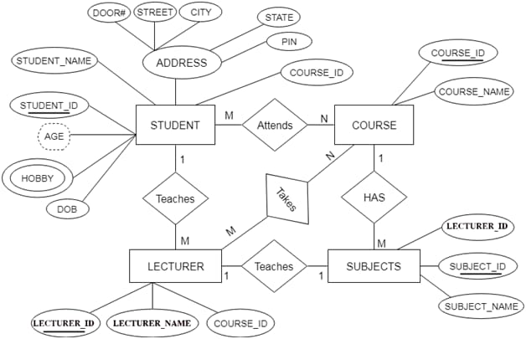

**CODE**

**Home Page :**

**<!DOCTYPE html>**

**<html lang="en">**

**<head>**

**<meta charset="UTF-8">**

**<meta name="viewport" content="width=device-width, initial-scale=1.0">**

**<title>Student Home</title>**

**{% include 'includes.html' %}**

**<link rel="icon" href="/media/science.png">**

**</head>**

**<body>**

**{% include 'home_design.html' %}**

**<div class="col-lg-10 col-12 background-setter">**

**<div class="card mt-3" style="border-radius: 3px; border-color: black;">**

**<div class="card-body">**

**<div class="row">**

**<div class="col-lg-5 col-sm-12">**

**<div class="card" style="border-radius: 3px; border-color: black;">**

**<div class="card-body wallpaper-photo-student" style="height: 35em;">**

**</div>**

**</div>**

**</div>**

**<div class="col-lg-7 col-12 pt-sm-2">**

**<div class="container-fluid">**

**<div class="row">**

**<div class="col-12">**

**<img src="/media/images/hello_student.png" class="mr-2" style="width: 5em; height: 5em;">**

**</div>**

**</div>**

**<div class="row mt-2 no-margin">**

**<div class="col-sm-12 ml-2" style="display: flex;">**

**<h1 class="mr-2">I'm</h1>**

**<h1><strong style="font-family: Arial, Helvetica, sans-serif;">{{object.student_first_name}} {{object.student_last_name}} </strong></h1>**

**</div>**

**</div>**

**<div class="row">**

**<div class="col-sm-12 ml-2">**

**<h4>{{object.student_branch}}</h4>**

**</div>**

**</div>**

**<div class="row">**

**<div class="col-sm-12">**

**<hr style="height: 2px;" noshade class="bg-secondary">**

**</div>**

**</div>**

**<div class="row">**

**<div class="col-sm-3 ml-2">**

**<p class="mt-1"><b>DATE OF BIRTH</b></p>**

**</div>**

**<div class="col-sm-7 offset-1">**

**<p class="mt-1 text-muted"><img src="/media/images/date_of_birth_student.png" class="mr-1" style="width: 23px; height: 23px;"> {{object.student_date_of_birth}}</p>**

**</div>**

**</div>**

**<div class="row">**

**<div class="col-sm-3 ml-2">**

**<p class="mt-1"><b>ADDRESS</b></p>**

**</div>**

**<div class="col-sm-7 offset-1">**

**<p class="mt-1 text-muted"><img src="/media/images/location_student.png" class="mr-1" style="width: 23px; height: 23px;"> {{object.student_address}}</p>**

**</div>**

**</div>**

**<div class="row">**

**<div class="col-sm-3 ml-2">**

**<p class="mt-1"><b>E-MAIL</b></p>**

**</div>**

**<div class="col-sm-7 offset-1">**

**<p class="mt-1 text-muted"><img src="/media/images/gmail_student.png" class="mr-1" style="width: 25px; height: 25px;">{{user.email}}</p>**

**</div>**

**</div>**

**<div class="row">**

**<div class="col-sm-3 ml-2">**

**<p class="mt-1"><b>PHONE</b></p>**

**</div>**

**<div class="col-sm-7 offset-1">**

**<p class="mt-1 text-muted"><img src="/media/images/phone_contact_student.png" class="mr-1" style="width: 23px; height: 23px;">+91 {{object.student_phone_number}}</p>**

**</div>**

**</div>**

**<div class="row">**

**<div class="col-sm-3 ml-2">**

**<p class="mt-1"><b>DESCRIPTION</b></p>**

**</div>**

**<div class="col-sm-7 offset-1">**

**<p class="mt-1 text-muted"><img src="/media/images/description_student.png" class="mr-1" style="width: 23px; height: 23px;">{{object.student_description}}</p>**

**</div>**

**</div>**

**<hr style="height: 2px;" noshade class="bg-secondary">**

**<div class="row ml-5">**

**<div class="col-sm-3 col-3">**

**<a href="https://linkedin.com/" target="_blank">**

**<img src="/media/images/linkedin_student.png" class="mr-1" style="width: 27px; height: 27px;">**

**</a>**

**</div>**

**<div class="col-sm-3 col-3">**

**<a href="https://instagram.com/" target="_blank">**

**<img src="/media/images/instagram_student.png" class="mr-1" style="width: 27px; height: 27px;">**

**</a>**

**</div>**

**<div class="col-sm-3 col-3">**

**<a href="https://twitter.com/" target="_blank">**

**<img src="/media/images/twitter_student.png" class="mr-1" style="width: 27px; height: 27px;">**

**</a>**

**</div>**

**<div class="col-sm-3 col-3">**

**<a href="https://github.com/" target="_blank">**

**<img src="/media/images/github_student.png" class="mr-1" style="width: 27px; height: 27px;">**

**</a>**

**</div>**

**</div>**

**</div>**

**</div>**

**</div>**

**</div>**

**</div>**

**<br>**

**</div>**

**{% include 'logout_popup.html' %}**

**</body>**

**</html>**

**INPUT**

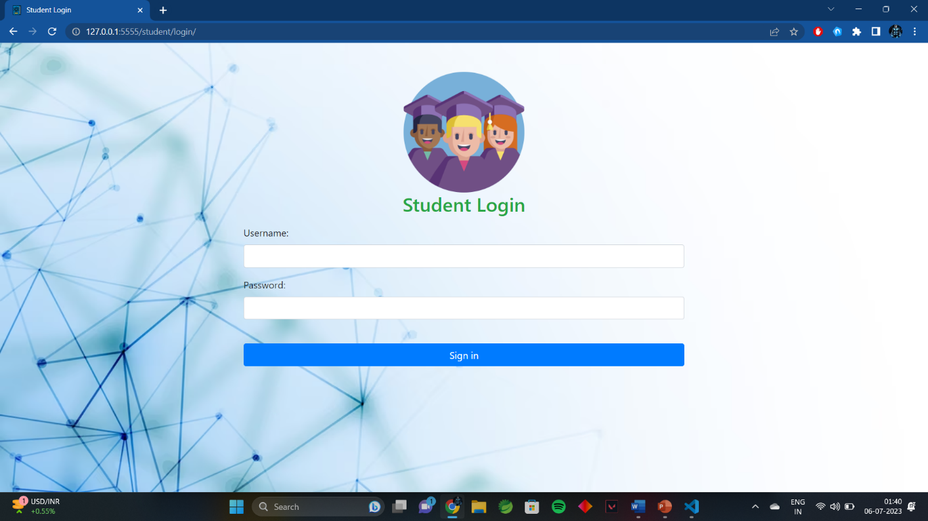

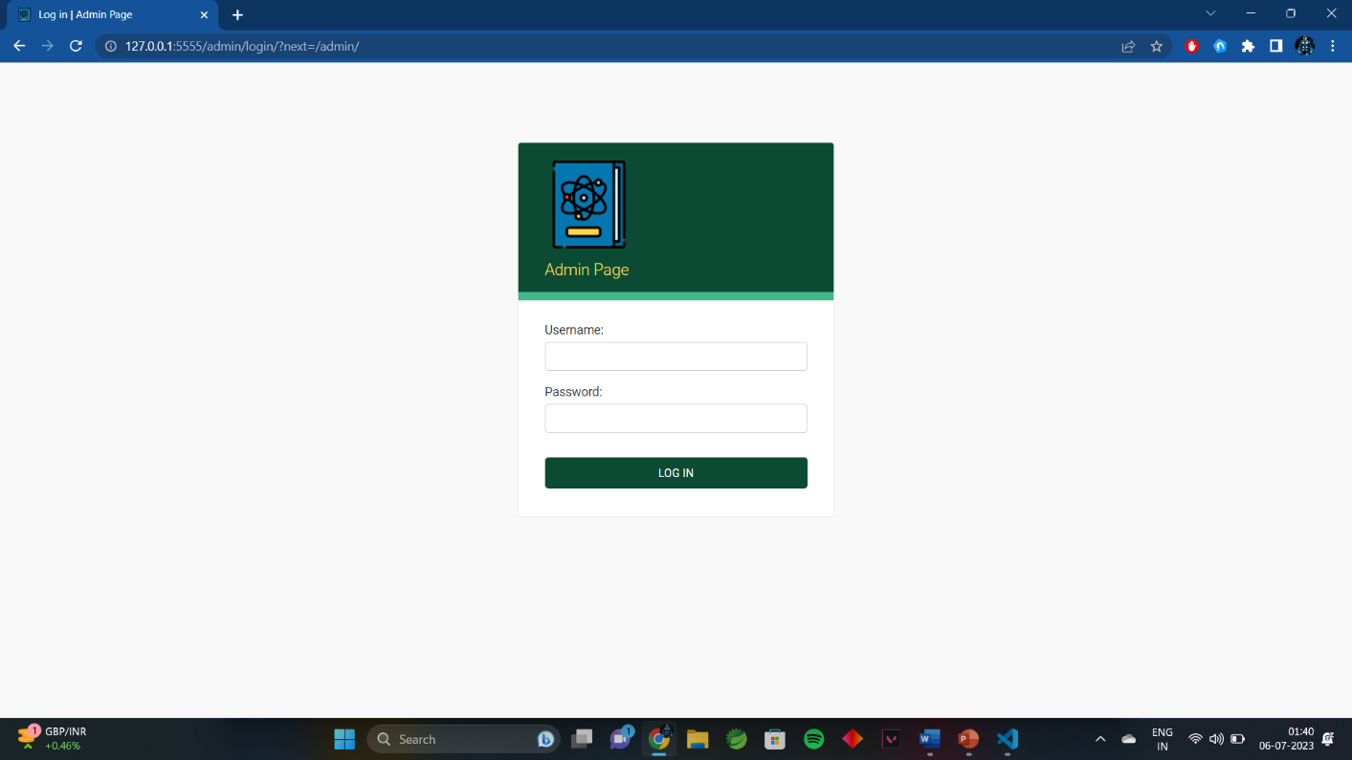

**OUTPUT**

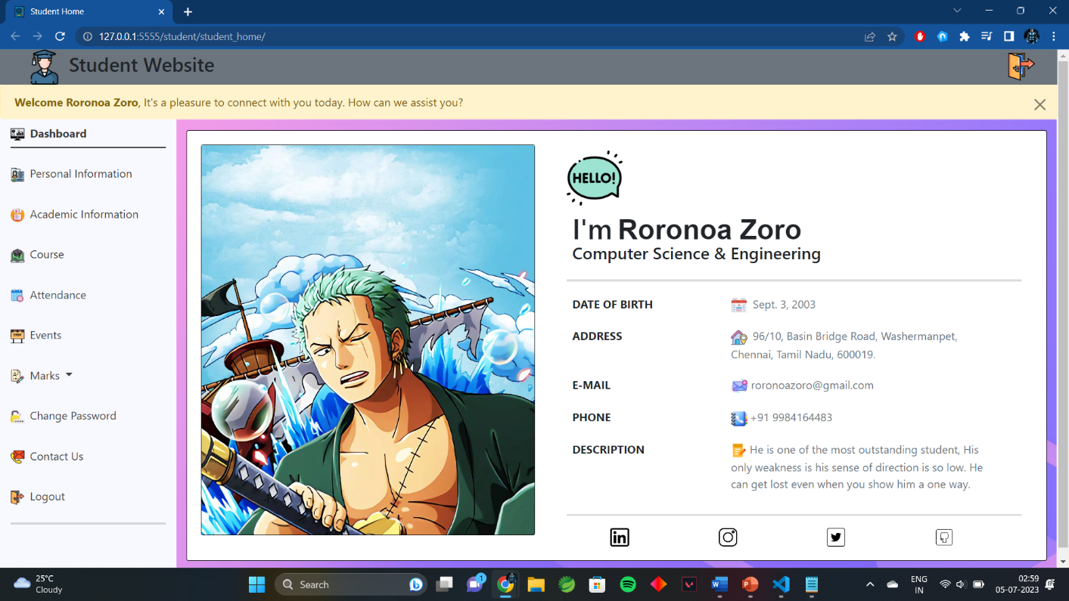

**Student Home Page**

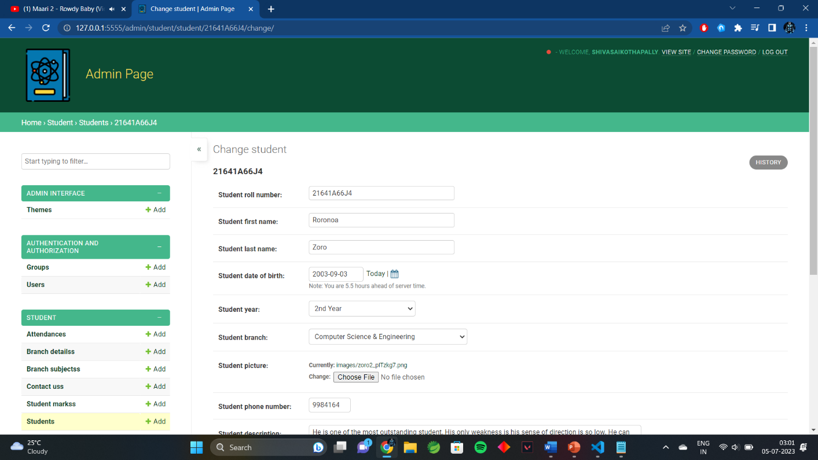

**Admin Home Page**

## CHAPTER-6

## CONCLUSION

The Student Management Website project has been a significant undertaking aimed at addressing the challenges faced by educational institutions in managing student information, academic records, and administrative tasks. Through this project, we have developed a robust, user-friendly online platform that streamlines student management processes, enhances communication, and promotes data-driven decision-making.

As we conclude this project, it is important to note that ongoing maintenance, updates, and improvements will be necessary to ensure the website remains relevant and aligned with evolving educational needs. It is our hope that this project serves as a foundation for further innovation in student management and contributes to the continuous improvement of educational institutions.

## REFERENCE

* We referred some of academic textbooks
* **For query a doubt:** [**www.google.com**](http://www.google.com/)