**Problem Statement**

Please develop a Cluster Python program and run single-link, Complete-link and average-link Clusters and upload code and screen captures.

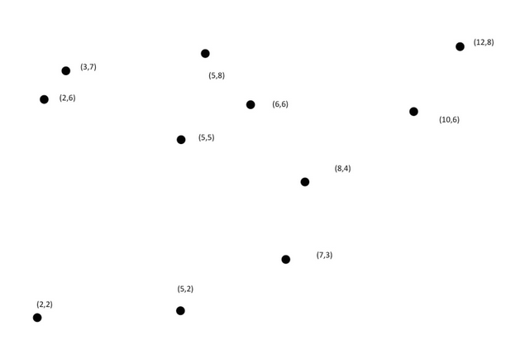

**Solution**

1. Assumption - There are 4 clusters
2. Link to code - <https://github.com/kotharisanjana/CMPE256_AdvDataMining_Fall2022/blob/main/Assignment_2/Clustering.py>

**Output**

1. Single Link -

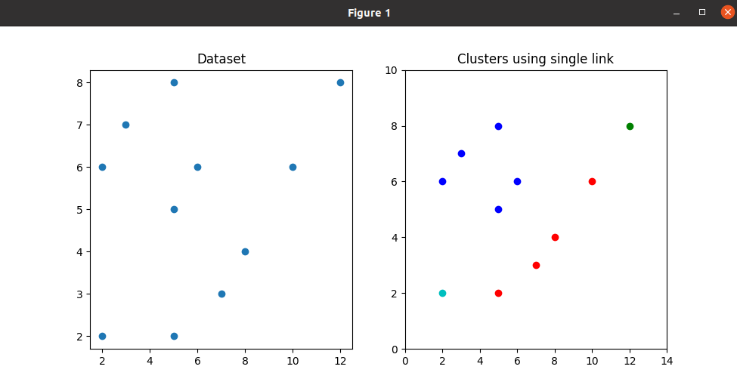

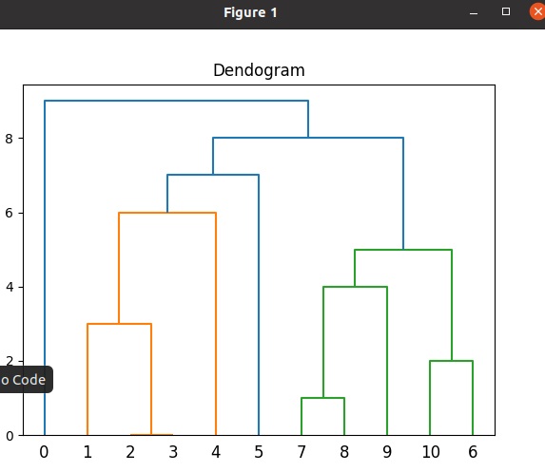

1. Average Link -

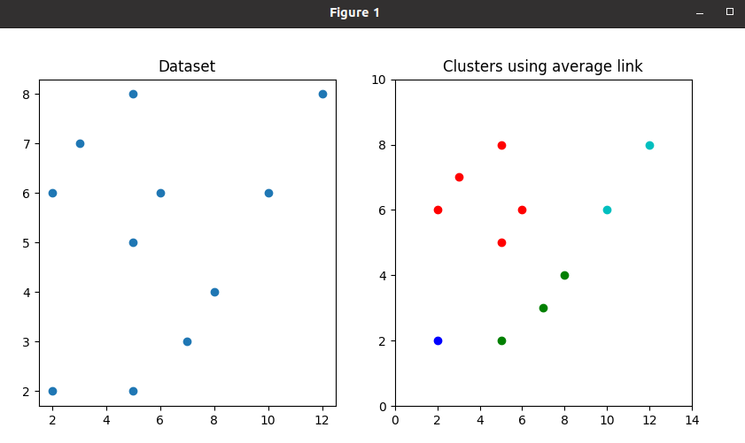

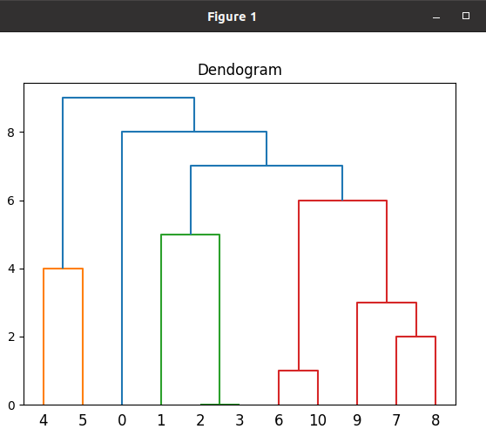

1. Complete Link -

