**What is Ansible?**

Ansible is an IT automation tool that automates provisioning, application deployment, configuration management, improving security and compliance, and shares automation across the organization. It is a powerful automation tool used to provide cross-platform computer support and streamlines the process of controlling large number of servers from one central location.

**How does Ansible work?**

In Ansible, there are two categories of computers: the control node and managed nodes. The control node is a computer that runs Ansible. A managed node is any device being managed by the control node. Ansible works by connecting to nodes on a network, and then sending a small program called an Ansible module to that node. Ansible executes these modules over SSH and removes them when finished. An Ansible module is written to be a model of the desired state of a system, used through Ansible playbooks. A playbook is a configuration file written in YAML that provides instructions for what needs to be done in order to bring a managed node into the desired state.

**Task**

1. Deploy 3 virtual machines
2. Configure Ansible server on VM 1 to deploy a web server to VM2 and VM3 on port 8080 that displays the message: “Hello World from SJSU”
3. Undeploy web server resources

**Solution**

Cloud service used - Amazon Web Services

Steps performed -

1. Create Master Node

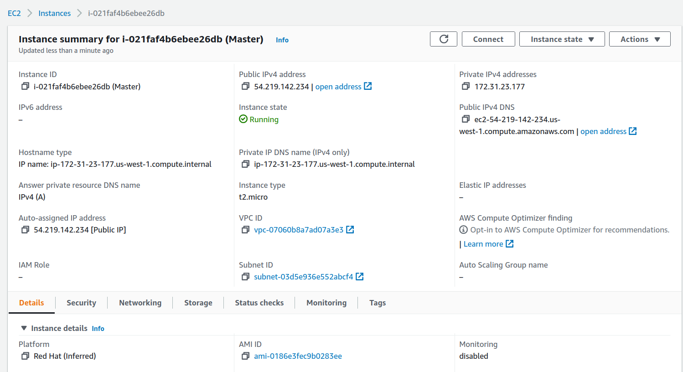

1. Generate Image and Key Pair of Master Node
2. Install Python, Ansible and Boto on Master machine

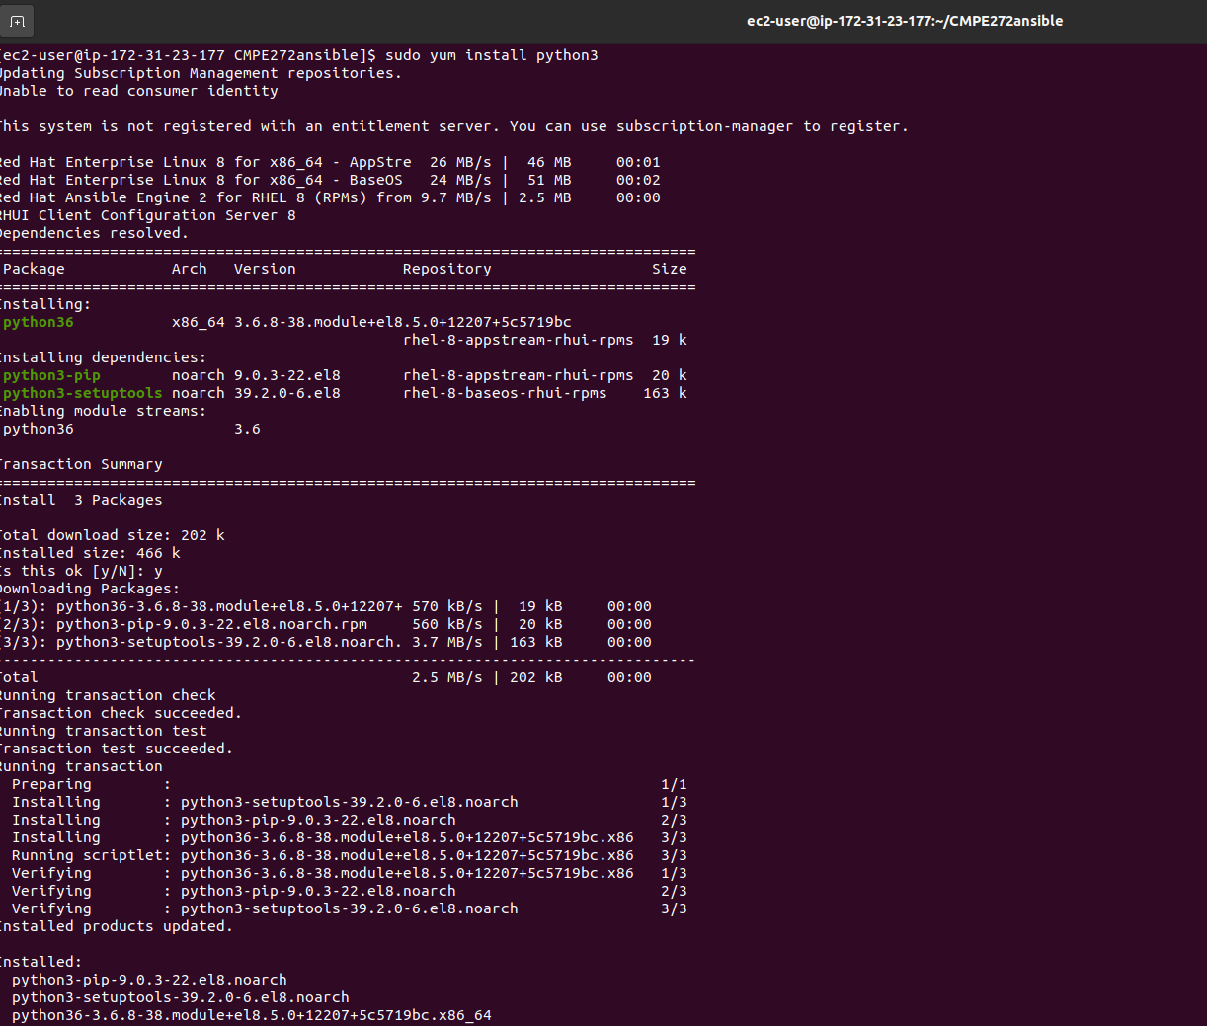

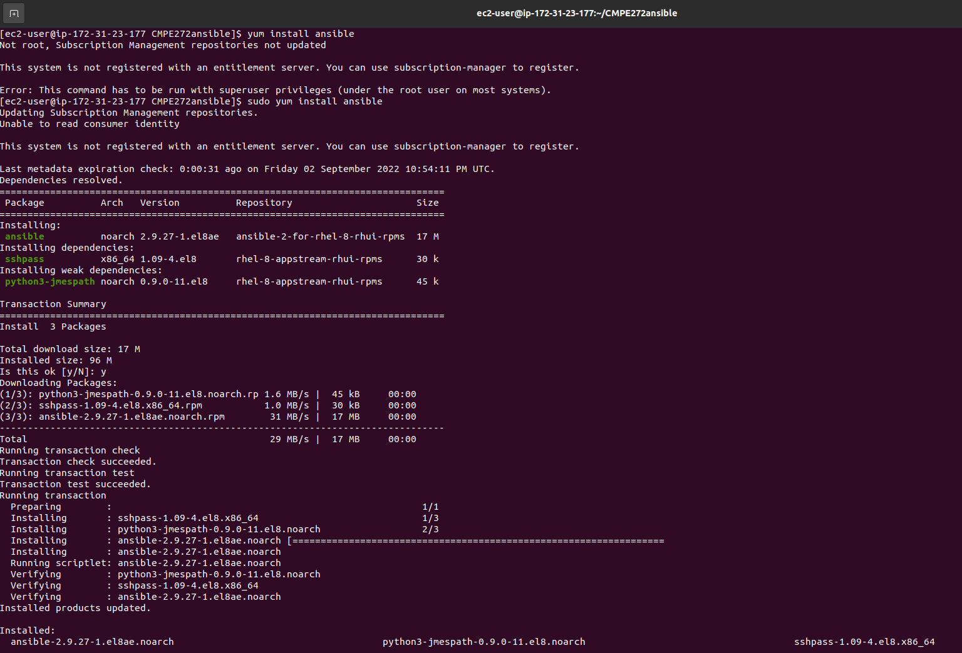



1. Create Target nodes - Target1 and Target2 using Ansible Playbook

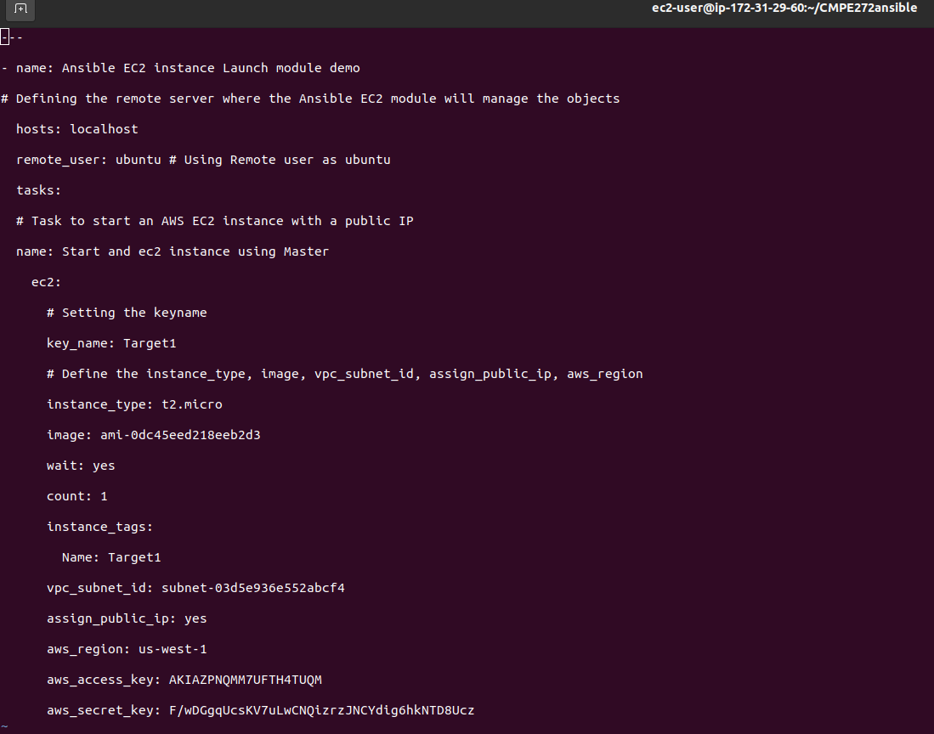

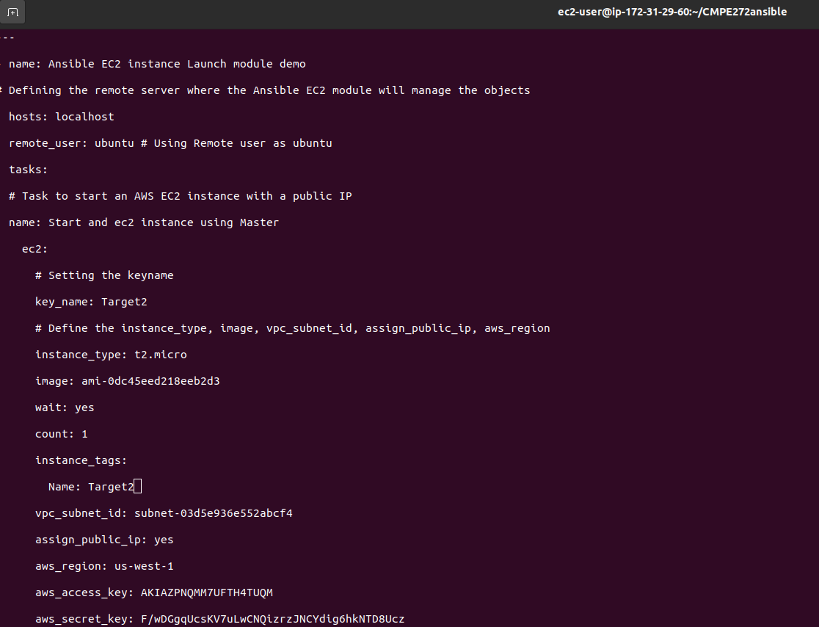

1. Deploy Target nodes

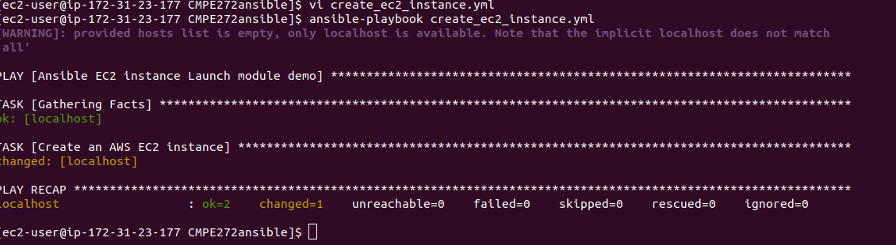

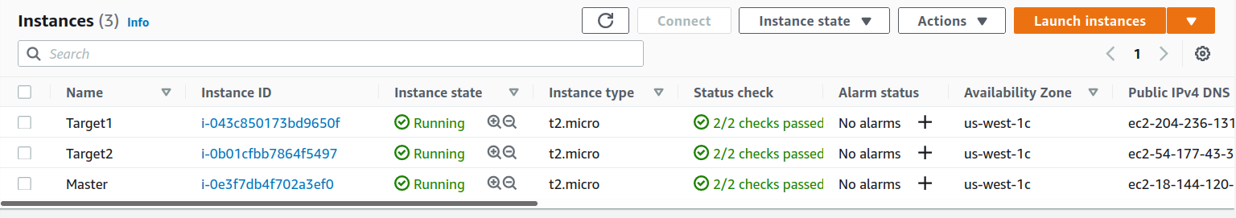

1. Generate RSA keys for Target1 and Target2 - Target1.pem and Target2.pem and save them in the folder CMPE272ansible on the Master machine

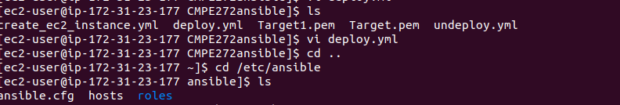

1. Attach Elastic IPS to all 3 machines so that the IP addresses are associated to my AWS account and the domain points to my instances.
2. Deploy web server on target nodes

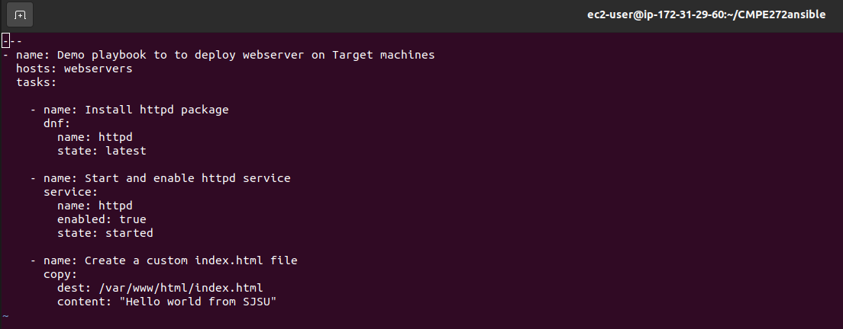

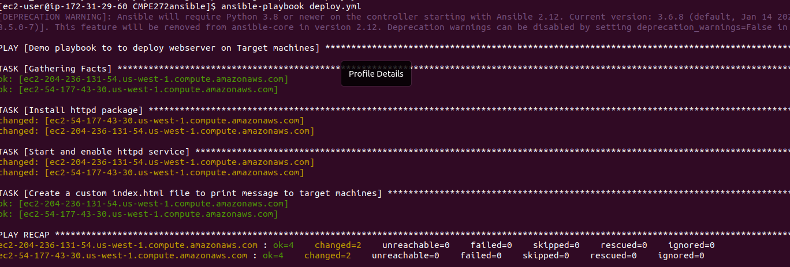

1. Message displayed on Target machines

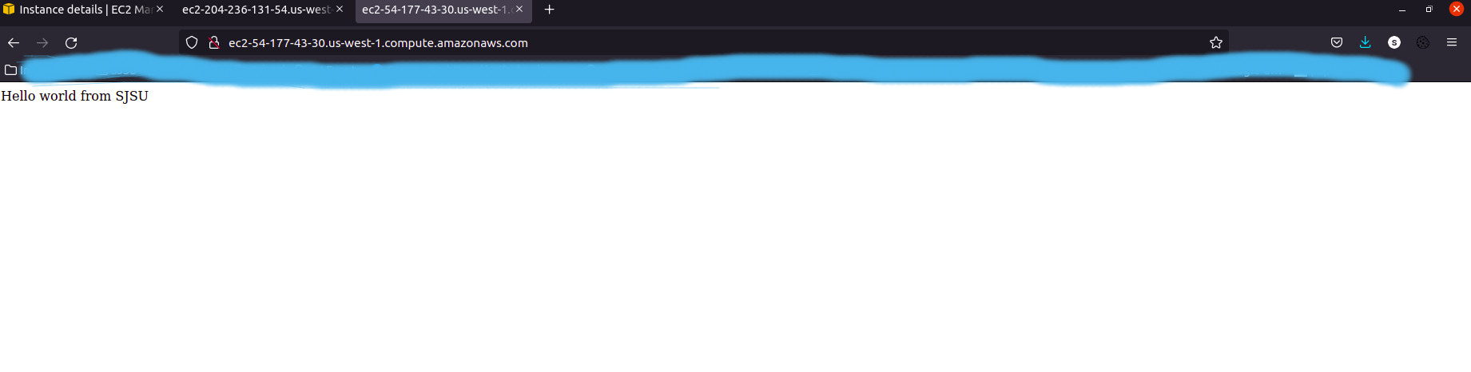

1. Undeploy web server (httpd) package from target machines

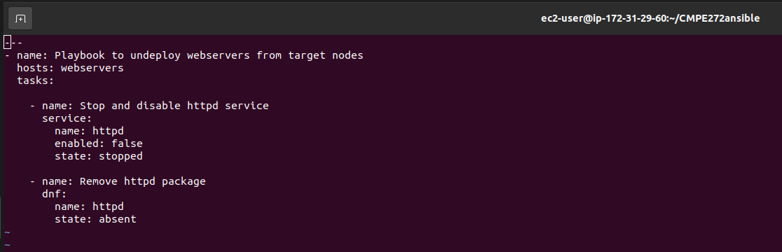

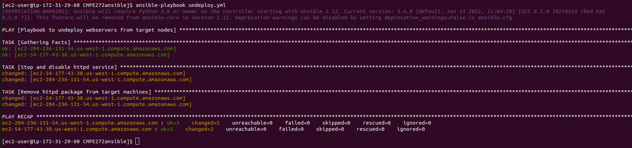

**Github link for ansible playbooks -**

<https://github.com/kotharisanjana/CMPE272_EnterpriseSWP_Fall2022>