**Jenkins Assignment**

**Team Name: - Code our Souls**

**Team members: -**

1. **Harika Satti**
2. **Siddhanth Sancheti**
3. **Sanjana Rajesh Kothari**
4. **Naga Bathula**
5. **Ravi Teja Reddy Dodda**

**Step 1: Installing Jenkins:**

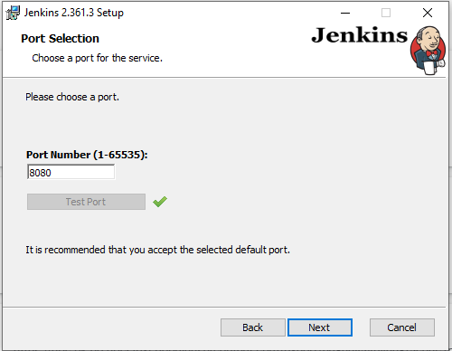

**Step 2: Starting Jenkins.**

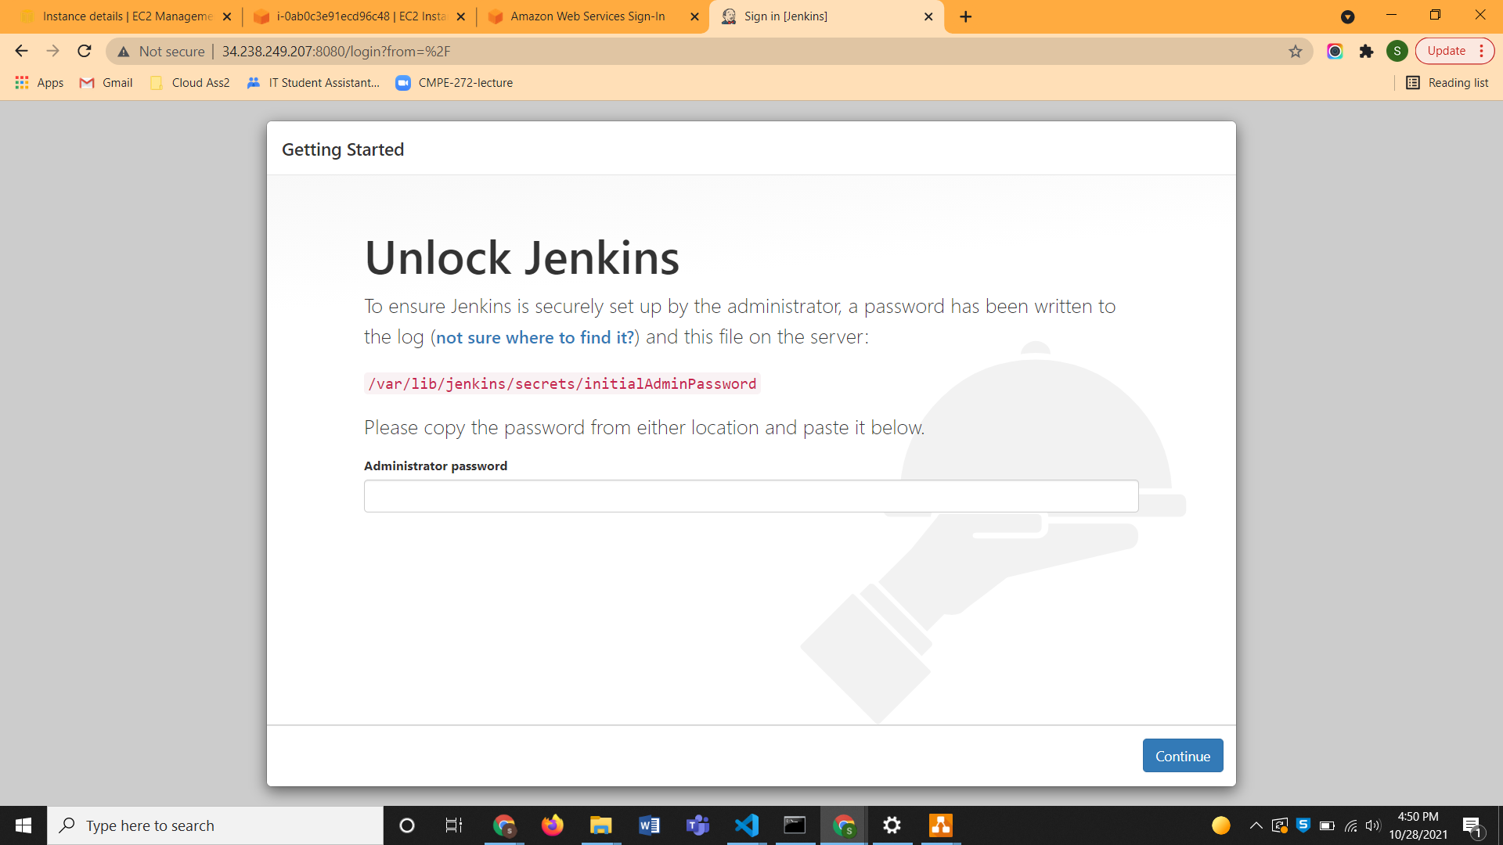

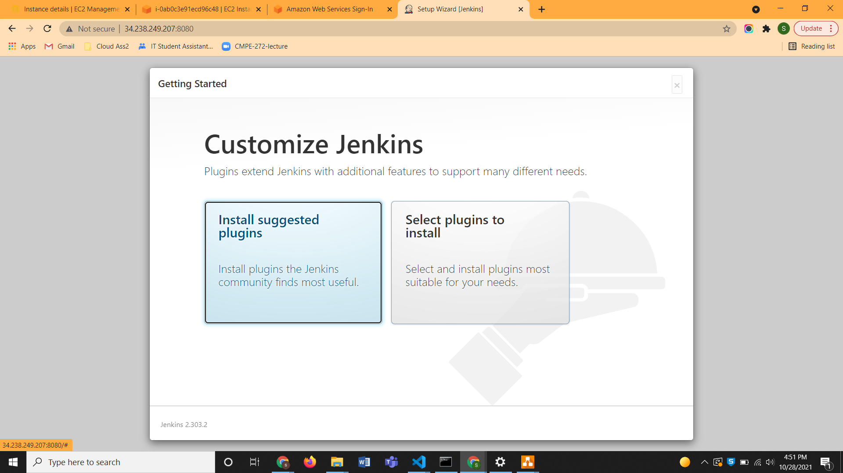

**Step 3: Creating user and logging in.**

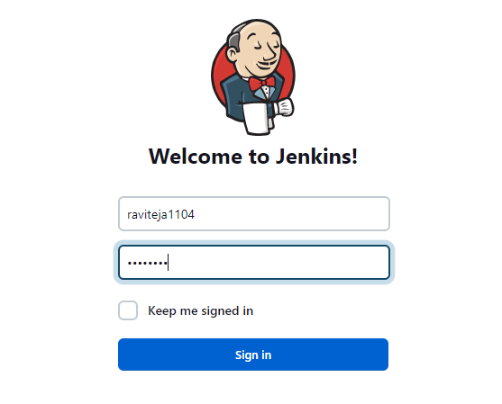

**Step 4: Create Pipeline.**

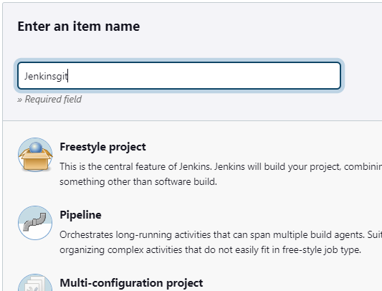

**Step 5: Integrating Jenkins with GitHub repository.**

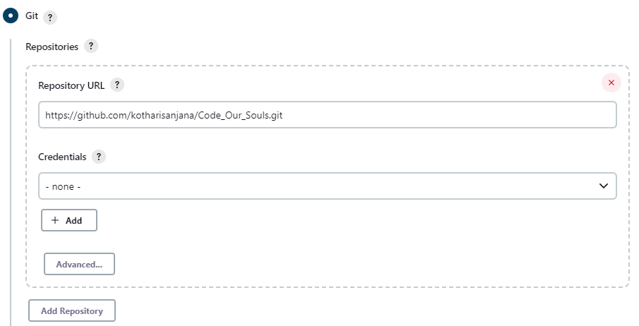

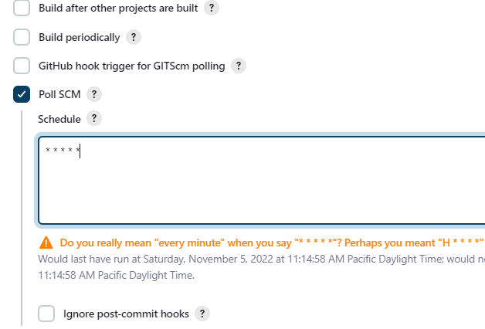

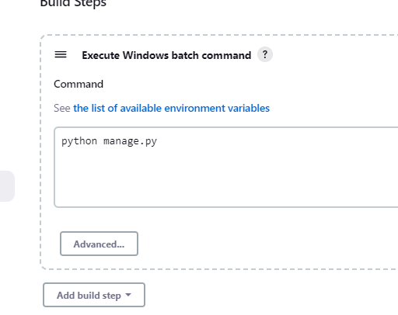

**Step 6: Building successfully**

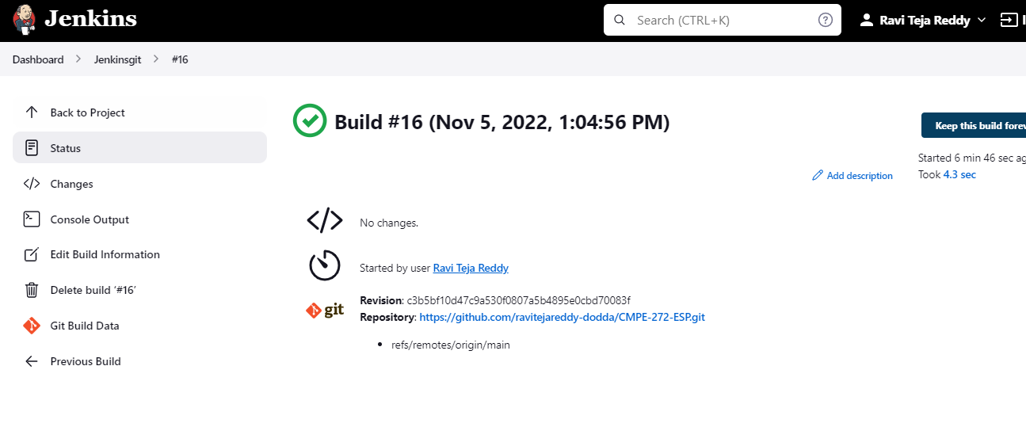

**Step 7: Adding Webhooks to Github repository**

