Grain Distribution & Export Optimization System for FCI

**Shreyans K. Jain, Vikram V. Kothekar, Abhijeet Kothari, Bahauddin Kalyani**

Department of Computer Science & Engineering, WIT Solapur

***Abstract-*** *India produces a vast amount of food grains which are more than sufficient for the country’s own need & exports. The management of food grains in India is overlooked by the Food Corporation of India. It is responsible for the management of thousands of tons of grains across the diversely geographical country. Despite the huge production, there arises situations where food is not available for people during disasters, or any such conditions.*

*In this paper we attempt to optimize the present system of distribution & management of grains across the country by applying the concepts of Big Data to the present system.*

***Keywords-*** Food Corporation of India, Big Data, Resource Management, Grain Distribution, Exports, Optimization.

# INTRODUCTION

Today’s Advanced India produces enough grains to not face any kind of grains shortage during tough times & even exports it. According to a report, India’s share in World Export of Rice was 17% in 2011. And according to the official data provided on the FCI website the total amount of wheat exported from 2012-16 was approx. 58 Lakh Metric Tons. Despite of this, many states in India still face the food shortage/unavailability problems during non-favorable conditions. The Food Corporation of India is responsible for the management & distribution of food grains across different parts of the country. Considering the above stated problem, it would be right to consider that the present system used for grain distribution across the country needs more optimization & need to be even more versatile, covering multiple factors & data from the same & previous years, in order to predict the need of grains in a particular area according to various factors such as grain production, rainfall, probability of a disaster, market requirements, exports, etc. Such an environment expects an integration of many technologies to generate results that are required by the user of the system. These results may require a versatile combination of various techniques and workarounds to achieve the designated goals.

The present system for the grain distribution & export management can be optimized a lot using the modern day Big Data technologies such as Hadoop. It can utilize the data from the past & various other factors to get us a more insightful look into the situation at hand & help us in dealing with it. The present system does not gives us any insights as to how the stored grains can be utilized more optimally & transported to other districts/states/UT’s to help reduce the food grain shortage problem there, if one arises. So, the system that we are proposing in this paper help us to get more insightful information from the FCI data while also optimizing the distribution system and hence helping in solving the age old problem of food grain shortage in India.

# LITERATURE REVIEW

The premise for the project is taken from [1]. It presents a foresight into the working of FCI & goals of FCI. The imports & exports data of the FCI is visited in [2], this web link includes the statistics provided by the FCI on the exports & Imports of food grains. The data & visualization of the total food grains export & imports & other data about other factors that are affecting the algorithm is presented by [3]. It is the data repository of the government of India. The concept of Big Data is explained in [4]. MapReduce the algorithm on which Hadoop will be processing the input data in order to give some useful insights is described in [5]. For the dynamicity of the project and its real-time implementation scope, we’ve referred this paper on the self-adjusting algorithm [6]. In order to relate huge amounts of data from varied fields to each another, we’ve referred [7] to find out the correlations in the data. Combining such amount of resources together might slow down the entire system and hence the process, so, in order to keep up the pace we referred [8] to speed up the Hadoop data processing.

# METHODOLOGY

1. **System Architecture**

Results

**Fig: System components & interactions**

The above model represents the basis for the operation of our proposed system. This system will take raw data from the Disaster Management Cluster, Rainfall Data Cluster and FCI Data Cluster .This data will be analyzed by the devised algorithm resulting into predictions of amount of grains which can be exported in forthcoming years or used at other places where they are needed.

The Main Working of our project is the Algorithm which is going to process Data from all three clusters to dynamically provide us with the data that we are going to use for calculating the total amount of extra grains in the storage. The Algorithm will cover-up various factors to get us the most accurate amount of grains that can be exported or be used at other places where there is a need of extra grains.

To make raw available data into concrete deductions for the expected results theorized, the present system is reshaped into multiple parts (with some more parts added) that are each then optimized and then put together for a reasonably improved result. The parts each have parameters that contribute to the data that’s used by the algorithm to calculate an optimum amount of grains that can be exported.

**Fig: Proposed system’s implementation diagram**

The implementation will have a single master computer system & multiple slave systems controlled by it. The master system will take input like zone ID, time-period, etc… from the user & send the data to the slaves or clusters to get back the relevant and analyzed data for that particular zone & time-period. Each slave system will be an independent Hadoop cluster which will have its own raw data accordingly. Once the master system gets all the required data from the slave systems, it’ll use this data in the algorithm to calculate the optimum amount of grains that can be exported.

1. **Modelling Diagrams**

We have used component diagrams, Use case Diagrams for better understanding of the proposed idea.

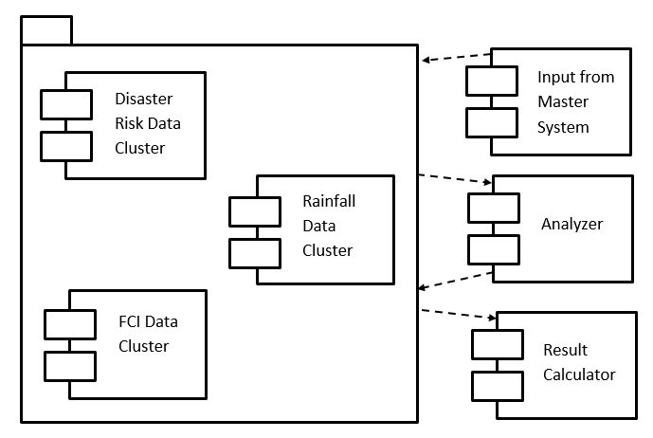

**Fig: Component Diagram**

The different components involved in the system react to and depend upon each other as well as the control systems (or, the Master System) to function expectedly.

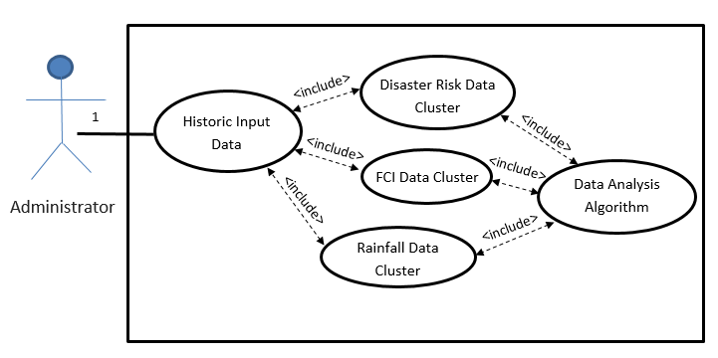

**Fig: Use Case Diagram**

Every system is directly or indirectly reacting to the inputs provided by the user. A use case diagram depicts this understanding between man and machine. Here, we input the historical data that is used to predict the target data that is going to be used for the succeeding term which in turn is used to approximate the resource allocation.

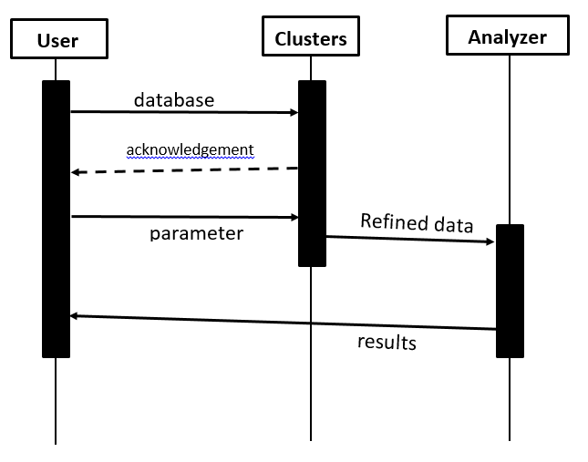

**Fig: Interaction/Sequence Diagram**

The sequence diagram shows the complete flow of all data and commands possible in the system and as such is a necessary tool for almost every project design.

1. **Dummy Data Used**

We have used some dummy data to clarify our case.

Data for FCI_Data.json:

[{  
"last_yr_stock": 1185612,  
"avrg_total_stock": 1023180,  
"last_yr_stock_left": 1214180,  
"avrg_total_stock_left": 1109911,  
"avrg_grain_exported": 10465.2,  
"last_yr_total_grain_exported": 31282.41,  
"avrg_grain_emergency_stock": 13084,  
"last_yr_grain_emergency_stock": 12964,  
"grain_used_by_gov": 381985,  
"current_total_stock": 1693116  
}]

# **Results**

We have used some dummy data to clarify our case and simplified the example visualization, simultaneously.

# **CONCLUSION**

Thus, we see that Big Data technologies are important in providing more accurate analysis, which may lead to more concrete decision-making resulting in greater operational efficiencies, cost reductions, and reduced risks for the business. This big data technology based project will be very facilitative for FCI (Food Corporation of India) and will assist to enhance export pertaining transaction and business with overseas markets. It will obviate any hasty actions during any calamities and will balance the total amount of grains in the country.

This first of its kind project will be very conducive to boost export related transactions with overseas and also help to equipoise the balance of grains within the country. It will assist FCI in accelerating export pertaining transactions, providing adequate supply of food grains to the affected area in case of a catastrophe, maintaining satisfactory levels of operational & buffer stock of food grains across the country to support National Food Security, regulating market prices for safe-guarding the interests of farmers. We heartily encourage all such endeavors and would gladly aid – in our capacity – any who require our foresight for their work, now or in the future.

# ACKNOWLEDGMENT

We would like to express our fond gratitude to Mr. D.P. Gandhmal, guide and mentor, for his omniscient guidance in the creation of this paper. Also, Mr. Prakhar Sharma gets an honorary mention for being our primary muse when we were stuck in a rut and needed esoteric ideas evaluated.

# References

1. [*Food Corporation of India - Wikipedia*](https://en.wikipedia.org/wiki/Food_Corporation_of_India)
2. [*Imports & Exports - Food Corporation of India*](http://fci.gov.in/imports.php?view=23)
3. [Data.gov.in](http://data.gov.in/)
4. Big Data  
   [Naren Ramakrishnan](http://ieeexplore.ieee.org/search/searchresult.jsp?searchWithin=%22Authors%22:.QT.Naren%20Ramakrishnan.QT.&newsearch=true); [Ravi Kumar](http://ieeexplore.ieee.org/search/searchresult.jsp?searchWithin=%22Authors%22:.QT.Ravi%20Kumar.QT.&newsearch=true)  
   [Computer](http://ieeexplore.ieee.org/xpl/RecentIssue.jsp?punumber=2) Science & Engineering
5. A Review Paper on Map Reducing Using Hadoop  
   Ms Tarunpreet Chawla, Mr Lalit, Dept. of CSE, Vivekananda Institute of Technology, Jaipur
6. Design of Self**-**Adjusting algorithm for data-intensive MapReduce Applications  
   Mr Amin Nazir Nagiwale, Mr Manish R. Umale, Computer Engineering, Lokamanya Tilak College of Engineering, Mumbai
7. SigCO: Mining Significant Correlations via a Distributed Real-time Computation EngineTian Guo, EPFL, Lausanne, Switzerland
8. Accelerating Apache Spark Big Data Analysis with FPGAs  
   Ehsan Ghasemi, Paul Chow, Dept. of Electrical and Computer Engineering, University of Toronto