

**A**

**MINI-PROJECT REPORT**

**ON**

**“COMPLAINT MANAGEMENT SYSTEM”**

Submitted in partial fulfillment of the requirement for the award of

**Bachelor of Engineering**

**In**

**Computer Science and Engineering**

**Solapur University**

By

**Shreyans K. Jain – 28 (605369)**

**Bahauddin Kalyani – 30 (605374)**

**Abhijeet Kothari – 01 (605383)**

**Vikram Kothekar – 34 (605385)**

Under Guidance Of

**Mr. S. N. Deshpande**



**DEPARTMENT OF COMPUTER SCIENCE AND ENGINEERING**

**WALCHAND INSTITUE OF TECHNOLOGY**

**SOLAPUR - 413006**

**(2015-2016)**



**CERTIFICATE**

This is to certify that the Mini-Project entitled

**“Complaint Management System”**

Is

Submitted By

**Shreyans K. Jain – 28 (605369)**

**Bahauddin Kalyani – 30 (605374)**

**Abhijeet Kothari – 01 (605383)**

**Vikram Kothekar – 34 (605385)**

**-----------------------------------  
(Mr. R.V. Argiddi)  
*Head  
Dept. Of Computer Sc. & Eng.***

**-----------------------------------  
(Dr. S.A. Halkude)  
*Principal***

**-----------------------------------  
(Mr. S. N. Deshpande)  
*Project Guide***

**DEPARTMENT OF COMPUTER SCIENCE AND ENGINEERING**

**WALCHAND INSTITUE OF TECHNOLOGY**

**SOLAPUR**

**(2015-2016)**

**INDEX**

|  |  |  |
| --- | --- | --- |
| Sr. No. | Topic | Page No. |
| 1 | Abstract | 4 |
| 2 | Introduction and Background | 5 |
| 3 | Technologies used | 6 |
| 4 | Description and Working | 8 |
| 5 | Objectives and Goals | 10 |
| 6 | Screenshots and Results | 11 |
| 7 | Advantages and Disadvantages | 13 |
| 8 | The Next Phase | 13 |
| 9 | Conclusion | 14 |
| 10 | References | 14 |

**ABSTRACT**

* This Complaint Management System is developed under the ‘Smart City’ initiative for ‘Solapur Municipal Corporation’.
* It consists of an Android App on the user (or public) side & a website on the corporation side (for viewing complaints).
* This Complaint Management System will be used by the people to report any complaints to the municipal corporation with a photo, location details, heading & a description of it.  
  For e.g. You are going for a walk in your colony, you saw a pothole; now instead of going to municipality & filling out forms & switching from one counter to another, you can file a complaint by clicking a pic of the pothole, adding a subject & description to the complaint, the location will be taken automatically; and you’re done. The complaint will be reported.
* Softwares used in project:  
  Dreamweaver CC 2015, Sublime Text, Firefox, XAMPP, Android Studio, Backendless PHP SDK, Backendless Android SDK.
* Services used in project:-  
  mBaaS (Backendless).
* Project Contents:

1. Android Application on complain filing side. Supported Android Version: all after, Ice Cream Sandwich.
2. A Website (HTML5, CSS3, Php) on Municipal Corporation side. Compatibility: Firefox (>v.20), Chrome (>v.14), IE (>v.9).

**Introduction & Background**

Filing complaints for problems that are faced daily by the common people is pretty hard considering the number of different counters that a person has to visit to file the complaint.  
  
With this **Complaint Management System** which issupporting ‘Smart City Initiative’ and ‘Digital India Initiative’ we aim to simplify the complaint filing system which is currently in use. With this **Complaint Management System** we are providing an android app for the complaint filing to the general public and we are also providing a digital record storage of the complaints filed which reduces the consumption of paper and digitalizes the complaint filing system.

The municipal corporation is provided with a website based solution to review the complaints filed by the general public. The website platform will also provide features like sorting based on area, complaint filing date, priority, departments etc. It will also provide direct communication between user and the municipal corporation people & also closing of the complaint on both the user and municipal corporation sides. These features will ensure that the complaints are actually resolved and hence reducing corruption in the municipal corporation.

For e.g. You are going for a walk in your colony, you saw a pothole; now instead of going to municipality & filling out forms & switching from one counter to another, you can file a complaint by clicking a pic of the pothole, adding a subject & description to the complaint, the location will be taken automatically; and you’re done. The complaint will be reported.

Now, the filed Complaint will be reported to the Municipal Corporation on the Complaint Management System website. And, the complaint will be processed to resolve the issue/problem that is being faced by the user.

**Technologies Used**

**mBaaS – Mobile Backend As A Service**Mobile backend as a service (MBaaS), also known as "backend as a service" (BaaS), is a model for providing web and [mobile app](https://en.wikipedia.org/wiki/Mobile_app) developers with a way to link their applications to [backend](https://en.wikipedia.org/wiki/Front_and_back_ends) [cloud storage](https://en.wikipedia.org/wiki/Cloud_storage) and APIs exposed by back end applications while also providing features such as user management, [push notifications](https://en.wikipedia.org/wiki/Push_technology), and integration with [social networking services](https://en.wikipedia.org/wiki/Social_networking_service). These services are provided via the use of custom [Software Development Kits](https://en.wikipedia.org/wiki/Software_development_kit) (SDKs) and [Application Programming Interfaces](https://en.wikipedia.org/wiki/Application_programming_interface) (APIs). BaaS is a relatively recent development in cloud computing, with most BaaS [startups](https://en.wikipedia.org/wiki/Startup_company) dating from 2011 or later. Although a fairly nascent industry, trends indicate that these services are gaining mainstream traction with enterprise consumers.  
  
Web and mobile apps require a similar set of features on the backend, including [push notifications](https://en.wikipedia.org/wiki/Push_technology), integration with [social networks](https://en.wikipedia.org/wiki/Social_network), and [cloud storage](https://en.wikipedia.org/wiki/Cloud_storage). Each of these services has its own [API](https://en.wikipedia.org/wiki/Application_programming_interface) that must be individually incorporated into an app, a process that can be time-consuming and complicated for app developers. BaaS providers form a bridge between the [frontend](https://en.wikipedia.org/wiki/Front_and_back_ends) of an application and various cloud-based backends via a unified API and [SDK](https://en.wikipedia.org/wiki/Software_development_kit).

Providing a consistent way to manage backend data means that developers do not need to redevelop their own backend for each of the services that their apps need to access, potentially saving both time and money. Although similar to other cloud-computing developer tools, such as [Software As A Service](https://en.wikipedia.org/wiki/Software_as_a_service) (SaaS), [Infrastructure As A Service](https://en.wikipedia.org/wiki/Cloud_computing#Infrastructure_as_a_service_.28IaaS.29) (IaaS), and [Platform As A Service](https://en.wikipedia.org/wiki/Platform_as_a_service) (PaaS), BaaS is distinct from these other services in that it specifically addresses the cloud-computing needs of web and mobile app developers by providing a unified means of connecting their apps to cloud services.  
  
The mBaaS service we’ve used is provided by [Backendless.com](http://backendless.com/) .

**HTML5 & CSS3**These are the premiere languages used in website development in these modern times.

**HTML5** is the latest version of the HTML standard. HTML5 includes detailed processing models to encourage more interoperable implementations; it extends, improves and rationalizes the markup available for documents, and introduces markup and [Application Programming Interfaces](https://en.wikipedia.org/wiki/Application_programming_interfaces) (APIs) for complex [web applications](https://en.wikipedia.org/wiki/Web_application). For the same reasons, HTML5 is also [a candidate for cross-platform mobile applications](https://en.wikipedia.org/wiki/HTML5_in_mobile_devices), because it includes features designed with low-powered devices such as smartphones and tablets.  
  
[**CSS3**](https://en.wikipedia.org/wiki/CSS3) is an abbreviation for Cascading Style Sheets, level 3, a declarative stylesheet language for structured documents. CSS is a [style sheet language](https://en.wikipedia.org/wiki/Style_sheet_language) used for describing the [presentation](https://en.wikipedia.org/wiki/Presentation_semantics) of a document written in a [markup language](https://en.wikipedia.org/wiki/Markup_language).

**Android Application Development  
  
Android** is a [mobile operating system](https://en.wikipedia.org/wiki/Mobile_operating_system) (OS) currently developed by [Google](https://en.wikipedia.org/wiki/Google), based on the [Linux kernel](https://en.wikipedia.org/wiki/Linux_kernel) and designed primarily for [touchscreen](https://en.wikipedia.org/wiki/Touchscreen) mobile devices such as [smartphones](https://en.wikipedia.org/wiki/Smartphone) and [tablets](https://en.wikipedia.org/wiki/Tablet_computer). Android's [user interface](https://en.wikipedia.org/wiki/User_interface) is mainly based on [direct manipulation](https://en.wikipedia.org/wiki/Direct_manipulation_interface), using touch gestures that loosely correspond to real-world actions, such as swiping, tapping and pinching, to manipulate on-screen objects, along with a [virtual keyboard](https://en.wikipedia.org/wiki/Virtual_keyboard) for text input. Android applications are developed using the Java language. As of now, that’s really your only option for native applications.

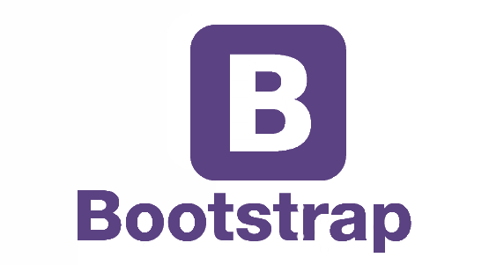

**  
  
  
Description and Working of Project**

It’s a really simple solution to a complex daily routine problem. The user side has an android application, which the user will use to file a complaint to the municipal corporation. On the first installation of the application, the user is required to register on the platform. After registration he/she can directly file complaints by clicking a picture of the problem, adding a subject and some description about the problem. The location where the problem exists is automatically fetched.

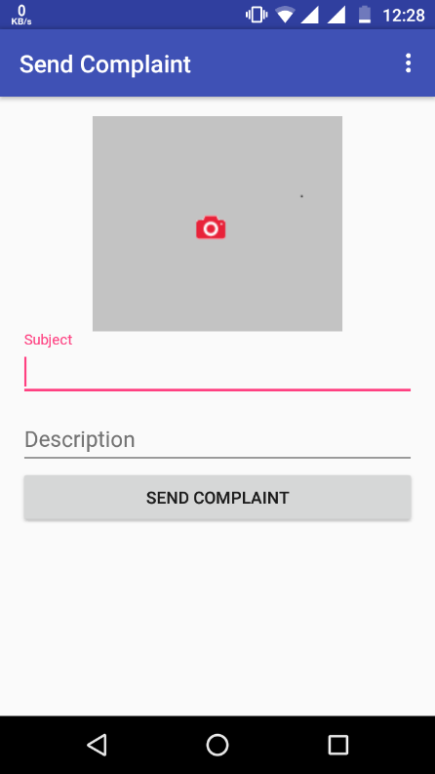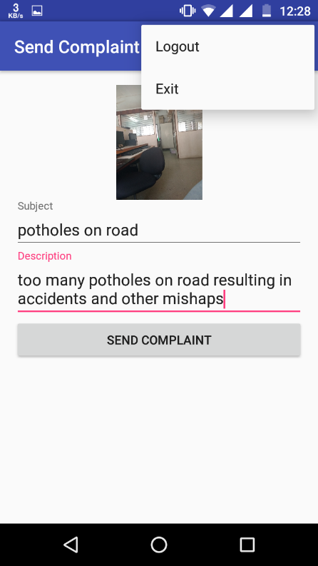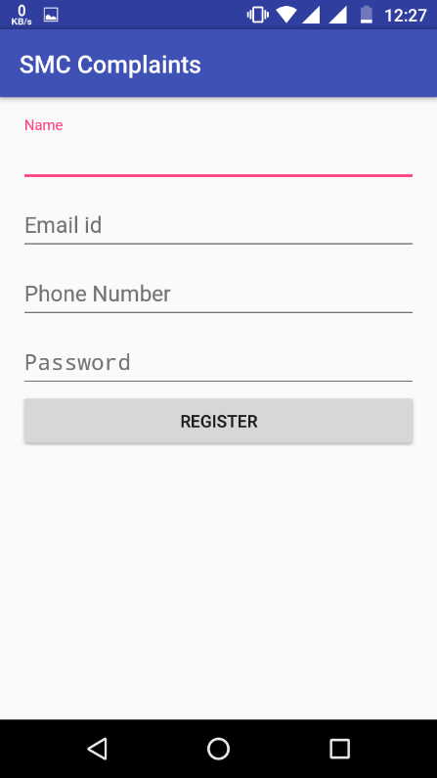

The Complaint is then sent to the database & stored. Now, these stored complaints are shown on the website. The website also has an admin login feature & acts as an Administrator Dashboard.  
The ‘Complaints’ page displays all the complaints in a group of 10. Each complaint has a ‘Continue Reading’ feature to go the complaint details & focus on just a single complaint. The ‘Complaint Details’ page will also have the features of commenting & Communication with the administration side (Municipal Corporation side). It will also have the feature of closing the complaint from the user side as well.

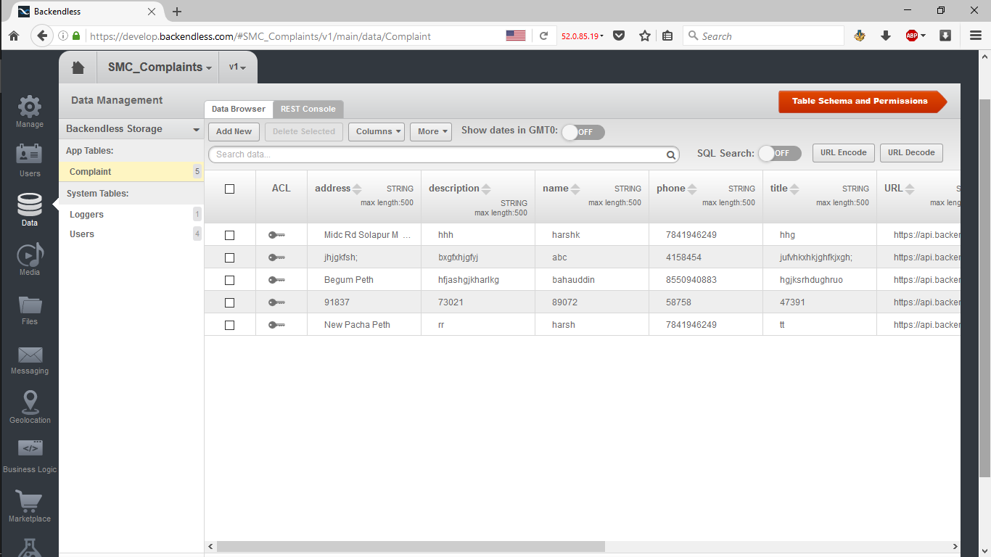–

**Objectives & Goals**

Our project aims to simplify the Complaint Filing System present today to a more digitally improved and efficient method which will ensure that the complaints are actually processed and solved.

Our project also supports the ‘Digital India” Initiative & ‘Smart City’ Initiative of the Central Government.



**Screenshots**

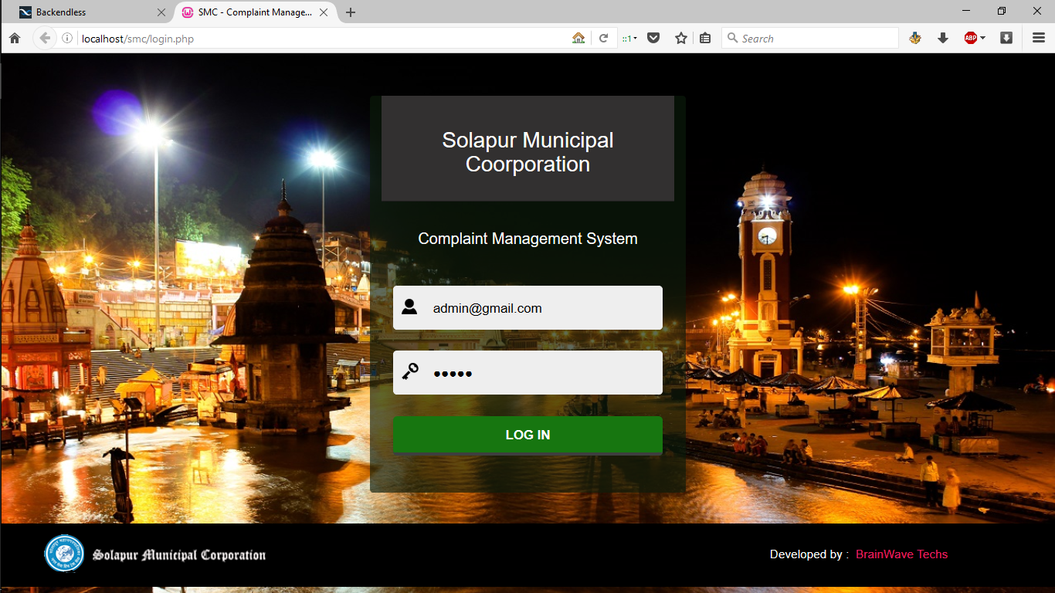

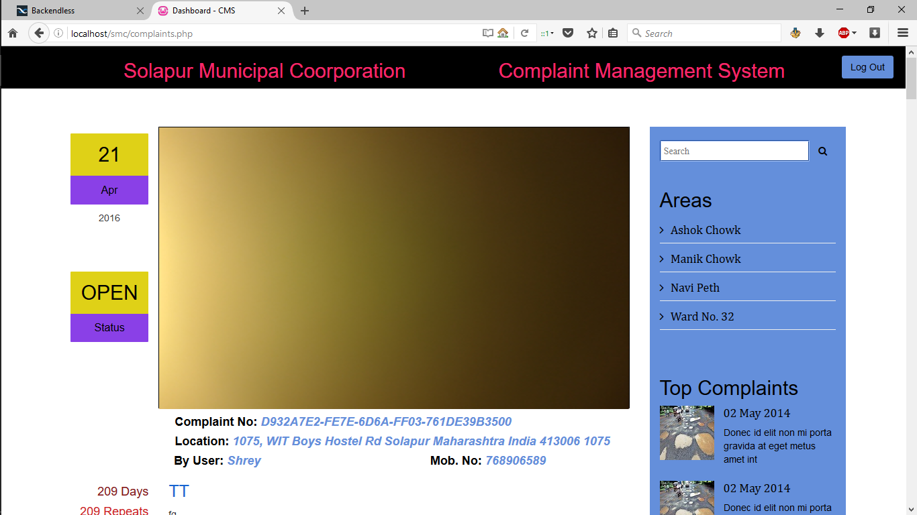

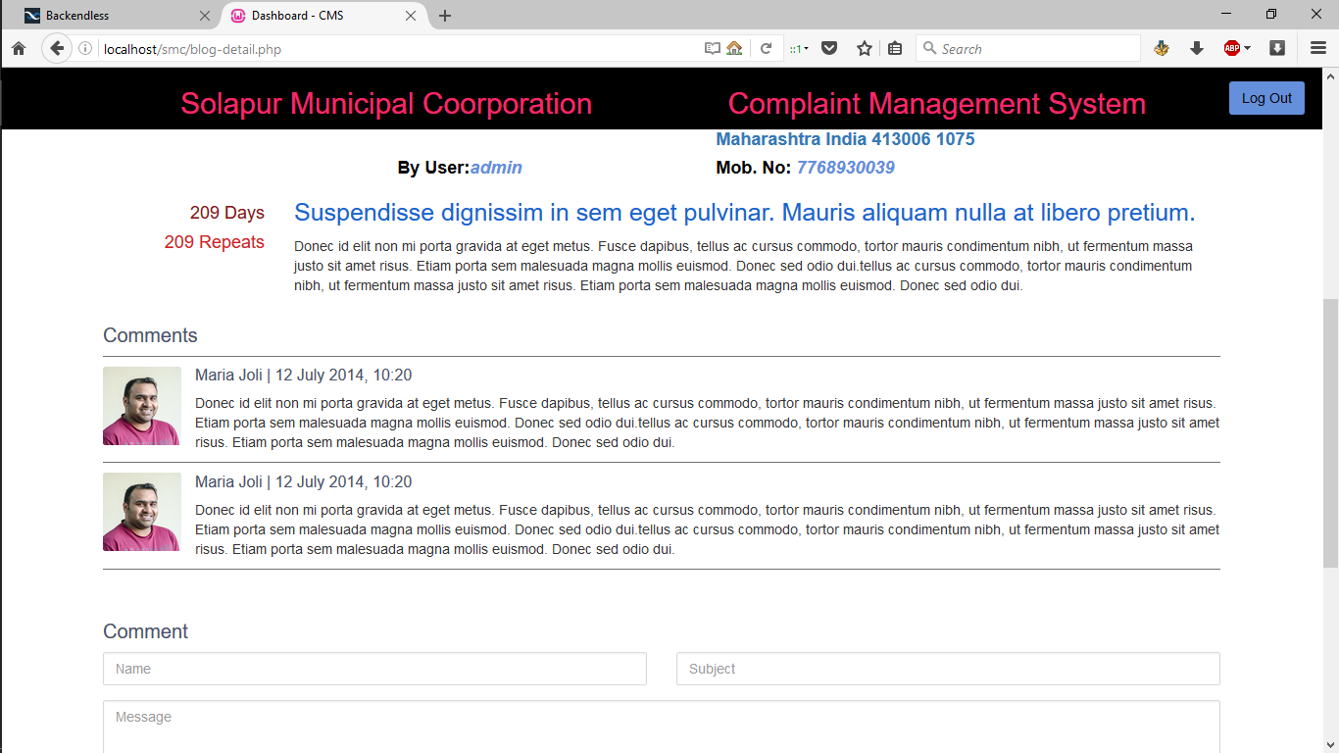

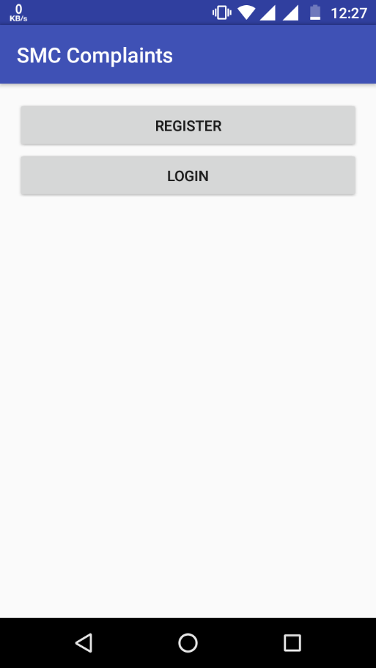

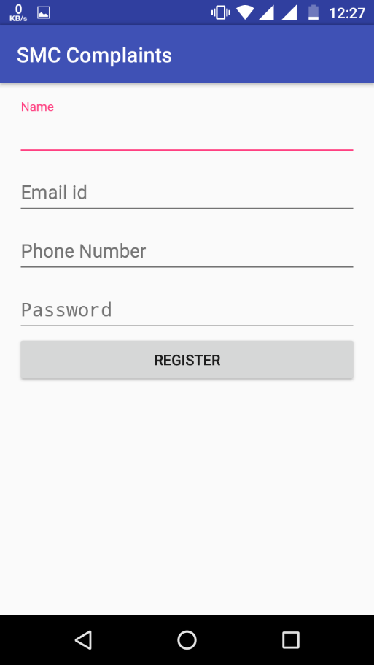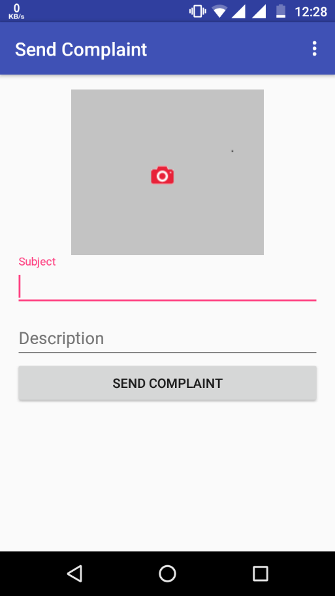

**Advantages and Disadvantages**

**Advantages**

* Anyone can use it (Android is the most widely used platform).
* The Complaint Management System is simplified as compared to the present system.
* Saves time of filing a complaint.
* You would be helping in the development of your city.
* The city will prosper & become developed with this direct involvement of the citizens with this complaint management system.
* The problems in the city will decrease exponentially with the Municipal Corporation knowing exactly where, and what type of problem is there being faced by the people.

**Disadvantages**

* A spam problem might occur. Although we’ve implemented proper measures to filter the spam, but still.
* Not everybody has an Android Smartphone.
* Internet Connectivity is required to file the complaint, which is not always possible.

**The Next Phase of this System**

* In the next phase of this Complaint Management System, we’ll be providing a feature ‘Complaint Later’ to overcome the problems of internet connectivity.
* Also, we’ll be providing the user with the facility to view its filed complaints, sorted according to the status of the complaint, filing date, status of compliant, etc.
* We’ll also provide direct communication between the user & the people at Municipal Corporation, so that the problem can be resolved in a better way.
* At the Municipal Corporation end, we’ll be providing the sorting features like sorting according to date, status, priority, etc. Also, features like closing a complaint, replying to the user comment, prioritizing a user according to the number of actual complaints filed by him/her.

**Conclusions and discussion**

In this work, we have presented a thorough replacement of the present complaint management system which is completely digital and secure. We have created a complaint registration app on the world’s largest used mobile OS platform, Android. And to ease up the tasks of the municipal corporation we have provided a website based dashboard.

We created a way in which the past solution can be enhanced and the ways in which interactions between the new system & the past system can be handled. In addition, this report gives a comprehensive review of theoretical background of methods and technologies used in website and app.

**References**

* backendless.com
* [www.stackoverflow.com](http://www.stackoverflow.com)
* Php.net
* getbootstrap.com
* www.w3schools.com