

Functional Safety Concept Lane Assistance

**Document Version: [Version]**

**Template Version 1.0, Released on 2017-06-21**



# Document history

|  |  |  |  |
| --- | --- | --- | --- |
| Date | Version | Editor | Description |
| 01.04.2018 | 1.0 | Siddarth Kothiwale | First Trial |
|  |  |  |  |
|  |  |  |  |
|  |  |  |  |
|  |  |  |  |

# 

# Table of Contents

Document history

Table of Contents

Purpose of the Functional Safety Concept

Inputs to the Functional Safety Analysis

Safety goals from the Hazard Analysis and Risk Assessment

Preliminary Architecture

Description of architecture elements

Functional Safety Concept

Functional Safety Analysis

Functional Safety Requirements

Refinement of the System Architecture

Allocation of Functional Safety Requirements to Architecture Elements

Warning and Degradation Concept

# Purpose of the Functional Safety Concept

The functionalional safety concept looks at item from higher level without going too deep in technicalities.

We need to allocate these safety requirements to the relevant parts of the system diagram. Allocation means defining which part of the system architecture will implement each requirement. This could involve expanding the system architecture with new element blocks.

We will then refine the system architecture to handle the new requirements.

This all information is handled in Functional safety concept.

# Inputs to the Functional Safety Concept

## Safety goals from the Hazard Analysis and Risk Assessment

|  |  |
| --- | --- |
| **ID** | **Safety Goal** |
| Safety_Goal_01 | The Oscillating steering torque from the lane departure warning function shall be limited. |
| Safety_Goal_02 | The Lane keeping assistance function shall be time limited and the additional steering torque shall end after a given time interval so that the driver cannot misuse the systema for autonomous driving |

## Preliminary Architecture

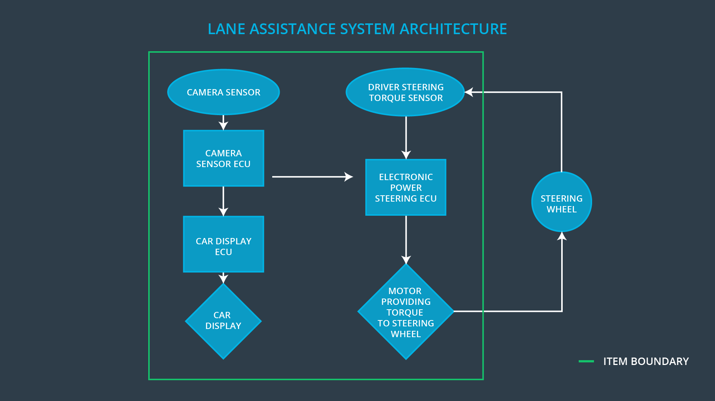

### Description of architecture elements

|  |  |
| --- | --- |
| **Element** | **Description** |
| Camera Sensor | To record the video of the road ahead |
| Camera Sensor ECU | To process the video from Camera Sensor and detect the lane lines |
| Car Display | To Display the warnings such as lane departure |
| Car Display ECU | Car Display processes the input from the Camera sensor ECU and provides different warnings |
| Driver Steering Torque Sensor | It detects the torque that the driver is providing |
| Electronic Power Steering ECU | The ECU calculates the necessity and the amount of torque that needs to be provided to keep the car in the lane |
| Motor | The Motor is the actuator here. It takes the input from the ECU and then provides the required torque to the steering wheel |

# Functional Safety Concept

The functional safety concept consists of:

* Functional safety analysis
* Functional safety requirements
* Functional safety architecture
* Warning and degradation concept

## Functional Safety Analysis

|  |  |  |  |
| --- | --- | --- | --- |
| **Malfunction ID** | **Main Function of the Item Related to Safety Goal Violations** | **Guidewords (NO, WRONG, EARLY, LATE, MORE, LESS)** | **Resulting Malfunction** |
| Malfunction_01 | Lane Departure Warning (LDW) function shall apply an oscillating steering torque to provide the driver a haptic feedback | MORE | The lane departure warning function applies an oscillating torque with very high torque amplitude |
| Malfunction_02 | Lane Departure Warning (LDW) function shall apply an oscillating steering torque to provide the driver a haptic feedback | MORE | The lane departure warning function applies an oscillating torque with very high torque frequency |
| Malfunction_03 | Lane Keeping Assistance (LKA) function shall apply the steering torque when active in order to stay in ego lane | NO | The lane keeping assistance function is not limited in time duration which leads to misuse as an autonomous driving function. |

## Functional Safety Requirements

Lane Departure Warning (LDW) Requirements:

|  |  |  |  |  |
| --- | --- | --- | --- | --- |
| **ID** | **Functional Safety Requirement** | **ASIL** | **Fault Tolerant Time Interval** | **Safe State** |
| Functional  Safety  Requirement  01-01 | The lane keeping item shall ensure that the lane departure oscillating torque amplitude is below Max_Torque_Amplitude | C | 50 ms | Set System torque to 0 |
| Functional  Safety  Requirement  01-02 | The lane keeping item shall ensure that the lane departure oscillating torque frequency is below Max_Torque_Frequency | C | 50 ms | Set System torque to 0 |

Lane Departure Warning (LDW) Verification and Validation Acceptance Criteria:

|  |  |  |
| --- | --- | --- |
| **ID** | **Validation Acceptance**  **Criteria and Method** | **Verification Acceptance**  **Criteria and Method** |
| Functional  Safety  Requirement  01-01 | test how drivers react to different torque amplitudes to prove that we chose an appropriate value | when the torque amplitude crosses the limit, the lane assistance output is set to zero within the 50 ms fault tolerant time interval.  Method: test inserting a fault into the system and seeing what happens. |
| Functional  Safety  Requirement  01-02 | test how drivers react to different torque Frequencies to prove that we chose an appropriate value | when the torque Frequency crosses the limit, the lane assistance output is set to zero within the 50 ms fault tolerant time interval.  Method: test inserting a fault into the system and seeing what happens. |

Lane Keeping Assistance (LKA) Requirements:

|  |  |  |  |  |
| --- | --- | --- | --- | --- |
| **ID** | **Functional Safety Requirement** | **ASIL** | **Fault Tolerant Time Interval** | **Safe State** |
| Functional  Safety  Requirement  02-01 | the electronic power steering ECU shall ensure that the lane keeping assistance torque is applied for only Max_Duration | B | 500 ms | Set System torque to 0 |

Lane Keeping Assistance (LKA) Verification and Validation Acceptance Criteria:

|  |  |  |
| --- | --- | --- |
| **ID** | **Validation Acceptance**  **Criteria and Method** | **Verification Acceptance**  **Criteria and Method** |
| Functional  Safety  Requirement  02-01 | the max_duration chosen really did dissuade drivers from taking their hands off the wheel | verify that the system really does turn off if the lane keeping assistance every exceeded max_duration |

## Refinement of the System Architecture

## Allocation of Functional Safety Requirements to Architecture Elements

|  |  |  |  |  |
| --- | --- | --- | --- | --- |
| **ID** | **Functional Safety Requirement** | **Electronic Power Steering ECU** | **Camera ECU** | **Car Display ECU** |
| Functional  Safety  Requirement  01-01 | The lane keeping item shall ensure that the lane departure oscillating torque amplitude is below Max_Torque_Amplitude | **x** |  |  |
| Functional  Safety  Requirement  01-02 | The lane keeping item shall ensure that the lane departure oscillating torque frequency is below Max_Torque_Frequency | **x** |  |  |
| Functional  Safety  Requirement  02-01 | the electronic power steering ECU shall ensure that the lane keeping assistance torque is applied for only Max_Duration | **x** |  |  |

## Warning and Degradation Concept

|  |  |  |  |  |
| --- | --- | --- | --- | --- |
| **ID** | **Degradation Mode** | **Trigger for Degradation Mode** | **Safe State invoked?** | **Driver Warning** |
| WDC-01 | Turn off the function | Amplitude> Max_Torque_Amplitude and  Frequency> Max_Torque_Frequency | Yes | Warning sign in driver display system |
| WDC-02 | Turn off the function | If LKA active for time > Max_Duration | Yes | Warning sign in driver display system |