

Technical Safety Concept Lane Assistance

**Document Version: [Version]**

**Template Version 1.0, Released on 2017-06-21**



# Document history

|  |  |  |  |
| --- | --- | --- | --- |
| Date | Version | Editor | Description |
| 02.04.2018 | 1.0 | Siddarth Kothiwale | First edit |
|  |  |  |  |
|  |  |  |  |
|  |  |  |  |
|  |  |  |  |

# 

# Table of Contents

Document history

Table of Contents

Purpose of the Technical Safety Concept

Inputs to the Technical Safety Concept

Functional Safety Requirements

Refined System Architecture from Functional Safety Concept

Functional overview of architecture elements

Technical Safety Concept

Technical Safety Requirements

Refinement of the System Architecture

Allocation of Technical Safety Requirements to Architecture Elements

Warning and Degradation Concept

# Purpose of the Technical Safety Concept

Technical safety concept is more concrete and gets into the details of the item's technology. It involves:

* Turning functional safety requirements into technical safety requirements
* Allocating technical safety requirements to the system architecture

# Inputs to the Technical Safety Concept

## Functional Safety Requirements

|  |  |  |  |  |
| --- | --- | --- | --- | --- |
| **ID** | **Functional Safety Requirement** | **ASIL** | **Fault Tolerant Time Interval** | **Safe State** |
| Functional  Safety  Requirement  01-01 | The lane keeping item shall ensure that the lane departure oscillating torque amplitude is below Max_Torque_Amplitude | C | 50 ms | LKA torque request should be set to zero |
| Functional  Safety  Requirement  01-02 | The lane keeping item shall ensure that the lane departure oscillating torque frequency is below Max_Torque_Frequency | C | 50 ms | LKA torque request should be set to zero |
| Functional  Safety  Requirement  02-01 | the electronic power steering ECU shall ensure that the lane keeping assistance torque is applied for only Max_Duration | B | 500 ms | LKA torque request should be set to zero |

## Refined System Architecture from Functional Safety Concept

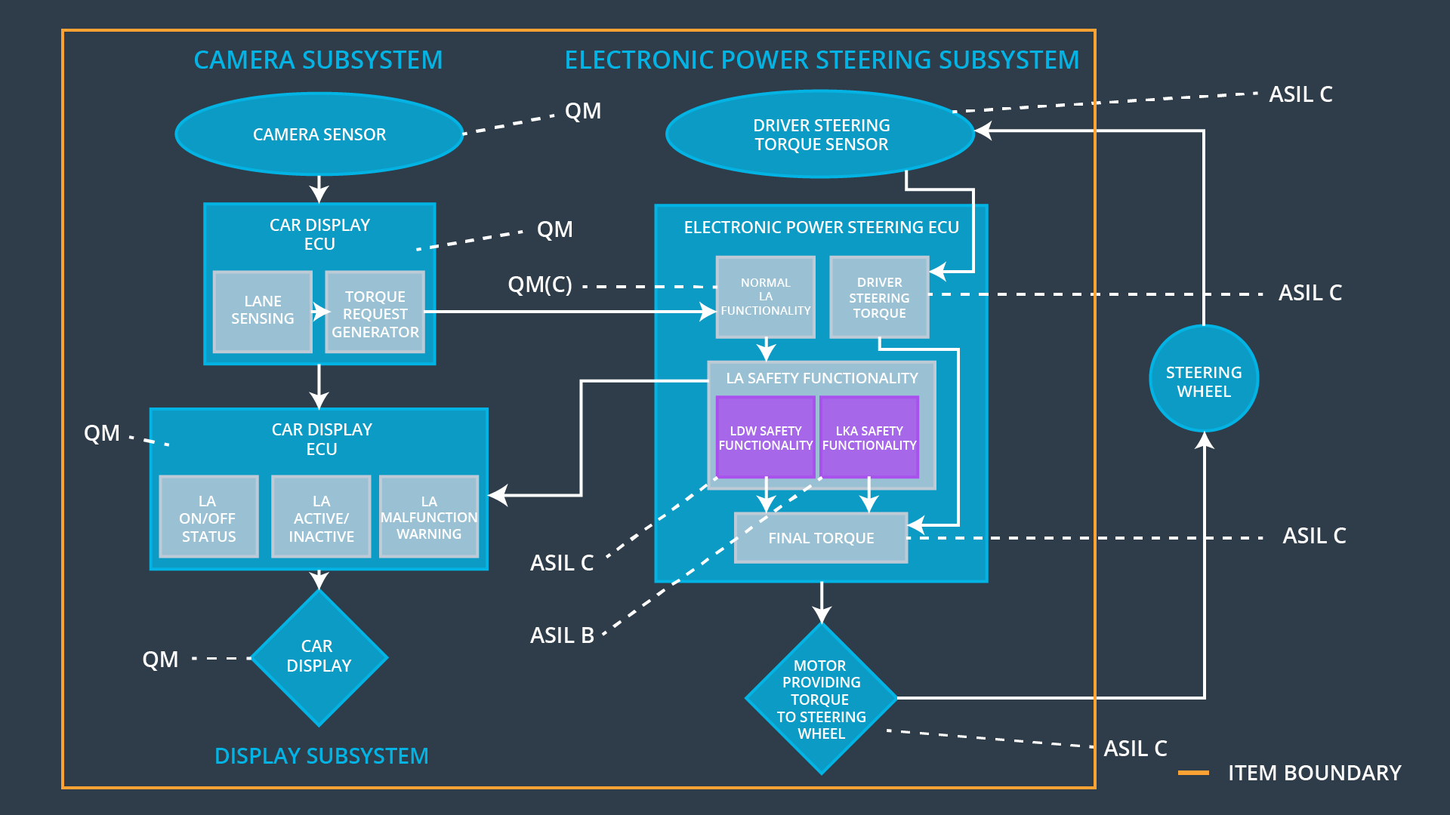

### Functional overview of architecture elements

|  |  |
| --- | --- |
| **Element** | **Description** |
| Camera Sensor | To sense or record the video of road |
| Camera Sensor ECU - Lane Sensing | To sense the lanes from the video |
| Camera Sensor ECU - Torque request generator | To generate torque request in case the car leaves the road |
| Car Display | To display the warnings |
| Car Display ECU - Lane Assistance On/Off Status | To issue a message to display to show on/off status |
| Car Display ECU - Lane Assistant Active/Inactive | To issue a message to display to show active/inactive |
| Car Display ECU - Lane Assistance malfunction warning | To issue a message to display to show malfunction |
| Driver Steering Torque Sensor | To sense the torque at the steering wheel (may be the driver is providing some torque |
| Electronic Power Steering (EPS) ECU - Driver Steering Torque | To calculate the amount to torque that needs to be applied taking into account the torque applied by driver |
| EPS ECU - Normal Lane Assistance Functionality | To steer by correct amount to keep the car in the lane |
| EPS ECU - Lane Departure Warning Safety Functionality | To provide a vibration to steering wheel to warn the driver and to see that the frequency and the amplitude is below the specified limit. |
| EPS ECU - Lane Keeping Assistant Safety Functionality | To see that the car remains in the lane and the system shuts down after the specified amount of time. |
| EPS ECU - Final Torque | To apply a final torque taking into account the functional safety concepts |
| Motor | To apply the required torque to the steering wheel |

# Technical Safety Concept

## Technical Safety Requirements

**Lane Departure Warning (LDW) Requirements:**

Functional Safety Requirement 01-01 with its associated system elements

(derived in the functional safety concept)

|  |  |  |  |  |
| --- | --- | --- | --- | --- |
| **ID** | **Functional Safety Requirement** | **Electronic Power Steering ECU** | **Camera ECU** | **Car Display ECU** |
| Functional  Safety  Requirement  01-01 | The lane keeping item shall ensure that the lane departure oscillating torque amplitude is below Max_Torque_Amplitude | X |  |  |

Technical Safety Requirements related to Functional Safety Requirement 01-01 are:

|  |  |  |  |  |  |
| --- | --- | --- | --- | --- | --- |
| **ID** | **Technical Safety Requirement** | **ASIL** | **Fault Tolerant Time Interval** | **Architecture Allocation** | **Safe State** |
| Technical  Safety  Requirement  01 | The LDW safety component shall ensure that the amplitude of the 'LDW_Torque_Request' sent to the 'Final electronic power steering Torque' component is below 'Max_Torque_Amplitude. | C | 50 ms | LDW Safety | LDW torque request amplitude should be set to zero |
| Technical  Safety  Requirement  02 | As soon as the LDW function deactivates the LDW feature, the 'LDW Safety' software block shall send a signal to the car display ECU to turn on a warning light. | C | 50 ms | LDW Safety | LDW torque request amplitude should be set to zero |
| Technical  Safety  Requirement  03 | As soon as a failure is detected by the LDW function, it shall deactivate the LDW feature and the 'LDW_Torque_Request' shall be set to zero. | C | 50 ms | LDW Safety | LDW torque request amplitude should be set to zero |
| Technical  Safety  Requirement  04 | The validity and integrity of the data transmission for 'LDW_Torque_Request' signal shall be ensured. | C | 50 ms | LDW Safety | LDW torque request amplitude should be set to zero |
| Technical  Safety  Requirement  05 | Memory test shall be conducted at start up of the EPS ECU to check for any faults in memory. | A | Ignition cycle | Safety startup | LDW torque request amplitude should be set to zero |

Functional Safety Requirement 01-2 with its associated system elements

(derived in the functional safety concept)

|  |  |  |  |  |
| --- | --- | --- | --- | --- |
| **ID** | **Functional Safety Requirement** | **Electronic Power Steering ECU** | **Camera ECU** | **Car Display ECU** |
| Functional  Safety  Requirement  01-02 | The lane keeping item shall ensure that the lane departure oscillating torque frequency is below Max_Torque_Frequency | X |  |  |

Technical Safety Requirements related to Functional Safety Requirement 01-02 are:

|  |  |  |  |  |  |
| --- | --- | --- | --- | --- | --- |
| **ID** | **Technical Safety Requirement** | **ASIL** | **Fault Tolerant Time Interval** | **Architecture Allocation** | **Safe State** |
| Technical  Safety  Requirement  01 | The LDW safety component shall ensure that the amplitude of the 'LDW_Torque_Request' sent to the 'Final electronic power steering Torque' component is below 'Max_Torque_Frequency. | C | 50 ms | LDW Safety | LDW torque request frequency should be set to zero |
| Technical  Safety  Requirement  02 | As soon as the LDW function deactivates the LDW feature, the 'LDW Safety' software block shall send a signal to the car display ECU to turn on a warning light. | C | 50 ms | LDW Safety | LDW torque request frequency should be set to zero |
| Technical  Safety  Requirement  03 | As soon as a failure is detected by the LDW function, it shall deactivate the LDW feature and the 'LDW_Torque_Request' shall be set to zero. | C | 50 ms | LDW Safety | LDW torque request frequency should be set to zero |
| Technical  Safety  Requirement  04 | The validity and integrity of the data transmission for 'LDW_Torque_Request' signal shall be ensured. | C | 50 ms | LDW Safety | LDW torque request frequency should be set to zero |
| Technical  Safety  Requirement  05 | Memory test shall be conducted at start up of the EPS ECU to check for any faults in memory. | A | Ignition cycle | Safety startup | LDW torque request frequency should be set to zero |

**Lane Departure Warning (LDW) Verification and Validation Acceptance Criteria:**

**Lane Keeping Assistance (LKA) Requirements:**

Functional Safety Requirement 02-1 with its associated system elements

(derived in the functional safety concept)

|  |  |  |  |  |
| --- | --- | --- | --- | --- |
| **ID** | **Functional Safety Requirement** | **Electronic Power Steering ECU** | **Camera ECU** | **Car Display ECU** |
| Functional  Safety  Requirement  02-01 | The lane keeping item shall ensure that the lane keeping assistance torque is applied for only Max_Duration | X |  |  |

Technical Safety Requirements related to Functional Safety Requirement 02-01 are:

|  |  |  |  |  |  |
| --- | --- | --- | --- | --- | --- |
| **ID** | **Technical Safety Requirement** | **ASIL** | **Fault Tolerant Time Interval** | **Allocation to Architecture** | **Safe State** |
| Technical  Safety  Requirement  01 | The LKA safety component shall ensure that the torque is applied for only Max_Duration | B | 500 ms | LKA Safety | LKA torque request should be set to zero |
| Technical  Safety  Requirement  02 | As soon as the LKA function deactivates the LKA feature, the ‘LKA Safety' software block shall send a signal to the car display ECU to turn on a warning light. | B | 500 ms | LKA Safety | LKA torque request should be set to zero |
| Technical  Safety  Requirement  03 | As soon as a failure is detected by the LKA function, it shall deactivate the LKA feature and the ' LKA _Torque_Request' shall be set to zero. | B | 500 ms | LKA Safety | LKA torque request should be set to zero |
| Technical  Safety  Requirement  04 | The validity and integrity of the data transmission for ' LKA _Torque_Request' signal shall be ensured. | B | 500 ms | LKA Safety | LKA torque request should be set to zero |
| Technical  Safety  Requirement  05 | Memory test shall be conducted at start up of the EPS ECU to check for any faults in memory. | A | Ignition cycle | Safety startup | LKA torque request should be set to zero |

**Lane Keeping Assistance (LKA) Verification and Validation Acceptance Criteria:**

## Refinement of the System Architecture

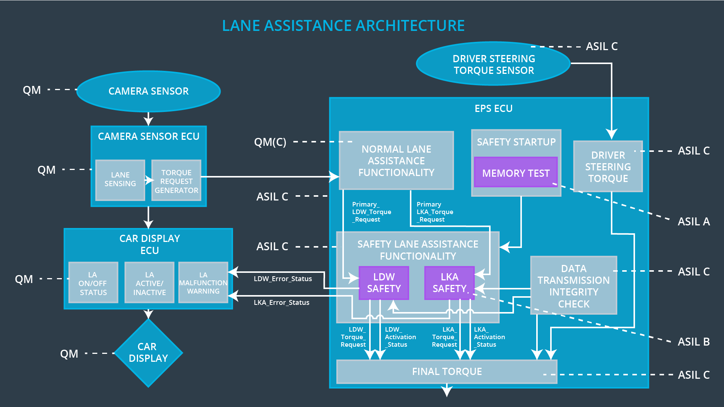

## Allocation of Technical Safety Requirements to Architecture Elements

All the technical safety requirements are applied to EPS ECU

## Warning and Degradation Concept

|  |  |  |  |  |
| --- | --- | --- | --- | --- |
| **ID** | **Degradation Mode** | **Trigger for Degradation Mode** | **Safe State invoked?** | **Driver Warning** |
| WDC-01 | Turn off the function | Amplitude> Max_Torque_Amplitude and  Frequency> Max_Torque_Frequency | Yes | Warning sign in Driver display system |
| WDC-02 | Turn off the function | If LKA active for time > Max_Duration | Yes | Warning sign in Driver display system |