# **Home Screen –**

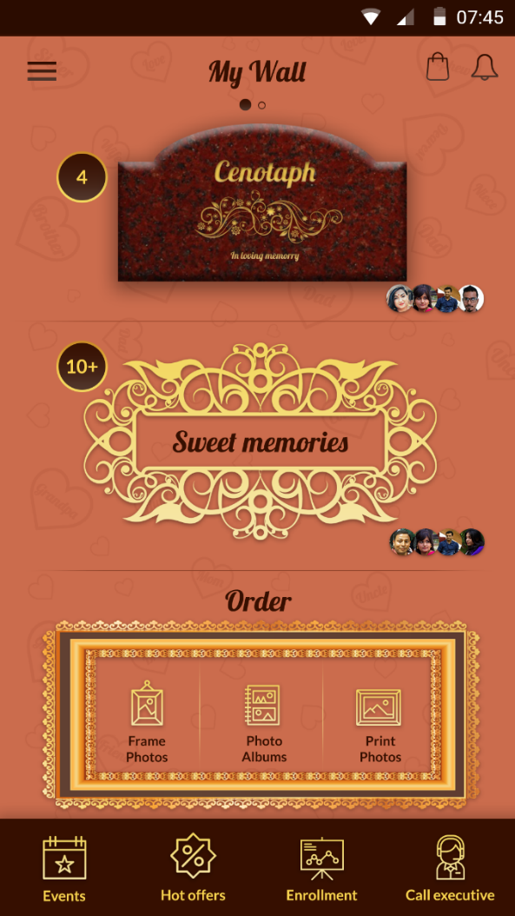

Implement Tutorial on home screen.

It Will have **Three Section** – **First section** will have Cenotaph and Sweet memories.

* User will have Personal Cenotaph and sweet memories (See the Two dots)
* User will also have Shared Cenotaph and sweet memories (See the Two dots)
* User can swipe left or right to navigate from shared to Personal wall.
* **Personal wall** will display users own created cenotaph and sweet memories post
* It will display the count of response either like or comments on home page for latest most recent post for both cenotaph and sweet memories.
* **Shared Wall** will display the post created by other user and shared with him.
* **Shared Wall** display the count of response either like or comments on home page for latest most recent post for both shared cenotaph and sweet memories.

The **Second Section** – Second section will have order Module for –

* Order section on home page will be fixed. User can’t swipe left right.
* Frame Photos C:\Users\Immi-Reshma\Dropbox\Phoana_PNGs\Assets\Home_Obituary_SweetMemory\drawable-hdpi\ic_frame_photos_dropdown.png , Photo Album C:\Users\Immi-Reshma\Dropbox\Phoana_PNGs\Assets\Home_Obituary_SweetMemory\drawable-hdpi\ic_photo_frames_dropdown.png and Print Photos C:\Users\Immi-Reshma\Dropbox\Phoana_PNGs\Assets\Home_Obituary_SweetMemory\drawable-hdpi\ic_print_photos_dropdown.png. There are three separate iocns for each one.
* User will click on individual icons to place order.
* When user click on any order type the app will take user to set delivery location screen. This screen will allow and save users delivery location.

The T**hird Section** – Third section will have Bottom bar, which have following icons–

* **Events:** when user click on this icon app will navigate user to event listing screen where for the first time it will be blank and it will display message to create first event.
* **Hot Offers:** when user click on this icon it will take user to Hot Offers list page.
* **Enrollment:** when user click on this screen app will take him to User enrollment screen.
* **Call Executive:** when user click on this icon app will navigate user to set delivery location screen. This screen will allow and save users delivery location.

The Two icons on top right corner My Cart C:\Users\Immi-Reshma\Dropbox\Phoana_PNGs\Assets\Home_Obituary_SweetMemory\drawable-hdpi\ic_cart.png will take user for the first time to his empty cart screen and Notification C:\Users\Immi-Reshma\Dropbox\Phoana_PNGs\Assets\Home_Obituary_SweetMemory\drawable-hdpi\ic_notification.png will take user to notification screen.

The side menu C:\Users\Immi-Reshma\Dropbox\Phoana_PNGs\Assets\Home_Obituary_SweetMemory\drawable-hdpi\ic_menu.png will display the list of other options related to app.

# **Order Frame Photos –**

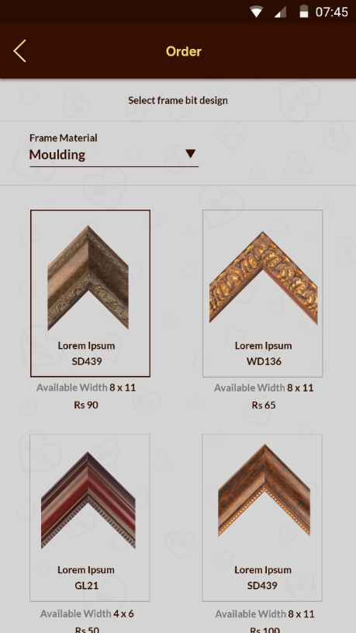

This screen will allow user to place new photo frame. Allow user to upload multiple photo. It can be 1 or max as user can. It should inform user to upload proper size photo based on selected **frame type and frame size**. First user need to select the design, then frame type, then frame size.

**Photo Frame order screen -**System will allow customer/user to choose the frame bit design first then frame type and frame size. Based on the selection system will create a frame which can be previewed by him. If user upload photo to be framed then system will display that photo inside the frame as preview. Delivery city will be by-default user geo location. But he changes it then he has to reselect the frame bit design as its city specific. User can order multiple frame with photo by adding and saving each frame design and photo one by one. Once done he can make final payment.

When user go for **Frame Photo order** then After setting the **delivery location** take user to “**Frame Bit design” Screen**.

In this screen user can select the desired design. Each frame bit design will have its specification like - Frame Bit available width (Bit Size - 1/2 inch, .75inch, 1 inch, 1.25 inch, 1.50 inch, 1.75 inch, 2 inch, 2.5 inch, 3 inch, 3.5 inch, 4 inch, 4.5 inch, 5 inch.), frame code.

For each **frame design** there will be two image one as shown in figure above and other will be horizontal image of fixed size. App will get the horizontal image from API and will draw the frame angle using the image from API.

As soon as user selects the frame design the app will take user to Order form screen. See below

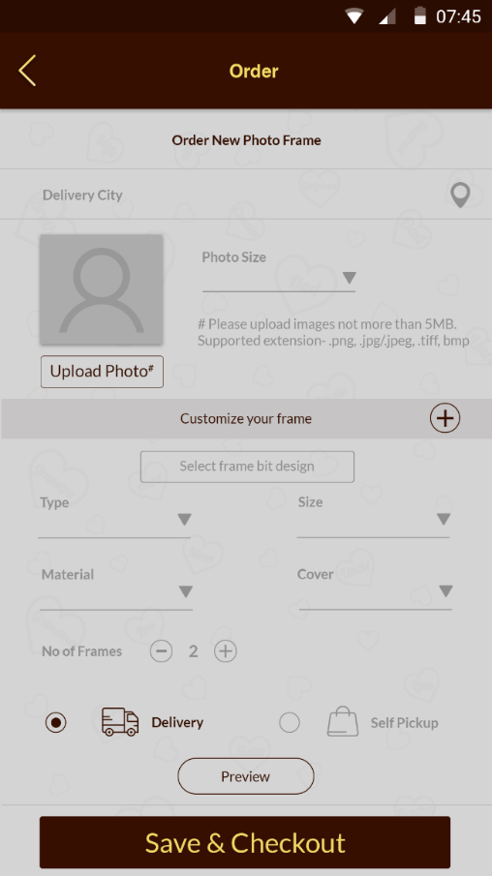

**Delivery City –** as set by user on set delivery location screen.

**Photo Size –** it will display the drop down list of available size of photo. It will come from Admin.

* Based on the photo size selected by user the app will validate the photo upload size. Minimum MB to be defined based on selected photo size.

**Upload Photo –** user can upload single photo for single frame. Display popup message for minimum Size in MB for the selected size.

Allow user to adjust/Crop photo. Open a photo cropping screen or square box.

Customize your frame section will allow user to set other Meta information like -

**Type (Frame) –** it will have value like Single Frame, Single Mounted Frame, Double Frame.

**Frame Width –** this value will come from frame bit design screen as selected by user.

Bit Size - 1/2 inch, .75inch, 1 inch, 1.25 inch, 1.50 inch, 1.75 inch, 2 inch, 2.5 inch, 3 inch, 3.5 inch, 4 inch, 4.5 inch, 5 inch.

**Size –** it will display the drop down list of available size of frame. It will come from Admin.

If user selects **photo size** 4 X 6 and **Frame Type Single** then the Frame size will display minimum value 6 X 8. Add one (1) inch both to Width and Height.

If user selects **photo size** 4 X 6 and **Frame Type Double** then the Frame size will display minimum value 10 X 12. Add three (3) inch to both Width and Height.

If user selects **photo size** 4 X 6 and **Frame Type Single Mounted** then the Frame size will display minimum value 10 X 12. Add three (3) inch to both Width and Height

The logic to display the maximum size for frame based on selected bit size.

The maximum 18 X 24 inch frame size for bit size ½ inch.

The maximum 18 X 30 inch frame size for bit size ¾ inch.

The maximum 30 X 40 inch frame size for bit size 1 inch.

Above 1 inch frame bit user can select maximum available frame size in the app.

4 X 6, 8 X 10, 8 X 12, 10 X 12, 15 X 12, 16 X 12, 18 X 12, 10 X 15, 12 X 15, 12 X 18, 12 X 20,

12 X 24, 12 X 30, 12 X 36, 16 X 20, 16 X 24, 20 X 24, 20 X 30, 20 X 32, 24 X 26, 24 X 28, 24 X 30, 24 X 36, 30 X 40, 40 X 50, 36 X 52, 48 X 60

**Material –** will be Molded by default as it will be set from frame bit design screen later in second phase it will display more options. Frame Material like – Wooden, Fiber, Metallic, Glass, Acrylic, Colored, Silver, Plastic, Crystal, LED Photo Frame, Leather, Marble, Hand Made, Synthetic, Fiber, Brass, 3D Picture Frame, Gold, Stone, Digital, Frame Moldings, Iron, Magnetic, Fabric, Shell, Antique Brass, Bamboo, MDF, White Metal, Embossed, Cardboard, PVC will be added later in second phase. So in database its flag will be N for the first phase later it can be changed to Y means to display it on app.

**Frame Cover –** it will have two value

* Glass Cover and
* Chemical Cover

**Orientation –** Portrait or landscape.

**Delivery –** if user select this option it will be delivered to their home else if user selects

**Self-Pick-up** then system will display the address location of pickup.

If user selects delivery display the saved shipping address, if address not saved earlier let user enter the address before moving to order summary screen.

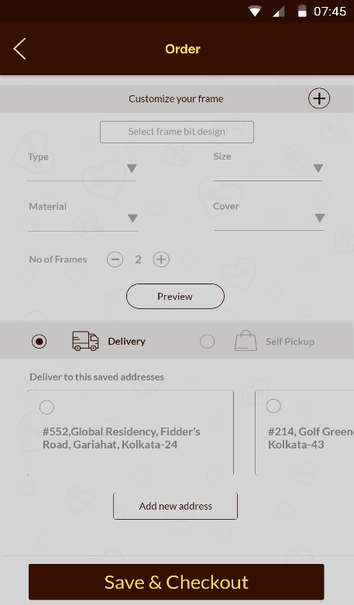

**Number of frames** C:\Users\Immi-Reshma\Dropbox\Phoana_PNGs\Assets\Order_Cart_Executive\drawable-hdpi\ic_increment.pngC:\Users\Immi-Reshma\Dropbox\Phoana_PNGs\Assets\Order_Cart_Executive\drawable-hdpi\ic_decrement.png– it will allow user to add no of copies for selected frame design with photos.

**Add More Frame** C:\Users\Immi-Reshma\Dropbox\Phoana_PNGs\Assets\Order_Cart_Executive\drawable-hdpi\ic_expand.png- this will allow user to select another frame. When user clicks on this button icon the app will save the current design and form details of frame in order cart and navigate user to select frame bit design. Each design will be saved under single order id.

**Delivery Time –** Display the estimated hours or day for delivery in city or out of city.

If the user selected fast delivery service then it will be for only within the city for Photo Album and Frame Photos.

Frame photos – we will serve in selected cities and it will be displayed on Set Delivery location Screen. Starting from 12 Hrs. to 24 hours maximum for the same city for fast service frame photos. For normal service it will be 2 days to 7 Days. Excluding Weekdays.

Photo Album – we will serve in selected cities and it will be displayed on Set Delivery location Screen. It will be minimum 7 Days to maximum 14 Days.

Print Photos – For Same city delivery will be 1 Day to 3 Days For separate city it will be Minimum 2 working day to 7 working days max for print photos. Excluding weekdays.

**Preview –** this option will redirect user to view the frame under separate screen. If user wants to select another frame bit then he can directly navigate to frame bit design screen from preview screen. Give one button (“Change Frame”) to navigate from preview screen else user can select OK and app will redirect to order form screen.

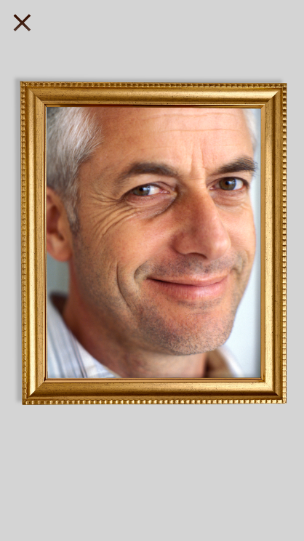

# **Order Preview Screen**

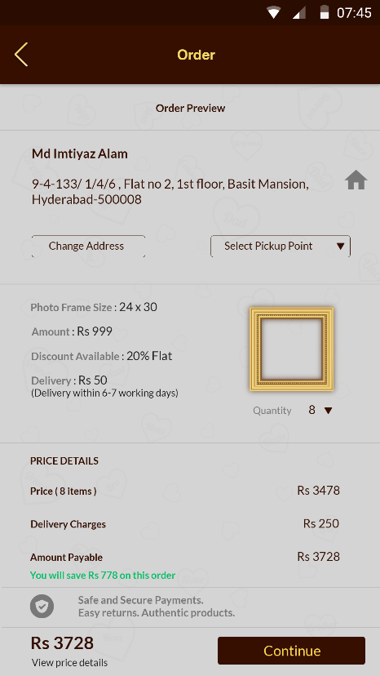

Display the Complete details for selected frame design like Size of Frame and Photo, Width of frame, Price for individual frame.

**Order summary** will display all cart gross pricing including delivery charges.

Allow user to apply coupon code to avail any discount before proceeding to final cart.

Give button to save the order for future. The saved order will be displayed under **“My Cart”**

Take user to **payment detail** screen when user clicks on **continue** button

# **Payment Detail**

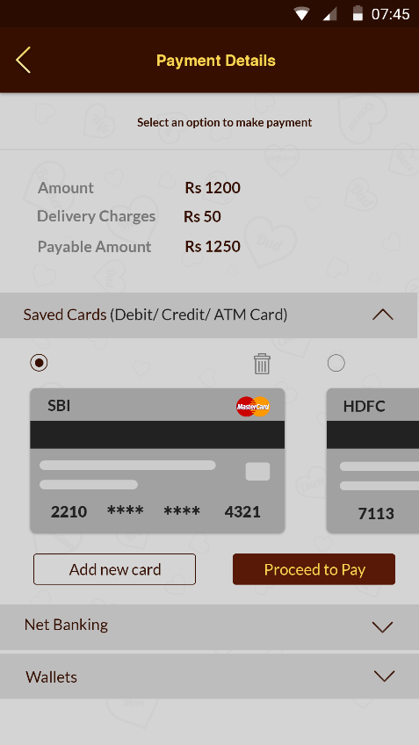

This screen will display the total pricing and payment option.

Do not display the Card instead show available Payment option?

App will not save any card details or any kind of user bank details.

Remove New Card button.

On Final payment send notification to Admin and customer.

Send payment detail email to customer and admin including the order details.

Save the order history.

In Admin when user assign vendor to selected order send email and notification to vendor which will have only photo and frame design to download, no payment details or pricing will be shared with vendor. Customer will get update as order processed via notification.

When vendor download the image it will update the admin via email/notification.

When vendor update the status as ready it will notify the admin and customer via email or notification.

When order is shipped it will notify the admin and customer via email and notification.