Практическая работа №12

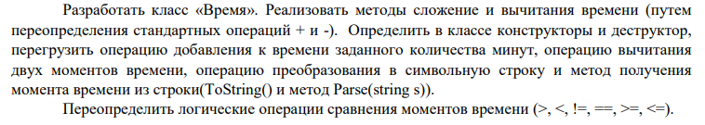

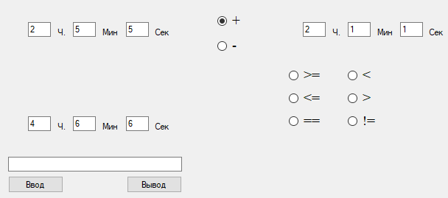

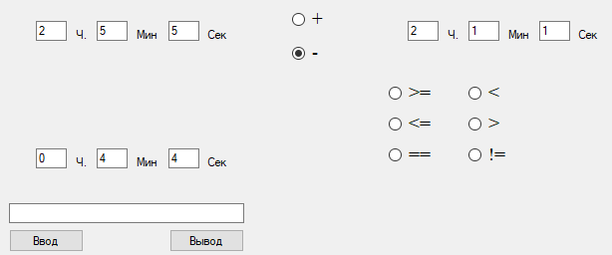

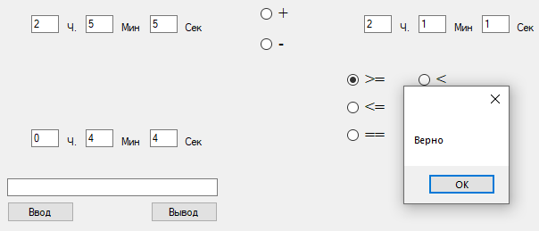

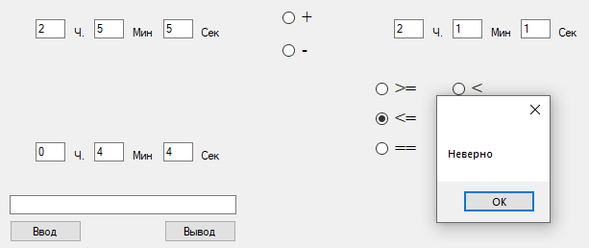

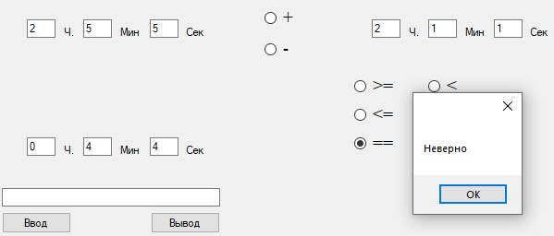

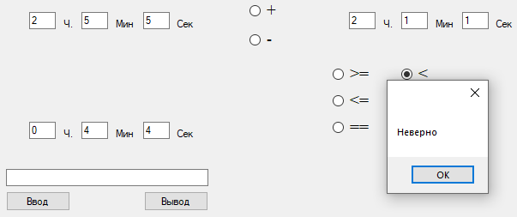

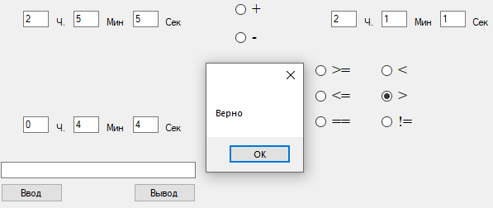

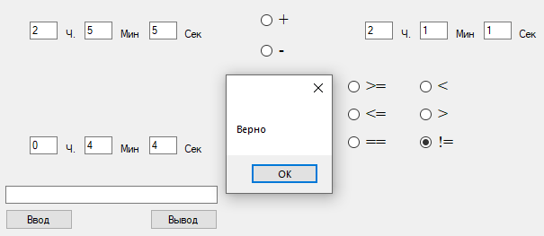

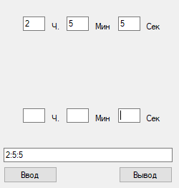

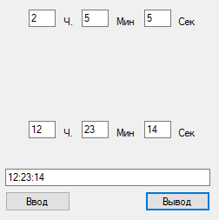

Time.cs

public int hour, minutes, seconds;

public Time (int n_hour,int n_minutes, int n_seconds)

{

hour = n_hour;

minutes = n_minutes;

seconds = n_seconds;

}

public Time()

{

hour = 1;

minutes = 0;

seconds = 0;

}

public void ToSeconds()

{

minutes = minutes + hour * 60;

hour = 0;

seconds = seconds + minutes * 60;

minutes = 0;

}

public void Addition(Time d) //Сложение времени

{

d.ToSeconds();

ToSeconds();

int s = Math.Abs(d.seconds + seconds);

minutes = s / 60;

seconds = s % 60;

hour = minutes / 60;

minutes = minutes % 60;

}

public void Subtraction(Time d) //Вычитание времени

{

d.ToSeconds();

ToSeconds();

int s = Math.Abs(d.seconds - seconds);

minutes = s / 60;

seconds = s % 60;

hour = minutes / 60;

minutes = minutes % 60;

}

public static Time operator +(Time b1, Time b2)

{

Time b = new Time();

b2.ToSeconds();

b1.ToSeconds();

int s = Math.Abs(b2.seconds + b1.seconds);

b.minutes = s / 60;

b.seconds = s % 60;

b.hour = b.minutes / 60;

b.minutes = b.minutes % 60;

return b;

}

public static Time operator -(Time b1, Time b2)

{

Time b = new Time();

b2.ToSeconds();

b1.ToSeconds();

int s = Math.Abs(b2.seconds - b1.seconds);

b.minutes = s / 60;

b.seconds = s % 60;

b.hour = b.minutes / 60;

b.minutes = b.minutes % 60;

return b;

}

public static bool operator >=(Time b1, Time b2)

{

int k1 = b1.hour * b1.minutes * b1.seconds;

int k2 = b2.hour * b2.minutes * b2.seconds;

if (k1 >= k2)

{

return true;

}

else

{

return false;

}

}

public static bool operator <=(Time b1, Time b2)

{

int k1 = b1.hour * b1.minutes * b1.seconds;

int k2 = b2.hour * b2.minutes * b2.seconds;

if (k1 <= k2)

{

return true;

}

else

{

return false;

}

}

public static bool operator <(Time b1, Time b2)

{

int k1 = b1.hour * b1.minutes * b1.seconds;

int k2 = b2.hour * b2.minutes * b2.seconds;

if (k1 < k2)

{

return true;

}

else

{

return false;

}

}

public static bool operator >(Time b1, Time b2)

{

int k1 = b1.hour * b1.minutes * b1.seconds;

int k2 = b2.hour * b2.minutes * b2.seconds;

if (k1 > k2)

{

return true;

}

else

{

return false;

}

}

public static bool operator ==(Time b1, Time b2)

{

int k1 = b1.hour * b1.minutes * b1.seconds;

int k2 = b2.hour * b2.minutes * b2.seconds;

if (k1 == k2)

{

return true;

}

else

{

return false;

}

}

public static bool operator !=(Time b1, Time b2)

{

int k1 = b1.hour * b1.minutes * b1.seconds;

int k2 = b2.hour * b2.minutes * b2.seconds;

if (k1 != k2)

{

return true;

}

else

{

return false;

}

}

public override string ToString()

{

string s = "";

if (hour != 0)

{

s = s + hour.ToString();

}

s = s + ":" + minutes + ":" + seconds;

return s;

}

public static Time Parse(string str)

{

Time f = new Time();

int l = str.Length;

int n = str.IndexOf(":");

int m = str.LastIndexOf(":");

f.hour = Convert.ToInt32(str.Substring(0, n));

f.minutes = Convert.ToInt32(str.Substring(n + 1, l - m - 1));

f.seconds = Convert.ToInt32(str.Substring(m + 1, l - m - 1));

return f;

}

Form1.cs

Time f, f2;

public Form1()

{

InitializeComponent();

}

private void label5_Click(object sender, EventArgs e)

{

}

private void label2_Click(object sender, EventArgs e)

{

}

public void Print(Time f)

{

textBox9.Text = f.hour.ToString();

textBox8.Text = f.minutes.ToString();

textBox7.Text = f.seconds.ToString();

}

public Time ReceiveF()

{

int hour = Convert.ToInt32(textBox1.Text);

int minutes = Convert.ToInt32(textBox2.Text);

int seconds = Convert.ToInt32(textBox3.Text);

Time newf= new Time(hour, minutes, seconds);

return newf;

}

public Time ReceiveF2()

{

int hour2 = Convert.ToInt32(textBox4.Text);

int minutes2 = Convert.ToInt32(textBox5.Text);

int seconds2 = Convert.ToInt32(textBox6.Text);

Time newf2= new Time(hour2, minutes2, seconds2);

return newf2;

}

public void Addition(Time d)//сложение времени

{

}

public void Print()

{

textBox9.Text = f.hour.ToString();

textBox8.Text = f.minutes.ToString();

textBox7.Text = f.seconds.ToString();

}

private void button1_Click(object sender, EventArgs e)

{

ReceiveF();

ReceiveF2();

f.Subtraction(f2);

Print();

}

private void radioButton1_CheckedChanged(object sender, EventArgs e)

{

if (radioButton1.Checked)

{

Time f = ReceiveF();

Time f2 = ReceiveF2();

if (f >= f2)

{

MessageBox.Show("Верно");

}

else

{

MessageBox.Show("Неверно");

}

}

}

private void radioButton2_CheckedChanged(object sender, EventArgs e)

{

if (radioButton2.Checked)

{

Time f1 = ReceiveF();

Time f2 = ReceiveF2();

Time f3 = f1 + f2;

Print(f3);

}

}

private void radioButton3_CheckedChanged(object sender, EventArgs e)

{

if (radioButton3.Checked)

{

Time f1 = ReceiveF();

Time f2 = ReceiveF2();

Time f4 = f1 - f2;

Print(f4);

}

}

private void radioButton4_CheckedChanged(object sender, EventArgs e)

{

if (radioButton4.Checked)

{

Time f = ReceiveF();

Time f2 = ReceiveF2();

if (f <= f2)

{

MessageBox.Show("Верно");

}

else

{

MessageBox.Show("Неверно");

}

}

}

private void radioButton5_CheckedChanged(object sender, EventArgs e)

{

if (radioButton5.Checked)

{

Time f = ReceiveF();

Time f2 = ReceiveF2();

if (f < f2)

{

MessageBox.Show("Верно");

}

else

{

MessageBox.Show("Неверно");

}

}

}

private void radioButton6_CheckedChanged(object sender, EventArgs e)

{

if (radioButton6.Checked)

{

Time f = ReceiveF();

Time f2 = ReceiveF2();

if (f > f2)

{

MessageBox.Show("Верно");

}

else

{

MessageBox.Show("Неверно");

}

}

}

private void radioButton7_CheckedChanged(object sender, EventArgs e)

{

if (radioButton7.Checked)

{

Time f = ReceiveF();

Time f2 = ReceiveF2();

if (f == f2)

{

MessageBox.Show("Верно");

}

else

{

MessageBox.Show("Неверно");

}

}

}

private void radioButton8_CheckedChanged(object sender, EventArgs e)

{

if (radioButton8.Checked)

{

Time f = ReceiveF();

Time f2 = ReceiveF2();

if (f != f2)

{

MessageBox.Show("Верно");

}

else

{

MessageBox.Show("Неверно");

}

}

}

private void button1_Click_1(object sender, EventArgs e)

{

Time f = ReceiveF();

textBox10.Text = f.ToString();

}

private void button2_Click(object sender, EventArgs e)

{

string s = textBox10.Text;

Time ff = Time.Parse(s);

Print(ff);

}

private void Form1_Load(object sender, EventArgs e)

{

}

private void button4_Click(object sender, EventArgs e)

{

ReceiveF();

ReceiveF2();

f.Addition(f2);

Print();

}

Ссылка на гитхаб:

<https://github.com/Alexandrov911/Practical-12.2022g.git>