1) You can load the "titanic" data set using the "Datasets" dropdown in the Data > Manage tab.  
2) Do not pick name and cabin as the predictor  
3) You can save and load Radiant status using the "Disk" button  
  
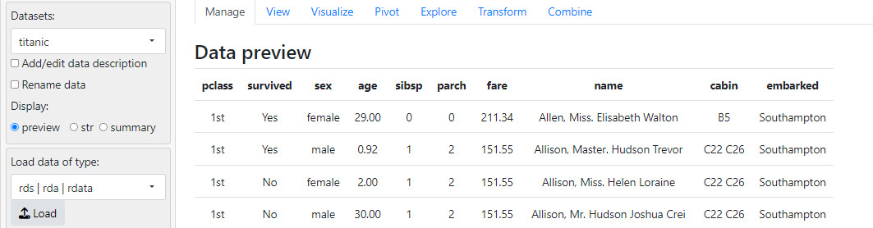

3. Build a logistic regression model using the income_train.csv to predict if the income is greater than 50k or not. Select all the explanatory variables.   
  
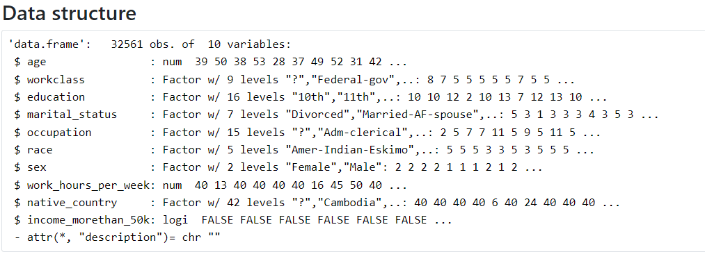  
**Based on the model's result,   
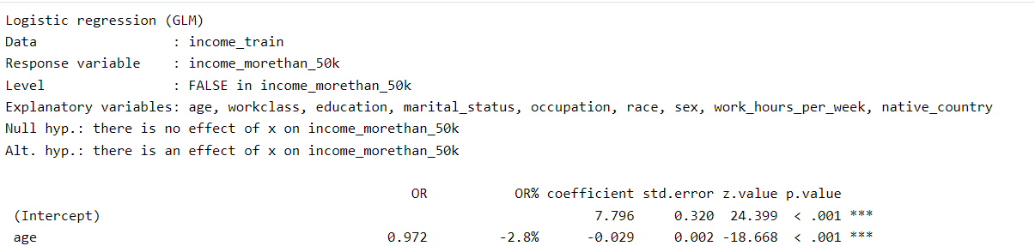  
Is the age predictive?** **Give an explanation for why that is so.**Age is predictive in this logistic regression model for the likelihood of having an income greater than $50,000. The odds ratio (OR) for age is 1.029, which suggests that for each additional year of age, the odds of earning more than $50,000 increase by 2.9%. The p-value is less than 0.001, indicating that the relationship between age and income is statistically significant. This means that age is a statistically significant predictor of having an income above $50,000 according to the model's results.

4. Use the model to predict the response variable using the income_valid.csv .   
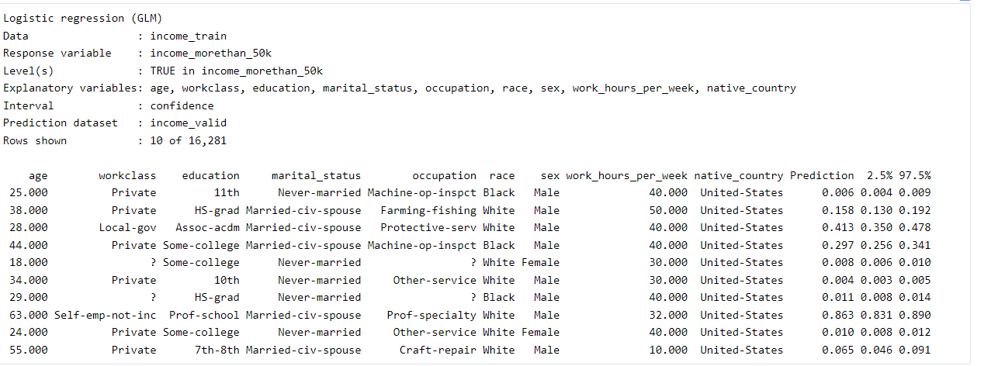

5. I've made progress in Lab 3 by learning to install Radiant on Windows, integrate it with RStudio, load and plot data, and perform linear and logistic regression for predictions. However, I'm finding it challenging to master Radiant, which is normal given its comprehensive capabilities. To improve, I should focus on mastering one feature at a time through regular practice, utilizing available resources, and applying my skills to real-world projects. Gradually, with patience and consistent effort, I'll become more proficient in using Radiant for my data analysis needs.