

Foundations of Programming
Assignment No. : 11

PROBLEM STATEMENT:
Write a program in C to accept a number from the user and compute the following:
- Square root of the number
- Square of the number
- Cube of the number
- Check whether the number is prime
- Factorial of the number
- Prime factors of the number

OBJECTIVE:
• To understand the use of mathematical operations in C.
• To implement loops and conditional statements
. • To perform number-based computations.
• To enhance logical thinking using menu-driven programs.

THEORY:
Numbers and their mathematical properties play a vital role in programming. Operations such as square, cube, and square root are basic mathematical computations. Prime number checking involves verifying whether a number has exactly two divisors. Factorial is calculated by multiplying a sequence of integers. Prime factorization breaks a number into its prime components. In C programming, these operations can be efficiently implemented using loops, conditional statements, and mathematical functions.

PLATFORM:
Linux

ALGORITHM:
1. Start
2. Declare the variables “entered” and “operationSelected” as integers
3. Ask the user for a number and store it in “entered”.
4. Print the menu, showing the user the 6 mathematical operations (square root, square, cube, prime check, factorial and prime factors)
5. Ask the user for the menu choice and store it in the integer variable “operationSelected”.
6. Depending on the users choice, execute a switch case statement.
7. Case 1 (Square Root): If entered is less than 0, display an error. Otherwise, calculate and print the square root using sqrt(entered).
8. Case 2 (Square): Calculate and print entered * entered.
9. Case 3 (Cube): Calculate and print entered * entered * entered.
10. Case 4 (Prime Check): If entered <= 1, it is not prime. Else, use a loop from 2 to (entered / 2). If entered is divisible by any integer i, it is not prime, otherwise it is prime.
11. Case 5 (Factorial): If entered is less than 0, display an error. Otherwise, use a loop to multiply integers from 1 to entered and store the result in an unsigned long long variable to prevent overflow.
12. Case 6 (Prime Factors): Use nested loops to find and print all prime numbers that divide entered.
13. Default case: If the choice is not between 1 and 6, display an invalid selection message.
14. Display result output.
15. Stop

C PROGRAM:
#include <stdio.h>
#include <math.h>

int main() {
printf("Enter a number: \n");

int entered;
scanf("%d", &entered);

printf("\n");
printf("Enter a number (1-6) to perform the following operations: \n");
printf("1) Calculate the square root of a number\n");
printf("2) Calculate the square of a number\n");
printf("3) Calculate the cube of a number\n");
printf("4) Check whether a number is prime\n");
printf("5) Calculate the factorial of a number\n");
printf("6) Calculate the prime factors of a number\n\n");

int operationSelected;
scanf("%d", &operationSelected);

switch (operationSelected) {
case 1: {
if (entered < 0) {
printf("Error: Cannot calculate square root of a negative number.\n");
} else {
printf("The square root of this number is: %f\n", sqrt(entered));
}
break;
}
case 2:
printf("The square of %d is: %d\n", entered, entered * entered);
break;
case 3:
printf("The cube of %d is: %d\n", entered, entered * entered * entered);
break;
case 4: {
int isPrime = 1;
if (entered <= 1) {
isPrime = 0;
}
else {
// Optimized to check divisibility up to n/2
for (int i = 2; i <= entered / 2; i++) {
if (entered % i == 0) {
isPrime = 0;
break;
}
}
}
if (isPrime) {
printf("%d is a prime number.\n", entered);
}
else {
printf("%d is not a prime number.\n", entered);
}
break;
}
case 5: {
if (entered < 0) {
printf("Error: Factorial of a negative number is undefined.\n");
} else {
unsigned long long fact = 1;
for (int i = 1; i <= entered; i++) {
fact *= i;
}
printf("The factorial of %d is: %llu\n", entered, fact);
}
break;
}

case 6: {
printf("Prime factors of %d are: ", entered);
int temp = entered;
for (int i = 2; i <= temp; i++) {
while (temp % i == 0) {
printf("%d ", i);
temp /= i;
}
}
printf("\n");
break;
}

default:
printf("Invalid selection. Please choose a number between 1 and 6.\n");
break;
}
return 0;
}

INPUT:
The user enters an integer number and selects an operation from the menu.
Example Input: Number: 5 Choice: 3
Paste Screen Shot of Input
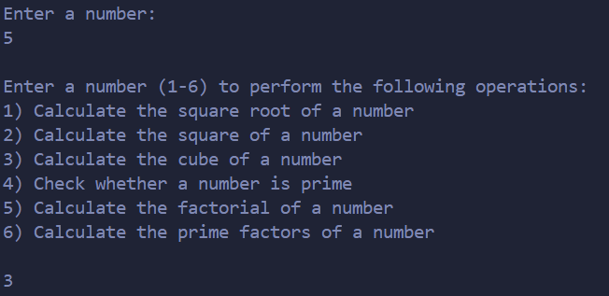

OUTPUT:
Example Output:
The program displays the result based on the selected operation.
Example Output: Cube = 125
Paste Screen Shot of Output
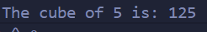

CONCLUSION:
Thus, the program to perform various mathematical operations on a number was successfully implemented using C programming. This program demonstrates the use of loops, conditional statements, switch-case, and mathematical functions.

FAQs:
- Why is checking divisibility only up to n/2 sufficient in prime number verification, and how can this be optimized further?
- What are the limitations of using int data type for factorial calculation, and how can overflow be handled in C?
- How does the time complexity of prime factorization change with increasing input size?
- Why is the math.h library required for square root calculation, and what happens if it is not included?
- How would the program behaviour change if a negative number is entered for factorial or square root operations?
- Explain the difference between checking a number for primality and generating prime factors of the same number.
- How can recursion be used to calculate factorial instead of loops, and what are its advantages and disadvantages?

