

Foundations of Programming

Assignment No.: 18
PROBLEM STATEMENT: Write a C program that accepts a string from the user and performs the following string operations: i) Calculate length of string ii) String reversal iii) Equality check of two strings iv) Check palindrome v) Check substring.

OBJECTIVE:

- To understand basic string operations in C.
- To learn how to manipulate strings using loops and functions.
- To perform comparison, reversal, and substring checking.
- To check whether a string is a palindrome.

THEORY:
In C programming, a string is a sequence of characters terminated by a null character ('\0'). Strings are commonly stored in character arrays. Various operations can be performed on strings such as calculating their length, reversing the characters, comparing two strings, checking whether a string is a palindrome, and finding a substring within another string. These operations can be implemented using loops and conditional statements or by using standard library functions from the string.h header file.
PLATFORM: Linux

INPUT: A string and another string for comparison and substring checking.
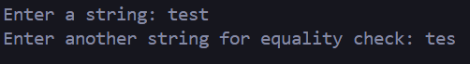

OUTPUT: Displays string length, reversed string, equality result, palindrome result, and substring check result.
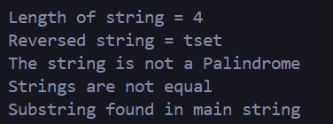

SAMPLE INPUT:

Enter a string: madam
Enter another string for equality check: mad
SAMPLE OUTPUT:
Length of string = 5
Reversed string = madam
The string is a Palindrome
Strings are not equal
Substring found in main string

CONCLUSION: Thus, the C program successfully performs different string operations such as length calculation, reversal, equality check, palindrome check, and substring detection.
CODE:
#include <stdio.h>
#include <string.h>

int main() {
char string1[100], string2[100], reversedString[100];
int len, i, j;

printf("Enter a string: ");
scanf("%s", string1);

printf("Enter another string for equality check: ");
scanf("%s", string2);

len = strlen(string1);
printf("\nLength of string = %d\n", len);

for (i = len - 1, j = 0; i >= 0; i--, j++) {
reversedString[j] = string1[i];
}
reversedString[j] = '\0';
printf("Reversed string = %s\n", reversedString);

if (strcmp(string1, reversedString) == 0) {
printf("The string is a Palindrome\n");
} else {
printf("The string is not a Palindrome\n");
}

if (strcmp(string1, string2) == 0) {
printf("Strings are equal\n");
} else {
printf("Strings are not equal\n");
}

if (strstr(string1, string2) != NULL) {
printf("Substring found in main string\n");
} else {
printf("Substring not found in main string\n");
}

return 0;
}

FAQs:
- What is a string in C programming?
- Which header file is required for string functions?
- What function is used to find the length of a string?
- What is a palindrome string?
- Which function is used to check a substring in C?

