

Foundations of Programming

Lab Assignment No. : 02

PROBLEM STATEMENT:
Write a menu driven program in C to implement the basic arithmetic operations such as Addition, Subtraction, Multiplication, and Division.

OBJECTIVES:
• To understand the concept of menu driven programming in C.
• To apply conditional statements and switch–case control structures.
• To perform basic arithmetic operations using user-defined input.
• To enhance logical thinking and problem-solving skills.

THEORY:
if–else ladder statements syntax and sample program
switch–case or if–else ladder statement syntax and sample progrM
Basic arithmetic operations include Addition, Subtraction, Multiplication, and Division. Division by zero should be avoided.

ALGORITHM:
- Start
- Ask the user to input an integer 1 or 2 or 3 or 4 for addition/subtraction/multiplication/division respectively.
- Read user-input value of addition or subtraction or multiplication or division option as an integer.
- Ask the user which 2 numbers to add/subtract/multiply/divide.
- Read user-input values of 2 numbers as floats.
- If the user has entered 1, then add the 2 numbers and display the result.
- Else if the user has entered 2, then subtract the 2 numbers and display the result.
- Else if the user has entered 3, then multiply the 2 numbers and display the result
- Else if the user has entered 4, then divide the 2 numbers and display the result.
- Stop
CODE:
#include <stdio.h>
int main()
{
printf("This program performs addition/subtraction/multiplication/division.\nPlease enter 1 or 2 or 3 or 4 respectively to perform the operation: \n");

int operationSelected;
scanf("%d", &operationSelected);

printf("Enter the 2 numbers: \n");

float num1;
float num2;
scanf("%f %f", &num1, &num2);

float result;

if (operationSelected == 1) {
result = num1 + num2;
printf("Addition: %f", result);
} else if (operationSelected == 2) {
result = num1 - num2;
printf("Subtraction: %f", result);
} else if (operationSelected == 3) {
result = num1 * num2;
printf("Multiplication: %f", result);
} else if (operationSelected == 4) {
result = num1 / num2;
printf("Division: %f", result);
}
return 0;
}

PLATFORM:
Linux

INPUT:
Choice of operation and two numbers
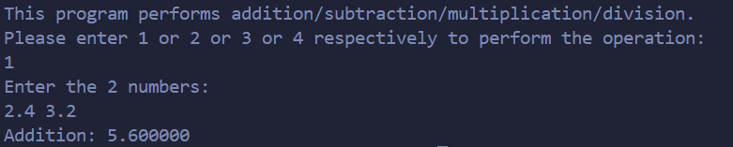
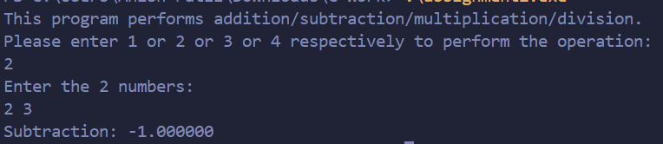
OUTPUT:
Displays the result of the selected arithmetic operation
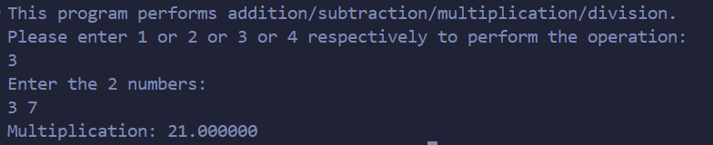
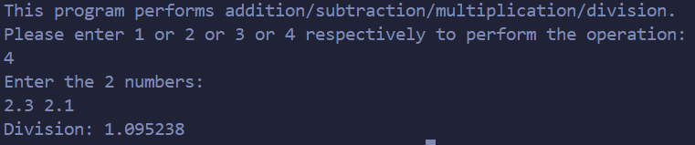
SAMPLE INPUT:
1
10 5

SAMPLE OUTPUT:
Addition = 15

CONCLUSION:
Thus, the menu driven program in C successfully performs basic arithmetic operations using switch–case statements.

FAQs:
1. What is a menu driven program?
2. Why is switch–case preferred over if–else ladder in menu driven programs?
3. What is the purpose of the break statement in switch–case?
4. What is the purpose of the break statement in switch–case?
5. What are the limitations of switch–case compared to if–else?

