

Foundations of Programming

Assignment No.: 22
PROBLEM STATEMENT: Write a menu driven program in C to perform various string operations using in-built functions.

OBJECTIVE:

- To understand the concept of strings in the C programming language.
- To learn how to use built-in string functions for string manipulation.
- To perform operations such as length calculation, copying, concatenation, comparison, and reversal using menu options.
.

THEORY:
In the C programming language, a string is a sequence of characters terminated by a null character ('\0'). Strings are stored in character arrays and manipulated using functions available in the string.h header file.
Common built-in string functions include strlen() for finding the length of a string, strcpy() for copying one string to another, strcat() for concatenating two strings, and strcmp() for comparing two strings.
A menu driven program allows the user to select different operations from a list of options. Based on the user’s choice, the corresponding string function is executed. This approach makes the program interactive and easy to use.

PLATFORM: Linux

INPUT: Two strings entered by the user.
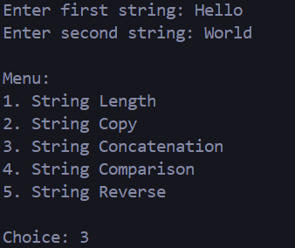

OUTPUT: Displays results of different string operations such as length, copy, concatenation, and comparison.

SAMPLE INPUT:
Enter first string: Hello
Enter second string: World
Choice: 3

SAMPLE OUTPUT:
Concatenated string: HelloWorld

CODE:
#include <stdio.h>
#include <string.h>

int main() {
char string1[100], string2[100], result[200];
int choice;

printf("Enter first string: ");
scanf("%s", string1);

printf("Enter second string: ");
scanf("%s", string2);

printf("\nMenu:\n");
printf("1. String Length\n");
printf("2. String Copy\n");
printf("3. String Concatenation\n");
printf("4. String Comparison\n");
printf("5. String Reverse\n\n");
printf("Choice: ");
scanf("%d", &choice);

switch (choice) {
case 1:
printf("Length of first string: %d\n", (int)strlen(string1));
printf("Length of second string: %d\n", (int)strlen(string2));
break;

case 2:
strcpy(result, string1);
printf("Copied first string into a new variable: %s\n", result);
break;

case 3:
strcpy(result, string1);
strcat(result, string2);
printf("Concatenated string: %s\n", result);
break;

case 4:
if (strcmp(string1, string2) == 0) {
printf("Result: The strings are identical.\n");
} else {
printf("Result: The strings are different.\n");
}
break;

case 5:
printf("Reversed first string: ");
for (int i = strlen(string1) - 1; i >= 0; i--) {
printf("%c", string1[i]);
}
printf("\n");
break;

default:
printf("Invalid choice. Please enter a valid menu option (1, 2, 3, 4 or 5).\n");
}

return 0;
}

CONCLUSION: Thus, the C program successfully demonstrates different string operations using built-in functions through a menu driven approach, making the program interactive and easy to use.

FAQs:
- What are built-in string functions in C and why are they used?
- What is the purpose of the string.h header file in C programs?
- How does a menu driven program improve user interaction in programming?

