

Foundations of Programming

Lab Assignment No. : 03

PROBLEM STATEMENT:
Write a program in C to generate multiplication tables for a given number.
OBJECTIVES:
- To understand the use of looping statements in C.
- To generate multiplication tables using loops.
- To improve program logic and execution flow understanding.

THEORY:
Syntax for for loop example program
Syntax for while loop example program
Syntax for do while loop example program
ALGORITHM:
- Start
- Ask the user to input an integer
- Read the input value and store it in the variable “entered”.
- Initialize the loop counter to 1 (using for loop)
- Check if i is less than 11
- If i is less than 11, calculate the product and display, and then increment i by 1
- If i is more than or equal to 11, exit the for loop.
- Stop
Code:
#include <stdio.h>
int main()
{
printf("Enter an integer to generate multiplication tables for: \n");

int entered;
scanf("%d", &entered);

int i;
for (i = 1; i < 11; i++) {
printf("%d x %d = %d\n", entered, i, entered * i);
if (i == 10) {
break;
}
}
return 0;
}
PLATFORM:
Linux

INPUT:
Choice of operation and two numbers
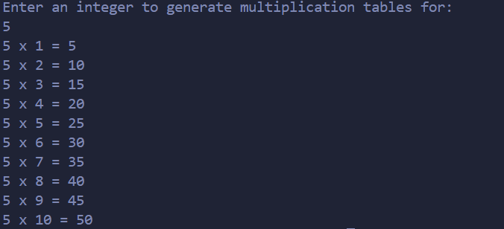
OUTPUT:
Displays the result of the selected arithmetic operation
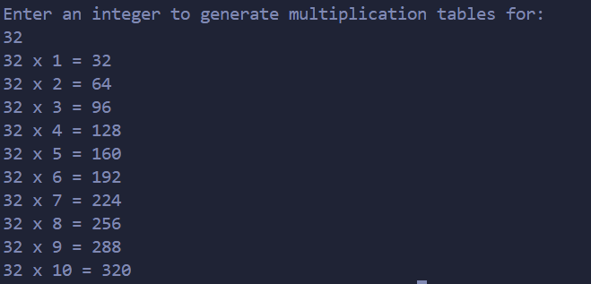
SAMPLE INPUT:
1
10 5

SAMPLE OUTPUT:
Addition = 15

CONCLUSION:
Thus, the menu driven program in C successfully performs basic arithmetic operations using switch–case statements.

FAQs:
- Which loop is best suited for generating multiplication tables?
- What is the role of loop initialization?
- Difference between for loop, while loop and do while loop?
- Can a do–while loop be used to generate multiplication tables? Explain.
- Why is the do–while loop called an exit-controlled loop?

