;l

Foundations of Programming

Assignment No. : 4
- PROBLEM STATEMENT: Write a C Program to calculate the salary of an employee given his basic pay (taken as input from the user). Calculate gross salary of employee. Let HRA be 10 % of basic pay and TA be 5% of basic pay. Let employees pay professional tax as 2% of total salary. Calculate net salary payable after deductions.

OBJECTIVE:

- To understand the importance of flowchart for any programming model.
- To learn simple flowchart symbols and arrows to define relationships.
- To understand and develop visual representations of flow of data.

THEORY:
- Define Algorithm.
An algorithm is a finite, step-by-step set of unambiguous instructions designed to solve a specific problem or perform a computation. It takes a set of defined inputs, processes them through a logical sequence of operations, and consistently produces a desired output.
- What are the different characteristics of an algorithm.
A good algorithm needs to have clear starting and ending points, instructions that make perfect sense, and a guaranteed finish line so it doesn't just run forever in a loop. Basically, every single step must be practical and specific enough that a computer can follow it without getting confused.
ALGORITHM:
1. Start
2. Ask the user the basic pay
3. Display the basic pay
4. Calculate HRA, TA, gross salary (HRA = 10% of basic pay, TA = 5% of basic pay)
5. Print HRA, TA, gross salary
6. Calculate professional tax (= 2% of gross salary)
7. Display professional tax
8. Calculate net salary (= gross salary – professional tax)
9. Display net salary
10. Stop
CODE:
#include <stdio.h>
int main()
{
float basicPay; // Declaring variable for the basic pay of the employee.

printf("Type the basic pay of the employee: \n");
scanf("%f", &basicPay); // Scan the basic pay of the employee in and set it to the variable basicPay

printf("The basic pay is: %f\n", basicPay); // Display the basic pay
printf("\n");

float HRA = 0.1 * basicPay; // Declare the house rent allowance variable and calculate it
float TA = 0.05 * basicPay; // Declare the travelling allowance variable and calculate it
float grossSalary = basicPay + HRA + TA; // Declare the gross salary variable and calculate it

// Display the house rent allowance, travelling allowance and gross salary
printf("The house rent allowance is: %f\n", HRA);
printf("The travelling allowance is: %f\n", TA);
printf("The gross salary is: %f\n", grossSalary);
printf("\n");

float professionalTax = 0.02 * grossSalary; // Declare the professional tax variable and calculate it

printf("The professional tax paid is: %f\n", professionalTax); // Display the professional tax paid

float netSalary = grossSalary - professionalTax; // Declare the net salary variable and calculate it
printf("Therefore, the net salary is: %f\n", netSalary); // Display the net salary
}

PLATFORM: Linux

INPUT: 50000
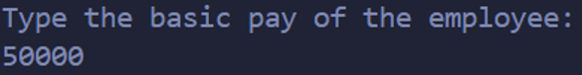
OUTPUT:
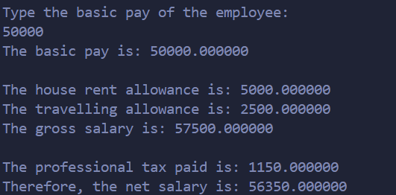
CONCLUSION: Thus, we have learned to write algorithms and to draw its representation in terms of flowchart.

FAQs:
- Describe various symbols and their use in flowchart.
- Difference between Algorithm and Flowchart.

