

Foundations of Programming
Assignment No. : 5
PROBLEM STATEMENT:
Write a program in C to perform basic matrix operations such as:
1. Addition of two matrices
2. Saddle point of a matrix
3. Inverse of a matrix
4. Magic square of a matrix

OBJECTIVE:
• To understand matrix representation in C using two-dimensional arrays.
• To implement various matrix operations using C programming.
• To develop logical thinking for solving matrix-based problems.

THEORY:
Matrix operations are widely used in engineering and scientific applications. Addition of matrices involves adding corresponding elements. A saddle point is an element that is the minimum in its row and maximum in its column. The inverse of a matrix exists only for square matrices with non-zero determinant. A magic square is a square matrix in which the sums of elements in each row, column, and diagonals are equal. (ADD Example for 1. Addition of two matrices
2. Saddle point of a matrix
3. Inverse of a matrix
4. Magic square of a matrix
)

PLATFORM:
Linux

ALGORITHM:
1. Start
2. Read the order of the matrix
3. Read elements of the matrices
4. Perform matrix addition
5. Check for saddle point
6. Find inverse of the matrix (if determinant ≠ 0)
7. Check whether the matrix is a magic square
8. Display results
9. Stop

C PROGRAM: (Type C Program)
#include <stdio.h>

int main() {
int i, j, k;
int r1, c1, r2, c2;

printf("Enter the number of rows of 1st matrix: ");
scanf("%d", &r1);
printf("Enter the number of columns of 1st matrix: ");
scanf("%d", &c1);

printf("Enter the number of rows of 2nd matrix: ");
scanf("%d", &r2);
printf("Enter the number of columns of 2nd matrix: ");
scanf("%d", &c2);

int matrixA[r1][c1];
int matrixB[r2][c2];

printf("\nEnter the elements of the 1st matrix:\n");
for (i = 0; i < r1; i++) {
for (j = 0; j < c1; j++) {
printf("Element [%d][%d]: ", i, j);
scanf("%d", &matrixA[i][j]);
}
}

printf("\nEnter the elements of the 2nd matrix (for addition):\n");
for (i = 0; i < r2; i++) {
for (j = 0; j < c2; j++) {
printf("Element [%d][%d]: ", i, j);
scanf("%d", &matrixB[i][j]);
}
}

// Perform matrix addition (Requires matching dimensions)
printf("\nMatrix Addition:\n");
if (r1 == r2 && c1 == c2) {
int matrixSum[r1][c1];
for (i = 0; i < r1; i++) {
for (j = 0; j < c1; j++) {
matrixSum[i][j] = matrixA[i][j] + matrixB[i][j];
printf("%d\t", matrixSum[i][j]);
}
printf("\n");
}
} else {
printf("Addition cannot be performed, as the dimensions do not match (requires r1==r2 and c1==c2).\n");
}

// Check for saddle point in the main matrix
int has_saddle = 0, saddle_val = 0, saddle_r = 0, saddle_c = 0;

for (i = 0; i < r1; i++) {
int min_row = matrixA[i][0];
int col_index = 0;

// Find minimum in the row
for (j = 1; j < c1; j++) {
if (matrixA[i][j] < min_row) {
min_row = matrixA[i][j];
col_index = j;
}
}

// Check if it is the maximum in its column
int is_max_col = 1;
for (k = 0; k < r1; k++) {
if (matrixA[k][col_index] > min_row) {
is_max_col = 0;
break;
}
}

if (is_max_col == 1) {
has_saddle = 1;
saddle_val = min_row;
saddle_r = i;
saddle_c = col_index;
}
}

//Find inverse (if determinant != 0)
int is_square = (r1 == c1);
int is_singular = 0;

// Dynamic sizing based on inputted square matrix, using float because division may result in decimal values
float augmented[r1][2 * c1];

if (is_square) {
int n = r1;
// Setup augmented matrix [A | I]
for (i = 0; i < n; i++) {
for (j = 0; j < n; j++) {
augmented[i][j] = matrixA[i][j];
}
for (j = n; j < 2 * n; j++) {
if (i == (j - n)) {
augmented[i][j] = 1.0;
} else {
augmented[i][j] = 0.0;
}
}
}

// Row operations
for (i = 0; i < n; i++) {
if (augmented[i][i] == 0.0) {
is_singular = 1; // Pivot is 0, determinant is 0
break;
}

float pivot = augmented[i][i];
for (j = 0; j < 2 * n; j++) {
augmented[i][j] = augmented[i][j] / pivot;
}

for (k = 0; k < n; k++) {
if (k != i) {
float factor = augmented[k][i];
for (j = 0; j < 2 * n; j++) {
augmented[k][j] = augmented[k][j] - (factor * augmented[i][j]);
}
}
}
}
}

// Check whether the matrix is a magic square
int is_magic = 0;
int magic_sum = 0;

if (is_square) {
is_magic = 1; // Assume true until proven false
int n = r1;

// Get sum of the first diagonal
for (i = 0; i < n; i++) {
magic_sum = magic_sum + matrixA[i][i];
}

// Check second diagonal
int diag2 = 0;
for (i = 0; i < n; i++) {
diag2 = diag2 + matrixA[i][n - 1 - i];
}

if (diag2 != magic_sum) {
is_magic = 0;
}

// Check rows and columns
for (i = 0; i < n; i++) {
int row_sum = 0;
int col_sum = 0;
for (j = 0; j < n; j++) {
row_sum = row_sum + matrixA[i][j];
col_sum = col_sum + matrixA[j][i];
}
if (row_sum != magic_sum || col_sum != magic_sum) {
is_magic = 0;
}
}
}

// Results
printf("\nSaddle Point:\n");
if (has_saddle == 1) {
printf("Saddle Point found at [%d][%d] with value: %d\n", saddle_r, saddle_c, saddle_val);
} else {
printf("No Saddle Point found in the main matrix.\n");
}

printf("\nMatrix Inverse:\n");
if (!is_square) {
printf("Matrix is not square. Inverse cannot be found.\n");
} else if (is_singular == 1) {
printf("Determinant is 0. Matrix is singular, so no inverse exists.\n");
} else {
for (i = 0; i < r1; i++) {
for (j = r1; j < 2 * r1; j++) {
printf("%.2f\t", augmented[i][j]);
}
printf("\n");
}
}

printf("\nMagic Square:\n");
if (!is_square) {
printf("Matrix is not square, so it cannot be a magic square.\n");
} else if (is_magic == 1) {
printf("The main matrix is a magic square. The Magic Sum is = %d\n", magic_sum);
} else {
printf("The main matrix is not a magic square.\n");
}

return 0;
}

INPUT:
Matrix elements entered by the user. Type Input also paste Screen Shot of Input
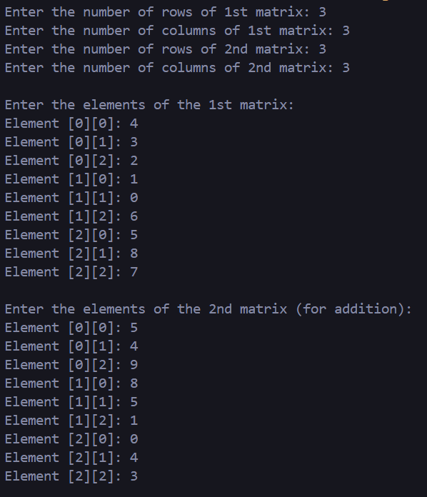

OUTPUT:
Result of matrix addition, saddle point, inverse, and magic square verification. Type Outptu also paste Screen Shot of Output
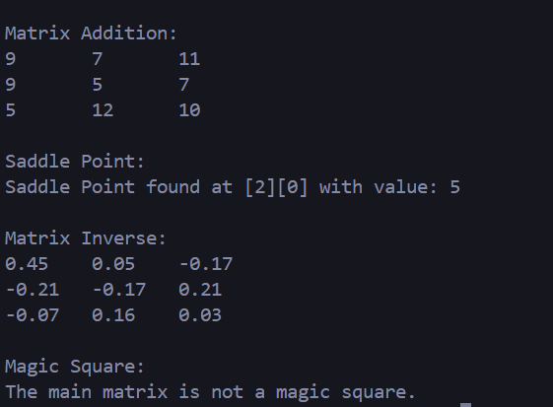

CONCLUSION:
Thus, we have learned how to perform basic matrix operations using C programming and understood their practical applications.

FAQs:
1. What is a saddle point in a matrix?
2. When does a matrix have an inverse?
3. What is a magic square?

