

Foundations of Programming
Assignment No. : 9

PROBLEM STATEMENT:
Write a program in C to check whether the given number is an Armstrong number or not.
An Armstrong number is an integer with three digits such that the sum of the cubes of its digits is equal to the number itself.
Example: 371

OBJECTIVE:
• To understand the concept of Armstrong numbers.
• To practice arithmetic operations in C.
• To develop logical thinking using loops and conditional statements.

THEORY:
An Armstrong number (also called a narcissistic number) is a number that is equal to the sum of the cubes of its digits. For a three-digit number abc, it is an Armstrong number if:
a³ + b³ + c³ = abc
For example, 371 is an Armstrong number because:
3³ + 7³ + 1³ = 27 + 343 + 1 = 371.

PLATFORM:
Linux

ALGORITHM:
1. Start
2. Display a message telling the user to input a positive 3 digit integer.
3. Store the input in an integer variable.
4. Divide the input by 100 and store it in the hundreds variable
5. Divide the input by 10 and then take the remainder when divided by 10 and store it in tens variable.
6. Calculate the sum of the cubes of the 3 isolated digits, and store in an integer variable.
7. If the sum of cubes is equal to the original number, display that it is an Armstrong number.
8. Else, display that it is not an Armstrong nu,ber.
9. Stop

C PROGRAM:
#include <stdio.h>
int main()
{
printf("Enter a 3 digit integer to check whether or not it is an Armstrong number: \n");

int entered;
scanf("%d", &entered);

int hundreds = entered / 100;
int tens = (entered / 10) % 10;
int units = entered % 10;

int LHS = hundreds * hundreds * hundreds + tens * tens * tens + units * units * units;

if (LHS == entered) {
printf("%d is an Armstrong number.", entered);
} else {
printf("%d is not an Armstrong number.", entered);
}
}

INPUT:
Enter a three-digit number.
Example Input:
371
Paste Screen Shot of Input

OUTPUT:
Example Output:
371 is an Armstrong number.
Paste Screen Shot of Output
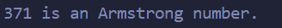
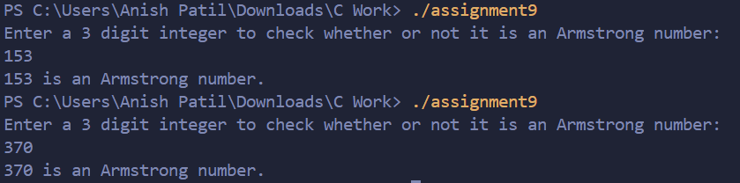

CONCLUSION:
Thus, we have successfully written a C program to check whether a given number is an Armstrong number using loops and arithmetic operations.

FAQs:
1. What is an Armstrong number?
2. Why is the Armstrong number concept important in programming?
3. How does this program work step by step?

