**Low Cost Ventilator**

**Vent-Now Inc.**

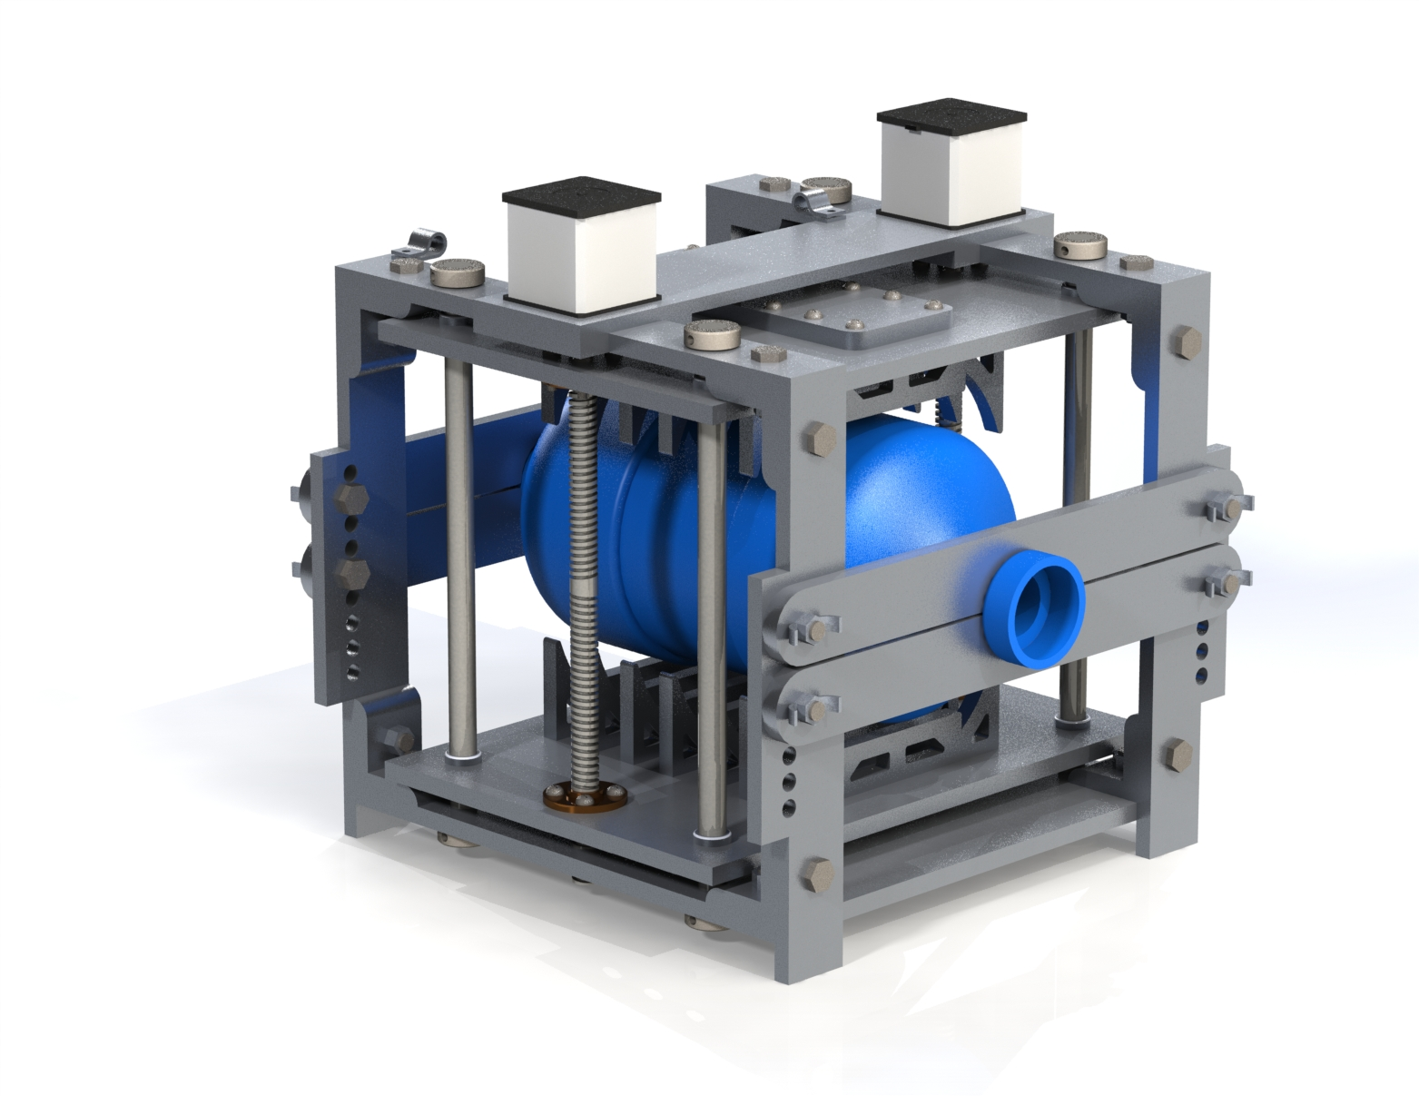

**Design Report**

MER 419: Design of Mechanical Systems

Professor: Ronald Bucinell

Jake Mazuryk, Giancarlo Sabetta, Marcello Agnitti, Matt Browne, Frank Dilone

Spring 2020

**EXECUTIVE SUMMARY**

**Problem Statement**

In early March of 2020, the World Health Organization declared COVID-19 a global pandemic. The disease, caused by the SARS-CoV-2 virus, attacks the respiratory system of infected individuals and can cause complete respiratory failure in some individuals. Due to the alarmingly high transmittal rates of the virus and the significant morbidity and mortality associated with the disease, the global health community quickly began to struggle to maintain an adequate supply of critical medical supplies. One of the most important devices that critical COVID-19 patients required was a mechanical ventilator to breathe for them when the disease attacked their respiratory system. Due to the rapid increased demand for ventilators, hospitals and other healthcare institutions did not have enough ventilators to adequately treat all of their patients.

While emergency departments and intensive care units in regions with a high number of infected individuals had the greatest need for additional ventilators, every health care organization with possible exposure to COVID-19 patients also needed a supply of mechanical ventilators. Emergency Medical Services organizations, Nursing Homes, rehabilitation hospitals and more were all struggling to maintain adequate ventilator supplies in the first half of 2020.

Commercial medical ventilators are extremely expensive and complex devices that can perform a very wide array of different types of ventilation from positive pressure assistance (for example, continuous positive airway pressure at night), to complete ventilatory control of a patient’s lungs. At their core, however, ventilators need to be able to control the volume, rate, rhythm and pressure of a breath. In designing a new ventilator, these four critical parameters *must* be adjustable by the clinician in order to be considered a viable mechanical ventilator for use in emergent or short-to-medium term applications.

**Assignment Statement**

The assignment was to create a device to help combat the problem of the world-wide ventilator shortage due to the COVID-19 pandemic. An attempt is made to solve this problem by designing a low cost ventilator that can be easily made from open-source designs and easy to read instructions, and be able to support a patient longer than other DIY solutions. The ability to regulate pressure, humidity, volumetric flow rate and temperature are a necessity in order for the design to be presented as a long term solution. Specific technical questions to be addressed are as follows:

* Can this device be used as a medium to long-term solution in substitution of more conventional ventilators?
* Will it be possible for the device to be designed in a way in which it can be assembled by the average medical practitioner?
* Will the current regulations around the development of medical devices allow for the device to reach the market and be utilized against the COVID-19 pandemic?
* How will a sufficient support network for the device be developed that offers not only instruction for the deivces’s proper use, but also proper scheduled maintenance?

**Rhetorical Purpose**

The purpose of this report is to inform the reader of all aspects of the Vent-Now ventilator. This includes the initial motivation for its creation, initial brainstorming, earlier prototyping and final design. The process of manufacturing and assembly are also discussed. Finally an explanation of marketing and the product awareness process are touched upon also.

**Objective and Background**

The objective of the project is to develop a cheaper and easily manufactured ventilator that doesn’t compromise useability to fill the high demand due to the COVID-19 pandemic. In order to design such a ventilator this team began with in depth research into professional ventilators, low cost DIY ventilators, and the effects of COVID-19 on the respiratory system to get a grasp on which are the most important functions of a ventilator for these patients. Once our design objectives were determined our team moved to the designing phase, iterating through multiple Solidworks models until the current model was reached. The main results from our project are the design of our ventilator which allows for rapid prototyping by consumers while still not compromising on the ability to apply ventilation to a patient and also giving medical care professionals control over the oxygen concentration on the air.

**Conclusions**

Creating a product which can be utilized in a state of emergency that can reach communities more extensively than most existing solutions provides the consumer with a safe and reliable method for self ventilation. This project provided insight on a pandemic which our team is witnessing and being impacted by first hand. This ventilator is far superior to other DIY designs and can provide much more accurate and appropriate ventilation. If passed through all CDC guidelines, this design has potential to be utilized on a global scale. Although this project started as a simple ventilator, the final design has reached a state which can be used by many people and benefit patient outcomes.

**Recommendations**

The team recommends that care be taken when constructing the ventilator, and that the instructions be followed closely. We also recommend the use of two motors for the ventilator, in case one motor should fail, to allow for a greater factor of safety.

**Implications for the Organization**

In order for our device to be integrated into the medical ecosystem, several actions must be taken to optimize efficiency and effectiveness. In order to bring the product to market our team must submit an emergency use authorization to the FDA to get the project to market as soon as possible. Once this has been secured manufacturing can begin and deals with providers can be made to reduce costs. A device specific training program will be developed to be taught to medical professionals about optimal use of the ventilator. Informational sessions will be held for those considering acquiring our device for use in their hospital or clinic. There will be implicit costs for the organization and execution of these services and events, but the benefits will be a better understanding of the device and all its possible uses. At the end of the day, this directly corresponds to lives saved.

**TABLE OF CONTENTS**

1. Introduction………………………………………………………………………………..6
   1. The Problem
   2. The Objective
   3. The Method of the Report
2. Background……………………………………..…………………………………………8
   1. Gas Preparation
   2. Flow Control
   3. Previous Work
3. Design Specifications…...………………………………..………………………………11
4. Feasibility Discussion……………………………………..…………..…………………13
   1. Gas Preparation
   2. Flow Control
   3. Final Design
5. Preliminary Design……………………………………..………………………………..15
   1. Presentation of Final Design
   2. Design Calculations and Performance Estimates
   3. Testing Plan/Design Implementation
   4. Production Schedule
   5. FEA Simulation
   6. Cost Analysis
   7. Product User Manual
6. Synthesis/Discussion, Conclusions and Recommendations…..…………………………25
   1. Problem Restated
   2. Summary
   3. Recommendations
7. References…………………………..…………………………………………………....28
8. Appendices……………………..………………………………………………………...30
   1. Appendix A: EES Code………………………………………………………….30
   2. Appendix B: Drawing Package……………………………………....…………..31
   3. Appendix C: Instruction Manual………………………………………………...64

**1. INTRODUCTION**

**1.1 The Problem:**

Due to the COVID-19 pandemic, the world is experiencing a large shortage of ventilators. The ventilators used in hospitals are expensive, difficult to use, and, due to manufacturing difficulty among other factors, are unfortunately not in abundance. The exponential growth of this viral outbreak has instilled stress on health care systems and individuals on a global scale. In certain countries, the shortage of life saving ventilators has resulted in first responders needing to make unbelievably difficult decisions on who will live and who will die. If countries had prepared better before the outbreak reached their borders many deaths could have been prevented, however, being this situation is now a reality, it must be addressed and fixed.

With society as a whole attempting to flatten the viral curve, the requirement for low cost and accessible ventilators is very high. Not only will COVID-19 create a different post-pandemic lifestyle, it will likely need to be addressed for months, maybe even years in the future. This necessitates a revolution and overhaul of ventilator designs to meet this demand and availability for quite some time in the foreseeable future. COVID-19 is very serious and has impacted every human around the world. It is necessary for every individual and organization in the world to do what they can to minimize the various complications and stress induced situations from this pandemic.

**1.2 The Objective:**

There is a high demand for ventilators however, it is infeasible to construct a fully functioning, long term ventilator as they are complex, and many better equipped companies are undertaking this challenge. With this project, we wish to alleviate the demand for short term ventilators in the healthcare industry. With this we would like to design a ventilator that is more permanent than the majority of the existing ‘DIY’ solutions at a lower cost than conventional ventilators. With this project we would like to construct a ventilator that is able to mix the gasses appropriately for a breath, administer the breath, and simulate the process of exhalation.

**1.3 The Method of the Report:**

This report will inform the reader of the extent of the problem proposed and the solution synthesized. A background of the approach to the problem will be explained, including a functional decomposition. Design specifications based on the functional decomposition will be provided, specifically those pertaining to producibility and reliability. A summary of the feasibility discussion and justification for design choices will be presented in the design report. The report will outline the preliminary design of the solution; including but not limited to: design calculations, performance estimates, design implementations, production schedule, and cost analysis. Further approaches and implementations will also be explored.

**2. BACKGROUND**

Mechanical ventilators need to be able regulate both the mixture of gas delivered to the patient as well as control the flow of air delivered. The number of control variables in mechanical ventilators varies by complexity and price of the device, however the crucial variables and their approximate values for these two main systems are presented

**2.1 Gas Preparation:**

*Air Temperature/Humidity:*

When breathing, ambient air is usually heated and humidified in the nasal cavity and pharynx; such that by the time it has reached the orifice of the right lower lobe bronchus, it is at 37.3 C with an absolute humidity of 44 mg/L [1]. Humidity is the measure of the moisture content of air and it is dependent on the temperature of the air. Mechanical ventilation bypasses many natural checks, to ensure safe breathing the temperature and humidity of air brought to the body by a ventilator must be strictly regulated. One study found that dry air introduced to the lungs caused 39% ciliar damage in respiratory epithelial cells [2]. Ventilators must take care to add enough moisture to the air to prevent the dry air from damaging cells in the body, but not so much that the moisture condenses in the lungs or within the piping.

*Regulate Gas Mixture*

The required amount of oxygen for a human breath is between 19.5% and 23.5% according to the Occupational Safety and Health Organization [3]. In order to provide this to the patient, this gas mixture must be prepared and monitored before administration to the patient. In past ‘DIY’ ventilator projects, many only operate by taking in ambient air and delivering it to the patient without monitoring this oxygen level. This works under the assumption that ambient air in a hospital has sufficient oxygen levels. In the ventilators that are currently used in hospitals, they are simply connected to a wall outlet that supplies oxygen for the ventilators [4]. The need for a commercial ventilator to be located in close proximity to a wall outlet creates other design complications.

**2.2 Flow Control:**

*Breathing Rate:*

A typical adult breathes between 12 and 16 times per minute, however during exercise or deep sleep respiratory rate can vary significantly [5]. Additionally, there are many pathologies that affect respiratory rate as the body works to compensate and maintain internal homeostasis. Determining the appropriate ventilatory rate for a critically ill patient requiring mechanical ventilation is a complex process that requires significant testing and careful monitoring by trained medical professionals. Commercial ventilators can operate in multiple modes to adjust the ventilation rate according to the patient condition. In assist control ventilation, the machine will deliver a breath at each predetermined interval, but allows the patient to breath faster on their own. In pressure support ventilation, the machine is not set to a specific rate, rather it relies on the patient to initiate a breath and then the ventilator supports the breath with supplemental pressure. In general, ventilators are able to deliver breaths at a set interval, only on demand (patient begins to breathe) or some combination of the two [6].

*Volume:*

Volume-controlled ventilation (VCV) is utilized as the prefered method of ventilating patients due to the ventilation rate being fixed. There are particular equations utilized by ventilators in order to calculate the volume which the patient needs. These equations are based on height, weight, and gender of the patient. This provides the patient with a pre-set tidal volume instead of a pressure regulated control [7]. The limitation to VCV is the clinician must appropriately set the various settings such as the inspiratory flow, flow waveform, and the inspiratory time [7]. Typically, both volume and pressure-control ventilation (PCV) work together to help the patient receive the correct ventilation requirements.

*Pressure:*

Pressure-controlled ventilation (PCV) is an important facet of the proper operation of a ventilator. PCV, along with VCV are different control variables of a ventilation mode that allow for the customization of the pressure and volumetric flow rate of a ventilator [7]. The ability to regulate ventilatory pressure allows the clinician to limit the maximum airway pressure to the lung of a patient; reducing the risk of respiratory injury. While the VCV required is determined by the physical characteristics of the patient, these calculations do not account for patient comfort. Often, even an accurately volume controlled ventilation rate can lead to disfort in the patient due to the sensitivity of the lungs. The ability of a ventilator to regulate pressure provides a greater capacity to customize treatment for comfort and effectiveness.

**2.3 Previous Work for DIY Ventilators:**

Various institutions, engineers, and even backyard designed ventilators are being built to combat the COVID-19 pandemic. Many of the designs which are found online are open source in order to expand units at a more rapid rate around the world. For example, MIT has created an E-Vent design which they encourage other individuals to expand on their project to improve performance [8]. Their design utilizes a BVM squeezing mechanism and various valves to control the flow based on patient requirements. Although MIT has a large budget for this design, other creators have made much cheaper designs which perform the same task with much more common parts [9]. These DIY designs utilize more common piping, valves, and miscellaneous parts purchased at local hardware stores. The materials are easily accessible and more likely to be in the home of an average person. These types of designs can be seen all over the internet due to the general public's concern of this pandemic. The existing lower budget ventilators likely have not passed CDC and FDA guidelines, however they are still able to ventilate patients in a time of need.

## 

**3. DESIGN SPECIFICATIONS**

Our design must have specific features which need to be met in order to correctly ventilate and maintain a patient in a stable condition. Throughout the design and build process these are the most important aspects which must be kept in mind until the end product was finished:

*Functional Requirements*

* Device must fit around a bag valve mask
* Must be small enough to fit comfortably in hospital rooms
* Controllable magnitude of ventilations
* Controllable frequency of ventilations
* Controllable force of ventilations
* Warm gas before delivery
* Deliver mixed gas before delivery (enough oxygen)
* Easy to use by all first responders
* Easy user interface
* Must have all required sensors

*Safety Requirements*

* Filters outside air
* Easy to understand instructions for use
* CDC/FDA approved
* Automatic shut off if any problems
* Avoid barotrauma

*Quality Requirements*

* Must utilize parts which are readily available
* Must utilize reliable parts (not inclined to breaking)
* Must be CDC/FDA approved

*Manufacturing Requirements*

* Use parts which are available to the general public
* Utilize a spec sheet and step by step instructions how to build
* Must be able to be built by the average person (ideally)

*Timing Constraints*

* Design has to be completed within 10 weeks of class
* Manufacturing should take a week
* Setup should take about a day

*Economic Constraints*

* Because of the high demand of ventilators due to the coronavirus the market size and demand are high
* The use of a bag valve mask will decrease costs of the system

*Ergonomic Constraints*

* Easy to replicate with instructions
* Easy to operate

*Ecological Constraints*

* Material used does not produce toxic waste
* Will not spontaneously combust

*Aesthetic Constraints*

* Looks finished
* No rough or sharp edges

*Life Cycle Constraints*

* Easy to construct
* Easy to transport if not constructible by hospitals
* Durable enough for extended use, but not long term
* Easy to repair and/or switch out parts

**4. FEASIBILITY DISCUSSION**

Various different approaches and alternative designs were considered before arriving at the final system. The feasibility of the different approaches was examined, and the justification for the final design selections is presented below.

**4.1 Gas Preparation**

The air has to be at an appropriate temperature and contain an appropriate level of oxygen before being delivered to the patient. To do this a few options were considered. The bag valve mask that would be manipulated to supply ventilations could either be simply open to ambient air, connected to the air outlets from the hospital, or a more complex version where two gas tanks were hooked up to the bag valve as well as heated, with humidity being added. The first idea, of ambient air, was disregarded because it would not be able to sufficiently regulate oxygen, and the last idea was disregarded for being too complex. It was then decided to hook up to the two hospital air outlets (medical air and oxygen), with a regulator on the oxygen tubing, both coming together with a y-valve, therefore supplying gas with enough oxygen content to the bag valve mask. The air would then run through an oxygen humidifier which would be able to add humidity to the air. This was added because it is a simple addition to increase the quality of the air being supplied to the patient.

**4.2 Flow Control**

To deliver the appropriate amount of gas to the patient, three different parameters have to be considered and controlled: volume, rate and pressure. The exact flow rate of the system will be determined by the mechanical action on the ball valve mask. The press rate and the press amount on the ball valve mask will be variable depending on the needs of the patient. As more air is needed, the presser can press faster and harder. The pressure of the flow will be determined during the gas mixing phase of the design and will be essentially ambient pressure. There were considerations of using a pump instead of a ball valve mask to regulate flow, but due to price considerations in the face of this epidemic it was decided that using a BVM would be better.

**4.3 Final Design**

The final design consists of a frame built around a bag valve mask. The BVM will be squeezed to release the air into the patient's lungs through stepper motors and a turnbuckle power screw design. The BVM input would be coming from the clean hospital air which pre-regulates the oxygen quantity. In addition, the rate and flow control can be adjusted. An in depth design can be seen in both the *Preliminary Design* section of the report, as well as in the attached instruction manual.

**5. PRELIMINARY DESIGN**

**5.1 Presentation of Final Design**

The mechanical portion of the design will consist of a universal frame able to be 3D printed/ laser cut using common materials. In addition, the stepper motors and various other parts of the frame will be able to be purchased from a product supply vendor such as McMaster-Carr. The goal of this simplistic, universal design is for widespread production and ease of building. During this time of unprecedented emergency, having an easy to build design that many can understand will increase the exposure and desire for the product.

The frame of the design seen in Figure 1 will be built with 6mm acrylic which is easy to access and a very reasonable price. The frame also has a “flute” design which interweaves the parts in order to make sure the correct parts are being placed together. This prevents confusion during the building process and provides users with a quick building process to have the product up and running when time wasted means lives lost. The frame also has mounting locations for a BVM which allows for different sizes to be placed within the frame. This allows hospitals to use existing supplies and not further the shortage of ventilators.

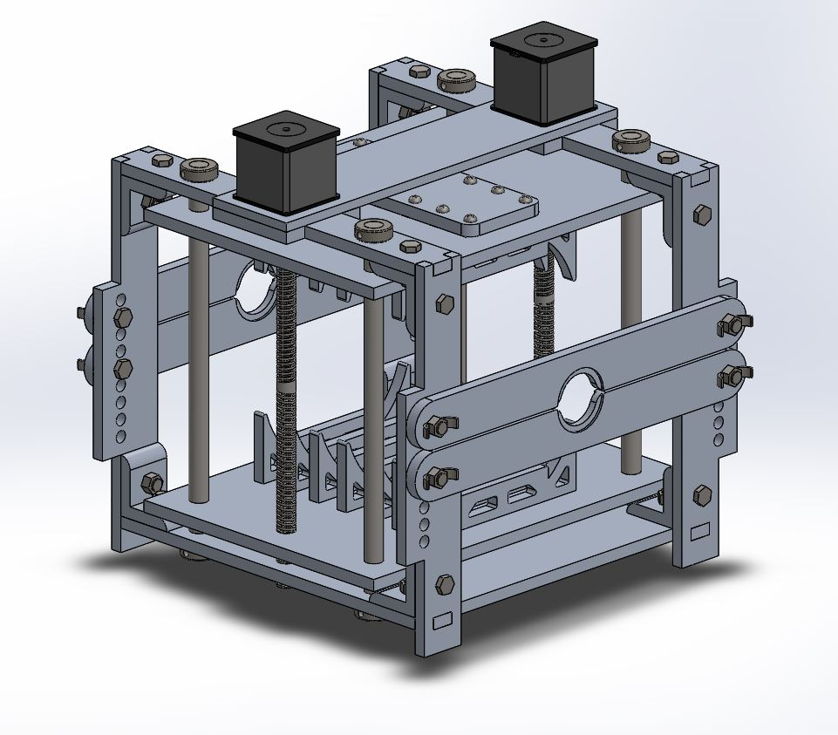 **Figure 1:** SolidWorks model of the mechanical portion of the design.

The stepper motors will be mounted on the top of the fixture, directly connected to the turnbuckle in order to move the plates up and down to perform the ventilation. Although the design does not require two motors, it allows for safety and redundancy. It also means there is less stress on a single motor prolonging its safe to use lifespan. They will be controlled by an external PCB board. Although the electronic portion of the design is crucial to its function, it will not be outlined in this report.

The turnbuckle and follower shaft design seen in Figure 2 were created to ensure safety, accuracy, and simplicity were all maintained. The follower shafts are used in redundancy to make sure the clamping plates remain perfectly horizontal to prevent binding or buckling of the system.

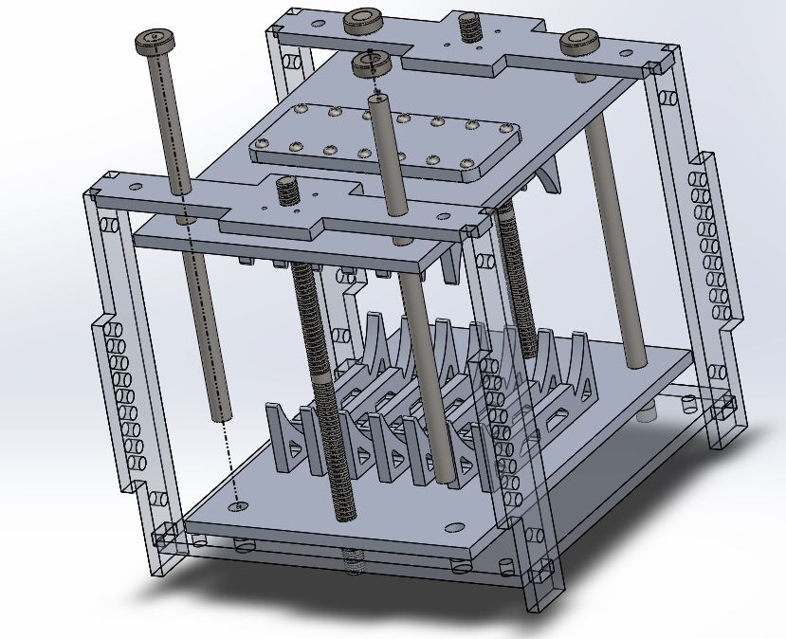

**Figure 2:** Following rod and turnbuckle design assembly.

The actual clamping plate design can be seen in Figure 3. The power screws rotate at the exact same rate to prevent this undesired motion as well. The clamping plates will be connected via couplers and fittings to convert the rotational motion to vertical, linear motion.

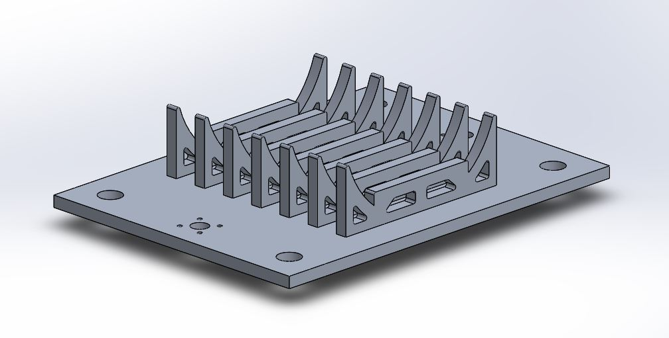 **Figure 3:** Ventilator clamping plate.

The final design will also come with an instruction manual for the user to build quickly and efficiently. More information can be seen about this in the section “Product User Manual” and in *Appendix B: Instruction Manual*. The design is rather simple and straightforward, however this aspect can assist in any confusion or miscommunication from initial exposure to the completed build.

Overall, this design was constrained on the principle of being simplistic but remained effective. The redundancies and over design ensure that this criteria is met. Guaranteeing the strength calculations take factor of safety (FOS) into consideration and the correct materials are chosen, this product has the potential to save lives and reach communities which high end, expensive ventilators are unable to do.

Many aspects of the design can be understood through the instruction manual as it provides in depth design visualizations and explains in close detail how the ventilator must be used in order to function properly. This can be seen in *Appendix B: Instruction Manual*.

**5.2 Design Calculations and Performance Estimates**

Due to its widespread use in medically critical applications with no tolerance for failure, the ventilator design must be reliable, robust and highly configurable. All design calculations were based on a “worst-case” assumption and the conservative estimate was always chosen when deciding between two choices. The two subsections, gas preparation and flow control, were designed with safety and reliable, repeatable performance as the most important design variables.

*Gas Preparation*

The percentage of oxygen that the patient breaths, FiO2 (Fraction of Inspired Oxygen), is prescribed by the medical provider and is then set using an Air-Oxygen Blender that can regulate between 21% O2 (room air) and 100% Oxygen at flow rates between 0 and 30 LPM. The flow rate is regulated by an inline oxygen flowmeter and can be adjusted by the clinical at the bedside. This fully mixed and regulated flow is then passed through a humidifier which adds water vapor into the line and is sent to the BVM reservoir.

*Flow Control*

The average ventilatory requirements for an adult are: 500mL tidal volume, 12 breaths per minute, breath delivered over 1.5s, at a positive end expiratory pressure (PEEP) of 4 cmH2O [10,11]. The ventilator is designed to accommodate a “worst-case” scenario with requirements as follows:

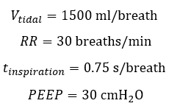

For patients requiring less aggressive ventilation in one or more of these categories, the clinician can adjust the performance of the system via software and hardware to independently control each parameter.

To achieve the required tidal volume and inspiratory time, the device must completely compress the bag (nominally 5” diameter) in 0.75s, for a linear speed of 6.67 in/s. To achieve a maximum bag pressure of 30 cmH2O, the force required from the clamp was calculated using P=F/A, where the compression area was assumed to be 25 in2 (based on a 5 in diameter, 5 in long BVM). The clamping force was calculated to be 10.67 lbf. In actuality, the compression area is expected to be <25 in2, therefore the calculated force requirement of 10.67 lbf is expected to be an overestimate.

The torque required to drive the system was determined using,

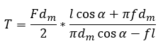

The shear and axial stress on the screw was determined using,

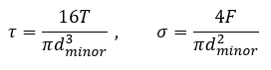

Where dm is the mean screw diameter, dminor is the minor diameter of the screw, l is the screw lead, ⍺ is the thread angle, and f is the friction factor.

In order to appropriately size the motor given the required torque, the maximum rotational speed of each was determined using



Where x is the maximum travel distance of the clamp and l is the lead of the screw.

An iterative design process was completed using the formulas above and the Engineering Equation Solver (EES) for commercially available stepper motors listed on McMaster-Carr and our custom turnbuckle design. The final turnbuckle lead screw design is based off McMaster-Carr part 98980A973, which is a Fast-Travel 304 Stainless Steel Precision ACME 3/8”-8 lead screw with 4 RH thread starts that has a lead of 0.5”/rev. The custom turnbuckle design uses two 4” long sections of the 3/8"-8 ACME 4:1 thread, however one length has left hand threads and the other has right hand threads as shown in figure 4.



**Figure 4:** Custom turnbuckle lead screw design

By merging the RH and LH threaded sections, the effective lead of the screw is doubled, allowing for increased linear motion of the clamp per revolution but with a higher torque requirement. One end of the lead screw is milled down to 0.20” to mate with the screw-motor coupling used to connect the motor shaft to the screw. The final lead screw is made from Stainless Steel to resist rust and degradation of performance over time. The final motor was a NEMA 17, 900 RPM, 102 oz-in stall torque, 18.9 oz-in continuous torque.

The results of the EES calculations (Figure 5) report the values of the final design variables. Complete EES code is presented in *Appendix A: EES Code*. The drive system has an overall safety factor of>90, the motor is able to supply approximately 2.7x the required torque at stall and has a maximum rotational speed 2.25x the required. Further, the drive system is able to fully operate the ventilator with only one functioning motor/screw in an emergency for complete redundancy.

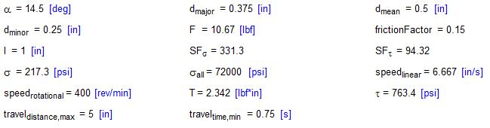

**Figure 5.** EES output for the power screw and motor selection of the final design.

**5.3 Testing Plan/Design Implementation**

The device will be tested in two facets. Firstly, individual components of the device for performance and secondarily the entire device will be tested with all integrated components. The electric motors that actuate the power screws will be tested for correct voltage and current ratings with a multimeter. The motors will also be connected to a laboratory power supply and their ability to move the power screws in the ventilator will be observed. Our calculations suggest these will reliably perform up to standards. The ability of the ventilator to produce adequate volumetric flow rate and pressure will be tested using a flow rate sensor and a digital barometer. The device will be calibrated accordingly using these measurements. The device will be used for extended periods of time to ensure reliable performance over extended use. After all preliminary testing of the device is completed to ensure it is a reliable machine from a mechanical perspective, our team will begin the process of gaining FDA approval for a medical device classification. Our device would be categorized as a Type II device and we would file it as a Humanitarian Device Exemption (HDE) in order to circumnavigate lengthy lab and human trials [10].

**5.4 FEA Simulation**

The structural components of the device were designed using acrylic to be more economical and save weight. An FEA study was performed in order to ensure structural integrity of the arctic material under the induced loads caused by the operation of the device. It was determined that the critical part of the device are the moving shelves holding the BVM, as shown Figure 5. This piece was calculated to have an applied force of 10.67 lbf. This loading system was simulated using SoldWorks FEA. A force normal to the shelve was applied and the power screw rail holes were set as the simulation fixtures. The max load was determined to be 1.195E6 von Mises and the yield strength of the material 4.5E7 von Monsises. This gives us a factor of safety greater than an order of magnitude.

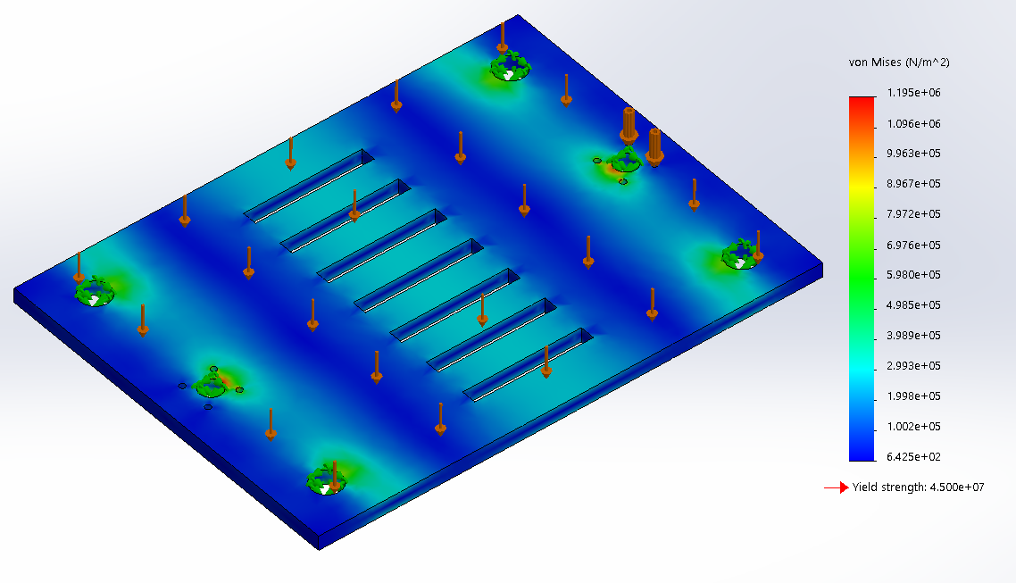

**Figure 5:** Results from using SolidWorks FEA analysis.

**5.5 Production Schedule**

As the primary focus of the device will be to make it as accessible to people as possible. The primary avenue of sending it would be by sending files to the customer for a slightly lower price or manufacturing it in house and shipping it to the customer. In the event that we have to manufacture the product ourselves the rapid prototyping nature of the design makes manufacturing easy. The main body of the model can be manufactured in a single day. The main bottleneck of our production is rapidly sending out the completed parts and shipping them to consumers. Availability of other parts that we cannot produce in house such as the stepper motors may provide shipping delays, but as long as a large enough stock is purchased or a deal is made with the seller then total production time could be minimized. If the consumer purchases the rights to make our device, shipping times would be the largest limiting factor in completing the build process. The goal of our design is to minimize these times when compared to other ventilators on the market, providing a safe, reliable alternative at a great price.

**5.6 Cost Analysis**

The total cost for the system is $850.39 USD. The price breakdown is as seen below:

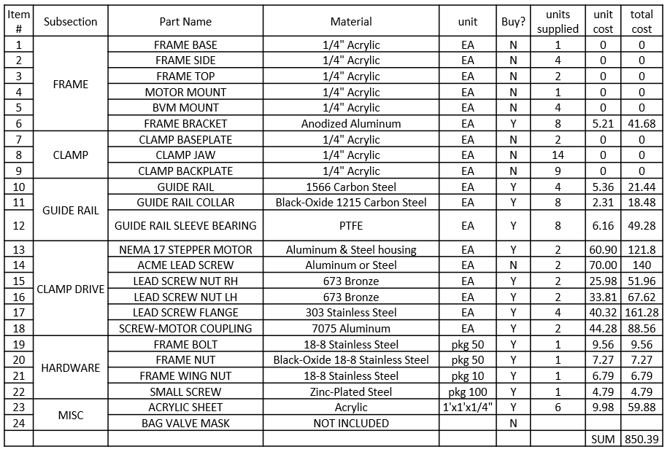 **Table 1:** Overall system cost.

At first glance, this price might seem rather high, however when compared to other conventional ventilator designs, our design is 96% cheaper than others. Other ventilator designs can range from $20k-$100k and all prices in between. Our alternative has the potential to not only help the general public, but make a huge impact in areas where money is an issue and lives are being lost.

**5.7 Product User Manual**

The manual which comes with this product design are step by step instructions on how to build it from the ground up. This utilized the 3D SolidWorks model to present the steps in a comprehensible format with visuals and a parts list. There will also be included dxf files (in a real world situation) which the user can laser cut or 3D print in order to begin the building process.

The hospital staff should have enough prior knowledge on how they utilize the pre and post BVM mechanical ventilator system in regards to air flow and concentration quantity. If there is any misconception in how to use the ventilator, there exists a section in the instruction manual which shows how it must be connected to provide safe ventilation.

The step by step instructions can be seen in *Appendix B: Ventilator Instruction Manual*.

## 

## **6. SYNTHESIS/DISCUSSION, CONCLUSIONS AND RECOMMENDATIONS**

**6.1 Problem Restated**

In the early part of 2020, the COVID-19 disease became a global pandemic. Which caused serious respiratory distress and ultimately respiratory failure amongst a significant percentage of the infected population. This rapid increase in patients requiring aggressive respiratory care, soon exceeded the local supply of mechanical ventilators in hospital emergency rooms and intensive care units. The objective of this project, therefore, was to develop a near term solution to the ventilator shortage, by designing a low cost mechanical ventilator that could be rapidly produced and assembled to meet the growing need.

**6.2 Summary**

There are two main parts of the design: Mechanical ventilation and air preparation. Mechanical ventilation is done via two platforms that close synchronously to squeeze a bag valve mask. This squeezing is controlled by motors and can be achieved at variable rates, dependent on the choices of health care workers and the needs of the patient. Air preparation was accomplished via a gas mixing chamber which adds humidity and pure oxygen to air inputs. Additionally, health care workers can control the gas preparation through the use of valves.

Unfortunately, this project never reached the manufacturing and prototyping stage, due to practical limitations brought about by COVID-19. Despite being unable to prototype the project, several avenues were explored to provide as robust a design as possible. To start, two motors are used in the project to add redundancy. Which is done to ensure that in the event of failure of one motor, the other motor is capable of supporting the entire system by itself, with a reasonable factor of safety. Secondly, solidworks motion studies were used to confirm the proper movement of the device. Finally, finite element modeling helped to ensure that failure did not occur on any parts of the device.

**6.3 Conclusions & Recommendations**

While the final design presented here is more than capable of emergency ventilation of a respiratory compromised patient, it can simply not compete with commercial ventilators ability to manage the ventilations of a long term, ventilator dependent patient. The robust design certainly has a wide range of applications in environments where access to advanced medical care and/or devices is not possible. Low cost, DIY solutions that can be built mostly from locally sourced components have promising applications in developing nations that do not have the resources to buy expensive commercial ventilators. In these regions, and in various austere conditions the Vent-Now and derivatives would provide much needed mechanical ventilatory support for patients who may otherwise not have access to a ventilator.

While as of 6/5/2020, the ventilator shortage in America has seemed to subside, the frequency and severity of global pandemics is certainly only going to increase. A design, or set of designs, for a mechanical ventilator able to cope with a short term rapid increase in need is an important part of a disaster readiness plan.

Further designs should work to reduce the cost of the design as well as reduce the reliance on specialized parts and tools in order to make the design even more accessible to those that need it most. Additional research into the bag valve mask should also be conducted and possible alternatives considered in future product iterations.

While this project involved a steep learning curve to understand the biomechanics behind breathing, the team was still able to gain valuable insight into the product development of medical devices and learn about the pathophysiology associated with mechanical ventilation. From a technical standpoint, a great deal was learned about the design and selection of power screws and stepper drive motors.

Ultimately, in partnership with an electrical/software engineering firm to design the motor controller hardware and software this design could have a significant positive impact in scenarios where access to a conventional ventilator is not possible or in austere emergent situations where the size and portability of this design excels. Future iterations of this project would undoubtedly result in a product able to meet the ventilatory needs of a complex respiratory compromised patient while the current design is more than capable of significantly improving outcomes for patient populations requiring emergent ventilations or for those who would otherwise not have access to a mechanical ventilator.

**7. REFERENCES**

[1] McFadden Jr, E. R., et al. "Thermal mapping of the airways in humans." *Journal of applied physiology* 58.2 (1985): 564-570.

[2] Chalon, Jack, Dolores AY Loew, and Josy Malebranche. "Effects of dry anesthetic gases on tracheobronchial ciliated epithelium." *Anesthesiology: The Journal of the American Society of Anesthesiologists* 37.3 (1972): 338-343.

[3] Malesky, M., 2020. *Minimum Oxygen Concentration For Human Breathing*. [online] Sciencing. Available at: <https://sciencing.com/minimum-oxygen-concentration-human-breathing-15546.html> [Accessed 5 June 2020].

[4] Chatburn, R. and Mireles-Cabodevila, E., 2020. *Chapter 3. Basic Principles Of Ventilator Design | Principles And Practice Of Mechanical Ventilation, 3E | Accessmedicine | Mcgraw-Hill Medical*. [online] Accessmedicine.mhmedical.com. Available at: <https://accessmedicine.mhmedical.com/content.aspx?bookid=520&sectionid=41692239%20> [Accessed 5 June 2020].

[5] Johns Hopkins Medicine, 2020. *Vital Signs (Body Temperature, Pulse Rate, Respiration Rate, Blood Pressure)*. [online] Johns Hopkins Medicine. Available at: <https://www.hopkinsmedicine.org/health/conditions-and-diseases/vital-signs-body-temperature-pulse-rate-respiration-rate-blood-pressure> [Accessed 5 June 2020].

[6] Carpio, A. and Mora, J., 2020. *Ventilator Management*. [online] Ncbi.nlm.nih.gov. Available at: <https://www.ncbi.nlm.nih.gov/books/NBK448186/> [Accessed 5 June 2020].

[7] Robert, C. and Bradley, D., 2020. *Pressure-Controlled Versus Volume-Controlled Ventilation: Does It Matter?*. [online] PubMed. Available at: <https://www.ncbi.nlm.nih.gov/pubmed/11929615> [Accessed 5 June 2020].

[8] Slocum, A., 2020. *MIT E-VENT | Emergency Ventilator Design Toolbox*. [online] MIT E-Vent | MIT Emergency Ventilator. Available at: <https://e-vent.mit.edu> [Accessed 5 June 2020].

[9]Panvent, 2020. *The Pandemic Ventilator*. [online] Instructables.com. Available at: <https://www.instructables.com/id/The-Pandemic-Ventilator/> [Accessed 5 June 2020].

[10] Amitai, A., 2020. *What Is The Ventilator Setting For Positive End-Expiratory Pressure (PEEP) In MechanicallVentilation?*.a[online]aMedscape.comaAvailableaat: <https://www.medscape.com/answers/810126-45489/what-is-the-ventilator-setting-for-positive-end-expiratory-pressure-peep-in-mechanical-ventilation> [Accessed 5 June 2020].

[11]Nickson, C., 2020. *Bag-Valve-Mask (BVM) Ventilation • LITFL • CCC Airway*. [online] Life in the Fast Lane • LITFL • Medical Blog. Available at: <https://litfl.com/bag-valve-mask-bvm-ventilation/> [Accessed 5 June 2020].

[12] Johnson, J., 2016. *FDA Regulation Of Medical Devices*. [online] Congressional Research Service. Available at: <https://fas.org/sgp/crs/misc/R42130.pdf> [Accessed 5 June 2020].

[13] gearbags.com, 2020. *Mini Medical Oxygen Regulator, Constant Flow, 0-15Lpm*. [online] GearBags.com BylLightninglX|GearBagslforlalllindustries.aAvailablelat: <https://gearbags.com/shop/supplies/airway/lxo2r-m/?gclid=EAIaIQobChMI2_aJ-fe16QIVhODICh2ZuQunEAQYASABEgJNvPD_BwE> [Accessed 5 June 2020].

[14] Directhomemedical.com, 2020. *Salter Black Lid Bubble Humidifier Bottle (With 6 PSI Safety Valve) For*l*Various*l*Oxygen*l*Concentrators*.l[online]lDirectlHomelMedical.lAvailablelat: <https://www.directhomemedical.com/cart/merchant.mvc?Screen=PROD&Product_Code=7600-6-psi-bubble-humidifier-oxygen-bottle-salter&Store_Code=DHM> [Accessed 5 June 2020].

[15] 911emergencysupply.org, 2020. *Peep Valve Disposable Pressure Manometer Ventilator Respiratory*. [online]l911emergencysupply.org.lAvailablelat: <https://www.911emergencysupply.org/index.aspx?pageid=3525242&prodid=17054211&gs=1> [Accessed 5 June 2020].

[16] Pololu.com. 2020. *3. Pricing*. [online] Available at: <https://www.pololu.com/docs/0J24/3> [Accessed 5 June 2020].

**8. APPENDICES**

***8.1 Appendix A:* EES Code**

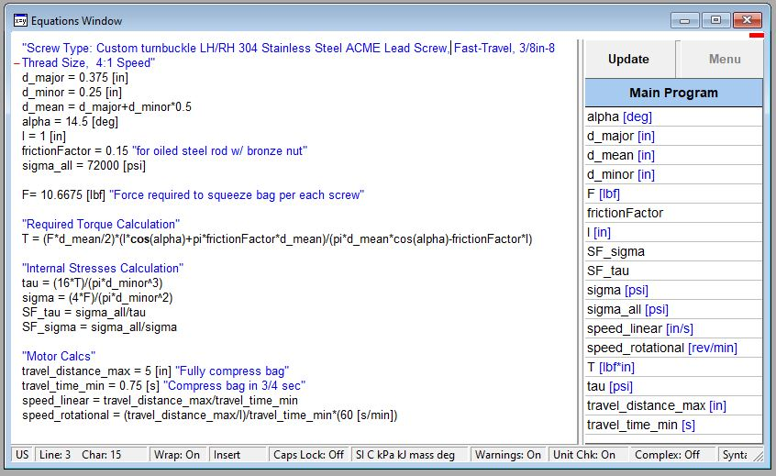

***8.2 Appendix B: Drawing Package***

(Begins on following page)