**Low Cost Ventilator**

**Vent-Now Inc.**

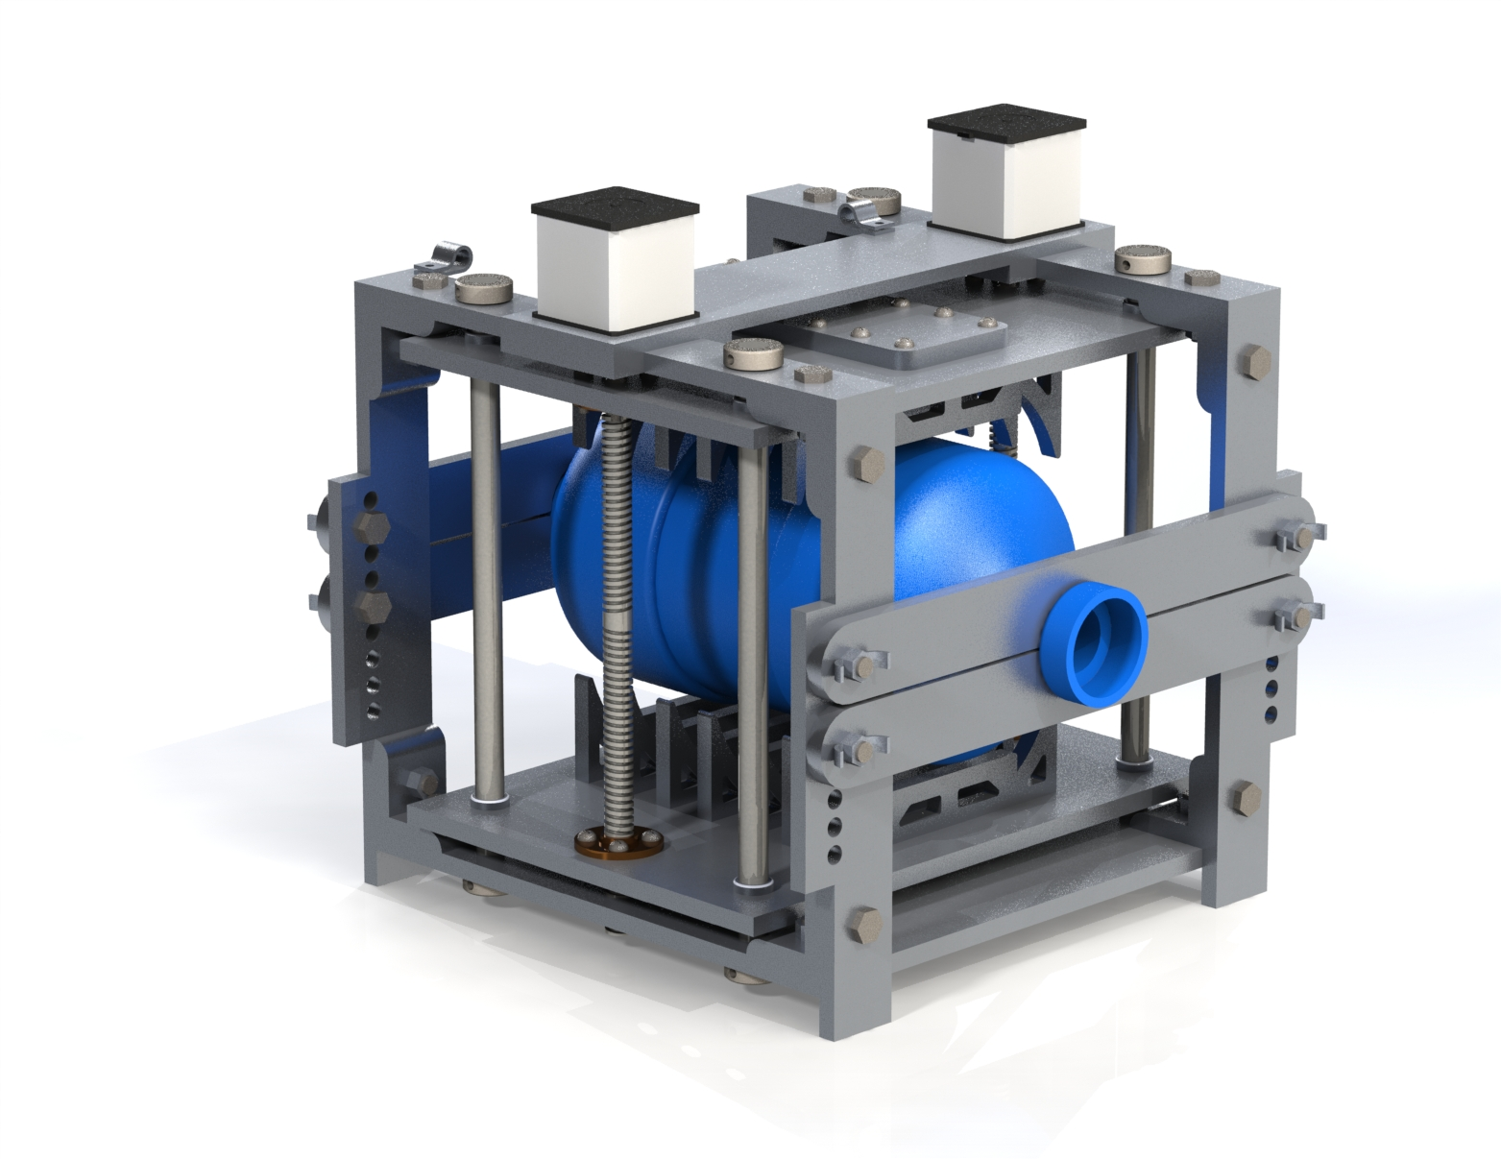

**Assembly & Instruction Manual**

Version 1

Revised: Spring 2020

**Table of Contents:**

Introduction and Conventions Used in this Manual…………………………………..….…...…67

Item Checklist…………………………………………………………………………….……...68

Assembly………………………………………………………………………………….……..75

*Part 1:* The Frame……………………………………………………………….….…...75

*Part 2:* Clamp Assembly Plate…………………………………………..………………79

*Part 3:* Bag Valve Mask (BVM) Supports…………………………...…………….……82

*Part 4:* Joining Assemblies and Creating the Ventilator…………………………...…....84

*Part 5:* Placing Bag Valve Mask (BVM) in the Frame…………………………...…......89

How to Connect the Ventilator (*READ BEFORE USE*)…………………….……...………...….91

Resources………………….……...………………………….……...…………………...….…...92

**Introduction and Conventions Used in this Manual:**

Throughout this manual, there will be step by step instructions to build the ventilator in order to use it on a variety of patients. It is important to ensure the ventilator is built correctly in order to function without problem. All parts must be tightened with tools and it is recommended to check all fasteners prior to using the product.

Tools Required:

* Phillips head screwdriver (No. 1 or No. 2 will be sufficient)
* 10mm open/closed end wrench or equivalent socket
* 2.5mm Allen / hex key

Note:

* Unless specified otherwise, all parts are connected with the standard 10mm hex head bolt and corresponding nut. Parts can be seen in the later sections of this manual.

**Item Checklist:**

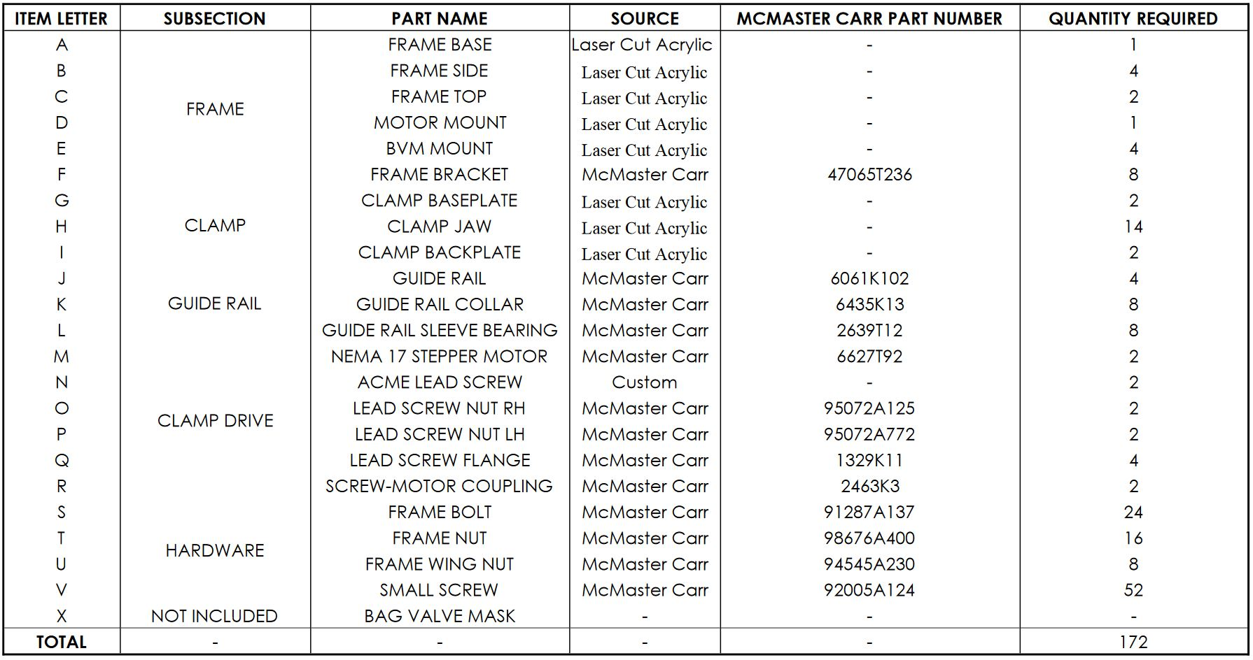

Frame Base (A) x1:

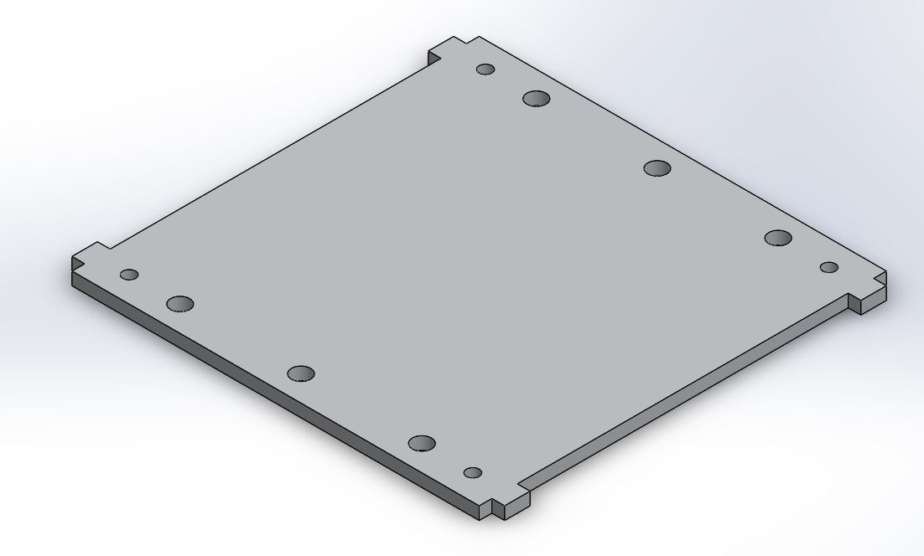

Frame Side (B) x4:

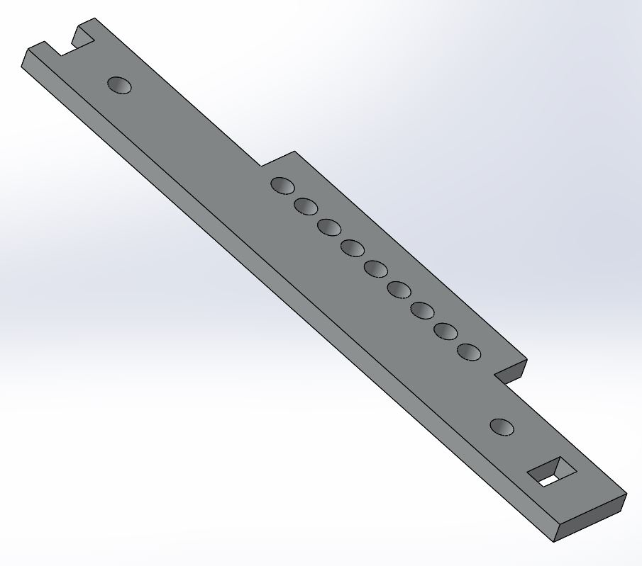

Frame Top (C) x2:

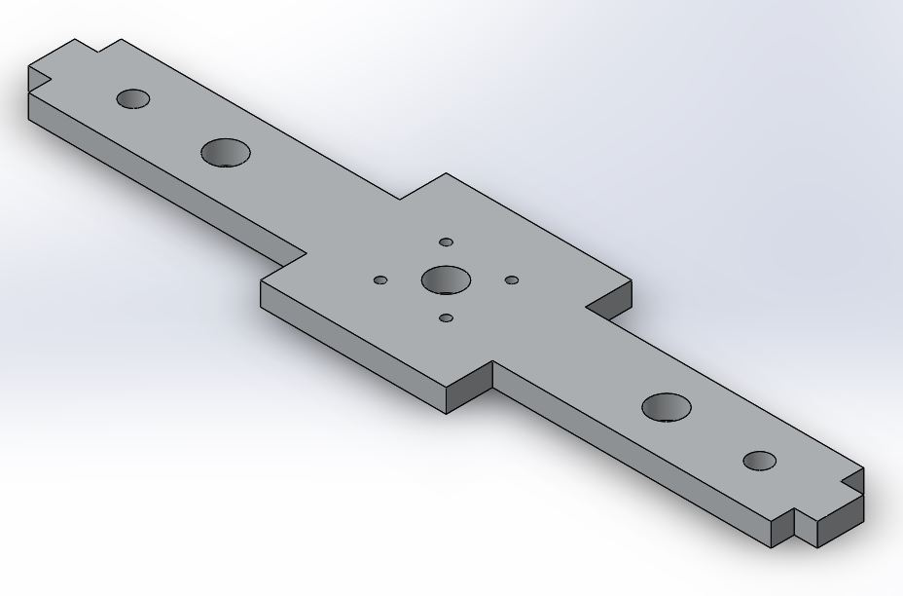

Motor Mount (D) x1:

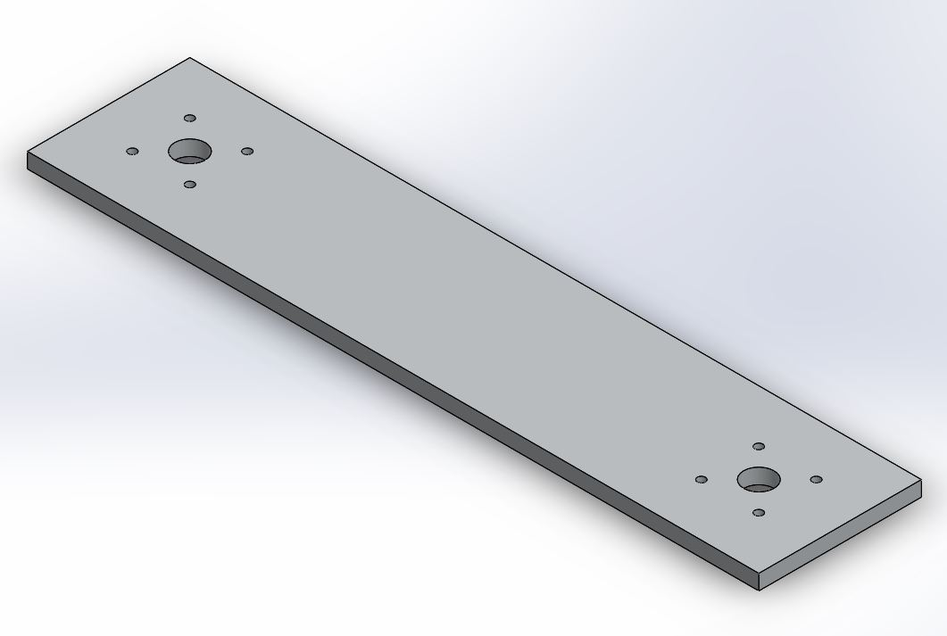

BVM Mount (E) x4:

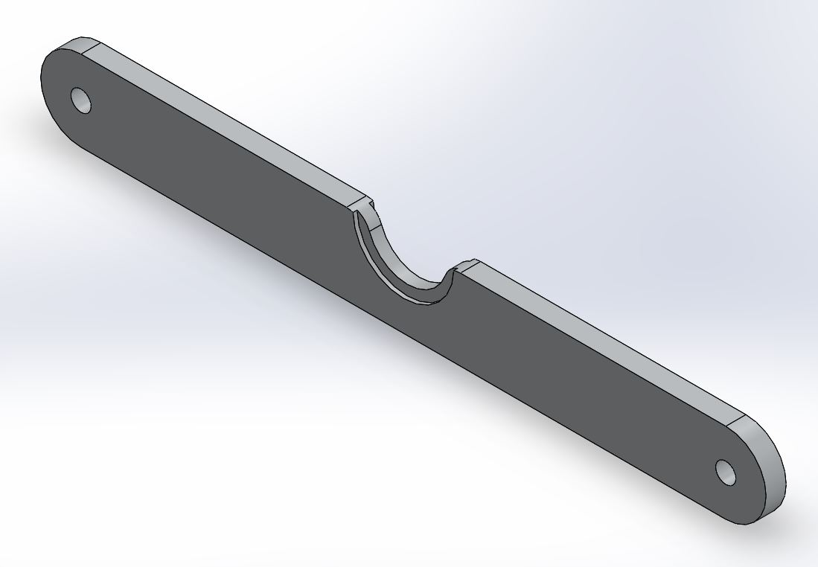

Frame Bracket (F) x8:

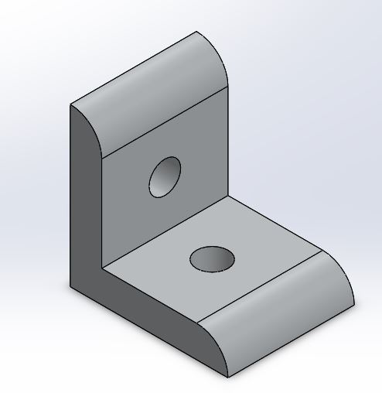

Clamping Plate (G) x2:

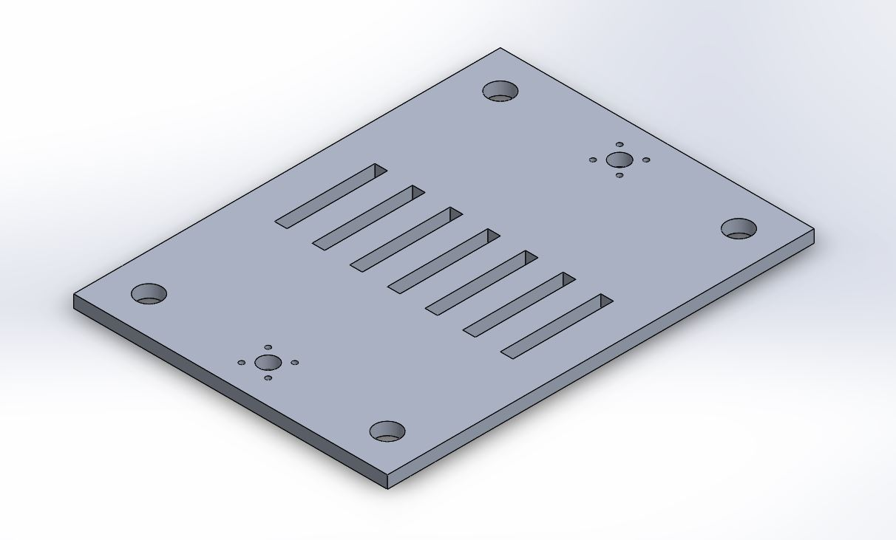

Clamp Jaw (H) x14:

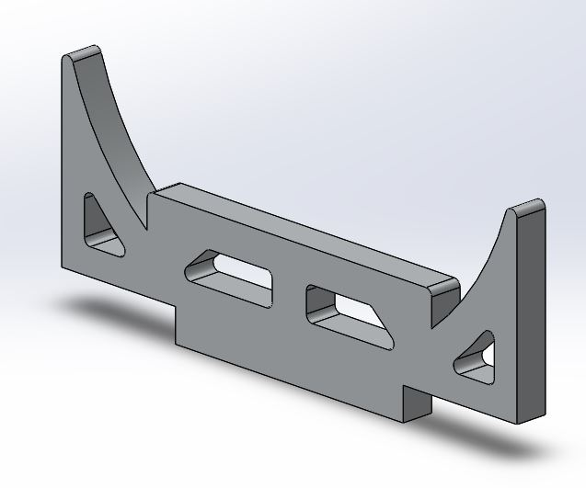

Clamp Backplate (I) x2:

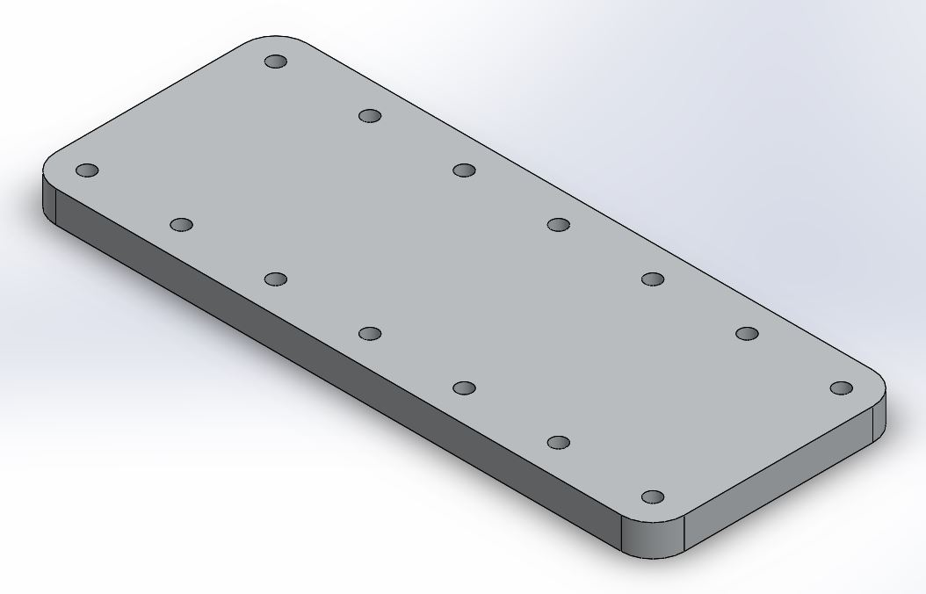

Guide Rail (J) x4:

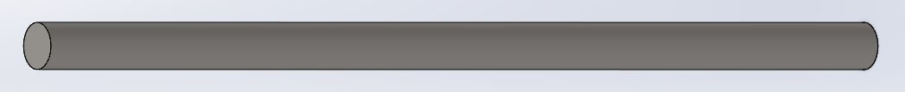

Guide Rail Collar (K) x8:

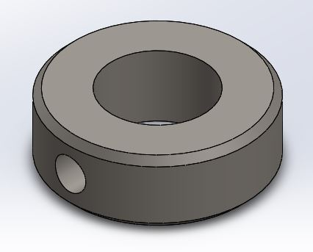

Guide Rail Sleeve Bearing (L) x8:

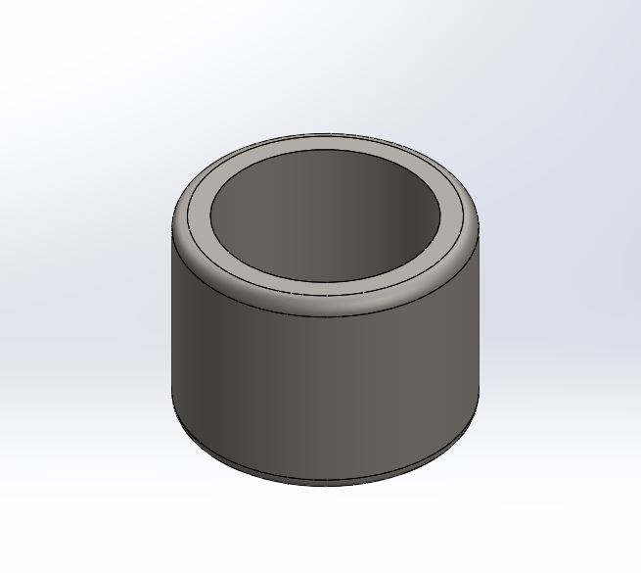

NEMA 17 Stepper Motor (M) x2:

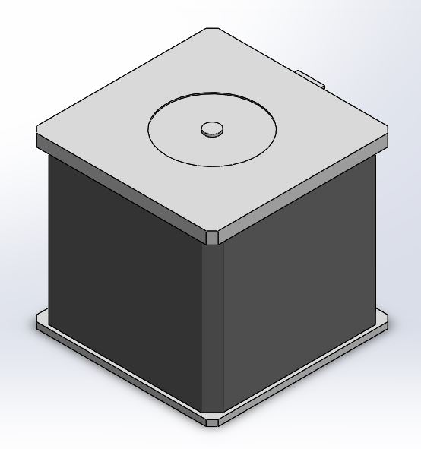

ACME Lead Screw (N) x2:

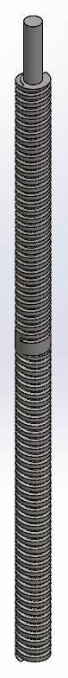

Lead screw Nut (RH and LH) & Lead Screw Flange (Ox2, Px2, Qx4):

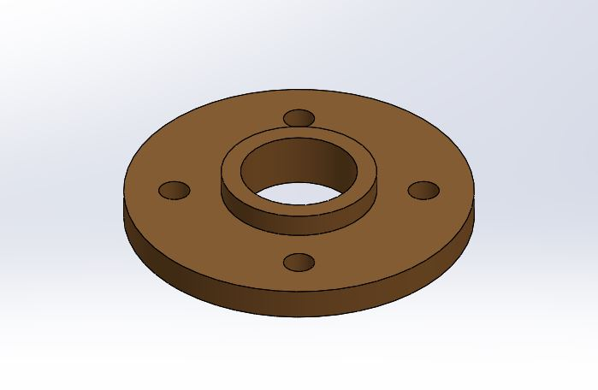

Screw-Motor Coupling (R) x2:

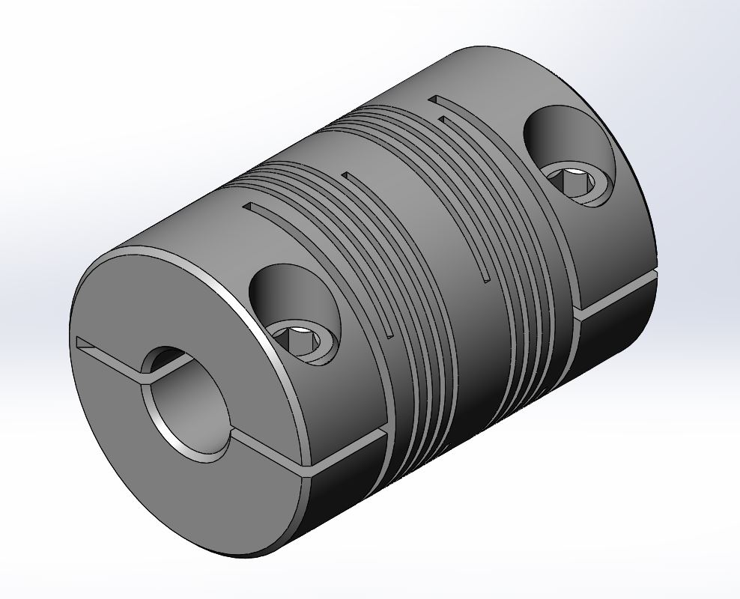[2]

Frame Bolt (S) x24:

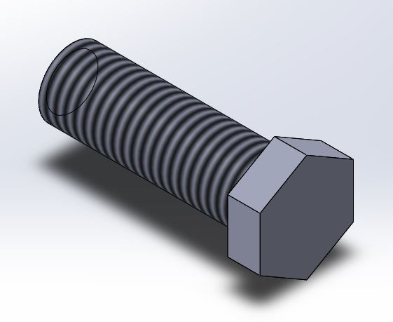

Frame Nut (T) x16:

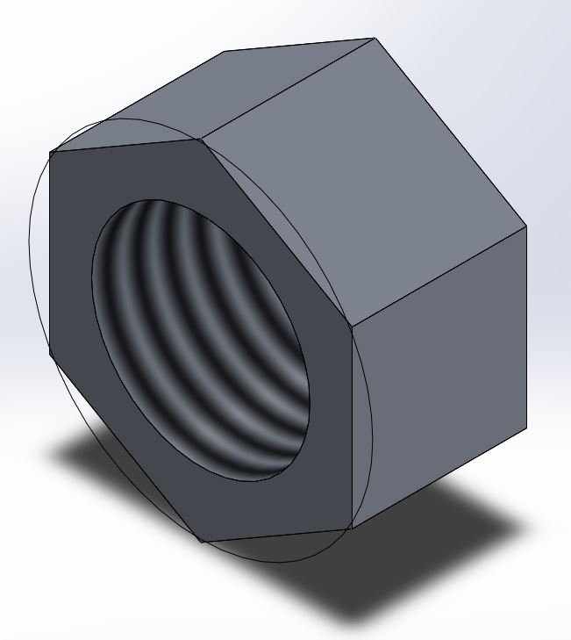

Frame Wing Nut (U) x8:

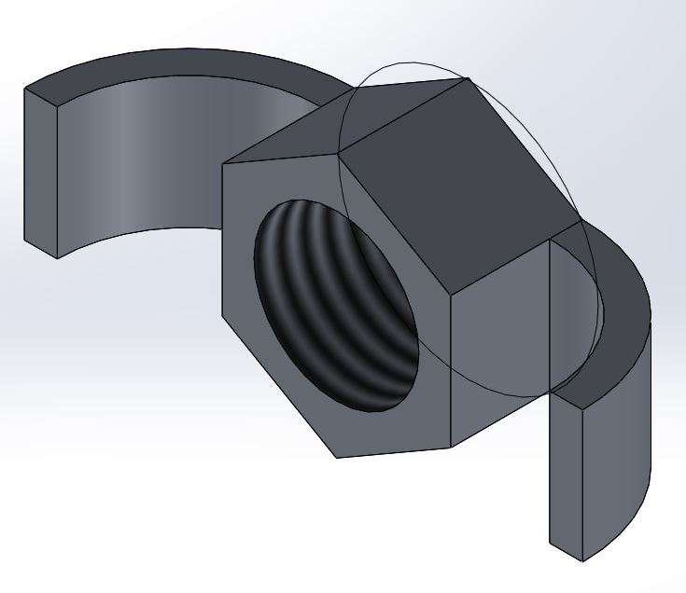

Small Screw (V) x52:

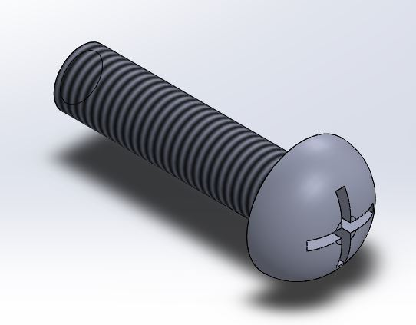

BVM (X) x1:

*(not supplied)*

**Assembly:**

Part 1: The Frame

*Completed Image:*

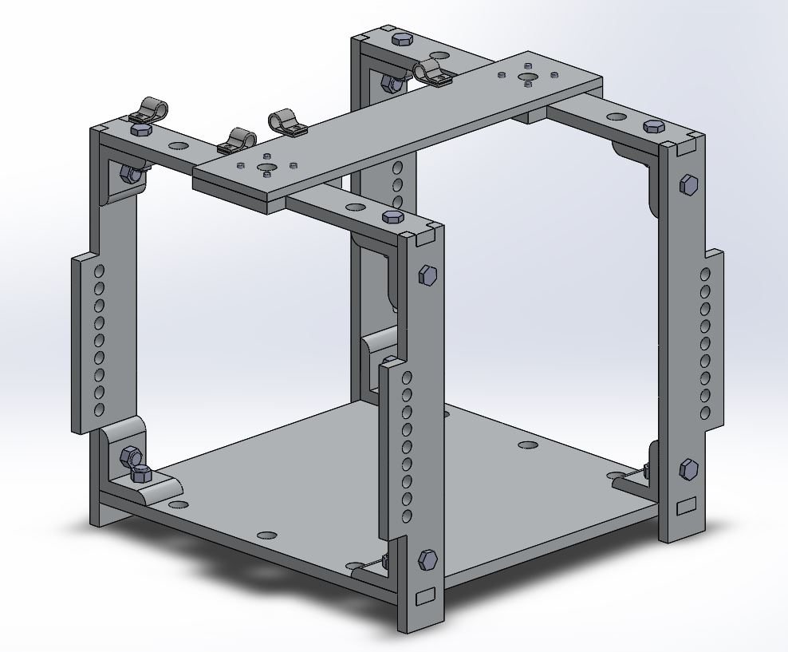

Step 1:

Tools Required: 10mm wrench

Parts Needed:

| **Part Denomination** | **Total Quantity** |
| --- | --- |
| A | 1 |
| B | 4 |
| F | 4 |

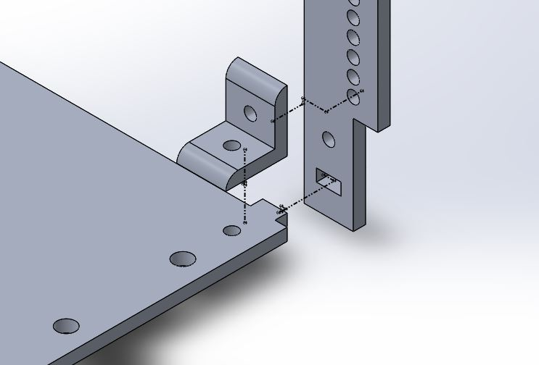

Repeat the above picture four (4) times for all sides of the Base Plate (A).

Step 2:

Tools Required: 10mm wrench

Parts Needed:

| **Part Denomination** | **Total Quantity** |
| --- | --- |
| C | 2 |
| F | 4 |

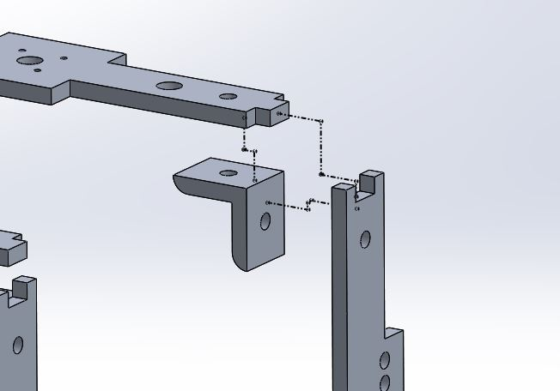

Repeat the above picture four (4) times for all Frame Top (C) connections with the Side Plates (B).

Step 3:

Tools Required: None

Parts Needed:

| **Part Denomination** | **Quantity** |
| --- | --- |
| D | 1 |

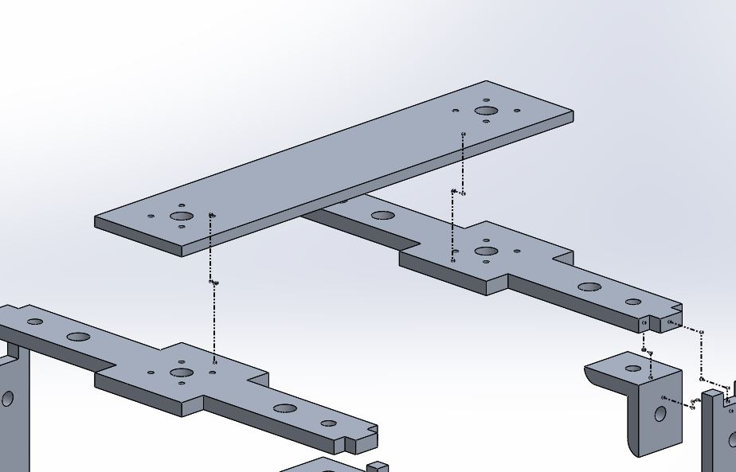

Place the Frame Top (D) piece on the structure. It will not be connected until a later step.

(Refer to Step 9)

- Frame Completed -

Part 2: Clamp Assembly Plate

*Completed Image:*

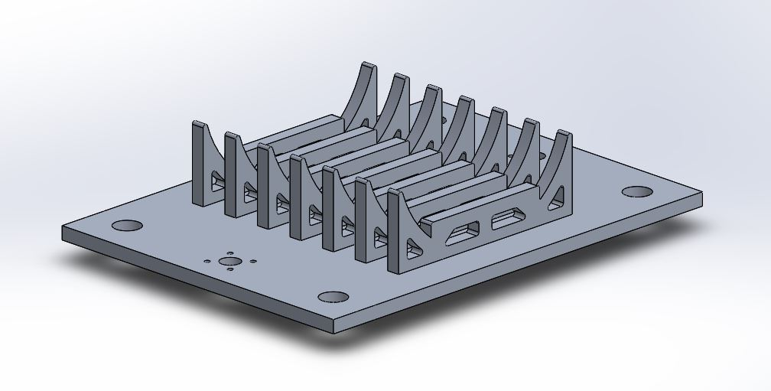

Step 4:

Tools Required: Screwdriver (*Small Bolt Fasteners*)

Parts Needed:

| **Part Denomination** | **Quantity** |
| --- | --- |
| H | 14 |
| I | 2 |
| G | 2 |
| V | 28 |

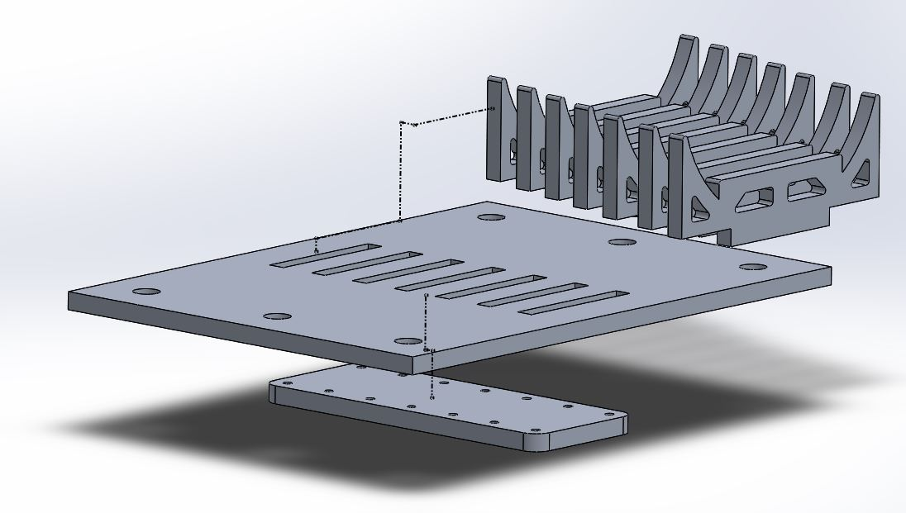

Place seven (7) of the Clamp Jaws (H) in the Clamping Baseplate (G). Bring the Clamp Backplate (I) to the backside of the Baseplate (G) and use the screwdriver to connect the subassembly together with 14 Small Bolts (V).

Repeat this process twice (2) for both the top and bottom Clamp Baseplates (G).

Step 5:

Tools Required: Screwdriver (*Small Bolt Fasteners*)

Parts Needed:

| **Part Denomination** | **Quantity** |
| --- | --- |
| L | 8 |
| Q | 4 |
| V | 16 |

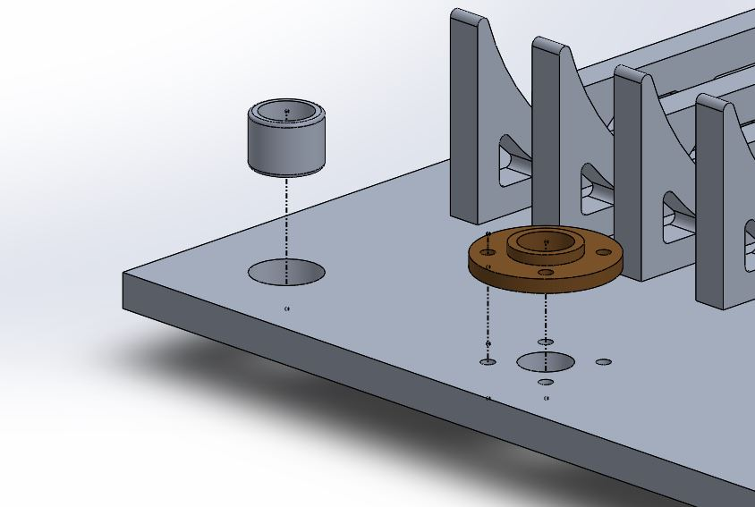

Press in the Guide Rail Sleeve Bearing (L) into the four corner holes in the existing Clamping Plate (G). In the two holes on the sides of the Clamping Baseplate (G), place the Lead Screw Flange (Q) and secure to the Clamping Baseplate (G) using 4 Small Screws (V). Thread the LH/RH Lead Screw Nuts (O,P) into the Lead Screw Flange (Q).

Repeat this process twice (2) for both the top and bottom Clamp Plates (G).

*Note:* Use RH threads (O) on one of the Clamping Plates (G) and LH threads (P) on the other.

- Clamp Plate Completed -

Part 3: Bag Valve Mask (BVM) Supports

*Completed Image:*

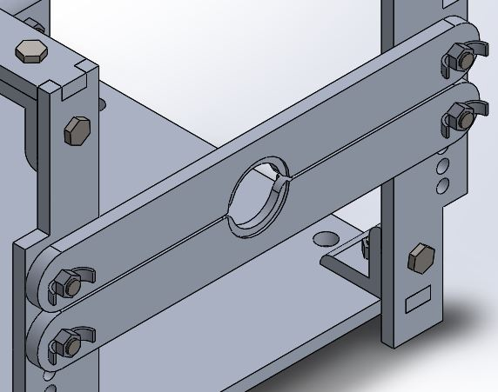

Step 6:

Tools Required: None

Parts Needed:

| **Part Denomination** | **Quantity** |
| --- | --- |
| E | 4 |
| U | 8 |
| S | 8 |

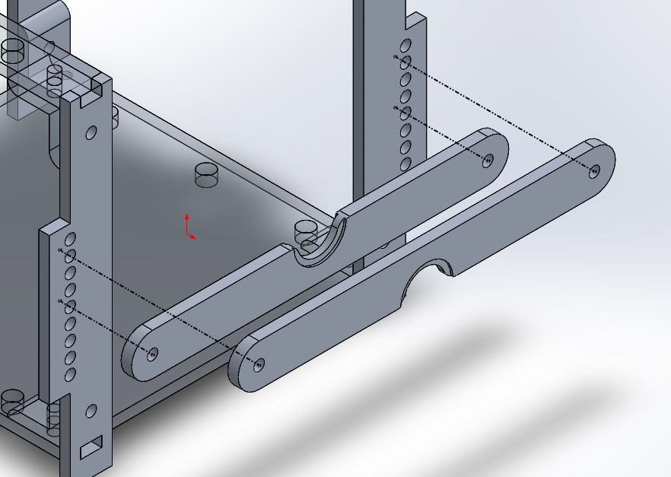

Place the BVM Holder (E) in a desired hole and hand tighten to the frame using the Frame Bolts (S) and Wing Nuts (U). These are used to change the location of the BVM throat to ensure it is secure.

Repeat this process twice (2) on the other side of The Frame.

- BVM Support Completed -

Part 4: Joining Assemblies and Creating the Ventilator

*Completed Image:*

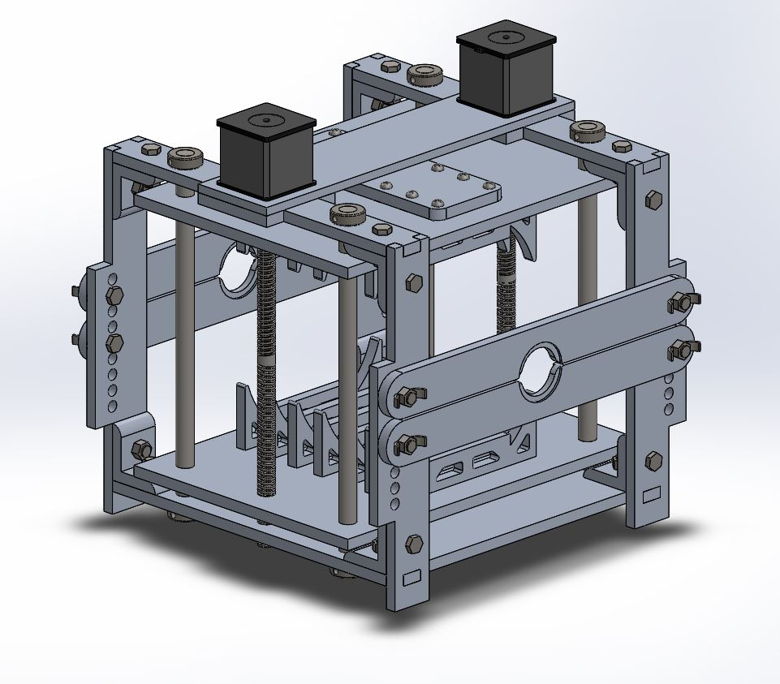

Step 7:

Tools Required: 2.5mm Allen Key

Parts Needed:

| **Part Denomination** | **Quantity** |
| --- | --- |
| J | 4 |
| K | 4 |

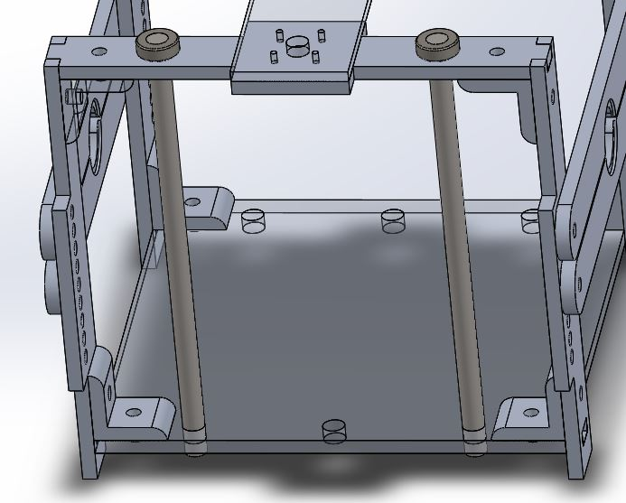

Take a set screw from the Shaft Lock (K) and tighten it at the very top of the Alignment Shaft (J). Slide the shafts down as seen in the above figure.

Repeat this process on the opposing side of The Frame.

Note: The only thing holding these shafts in the assembly is their own weight. Leave this for the time being.

Step 8:

Tools Required: None

Parts Needed:

| **Part Denomination** | **Quantity** |
| --- | --- |
| N | 2 |
| Clamp Subassembly (From Part 2) | 2 |

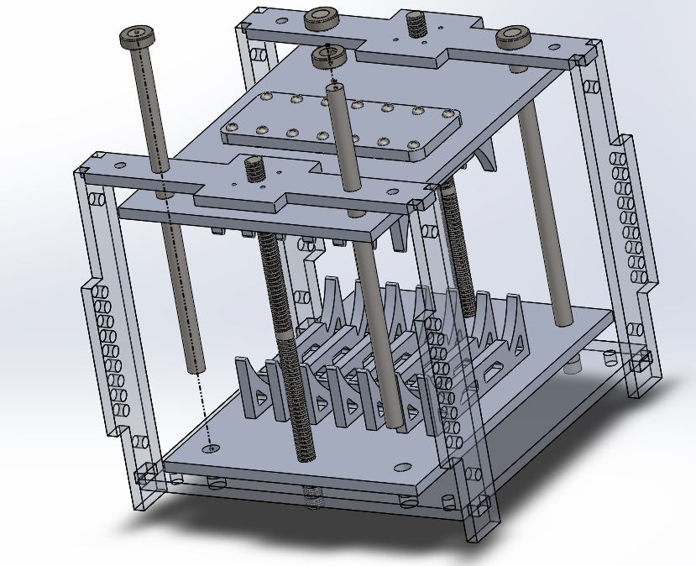

*Important Step*

Place both Clamp Subassemblies and tighten the threaded rod on them EVENLY. Leave 0.75” from the outside face of the Clamping Baseplate (G) to the end of the ACME Lead Screw (N).

Both plates should be equidistant from the end to ensure equal ventilation from both the top and bottom.

Place the threaded rod and plate fixture into The Frame.

*This step ensures accurate ventilation*

Step 9:

Tools Required: 2.5mm Allen Key

Parts Needed:

| **Part Denomination** | **Quantity** |
| --- | --- |
| K | 4 |

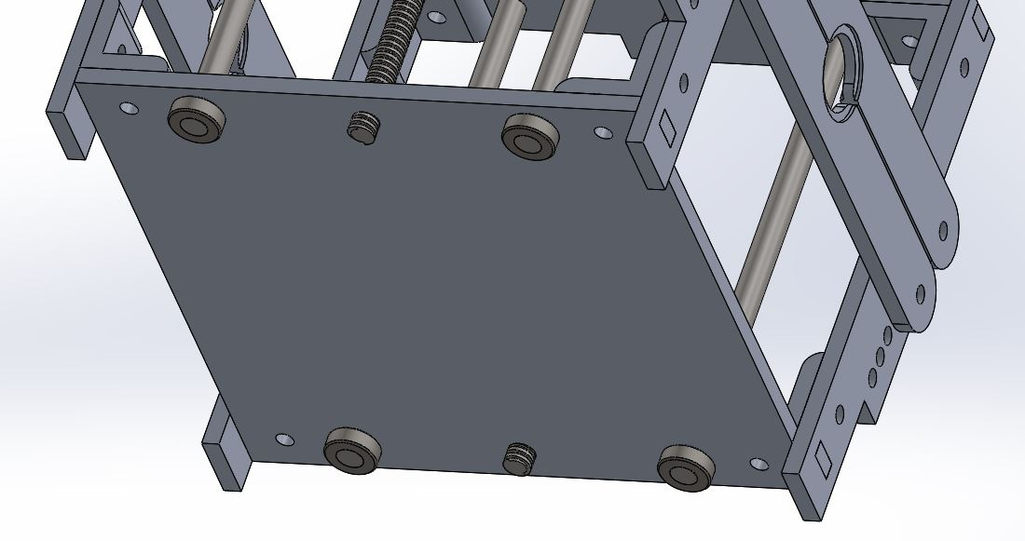

Place all four (4) Shaft Locks (K) on the bottom of the Alignment Shafts (J). Make sure they are snug, but not putting any stress on The Frame.

Step 10:

Tools Required: Screwdriver

Parts Needed:

| **Part Denomination** | **Quantity** |
| --- | --- |
| M | 2 |

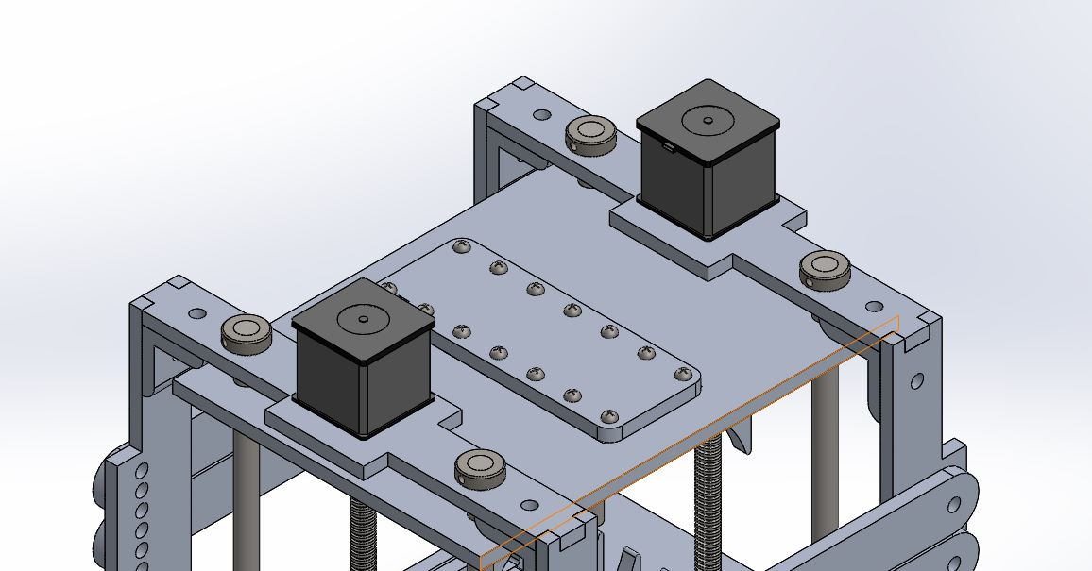

Place both Motors (M) on top of The Frame. There will be four screws in the plate which can be used to tighten both the Motor Mount (D) and the Stepper Motors (M) to The Frame.

Connect the Stepper Motor (M) to the Power Screw (M) with the Screw-Motor Coupling (R - Not Pictured). Screw until tight on the Motor output shaft.

Part 5: Placing Bag Valve Mask (BVM) in the Frame

Current Build State:



How to place a BVM inside of The Frame:

1. Loosen the Wing Nuts (U) on both the upper BVM Holder Plates (E). This opens the BVM clamp.
2. Place BVM throat/neck on both sides so it rests on the lower BVM Holder Plates (E).
3. Bring down the upper BVM Holder Plates (E) to tighten around the throat/neck of the BVM.
4. Retighten the Wing Nuts (U)
5. Ensure the BVM is snug inside of the clamps.

Final Build State with BVM. Product is now ready to be used.

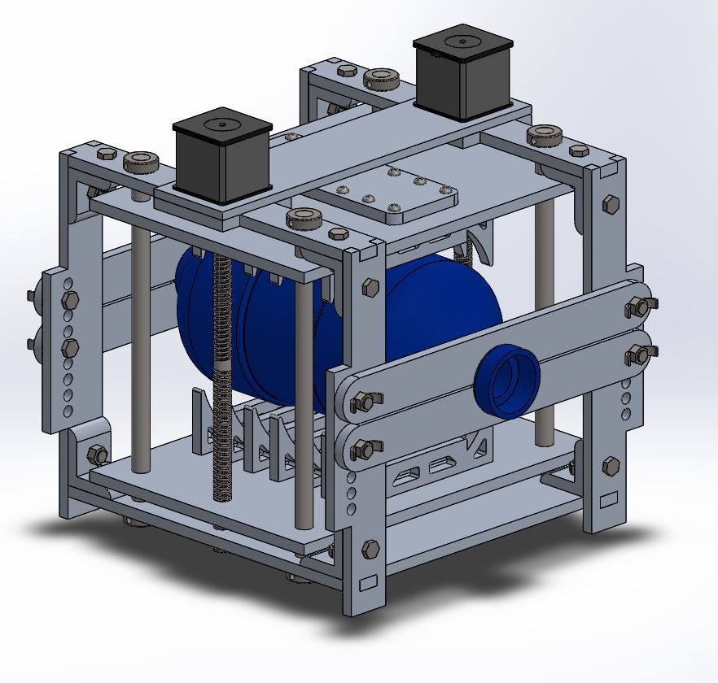

- Assembly Complete -

**How to Connect the Ventilator:**

The ventilator will require existing Oxygen and Air inputs from the hospital. If these inputs are unavailable, utilize ambient air as the BVM input. The picture below represents the two scenarios which the ventilator may be built to begin functioning.

Important Note:

Ensure the BVM is connected as it would for any other ventilation situation with all one-way valves, pressure regulators and supply quantities met.

Access to Clean Supply Air (Recommended):

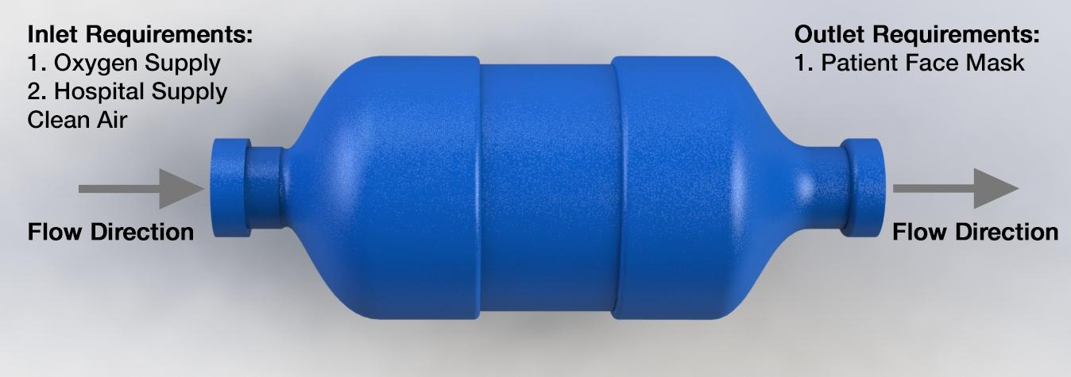

- How to Connect the Ventilator Completed -

**Resources:**

[1] To create the design, drawings and motion study, SolidWorks 2019 Education was utilized:

<https://www.solidworks.com>

[2] The 3D model for Screw-Motor Coupling (R) was downloaded from McMaster-Carr.com