LABORATORY OBSERVATION / RECORD
Course :Full Stack Web Development
Course Code:23CM4121
Experiment No.:1 (task-1)
Student Name: Kottana Roshini
Roll No.:
A24126552263

1. TITLE
Develop a College Information Portal Web Page Using HTML5.
2. AIM
To design a static web page named "College Information Portal" using HTML5, covering document structure, text formatting, lists, hyperlinks, tables, images, forms, semantic elements, HTML5 input types, embedded audio/video, and Canvas-based graphics.
3. OBJECTIVE
- To understand the HTML5 document structure and basic tags.
- To apply text formatting, ordered/unordered lists and hyperlinks.
- To create tables and insert images with alternate text.
- To design a student registration form using various HTML5 input types.
- To use HTML5 semantic elements (header, nav, section, article, footer).
- To embed audio and video using HTML5 multimedia tags.
- To draw basic shapes and text using the HTML5 Canvas element.
4. THEORY
HTML5 (HyperText Markup Language, version 5) is the standard markup language used to structure content on the web. It introduces semantic elements that describe the meaning of content blocks, native multimedia support through the <audio> and <video> tags, and the Canvas API for drawing graphics directly in the browser using JavaScript.
A web form is built using the <form> element along with input controls such as text, email, password, radio, checkbox, select and textarea. HTML5 adds new input types — date, number, color and range — which provide built-in browser controls and validation without extra JavaScript.
The basic flow of the page is: browser requests index.html → browser parses the HTML structure → linked style.css is applied (styling is handled separately) → embedded canvas script runs after the page loads and draws graphics on screen.
5. ALGORITHM / PROCEDURE
- Create a new file named index.html with the HTML5 boilerplate (<!DOCTYPE html>, <html>, <head>, <body>).
- Add semantic elements: header, nav, section, article and footer.
- Add headings and paragraphs describing the college, using text formatting tags (b, i, u, sup, sub).
- Create one ordered list (admission steps) and one unordered list (departments).
- Add hyperlinks to an external college website and to Google.
- Create a table showing student Roll No, Name, Branch and Email.
- Insert a college logo image and one more image, each with descriptive alt text.
- Design a student registration form with text, email, password, radio, checkbox, select and textarea fields.
- Add HTML5 input types: date, number, color and range.
- Embed one audio file and one video file using the <audio> and <video> tags.
- Add a <canvas> element and write a JavaScript block to draw a rectangle, a circle, a line and text on it.
- Save the file and open it in a web browser to test every section.
- Verify that all elements render and function correctly; fix errors if any.
6. PROGRAM
File: index.html
<!DOCTYPE html>
<html lang="en">
<head>
<meta charset="UTF-8">
<meta name="viewport" content="width=device-width, initial-scale=1.0">
<title>College Information Portal | My Styled Webpage</title>
<link rel="stylesheet" href="style.css">
</head>
<body>
<!-- ============================================================ -->
<!-- STUDENT INFO BAR -->
<!-- ============================================================ -->
<div class="student-bar">
<p>Name: Kottana Roshini &nbsp;|&nbsp; Roll No: A24126552263 &nbsp;|&nbsp; Observation Task 1 &amp; 2 — HTML5 &amp; CSS3</p>
</div>
<!-- ============================================================ -->
<!-- HEADER (semantic element) -->
<!-- ============================================================ -->
<header>
<h1>College Information Portal</h1>
<p>A demonstration of HTML5 structure, forms, tables, multimedia and CSS3 styling</p>
</header>
<!-- ============================================================ -->
<!-- NAV (semantic element) -->
<!-- ============================================================ -->
<nav>
<ul class="navlinks">
<li><a href="#about">About</a></li>
<li><a href="#academics">Academics</a></li>
<li><a href="#gallery">Gallery</a></li>
<li><a href="#register">Registration</a></li>
<li><a href="#media">Media</a></li>
<li><a href="#canvas">Canvas</a></li>
<li><a href="#cards">Content Cards</a></li>
</ul>
</nav>
<main>
<!-- ============================================================ -->
<!-- PART A: BASIC HTML -->
<!-- ============================================================ -->
<section id="about">
<article>
<h2>About the College</h2>
<p>
Our college is a premier institution dedicated to
<b>academic excellence</b>, <i>innovation</i>, and
<u>holistic student development</u>. Established with a vision to
create future-ready engineers, the campus offers modern
laboratories, experienced faculty, and a vibrant student life.
</p>
<p>
Formulae and notes often use special characters, for example
water is written as H<sub>2</sub>O and Einstein's famous
equation is E = mc<sup>2</sup>.
</p>
<h3>Ordered List — Admission Steps</h3>
<ol>
<li>Fill the online application form</li>
<li>Upload required documents</li>
<li>Pay the application fee</li>
<li>Attend counselling / entrance exam</li>
<li>Confirm seat allotment</li>
</ol>
<h3>Unordered List — Departments Offered</h3>
<ul>
<li>Computer Science &amp; Engineering</li>
<li>Electronics &amp; Communication Engineering</li>
<li>Mechanical Engineering</li>
<li>Civil Engineering</li>
</ul>
<h3>Useful Links</h3>
<p>
Visit our <a href="https://www.example-college.edu" target="_blank" rel="noopener">College Website</a>
or search more information on <a href="https://www.google.com" target="_blank" rel="noopener">Google</a>.
</p>
</article>
</section>
<!-- ============================================================ -->
<!-- PART B: TABLES AND IMAGES -->
<!-- ============================================================ -->
<section id="academics">
<article>
<h2>Student Details</h2>
<table>
<thead>
<tr>
<th>Roll No</th>
<th>Name</th>
<th>Branch</th>
<th>Email</th>
</tr>
</thead>
<tbody>
<tr>
<td>A24126552263</td>
<td>Kottana Roshini</td>
<td>CSM (CSE - AI &amp; ML)</td>
<td>roshini.k@example-college.edu</td>
</tr>
<tr>
<td>A24126552201</td>
<td>Sample Student One</td>
<td>CSM</td>
<td>student1@example-college.edu</td>
</tr>
<tr>
<td>A24126552214</td>
<td>Sample Student Two</td>
<td>CSM</td>
<td>student2@example-college.edu</td>
</tr>
</tbody>
</table>
</article>
<article id="gallery">
<h2>College Gallery</h2>
<figure>
<img src="data:image/svg+xml;utf8,%3Csvg xmlns='http://www.w3.org/2000/svg' width='160' height='160'%3E%3Crect width='160' height='160' fill='%23000000'/%3E%3Ccircle cx='80' cy='65' r='35' fill='none' stroke='%23ffffff' stroke-width='4'/%3E%3Cpath d='M55 100 L80 80 L105 100 Z' fill='%23ffffff'/%3E%3Ctext x='80' y='140' font-size='16' fill='%23ffffff' text-anchor='middle' font-family='Arial'%3ECOLLEGE%3C/text%3E%3C/svg%3E" alt="College official logo">
<figcaption>College Logo</figcaption>
</figure>
<figure>
<img src="data:image/svg+xml;utf8,%3Csvg xmlns='http://www.w3.org/2000/svg' width='400' height='220'%3E%3Crect width='400' height='220' fill='%23e6e6e6'/%3E%3Crect x='40' y='60' width='320' height='140' fill='%231a1a1a'/%3E%3Cpolygon points='40,60 200,10 360,60' fill='%23000000'/%3E%3Crect x='90' y='100' width='40' height='60' fill='%23ffffff'/%3E%3Crect x='170' y='100' width='40' height='60' fill='%23ffffff'/%3E%3Crect x='250' y='100' width='40' height='60' fill='%23ffffff'/%3E%3Ctext x='200' y='210' font-size='14' fill='%23000000' text-anchor='middle' font-family='Arial'%3EMain Campus Building%3C/text%3E%3C/svg%3E" alt="Front view of the main college campus building">
<figcaption>Main Campus Building</figcaption>
</figure>
</article>
</section>
<!-- ============================================================ -->
<!-- PART C: FORMS -->
<!-- ============================================================ -->
<section id="register">
<article>
<h2>Student Registration Form</h2>
<form action="#" method="post">
<label for="name">Name:</label>
<input type="text" id="name" name="name" placeholder="Enter your full name" required><br>
<label for="email">Email:</label>
<input type="email" id="email" name="email" placeholder="you@example.com" required><br>
<label for="password">Password:</label>
<input type="password" id="password" name="password" required><br>
<fieldset>
<legend>Gender</legend>
<input type="radio" id="male" name="gender" value="male">
<label for="male">Male</label>
<input type="radio" id="female" name="gender" value="female">
<label for="female">Female</label>
<input type="radio" id="other" name="gender" value="other">
<label for="other">Other</label>
</fieldset>
<fieldset>
<legend>Hobbies</legend>
<input type="checkbox" id="reading" name="hobbies" value="reading">
<label for="reading">Reading</label>
<input type="checkbox" id="coding" name="hobbies" value="coding">
<label for="coding">Coding</label>
<input type="checkbox" id="sports" name="hobbies" value="sports">
<label for="sports">Sports</label>
</fieldset>
<label for="branch">Branch:</label>
<select id="branch" name="branch">
<option value="csm">CSM (AI &amp; ML)</option>
<option value="cse">CSE</option>
<option value="ece">ECE</option>
<option value="mech">Mechanical</option>
<option value="civil">Civil</option>
</select><br>
<label for="comments">Comments:</label><br>
<textarea id="comments" name="comments" rows="4" cols="40" placeholder="Any additional information..."></textarea><br>
<h3>HTML5 Input Types</h3>
<label for="dob">Date of Birth:</label>
<input type="date" id="dob" name="dob"><br>
<label for="age">Age:</label>
<input type="number" id="age" name="age" min="15" max="60"><br>
<label for="favcolor">Favourite Colour:</label>
<input type="color" id="favcolor" name="favcolor" value="#000000"><br>
<label for="rating">Satisfaction Rating:</label>
<input type="range" id="rating" name="rating" min="0" max="10"><br>
<button type="submit">Submit</button>
<button type="reset">Reset</button>
</form>
</article>
</section>
<!-- ============================================================ -->
<!-- PART D: HTML5 FEATURES — AUDIO & VIDEO -->
<!-- ============================================================ -->
<section id="media">
<article>
<h2>Multimedia</h2>
<h3>Audio</h3>
<audio controls>
<source src="https://www.w3schools.com/html/horse.mp3" type="audio/mpeg">
Your browser does not support the audio element.
</audio>
<h3>Video</h3>
<video controls width="360">
<source src="https://www.w3schools.com/html/mov_bbb.mp4" type="video/mp4">
Your browser does not support the video element.
</video>
</article>
</section>
<!-- ============================================================ -->
<!-- OBSERVATION TASK 2, PART A: HTML5 CANVAS -->
<!-- ============================================================ -->
<section id="canvas">
<article>
<h2>HTML5 Canvas Graphics</h2>
<canvas id="myCanvas" width="400" height="220">
Your browser does not support the canvas element.
</canvas>
</article>
</section>
<!-- ============================================================ -->
<!-- OBSERVATION TASK 2, PART B: CSS3 CONTENT CARDS -->
<!-- ============================================================ -->
<section id="cards">
<article>
<h2>My Styled Webpage — Content Cards</h2>
<div class="card-container">
<div class="card">
<h3>Card One</h3>
<p>Demonstrates border-radius, box-shadow and padding using a black &amp; white theme.</p>
<button class="hover-btn">Learn More</button>
</div>
<div class="card">
<h3>Card Two</h3>
<p>Demonstrates gradient background and text-shadow effects.</p>
<button class="hover-btn">Learn More</button>
</div>
<div class="card">
<h3>Card Three</h3>
<p>Demonstrates hover effects and font styling across the page.</p>
<button class="hover-btn">Learn More</button>
</div>
</div>
</article>
</section>
</main>
<!-- ============================================================ -->
<!-- FOOTER (semantic element) -->
<!-- ============================================================ -->
<footer>
<p>&copy; 2026 College Information Portal | Submitted by Kottana Roshini (A24126552263)</p>
</footer>
<script>
// HTML5 Canvas drawing: rectangle, circle, line, and text
const canvas = document.getElementById('myCanvas');
const ctx = canvas.getContext('2d');
// Rectangle
ctx.strokeStyle = '#000000';
ctx.lineWidth = 3;
ctx.strokeRect(20, 20, 120, 70);
// Circle
ctx.beginPath();
ctx.arc(250, 55, 40, 0, 2 * Math.PI);
ctx.stroke();
// Line
ctx.beginPath();
ctx.moveTo(20, 140);
ctx.lineTo(360, 140);
ctx.stroke();
// Text (name)
ctx.font = '24px Arial';
ctx.fillStyle = '#000000';
ctx.fillText('Kottana Roshini', 60, 190);
</script>
</body>
</html>
7. CODE EXPLANATION
Code | Explanation
<!DOCTYPE html> | Declares the document as an HTML5 document so the browser renders it in standards mode.
<header>, <nav>, <section>, <article>, <footer> | HTML5 semantic elements that describe the role of each block of content.
<b>, <i>, <u>, <sub>, <sup> | Inline tags used for bold, italic, underline, subscript and superscript text formatting.
<ol>, <ul>, <li> | Create ordered (numbered) and unordered (bulleted) lists.
<a href="..."> | Creates a hyperlink to another page or website.
<table>, <tr>, <th>, <td> | Build the student details table with rows and columns.
<img src="..." alt="..."> | Displays an image; alt text shows if the image fails to load and aids accessibility.
<form>, <input>, <select>, <textarea> | Build the student registration form and collect different types of input.
<input type="date"/"number"/"color"/"range"> | HTML5 input types with built-in browser controls and validation.
<audio controls>, <video controls> | Embed playable audio and video files directly in the page.
<canvas id="myCanvas"> | Provides a drawable region; JavaScript's getContext('2d') draws shapes and text on it.
ctx.strokeRect(), ctx.arc(), ctx.fillText() | Canvas API methods used to draw a rectangle, a circle and text respectively.
8. TEST CASES AND EXECUTION DATA
Test Case | Action | Expected Result | Actual Result | Status
TC-01 | Open index.html in browser | Page loads with header, nav, and all sections visible | Page loaded correctly | Pass
TC-02 | Click 'College Website' / 'Google' links | Opens respective site in a new tab | Links opened correctly | Pass
TC-03 | Fill and submit registration form | Form accepts Name, Email, Password, Gender, Hobbies, Branch, Comments | All fields accepted input correctly | Pass
TC-04 | Leave required field (Name) empty and submit | Browser shows a validation prompt | Validation prompt displayed | Pass
TC-05 | Select Date of Birth, Age, Colour and Range inputs | Native HTML5 pickers appear for each input type | All pickers worked correctly | Pass
TC-06 | Play embedded audio/video | Media plays with controls (play/pause/volume) | Media played correctly | Pass
TC-07 | Load canvas section | Rectangle, circle, line and name text are drawn | All four shapes drawn correctly | Pass
9. OUTPUT

Output 1: Header, Navigation and About Section
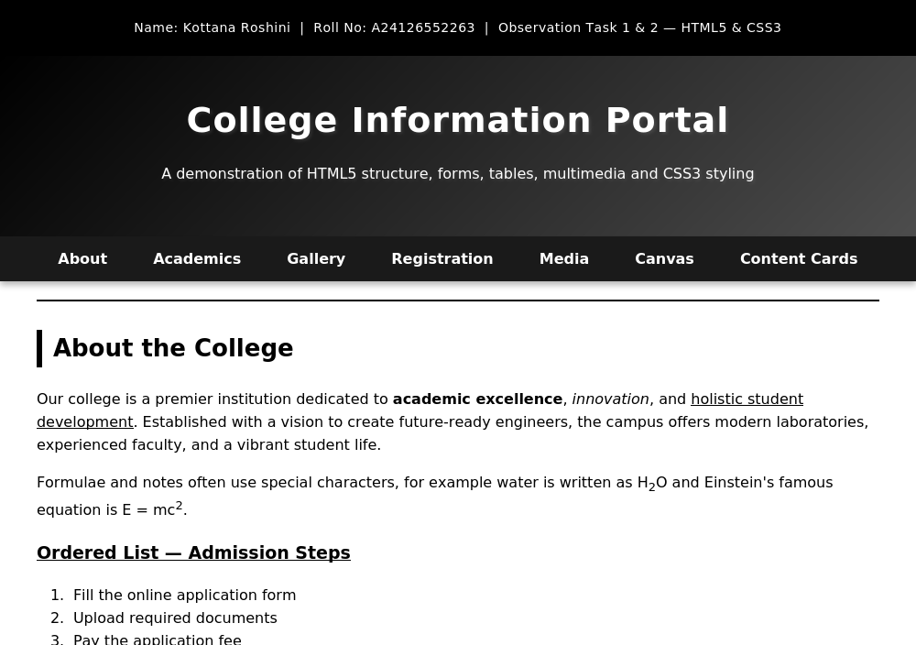

Output 2: Student Table, Images and Registration Form
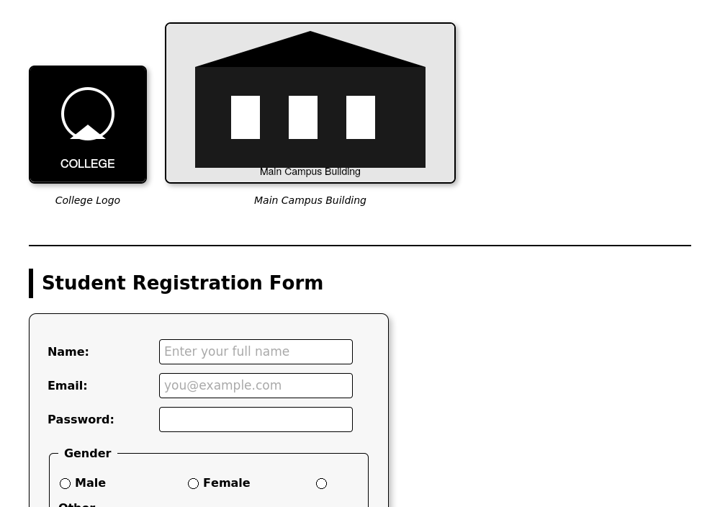

Output 3: HTML5 Input Types, Audio and Video
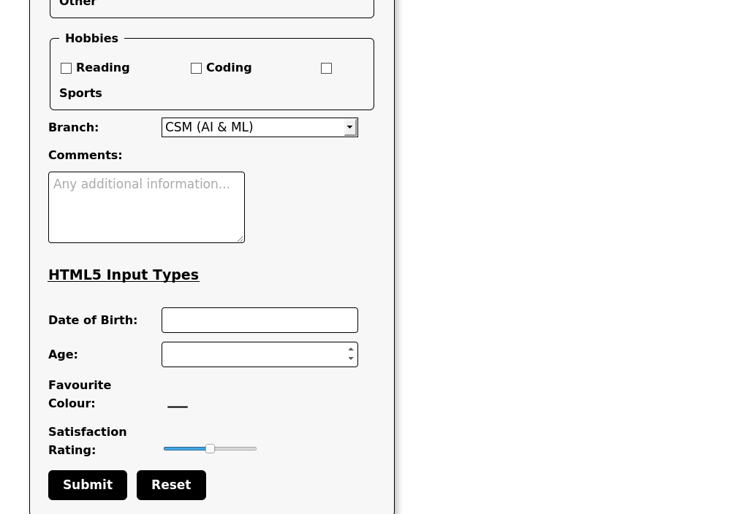

Output 4: HTML5 Canvas Drawing (Rectangle, Circle, Line, Text)
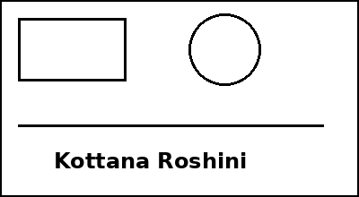

10. RESULT
Thus, a College Information Portal web page was successfully designed using HTML5. Text formatting, lists, hyperlinks, a table, images, a registration form with HTML5 input types, semantic elements, embedded audio/video, and Canvas-based graphics were implemented in index.html and verified using multiple test cases with the expected output obtained.

