LABORATORY OBSERVATION/RECORD
Course: Full Stack Web Development
Course Code: 23CM4121
Experiment No.: 5
Student Name: Kottana Roshini
Roll No.: A24126552263

1. TITLE
Working with Node.js Modules — CommonJS, Built-in, Third-party, and ES6 Modules

2. AIM
To understand and demonstrate the module system in Node.js by creating and using CommonJS modules, built-in (core) modules, third-party modules installed via npm, and ES6 modules using import/export syntax.

3. OBJECTIVE
The objectives of this experiment are:
• To understand what a module is and why modularity is important in Node.js.
• To create and use a custom CommonJS module with require() and module.exports.
• To use Node.js built-in (core) modules such as os and fs.
• To install and use a third-party module from npm (lodash).
• To understand and implement ES6 modules using import and export.
• To compare CommonJS and ES6 module syntax.

4. THEORY
A module in Node.js is a reusable block of code whose functionality can be exported and used in other files. Node.js follows a modular architecture where every file is treated as a separate module.
CommonJS is the default module system used by Node.js. It uses require() to import a module and module.exports (or exports) to export functionality from a file.
Built-in (core) modules are modules that come pre-packaged with Node.js and do not need to be installed separately, such as fs (file system), os (operating system information), path, and http.
Third-party modules are packages published on the npm registry by other developers. They are installed using npm install <package-name> and then imported using require() (or import in ES6 module mode).
ES6 modules (ECMAScript modules) are the standardized JavaScript module system that uses the export and import keywords. In Node.js, ES6 modules are enabled either by using the .mjs file extension or by setting "type": "module" in package.json.
The key difference between CommonJS and ES6 modules is that CommonJS modules are loaded synchronously using require(), whereas ES6 modules are loaded using the static import statement and support features like named exports, default exports, and tree-shaking.

5. ALGORITHM / PROCEDURE
• Create a Node.js project folder for each type of module demonstration.
• For the CommonJS demo, create a module file that defines functions and exports them using module.exports.
• Create a separate file that imports the custom module using require() and calls its functions.
• For the built-in module demo, import the os and fs core modules without installing anything.
• Use the os module to retrieve system information and the fs module to write and read a file.
• For the third-party module demo, run npm init and npm install lodash to add the package to the project.
• Import lodash using require() and use its utility functions on sample data.
• For the ES6 module demo, set "type": "module" in package.json (or use .mjs files).
• Create a module file using the export keyword and a consumer file using the import keyword.
• Run each program using Node.js and record the output.
• Verify the actual output against the expected output for each test case.

6. PROGRAM

6.1 CommonJS Custom Module
mathUtils.js
// mathUtils.js - Custom CommonJS Module
function add(a, b) {
return a + b;
}

function subtract(a, b) {
return a - b;
}

function multiply(a, b) {
return a * b;
}

module.exports = { add, subtract, multiply };

app.js
// app.js - Using the custom CommonJS module
const mathUtils = require("./mathUtils");

console.log("---- CommonJS Custom Module Demo ----");
console.log("Addition (5 + 3):", mathUtils.add(5, 3));
console.log("Subtraction (5 - 3):", mathUtils.subtract(5, 3));
console.log("Multiplication (5 * 3):", mathUtils.multiply(5, 3));

6.2 Built-in (Core) Module
systemInfo.js
// systemInfo.js - Using Node.js Built-in Modules
const os = require("os");
const fs = require("fs");

console.log("---- Built-in Module Demo (os, fs) ----");
console.log("Operating System Platform:", os.platform());
console.log("CPU Architecture:", os.arch());
console.log("Total Memory (MB):", (os.totalmem() / (1024 * 1024)).toFixed(2));
console.log("Free Memory (MB):", (os.freemem() / (1024 * 1024)).toFixed(2));
console.log("Number of CPU Cores:", os.cpus().length);

// Using fs module to write and read a file
fs.writeFileSync("sample.txt", "Hello from the fs built-in module!");
const data = fs.readFileSync("sample.txt", "utf8");
console.log("File Content Read Using fs Module:", data);

6.3 Third-party Module (lodash)
lodashDemo.js
// lodashDemo.js - Using a Third-party Module (lodash)
const _ = require("lodash");

console.log("---- Third-party Module Demo (lodash) ----");

const numbers = [10, 20, 30, 40, 50];
console.log("Original Array:", numbers);
console.log("Chunked Array (size 2):", _.chunk(numbers, 2));
console.log("Reversed Array:", _.reverse([...numbers]));
console.log("Maximum Value:", _.max(numbers));
console.log("Sum of Array:", _.sum(numbers));

const student = { name: "Kottana Roshini", rollno: "A24126552263" };
console.log("Cloned Object:", _.cloneDeep(student));

6.4 ES6 Module (import / export)
package.json
{
"name": "es6-module-demo",
"version": "1.0.0",
"type": "module"
}

mathES6.mjs
// mathES6.mjs - Custom ES6 Module
export function add(a, b) {
return a + b;
}

export function subtract(a, b) {
return a - b;
}

export default function multiply(a, b) {
return a * b;
}

appES6.mjs
// appES6.mjs - Using ES6 import/export
import multiply, { add, subtract } from "./mathES6.mjs";

console.log("---- ES6 Module Demo (import/export) ----");
console.log("Addition (7 + 4):", add(7, 4));
console.log("Subtraction (7 - 4):", subtract(7, 4));
console.log("Multiplication (7 * 4):", multiply(7, 4));

7. CODE EXPLANATION
Code | Explanation
module.exports | Exposes functions/values from a file so they can be used in other files.
require("./mathUtils") | Imports a custom CommonJS module using its relative file path.
require("os") / require("fs") | Imports Node.js built-in modules for system info and file handling.
os.platform() / os.cpus() | Returns operating system and CPU details of the host machine.
fs.writeFileSync() / fs.readFileSync() | Writes to and reads from a file synchronously.
npm install lodash | Downloads and adds the lodash third-party package to node_modules.
require("lodash") | Imports the third-party lodash module for use in the program.
"type": "module" | Tells Node.js to treat .js files in the project as ES6 modules.
export / export default | Exposes named or default values from an ES6 module.
import ... from "./file.mjs" | Imports named and default exports from an ES6 module.

8. TEST CASES AND EXECUTION DATA
Test Case | Action | Expected Result | Actual Result | Status
TC-01 | Run app.js (CommonJS) | Correct sum, difference and product printed | Correct sum, difference and product printed | Pass
TC-02 | Run systemInfo.js (built-in modules) | OS, CPU and memory details printed; file written and read | OS, CPU and memory details printed; file written and read | Pass
TC-03 | Run lodashDemo.js (third-party module) | Array and object operations performed using lodash | Array and object operations performed using lodash | Pass
TC-04 | Run appES6.mjs (ES6 module) | Correct sum, difference and product printed using import/export | Correct sum, difference and product printed using import/export | Pass

9. OUTPUT
Each program was executed in the terminal using the Node.js runtime. The screenshots below show the actual output produced for every module type.
Output 1: CommonJS Custom Module (app.js)
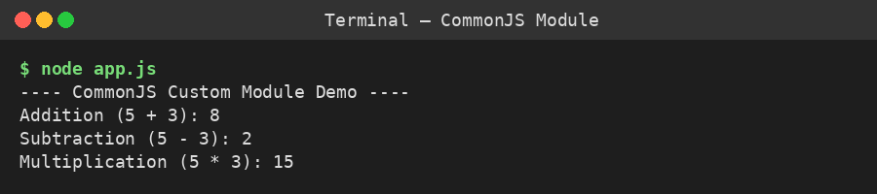
Output 2: Built-in Module — os and fs (systemInfo.js)
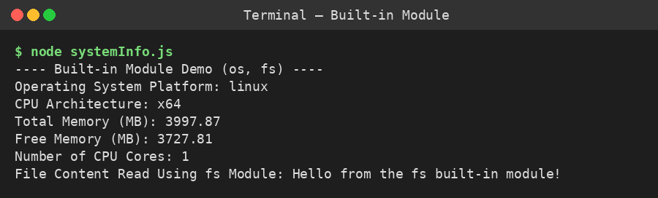
Output 3: Third-party Module — lodash (lodashDemo.js)
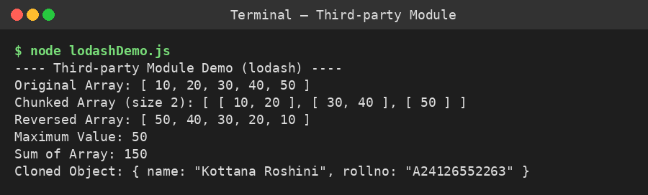
Output 4: ES6 Module — import/export (appES6.mjs)
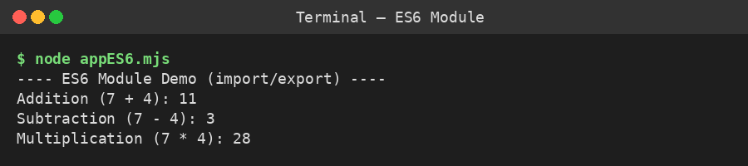

10. RESULT
Thus, the module system in Node.js was successfully studied and demonstrated. A custom CommonJS module was created and used with require()/module.exports, built-in modules (os, fs) were used to read system information and handle files, a third-party module (lodash) was installed via npm and used for array and object operations, and an ES6 module was implemented using export and import syntax. All programs were executed and verified successfully.

