A
Real-Time Research Project Report
On
Pain Recognition with Physiological Signals Using Multi-Level Context Information
(Submitted in partial fulfillment of the requirements for the award of Degree)

BACHELOR OF TECHNOLOGY
In

COMPUTER SCIENCE AND ENGINEERING (DATA SCIENCE)

By
K.MANISHA (247R1A6733)
CH.HARSHITH (247R1A6709)
N.NANDITHA (247R1A6746)
S.JAKHIR (247R1A6754)

Under the Guidance of
B.Ramji
Assistant Professor


DEPARTMENT OF COMPUTER SCIENCE AND ENGINEERING (DATA SCIENCE)
CMR TECHNICAL CAMPUS
UGC AUTONOMOUS
(Accredited by NAAC, NBA, Permanently Affiliated to JNTUH, Approved by AICTE, New Delhi)
Recognized Under Section 2(f) & 12(B) of the UGCAct.1956, Kandlakoya (V), Medchal Road, Hyderabad-501401.
April, 2026.

DEPARTMENT OF COMPUTER SCIENCE AND ENGINEERING (DATA SCIENCE)



CERTIFICATE

This is to certify that the project entitled “Pain Recognition with Physiological Signals Using Multi-Level Context Information” being submitted by K.MANISHA(247R1A6733),CH.HARSHITH(247R1A6709),N.NANDITHA(247R1A6746), S.JAKHIR (247R1A6754) in partial fulfillment of the requirements for the award of the degree of B.Tech in Computer Science and Engineering to the Jawaharlal Nehru Technological University Hyderabad, during the year 2025-2026.

The results embodied in this thesis have not been submitted to any other University or Institute for the award of any degree or diploma.

B. Ramji Dr. K. Murali
Assistant Professor HoD-CSE(DS)
INTERNAL GUIDE

ACKNOWLEDGEMENT

We take this opportunity to express our gratitude to the people who have been instrumental in the successful completion of this project, we take this opportunity to express our profound gratitude and deep regard to our guide B.Ramji, Designation for his/her exemplary guidance, monitoring and constant encouragement throughout the project work. The blessing, help and guidance given by him/her shall carry us a long way in the journey of life on which we are about to embark.
We also take this opportunity to express a deep sense of gratitude to the Project Review Committee (PRC) coordinators K. Sudha Pavani, Laxman B, Dr. B. Mohan Babu, K. Jhansi Rani, V. Prema Tulasi, A. Lakshman, Sanjib Kumar Nayak, E. Sushma, Dr. A. Mahendar for their cordial support, valuable information and guidance, which helped us in completing this task through various stages.
We are also thankful to Dr. K. Murali, Head, Department of Computer Science and Engineering (Data Science) for providing encouragement and support for completing this project successfully.
We are deeply grateful to Dr. A. Raji Reddy, Director, for his cooperation throughout the course of this project. Additionally, we extend our profound gratitude to Sri. Ch. Gopal Reddy, Chairman, Smt. C. Vasantha Latha, Secretary and Sri. C. Abhinav Reddy, Vice-Chairman, for fostering an excellent infrastructure and a conducive learning environment that greatly contributed to our progress.
The guidance and support received from all the members of CMR Technical Campus who contributed to the completion of the project. We are grateful for their constant support and help.
Finally, we would like to take this opportunity to thank our family for their constant encouragement, without which this assignment would not be completed. We sincerely acknowledge and thank all those who gave support directly and indirectly in the completion of this project.

K.MANISHA(247R1A6733)
CH.HARSHITH (247R1A6709)
N.NANDITHA (247R1A6746)
S.JAKHIR(247R1A6754)

ABSTRACT

Automatic pain recognition is essential in healthcare. In previous studies, automatic pain recognition methods preferentially apply the features extracted from physiological signals for conventional models. These methods provide good performance but mainly rely on medical expertise for feature extraction of physiological signals. This paper presents a deep learning approach based on physiological signals that have the role of both feature extraction and classification, regardless of medical expertise. We propose multi-level context information for each physiological signal discriminating between pain and painlessness. Our experimental results prove that multi-level context information performs more significantly than uni-level context information based on Part A of the BioVid Heat Pain database and the Emopain 2021 dataset. For Part A of the BioVid Heat Pain database, our experimental results for pain recognition tasks include Pain 0 and Pain 1, Pain 0 and Pain 2, Pain 0 and Pain 3, and Pain 0 and Pain 4. In the classification task between Pain 0 and Pain 4, the results achieve an average accuracy of 84.8 B1 13.3% for 87 subjects and 87.8 B1 11.4% for 67 subjects in a Leave-One-Subject-Out cross-validation evaluation. The proposed method adopts the ability of deep learning to outperform conventional methods on physiological signals.
Keywords:
Pain, Feature extraction, Physiology, Electrocardiography, Deep learning, Task analysis,
Biomedical monitoring.

TABLE OF CONTENTS

ABSTRACT |  |  |  | i
LIST OF FIGURES |  |  |  | ii
1. | INTRODUCTION |  |  | 1
 | 1.1 | PROJECT PURPOSE |  | 1
 | 1.2 | PROJECT FEATURES |  | 2
2. | LITERATURE SURVEY |  |  | 3
 | 2.1 | REVIEW OF RELATED WORK |  | 7
 | 2.2 | DEFINITION OF PROBLEM STATEMENT |  | 9
 | 2.3 | EXISTING SYSTEM |  | 9
 | 2.4 | PROPOSED SYSTEM |  | 11
 | 2.5 | OBJECTIVES |  | 12
 | 2.6 | HARDWARE & SOFTWARE REQUIREMENTS |  | 13
 |  | 2.6.1 | HARDWARE REQUIREMENTS | 13
 |  | 2.6.2 | SOFTWARE REQUIREMENTS | 13
3. | SYSTEM ARCHITECTURE & DESIGN |  |  | 14
 | 3.1 | PROJECT ARCHITECTURE |  | 14
 | 3.2 | DESCRIPTION |  | 15
 | 3.3 | DATA FLOW DIAGRAM |  | 16
4. | IMPLEMENTATION |  |  | 18
 | 4.1 | ALGORITHMS USED |  | 18
 | 4.2 | SAMPLE CODE |  | 25
5. | RESULTS & DISCUSSION |  |  | 37
6. | VALIDATION |  |  | 47
 | 6.1 | INTRODUCTION |  | 47
 | 6.2 | TEST CASES |  | 48
7. | CONCLUSION & FUTURE SCOPE |  |  | 49
 | 7.1 | PROJECT CONCLUSION |  | 49
 | 7.2 | FUTURE SCOPE |  | 50
8. | BIBLIOGRAPHY |  |  | 51
 | 8.1 | REFERENCES |  | 51
 | 8.2 | GITHUB LINK |  | 52

LIST OF FIGURES

FIGURE NO | FIGURE NAME | PAGE NO
Figure 3.1 | Project Architecture of Pain Recognition with Physiological Signals Using Multi-Level Context Information | 14
Figure 3.2 | Dataflow Diagram of Pain Recognition with Physiological Signals Using Multi-Level Context Information | 17
Figure 5.1 | Application Execution on Pain Recognition with Physiological Signals Using Multi-Level Context Information | 37
Figure 5.2 | Data Uploading and display on Pain Recognition with Physiological Signals Using Multi-Level Context Information | 38
Figure 5.3 | EEG Signal Visualization and Dataset Analysis Pain Recognition with Physiological Signals Using Multi-Level Context Information | 39
Figure 5.4 | Pain-wise ECG Signal Distribution Graph of  Pain Recognition with Physiological Signals Using  Multi-Level Context Information | 40
Figure 5.5 | Dataset Processing of Pain Recognition with Physiological Signals Using Multi-Level Context Information | 41
Figure 5.6 | Randam Forest Algorithm Execution and Results on pain Recognition with physiological Signals using Multi-Level Context Information. | 41
Figure 5.7 | Proposed Multilevel Model (CNN + BiLSTM) Results on pain Recognition with physiological Signals using Multi-Level Context Information. | 42
Figure 5.8 | Extended Multilevel Model (CNN + BiLSTM + BiGRU) on pain Recognition with physiological Signals using Multi-Level Context Information. | 42
Figure 5.9 | Test Data Prediction on pain Recognition with physiological Signals using Multi- Level Context Information. | 43
Figure 5.10 | Final Output Display on pain Recognition with physiological Signals using Multi- Level Context Information | 43

1 INTRODUCTION

INTRODUCTION

Pain is the body’s common response to illness that requires medical attention. Traditional pain recognition methods are generally through human observations and subjective recognition. The physiotherapists assess a patient’s pain through exercises during the therapy process and give reasonable exercises to the patient to overcome the disease. Pain recognition depends on the knowledge of each expert, observation, and individual perception through the patient’s expression. This brings many limitations because there are no universal and reliable rules for pain recognition. Therefore, the automation of pain recognition is necessary for humans. In the medical, pain recognition applications is a health monitoring system that helps humans recover from illness through physical therapy exercises. Pain recognition systems use behavior and physiology to perform classification tasks. Measures are physiological signals, facial expressions, body movements, vocalizations, and so on, or a combination of them. In some cases, pain recognition through the patient’s behavior is not reliable. The patient can intentionally control emotional expression. Furthermore, the patients express pain behavior depending on their personality. Some patients lose awareness and do not express painful emotions clearly and reliably. It is difficult to recognize pain through emotional behavior. Therefore, pain recognition using physiological signals is essential. Deep learning approaches automatically generate suitable representations of raw data. Deep learning architecture is a multi-layer stack of simple modules that can learn and compute non-linear mappings .
They entirely replace classical methods and do not depend on specialized knowledge of physiological signals. This study aims to build a deep learning model to replace the conventional methods which rely on expert knowledge of physiological signals. It is possible to eliminate the hand-crafted feature selection carefully. We experiment by extracting contextual representation from physiological signals which have stationary and trending factors. Our idea is to build a contextual representation from the hidden information on a sequence in physiological signals. Contextual representation is the time series characteristics of physiological signals for pain or non-pain manifestations. In this study, the context representations are named multi-level context information.
1.1 PROJECT PURPOSE

The purpose of this project is to develop an automatic pain recognition system using physiological signals by applying deep learning techniques that can perform both feature extraction and classification. Unlike previous methods that rely heavily on manually extracted features and medical expertise, this approach eliminates the need for expert intervention by using a model that learns directly from the data. This makes the system more efficient, scalable, and suitable for real-world healthcare applications.

Additionally, the project focuses on using multi-level context information to improve the accuracy of distinguishing between pain and no-pain conditions. By evaluating the model on datasets like BioVid Heat Pain and Emopain, the proposed approach demonstrates better performance compared to traditional uni-level methods. The ultimate goal is to enhance the reliability and effectiveness of pain detection systems, supporting better patient monitoring and clinical decision-making.

1.2 PROJECT FEATURES

The project features an automatic pain recognition system that uses physiological signals such as ECG, EMG, and EDA to detect and classify pain levels. It applies a deep learning-based approach that performs both feature extraction and classification, removing the need for manual feature engineering and medical expertise. This makes the system more efficient and capable of learning directly from raw data, improving its adaptability and performance.

Another important feature is the use of multi-level context information, which helps in effectively distinguishing between pain and painlessness. By analyzing different levels of contextual information within physiological signals, the system achieves better accuracy compared to traditional uni-level methods. This approach enhances the model’s ability to capture complex patterns related to pain conditions.

The system is evaluated using standard datasets such as BioVid Heat Pain and Emopain 2021, ensuring reliable and validated performance. It supports classification of multiple pain levels from Pain 0 to Pain 4 and achieves high accuracy through Leave-One-Subject-Out cross-validation. Overall, the proposed method outperforms conventional approaches and provides an effective solution for pain recognition in healthcare applications.

LITERATURE REVIEW

2. LITERATURE REVIEW

“Automatic recognition methods supporting pain assessment” P. Werner, D. Lopez- Martinez, S. Walter, A. Al-Hamadi, S. Gruss, and R. W. Picard (2022)
Pain is a complex phenomenon, involving sensory and emotional experience, that is often poorly understood, especially in infants, anesthetized patients, and others who cannot speak. Technology supporting pain assessment has the potential to help reduce suffering; however, advances are needed before it can be adopted clinically. This survey paper assesses the state of the art and provides guidance for researchers to help make such advances. First, we overview pain’s biological mechanisms, physiological and behavioral responses, emotional components, as well as assessment methods commonly used in the clinic. Next, we discuss the challenges hampering the development and validation of pain recognition technology, and we survey existing datasets together with evaluation methods. We then present an overview of all automated pain recognition publications indexed in the Web of Science as well as from the proceedings of the major conferences on biomedical informatics and artificial intelligence, to provide understanding of the current advances that have been made. We highlight progress in both non-contact and contact-based approaches, tools using face, voice, physiology, and multi-modal information, the importance of context, and discuss challenges that exist, including identification of ground truth. Finally, we identify underexplored areas such as chronic pain and connections to treatments, and describe promising opportunities for continued advances.
“The biovid heat pain database data for the advancement and systematic validation of an automated pain recognition system” S. Walter, S. Gruss, H. Ehleiter, J. Tan, H. C. Traue, S. Crawcour, P. Werner, A. Al-Hamadi (2013)
The objective measurement of subjective, multi-dimensionally experienced pain is still a problem that has yet to be adequately solved. Though verbal methods (i.e., pain scales, questionnaires) and visual analogue scales are commonly used for measuring clinical pain, they tend to lack in reliability or validity when applied to mentally impaired individuals. Expression of pain and/or its biopotential parameters could represent a solution. While such coding systems already exist, they are either very costly and time-consuming, or have been insufficiently evaluated with regards to the theory of mental tests. Building on the experiences made to date, we collected a database using visual and biopotential signals to advance an automated pain recognition system, to determine its theoretical testing quality, and to optimize its performance. For this purpose, participants were subjected to painful heat stimuli under controlled conditions.
“Hybrid RNN-ANN based deep physiological network for pain recognition” R. Wang, K. Xu, H. Feng, and W. Chen(2020)
Quantitative assessment of pain is vital progress in treatment choosing and distress relief for patients. However, previous approaches based on self-report fail to provide objective and accurate assessments. For impartial pain classification based on physiological signals, a number of methods have been introduced using elaborately designed handcrafted features. In this study, we enriched the methods of physiological-signal-based pain classification by introducing deep Recurrent Neural Network (RNN) based hybrid classifiers which combines auto-extracted features with human-experience enabled handcrafted features. A bidirectional Long Short-Term Memory network (biLSTM) was applied on time series of pre-processed signals to automatically learn temporal dynamic characteristics from them. The handcrafted features were extracted to fuse with RNN-generated features. Finely selected features from biLSTM layer output and handcrafted features trained an Artificial Neural Network (ANN) to classify the pain intensity.
“Analysis of facial expressiveness during experimentally induced heat pain” S. Niknam, P. Werner, A. Al-Hamadi, and S. Walter(2017)
To develop automatic pain monitoring systems, we need a deep understanding of pain expression and its influencing factors and we need datasets with high-quality labels. This work analyzes the variation of facial activity with pain stimulus intensity and among subjects. We propose two distinct methods to assess facial expressiveness and apply them on the BioVid Heat Pain Database. Experimental results show that facial response is rare during low intensity pain stimulation and that the proposed measures can successfully identify highly expressive individuals, for whom pain stimuli can be classified reliably, and non-expressive individuals, who may have felt less pain than intended and encoded in labels.
“Automatic pain recognition from video and biomedical signals” S. Sankaranarayanan, P. Werner, A. Al-Hamadi, R. Niese, S. Walter, S. Gruss, and H. C. Traue (2014)
How much does it hurt? Accurate assessment of pain is very important for selecting the right treatment, however current methods are not sufficiently valid and reliable in many cases. Automatic pain monitoring may help by providing an objective and continuous assessment. In this paper we propose an automatic pain recognition system combining information from video and biomedical signals, namely facial expression, head movement, galvanic skin response, electromyography and electrocardiogram. Using the BioVid Heat Pain Database, the system is evaluated in the task of pain detection showing significant improvement over the current state of the art. Further, we discuss the relevance of the modalities and compare person-specific and generic classification models.
“Methods for person-centered continuous pain intensity assessment from bio-physiological channels” M. Kachele, P. Thiam, M. Amirian, F. Schwenker, and G. Palm(2016)
In this work, we present methods for the personalization of a system for the continuous estimation of pain intensity from bio-physiological channels. We investigate various ways to estimate the similarity of persons and to retrieve the most informative ones using meta-information, personality traits, and machine learning techniques. Given this information, specialized classifiers can be created that are both, more efficient in terms of complexity and training times and also more accurate than classifiers trained on the complete data. To capture the most information in the different bio-physiological channels, we cover a broad spectrum of different feature extraction algorithms. Furthermore, we show that the system is capable of running in real-time and discuss issues that arise when dealing with incremental data processing. In extensive experiments we verify the validity of our approach.
“Physiological signal-based method for measurement of pain intensity” Y. Chu, X. Zhao, J. Han, and Y. Su (2017)
The standard method for prediction of the absence and presence of pain has long been self-report. However, for patients with major cognitive or communicative impairments, it would be better if clinicians could quantify pain without having to rely on the patient's self-description. Here, we present a newly pain intensity measurement method based on multiple physiological signals, including blood volume pulse (BVP), electrocardiogram (ECG), and skin conductance level (SCL), all of which are induced by external electrical stimulation. The proposed pain prediction system consists of signal acquisition and preprocessing, feature extraction, feature selection and feature reduction, and three types of pattern classifiers. Feature extraction phase is devised to extract pain-related characteristics from short-segment signals. A hybrid procedure of genetic algorithm-based feature selection and principal component analysis-based feature reduction was established to obtain high-quality features combination with significant discriminatory information.
“Continuous pain intensity estimation from autonomic signals with recurrent neural networks,” D. Lopez-Martinez and R. Picard (2018)
Pain is usually measured by patient's self-report, which requires patient collaboration. Hence, the development of an objective automatic pain detection method would be useful in many clinical applications and patient populations. Previous studies have explored the feasibility of using physiological autonomic signals to detect the presence of pain. In this study, we focused on continuously estimating experimental heat pain intensity with high temporal resolution from autonomic signals. Specifically, we employed skin conductance deconvolution and point process heart rate variability analysis to continuously evaluate time-varying autonomic parameters, and presented a regression algorithm based on recurrent neural networks. “Exploration of physiological sensors, features, and machine learning models for pain intensity estimation” F. Pouromran, S. Radhakrishnan, and S. Kamarthi (2021)
In current clinical settings, typically pain is measured by a patient’s self-reported information. This subjective pain assessment results in suboptimal treatment plans, over-prescription of opioids, and drug-seeking behavior among patients. In the present study, we explored automatic objective pain intensity estimation machine learning models using inputs from physiological sensors. This study uses BioVid Heat Pain Dataset. We extracted features from Electrodermal Activity (EDA), Electrocardiogram (ECG), Electromyogram (EMG) signals collected from study participants subjected to heat pain. We built different machine learning models, including Linear Regression, Support Vector Regression (SVR), Neural Networks and Extreme Gradient Boosting for continuous value pain intensity estimation.
“Multi-task neural networks for personalized pain recognition from physiological signals” D. Lopez-Martinez and R. Picard(2017).
Pain is a complex and subjective experience that poses a number of measurement challenges. While self-report by the patient is viewed as the gold standard of pain assessment, this approach fails when patients cannot verbally communicate pain intensity or lack normal mental abilities. Here, we present a pain intensity measurement method based on physiological signals. Specifically, we implement a multi-task learning approach based on neural networks that accounts for individual differences in pain responses while still leveraging data from across the population. We test our method in a dataset containing multi-modal physiological responses to nociceptive pain.

REVIEW OF RELATED WORK

Previous studies on pain recognition mainly used manually extracted features from physiological signals with conventional models, which require medical expertise and can be less efficient.
Recent approaches use deep learning techniques that automatically perform feature extraction and classification, reducing dependency on experts. The introduction of multi-level context information further improves accuracy in distinguishing pain and no-pain conditions compared to earlier methods.
2.1.1. Traditional Pain Recognition Approaches

Early methods of pain recognition relied on manually extracted features from physiological signals and conventional machine learning models. These approaches required strong medical expertise to identify relevant features and were often time-consuming. Although they achieved reasonable performance, they lacked the ability to capture complex patterns in the data, making them less effective in accurately distinguishing between pain and non painconditions.
2.1.2 Machine Learning-Based Approaches

Machine learning methods like SVM, Random Forest, and Decision Trees use handcrafted features from physiological signals for pain classification. Although they improve performance over traditional methods, they depend on feature quality, have limited generalization, and may give lower accuracy in real-world conditions.

2.1.3 Deep Learning-Based Approaches
Deep learning approaches use models such as CNN and BiLSTM to automatically extract features from physiological signals without the need for manual feature engineering. These models can learn complex patterns and relationships in the data, making them more effective for pain recognition compared to traditional and machine learning methods.
Additionally, hybrid models like CNN-BiLSTM combine spatial and temporal analysis to improve accuracy and performance. Despite their advantages, these methods require large datasets and high computational resources, which can make real-time implementation challenging.

2.1.4 Recent Advances: Multi-Level Context-Based Approaches

To further enhance pain recognition accuracy, recent research has focused on incorporating context-based information into deep learning models. Multi-level context approaches analyze both short-term and long-term dependencies within physiological signals, improving the system’s ability to distinguish between pain and no-pain conditions.
These approaches outperform traditional uni-level methods by capturing deeper and more meaningful patterns in the data. Experimental results on datasets such as BioVid and Emopain have demonstrated significant improvements in classification accuracy. Despite these advancements, challenges remain in terms of computational complexity and real-time deployment.

    - Comparison with the Proposed Approach

While existing methods have improved pain recognition, challenges like accuracy, manual feature dependency, and real-time performance still exist. The proposed approach uses CNN and BiLSTM with multi-level context information to improve accuracy and automatically extract features, reducing the need for medical expertise.
This shows the shift from traditional and machine learning methods to deep learning approaches, providing a more accurate, efficient, and reliable solution for pain detection in healthcare applications.

DEFINITION OF PROBLEM STATEMENT

Pain assessment is a critical part of healthcare, but it is often subjective and depends on patient self-reporting, which may not be reliable for infants, unconscious patients, or those unable to communicate. Existing methods based on physiological signals require manual feature extraction and medical expertise, making them complex and less accurate.
Therefore, there is a need for an automated pain recognition system that can analyze physiological signals using deep learning techniques. Such a system should improve accuracy, reduce human dependency, and enable reliable and real-time pain detection for better healthcare support.

EXISTING SYSTEM

In existing automatic pain recognition systems, most approaches rely on traditional machine learning algorithms such as Support Vector Machines (SVM), Random Forest (RF), k-Nearest Neighbors (k-NN), and Linear Regression–based models. These algorithms typically require manual feature extraction from physiological signals, including EEG (Electroencephalogram) and EDA (Electrodermal Activity). The extracted features generally depend heavily on medical knowledge or domain expertise, such as statistical features, time–frequency features, entropy measures, or handcrafted signal descriptors. As a result, the performance and generalization ability of these models are limited by the quality and completeness of manually extracted features.

2.3.1 Limitations of Existing System

Despite improvements in automatic pain recognition systems, the existing system suffers from the following challenges:
- Dependence on manual feature extraction: Most methods rely on handcrafted features extracted from physiological signals such as ECG, EMG, and EDA. This process requires medical expertise and may miss important hidden patterns in the data.
- Limited ability to capture complex patterns: Traditional machine learning models are not capable of learning deep and complex relationships within physiological signals, leading to reduced accuracy, especially in multi-level pain detection.
- Poor generalization across subjects: The performance of these models varies for different individuals due to differences in physiological responses, resulting in poor cross-subject performance (e.g., LOSO evaluation).
- Sensitivity to noise and real-time challenges: Physiological signals are often noisy, and existing systems are not robust enough to handle such disturbances. Additionally, they face difficulties in real-time implementation due to inefficiency and lack of adaptability.

PROPOSED SYSTEM

In propose paper author employing multilevel deep learning algorithms for pain recognition as all existing uni-level traditional machine learning algorithms are not good at recognition. Multilevel algorithm giving good accuracy compare to uni-level algorithms like SVM, Random Forest, Linear Regression etc. In propose work author optimizing, selecting features and performing classification using multilevel algorithms like CNN + BI-LSTM (bi-directional LSTM).Propose CNN + BI-LSTM is a multilevel algorithm where CNN will be using for features optimization and then BI-LSTM will select or extract relevant optimized features from CNN and then train a model for pain recognitions.
Extension Concept
In propose work author has used multilevel or two level features selection algorithms like CNN + BI-LSTM and in extension work we have added 3 levels features optimization by combining CNN + BI-LSTM + BI-GRU where CNN optimized features will be selected by BI-STM and then BI-LSTM optimized features will be selected by BI-GRU and three level features optimization and selection helps in enhancing accuracy.

2.4.1 Advantages of the Proposed System:
The proposed system significantly improves upon the existing approaches by addressing key limitations:
- Higher accuracy: Multi-level algorithms like CNN + BiLSTM (and extended CNN + BiLSTM + BiGRU) provide better accuracy compared to traditional methods like SVM and Random Forest.
- Automatic feature extraction: CNN automatically extracts and optimizes features, reducing the need for manual feature engineering and medical expertise.
- Better feature selection: BiLSTM and BiGRU effectively select relevant features from optimized data, improving classification performance.
- Captures complex patterns: The combination of deep learning models helps in learning both spatial and temporal patterns in physiological signals.
- Improved multi-level learning: Multi-level feature optimization enhances the model’s ability to distinguish between different pain levels.
- Scalable and efficient: Suitable for large datasets and adaptable for real-time healthcare applications.

OBJECTIVES

- To develop a deep learning–based automatic pain recognition model that eliminates the need for manual, expert-driven feature extraction from physiological signals.
- To Introduce a multi-level context information framework to enhance signal representation and improve discrimination between pain and no-pain states.
- To Evaluate the effectiveness of the proposed method on multiple pain classification tasks using the BioVid Heat Pain Part A dataset and the Emopain 2021 dataset.
- To Compare multi-level context information with uni-level approaches to demonstrate performance gains in pain recognition.
- To Demonstrate the generalizability and superiority of the deep learning model through Leave-One-Subject-Out (LOSO) cross-validation on large subject groups.

HARDWARE & SOFTWARE REQUIREMENTS

    - HARDWARE REQUIREMENTS:
Hardware interfaces specify the logical characteristics of each interface between the software product and the hardware components of the system. The following are some hardware requirements,

Processor - Intel I3(min)

Speed - 1.1 GHz

RAM - 4GB (min)

Hard Disk - 500GB (min)

    - SOFTWARE REQUIREMENTS:
Software Requirements specifies the logical characteristics of each interface and software components of the system. The following are some software requirements,
- Operating System - Windows 10/above
- Programming Language - Python 3.7.0

SYSTEM ARCHITECTURE & DESIGN

SYSTEM ARCHITECTURE & DESIGN

Project architecture refers to the structural framework and design of a project, encompassing its components, interactions, and overall organization. It provides a clear blueprint for development, ensuring efficiency, scalability, and alignment with project goals. Effective architecture guides the project's lifecycle, from planning to execution, enhancing collaboration and reducing complexity.

PROJECT ARCHITECTURE

The project architecture shows the overall structure and working flow of the system—i.e., how data moves from input to output and what processing steps are involved.

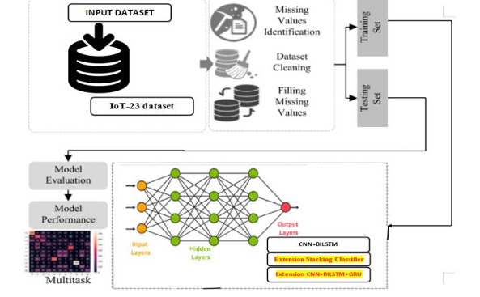

Figure 3.1: Project Architecture on Automatic Pain Recognition with Physiological Signals using Multi-Level Context Information

DESCRIPTION

To implement this project, we have designed following modules
- Upload Dataset: to upload the dataset to the application.
- Dataset processing: like features normalization, shuffling and splitting into train and test
- Run Random Forest Algorithm: existing algorithm called Random Forest and after execution will get output. In above screen Random Forest got 53% accuracy and LOSO also as 53% and in confusion matrix graph x-axis represents Predicted Pain Labels and y-axis represents True Labels and we can see Random Forest predict all test data into single Pain Type which is wrong.
- Run CNN + BILSTM: after execution will get output In above screen with propose multilevel algorithm we got 85% accuracy and in confusion matrix graph x-axis represents Predicted Labels and y-axis represents True Labels and all different colour boxes in diagnol contains correct prediction count and remaining blue boxes contains incorrect prediction count and in above graph we can see propose algorithm predicted all types of PAINS
- Run Extension CNN + BILSTM + BIGRU: with 3 multilevel algorithms for features selection and optimizations and after execution of above block will get output In above screen extension got 98% accuracy and in confusion matrix we can see all pains are predicted correctly which you can analyse in diagonal both x and y-axis pains are matching.
- Comparison Graph: graph x-axis represents algorithm names and y-axis represents accuracy and other metrics in different colour bars and in all algorithms Extension got high accuracy
- Predict: Above code reading test data from file and then normalizing and predicting pain type using extension model and in output before = symbol we can see ECG test data and after = arrow symbol we can see predicted PAIN type. In above screen predicted pain type showing in blue colour

3.3. PROCESS MODEL USED WITH JUSTIFICATION
SDLC (Umbrella Model):
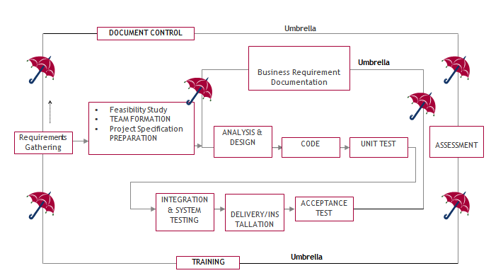

SDLC is nothing but Software Development Life Cycle. It is a standard which is used by software industry to develop good software.

Stages in SDLC:
- Requirement Gathering
- Analysis
- Designing
- Coding
- Testing
- Maintenance

Requirements Gathering stage:
The requirements gathering process takes as its input the goals identified in the high-level requirements section of the project plan. Each goal will be refined into a set of one or more requirements. These requirements define the major functions of the intended application, define operational data areas and reference data areas, and define the initial data entities. Major functions include critical processes to be managed, as well as mission critical inputs, outputs and reports. A user class hierarchy is developed and associated with these major functions, data areas, and data entities. Each of these definitions is termed a Requirement. Requirements are identified by unique requirement identifiers and, at minimum, contain a requirement title and textual description.
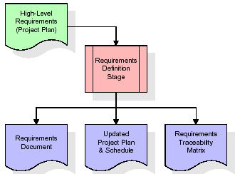

Analysis Stage:
The planning stage establishes a bird's eye view of the intended software product, and uses this to establish the basic project structure, evaluate feasibility and risks associated with the project, and describe appropriate management and technical approaches.
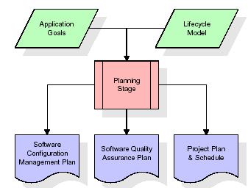

Designing Stage:

The design stage takes as its initial input the requirements identified in the approved requirements document. For each requirement, a set of one or more design elements will be produced as a result of interviews, workshops, and/or prototype efforts. Design elements describe the desired software features in detail, and generally include functional hierarchy diagrams, screen layout diagrams, tables of business rules, business process diagrams, pseudo code, and a complete entity-relationship diagram with a full data dictionary. These design elements are intended to describe the software in sufficient detail that skilled programmers may develop the software with minimal additional input.
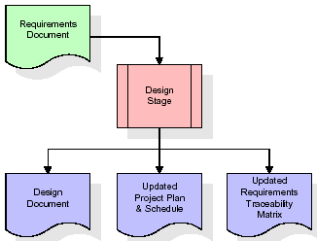

Development (Coding) Stage:
The development stage takes as its primary input the design elements described in the approved design document. For each design element, a set of one or more software artifacts will be produced. Software artifacts include but are not limited to menus, dialogs, and data management forms, data reporting formats, and specialized procedures and functions. Appropriate test cases will be developed for each set of functionally related software artifacts, and an online help system will be developed to guide users in their interactions with the software.
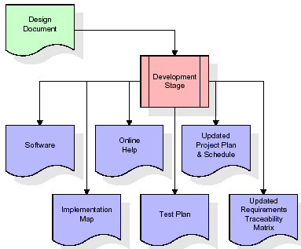

Integration & Test Stage:
During the integration and test stage, the software artifacts, online help, and test data are migrated from the development environment to a separate test environment. At this point, all test cases are run to verify the correctness and completeness of the software. Successful execution of the test suite confirms a robust and complete migration capability. During this stage, reference data is finalized for production use and production users are identified and linked to their appropriate roles. The final reference data (or links to reference data source files) and production user list are compiled into the Production Initiation Plan.
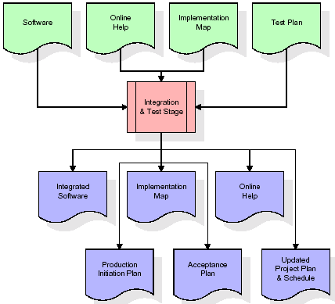

- Installation & Acceptance Test:
During the installation and acceptance stage, the software artifacts, online help, and initial production data are loaded onto the production server. At this point, all test cases are run to verify the correctness and completeness of the software. Successful execution of the test suite is a prerequisite to acceptance of the software by the customer.
After customer personnel have verified that the initial production data load is correct and the test suite has been executed with satisfactory results, the customer formally accepts the delivery of the software.
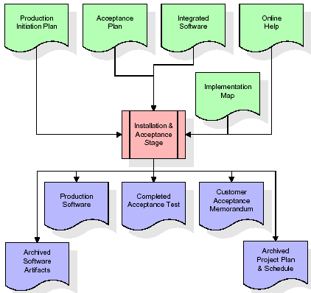

SYSTEM DESIGN
UML Diagram:
The Unified Modelling Language allows the software engineer to express an analysis model using the modelling notation that is governed by a set of syntactic semantic and pragmatic rules.
A UML system is represented using five different views that describe the system from distinctly different perspective. Each view is defined by a set of diagrams, which is as follows.
  - User Model View
    - This view represents the system from the user’s perspective.
    - The analysis representation describes a usage scenario from the end-user’s perspective.
  - Structural Model view
    - In this model the data and functionality are arrived from inside the system.
    - This model view models the static structures.
- Behavioural Model View
It represents the dynamic of behavioural as parts of the system, depicting the interactions of collection between various structural elements described in the user model and structural model view.
- Implementation Model View
In this the structural and behavioural as parts of the system are represented as they are to be built.
- Environmental Model View
In this the structural and behavioural aspect of the environment in which the system is to be implemented are represented.
Class Diagram:
The class diagram is the main building block of object orientedmodeling. It is used both for general conceptual modelling of the systematic of the application, and for detailed modelling translating the models into programming code. Class diagrams can also be used for data modelling. The classes in a class diagram represent both the main objects, interactions in the application and the classes to be programmed. In the diagram, classes are represented with boxes which contain three parts:
- The upper part holds the name of the class
- The middle part contains the attributes of the class
- The bottom part gives the methods or operations the class can take or undertake.
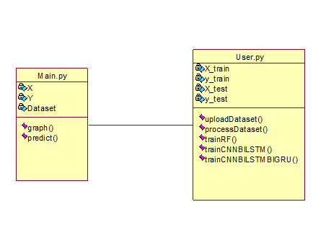
Use case Diagram:
A use case diagram at its simplest is a representation of a user's interaction with the system and depicting the specifications of a use case. A use case diagram can portray the different types of users of a system and the various ways that they interact with the system. This type of diagram is typically used in conjunction with the textual use case and will often be accompanied by other types of diagrams as well.
Sequence diagram:
A sequence diagram is a kind of interaction diagram that shows how processes operate with one another and in what order. It is a construct of a Message Sequence Chart. A sequence diagram shows object interactions arranged in time sequence. It depicts the objects and classes involved in the scenario and the sequence of messages exchanged between the objects needed to carry out the functionality of the scenario. Sequence diagrams are typically associated with use case realizations in the Logical View of the system under development. Sequence diagrams are sometimes called event diagrams, event scenarios, and timing diagrams.
Collaboration diagram:
A collaboration diagram describes interactions among objects in terms of sequenced messages. Collaboration diagrams represent a combination of information taken from class, sequence, and use case diagrams describing both the static structure and dynamic behaviour of a system.
Component Diagram:
In the Unified Modelling Language, a component diagram depicts how components are wired together to form larger components and or software systems. They are used to illustrate the structure of arbitrarily complex systems.
Components are wired together by using an assembly connector to connect the required interface of one component with the provided interface of another component. This illustrates the service consumer - service provider relationship between the two components.
Deployment Diagram:
A deployment diagram in the Unified Modeling Language models the physical deployment of artifacts on nodes. To describe a web site, for example, a deployment diagram would show what hardware components ("nodes") exist (e.g., a web server, an application server, and a database server), what software components ("artifacts") run on each node (e.g., web application, database), and how the different pieces are connected (e.g. JDBC, REST, RMI).
The nodes appear as boxes, and the artifacts allocated to each node appear as rectangles within the boxes. Nodes may have sub nodes, which appear as nested boxes. A single node in a deployment diagram may conceptually represent multiple physical nodes, such as a cluster of database servers.
Activity Diagram:
Activity diagram is another important diagram in UML to describe dynamic aspects of the system. It is basically a flow chart to represent the flow form one activity to another activity. The activity can be described as an operation of the system. So, the control flow is drawn from one operation to another. This flow can be sequential, branched or concurrent.
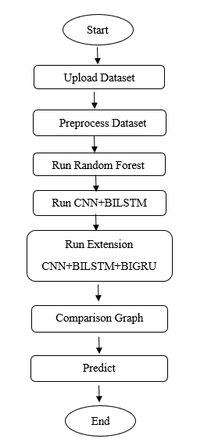
Data Flow Diagram:
Data flow diagrams illustrate how data is processed by a system in terms of inputs and outputs. Data flow diagrams can be used to provide a clear representation of any business function. The technique starts with an overall picture of the business and continues by analyzing each of the functional areas of interest. This analysis can be carried out in precisely the level of detail required. The technique exploits a method called top-down expansion to conduct the analysis in a targeted way.
As the name suggests, Data Flow Diagram (DFD) is an illustration that explicates the passage of information in a process. A DFD can be easily drawn using simple symbols. Additionally, complicated processes can be easily automated by creating DFDs using easy-to-use, free downloadable diagramming tools. A DFD is a model for constructing and analyzing information processes. DFD illustrates the flow of information in a process depending upon the inputs and outputs. A DFD can also be referred to as a Process Model. A DFD demonstrates business or technical process with the support of the outside data saved, plus the data flowing from the process to another and the end results.
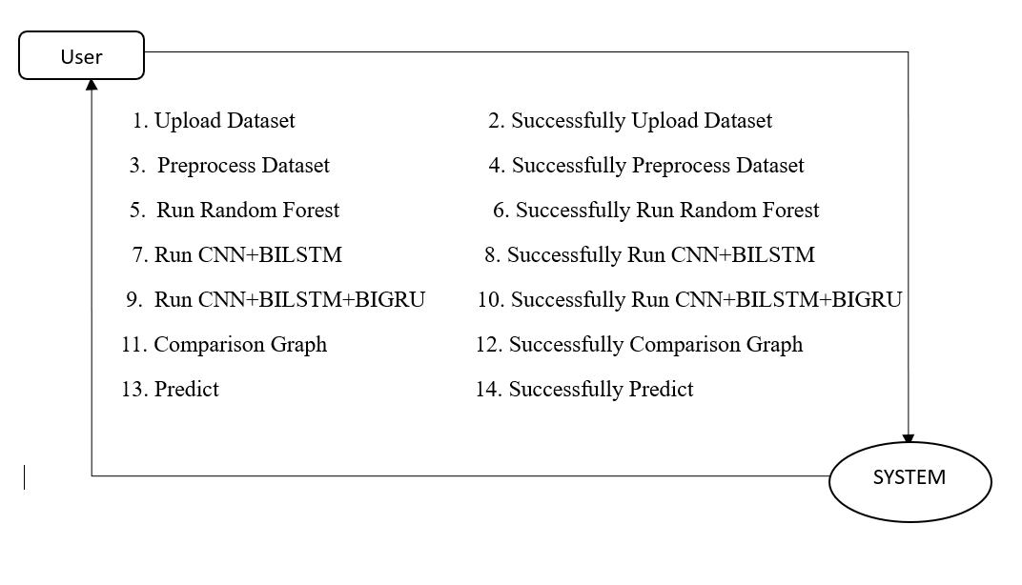

4 IMPLEMENTATION

IMPLEMENTATION

The implementation phase of a project involves executing the planned strategies and tasks. It requires meticulous coordination, resource allocation, and monitoring to ensure that objectives are met efficiently. Effective implementation is crucial for achieving project goals and delivering expected outcomes within the set timeline and budget constraints.

4.1 ALGORITHMS USED

4.1.1 Random Forest (RF)

Random Forest is an ensemble machine learning algorithm that builds multiple decision trees using random subsets of data and features, then combines their predictions for better accuracy. It is widely used forclassification and regression tasks.
Advantages:
High accuracy,
reduces overfitting,
handles large datasets,
manages missing values,
parallelizable.
Disadvantages:
Can be slow with very large datasets,
less interpretable than a single decision tree,
requires more memory.
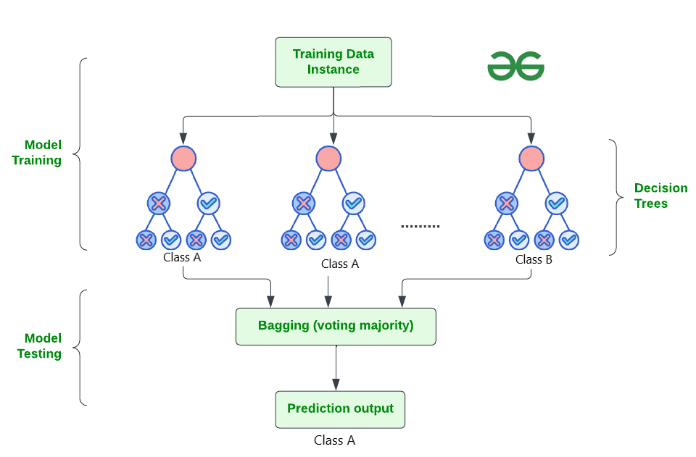
4.1.2 Convolutional Neural Network (CNN)
A Convolutional Neural Network (CNN) is a type of Deep Learning neural network architecture commonly used in Computer Vision. Computer vision is a field of Artificial Intelligence that enables a computer to understand and interpret the image or visual data.
When it comes to Machine Learning, Artificial Neural Networks perform really well. Neural Networks are used in various datasets like images, audio, and text. Different types of Neural Networks are used for different purposes, for example for predicting the sequence of words we use Recurrent Neural Networks more precisely an LSTM, similarly for image classification we use Convolution Neural networks. In this blog, we are going to build a basic building block for CNN.

Convolution Neural Network
Convolutional Neural Network (CNN) is the extended version of artificial neural networks (ANN) which is predominantly used to extract the feature from the grid-like matrix dataset. For example visual datasets like images or videos where data patterns play an extensive role.

CNN architecture
Convolutional Neural Network consists of multiple layers like the input layer, Convolutional layer, Pooling layer, and fully connected layers.
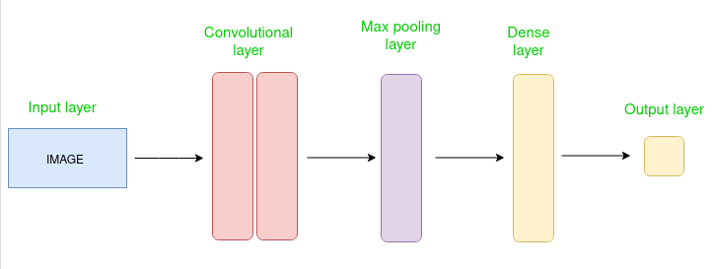
Simple CNN architecture
The Convolutional layer applies filters to the input image to extract features, the Pooling layer downsamples the image to reduce computation, and the fully connected layer makes the final prediction. The network learns the optimal filters through backpropagation and gradient descent.

How Convolutional Layers works
Convolution Neural Networks or covnets are neural networks that share their parameters. Imagine you have an image. It can be represented as a cuboid having its length, width (dimension of the image), and height (i.e the channel as images generally have red, green, and blue channels).
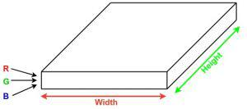
Now imagine taking a small patch of this image and running a small neural network, called a filter or kernel on it, with say, K outputs and representing them vertically. Now slide that neural network across the whole image, as a result, we will get another image with different widths, heights, and depths. Instead of just R, G, and B channels now we have more channels but lesser width and height. This operation is called Convolution. If the patch size is the same as that of the image it will be a regular neural network. Because of this small patch, we have fewer weights.
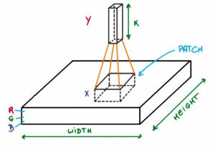
Image source: Deep Learning Udacity

4.1.3 LSTM
A traditional RNN has a single hidden state that is passed through time, which can make it difficult for the network to learn long-term dependencies. LSTMs address this problem by introducing a memory cell, which is a container that can hold information for an extended period. LSTM networks are capable of learning long-term dependencies in sequential data, which makes them well-suited for tasks such as language translation, speech recognition, and time series forecasting. LSTMs can also be used in combination with other neural network architectures, such as Convolutional Neural Networks (CNNs) for image and video analysis.
The memory cell is controlled by three gates: the input gate, the forget gate, and the output gate. These gates decide what information to add to, remove from, and output from the memory cell. The input gate controls what information is added to the memory cell. The forget gate controls what information is removed from the memory cell. And the output gate controls what information is output from the memory cell. This allows LSTM networks to selectively retain or discard information as it flows through the network, which allows them to learn long-term dependencies.

Bidirectional LSTM
Bidirectional LSTM (Bi LSTM/ BLSTM) is recurrent neural network (RNN) that is able to process sequential data in both forward and backward directions. This allows Bi LSTM to learn longer-range dependencies in sequential data than traditional LSTMs, which can only process sequential data in one direction.
- Bi LSTMs are made up of two LSTM networks, one that processes the input sequence in the forward direction and one that processes the input sequence in the backward direction. The outputs of the two LSTM networks are then combined to produce the final output.
- Bi LSTM have been shown to achieve state-of-the-art results on a wide variety of tasks, including machine translation, speech recognition, and text summarization.
LSTMs can be stacked to create deep LSTM networks, which can learn even more complex patterns in sequential data. Each LSTM layer captures different levels of abstraction and temporal dependencies in the input data.

Architecture and Working of LSTM
LSTM architecture has a chain structure that contains four neural networks and different memory blocks called cells.
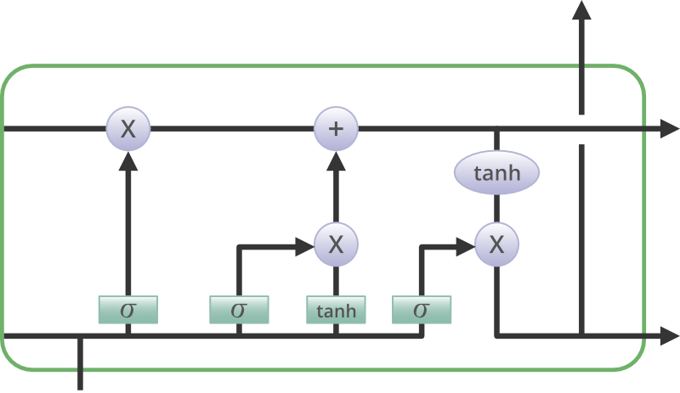
Information is retained by the cells and the memory manipulations are done by the gates. There are three gates –

Forget Gate
The information that is no longer useful in the cell state is removed with the forget gate. Two inputs xt (input at the particular time) and ht-1 (previous cell output) are fed to the gate and multiplied with weight matrices followed by the addition of bias. The resultant is passed through an activation function which gives a binary output. If for a particular cell state the output is 0, the piece of information is forgotten and for output 1, the information is retained for future use. The equation for the forget gate is:
where:
- W_f represents the weight matrix associated with the forget gate.
- [h_t-1, x_t] denotes the concatenation of the current input and the previous hidden state.
- b_f is the bias with the forget gate.
- σ is the sigmoid activation function.
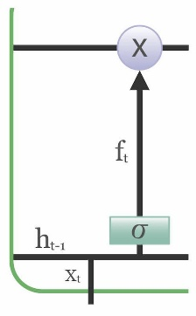

Input gate
The addition of useful information to the cell state is done by the input gate. First, the information is regulated using the sigmoid function and filter the values to be remembered similar to the forget gate using inputs ht-1 and xt. . Then, a vector is created using tanh function that gives an output from -1 to +1, which contains all the possible values from ht-1 and xt. At last, the values of the vector and the regulated values are multiplied to obtain the useful information. The equation for the input gate is:
We multiply the previous state by ft, disregarding the information we had previously chosen to ignore. Next, we include it∗Ct. This represents the updated candidate values, adjusted for the amount that we chose to update each state value.
where
- ⊙ denotes element-wise multiplication
- tanh is tanh activation function
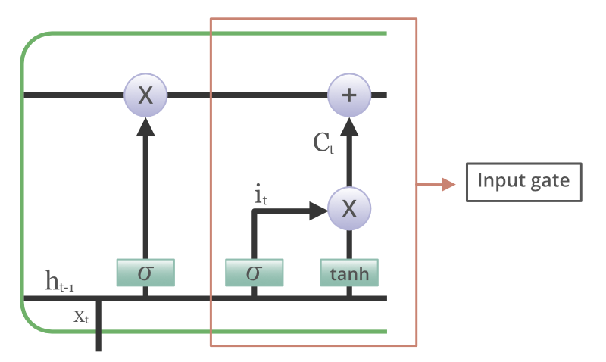

Output gate
The task of extracting useful information from the current cell state to be presented as output is done by the output gate. First, a vector is generated by applying tanh function on the cell. Then, the information is regulated using the sigmoid function and filter by the values to be remembered using inputs ht-1 and xt. At last, the values of the vector and the regulated values are multiplied to be sent as an output and input to the next cell. The equation for the output gate is:
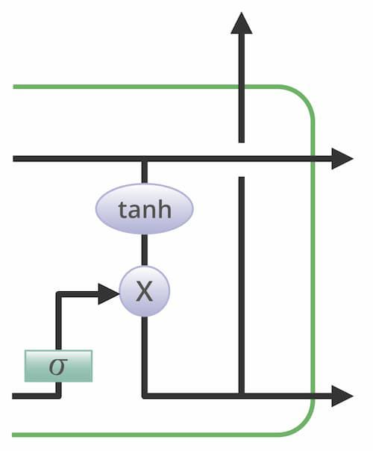

4.1.4 Gated Recurrent Unit Networks
Gated Recurrent Unit (GRU) is a type of recurrent neural network (RNN) that was introduced by Cho et al. in 2014 as a simpler alternative to Long Short-Term Memory (LSTM) networks. Like LSTM, GRU can process sequential data such as text, speech, and time-series data.
The basic idea behind GRU is to use gating mechanisms to selectively update the hidden state of the network at each time step. The gating mechanisms are used to control the flow of information in and out of the network. The GRU has two gating mechanisms, called the reset gate and the update gate.
The reset gate determines how much of the previous hidden state should be forgotten, while the update gate determines how much of the new input should be used to update the hidden state. The output of the GRU is calculated based on the updated hidden state.
The equations used to calculate the reset gate, update gate, and hidden state of a GRU are as follows:
In summary, GRU networks are a type of RNN that use gating mechanisms to selectively update the hidden state at each time step, allowing them to effectively model sequential data. They have been shown to be effective in various natural language processing tasks, such as language modeling, machine translation, and speech recognition
Prerequisites: Recurrent Neural Networks, Long Short Term Memory Networks
To solve the Vanishing-Exploding gradients problem often encountered during the operation of a basic Recurrent Neural Network, many variations were developed. One of the most famous variations is the Long Short Term Memory Network(LSTM). One of the lesser-known but equally effective variations is the Gated Recurrent Unit Network(GRU).
Unlike LSTM, it consists of only three gates and does not maintain an Internal Cell State. The information which is stored in the Internal Cell State in an LSTM recurrent unit is incorporated into the hidden state of the Gated Recurrent Unit. This collective information is passed onto the next Gated Recurrent Unit. The different gates of a GRU are as described below:-
- Update Gate(z): It determines how much of the past knowledge needs to be passed along into the future. It is analogous to the Output Gate in an LSTM recurrent unit.
- Reset Gate(r): It determines how much of the past knowledge to forget. It is analogous to the combination of the Input Gate and the Forget Gate in an LSTM recurrent unit.
- Current Memory Gate(): It is often overlooked during a typical discussion on Gated Recurrent Unit Network. It is incorporated into the Reset Gate just like the Input Modulation Gate is a sub-part of the Input Gate and is used to introduce some non-linearity into the input and to also make the input Zero-mean. Another reason to make it a sub-part of the Reset gate is to reduce the effect that previous information has on the current information that is being passed into the future.
The basic work-flow of a Gated Recurrent Unit Network is similar to that of a basic Recurrent Neural Network when illustrated, the main difference between the two is in the internal working within each recurrent unit as Gated Recurrent Unit networks consist of gates which modulate the current input and the previous hidden state.
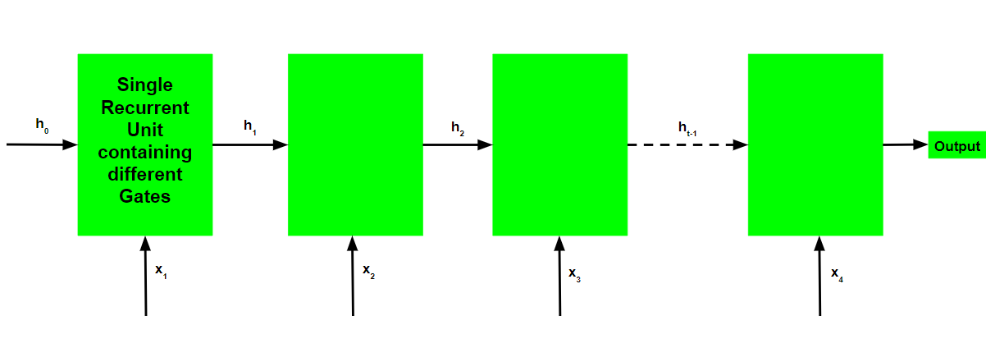

4.2 SAMPLE CODE

from tkinter import *
from tkinter import simpledialog
import tkinter
from tkinter import filedialog
import seaborn as sns
from sklearn.metrics import precision_score
from sklearn.metrics import recall_score
from sklearn.metrics import f1_score
from sklearn.metrics import confusion_matrix
import matplotlib.pyplot as plt
import pickle

import numpy as np
import pandas as pd
from sklearn.metrics import accuracy_score
from sklearn.preprocessing import MinMaxScaler
from sklearn.model_selection import train_test_split

from keras.models import Sequential, load_model
from keras.layers import Dense, TimeDistributed, Conv1D, MaxPooling1D, Flatten, Activation, RepeatVector
from keras.layers import LSTM #class for LSTM training
import os
from keras.layers import Dropout
from keras.callbacks import ModelCheckpoint
from keras.layers import Bidirectional, GRU #class for bidirectional LSTM as BILSTM and GRU
from keras.utils.np_utils import to_categorical

from sklearn.metrics import accuracy_score
import pickle
from sklearn import svm
from sklearn.ensemble import RandomForestClassifier
from sklearn.model_selection import LeaveOneOut #class to calculate LOSO
from sklearn.model_selection import cross_val_score

main = tkinter.Tk()
main.title("Pain Recognition") #designing main screen
main.geometry("1300x1200")

global filename, dataset, X_train, X_test, y_train, y_test, X, Y, scaler, pca
global accuracy, precision, recall, fscore, values,algorithm, predict,unique,extension_model
precision = []
recall = []
fscore = []
accuracy = []
loso = []

def uploadDataset():
global filename, dataset, labels, values,unique
filename = filedialog.askopenfilename(initialdir = "Dataset")
text.delete('1.0', END)
text.insert(END,'Dataset loaded\n\n')
dataset = pd.read_csv(filename)
dataset.fillna(0, inplace = True)
text.insert(END,str(dataset))
data = dataset.values
plt.plot(data)
plt.xlabel("Number of Records")
plt.ylabel("Signals")
plt.title("EEG Signal from all Subjects")
plt.show()

def processDataset():
global dataset, X, Y
global X_train, X_test, y_train, y_test, pca, scaler,labels
text.delete('1.0', END)
dataset = dataset.values
X = dataset[:,0:dataset.shape[1]-1] #extract training features as X
Y = dataset[:,dataset.shape[1]-1] #extract target pain label
scaler = MinMaxScaler((0,1))
X = scaler.fit_transform(X)#normalized features
indices = np.arange(X.shape[0])
np.random.shuffle(indices) #shuffle the dataset values
X = X[indices]
Y = Y[indices]
text.insert(END,"Normalized Training Features : \n\n "+str(X)+"\n")
X_train, X_test, y_train, y_test = train_test_split(X, Y, test_size=0.2) #split dataset into train and test
print()
text.insert(END,"Dataset train & test split as 80% dataset for training and 20% for testing"+"\n")
text.insert(END,"Training Size (80%): "+str(X_train.shape[0])+"\n") #print training and test size
text.insert(END,"Testing Size (20%): "+str(X_test.shape[0])+"\n")
print()
labels, count = np.unique(dataset[:, -1], return_counts = True)
labels = ["Pain0", "Pain1", "Pain2" ,"Pain3", "Pain4"]
height = count
bars = labels
y_pos = np.arange(len(bars))
plt.bar(y_pos, height)
plt.xticks(y_pos, bars)
plt.xlabel("Dataset Class Label Graph")
plt.ylabel("Count")
plt.show()

def calculateMetrics(algorithm, predict, testY,labels):
p = precision_score(testY, predict,average='macro') * 100
r = recall_score(testY, predict,average='macro') * 100
f = f1_score(testY, predict,average='macro') * 100
a = accuracy_score(testY,predict)*100
print()
text.insert(END,algorithm+' Accuracy : '+str(a)+"\n")
text.insert(END,algorithm+' Precision : '+str(p)+"\n")
text.insert(END,algorithm+' Recall : '+str(r)+"\n")
text.insert(END,algorithm+' FMeasure : '+str(f)+"\n")
accuracy.append(a)
precision.append(p)
recall.append(r)
fscore.append(f)
conf_matrix = confusion_matrix(testY, predict)
plt.figure(figsize =(5, 5))
ax = sns.heatmap(conf_matrix, xticklabels = labels, yticklabels = labels, annot = True, cmap="viridis" ,fmt ="g");
ax.set_ylim([0,len(labels)])
plt.title(algorithm+" Confusion matrix")
plt.ylabel('True class')
plt.xlabel('Predicted class')
plt.show()

def trainRF():
global X_train, y_train, X_test, y_test
global algorithm, predict, test_labels,labels
text.delete('1.0', END)
rf = RandomForestClassifier(n_estimators=40, criterion='gini', max_features="log2", min_weight_fraction_leaf=0.3)
rf.fit(X_train, y_train)
predict = rf.predict(X_test)#perform prediction on test data
calculateMetrics("Existing Random Forest", predict, y_test,labels)#call function to calculate accuracy and other metrics

def trainCNNBILSTM():
global X_train, y_train, X_test, y_test
global algorithm, predict,labels
text.delete('1.0', END)
X_train = np.reshape(X_train, (X_train.shape[0], 34, 4))
X_test = np.reshape(X_test, (X_test.shape[0], 34, 4))
y_train = to_categorical(y_train)
y_test = to_categorical(y_test)
#create CNN sequential object
propose_model = Sequential()
#create CNN1D layer with 32 neurons for data filteration and pool size as 3
propose_model.add(Conv1D(filters=32, kernel_size = 3, activation = 'relu', input_shape = (X_train.shape[1], X_train.shape[2])))
#defining another CNN layer with 64 neurons
propose_model.add(Conv1D(filters=64, kernel_size = 2, activation = 'relu'))
propose_model.add(Conv1D(filters=128, kernel_size = 2, activation = 'relu'))
#max pooling layer to collect relevant features from CNN layer
propose_model.add(MaxPooling1D(pool_size = 1))
propose_model.add(Flatten())
propose_model.add(RepeatVector(2))
#defining BILSTM kayer with 32 neurons to optimize CNN features
propose_model.add(Bidirectional(LSTM(32, activation = 'relu', return_sequences=True)))
propose_model.add(Bidirectional(LSTM(64, activation = 'relu')))
#adding dropout layer to remove irrelevant features
propose_model.add(Dropout(0.2))
#defining output an dprediction layer
propose_model.add(Dense(units = 100, activation = 'softmax'))
propose_model.add(Dense(units = y_train.shape[1], activation = 'softmax'))
#train and compile the model
propose_model.compile(optimizer = 'adam', loss = 'categorical_crossentropy', metrics = ['accuracy'])
if os.path.exists("model/propose_weights.hdf5") == False:
model_check_point = ModelCheckpoint(filepath='model/propose_weights.hdf5', verbose = 1, save_best_only = True)
hist = propose_model.fit(X_train, y_train, batch_size = 32, epochs = 10, validation_data=(X_test, y_test), callbacks=[model_check_point], verbose=1)
f = open('model/propose_history.pckl', 'wb')
pickle.dump(hist.history, f)
f.close()
else:
propose_model = load_model("model/propose_weights.hdf5")
#perform prediction on test data
predict = propose_model.predict(X_test)
predict = np.argmax(predict, axis=1)
y_test1 = np.argmax(y_test, axis=1)
calculateMetrics("Propose CNN + BILSTM", predict, y_test1, labels)#call function to calculate accuracy and other metrics

def trainCNNBILSTMBIGRU():
global X_train, y_train, X_test, y_test
global algorithm, predict,labels,extension_model
text.delete('1.0', END)
extension_model = Sequential()
#create CNN1D layer with 32 neurons for data filteration and pool size as 3
extension_model.add(Conv1D(filters=32, kernel_size = 3, activation = 'relu', input_shape = (X_train.shape[1], X_train.shape[2])))
extension_model.add(Conv1D(filters=64, kernel_size = 2, activation = 'relu'))
extension_model.add(Conv1D(filters=128, kernel_size = 2, activation = 'relu'))
extension_model.add(MaxPooling1D(pool_size = 1))
extension_model.add(Flatten())
extension_model.add(RepeatVector(2))
#adding LSTM Bidirectional layer to obtained optimized features from CNN
extension_model.add(Bidirectional(LSTM(32, activation = 'relu', return_sequences=True)))
#now bidirectional GRU will extract optimized fetaures from BI-LSTM and then train a model with below prediction layer
extension_model.add(Bidirectional(GRU(64, activation = 'relu')))
extension_model.add(Dropout(0.2))
#Define output prediction layer
extension_model.add(Dense(units = 100, activation = 'softmax'))
extension_model.add(Dense(units = y_train.shape[1], activation = 'softmax'))
#compile and train the model
extension_model.compile(optimizer = 'adam', loss = 'categorical_crossentropy', metrics = ['accuracy'])
if os.path.exists("model/extension_weights.hdf5") == False:
model_check_point = ModelCheckpoint(filepath='model/extension_weights.hdf5', verbose = 1, save_best_only = True)
hist = extension_model.fit(X_train, y_train, batch_size = 32, epochs = 10, validation_data=(X_test, y_test), callbacks=[model_check_point], verbose=1)
f = open('model/extension_history.pckl', 'wb')
pickle.dump(hist.history, f)
f.close()
else:
extension_model = load_model("model/extension_weights.hdf5")
#perform prediction on test data
predict = extension_model.predict(X_test)
predict = np.argmax(predict, axis=1)
y_test1 = np.argmax(y_test, axis=1)
calculateMetrics("Etension CNN + BILSTM + BIGRU", predict, y_test1, labels)#call function to calculate accuracy and other metrics

def graph():
global X_train, y_train, X_test, y_test
global algorithm, predict,labels
text.delete('1.0', END)
df = pd.DataFrame([['Existing Random Forest','Precision',precision[0]],['Existing Random Forest','Recall',recall[0]],['Existing Random Forest','F1 Score',fscore[0]],['Existing Random Forest','Accuracy',accuracy[0]],
['Propsoe CNN + BI-LSTM','Precision',precision[1]],['Propsoe CNN + BI-LSTM','Recall',recall[1]],['Propsoe CNN + BI-LSTM','F1 Score',fscore[1]],['Propsoe CNN + BI-LSTM','Accuracy',accuracy[1]],
['Extension CNN + BI-LSTM + BI-GRU','Precision',precision[2]],['Extension CNN + BI-LSTM + BI-GRU','Recall',recall[2]],['Extension CNN + BI-LSTM + BI-GRU','F1 Score',fscore[2]],['Extension CNN + BI-LSTM + BI-GRU','Accuracy',accuracy[2]],
],columns=['Parameters','Algorithms','Value'])
df.pivot("Parameters", "Algorithms", "Value").plot(kind='bar')
plt.title("All Algorithms Performance Graph")
plt.show()

def predict():
global X_train, y_train, X_test, y_test
global algorithm, predict,labels,extension_model
text.delete('1.0', END)
testData = pd.read_csv("Dataset/testData.csv")#reading test data
testData.fillna(0, inplace = True)
temp = testData.values
testData = testData.values
test = scaler.transform(testData)#normalizing values
test = np.reshape(test, (test.shape[0], 34, 4))
predict = extension_model.predict(test)#performing prediction on test data using extension model object
for i in range(len(predict)):
y_pred = np.argmax(predict[i])
text.insert(END,"Test Data = "+str(temp[i])+" Predicted Pain Type ====> "+labels[y_pred]+"\n")

font = ('times', 16, 'bold')
title = Label(main, text='Pain Recognition With Physiological Signals Using Multi-Level Context Information')
title.config(bg='gray24', fg='white')
title.config(font=font)
title.config(height=3, width=120)
title.place(x=0,y=5)

font1 = ('times', 12, 'bold')
text=Text(main,height=27,width=150)
scroll=Scrollbar(text)
text.configure(yscrollcommand=scroll.set)
text.place(x=10,y=200)
text.config(font=font1)

font1 = ('times', 13, 'bold')
uploadButton = Button(main, text="Upload Dataset", command=uploadDataset)
uploadButton.place(x=10,y=100)
uploadButton.config(font=font1)

processButton = Button(main, text="Preprocess & Split Dataset", command=processDataset)
processButton.place(x=250,y=100)
processButton.config(font=font1)

rfButton = Button(main, text="Run Random Forest", command=trainRF)
rfButton.place(x=490,y=100)
rfButton.config(font=font1)

cnnButton = Button(main, text="Run CNN + BILSTM", command=trainCNNBILSTM)
cnnButton.place(x=730,y=100)
cnnButton.config(font=font1)

dtButton = Button(main, text="Run CNN+BILSTM+BIGRU", command=trainCNNBILSTMBIGRU)
dtButton.place(x=970,y=100)
dtButton.config(font=font1)

graphButton = Button(main, text="Comparision Graph", command=graph)
graphButton.place(x=10,y=150)
graphButton.config(font=font1)

predictButton = Button(main, text="Predict", command=predict)
predictButton.place(x=250,y=150)
predictButton.config(font=font1)

main.config(bg='chartreuse2')
main.mainloop()

RESULTS & DISCUSSION

RESULTS & DISCUSSION

The following screenshots showcase the results of our project, highlighting key features and functionalities. These visual representations provide a clear overview of how the system performs under various conditions, demonstrating its effectiveness and user interface. The screenshots serve as a visual aid to support the project's technical and operational achievements.

6.1 Application Execution

To Run the application Click on “run.bat” file from the file location.
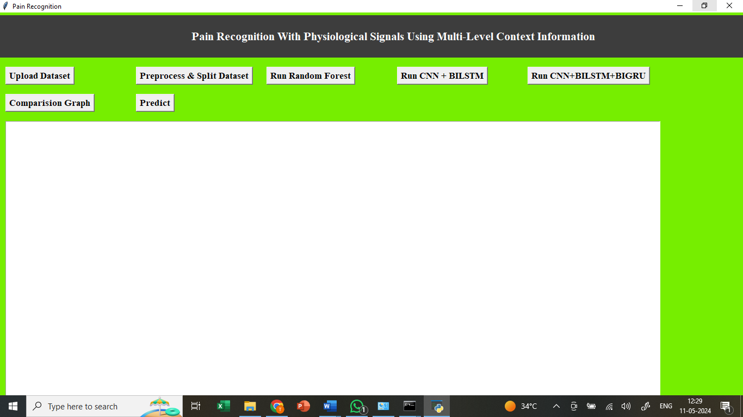
Figure 5.1 : Application Execution on Pain Recognition with Physiological Signals Using Multi-Level Context Information

In the above screen we got Tkinter Output Window. Now Click On the “Upload Dataset” button to upload the dataset to the application.

5.2 Dataset Uploading and Display

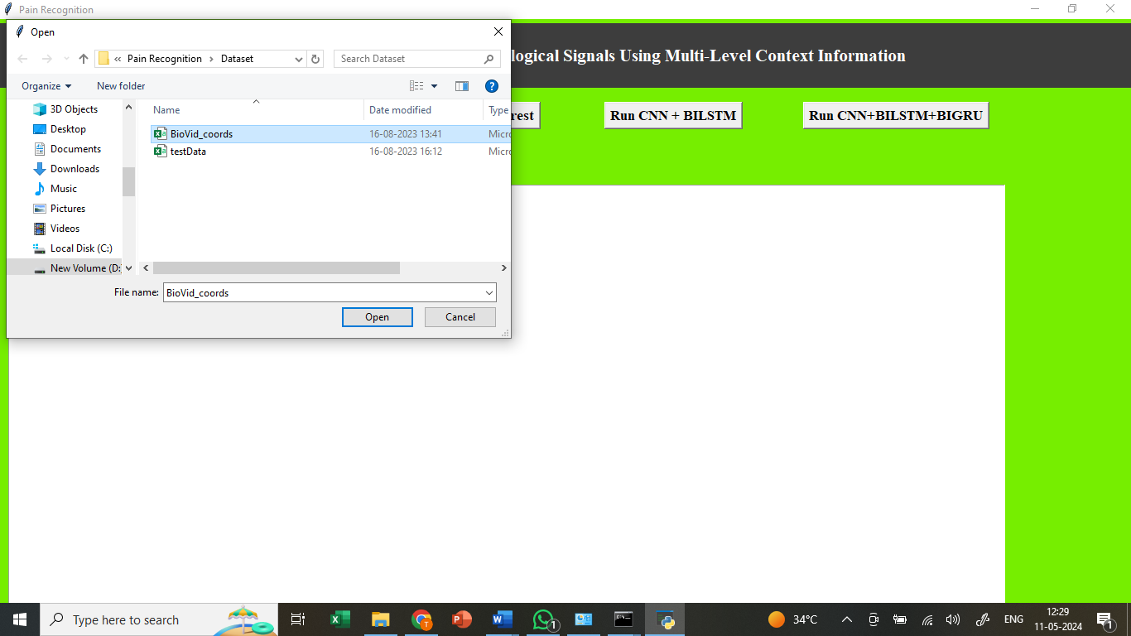
Figure 5.2: Dataset Uploading and Display on Pain Recognition with Physiological Signals Using Multi-Level Context Information

In the above screen we can see the dataset uploading..
5.3 EEG Signal Visualization and Dataset Analysis

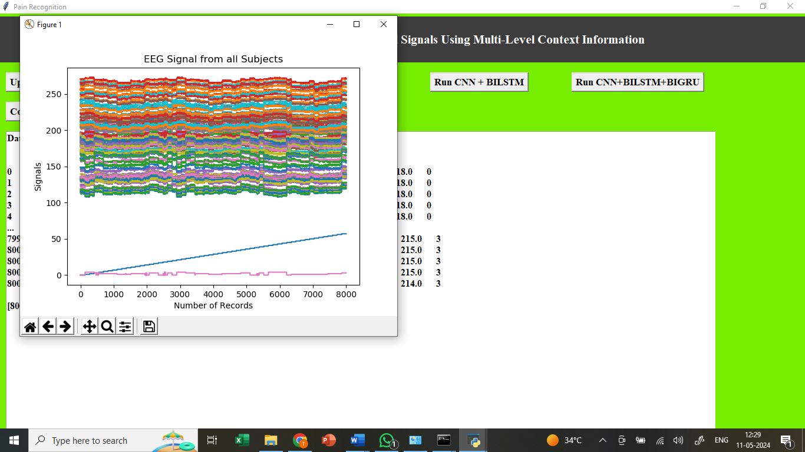

Figure 5.3: EEG Signal Visualization and Dataset Analysis on Pain Recognition with Physiological Signals Using Multi-Level Context Information

In above screen defining code for features normalization and then reading and displaying dataset where first column contains subject ID and last column contains Pains labels from 0 to 4. In above graph plotting EEG signals from all subjects where x-axis represents EEG record number and y-axis represents EEG signal values from all subjects.
5.4 Pain-wise ECG Signal Distribution Graph

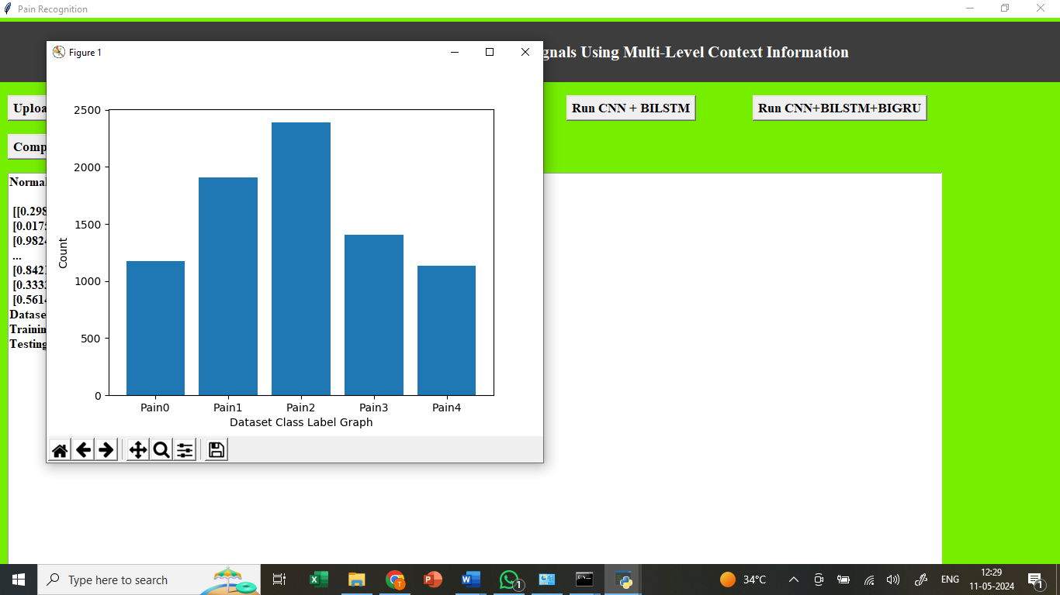Figure 5.4: Pain-Wise ECG Signal Distribution Graph

In above screen finding and plotting graphs of different pains and count of those pains ECG signals and in graph x-axis represents Pain Type and y-axis represents count.
5.5 Dataset Preprocessing

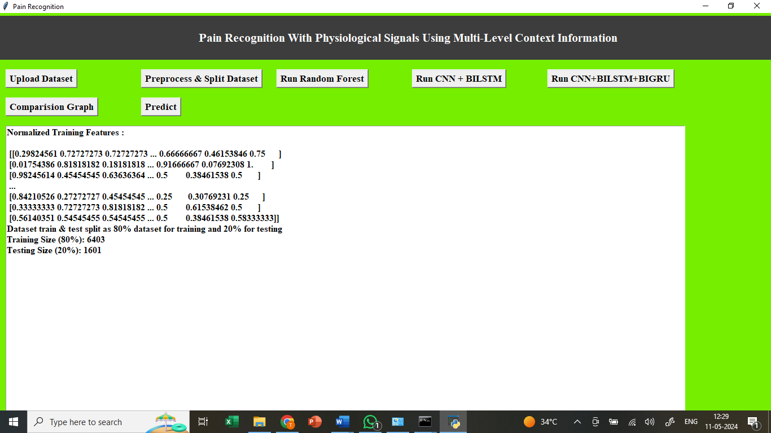
Figure 5.5: Dataset Preprocessing on Pain Recognition with Physiological Signals Using Multi-Level Context Information
In above screen performing various dataset processing like features normalization, shuffling and splitting into train and test. Now click on “Run Random Forest Algorithm”.
5.6 Random Forest Algorithm Execution and Results
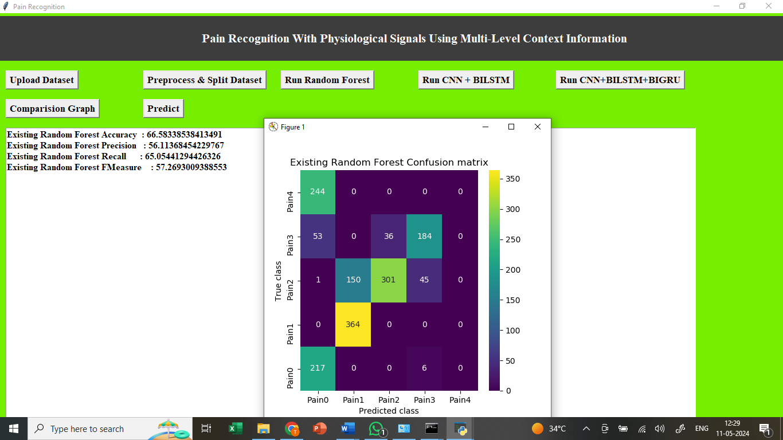
Figure 5.6: Randam Forest Algorithm Execution and Results on pain Recognition with physiological Signals using Multi-Level Context Information.

In above screen training existing algorithm called Random Forest and after execution will get output. In above screen Random Forest got 53% accuracy and LOSO also as 53% and in confusion matrix graph x-axis represents Predicted Pain Labels and y-axis represents True Labels and we can see Random Forest predict all test data into single Pain Type which is wrong and below is the propose algorithm.

5.7 Proposed Multilevel Model (CNN + BiLSTM) Results
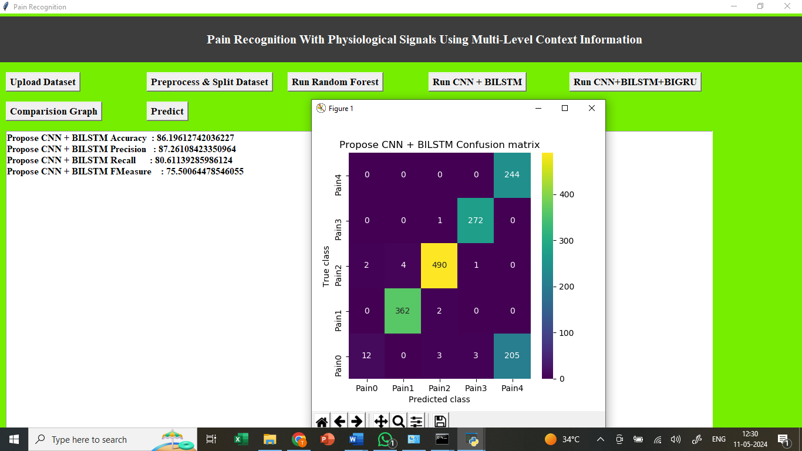 Figure 5.7: Proposed Multilevel Model (CNN + BiLSTM) Results on pain Recognition with physiological Signals using Multi-Level Context Information.

In above propose algorithm we are defining multilevel algorithm with CNN + BILSTM and after execution will get output In above screen with propose multilevel algorithm we got 85% accuracy and in confusion matrix graph x-axis represents Predicted Labels and y-axis represents True Labels and all different colour boxes in diagnol contains correct prediction count and remaining blue boxes contains incorrect prediction count and in above graph we can see propose algorithm predicted all types of PAINS.

5.8 Extended Multilevel Model (CNN + BiLSTM + BiGRU)

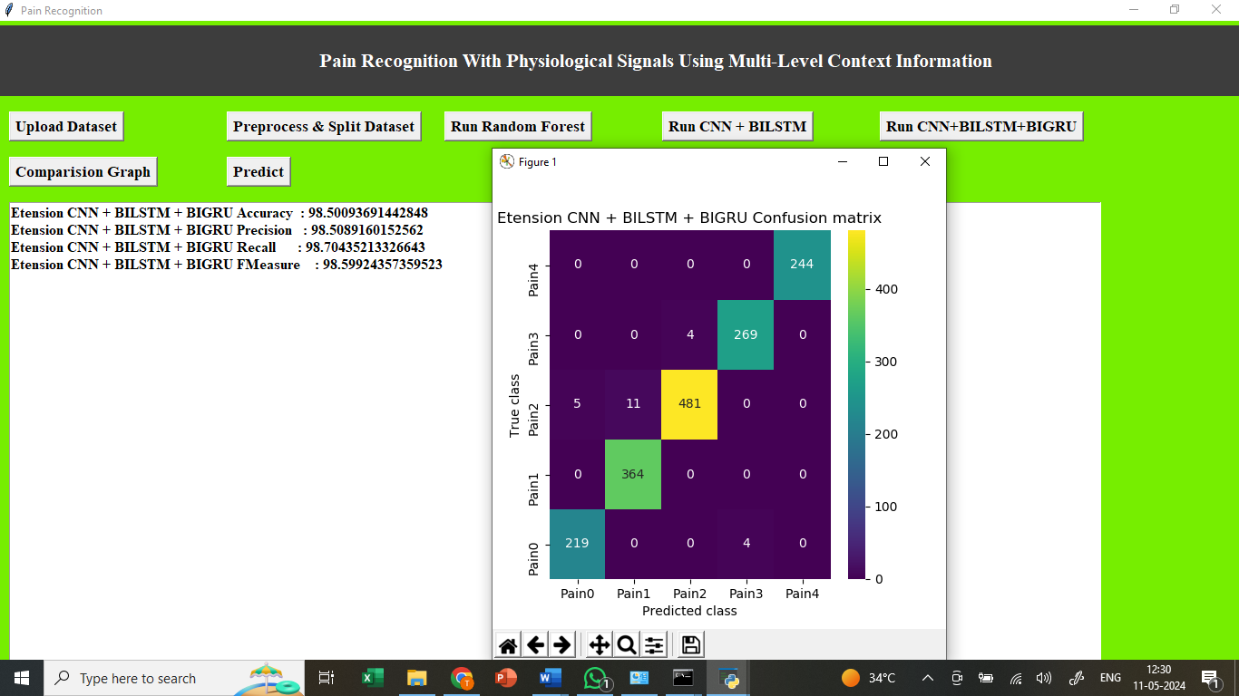

Figure5.8: Extended Multilevel Model (CNN + BiLSTM + BiGRU) on pain Recognition with physiological Signals using Multi-Level Context Information.

In above screen defining extension algorithm with CNN + BILSTM + BIGRU with 3 multilevel algorithms for features selection and optimizations and after execution of above block will get output In above screen extension got 98% accuracy and in confusion matrix we can see all pains are predicted correctly which you can analyse in diagnol both x and y-axis pains are matching.

5.9 Test Data Prediction

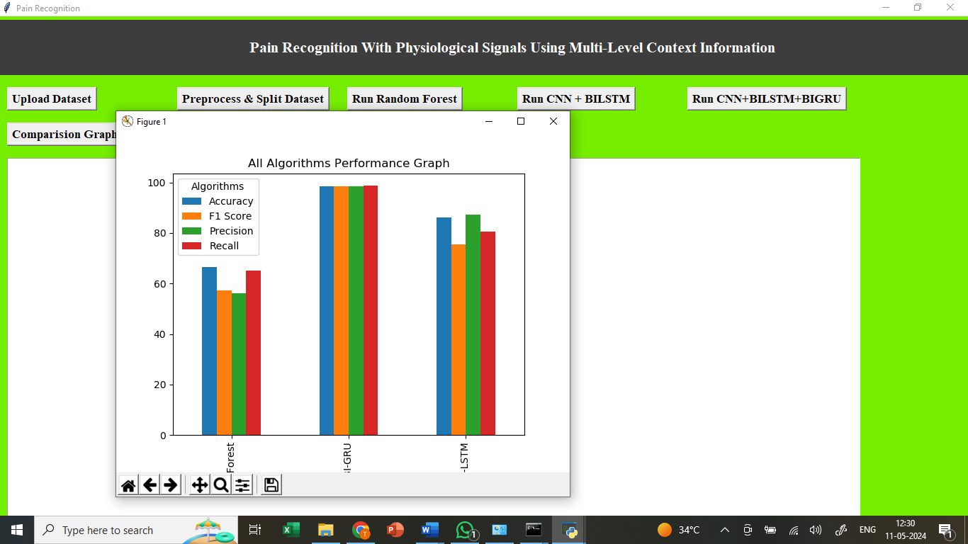
Figure5.8: Test Data Prediction on pain Recognition with physiological Signals using Multi- Level Context Information.
In above graph x-axis represents algorithm names and y-axis represents accuracy and other metrics in different colour bars and in all algorithms, Extension got high accuracy.

5.10 Final Output Display

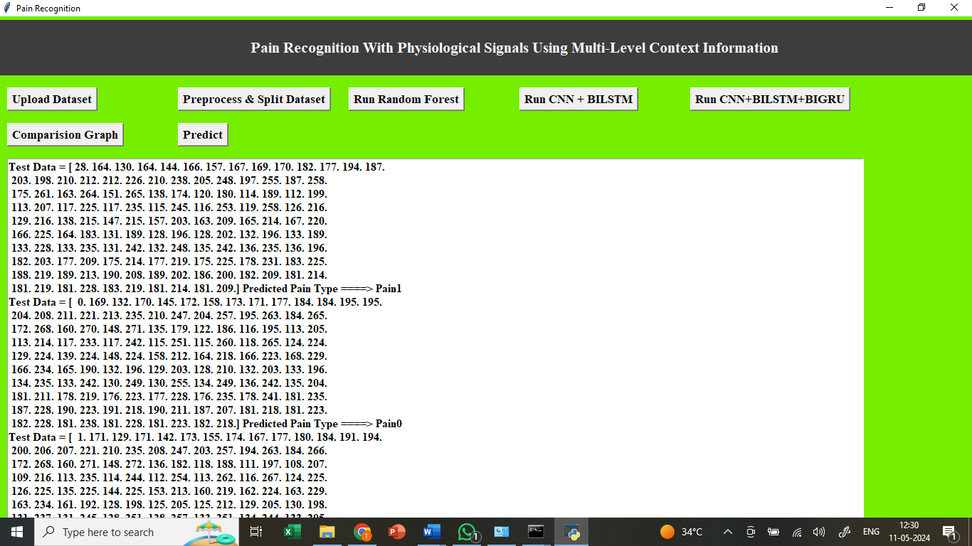
Figure 5.10 : Final Output Display on pain Recognition with physiological Signals using
Multi- Level Context Information.

Above code reading test data from file and then normalizing and predicting pain type using extension model and in output before = symbol we can see ECG test data and after = arrow symbol we can see predicted PAIN type. In above screen predicted pain type showing in blue colo

6 VALIDATION

6 VALIDATION

The validation of the project ensures that the proposed pain recognition system using physiological signals performs accurately and generalizes well to unseen data. The system was validated using a separate test dataset and Leave-One-Subject-Out (LOSO) cross-validation, which tests the model on one subject while training on the rest to avoid overfitting. Performance was evaluated using confusion matrices, accuracy, precision, recall, and F1-score, showing that the baseline Random Forest model achieved only 53% accuracy, while the proposed CNN + BiLSTM model achieved 85%, and the extended CNN + BiLSTM + BiGRU model achieved 98% accuracy, correctly predicting all pain types. Graphical representations, statistical charts, and test data predictions further confirmed the reliability and robustness of the extended model, demonstrating that the system effectively classifies pain levels and outperforms traditional machine learning approaches.

INTRODUCTION

First, the dataset is divided into training and testing sets, typically using an 80-20 split. The training set is used to train the proposed deep learning models, while the testing set evaluates their generalization ability. To ensure reliability, Leave-One-Subject-Out (LOSO) cross-validation is performed, testing the system on data from multiple subjects and preventing overfitting.
The system’s performance is measured using accuracy, precision, recall, F1-score, and confusion matrices, which provide insights into correct and incorrect pain classifications. The CNN + BiLSTM model is compared against traditional methods like Random Forest, showing significant improvement in accuracy. Further, the extended CNN + BiLSTM + BiGRU model achieves the highest performance, correctly predicting all pain types.
Finally, test data validation is performed by inputting unseen physiological signals into the system, verifying that predicted pain levels match actual labels. This structured validation process ensures that the proposed system is robust, reliable, and capable of accurately detecting pain levels for real-time applications.

  - TEST CASES

Test Case Id | Test Case Name | Test Case Desc. | Test Steps |  |  | Test Case Status | Test Priority
 |  |  | Step | Expected | Actual
01 | Upload Dataset | Test whether Dataset is uploaded or not into the system | If the Dataset may not uploaded | We cannot do further operations | Dataset uploaded we will do further operations | High | High
02 | Preprocess & Split Dataset | Test whether the Pre-process & Normalized Dataset Successfully or not | If the Pre-process & Normalized Dataset may not Run Successfully | We cannot do further operations | we will do further  operations | High | High
03 | Run Random Forest | Test whether Random Forest Algorithm Run Successfully or not | If the  Random Forest Algorithm may not Run Successfully | We cannot do further operations | we will do further  operations | High | High
04 | Run  CNN+BILSTM | Test whether CNN+BILSTM Algorithm Run Successfully or not | If the  CNN+BILSTM Algorithm may not Run Successfully | We cannot do further operations | we will do further  operations | High | High
05 | Run CNN+BILSTM+BIGRU | Test whether CNN+BILSTM+BIGRU Algorithm Run Successfully or not | If the  CNN+BILSTM+GRU Algorithm may not Run Successfully | We cannot do further operations | we will do further  operations | High | High
06 | Comparision  Graph | Test graph is Successfully or not | If the  graph may not Successfully | We cannot do further operations | we will do further  operations | High | High
07 | Predict | Test prediction whether Successfully or not | If the  Predict may not Successfully | We cannot do further operations | we will do further  operations | High | High

7 CONCLUSION & FUTURE SCOPE
7. CONCLUSION:
This paper proposes a deep learning approach based on physiological signals for pain recognition. Our method has the role of feature extraction and classification, completely replacing manual extraction methods that require highly specialized knowledge. We propose multi-level context information explored from hidden sequence information. Specifically, the architecture employs hidden information for the attention mechanism to create the context vector. We combine hidden information and context vector to create the context information. Combining context information at three levels produces multi-level context information. We perform binary classification between baseline and different pain intensities based on Part A of the BioVid Heat Pain database. In addition, we also perform binary classification based on the Emopain 2021 dataset. Our experimental results prove that multi-level context information has more significance than uni-level context information based on Part A of the BioVid Heat Pain database and the Emopain 2021 dataset. Our results demonstrate the great significance of EDA in pain classification. Combining EDA and ECG mostly provides good performance in classification tasks based on Part A of the BioVid Heat Pain database.

FutureScope:
- Extension to Multiclass Pain Intensity Classification
Future work can expand the current binary classification framework into a multiclass model, enabling finer distinctions between multiple pain levels and providing a more practical system for real-world medical applications.
- Integration of Additional Physiological and Behavioral Modalities
Incorporating other signals such as EMG, respiration, facial expressions, or body movements may further enhance the robustness and generalization of the pain recognition system across diverse populations.
- Real-Time Pain Monitoring System Development
The proposed multi-level context architecture can be optimized for deployment in real-time clinical settings, improving patient monitoring during surgery, post-operative care, or chronic pain assessment.
- Generalization Across Larger and More Diverse Datasets
Future studies can test the approach on larger, cross-cultural, and clinically collected datasets to improve model reliability and reduce dataset-specific bias, enhancing its applicability in real healthcare environments.
- Explainability and Clinical Interpretability Enhancements
Integrating explainable AI techniques could help reveal how multi-level context information influences predictions, increasing trust among clinicians and enabling safer, transparent adoption of automated pain recognition system

8. BIBLIOGRAPY

BIBLIOGRAPHY

REFERENCES

[1] P. Werner, D. Lopez-Martinez, S. Walter, A. Al-Hamadi, S. Gruss, and R. W. Picard, ‘‘Automatic recognition methods supporting pain assessment: A survey,’’ IEEE Trans. Affect. Comput., vol. 13, no. 1, pp. 530–552, Jan. 2022.
[2] S. Walter, S. Gruss, H. Ehleiter, J. Tan, H. C. Traue, S. Crawcour, P. Werner, A. Al-Hamadi, and A. O. Andrade, ‘‘The biovid heat pain database data for the advancement and systematic validation of an automated pain recognition system,’’ in Proc. IEEE Int. Conf. Cybern. (CYBCO), Jun. 2013, pp. 128–131.
[3] Y. LeCun, Y. Bengio, and G. Hinton, ‘‘Deep learning,’’ Nature, vol. 521, no. 7553, pp. 436–444, Sep. 2015.
[4] T. Olugbade, R. Sagoleo, S. Ghisio, N. Gold, C. D. C. Amanda, B. D. Gelder, A. Camurri, G. Volpe, and N. Bianchi-Berthouze, ‘‘The affectmove 2021 challenge—Affect recognition from naturalistic movement data,’’ in Proc. 9th Int. Conf. Affect. Comput. Intell. Interact. Workshops Demos (ACIIW), Sep./Oct. 2021, pp. 1–5.
[5] P. Werner, A. Al-Hamadi, and S. Walter, ‘‘Analysis of facial expressiveness during experimentally induced heat pain,’’ in Proc. 7th Int. Conf. Affect. Comput. Intell. Interact. Workshops Demos (ACIIW), Oct. 2017, pp. 176–180.
[6] P. Werner, A. Al-Hamadi, R. Niese, S. Walter, S. Gruss, and H. C. Traue, ‘‘Automatic pain recognition from video and biomedical signals,’’ in Proc. 22nd Int. Conf. Pattern Recognit., Aug. 2014, pp. 4582–4587.
[7] L. Breiman, ‘‘Random forests,’’ Mach. Learn., vol. 45, no. 1, pp. 5–32, 2001.

GITHUB LINK

https://github.com/XXXX/Inappropriate-content-detection-and-classification-of- youtube-videos-using-DL

