|  |  |
| --- | --- |
|  | #---LAB 1--- |
|  | #3. |
|  | # This code has the complexity t=0.4736e^(1.082x) in microseconds (R^2 = 0.998). |
|  | # This means that it would take 93944 years to compute N = 40. |
|  | # If N = 100, it would take 1.47 * 10^33 years to compute. |
|  | # The significance of this is that this extremely simple model cannot handle relatively small values of N. |
|  | # The one optimization that could be made is if I used a lookup table grid instead of a chain of polymers as this would make looking up individual units O(1) instead of O(n). |
|  | # One could speed up the search by pruning chains with three consecutive same-handed turns. This would speed up the process by 22.2% (2/9) as there are 2 such handed turns every three steps. |
|  |  |
|  | #4. |
|  | #Plotting <R_g> against N, I get the fit <R_g> = 0.3119x^0.7614 . This exponent value is very close to the expected value of 0.75. The difference between the two values could be due to the relatively small sample size. |
|  | #Given this value, the lattice model seems to be useful for investigating <R_g>. |
|  |  |
|  | #Plotting R_min against N, I get the fit R_min = 0.3563x^0.5412. This is near what I would expect as the minimal R value occurs when the chain coils up on itself thus the R_g would be constant. Since side length is N^(1/2) This would mean that the R value would be around N^(1/2). |
|  | #Estimating, R_min for N=25 = 1.78 and R_min for N=100 = 3.56. |
|  | #After calculating the integral N=25 should equal 2.04 and N=100 should equal 4.08. |
|  | Graph of time taken versus protein size to generate all possible proteins |

Graph of Radius of gyrations based on length of the protein

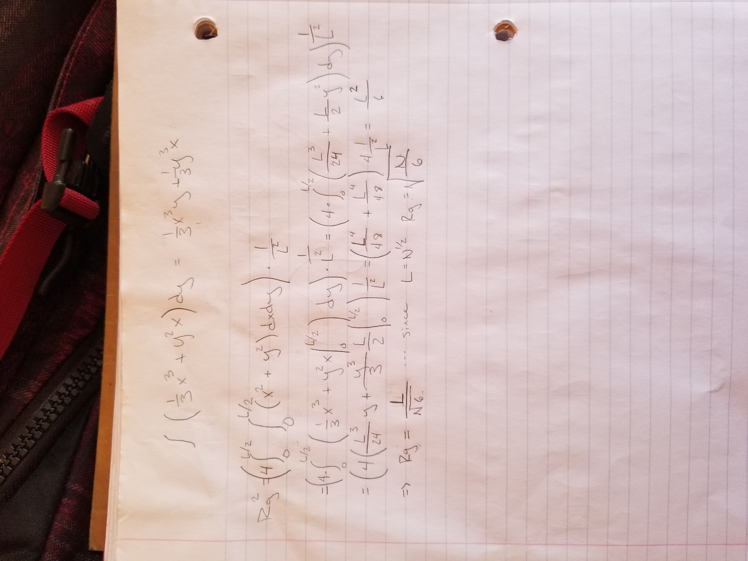

Math showing that the theoretical value for the radius of gyration of a protein length N on a 2D grid is root(N/6).

|  |
| --- |
| #LAB2  --- |
|  |  |
|  | 1. I note that as chain length increases, the acceptance rate decreases in what seems to be a negative log curve. This would make sense as when chain length increases, the chance that any two residues are overlapping increases. |
|  | 2. Go Latice |
|  | In this case, the minimal energy is -24 corresponding to the starting state of the protein given. Initially, the energy of the system averages around -20.5, but as the temperature is lowered, the energy settles to -23 and remains constant. I attribute the significance of the -23 state to be that this is the energy that is balanced by the greatest entropy. |
|  | Random Protein |
|  | In the case of the random protein, the initial energy begins higher, and it takes more time for the protein to fold into a stable configuration, but when it settles, it does so at an energy of -24. |
|  | When the initial temperature is lowered, the energy of the protein almost instantly drops to -23 and stays there |
|  | This is because the temperature is no longer high enough to support a exploration of higher energy states. |
|  | 3.Go Latice 2 |
|  | Similar to the first go latice, this run had an initial energy that was high but eventually settled to -24 and stayed there. |
|  |  |