Infotainment Warranty Claims: What the Data Says and What to Do
HanuAi ML Assessment, Task 2 Stakeholder Report

1. Summary
We analysed 1,000 warranty claims on infotainment systems (radio, display, camera, USB, navigation) for vehicles built in a single five-week window in August and September 2019. The free-text notes from customers and technicians were converted into structured tags, grouped into issue types and clustered into failure themes.
The headline: the problem centres on the radio unit, not on one plant or one time period, and the standard fix is heavy: replace the unit and reprogram it. A part was replaced in 89% of claims, the radio unit was part of the fix in 88%, and 74% also needed reprogramming. The mix of problem types looks the same across plants and across time, which is consistent with a design or supplier cause rather than one factory.
Finding | Evidence (from our analysis)
Radio unit dominates | Radio or audio unit tagged in 71% of claims; display or screen in 39%; camera 12%. Radio is a fix component in 88% of claims.
Replacement is the norm | A part was replaced in 89% of claims; 67% involved both a replacement and a reprogramming.
Not plant-specific | Issue mix inside the five largest plants is not statistically different (chi-square p = 0.38).
Stable over time | Issue mix is not different between Aug 2019 to Jun 2020 and Jul 2020 to Jun 2021 (p = 0.27). Claim volume rose from about 27 per month in late 2019 to about 58 per month in 2020.
Failures take time to appear | Median 228 days in service at claim; 43% within 180 days, 75% within a year.
The dealer cause code is a weak guide | Technician notes agree with the code only 51% of the time for Shorted and 41% for No/Incorrect Communication.

2. What we did
- Cleaned the data. Fixed hidden characters in one complaint code, filled one missing in-use date (median gap), flagged three missing cause codes, and flagged 76 claims (7.6%) opened before the recorded in-use date. The six tag columns in the file are empty for 995 rows because only 5 rows were given as worked examples, so we generated them for all 1,000.
- Mined the text. A transparent dictionary of rules reads symptoms from the customer text, causes from the technician's cause note, and repairs from the correction note. A part counts as repaired only when it appears next to a repair verb, which avoids tagging parts that were merely checked.
- Classified issues. Each claim received one issue category, decided by the text first and the dealer's cause code only as a fallback.
- Clustered. TF-IDF with K-Means grouped customer symptoms and technician causes into eight natural groups each.

3. Findings

3.1 What fails and how it is fixed
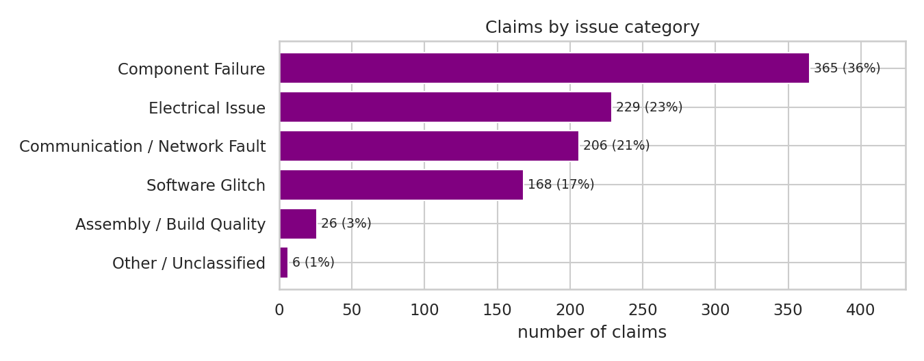
Figure 1. Claims by issue category (text-mined).
Issue category | Claims | What it means
Component Failure | 365 (36.5%) | The technician names a faulty or failed unit; the unit is replaced.
Electrical Issue | 229 (22.9%) | Short circuit, wiring or connector problem stated in the cause note.
Communication / Network Fault | 206 (20.6%) | Lost communication, often on the internal data link.
Software Glitch | 168 (16.8%) | Software named as the cause, or fixed by reprogramming alone.
Assembly / Build Quality | 26 (2.6%) | Loose, misrouted or misaligned parts (from the coded cause).

The most common failure conditions were internal fault (265 claims), black screen (231), inoperative (217), intermittent behaviour (167), communication loss (121) and no sound (100). Reversing is the most frequently mentioned trigger (120 claims, mostly the backup camera), followed by start-up (87). 64 claims explicitly mention a repeat visit for the same problem.
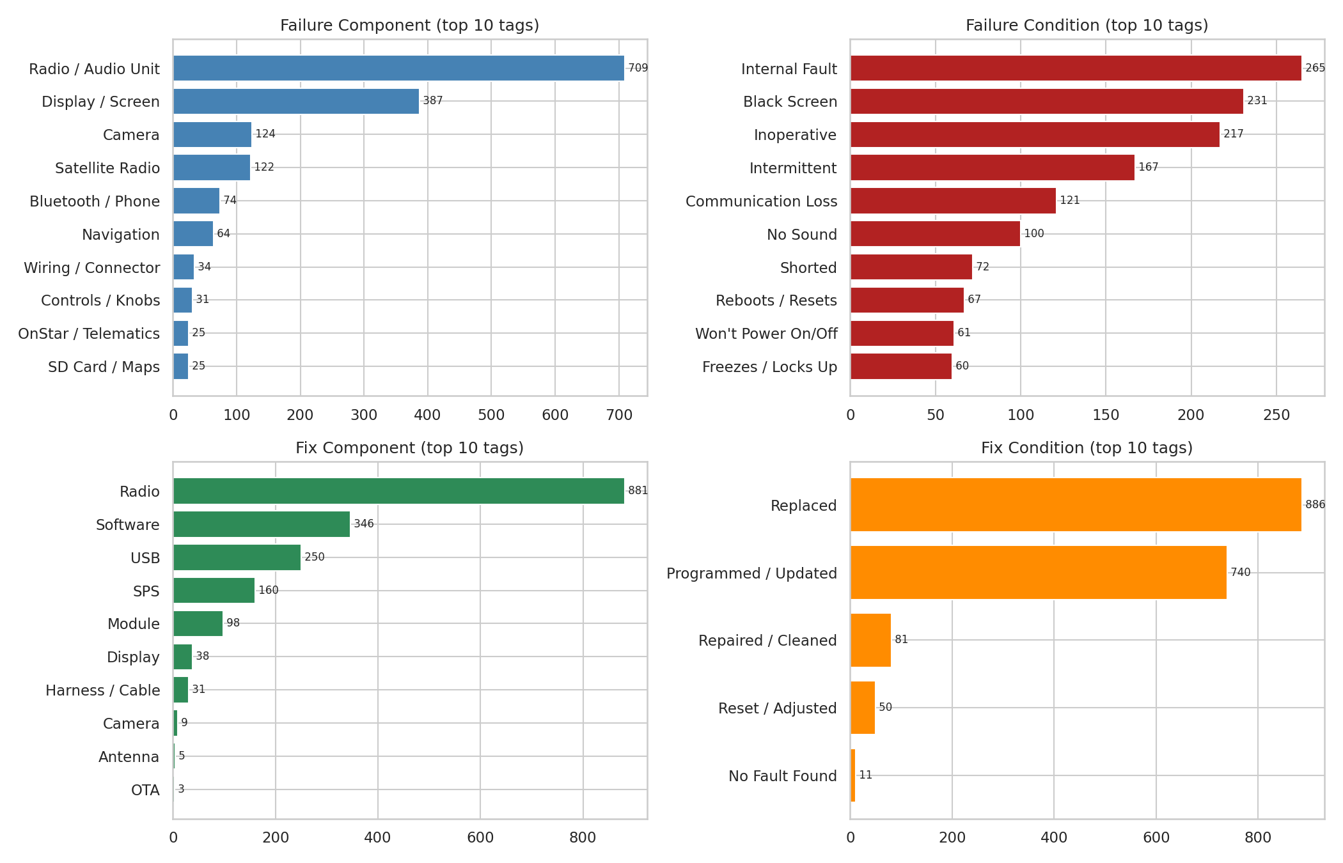
Figure 2. Most common extracted tags.

3.2 Trends over time
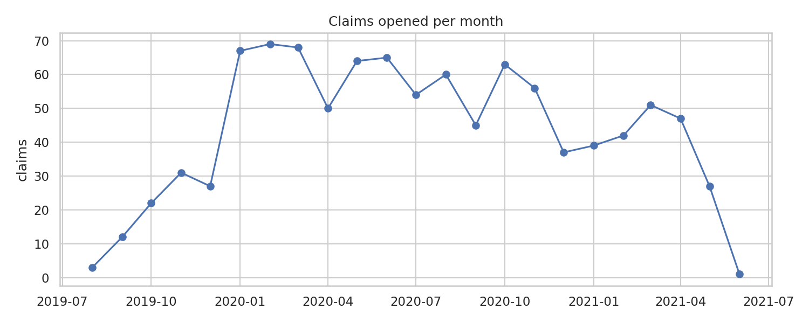
Figure 3. Claims opened per month. The first months are low because vehicles had only just been delivered.
Claims climb from 27 in December 2019 to 67 in January 2020 and stay between roughly 37 and 69 per month until spring 2021. The plateau, not the first jump, is the signal: this is a steady stream of failures, not a single event. Because we have no counts of vehicles in service, we cannot say whether the rate per vehicle is rising or falling.

3.3 Failure clusters and likely root causes
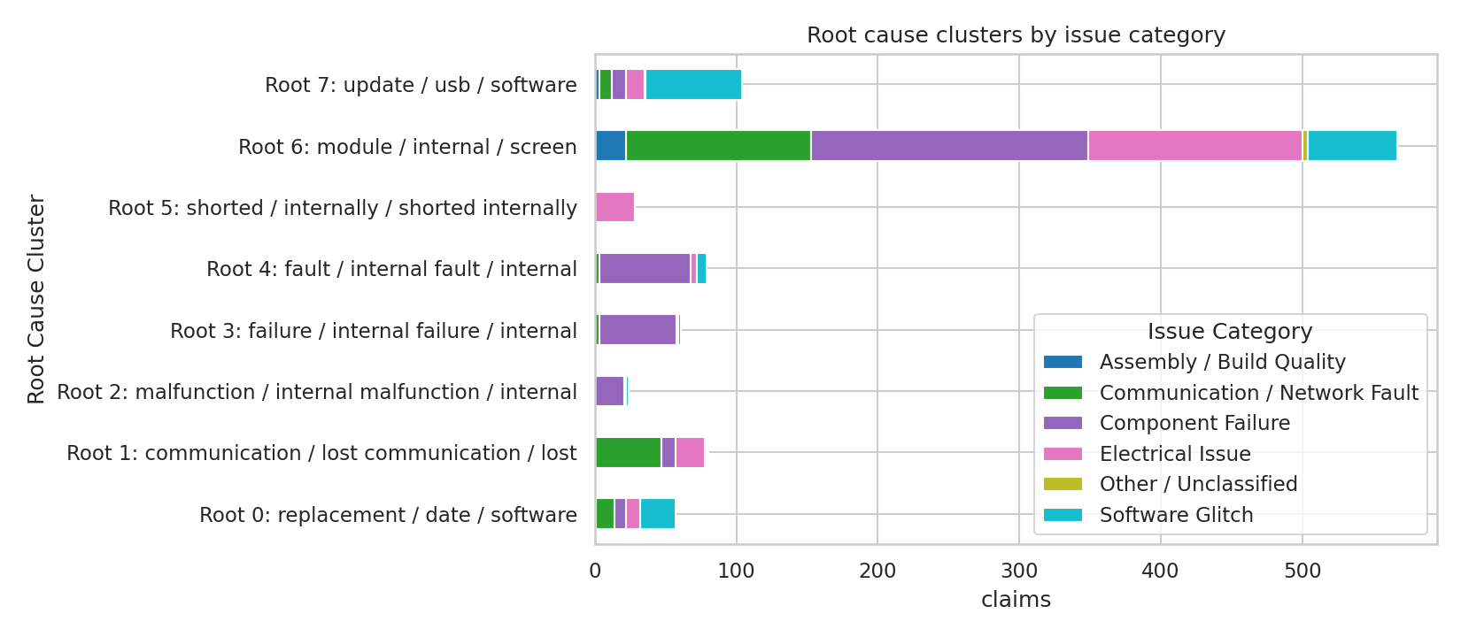
Figure 4. Technician cause clusters by issue category.
Cluster (top terms) | Claims | Reading
Module, internal, screen (generic) | 567 | Broad group: an internal fault in the radio or display module, often with a short or power diagnosis.
Update, USB, software, TAC advised | 104 | A software update was tried first on advice from technical support. 81% of these ended in a replacement anyway.
Communication, lost communication | 80 | Radio drops off the internal data bus. Highest median time in service (279 days) among the larger groups.
Internal fault | 79 | Radio confirmed faulty internally, often found early (median 177 days).
Internal failure | 61 | Short notes: "radio has internal failure".
Replacement on TAC instruction | 57 | Technician follows support instruction to replace and update. Early failures (median 170 days).
Shorted internally | 28 | Internal short, found late (median 304 days).

Caution. The difference in time in service between clusters is suggestive, not proven (Kruskal-Wallis p = 0.08). Cluster quality scores are low, as they usually are for short repair notes, so the clusters are themes to investigate, not hard boundaries. Cluster interpretations are our reading of the top terms.

4. Recommended actions and business impact
Action | Why (evidence) | Business impact
1. Send failed radios for teardown analysis, with the supplier | Radio unit in 71% of claims; internal fault is the top condition (265); issue mix is the same across plants. | Targets the cause for about nine in ten claims. Each 1% of claims avoided is 10 claims per 1,000 in this sample; multiply by your cost per radio replacement to size it.
2. Review the repair procedure for "update first, then replace" | 104 claims describe a software update attempted on support advice; 81% were replaced anyway. | Shorter repair time and fewer unnecessary programming attempts. Test it on the internal-fault signature first.
3. Investigate the backup camera and reversing trigger | Camera tagged in 12% of claims; reversing is the top trigger (120). | Safety-relevant function, so priority is higher than the count suggests.
4. Fix how causes are coded | Codes agree with technician notes only 41 to 51% for the two largest codes. | Dashboards built on the code mislead; better codes make every future analysis cheaper.
5. Keep diagnostic trouble codes in the data | No usable codes in the text; numbers were redacted. | Codes would allow far sharper root cause work than text alone.
6. Add vehicles built and in service per plant and model | We can only count claims, not rates. | Turns counts into failure rates and enables early-warning alerts.
7. Track repeat visits | 64 claims mention a repeat visit. | Repeat visits drive customer dissatisfaction and double repair cost.

5. Limits and assumptions
- Tags come from rules, not a trained model. On the 5 worked examples we reproduced 18 of 34 expected tags and added 23 more; five rows are too few to call that accuracy. About one in five claims has no named failure condition.
- All vehicles were built in the same five weeks, so build timing and plant effects cannot be separated.
- Plant, model and make figures are counts, not rates, because we have no production volumes.
- 76 claims were opened before the recorded in-use date and were left out of time-in-service statistics.
- Some technician notes are in Spanish and are only partly covered.

6. Key learnings and next improvements
- Reading a part only near a repair verb removed most false tags; naive keyword matching tagged every part that had been checked.
- The coded cause and the technician's words often disagree, so text mining adds real information beyond the existing codes.
- Next: hand-label about 150 claims, measure precision and recall for the rules, then test a small trained tagger or an open-source LLM against them.
- Next: survival analysis by months in service once vehicle counts are available, and a monthly dashboard of issue categories.

