ROBOTAXI FLEET OPS · BROWSER GAME
DEADHEAD
A robotaxi fleet simulator where you never touch a steering wheel.

Nine real Teslas · five real Tesla Robotaxi geofences · a spreadsheet that bites
You are not the driver. You are the person the driver got replaced by — and the job turns out to be harder. You own and operate a small robotaxi fleet in a real city, played entirely through the car's own centre console screen: no menus, no HUD outside the diegetic frame.
Deadhead — the trade word for driving with no fare aboard. It is the thing that quietly kills a robotaxi fleet's margin, and the reason this game is named after it.

Play now: game.deadhead.workers.dev
Price: Free. No ads, no account required, no paywall. Runs in any browser — no install.
Platform: Single-page web app (HTML/CSS/JS) — desktop, laptop and phone.

The premise
You never drive. The cars drive themselves from car #1. Your job is the one that replaces driving: capital allocation, geofence design, charging strategy, pricing, and — above all — staffing a room of remote human operators who supervise the cars.
The pitch is not “here is the machine that took your job.” It is “here is the job on the other side of it, and it is harder than it looks.”
The first decision is the whole game
You start with $7,500 and no car. Every vehicle in the catalogue costs more than that. That is not a difficulty spike — it is the lesson. You cannot buy your way in, so you have to choose how you hold the asset, and each way of holding it is wrong in a different way:
- Buy outright — $30,000+ up front, least per day. Impossible on day one — and that's the point.
- Finance — 15% down, a debt you cannot hand back. Cheaper than renting for exactly as long as you keep working.
- Rent — Nothing down, the most per day. The meter never stops. Ever.
The trilemma
Three failure modes are active at once, and deliberately interlocked — mitigating one worsens another:
- Cash pressure — Run cars harder, defer maintenance, thin staffing to survive → risks bankruptcy.
- The regulator — A slow-moving antagonist with memory: at-fault incidents, latency, complaints. One bad month costs a quarter.
- Competition — Undercut on fare or lose riders and zones to the rival platform, Meridian.
No screen offers a pure upgrade. Every decision is a move along this triangle.
Remote operators are the headline system
Remote monitoring is the largest controllable cost line in real robotaxi economics ($0.05–0.10/mile) — and it's a labour cost. Hire named operators, each with skill, fatigue and shift preferences, and set the cars-per-operator ratio: the single most consequential slider in the game. That ratio drives intervention latency — how long a blocked car waits before someone unsticks it — which drives cancellations, complaints, and incident escalation. You are running a call centre that happens to steer cars.
What you actually do
- Clock on — Cars only earn while you're watching them. Clock off and they park — and still owe their fixed cost at midnight.
- Read the offers — Three numbers on every offer: what the meter says, what you keep after commission, and how far you drive empty to reach the rider. The third decides whether you made money.
- Play the tariff — Every city runs its own real utility's time-of-use pricing, backed by real Superchargers with real stall counts and charging speeds.
- Draw the map — Every city has its own zones and demand curve by hour — no two read the same way.
- Take control — When a car gets wedged, the console switches to its camera feed and you drive it out yourself. Entirely optional.

Nine real cars
Every vehicle is real, and every technical figure is the published one — the Cybercab's numbers come straight off its EPA filing. None of it is flavour text; each spec feeds a system that is already running.
Vehicle | Pack | Range | Seats | What it means for you
Cybercab | 48 kWh | 300 mi | 2 | No wheel, no pedals, cheapest to own — and on a charger constantly
Model 3 | 62 kWh | 321 mi | 5 | Entry trim: cheap to hold, short on legs
Model Y | 70 kWh | 321 mi | 5 | More pack, more frontal area — same distance for more money
Model 3 Premium | 82 kWh | 363 mi | 5 | Longest range here, last car financeable on day one
Model Y Premium | 82 kWh | 357 mi | 5 | Nearly that range, in a crossover body
Model Y L | 85 kWh | 330 mi | 6 | Biggest pack short of the truck, spent on a third row
Model 3 Performance | 82 kWh | 309 mi | 5 | 54 fewer miles from the same pack — nothing here pays for acceleration
Model Y Performance | 82 kWh | 306 mi | 5 | Buy it because you want it. The arithmetic says no
Cybertruck | 123 kWh | 320 mi | 5 | Worst cost per mile by a mile, 38 minutes to fill, $152 every midnight
In-game vehicle-selection screen, showing live cost-of-ownership math per car.
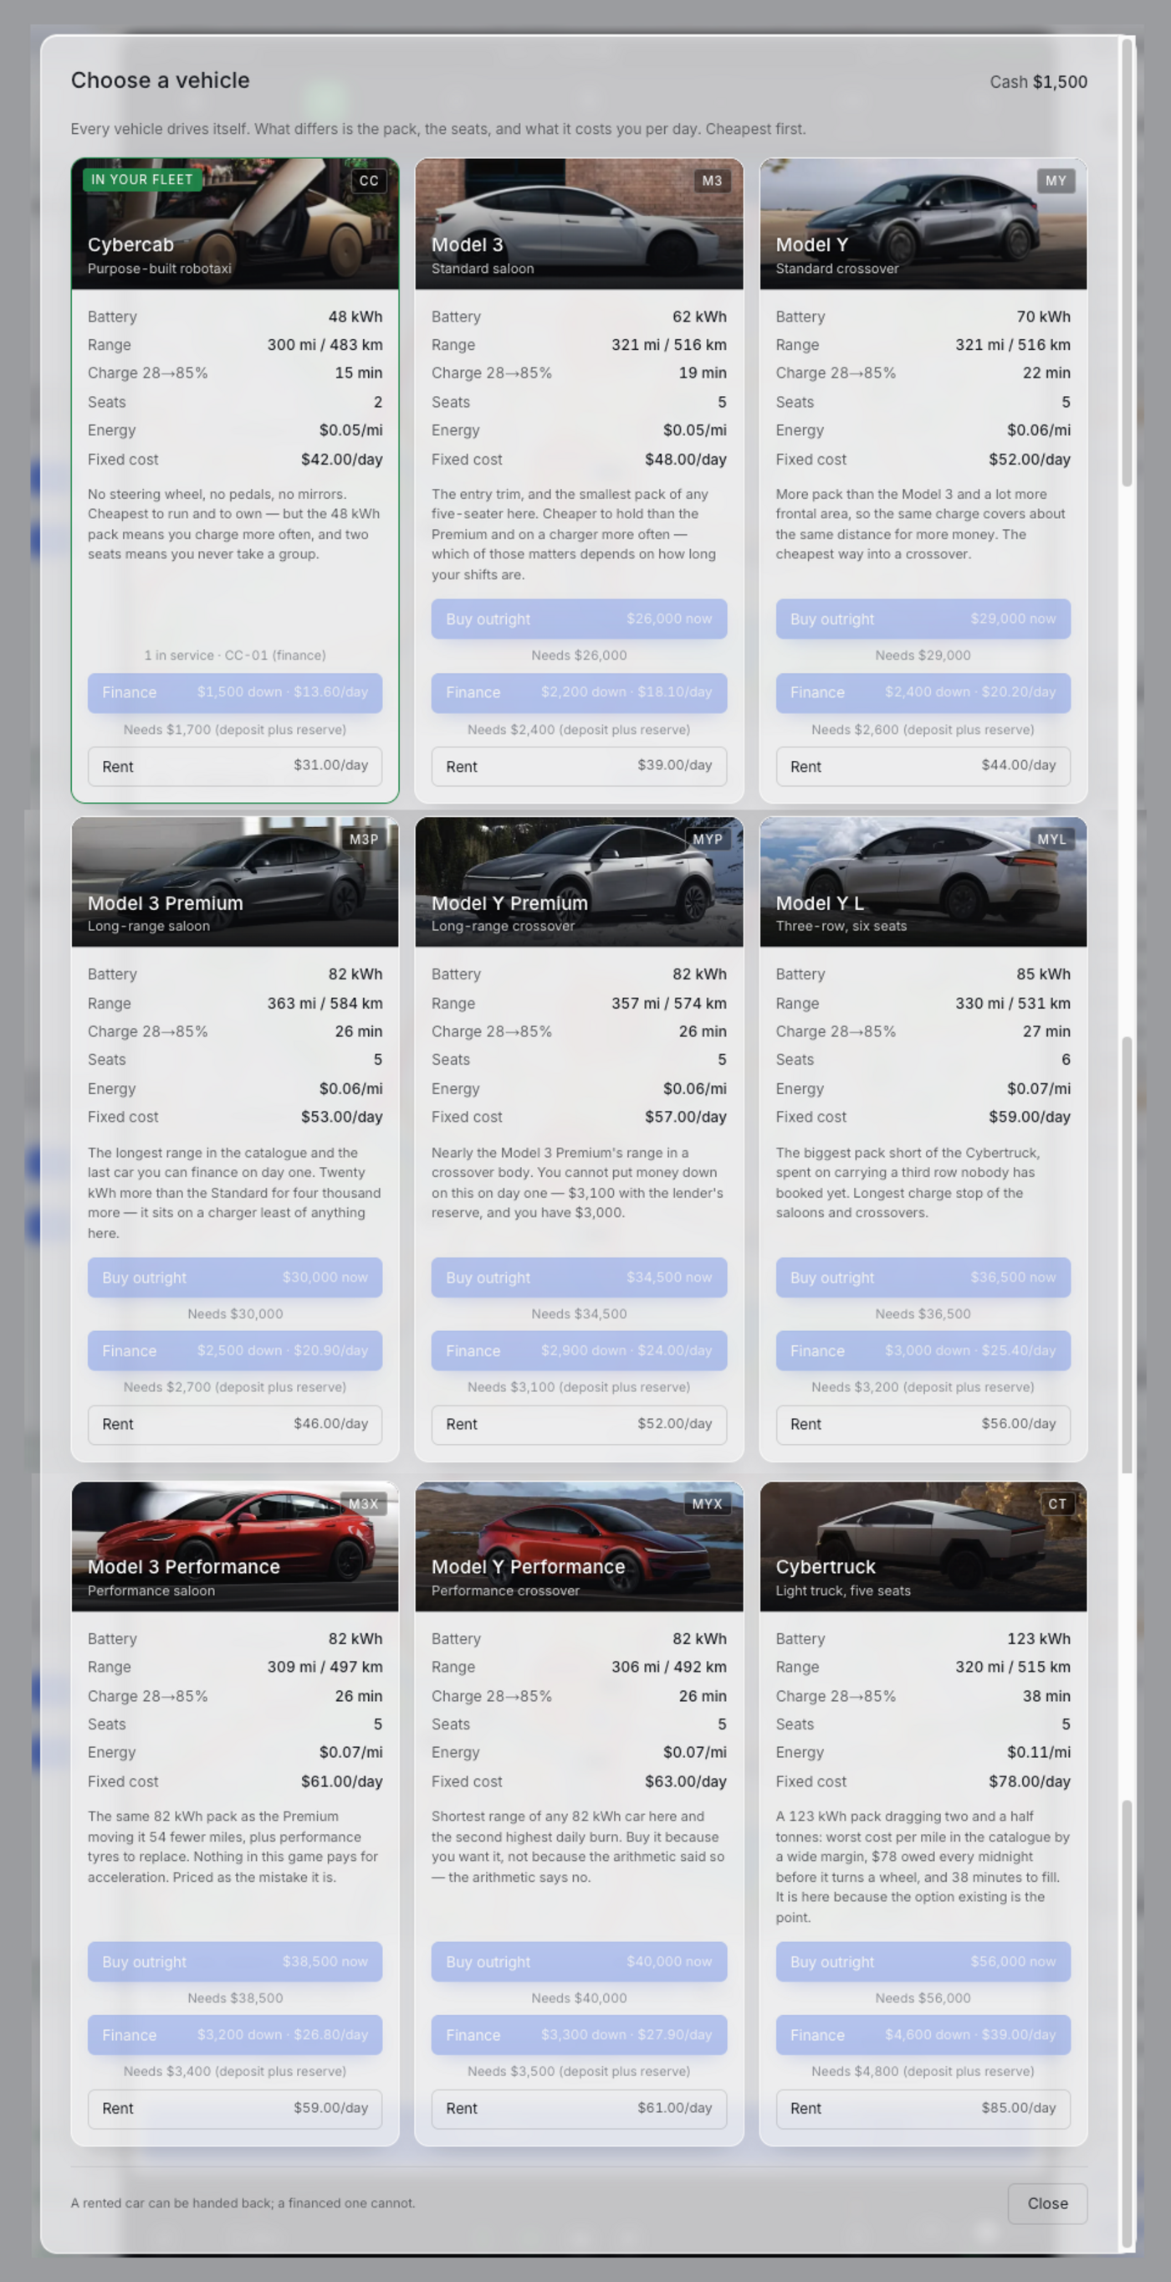

Five cities, one chain
Austin is the tutorial. Clock off your first shift there and Dallas unlocks; then Miami, Tampa, and Orlando. Every city is a real, currently-operating (or just-launched) Tesla Robotaxi service area built from its actual geofence, tariff and permit status — not a reskin with a new coat of paint.
City | Permit | Fleet cap | Goal | What's actually true about it
Austin | Supervised | 17 | $40,000 | The tutorial. Seven zones plus the airport, and Austin Energy's real five-hour evening peak
Dallas | Unsupervised | 24 | $60,000, safety ≥ 70 | Launched with no safety monitor at all. S Riverfront is 34 stalls at 325 kW — best charging in the game
Miami | Unsupervised | 16 | $50,000, safety ≥ 75 | Tiny geofence, no airport, no downtown. FPL's peak runs nine straight hours; harshest insurance in the table
Tampa | Unsupervised | 14 | $45,000 | Mirror of Miami: all core, no suburbs. Evening rush instead of morning; cheapest overnight power in the game
Orlando | Unsupervised | 14 | $42,000 | A corridor past MCO that never touches it. No airport, no brewery zones, thinnest demand — and the cheapest power of all
Nothing above is tuned for difficulty after the fact. Where the real service area excludes downtown, the airport, or every brewery in town, the game excludes it too.
Real data, not set dressing
- Geography — Five real geofences, each drawn from the actual published or reported service area.
- Weather & time — Live weather for whichever city you're in, and its real local clock.
- Charging — Real Superchargers in every city — actual coordinates, stall counts and peak kW.
- Fares — Calibrated against observed prices per market — about $18 for a downtown Austin hop, $29–32 from the airport.
- Electricity tariffs — From each city's actual utility — Austin Energy, Oncor, FPL, TECO, OUC.
Everything around the hardware — Hitchr, Zipp, Meridian, Halo — is invented. The cars and the numbers are not. That line is deliberate.

Paolo
Forty-one years in a cab before he got out, while getting out was still his idea. He walks you through your first day, then goes quiet — and speaks again only once you've been stuck long enough to need it. He isn't a tooltip. He has opinions about what you're doing, and he's usually right.
A standing “Now” line always names the single most useful next thing, so you're never lost. It never tells you what to choose.
Also in the box
- Save anywhere, or sign in for cloud saves synced across devices.
- Light and dark themes.
- Works on a phone, a laptop and an ultrawide — the layout genuinely reworks itself.
- Passwords are never transmitted: key derivation runs in your browser.
- One HTML file, no build step — download it and it runs offline.
Free, and stays free
Deadhead is free and stays free. No ads, nothing behind a paywall, no second version that costs money. If it turned out to be worth something to you, there's a tip jar via Ko-fi — and if it didn't, that's completely fine.
Links
▶ Play Deadhead — game.deadhead.workers.dev
☕ Support the project on Ko-fi
Deadhead is an independent fan project, not affiliated with, endorsed by or connected to Tesla, Inc. Vehicle names and specifications are referenced for realism; every company, platform and commercial term in the game is fictional.

