A girl named Emma wearing a school uniform and glasses, with straight black hair and a shy, intelligent personality, loves to read and solve problems. Emma is a curious little girl. Today, she decides to start a learning adventure and explore the wonderful world. She finds her backpack at home, ready to set off.

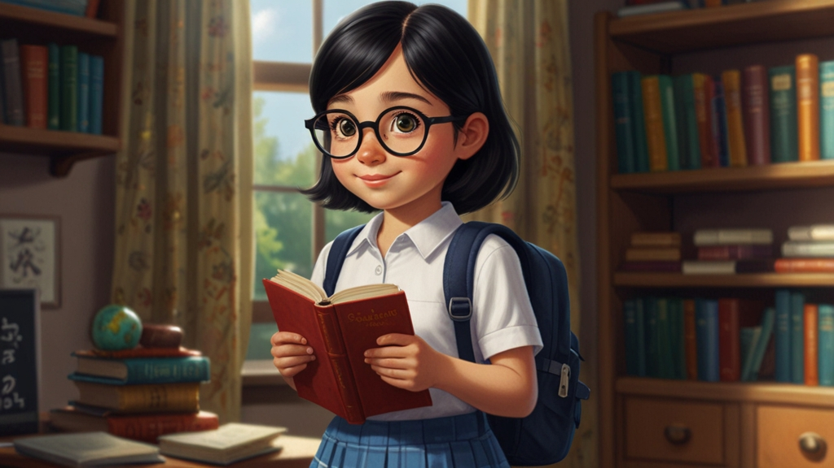

A girl named Emma wearing a school uniform and glasses, with straight black hair and a shy, intelligent personality, loves to read and solve problems. Emma walks into the forest and meets a little bunny. She learns how to observe animals patiently and how to interact with them peacefully.

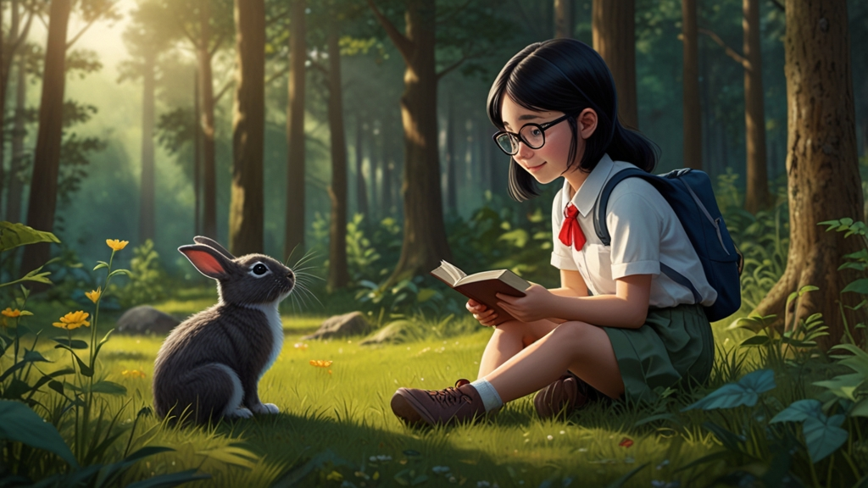

A girl named Emma wearing a school uniform and glasses, with straight black hair and a shy, intelligent personality, loves to read and solve problems. Emma finds five beautiful apples in the forest. She starts counting them and learns to recognize numbers.

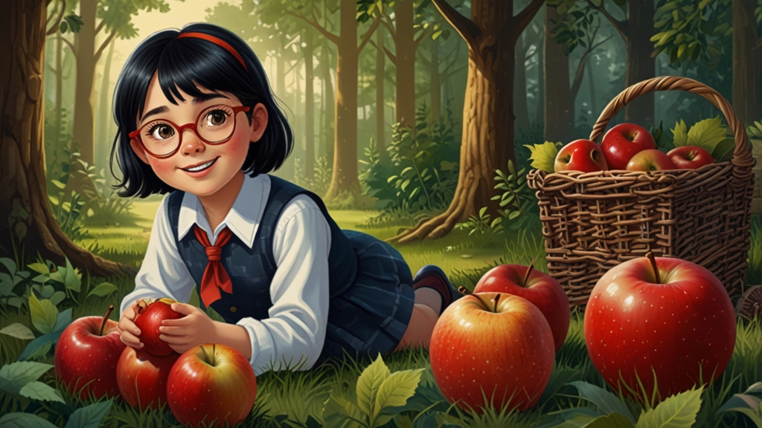

A girl named Emma wearing a school uniform and glasses, with straight black hair and a shy, intelligent personality, loves to read and solve problems. Emma finds different shapes and colors of stones. She learns to recognize circles, squares, and triangles, as well as red, blue, and yellow.

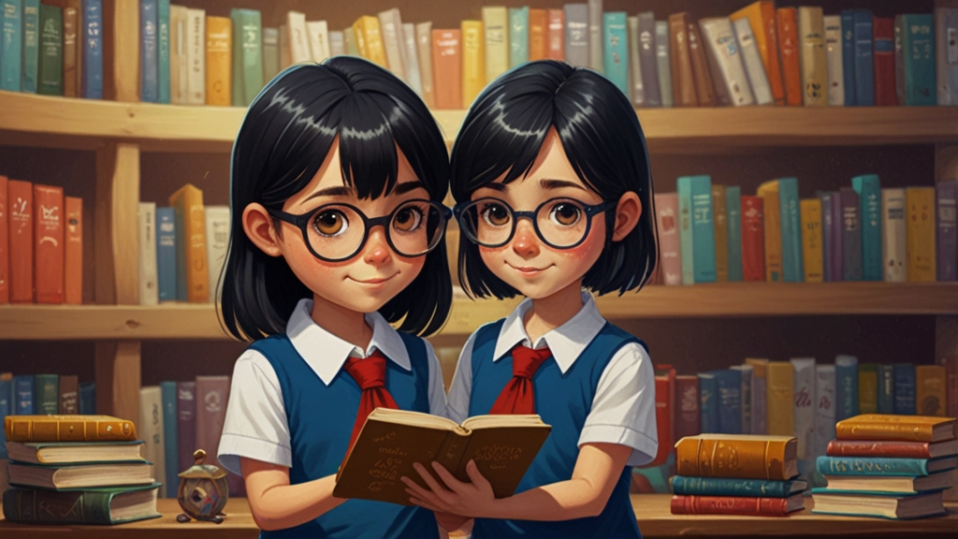

A girl named Emma wearing a school uniform and glasses, with straight black hair and a shy, intelligent personality, loves to read and solve problems. Emma meets a little fox who needs help collecting some twigs. Emma learns the value of teamwork, and the two friends work together to complete the task.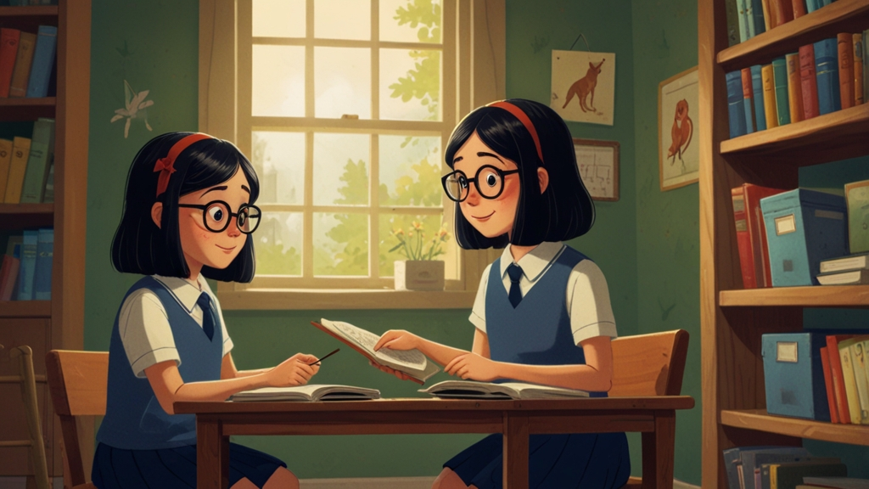

A girl named Emma wearing a school uniform and glasses, with straight black hair and a shy, intelligent personality, loves to read and solve problems. Emma comes across a small bridge that looks a little shaky. She feels scared but gathers her courage and walks across slowly, successfully making it to the other side.

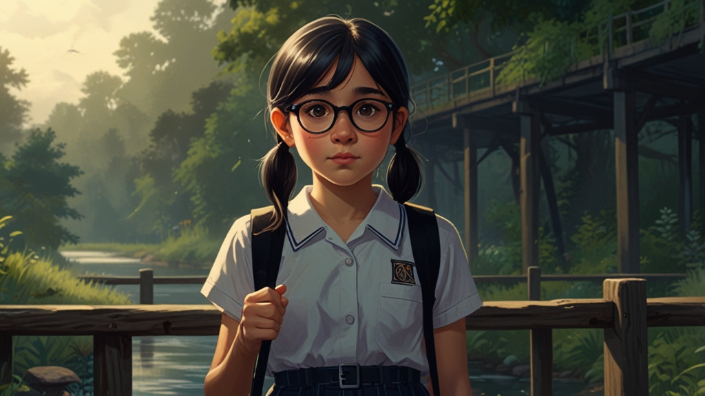

A girl named Emma wearing a school uniform and glasses, with straight black hair and a shy, intelligent personality, loves to read and solve problems. On a beautiful meadow, Emma thanks nature for its beauty. She learns to appreciate natural resources and understands the importance of gratitude.

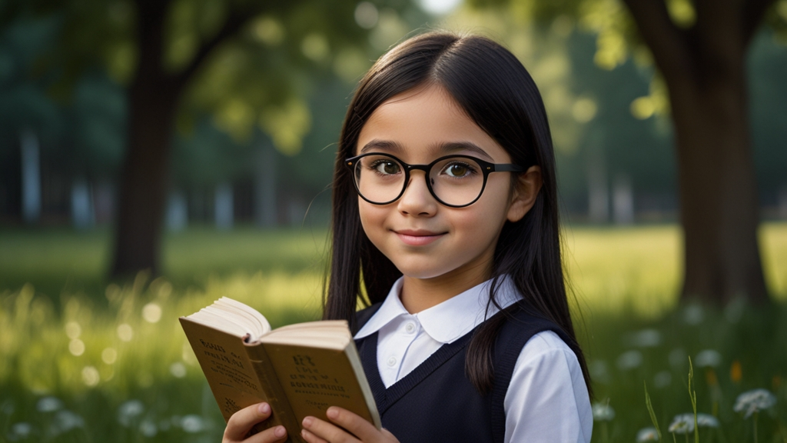

A girl named Emma wearing a school uniform and glasses, with straight black hair and a shy, intelligent personality, loves to read and solve problems. Emma notices that the sky is getting darker, and she knows it's time to go home. She learns how to manage her time and not procrastinate.

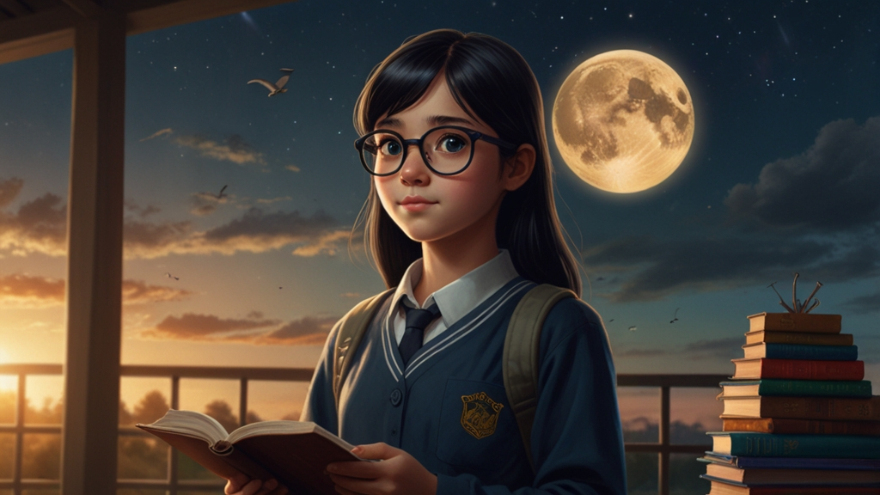

A girl named Emma wearing a school uniform and glasses, with straight black hair and a shy, intelligent personality, loves to read and solve problems. Emma brings some fruits home and decides to share them with her family. They enjoy the fruits together and feel the joy of sharing.

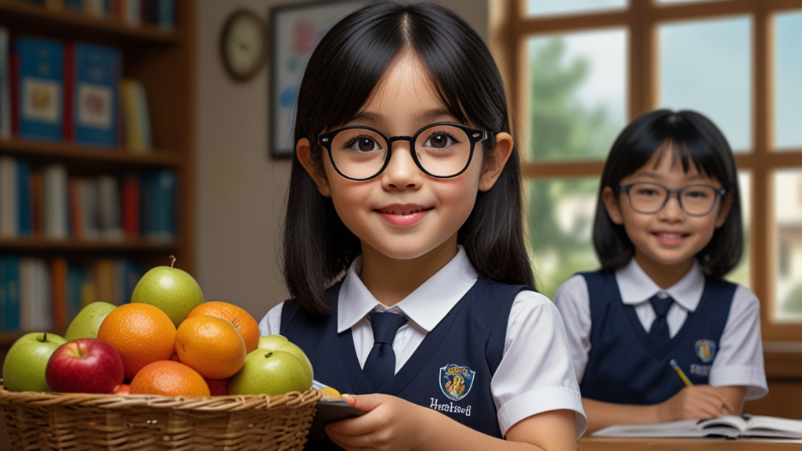

A girl named Emma wearing a school uniform and glasses, with straight black hair and a shy, intelligent personality, loves to read and solve problems. When Emma returns home, she organizes her adventure journal for the day and reflects on everything she has learned. She feels happy and looks forward to her next adventure.

