CML Formatted File
Nov 28, 2005. Kazumi Matsui
(Yokohama National University)

Introduction
This document describes the structure of CML formatted files. This format must be the most basic format of FORTRAN programs for the finite element analysis in our research group. All of the FORTRAN programs for the FE analysis need to use this format for our conveniences.
We can separate this format into the 3 kinds of data statements, INPUT, OUTPUT and OPTIONAL. The INPUT file contains some properties of the FE model made by “FEMAP”, and is translated from the “FEMAP NEUtral formatted file” to the CML format by the program “NEU2CML”. The OUTPUT file has several results gotten through your FE analysis. So, if your FE codes output some results by CML format, you can get “FEMAP NEUtral formatted file” through the program “CML2NEU”.
The OPTIONAL data block statements are not necessary for the usual FE analysis and used in some programs to control the analysis. Though the program “NEU2CML” does not create these special statements, you must add these statements by your hand or execute some special program for this purpose. If you need another kind of data block statements, you may create the new data blocks. However in such a case, you MUST announce the format of your new data blocks to the member of this working group and NEVER use the same data block statements.

Outline of the format
A CML formatted file has several data blocks (coordinates of nodes, properties of elements, deformation data, etc). Each data block starts with the data block’s header “/*****/” with 5 characters, and continue to the next header. The total number of data described at the next line of the header and the data statements begin after that.
The INPUT and the OUTPUT data are separated by the header “/LASTD/”. The INPUT data of your CML formatted file must be described until the header “/LASTD/” is stated, and the OUTPUT data must be described after this header. You may place the OPTIONAL data in wherever you want. But note that the OPTIONAL data in the output section in CML formatted file is never translated into the “FEMAP NEUtral formatted file”.

Headers of data blocks

INPUT Data Statements
/TITLE/ | Title of the model
/COORD/ | Coordinates of nodes
/TRIA3/ | Properties of elements (Constant Strain Triangle element, 2D)
/TRIA6/ | Properties of elements (6 nodes quadratic triangular element, 2D)
/QUAD4/ | Properties of elements (4 nodes linear rectangular element, 2D)
/QUAD8/ | Properties of elements (8 nodes quadratic rectangular element, 2D)
/TTRA4/ | Properties of elements (6 nodes linear tetrahedral element, 3D)
/TTR10/ | Properties of elements (10 nodes quadratic tetrahedral element, 3D)
/HEXA8/ | Properties of elements (8 nodes linear hexahedral element, 3D)
/HEX20/ | Properties of elements (20 nodes quadratic tetrahedral element, 3D)
/MATER/ | Material properties
/EULER/ | Euler angles
/LOCRD/ | Local coordinates
/CONST/ | Loading conditions
/LOADC/ | Constraint conditions

OUTPUT Data Statements
/NODAL/ | Nodal output (ex. displacement)
/ELMTL/ | Elemental output (ex. stress, strain, density)

OPTIONAL Data Statements
/SOLUT/ | Control parameters for the computation (Kazumi)
/PSTEP/ | Define the loading step at which some results should be outputted (Kazumi)
/PELEM/ | Define the macroscopic ID of element and its integration point where the microscopic deformations should be outputted  (Especially in program “GNGLAN”) (Kazumi)
/CTRLV/ | Control values and general settings (Yamakawa)
/PDISP/ | Define ID of node where the nodal displacements should be outputted (Yamakawa)
/PFOCE/ | Define ID of node where the nodal forces should be outputted (Yamakawa)
/OPTIM/ | Data block for Topology optimization (Kazumi)
/OPTMZ/ | New data block for Topology optimization (kzm)

General statements
/LASTD/ | Header to describe the last of INPUT data
/ENDOF/ | Header to describe the END OF FILE

INPUT Data Block Statement
The data blocks listed below are the most basic data for FE analysis, so all the FORTRAN programs may need to have them. If some programs need other data statements (Lames’s constants for example), you can use “dummy value” statements in this format for your new statements.

/TITLE/ - Title of the Model
Record | Column | Description | Format | etc
1 | 1-7 | Header of data block (/TITLE/) | A7
2 | 1-80 | Title of the model | A80

/COORD/ - Coordinates of nodes
Record | Column | Description | Format | etc
1 | 1-7 | Header of data block (/COORD/) | A7
2 | 1-8 | Total number of nodes | I8
3 –  (1 record per node) | 1-8 | ID of node | I8
3 –  (1 record per node) | 9-23 | Coordinate of X-direction | E15.5
3 –  (1 record per node) | 24-38 | Coordinate of Y-direction | E15.5
3 –  (1 record per node) | 39-53 | Coordinate of Z-direction | E15.5

/TRIA3/ - Properties of Elements (2D, Constant Strain Triangle element)
Record | Column | Description | Format | etc
1 | 1-7 | Header of data block (/TRIA3/) | A7
2 | 1-8 | Total number of elements | I8
2 | 9-13 | Dummy Value | I5
3 –  (1 record per element) | 1-8 | ID of element | I8
3 –  (1 record per element) | 9-13 | Material ID of this element | I5
3 –  (1 record per element) | 14-18 | ID of Euler angle | I5
3 –  (1 record per element) | 19-23 | Integration method  1: = normal integration (fully)  2: = selective reduced integration  5: = single point integration  (special scheme for “GNGLAN”) | I5
3 –  (1 record per element) | 24-28 | Dummy value | I5
3 –  (1 record per element) | 29-60 | Connectivity of element (1-3)  (follow the right-hand rule) | 3I8

/TRIA6/ - Properties of Elements (2D, 6-nodes quadratic triangle)
Record | Column | Description | Format | etc
1 | 1-7 | Header of data block (/TRIA6/) | A7
2 | 1-8 | Total number of elements | I8
2 | 9-13 | Switch for incompressibility  0: Usual displacement-based formulation  3: P1-iso-P2/P0 element | I5 | 2012/11
3 –  (1 record per element) | 1-8 | ID of element | I8
3 –  (1 record per element) | 9-13 | Material ID of this element | I5
3 –  (1 record per element) | 14-18 | ID of Euler angle | I5
3 –  (1 record per element) | 19-23 | Integration method  1: = normal integration (fully)  2: = selective reduced integration  5: = single point integration  (special scheme for “GNGLAN”) | I5
3 –  (1 record per element) | 24-28 | Dummy value | I5
3 –  (1 record per element) | 29-60 | Connectivity of element (1-6)  (follow the right-hand rule) | 4I8
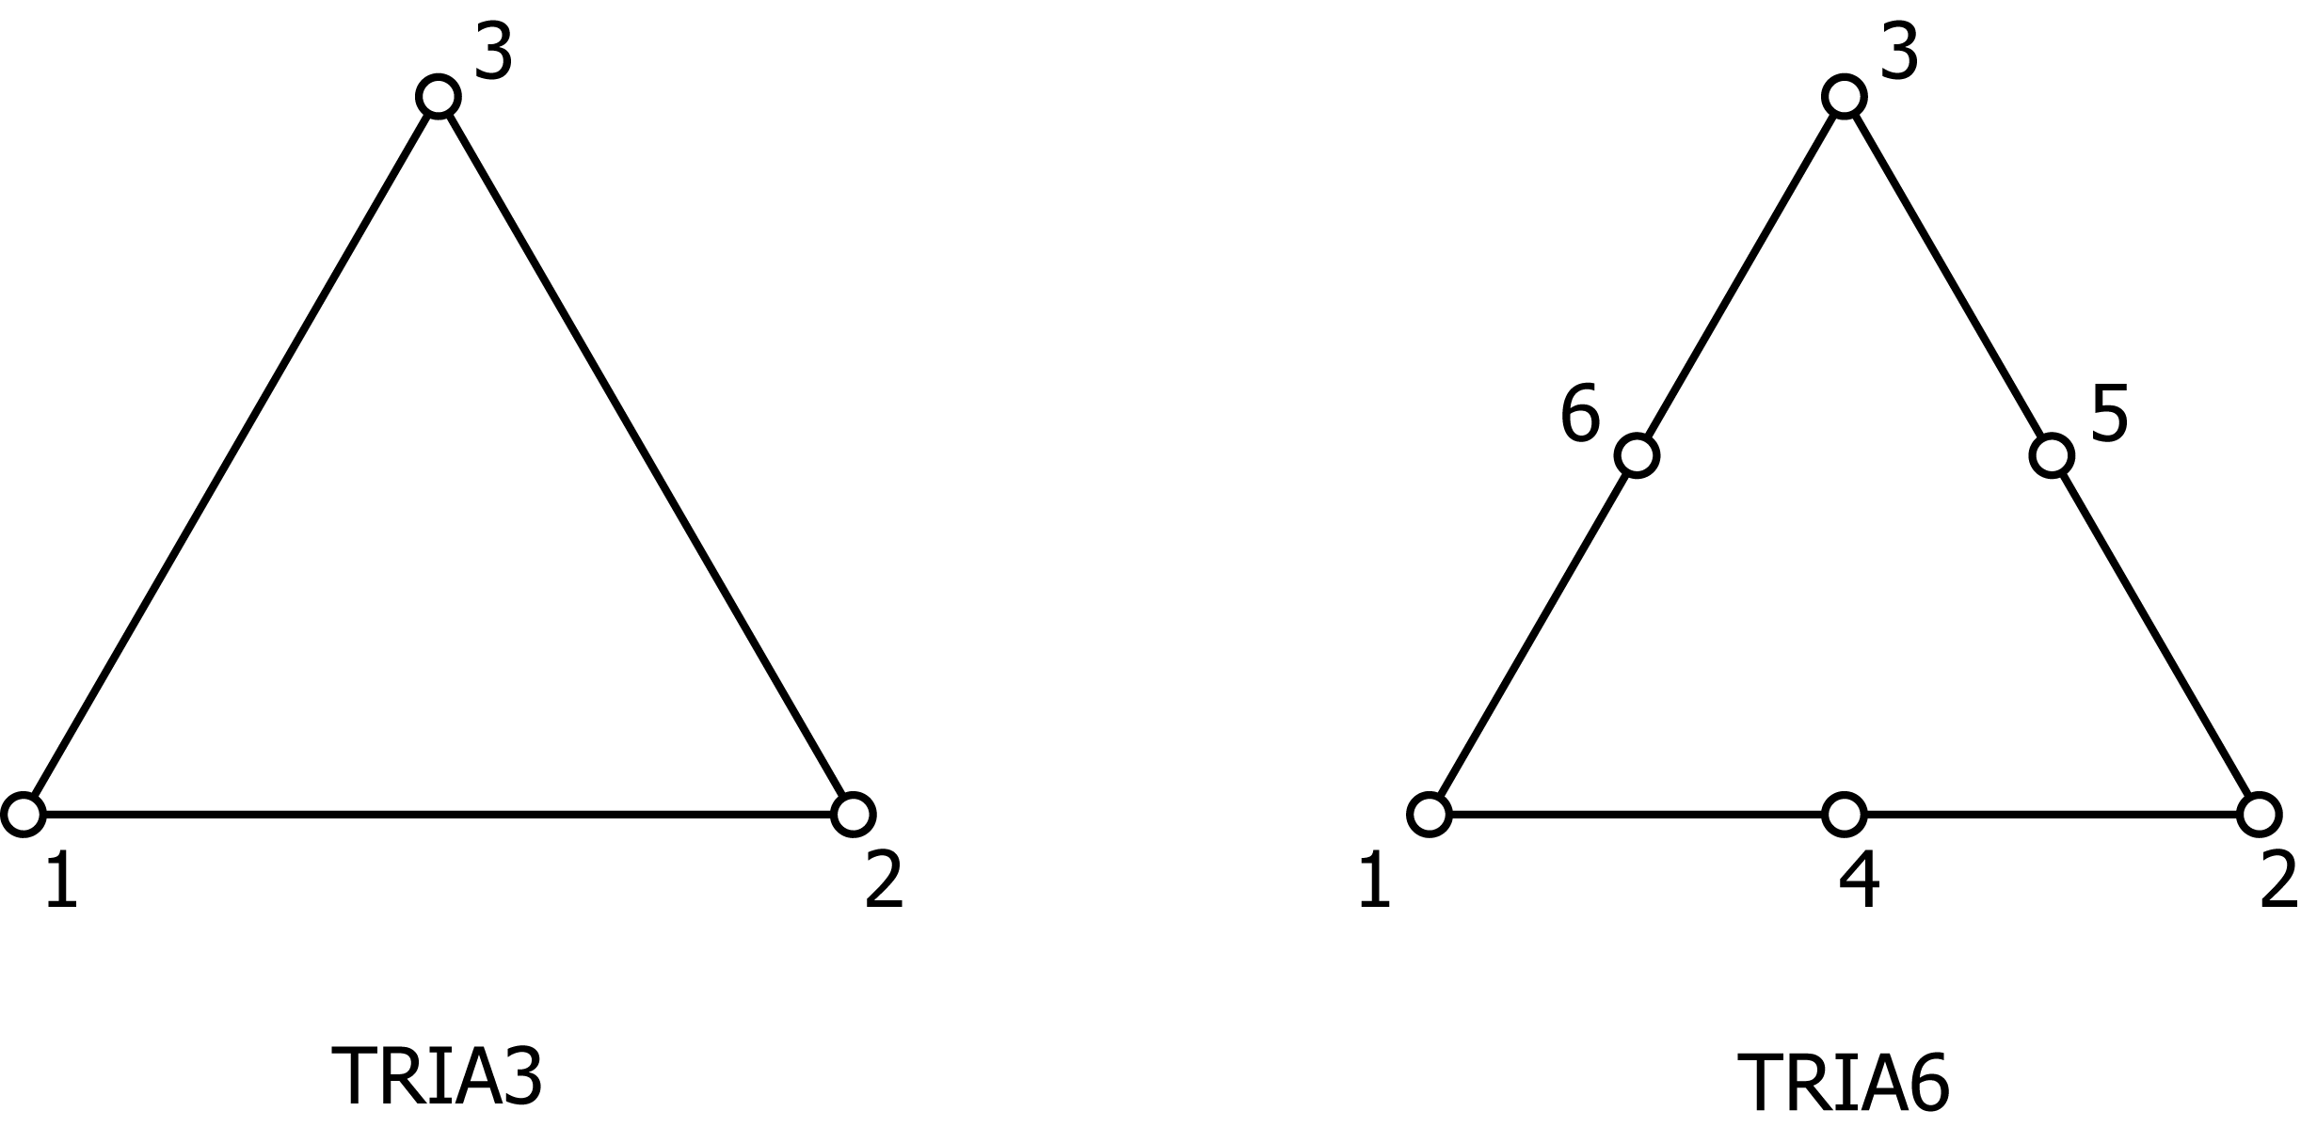

/QUAD4/ - Properties of Elements (2D, 4-nodes linear rectangular)
Record | Column | Description | Format | etc
1 | 1-7 | Header of data block (/QUAD4/) | A7
2 | 1-8 | Total number of elements | I8
2 | 9-13 | Switch for incompressibility  0: Usual displacement-based formulation  3: Mean dilatation method | I5 | 2012/11
3 –  (1 record per element) | 1-8 | ID of element | I8
3 –  (1 record per element) | 9-13 | Material ID of this element | I5
3 –  (1 record per element) | 14-18 | ID of Euler angle | I5
3 –  (1 record per element) | 19-23 | Integration method  1: = normal integration (fully)  2: = selective reduced integration  5: = single point integration  (special scheme for “GNGLAN”) | I5
3 –  (1 record per element) | 24-28 | Dummy value | I5
3 –  (1 record per element) | 29-60 | Connectivity of element (1-4)  (follow the right-hand rule) | 4I8

/QUAD8/ - Properties of Elements (2D, 8-nodes quadratic rectangular)
Record | Column | Description | Format | etc
1 | 1-7 | Header of data block (/QUAD8/) | A7
2 | 1-8 | Total number of elements | I8
2 | 9-13 | Dummy Value | I5
3 –  (1 record per element) | 1-8 | ID of element | I8
3 –  (1 record per element) | 9-13 | Material ID of this element | I5
3 –  (1 record per element) | 14-18 | ID of Euler angle | I5
3 –  (1 record per element) | 19-23 | Integration method  1: = normal integration (fully)  2: = selective reduced integration  5: = single point integration  (special scheme for “GNGLAN”) | I5
3 –  (1 record per element) | 24-28 | Dummy Value | I5
3 –  (1 record per element) | 29-92 | Connectivity of element (1-8)  (follow the right-hand rule) | 8I8

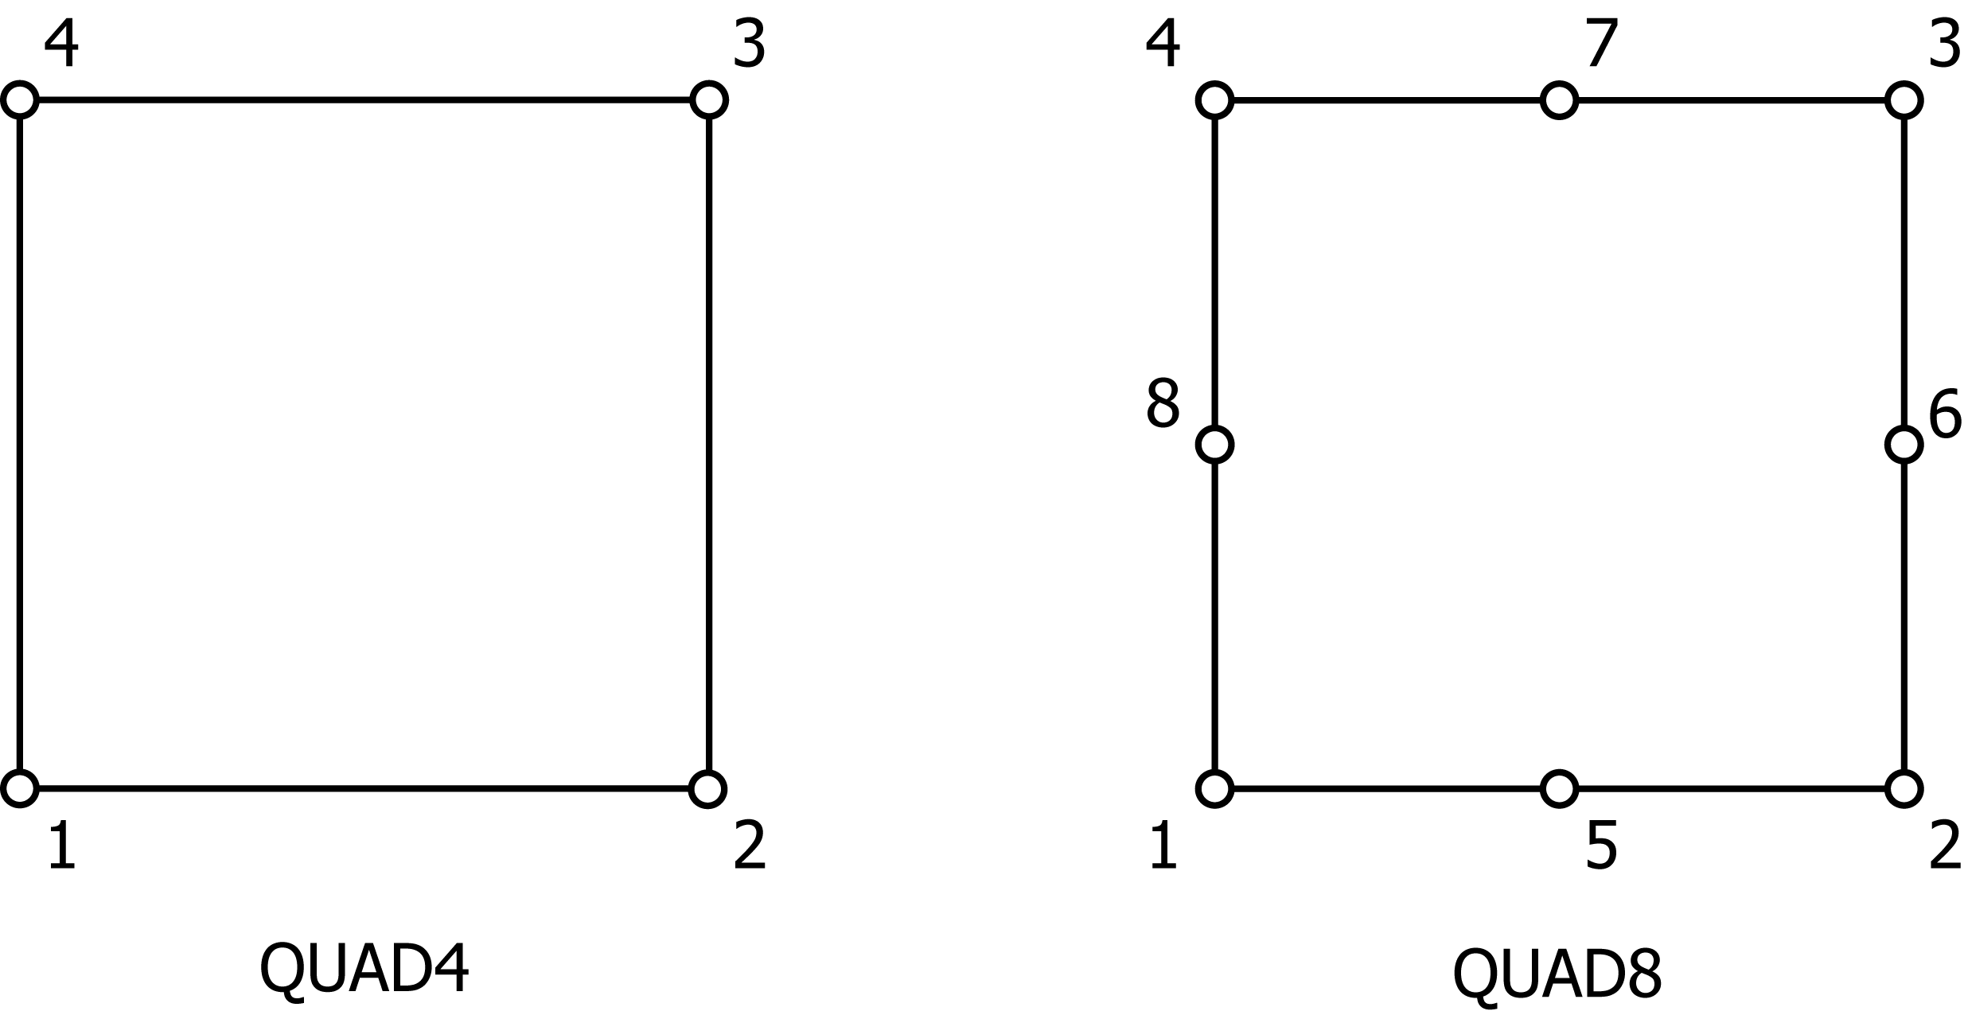

/TTRA4/ - Properties of Elements (3D, 4-nodes linear tetrahedral element)
Record | Column | Description | Format | etc
1 | 1-7 | Header of data block (/TTRA4/) | A7
2 | 1-8 | Total number of elements | I8
2 | 9-13 | Dummy Value | I5
3 –  (1 record per element) | 1-8 | ID of element | I8
3 –  (1 record per element) | 9-13 | Material ID of this element | I5
3 –  (1 record per element) | 14-18 | ID of Euler angle | I5
3 –  (1 record per element) | 19-23 | Integration method  1: = normal integration (fully)  2: = selective reduced integration  5: = single point integration  (special scheme for “GNGLAN”) | I5
3 –  (1 record per element) | 24-55 | Connectivity of element (1-4)  (follow the right-hand rule) | 4I8

/TTR10/ - Properties of Elements (3D, 10-nodes tetrahedral element)
Record | Column | Description | Format | etc
1 | 1-7 | Header of data block (/TTR10/) | A7
2 | 1-8 | Total number of elements | I8
2 | 9-13 | Dummy Value | I5
3 –  (1 record per element) | 1-8 | ID of element | I8
3 –  (1 record per element) | 9-13 | Material ID of this element | I5
3 –  (1 record per element) | 14-18 | ID of Euler angle | I5
3 –  (1 record per element) | 19-23 | Integration method  1: = normal integration (fully)  2: = selective reduced integration  5: = single point integration  (special scheme for “GNGLAN”) | I5
3 –  (1 record per element) | 24-103 | Connectivity of element (1-10)  (follow the right-hand rule) | 10I8

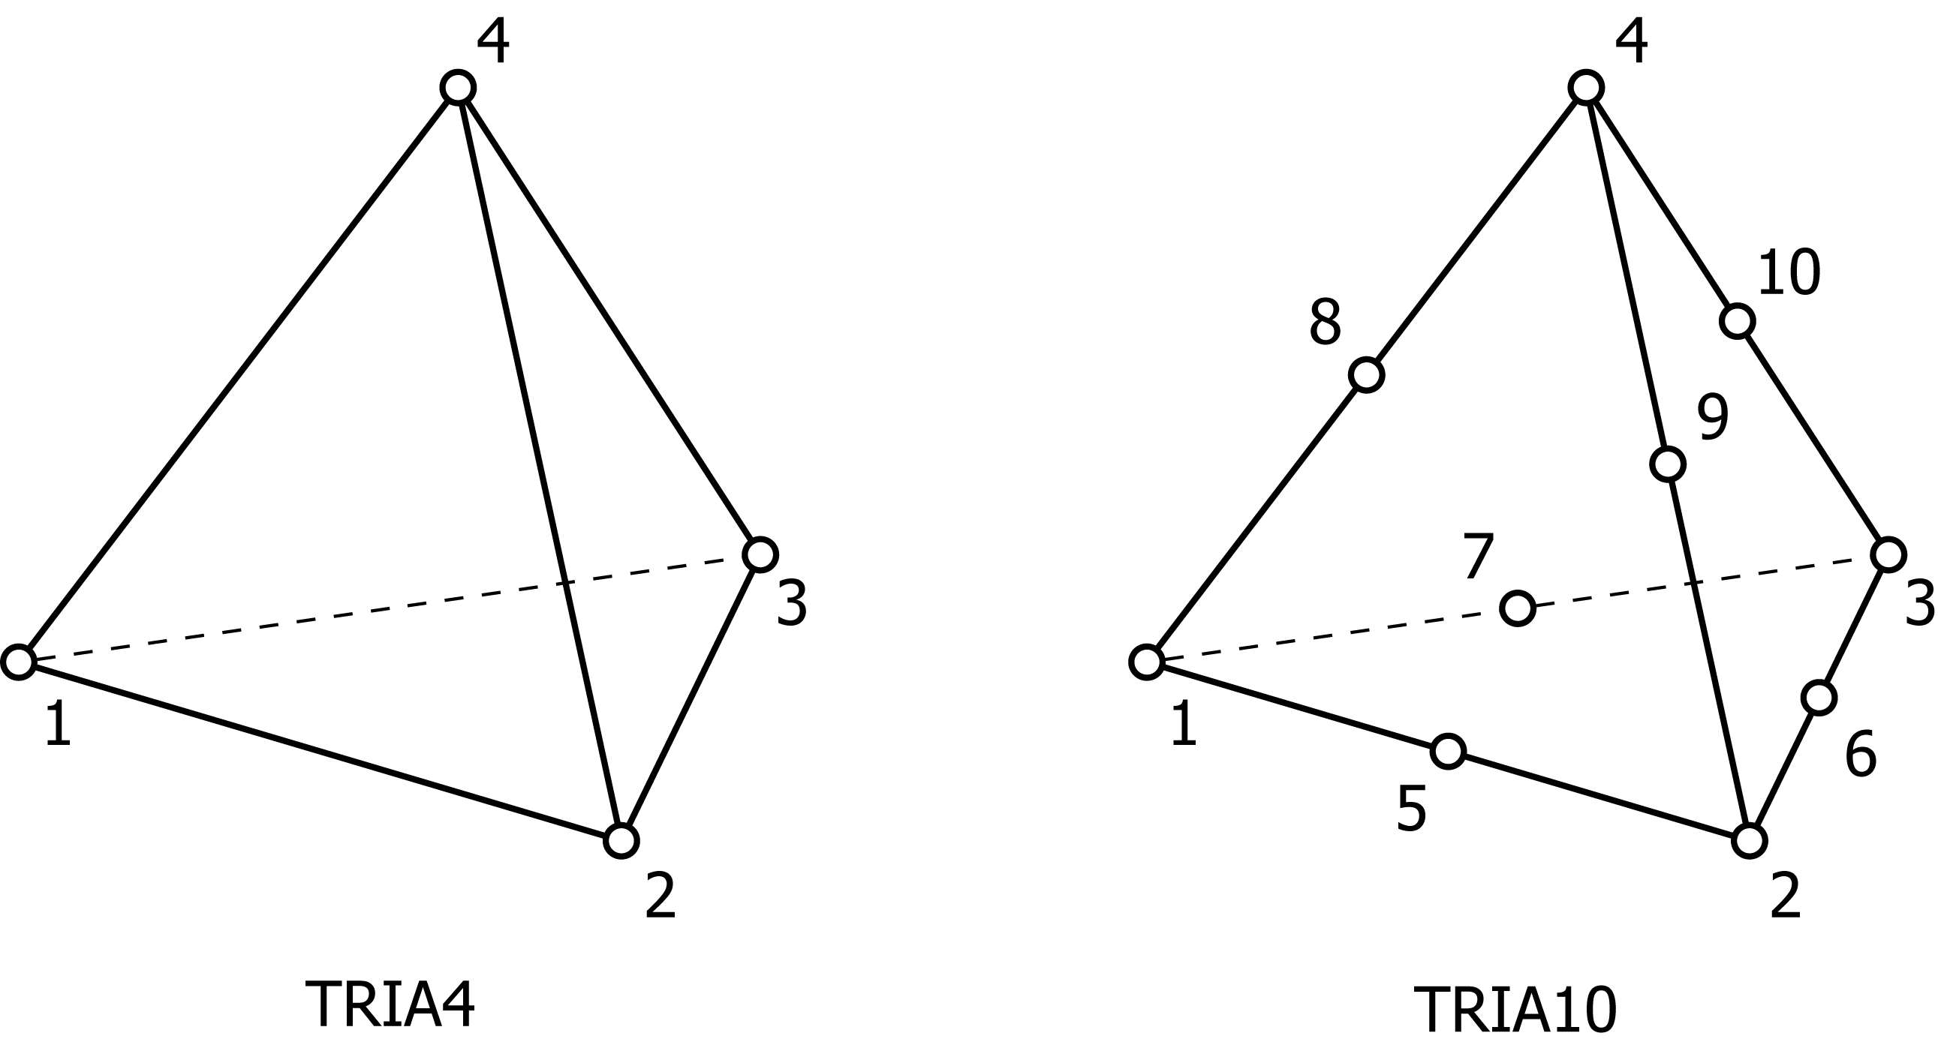

/HEXA8/ - Properties of Elements (3D, 8-nodes linear hexahedral element)
Record | Column | Description | Format | etc
1 | 1-7 | Header of data block (/HEXA8/) | A7
2 | 1-8 | Total number of elements | I8
2 | 9-13 | Additional element type  0: = normal  2: = mean dilatation (hex8m) | I5
3 –  (1 record per element) | 1-8 | ID of element | I8
3 –  (1 record per element) | 9-13 | Material ID of this element | I5
3 –  (1 record per element) | 14-18 | ID of Euler angle | I5
3 –  (1 record per element) | 19-23 | Integration method  1: = normal integration (fully)  2: = selective reduced integration  5: = single point integration  (special scheme for “GNGLAN”) | I5
3 –  (1 record per element) | 24-87 | Connectivity of element (1-8)  (follow the right-hand rule) | 8I8

/HEX20/ - Properties of Elements (3D, 20-nodes hexahedral element)
Record | Column | Description | Format | etc
1 | 1-7 | Header of data block (/HEX20/) | A7
2 | 1-8 | Total number of elements | I8
2 | 9-13 | Dummy Value | I5
3 –  (1 record per element) | 1-8 | ID of element | I8
3 –  (1 record per element) | 9-13 | Material ID of this element | I5
3 –  (1 record per element) | 14-18 | ID of Euler angle | I5
3 –  (1 record per element) | 19-23 | Integration method  1: = normal integration (fully)  2: = selective reduced integration  5: = single point integration  (special scheme for “GNGLAN”) | I5
3 –  (1 record per element) | 24-183 | Connectivity of element (1-20)  (follow the right-hand rule) | 20I8

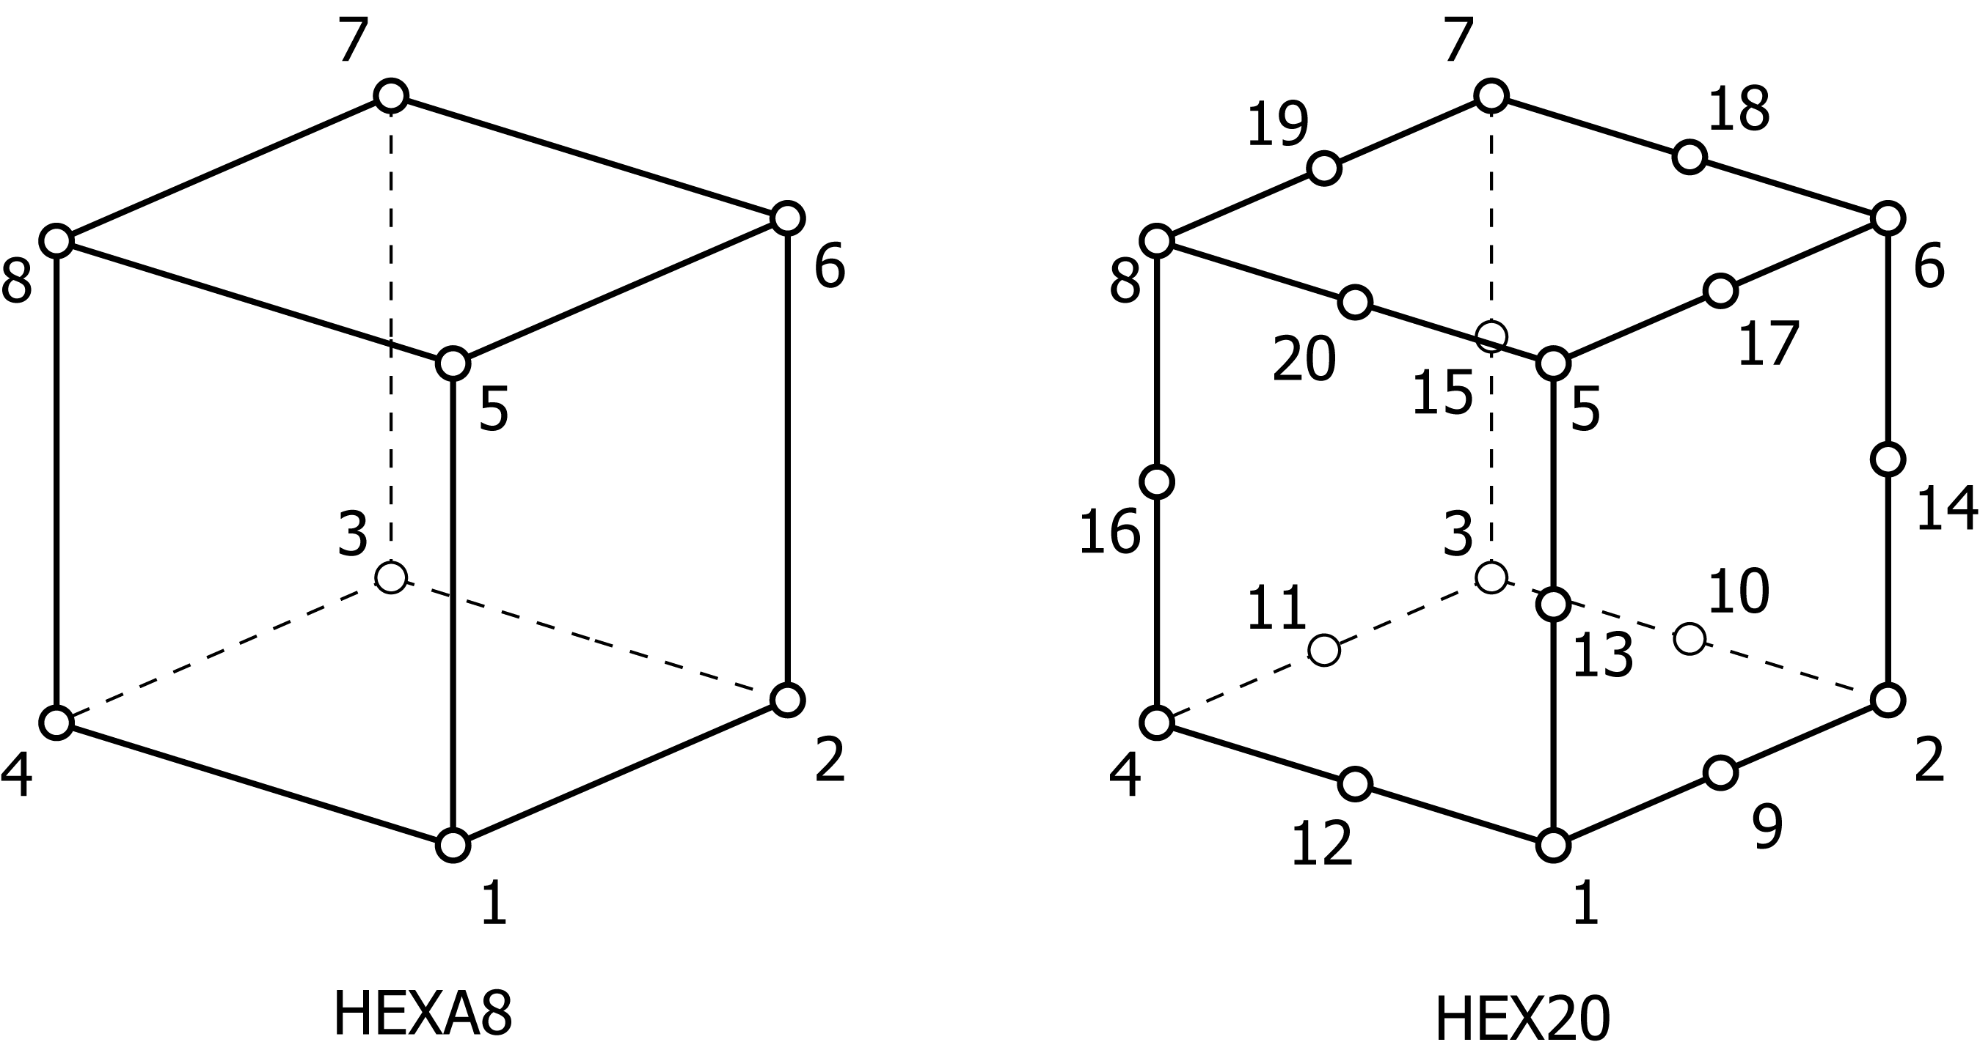

/MATER/ - Material Properties
Record | Column | Description | Format | etc
1 | 1-7 | Header of data block (/MATER/) | A7
2 | 1-5 | Total number of materials | I5
3 –  (5 records per material) | 1-5 | ID of material | I5
3 –  (5 records per material) | 6-10 | Definition of material model  --- for small strain problems ---  1: Isotropic linear elastic - plastic material  ( Plane Strain or 3D)  2: Isotropic linear elastic - plastic material  (Plane Stress)  3: Anisotropic linear elasticity (P. Strain / 3D)  4: Anisotropic linear elasticity (P. Stress)  or GTN model  5: GTN model (Hutchinson & Nahshon)  6: Lemaitre model  --- for large deformation problems ---  1: Neo-Hookean material  2: Hencky type material  3: Hencky based elastic – plastic material | I5 | 2012/11
3 –  (5 records per material) | 1-12 | Young modulus | E12.5 | $$E$$
3 –  (5 records per material) | 13-24 | Poisson’s ratio | E12.5 | $$ν$$
3 –  (5 records per material) | 25-36 | Density | E12.5 | $$ρ$$
3 –  (5 records per material) | 37-48 | Thermal expansion coefficient | E12.5
3 –  (5 records per material) | 49-60 | Heat Conductivity | E12.5
3 –  (5 records per material) | 1-12 | Specific Heat | E12.5
3 –  (5 records per material) | 13-24 | Initial void fraction (GTN) | E12.5 | $$frac_i$$
3 –  (5 records per material) | 25-36 | Damage parameter (GTN) | E12.5 | $$q_{1}$$
3 –  (5 records per material) | 37-48 | Damage parameter (GTN) | E12.5 | $$q_{2}$$
3 –  (5 records per material) | 49-60 | Initial yield stress (uniaxial) | E12.5 | $$σ_{Y}$$
3 –  (5 records per material) | 1-12 | Hardening parameter 1 | E12.5 | $$H$$
3 –  (5 records per material) | 13-24 | Hardening parameter 2 | E12.5 | $$σ_{Y}^{∞}$$
3 –  (5 records per material) | 25-36 | Hardening parameter 3 | E12.5 | $$δ$$
3 –  (5 records per material) | 37-48 | Hardening parameter 4  Damage parameter (GTN) | E12.5 | $$n$$  $$f_{c}$$
3 –  (5 records per material) | 49-60 | Hardening parameter 5  Damage parameter (GTN) | E12.5 | $$θ$$  $$f_{F}$$
3 –  (5 records per material) | 1-12 | Pressure yield parameter (Drucker–Prager)  Damage parameter 1 (Lemaitre) | E12.5 | $$k$$  $$S$$
3 –  (5 records per material) | 13-24 | Damage parameter 2 (Lemaitre)  Damage-parameter(GTN) | E12.5 | $$r$$  $$f_{N}$$
3 –  (5 records per material) | 25-36 | Damage-parameter(GTN) | E12.5 | $$S_{N}$$
3 –  (5 records per material) | 37-48 | Damage-parameter(GTN) | E12.5 | $$ε_{N}$$
3 –  (5 records per material) | 49-60 | Definition of hyperelastic material model  (negative value means “INCOMPRESSIBLE”)  0: Hencky’s material model  1: Neo-Hookean Material  2: Mooney-Rivlin model  3: Ogden’s model  4: St. Venant-Kirchhoff material | E12.5 | obsoleted  2012/11
 | (continued for anisotropic materials)
(+6 records  per  an-  isotropic  material) |  | Anisotropic elastic material properties in D-matrix form  $$\left[\begin{matrix}\begin{matrix}D11 & D12 \\ & D22\end{matrix} & \begin{matrix}D13 & D14 \\ D23 & D24\end{matrix} & \begin{matrix}D15 & D16 \\ D25 & D26\end{matrix} \\ \begin{matrix} & \\ & \end{matrix} & \begin{matrix}D33 & D34 \\ & D44\end{matrix} & \begin{matrix}D35 & D36 \\ D45 & D46\end{matrix} \\ \begin{matrix} & \\ & \end{matrix} & \begin{matrix} & \\ & \end{matrix} & \begin{matrix}D55 & D56 \\ & D66\end{matrix}\end{matrix}\right]$$ |  | 2012/11
for piezo-electric materials
3 –  (5 records per material) | 1-5 | ID of material | I5
3 –  (5 records per material) | 6-10 | Dummy Value | I5 | 2012/11
3 –  (5 records per material) | 1-12 | Dummy Value | E12.5
3 –  (5 records per material) | 13-24 | Dummy Value | E12.5
3 –  (5 records per material) | 25-36 | Dummy Value | E12.5
3 –  (5 records per material) | 37-48 | Dummy Value | E12.5
3 –  (5 records per material) | 49-60 | Dummy Value | E12.5
3 –  (5 records per material) | 1-12 | Elastic property C_11 | E12.5
3 –  (5 records per material) | 13-24 | Elastic property C_12 | E12.5
3 –  (5 records per material) | 25-36 | Elastic property C_13 | E12.5
3 –  (5 records per material) | 37-48 | Elastic property C_33 | E12.5
3 –  (5 records per material) | 49-60 | Elastic property C_44 | E12.5
3 –  (5 records per material) | 1-12 | Elastic property C_66 | E12.5
3 –  (5 records per material) | 13-24 | Electric property e_31 | E12.5
3 –  (5 records per material) | 25-36 | Electric property e_33 | E12.5
3 –  (5 records per material) | 37-48 | Electric property e_15 | E12.5
3 –  (5 records per material) | 49-60 | Piezo electric property x_11 | E12.5
3 –  (5 records per material) | 1-12 | Piezo electric property x_33 | E12.5
3 –  (5 records per material) | 13-24 | Dummy Value | E12.5
3 –  (5 records per material) | 25-36 | Dummy Value | E12.5
3 –  (5 records per material) | 37-48 | Dummy Value | E12.5
3 –  (5 records per material) | 49-60 | Dummy Value | E12.5
J₂ Flow Theory with nonlinear Isotropic Hardening
$$f\left(σ,α\right)=\left\|\text{dev}\left(σ\right)\right\|-\sqrt{\frac{2}{3}}K\left(α\right), K\left(α\right)=θ\left\{σ_{Y}+Hα+\left(σ_{Y}^{∞}-σ_{Y}\right)\left(1-\exp\left[-δα\right]\right)\right\}$$

/EULER/ - Euler Angles
Record | Column | Description | Format | etc
1 | 1-7 | Header of data block (/EULER/) | A7
2 | 1-5 | Total number of Euler angles | I5
3 –  (1 record per angle) | 1-5 | ID No. of Euler angle | I5
3 –  (1 record per angle) | 6-18 | Euler angle around Z-axis (degree) | E13.5
3 –  (1 record per angle) | 19-31 | Euler angle around X-axis (degree) | E13.5
3 –  (1 record per angle) | 25-36 | Euler angle around Y-axis (degree) | E13.5
These statements describe the angles between the macroscopic coordinate system and the microscopic one in the macroscopic model for the program “GNGLAN”.

/LOCRD/ - Local Coordinate
Record | Column | Description | Format | etc
1 | 1-7 | Header of data block (/LOCRD/) | A7
2 | 1-5 | Total number of Local coordinate | I5
3  (3 record per system) | 1-5 | ID No. of Local coordinate | I5
3  (3 record per system) | 6-18 | Coordinate of origin (X-coordinate) | E13.5
3  (3 record per system) | 19-31 | Coordinate of origin (Y-coordinate) | E13.5
3  (3 record per system) | 25-36 | Coordinate of origin (Z-coordinate) | E13.5
3  (3 record per system) | 6-18 | Coordinate of local Z-axis (X-coordinate) | E13.5
3  (3 record per system) | 19-31 | Coordinate of local Z-axis (Y-coordinate) | E13.5
3  (3 record per system) | 25-36 | Coordinate of local Z-axis (Z-coordinate) | E13.5
3  (3 record per system) | 6-18 | Coordinate of local X-axis (X-coordinate) | E13.5
3  (3 record per system) | 19-31 | Coordinate of local X-axis (Y-coordinate) | E13.5
3  (3 record per system) | 25-36 | Coordinate of local X-axis (Z-coordinate) | E13.5
These statements describe the position of the microscopic coordinate system relative to the macroscopic one in the macroscopic model of the program “GNGLAN”.

/CONST/ - Conditions for Constraint
Record | Column | Description | Format | etc
1 | 1-7 | Header of data block (/CONST/) | A7
2 | 1-5 | No. of the Multiple Constraints | I5
2 | 6-10 | No. of the Single Point Constraints | I5
2 | 11-15 | No. of the Periodic Conditions | I5

In the case of the Multiple constraint (arranged by Oide, K.)
3—  (2 records per pair) | 1-8 | ID of the master node | I8
3—  (2 records per pair) | 9-16 | ID of DOF that be constrained | I8
3—  (2 records per pair) | 17-24 | No. of the slave nodes | I8
3—  (2 records per pair) | 1-8 | ID of the slave node | I8
3—  (2 records per pair) | 9-16 | ID of DOF that be constrained | I8

In the case of the Single Point Constraint
3 –  (1 record per point) | 1-8 | ID of node being constrained | I8
3 –  (1 record per point) | 9-13 | Dummy Value | I5
3 –  (1 record per point) | 14 | EMPTY | X
3 –  (1 record per point) | 15-20 | Flags of constraint (for each component)  0: = OFF  1: = ON  (translation for x,y,z, rotation around x,y,z-axis) | 6I1
3 –  (1 record per point) | 21-32 | Constrained displacement (X-direction) | E12.5
3 –  (1 record per point) | 33-44 | Constrained displacement (Y-direction) | E12.5
3 –  (1 record per point) | 45- 56 | Constrained displacement (Z-direction) | E12.5
3 –  (1 record per point) | 57-68 | Constrained angle (around X-axis) | E12.5
3 –  (1 record per point) | 69-80 | Constrained angle (around Y-axis) | E12.5
3 –  (1 record per point) | 81-92 | Constrained angle (around Z-axis) | E12.5

In the case of the Periodic Condition
3 –  (2 records per pair) | 1-8 | ID of Node which has periodicity (base) | I8
3 –  (2 records per pair) | 9-13 | Number of DOF (default = 7) | I5
3 –  (2 records per pair) | 14-18 | Dummy Value (default = 1) | I5
3 –  (2 records per pair) | 1-8 | ID of node corresponding to base one | I8
3 –  (2 records per pair) | 9-13 | Number of DOF (default = 7) | I5
3 –  (2 records per pair) | 14-25 | Weight apply to node (default = 1.0) | F12.5

/LOADC/ - Loading Conditions
Record | Column | Description | Format | etc
1 | 1-7 | Header of data block (/LOADC/) | A7
2 | 1-5 | No. of the loading sets | I5
3 | 1-5 | No. of the Nodal Loading | I5 | npoin
3 | 6-10 | No. of the Distributed Loading | I5 | npres
3 | 11-15 | No. of the Body Force | I5 | nbody
3 | 16-27 | Factor of Total Loads | E12.5 | 2012/11

In the case of The Nodal Loading
4 –  (1 record per node) | 1-8 | ID of node on where the load is applying | I8
4 –  (1 record per node) | 9-20 | Traction force component for X-direction | E12.5
4 –  (1 record per node) | 21-32 | Traction force component for Y-direction | E12.5
4 –  (1 record per node) | 33-44 | Traction force component for Z-direction | E12.5
4 –  (1 record per node) | 45-56 | Moment around X-axis | E12.5
4 –  (1 record per node) | 57-68 | Moment around Y-axis | E12.5
4 –  (1 record per node) | 69-80 | Moment around Z-axis | E12.5

In the case of The Distributed Loading (for 2D)
4 –  (1 record per element) | 1-8 | ID of element on where the load is applying | I8
4 –  (1 record per element) | 9-16 | ID’s of 2-nodes which define the line where the load is distributing (follow the right-hand rule) | I8
4 –  (1 record per element) | 17-24 |  | I8
4 –  (1 record per element) | 25-36 | Magnitude of pressure | E12.5
4 –  (1 record per element) | 37-48 | Traction force component X-direction per length | E12.5
4 –  (1 record per element) | 49-60 | Traction force component Y-direction per length | E12.5
4 –  (1 record per element) | 61-71 | Dummy Value | E12.5

In the case of The Distributed Loading (for 3D)
4 –  (1 record per element) | 1-8 | ID of element on where the load is applying | I8
4 –  (1 record per element) | 9-16 | ID’s of 4-nodes which define the surface where the load is distributing (follow the right-hand rule) | I8
4 –  (1 record per element) | 17-24 |  | I8
4 –  (1 record per element) | 25-32 |  | I8
4 –  (1 record per element) | 33-40 |  | I8
4 –  (1 record per element) | 41-52 | Magnitude of pressure | E12.5
4 –  (1 record per element) | 53-64 | Traction force component for X-direction per area | E12.5
4 –  (1 record per element) | 65-76 | Traction force component for Y-direction per area | E12.5
4 –  (1 record per element) | 77-88 | Traction force component for Z-direction per area | E12.5

In the case of The Body Force
4 –  (1 record per element) | 1-8 | ID of element on where the load is applying | I8
4 –  (1 record per element) | 9-20 | Dummy Value | E12.5
4 –  (1 record per element) | 21-32 | Body force component X-direction per volume | E12.5
4 –  (1 record per element) | 33-44 | Body force component Y-direction per volume | E12.5
4 –  (1 record per element) | 45-56 | Body force component Z-direction per volume | E12.5

OPTIONAL Data Block Statement

/SOLUT/ - Control Block for loading (GNGLAN /PLAST)
Record | Column | Description | Format | etc
1 | 1-7 | Header of data block (/SOLUT/) | A7
2 | 1-5 | Total number of the loading step | I5 | nstep
2 | 6-10 | Defined Area of Pressure Loads  The pressure loads are defined in;  0 = Initial Configuration (Kirchhoff Stress)  1 = Deformed Configuration (Cauchy Stress) | I5 | ifoc
2 | 11-15 | Contact condition  0:= Ignore contact or release  1:= Opened fissure (contact problem)  2:= Release the connection  when the criterion has been violated  3:= Perfectly constrained | I5 | idum
2 | 16-20 | Initial condition for the analysis  0:= Start from initial state  1:= Resume with historical data  (Ext. forces are additional ones)  2:= Resume with historical data  (Ext. forces are the objective loading level) | I5 | istart
2 | 21-25 | Controlling method  0:= Load & Disp. Are directly controlled  1:= Standard arc-length method  (Final load levels are unknown)  2:= Arc-length method for objective load level  (Final load levels are guaranteed) | I5 | iarc
3 | 1-5 | The loading step from which the analysis starts | I5 | iamax
3 | 6-10 | Number of the increment defined explicitly  0: = Constant increment  1~: = Follow the explicit definition  (see; below definitions for details) | I5 | minc
3 | 6-10 | Objective # of iterations for arc-length method  default value = 3  (in the case “iarc” = 1 or 2) | I5 | minc
3 | 11-15 | Dummy Value | I5 | itrobj
3 | 16-20 | Dummy Value | I5 | itrmax
3 | 21-25 | Dummy Value | I5 | mtol

In the case the loading increments are defined explicitly
4 –  (minc-1) | 1-5 | Beginning loading step with this increment | I5
4 –  (minc-1) | 6-10 | End of loading step with this increment | I5
4 –  (minc-1) | 11-22 | Loading increment | F12.5

In the case of “arc-length” control (iarc = 1 or 2)
4 | 1-12 | Initial length of “arc” | F12.5 | arcini
Combinations of “istart” and “iarc” (initial condition and controlling method)
Istart = 1, iarc = 2: defined increments are guaranteed
Istart = 2, iarc = 2: defined final load levels are guaranteed

/PSTEP/ - Loading Step for Output (GNGLAN / PLAST)
Record | Column | Description | Format | etc
1 | 1-7 | Header of data block (/PSTEP/) | A7
2 | 1-5 | Total number of steps for output  (negative value “-n” means output per “n” steps without the following explicit definitions) | I5 | lstp
3 –  (lstp –1) | 1-5 | Numbering for convenience | I5
3 –  (lstp –1) | 6-10 | ID of loading step for output | I5

/PELEM/ - Microscopic Output (GNGLAN)
Record | Column | Description | Format | etc
1 | 1-7 | Header of data block (/PELEM/) | A7
2 | 1-5 | Number of the points for microscopic output | I5 | lpel
3 –  (lpel –1) | 1-5 | Numbering for convenience | I5
3 –  (lpel –1) | 6-13 | ID of Macroscopic element | I8
3 –  (lpel –1) | 11-18 | ID of Gaussian point of the element (see Fig. 1) | I5

/PDISP/ - Output the displacement
Record | Column | Description | Format | etc
1 | 1-7 | Header of data block (/PDISP/) | A7
2 | 1-5 | Total number of node at which the nodal displacements should be outputted | I5
3 –  (1 record per node) | 1-5 | ID | I5
3 –  (1 record per node) | 6-13 | ID of the Node | I8
3 –  (1 record per node) | 14-18 | ID of DOF to be printed  1: x-dir displacement  2: y-dir displacement  3: z-dir displacement  4: Nodal potential value (temp. ele. potential) | I5 | 2012/11

/PFOCE/ - Output the equivalent nodal force
Record | Column | Description | Format | etc
1 | 1-7 | Header of data block (/PFOCE/) | A7
2 | 1-5 | Total number of node at which the equivalent nodal forces should be outputted | I5
3 –  (1 record per node) | 1-5 | ID | I5
3 –  (1 record per node) | 6-13 | ID of the Node | I8
3 –  (1 record per node) | 14-18 | ID of DOF to be printed  1: x-dir displacement  2: y-dir displacement  3: z-dir displacement  4: Nodal potential value (heat. /charge) | I5 | 2012/11

/PSTRS/ /PSTRN/- Output the Stresses
Record | Column | Description | Format | etc
1 | 1-7 | Header of data block (/PSTRS/, /PSTRN/) | A7
2 | 1-5 | Total number of records, at which elemental stresses/strrains should be outputted | I5
3 –  (1 record per node) | 1-5 | ID | I5
3 –  (1 record per node) | 6-13 | ID of the Element | I8
3 –  (1 record per node) | 14-18 | ID of component to be printed  1: xx , 2: yy, 3: zz (stress / strain)  4: xy, 5: yz, 6: zx (stress / strain)  7: x, 8: y, 9: z (thermal gradient /electric field) | I5 | 2012/11

/CTRLV/ - Control values for general setting for the analysis
Record | Column | Description | Format | etc
1 | 1-7 | Header of data block (/CTRLV/) | A7
2 | 1-12 | Tolerance | E12.4
2 | 13-17 | Max number of iteration | I5
3 | 1-12 | Tolerance of Pin-point for bifurcation point | E12.4
3 | 13-17 | Max number of iteration for Pin-Point | I5
4 | 1-12 | Step size for arc-length method | E12.4
4 | 13-17 | Number of loading steps | I5
5 | 1-12 | Initial data of force parameter | E12.4
6 | 1-5 | ID of the bifurcation point that is analyzed | I5
7 | 1-12 | Scale of bifurcation mode | E12.4
7 | 13-17 | Direction of bifurcation mode (+1 or –1) | I5
8 | 1-5 | Type of analysis  0=: Axial symmetry  2=: Plain strain  3=: 3-dimension | I5 | iswdim
9 | 1-5 | Switch for the initial condition  0=: start the analysis from zero  1=: start the analysis from non-zero | I5 | iswstr
10 | 1-5 | Switch for Tangential stiffness  0=: Use the “continuum” elastoplastic tangent  1=: Use the “Consistent” tangent moduli | I5 | iswtgt
11 | 1-5 | Switch for the integration method  0=: perfect integration  1=: selective integration | I5 | iswsri

/OPTIM/ - Data block for Topology Optimization
Record | Column | Description | Format | etc
1 | 1-7 | Header of data block (/OPTIM/) | A7
2 | 1-10 | Volume constraint (%) | F10.5
2 | 11-22 | Initial value of Lagrange Multiplier | E12.5
2 | 23-27 | Beginning of iteration (default = 1) | I5
2 | 28-32 | Maximum iteration number | I5
2 | 33-44 | Tolerance for the Volume Constraint | E12.5
2 | 45-56 | Tolerance for the Objective Function | E12.5
3 | 1-8 | Number of Design variables (Element or Node) | I8
3 | 9-13 | Dummy value | I5
3 | 14-18 | Dummy value | I5
4—  (1 record per  1 design variable) | 1-8 | ID of the design variable (Element or Node) | E12.4
4—  (1 record per  1 design variable) | 9-13 | Switch for design  0=: OFF  1=: ON | I5
4—  (1 record per  1 design variable) | 14-25 | Initial value of design variable 1 | E12.5 | a
4—  (1 record per  1 design variable) | 26-37 | Initial value of design variable 2 | E12.5 | b
4—  (1 record per  1 design variable) | 38-49 | Initial value of design variable 3 | E12.5 | ρ
4—  (1 record per  1 design variable) | 50-61 | Initial value of design variable 4 | E12.5 | θ

/OPTMZ/ - New data block for Topology Optimization
Record | Column | Description | Format | etc
1 | 1-7 | Header of data block (/OPTMZ/) | A7
2 | 1-5 | Beginning of iteration | I5
2 | 6-10 | End of iteration (Not a number of step) | I5
2 | 11-15 | Dummy value | I5
2 | 16-20 | Dummy value | I5
2 | 21-25 | Objective function for Optimization  1: End compliance  2: Stored potential energy | I5
3 | 1-5 | Increment of iteration where to print | I5
3 | 6-10 | 1st threshold for modification of move limit | I5
3 | 11-15 | 2nd threshold for modification of move limit | I5
3 | 16-20 | Dummy value | I5
3 | 16-20 | Dummy value | I5
4 | 1-12 | Volume constraint (%) | E12.5
4 | 13-24 | Tolerance for the Volume Constraint | E12.5
4 | 25-36 | Tolerance for the Objective Function | E12.5
4 | 37-48 | Minimum value for move limit | E12.5
4 | 49-60 | Maximum value for move limit | E12.5
4—  (1 record per  1 design variable) | 1-8 | ID of the design variable (Element or Node) | E12.4
4—  (1 record per  1 design variable) | 9-13 | Switch for design  0=: OFF  1=: ON | I5
4—  (1 record per  1 design variable) | 14-25 | Initial value of design variable 1 | E12.5 | a
4—  (1 record per  1 design variable) | 26-37 | Initial value of design variable 2 | E12.5 | b
4—  (1 record per  1 design variable) | 38-49 | Initial value of design variable 3 | E12.5 | ρ
4—  (1 record per  1 design variable) | 50-61 | Initial value of design variable 4 | E12.5 | θ

OUTPUT Data Block Statement

/NODAL/ - Nodal data of output
Record | Column | Description | Format | etc
1 | 1-7 | Header of data block (/NODAL/) | A7
2 | 1-5 | ID of loading step now printing | I5
2 | 6-10 | Dummy value | I5
2 | 11-15 | Dummy value | I5
3 | 1-8 | Total number of nodes | I8
4 –  (1 record per node) | 1-8 | ID of node | I8
4 –  (1 record per node) | 9-21 | Displacement for X-direction | E13.5
4 –  (1 record per node) | 22-34 | Displacement for Y-direction | E13.5
4 –  (1 record per node) | 35-47 | Displacement for Z-direction | E13.5
4 –  (1 record per node) | 48-60 | Dummy value (Undefined Nodal Data A) | E13.5
4 –  (1 record per node) | 61-73 | Dummy value (Undefined Nodal Data B) | E13.5
4 –  (1 record per node) | 74-86 | Dummy value (Undefined Nodal Data C) | E13.5

/ELMTL/ - Elemental data of output
Record | Column | Description | Format | etc
1 | 1-7 | Header of data block (/ELMTL/) | A7
2 | 1-5 | ID of loading step now printing | I5
2 | 6-10 | Dummy value | I5
2 | 11-15 | Dummy value | I5
3 | 1-8 | Total number of elements | I8

In the case of 2-dimensional analysis
4 –  (2 records per element) | 1-8 | ID of element | I8
4 –  (2 records per element) | 9-21 | Stress value of XX-component | E13.5 | $$σ_{11}$$
4 –  (2 records per element) | 22-34 | Stress value of YY-component | E13.5 | $$σ_{22}$$
4 –  (2 records per element) | 35-47 | Stress value of XY-component | E13.5 | $$σ_{12}$$
4 –  (2 records per element) | 48-60 | Strain value of XX-component | E13.5 | $$E_{11}$$
4 –  (2 records per element) | 61-73 | Strain value of YY-component | E13.5 | $$E_{22}$$
4 –  (2 records per element) | 74-86 | Strain value of XY-component | E13.5 | $$E_{12}$$
4 –  (2 records per element) | 1-8 | Empty | 8X
4 –  (2 records per element) | 9-21 | von Mises stress | E13.5 | $$\bar{σ}$$
4 –  (2 records per element) | 22-34 | Effective plastic strain | E13.5 | $${\bar{ε}}^{p}$$
4 –  (2 records per element) | 35-47 | Dummy value (Undefined Elemental Data A) | E13.5
4 –  (2 records per element) | 48-60 | Dummy value (Undefined Elemental Data B) | E13.5
4 –  (2 records per element) | 61-73 | Dummy value (Undefined Elemental Data C) | E13.5
4 –  (2 records per element) | 74-86 | Density | E13.5

In the case of 3-dimensional analysis
4 –  (3 records per element) | 1-8 | ID of element | I8
4 –  (3 records per element) | 9-21 | Stress value of XX-component | E13.5 | $$σ_{11}$$
4 –  (3 records per element) | 22-34 | Stress value of YY-component | E13.5 | $$σ_{22}$$
4 –  (3 records per element) | 35-47 | Stress value of ZZ-component | E13.5 | $$σ_{33}$$
4 –  (3 records per element) | 48-60 | Stress value of YZ-component | E13.5 | $$σ_{23}$$
4 –  (3 records per element) | 61-73 | Stress value of ZX-component | E13.5 | $$σ_{31}$$
4 –  (3 records per element) | 74-86 | Stress value of XY-component | E13.5 | $$σ_{12}$$
4 –  (3 records per element) | 1-8 | Empty | 8X
4 –  (3 records per element) | 9-21 | Strain value of XX-component | E13.5 | $$E_{11}$$
4 –  (3 records per element) | 22-34 | Strain value of YY-component | E13.5 | $$E_{22}$$
4 –  (3 records per element) | 35-47 | Strain value of ZZ-component | E13.5 | $$E_{33}$$
4 –  (3 records per element) | 48-60 | Strain value of YZ-component | E13.5 | $$E_{23}$$
4 –  (3 records per element) | 61-73 | Strain value of ZX-component | E13.5 | $$E_{31}$$
4 –  (3 records per element) | 74-86 | Strain value of XY-component | E13.5 | $$E_{12}$$
4 –  (3 records per element) | 1-8 | Empty | 8X
4 –  (3 records per element) | 9-21 | von Mises stress | E13.5 | $$\bar{σ}$$
4 –  (3 records per element) | 22-34 | Effective plastic strain | E13.5 | $${\bar{ε}}^{p}$$
4 –  (3 records per element) | 35-47 | Dummy value (Undefined Elemental Data A) | E13.5
4 –  (3 records per element) | 48-60 | Dummy value (Undefined Elemental Data B) | E13.5
4 –  (3 records per element) | 61-73 | Dummy value (Undefined Elemental Data C) | E13.5
4 –  (3 records per element) | 74-86 | Density | E13.5

Example of CML formatted file
- Macroscopic FE Model for “GNGLAN”
/TITLE/
Sample data of CML format (Macroscopic Model for “GNGLAN”)
/COORD/
4
1 0.00000E+00 0.00000E+00 0.00000E+00
2 1.00000E+00 0.00000E+00 0.00000E+00
3 1.00000E+00 1.00000E+00 0.00000E+00
4 0.00000E+00 1.00000E+00 0.00000E+00
/QUAD4/
1
1 1 1 1 1 1 2 3 4
/MATER/
1
1
0.00000E+00 0.00000E+00 0.00000E+00 0.00000E+00 0.00000E+00
0.00000E+00 0.00000E+00 0.00000E+00 0.00000E+00 0.00000E+00
0.00000E+00 0.00000E+00 0.00000E+00 0.00000E+00 0.00000E+00
0.00000E+00 0.00000E+00 0.00000E+00 0.00000E+00 0.00000E+00
/EULER/
1
1 0.00000E+00 0.00000E+00 0.00000E+00
/CONST/
0 2 0
1 110000 0.00000E+00 0.00000E+00 0.00000E+00 0.00000E+00 0.00000E+00 0.00000E+00
4 100000 0.00000E+00 0.00000E+00 0.00000E+00 0.00000E+00 0.00000E+00 0.00000E+00
/LOADC/
1
0 1 0
1 2 3 0.00000E+00 1.00000E+00 0.00000E+00 0.00000E+00
/SOLUT/
10 1 0 0 0
1 1 0 0 0
/PSTEP/
2
1 1
2 10
/PELEM/
2
1 1 1
2 1 4
/LASTD/
/ENDOF/

- Microscopic FE Model for “GNGLAN”
/TITLE/
Sample data of CML format (Microscopic Model for “GNGLAN”)
/COORD/
9
1 0.00000E+00 0.00000E+00 0.00000E+00
2 1.00000E+00 0.00000E+00 0.00000E+00
3 2.00000E+00 0.00000E+00 0.00000E+00
4 0.00000E+00 1.00000E+00 0.00000E+00
5 1.00000E+00 1.00000E+00 0.00000E+00
6 2.00000E+00 1.00000E+00 0.00000E+00
7 0.00000E+00 2.00000E+00 0.00000E+00
8 1.00000E+00 2.00000E+00 0.00000E+00
9 2.00000E+00 2.00000E+00 0.00000E+00
/QUAD4/
4
1 2 1 1 1 1 2 5 4
2 1 1 1 1 2 3 6 5
3 1 1 1 1 4 5 8 7
4 2 1 1 1 5 6 9 8
/MATER/
2
1
1.00000E+02 3.00000E-01 0.00000E+00 0.00000E+00 0.00000E+00
0.00000E+00 0.00000E+00 0.00000E+00 0.00000E+00 1.00000E+05
0.00000E+00 0.00000E+00 0.00000E+00 0.00000E+00 0.00000E+00
0.00000E+00 0.00000E+00 0.00000E+00 0.00000E+00 0.00000E+00
2
5.00000E+01 2.30000E-01 0.00000E+00 0.00000E+00 0.00000E+00
0.00000E+00 0.00000E+00 0.00000E+00 0.00000E+00 2.50000E-02
1.20000E+01 0.00000E+00 0.00000E+00 0.00000E+00 0.00000E+00
0.00000E+00 0.00000E+00 0.00000E+00 0.00000E+00 0.00000E+00
/EULER/
1
1 0.00000E+00 0.00000E+00 0.00000E+00
/CONST/
0 0 5
1 7 1
3 7 1.00000
1 7 1
7 7 1.00000
1 7 1
9 7 1.00000
2 7 1
8 7 1.00000
4 7 1
6 7 1.00000
/LASTD/
/ENDOF/

