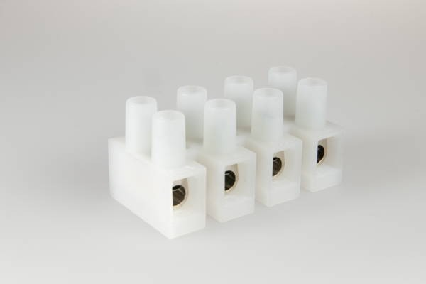
Screw Connectors

1500/ 4 DS
Terminal Block, 4 pole, Insulating Material: PA 6, Cross-
Section: 10.0 mm², Pin Spacing: 13.5 mm, Wire Protector (DS): yes, Fixing: Screw, Voltage Rating: 500 V, Current Rating: 57 A

Order Info

Reference Number (ref. no.) 127104

Applications Installation, Electrical Appliances, Transformers
PU 400
EAN 4028012106431

Type
Type Terminal Block
Number of poles 4 pole
Clamping Units per Pole 1
Colour natural

Cross-Section 10.0 mm²
Connection Type Screw

Wire Protector (DS) yes

Technical Data

Voltage Rating 500 V

Current Rating 57 A
Insulating Material PA 6

Contact Material Brass
Core Cross-Section min. 0.5 mm²

Core Cross-Section max. 6.0 mm²
Flammability Rating V-2

max. Ambient Temperature Operation 85 °C
Type of Conductor Solid yes

Type of Conductor Flexible yes
Type of Conductor Stranded yes

Stripping Length 8.0-8.5 mm
Assembly Contact Screw 0.8x4.0 /  1.2 Nm

Pin Spacing 13.5 mm
Fixing Screw

Approbation EN60998 1500_EN60998_20070823_20160412_VDE_ENEC_40021887_web.p
Approbation UL 1500_2000_19890315_20170213_UL_E63492_1-08_Description_w

Approbation CSA Schraub_Steck_Schraubenlos_SI_Klemmen_20160429_CSA_700765

Accessories

ZEL 110 196420

