


date 12/06/2016
page 1 of 4

SERIES: SJ2-2591X-SMT │ DESCRIPTION: AUDIO JACK

FEATURES
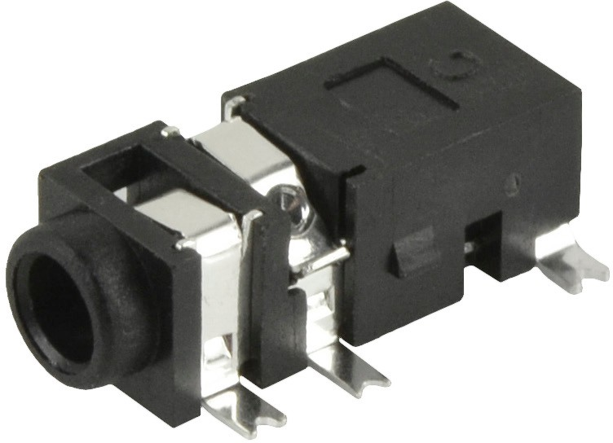
- multiple switch configurations
- low profile design
- reflow solder compatible
- surface mount

PART NUMBER KEY

-
SJ2-2591 X X
SMT-TR

Base Number
# Conductors: 21 = 2
3 = 3
Switch Options:
A = no switch
B = tip switch
C = ring switch
D = tip & ring switch
Package Style:
SMT = surface mount
Packaging:
TR = Tape & Reel

Note: 1. 2 conductor option only available with tip switch

SPECIFICATIONS
parameter | conditions/description | min | typ | max | units
rated input voltage |  |  | 12 |  | Vdc
rated input current |  |  |  | 1 | A

contact resistance2 | between terminal and mating plug between terminal in a closed circuit |  |  | 50  30 | mΩ mΩ
insulation resistance | at 500 Vdc | 100 |  |  | MΩ
voltage withstand | for 1 minute |  |  | 500 | Vac
insertion/withdrawal force |  | 0.3 |  | 3 | kg
operating temperature |  | -25 |  | 85 | °C
life | at a rate of 24 cycles/minute |  | 5,000 |  | cycles
flammability rating | UL94V-0
RoHS | 2011/65/EU
Note: 2. When measured at a current of less than 100 mA/1 kHz
3. All specifications measured at 10~35°C, humidity at 45~85%, under standard atmospheric pressure, unless otherwise noted.

MECHANICAL DRAWING
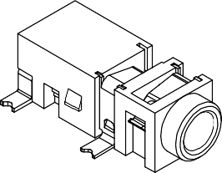
units: mm tolerance:
 | MATERIAL | PLATING
terminal 1 | copper alloy | silver
terminal 2 | copper alloy | silver
terminal 3 | copper alloy | silver
terminal 10 | brass | silver
terminal 11 | brass | silver
plastic | PA10T

X.X ±0.2 mm
X.XX ±0.10 mm
X.XXX ±0.050 mm
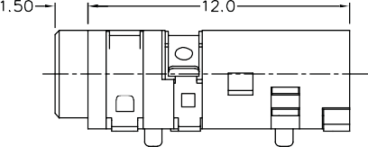
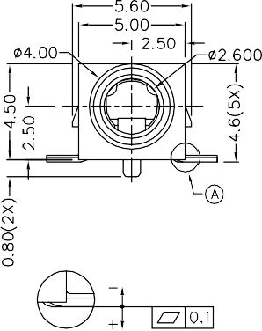
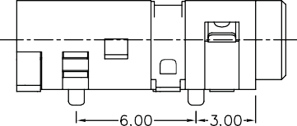
PCB: ±0.05 mm

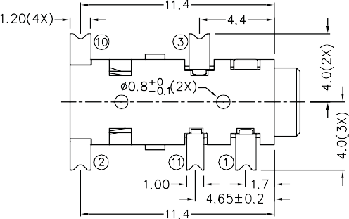

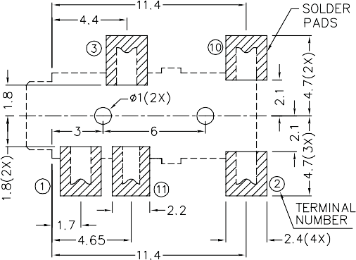
Recommended PCB Layout Top View

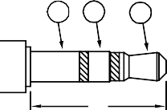
1 3 2
Model No. | SJ2-25912B-SMT | SJ2-25913A-SMT | SJ2-25913B-SMT | SJ2-25913C-SMT | SJ2-25913D-SMT
 | 1 | 1 | 1 | 1 | 1
Schematic | 10  2 | 3  2 | 3  10  2 | 3  11  2 | 3  11  10  2
PIN
1 | sleeve | sleeve | sleeve | sleeve | sleeve
2 | tip | tip | tip | tip | tip
3 | NP | ring | ring | ring | ring
10 | tip switch | NP | tip switch | NP | tip switch
11 | NP | NP | NP | ring switch | ring switch


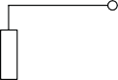
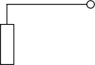

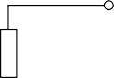

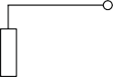
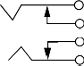
11
Ø2.5 MATING PLUG

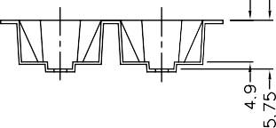
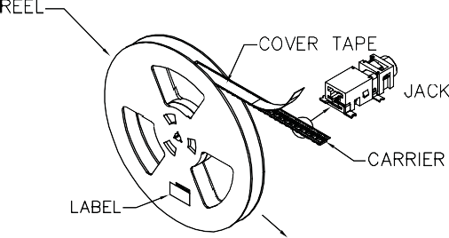

SOLDERABILITY
parameter conditions/description min typ max units
reflow soldering see reflow profile 255 260 265 °C

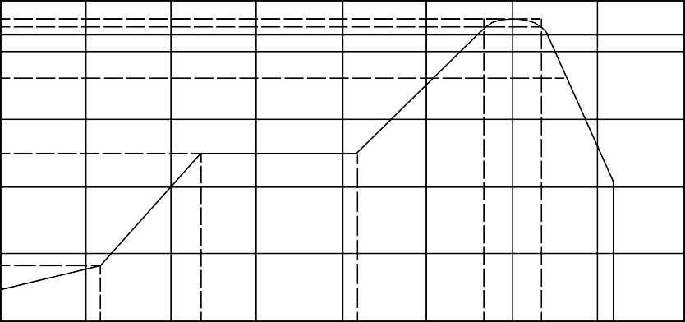
270
260
250
240
217
Temperature (°C)

180

120
150

60
50

430

380

340

250

140

70
60 120 180 240 300 360 420 480
Time (sec)

PACKAGING
units: mm
Reel Size: Ø330 mm
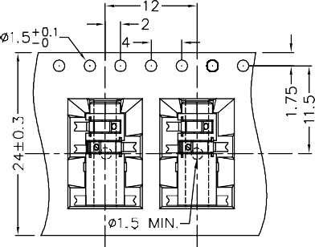
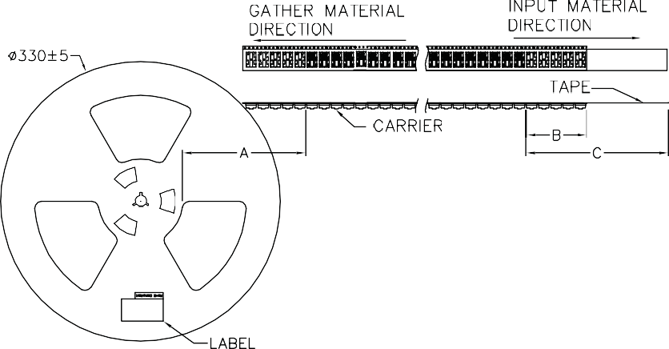
Reel QTY: 1,000 pcs per reel

A: Empty 160 mm min. B: Empty 100 mm min. C: Cover 400 mm min.

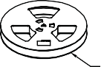

REVISION HISTORY

rev. | description | date
1.0 | initial release | 12/06/2016
The revision history provided is for informational purposes only and is believed to be accurate.


Headquarters
20050 SW 112th Ave.
Tualatin, OR 97062

800.275.4899

Fax 503.612.2383
cui.com techsupport@cui.com

CUI offers a one (1) year limited warranty. Complete warranty information is listed on our website.
CUI reserves the right to make changes to the product at any time without notice. Information provided by CUI is believed to be accurate and reliable. However, no responsibility is assumed by CUI for its use, nor for any infringements of patents or other rights of third parties which may result from its use.
CUI products are not authorized or warranted for use as critical components in equipment that requires an extremely high level of reliability. A critical component is any component of a life support device or system whose failure to perform can be reasonably expected to cause the failure of the life support device or system, or to affect its safety or effectiveness.

