**STAT 628 Module3: Analysis on Yelp Reviews Data**

Huitong Kou, Zihang Wang, Peibin Rui

November 2020

1. **Introduction**

There are tens of thousands of reviews for different types of businesses. Our analysis mainly focuses on restaurants which serve steak in several US cities such as Madison and Pittsburgh. Among these restaurants, our specific goals are:

* Investigate the relationship between ratings and words in reviews from two different aspects: foods, non-food factors.
* Provide useful advice for improving the ratings of steak restaurants on Yelp based on our analysis.

1. **Data Cleaning**

Our dataset contains a subset of million reviews from restaurants in Madison (U.S.), Cleveland (U.S.), Pittsburgh (U.S.) and Urbana-Champaign (U.S.) released by Yelp. The restaurants with at least 3 reviews older than 14 days are included and only reviews that were recommended at the time of the data collection are included

Limited by the computing power, we chose to focus on restaurants whose category contained the word “steak”. We followed the standard practice in NLP using the software package *nltk* in Python and split, clean and recreate the reviews. In order to match reviews with corresponding restaurants, we combine the tables created from *business.json* and *review.json*. To get some insights on how words in reviews are related with Yelp ratings, we created new columns by calculating the word frequencies in each review.

After filtering and combination, our primary cleaned data set *steak_cleaned.csv* has 33629 rows and 6085 columns.

1. **Exploratory Data Analysis and Key Findings**

**3.1 Insights on different types of steak**

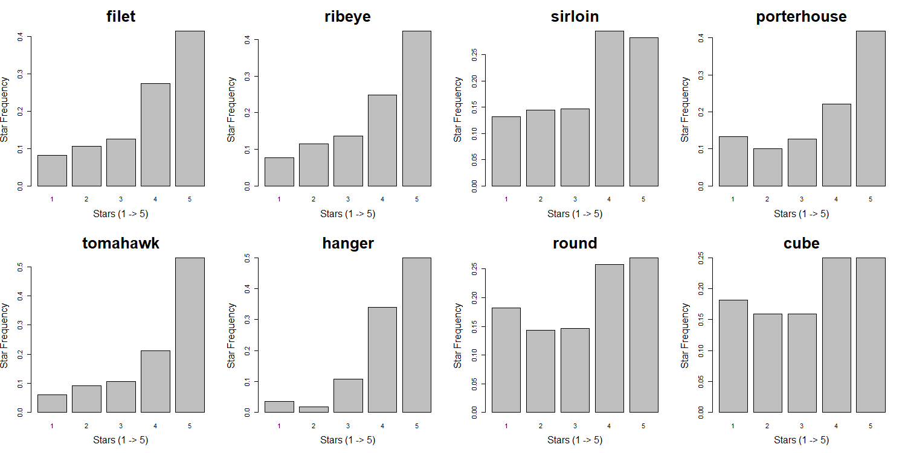

Figure 1

Firstly, we looked at the common types of steaks which appear many times in the comments and investigated the distribution of their ratings. We found that reviews mentioned filet, ribeye, porterhouse, tomahawk and hanger steaks tend to have more 5-star ratings. The portion of their 5-star comments is significantly over 45%.

However, although reviews mentioned sirloin, round, and cube steak also have a large proportion of high ratings, customers seem to be pickier since they also gave many low ratings on these steaks and the 5-star comments is roughly less than 30%.

* 1. **Insights on factors other than steak**

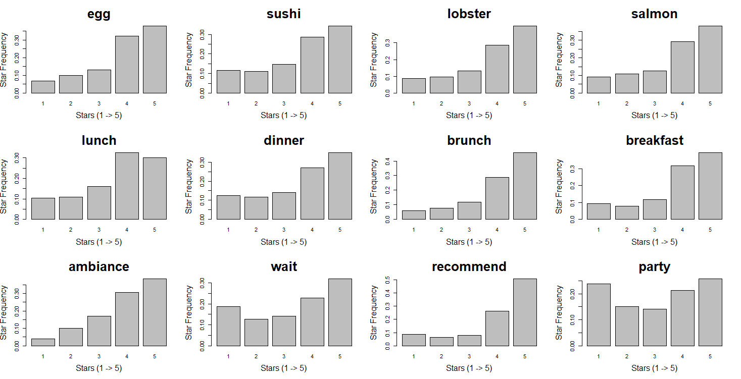

Figure 2

According to these plots of star distribution, we found that generally customers tended to give higher ratings if they mentioned some side orders other than steak. For examples, egg, sushi, lobster and salmon are more frequently mentioned as the star goes up, especially from 1-star to 4-star.

As for the meal time, all of them have a large proportion of high ratings. And brunch seems to be more popular than other meal times.

Non-food factors also play an important role in reviews’ rating. Clearly, customers don’t like waiting for seats and having meals when there is a party. Ambiance is one of the environmental factors that customers may pay more attention to or have higher expectation. A friendly and quiet ambiance can make people feel comfortable. And people tend to higher ratings if the steak restaurant is recommended by friends or relatives.

1. **Statistical Analysis**
   1. **T-tests on Business Attributes**

It’s noticeable that the *business_city.json* contains many useful attributes of each restaurant. We decided to conduct t-test on some of the attributes to see whether different levels of some attributes can make a statistically significant difference on a restaurant’s stars.

We conducted the t-tests on different subsets since the attributes each restaurant has differ from others. The first step is checking the variance equality of each 2 subsets. Then t-tests were conducted accordingly using the *t.test* function in R.

Figure 3 shows the overall star distributions of all steak restaurants. There are seven attributes selected and the p-value of each t-test is listed in table 1. According to the results of t-tests, with significance level of 0.05, the Restaurants Reservations (True), Restaurants Attire (Dressy), Outdoor Seating (True) and Restaurants Delivery (False) can statistically lead to significant higher stars. The Noise Level (Quiet), WiFi (Free), Restaurants Good For Groups (True) didn’t statistically matter.

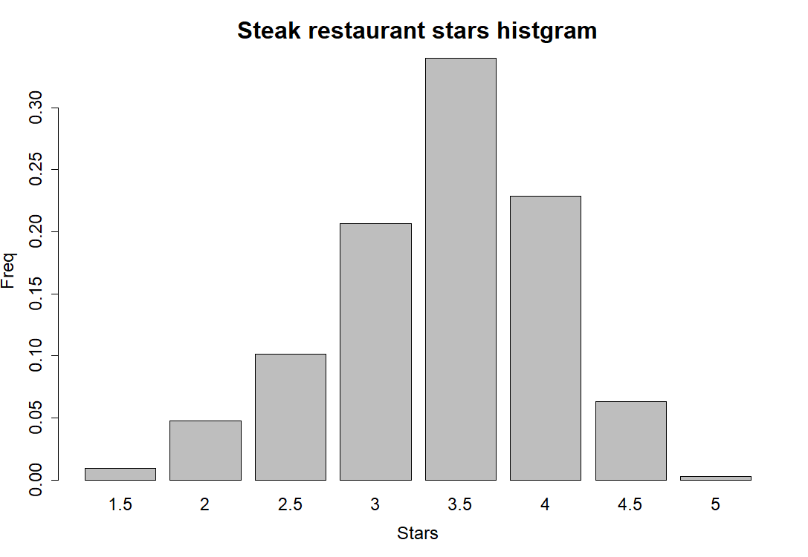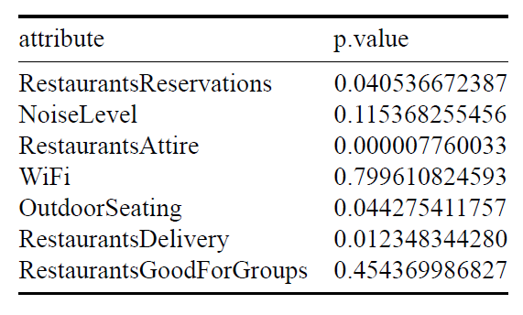

Figure 3 Table 1

**4.2 Multiple Linear Regression Model**

To quantitively analyze the influence of word frequency on review ratings, we fit a multiple linear regression model. The outcomes are star ratings and predictors are word frequencies in each review. Only words which occur more than 4000 times and we are interested in are included. So there are 93 predictors in total. The linear regression model has an $R^{2}$ of 0.3365, which implies that these predictors can explain 33.65% variation of review ratings. It is relatively low but reasonable since only a small part of whole words are considered in this model.

Using this regression model, we conduct t-test for each predictor to see whether having the word is significant in predicting ratings, while controlling for other words. Results of estimated slope and 95% CIs for some interesting words are shown as below:

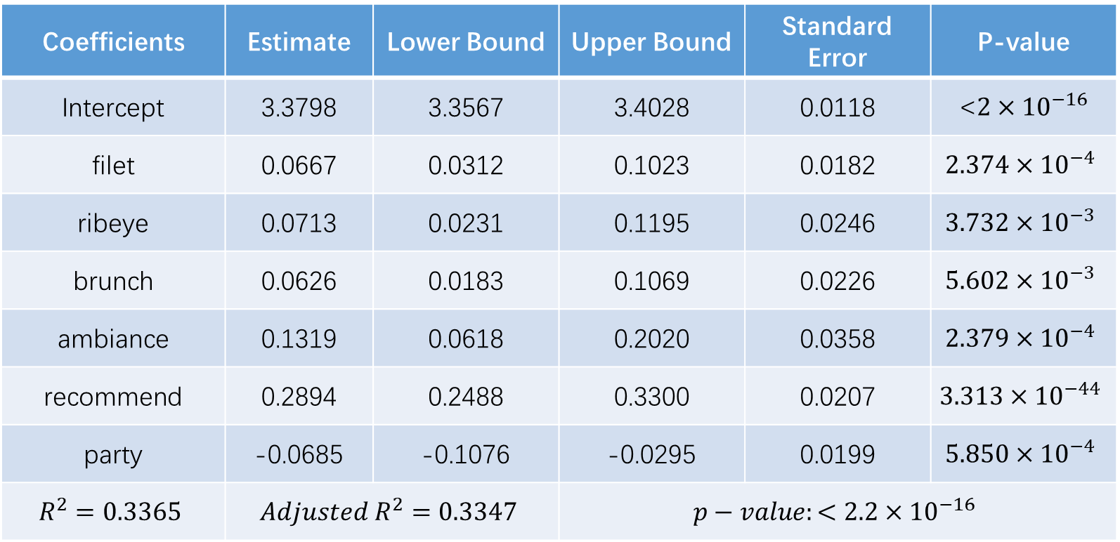

Table 2

These results reinforce the key findings in EDA part. Mentioning words “filet”, “ribeye”, “brunch”, “ambiance” and “recommend” in reviews has a positive effect on ratings while mentioning word “party” may decrease the ratings. Take the result of word “recommend” as an example, mentioning “recommend” in reviews one more time increases ratings by 0.2894 on average.

As for model diagnostics, all VIFs are less than 2, which means there is little multicollinearity. Then we used QQ-plot to check the normality of residuals. Most of the points follow the diagonal, so the normality assumption holds. However, the residuals distributed not randomly, there exits some linear patterns. It is reasonable since the response of this model only has five outcomes. This is also the limitation of our multiple linear regression model. Ordinal logistic regression may be a better choice but it is more complicated and harder to interpret the results.

1. **Data-Driven Recommendations and Actionable Plans**

Based on our analytics we done above, we can provide some recommendations for steak restaurant owners or someone who would like to open a new restaurant serving steaks.

* For types of steaks, we suggest the business owners pay more attention on improving the quality of filet, ribeye, tomahawk, hanger and porterhouse steaks and emphasize them on their menus, since customers tend to be more satisfied with these dishes according to Figure 1 and results of regression model. At the same time, advertise their sirloin, round and cube steaks if one of them has brought their restaurant high-star comments. Since these steaks seem to be less welcomed, having highly rated them is praiseworthy and will make the restaurant competitive.
* For food other than steaks, we suggest the steak restaurants consider providing or improving lobster and salmon as side orders since they are highly related with high ratings. They should also consider hiring cooks to serve desserts, salad and cheese, especially sushi. The steak restaurants serving these foods will get higher ratings on Yelp. What’s more, providing brunches is also helpful for improving ratings.
* For other environmental factors, our suggestions are creating a comfortable inner ambiance and avoiding holding noisy activities such as parties. Besides, paying attention to the attire of their waiters/waitresses, improving reservation system and offering outdoor seating are also good for improving ratings. Last but not least, recommendation is one of the most important factors affecting review ratings. Steak restaurants can design some special offers to encourage customers to recommend them to friends and relatives.

**Conclusion and Discussion**

In summary, we cleaned reviews from Yelp and tried to get some insights through exploratory data analysis. Then we performed some tests and built a multiple linear regression model to analyze the relationship between word frequencies in reviews and ratings quantitively. Finally, based on our results, we proposed some recommendations and actionable plans for steak restaurant owners which could potentially help them improve their ratings on Yelp.

Due to time constrains, there are also some limitations in our analysis. For example, the data may not be completely cleaned up so that some observations may be misleading. And some conclusions may be reached too hastily considering the lack of our marketing knowledge.

**Contributions**

HK contributed to the coding and writing of summary outline and the food and t-test part.

ZW contributed to the coding and writing of other parts and the slides of presentation.

PR contributed to the coding and writing of the shiny app and the slides of presentation.

**References**